**Лабораторна 5**

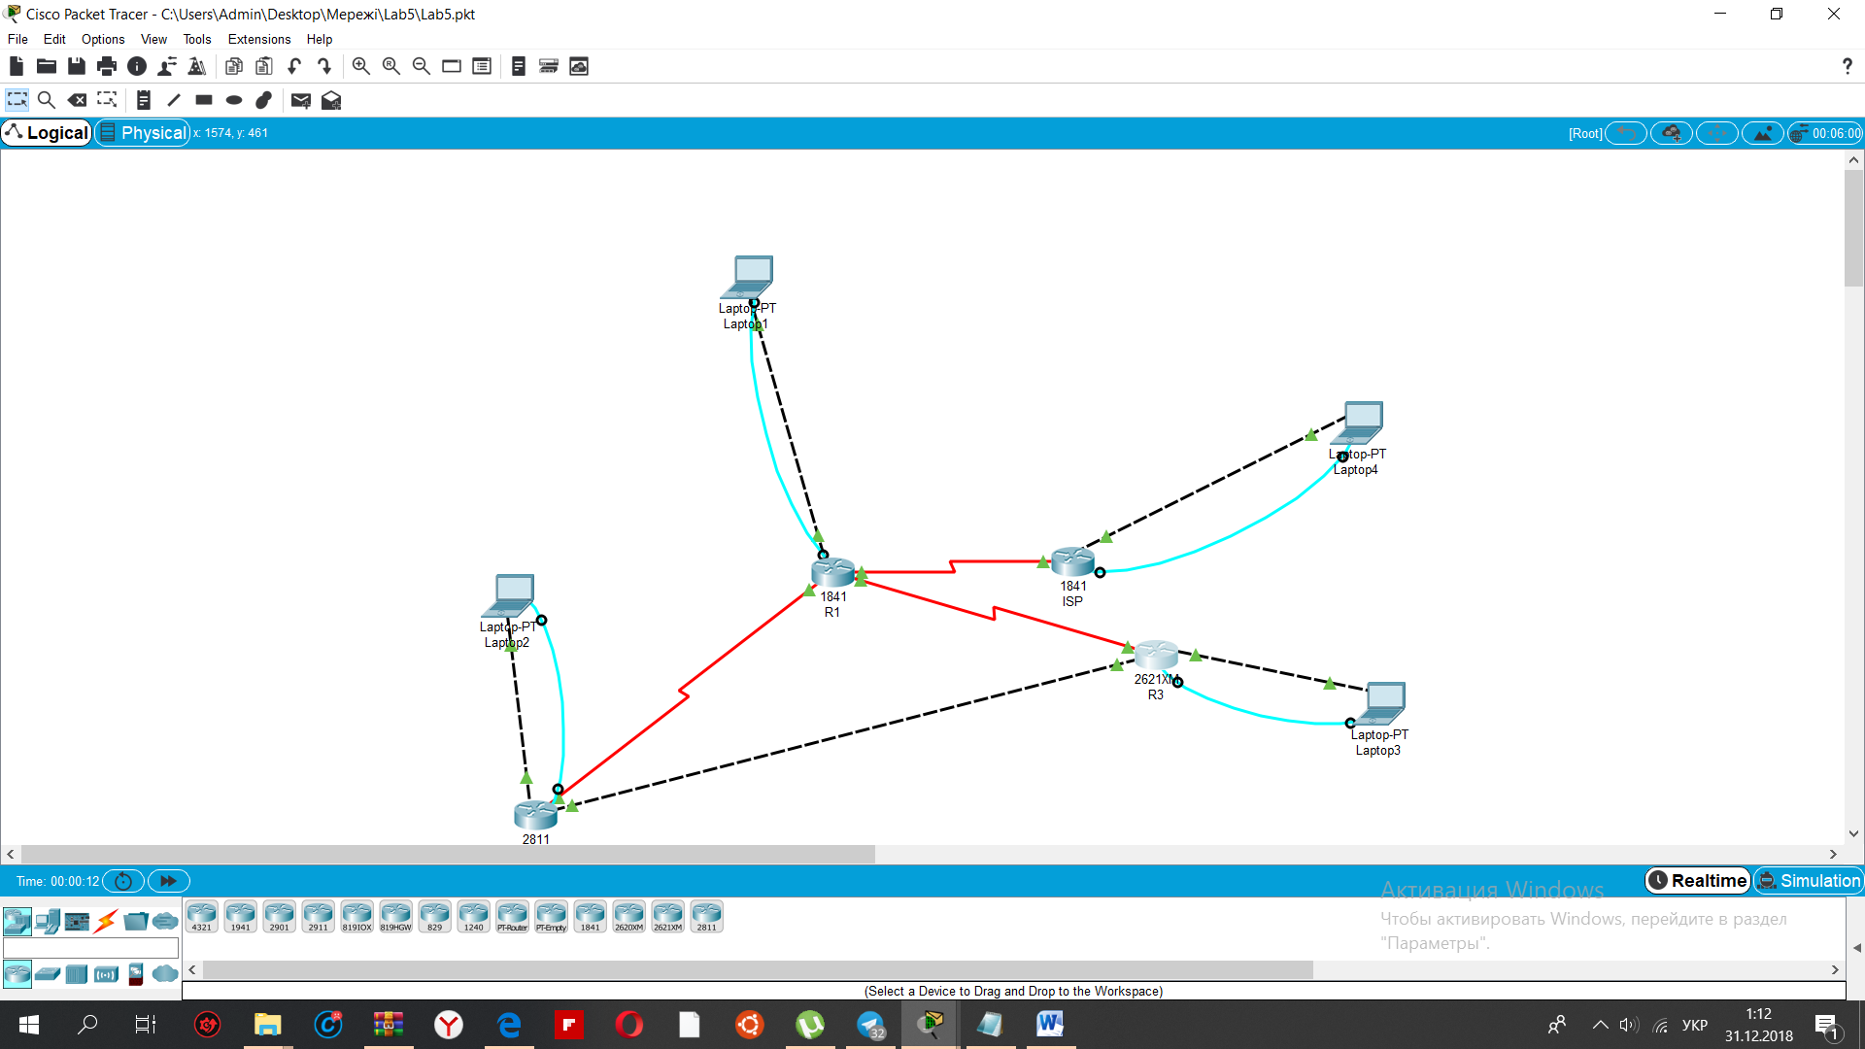

Коментарі: Налаштовано мережу таким чином, щоб при надсиланні пакета з однієї підмережі до іншої автоматично та знаходились нам потрібні. Наприклад при надсиланні пакету з 172.16.10.254 до 192.168.1.254 пакет спершу попадає до 172.16.10.1 тоді перенаправляється в 204.10.10.1 і лише тоді з роутера1 потрапляє до 192.168.1.254.

Перелік конфігурацій пристроїв які були задіяні

Роутер 1 конфігурація

R1#show running-config

Building configuration...

Current configuration : 1094 bytes

!

version 12.4

no service timestamps log datetime msec

no service timestamps debug datetime msec

no service password-encryption

!

hostname R1

!

!

!

enable secret 5 $1$mERr$5.a6P4JqbNiMX01usIfka/

!

!

!

!

!

!

no ip cef

no ipv6 cef

!

!

!

!

!

!

!

!

!

!

no ip domain-lookup

!

!

spanning-tree mode pvst

!

!

!

!

!

!

interface FastEthernet0/0

ip address 192.168.1.1 255.255.255.0

duplex auto

speed auto

!

interface FastEthernet0/1

no ip address

duplex auto

speed auto

shutdown

!

interface Serial0/0/0

ip address 10.1.1.2 255.255.255.252

clock rate 64000

!

interface Serial0/0/1

ip address 10.2.2.2 255.255.255.252

!

interface Serial0/1/0

ip address 204.10.10.1 255.255.255.248

clock rate 2000000

!

interface Serial0/1/1

no ip address

clock rate 2000000

shutdown

!

interface Vlan1

no ip address

shutdown

!

ip classless

ip route 192.168.2.0 255.255.255.0 10.1.1.1

ip route 192.168.3.0 255.255.255.0 10.2.2.1

ip route 0.0.0.0 0.0.0.0 204.10.10.6

!

ip flow-export version 9

!

!

!

!

!

!

!

!

line con 0

password cisco

login

!

line aux 0

!

line vty 0 4

password class

login

!

!

!

end

Роутер 2 конфігурація

R2#show running-config

Building configuration...

Current configuration : 940 bytes

!

version 12.4

no service timestamps log datetime msec

no service timestamps debug datetime msec

no service password-encryption

!

hostname R2

!

!

!

enable secret 5 $1$mERr$5.a6P4JqbNiMX01usIfka/

!

!

!

!

!

!

no ip cef

no ipv6 cef

!

!

!

!

!

!

!

!

!

!

no ip domain-lookup

!

!

spanning-tree mode pvst

!

!

!

!

!

!

interface FastEthernet0/0

ip address 192.168.2.1 255.255.255.0

duplex auto

speed auto

!

interface FastEthernet0/1

ip address 10.3.3.1 255.255.255.252

duplex auto

speed auto

!

interface Serial0/3/0

ip address 10.1.1.1 255.255.255.252

!

interface Serial0/3/1

no ip address

clock rate 2000000

shutdown

!

interface Vlan1

no ip address

shutdown

!

ip classless

ip route 192.168.1.0 255.255.255.0 10.1.1.2

ip route 192.168.3.0 255.255.255.0 10.3.3.2

ip route 0.0.0.0 0.0.0.0 10.1.1.2

!

ip flow-export version 9

!

!

!

!

!

!

!

!

line con 0

password cisco

login

!

line aux 0

!

line vty 0 4

password class

login

!

!

!

end

Роутер 3 конфігурація

R3#show running-config

Building configuration...

Current configuration : 820 bytes

!

version 12.2

no service timestamps log datetime msec

no service timestamps debug datetime msec

no service password-encryption

!

hostname R3

!

!

!

enable secret 5 $1$mERr$5.a6P4JqbNiMX01usIfka/

!

!

!

!

!

!

no ip cef

no ipv6 cef

!

!

!

!

!

!

!

!

!

!

no ip domain-lookup

!

!

!

!

!

!

!

!

interface FastEthernet0/0

ip address 192.168.3.1 255.255.255.0

duplex auto

speed auto

!

interface FastEthernet0/1

ip address 10.3.3.2 255.255.255.252

duplex auto

speed auto

!

interface Serial0/0

ip address 10.2.2.1 255.255.255.252

clock rate 64000

!

ip classless

ip route 192.168.1.0 255.255.255.0 10.2.2.2

ip route 192.168.2.0 255.255.255.0 10.3.3.1

ip route 0.0.0.0 0.0.0.0 10.2.2.2

!

ip flow-export version 9

!

!

!

!

!

!

!

!

line con 0

password cisco

login

!

line aux 0

!

line vty 0 4

password class

login

!

!

!

end

ISP конфігурація

ISP#show running-config

Building configuration...

Current configuration : 948 bytes

!

version 12.4

no service timestamps log datetime msec

no service timestamps debug datetime msec

no service password-encryption

!

hostname ISP

!

!

!

enable secret 5 $1$mERr$5.a6P4JqbNiMX01usIfka/

!

!

!

!

!

!

ip cef

no ipv6 cef

!

!

!

!

!

!

!

!

!

!

no ip domain-lookup

!

!

spanning-tree mode pvst

!

!

!

!

!

!

interface FastEthernet0/0

ip address 172.16.10.1 255.255.255.0

duplex auto

speed auto

!

interface FastEthernet0/1

no ip address

duplex auto

speed auto

shutdown

!

interface Serial0/0/0

ip address 204.10.10.6 255.255.255.248

!

interface Serial0/0/1

no ip address

clock rate 2000000

shutdown

!

interface Vlan1

no ip address

shutdown

!

ip classless

ip route 192.168.1.0 255.255.255.0 204.10.10.1

ip route 192.168.2.0 255.255.255.0 204.10.10.1

ip route 192.168.3.0 255.255.255.0 204.10.10.1

!

ip flow-export version 9

!

!

!

!

!

!

!

!

line con 0

password cisco

login

!

line aux 0

!

line vty 0 4

password class

login

!

!

!

end