Data preparation for purchase prediction
Fedoriv Sviatoslav
Applied Sciences Faculty, Ukrainian Catholic University
fedoriv@ucu.edu.ua
ABSTRACT
Imagine that you are supermarket. You want to maximize your profits on black Friday. That why you want to understand the customer purchase behavior (specifically, purchase amount) against various products of different categories. That way it is good to build a model to predict the purchase amount of customer against various products which will help to create personalized offer for customers against different products.
1 Introduction and task deﬁnition
These model should predict how many purchase will spent customers on black Friday. It was hard to make good prediction for one customer, but how many purchase will spent a large number of customers.
2 Related Work
If you will look on the free Kegel dataset. You will see the categorical feathers and one purchase feather. It has a lot of missing values. So how can we manage missing values in these dataset?
Let’s look on our data
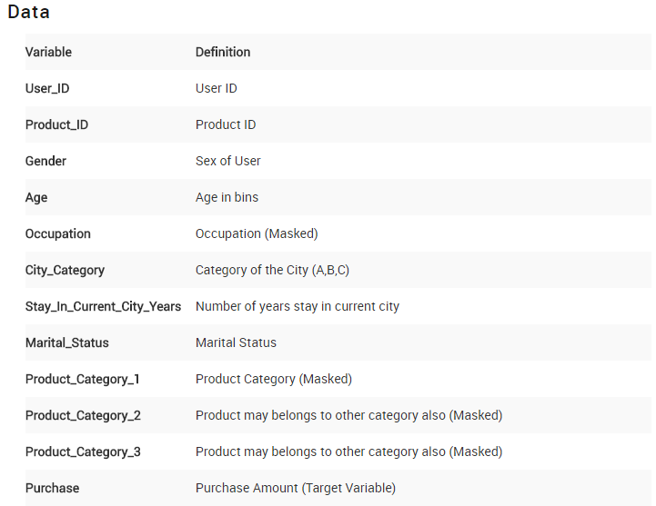
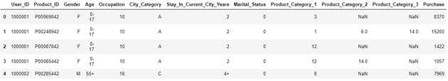
We can see missing values in product categories 2 and 3. In product categories 2 missing: 31% and product categories 3 Missing:69%. We also had purchase missing values 29%, but we can just remove these rows.
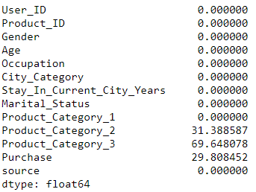
Product categories columns are categories data, so that’s mean we can use most frequent strategy for 2 product categorie and then predict 3 product categories using some tree classifier algorithm. If we will take only those rows that haven’t missing values we can predict missing by DecisionTreeClassifier(). Product category 2 we can fill by most frequent value.
3 Dataset and Features.
Her we can see correlation for data without missing values. As we can see from it we can predict product category from one or two another. 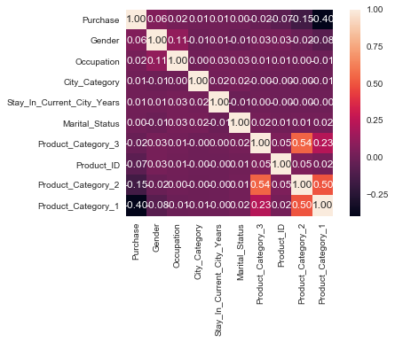
Lets look on our plot. Using TSNE, we see that we should use Tree.
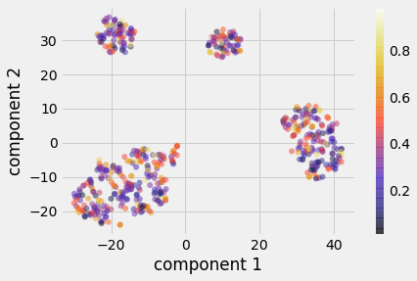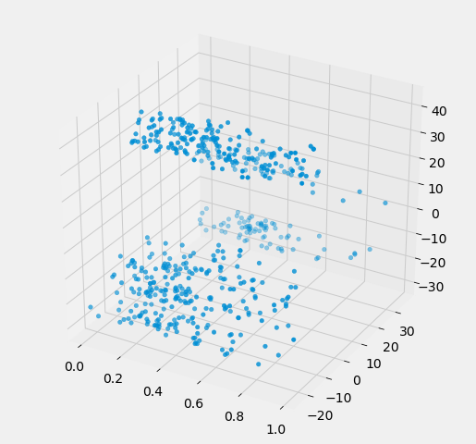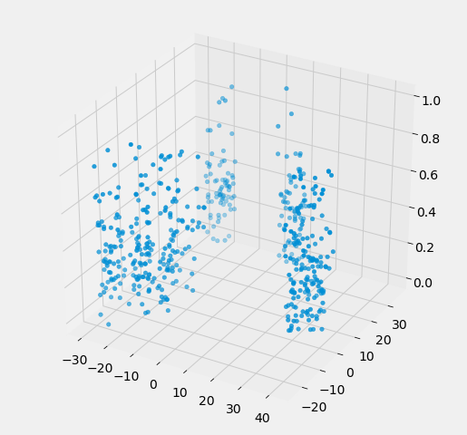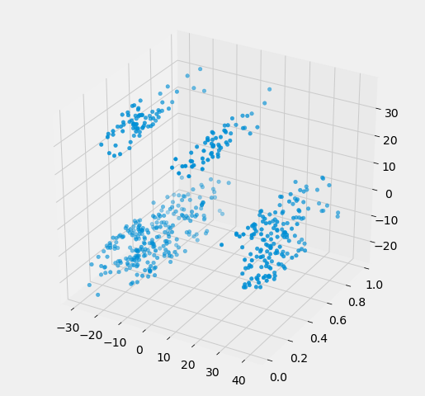
4 Models and Method
Finally, we have a data set without missing values. I use a different model to find optimal repressor. But the best was decision tree repressor. It is built top-down from a root node and involves partitioning the data into subsets that contain instances with similar values. The best results was shown by RandomForestRegressor.
###############################Model_report#############################################
mean_squared_error on train : 0.012171099833985791
mean_squared_error on test : 0.015682259260149684
mean_absolute_error on train : 0.08422313974883826
mean_absolute_error on test : 0.09300154221881753
##############################End_of_report############################################
5 Results and Discussion
The best results was shown by RandomForestRegressor. Error disiribution is shoun on plot.
