Data preparation for purchase prediction
by Fedoriv Sviatoslav
fedoriv@ucu.edu.ua
Applied Sciences Faculty, Ukrainian Catholic University, Lviv, Ukraine
ABSTRACT
Imagine that you are supermarket. You want to maximize your profits on black Friday. That why you want to understand the customer purchase behavior (specifically, purchase amount) against various products of different categories. That way it is good to build a model to predict the purchase amount of customer against various products which will help to create personalized offer for customers against different products.
Introduction
If you will look on the free Kegel dataset. You will see the categorical feathers and one purchase feather. It has a lot of missing values. So how can we manage missing values in these dataset. I used random forest tree classifier to find missing values.
Frame the problem
Before looking at the data it is important to understand how does the company expect to use and benefit from this model? This first brainstorming helps to determine how to frame the problem, what algorithms to select and measure the performance of each one.
I can categorize my Machine Learning (ML) system as:
Supervised Learning task: we are given labeled training data (e.g. we already know how much a customer spent on a specific product).
Regression task: our algorithm is expected to predict the purchase amount a client is expected to spend on this day.
Usually for regression problems the typical performance measure is the Root Mean Square Error (RMSE=(mse)*1/2). This function gives an idea of how much error the system makes in its predictions with higher weight for large errors.
Make Assumptions
Let’s start to think about possible parameters that might influence the amount a client spends on Black Friday. I think we can divide the different factors into four levels:
City Level Hypotheses:
City Type and Size : Urban or Tier 1 cities should have higher sales because of the higher income levels of people there.
Population Density: Cities with densely populated areas should have higher sales because of more demand.
Younger Population : Cities with younger populations might have higher tendency to spend more on Black Friday
Customer Level Hypotheses:
Income
Age and Gender
Family Size
Purchase History
Store Level Hypotheses:
Location
Size
Competition
Marketing
Product Level Hypotheses:
Category(clients should be looking to buy technological products)
Price(customer will spend more on products with higher discounts)
Advertising (advertised products should sell more)
Visibility(visible products should sell more)
Available data
Let’s see our data.
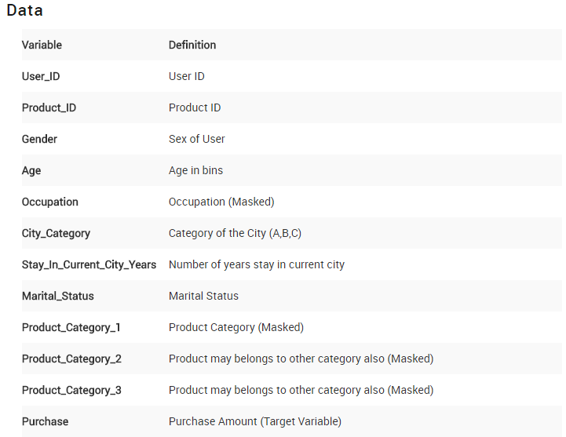
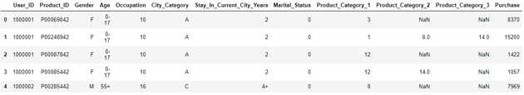
Methods
Data set selection was the entry point of the experiment. It was taken from online resource Kaggle. The data set originally consisted of one file. The data set has ten columns three of them is product category that represents eighteen product of each categories. These three columns have missing values. Each row represent one observation with users(one user can have a feu observation).
The process of data preparation consists of several stages:
• Data Cleaning
• Missing Values Imputation
• Data Scaling
• Dimension Reduction for plot.
Data cleaning
Here I investigated data set for duplicates, but there was not column or row duplicates. Because each row is one observation with one user.
Missing Values Imputation
Prod2 Missing:31% and Prod3 Missing:69%
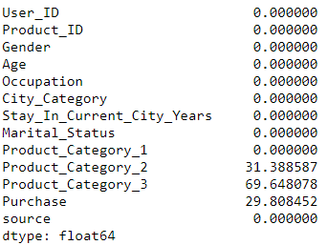

We really have a shortage of data in the Product Category 3 field, almost 70% If we will take only those rows that haven’t missing values we can predict missing by DecisionTreeClassifier(). Product category 2 we can fill by most frequent value.

Her we can see correlation for data without missing values. As we can see from it we can predict product category from one or two enother. 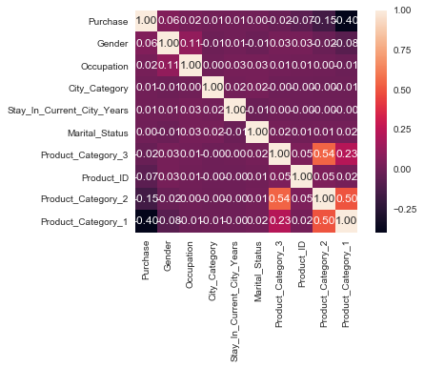
Lets look on our plot. Using TSNE, we see that we should use Tree.
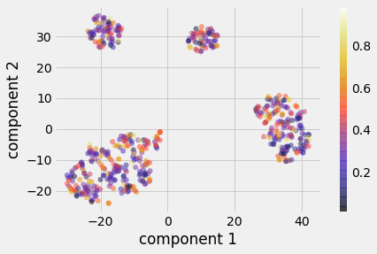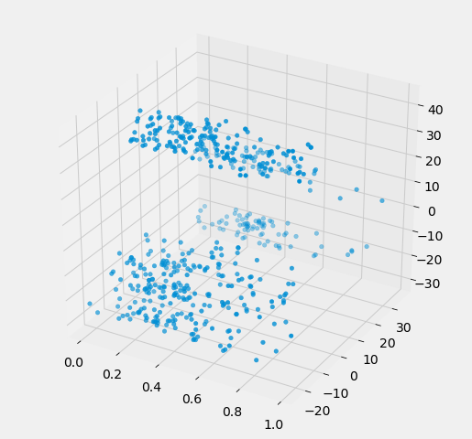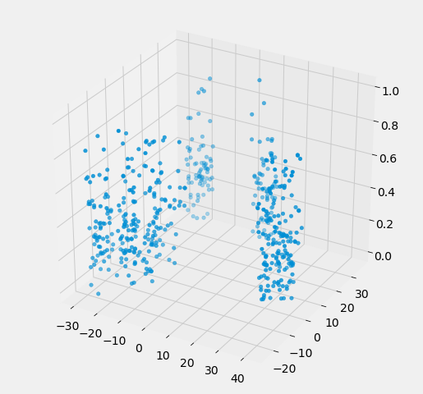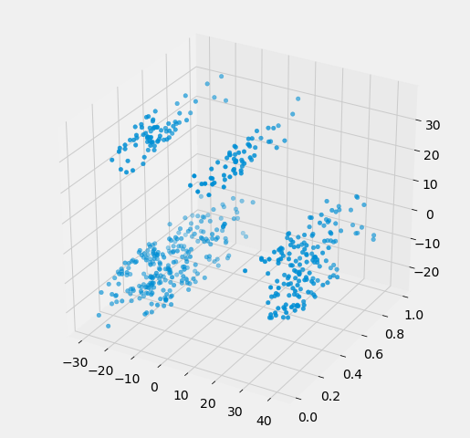
Model Selection
Finally, we have a data set without missing values. I use a different model to find optimal repressor. But the best was decision tree repressor. It is built top-down from a root node and involves partitioning the data into subsets that contain instances with similar values. The best results was shown by RandomForestRegressor.
###########################Model_report#############################################
mean_squared_error on train : 0.012171099833985791
mean_squared_error on test : 0.015682259260149684
mean_absolute_error on train : 0.08422313974883826
mean_absolute_error on test : 0.09300154221881753
###########################End_of_report############################################

