**1.Change part of name of procedure “Inser 🡪 Insert”. I just forgot rename it in FillDataBase file**  
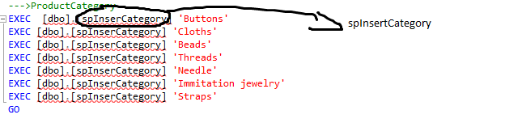

**2. It will not execute, I use it when I create DB but when I write code I change implementation of this procedure for using from my code. In any way we can add new supply in Manager panel**

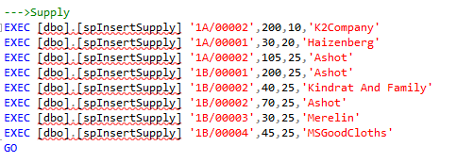

**3. In MainStorageProcedure.sql this two snippet repeated.**

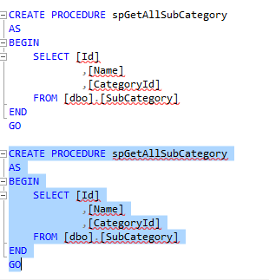

**4. If you click Review it throw exception**

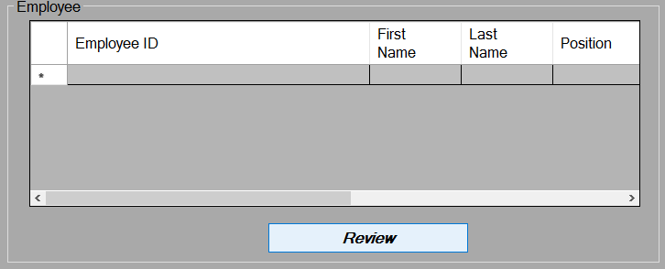

Must be spGetAllEmployee

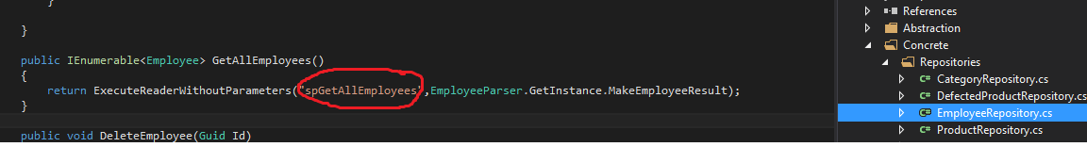

**5. Add it to clear DataGrid**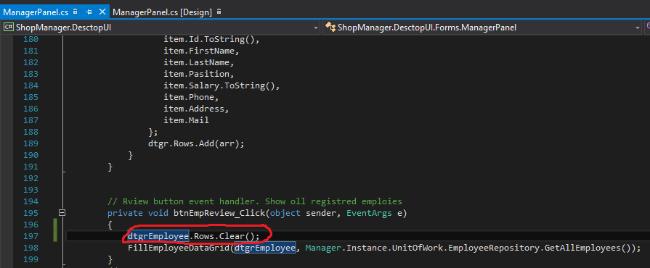

6.Change page1 on page2

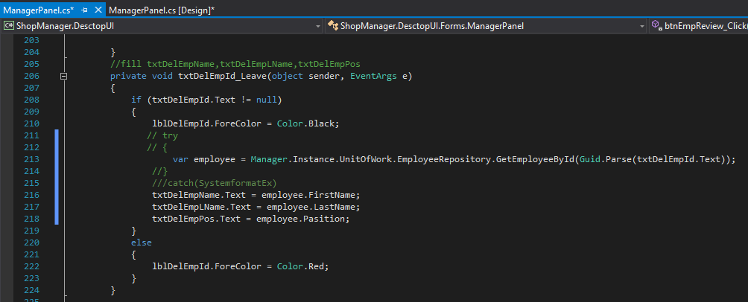

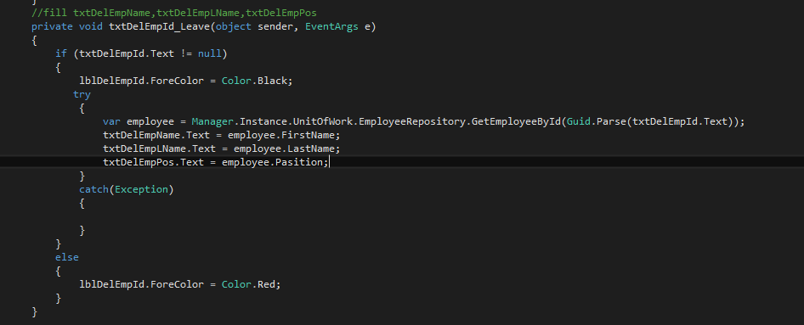

7. spGetAllProducts 🡪 spGetAllProduct

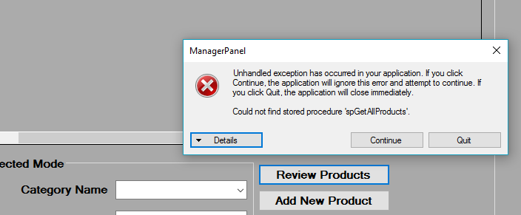

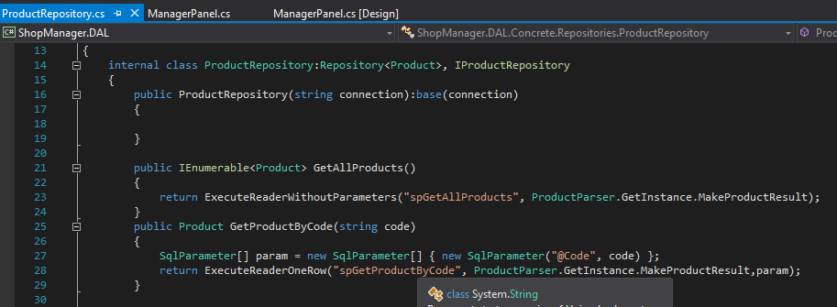

8. Not implement change category subcategory

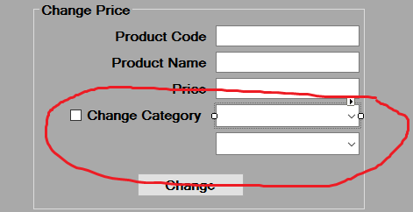

9. Clear treeView

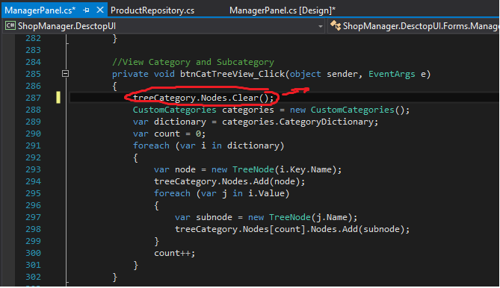

10. Not implement

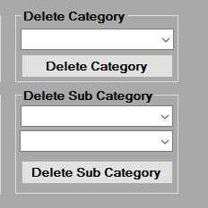

11.

