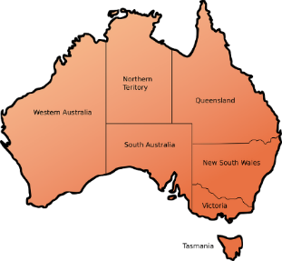Size of Australia by State

Acquire and visualise data from secondary sources

**Activity resources**

This activity requires the following resources:

**Wikipedia**

Access to Wikipedia via the internet.

**Spreadsheet software**

Spreadsheet software to store, clean and then upload data.

**Infogram.com**

To create a data visualisation and create HTML code. Students can use a google account (e.g. Monash College email account) to access Infogram.

**Notepad or Notepad++ or TextEdit (Mac)**

Used to create a website and embed html code.

**Web browser**

Use to view the web page.

**Acquiring data**

**1. Go** to <https://en.wikipedia.org/wiki/Ranked_list_of_states_and_territories_of_Australia>.

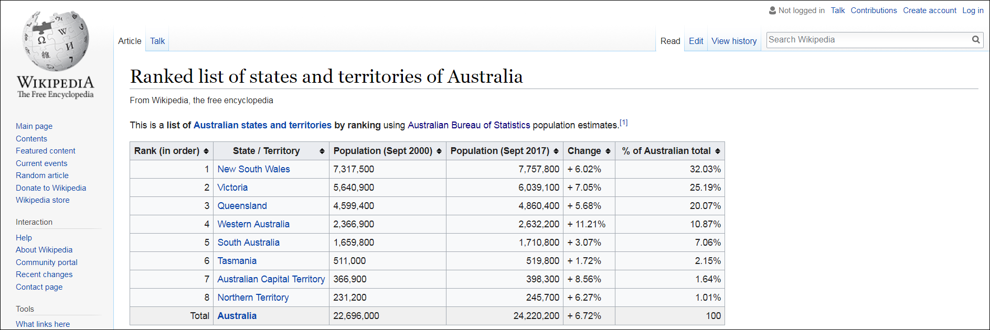

**2. Scroll down** to the “by area” section and copy the data shown.

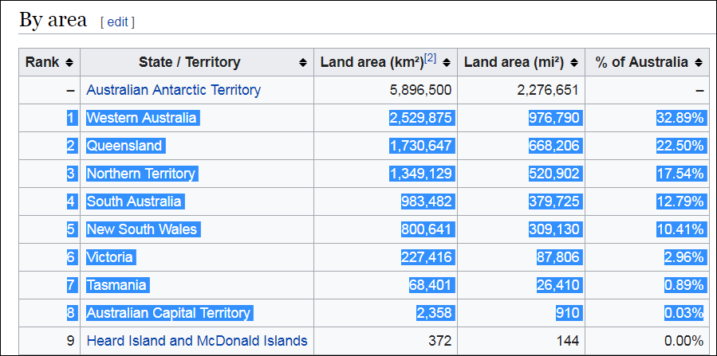

**3. Paste** the data into a spreadsheet. Save the spreadsheet as States.csv

**Note:** Make sure you save the data as a .csv file, not .xlsx.

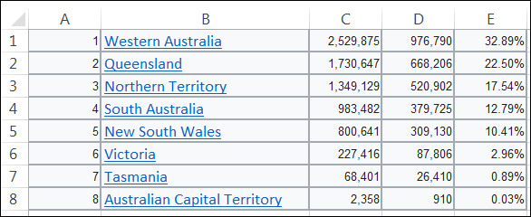

**Cleaning the data**

**4. Insert** a row at the top of the spreadsheet. Add the titles ‘State’, ‘Size’.

**5. Delete** the 1st, 4th and 5th row.

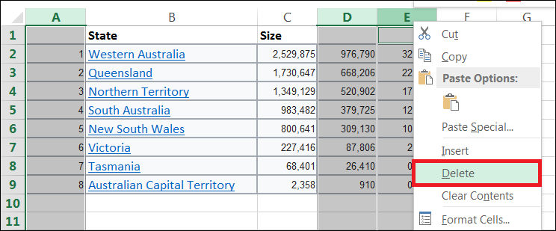

The spreadsheet should now appear as shown below:

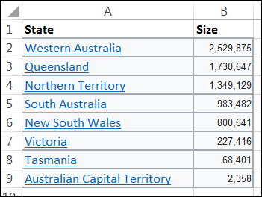

**Visualising the data**

**5. Go to** infogram.com.

**6. Select** Single chart.

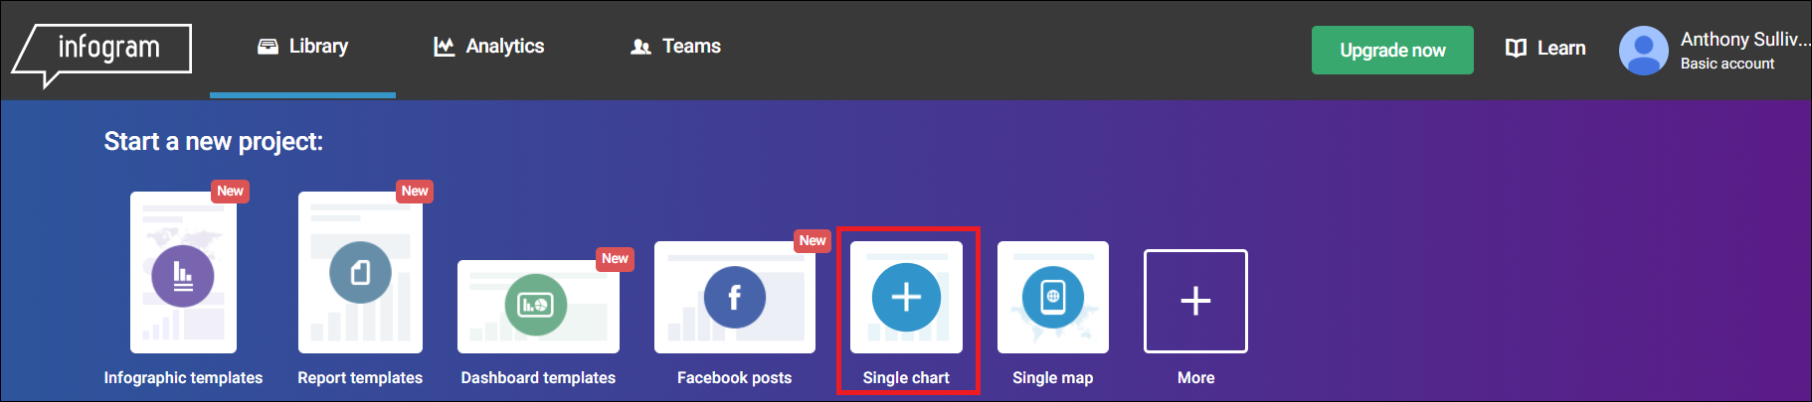

**7. Name** the chart ‘Australia’s size by state’ then click ‘create’.

**8. Select** a Treemap chart type.

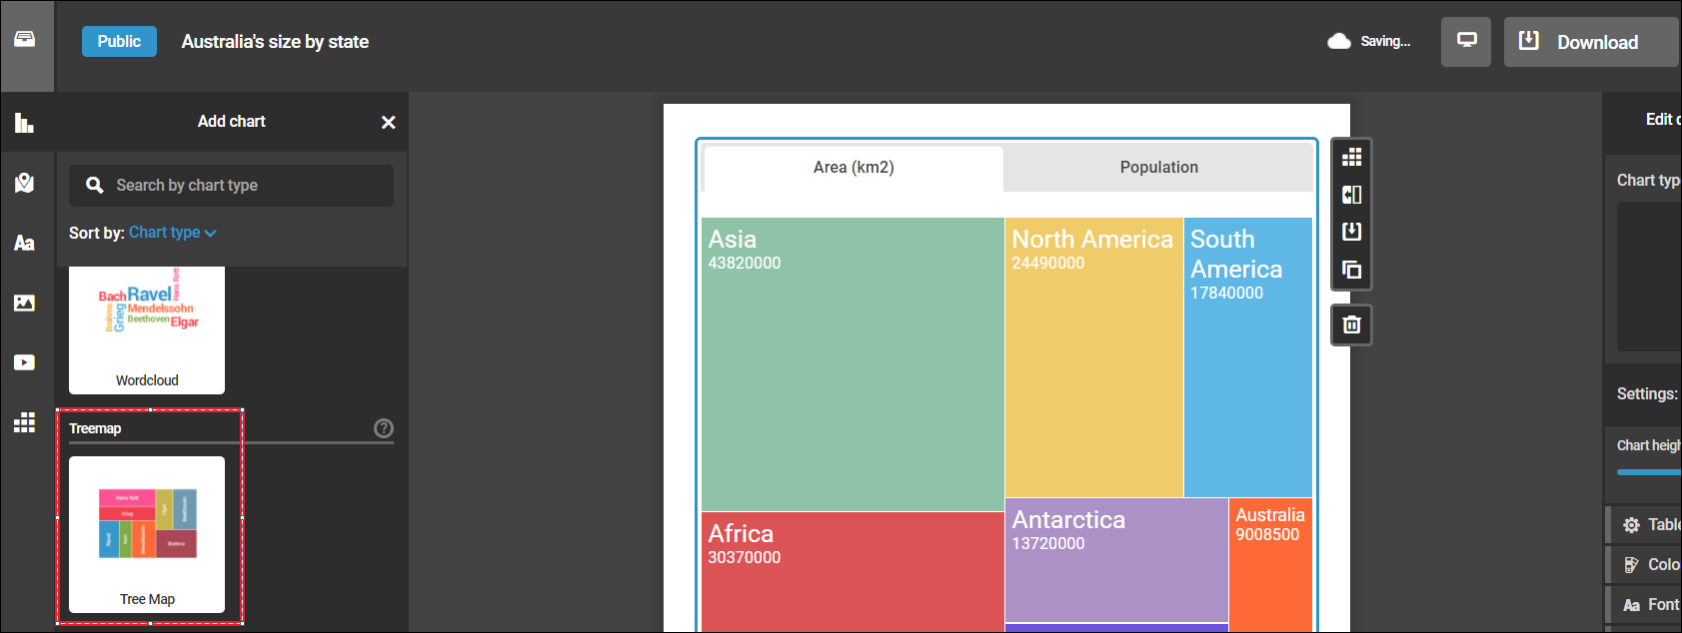

**9. Select** ‘edit data’.

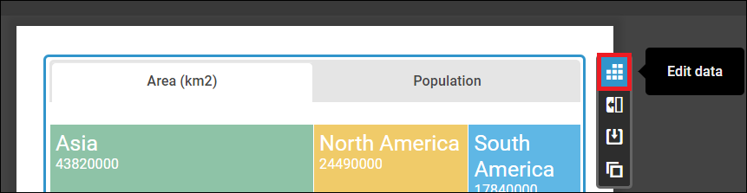

**10. Select** ‘upload file’ then **select** ‘States.csv’ file.

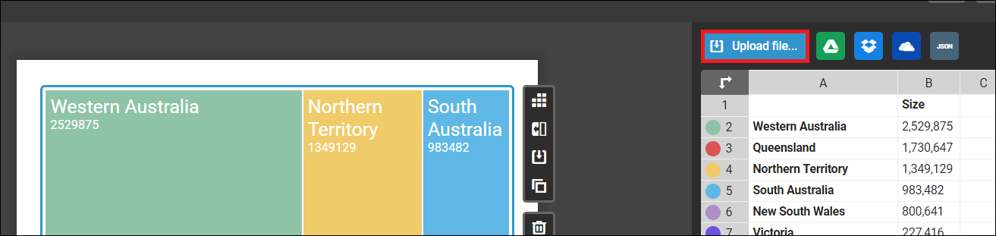

The treemap should now be visible:

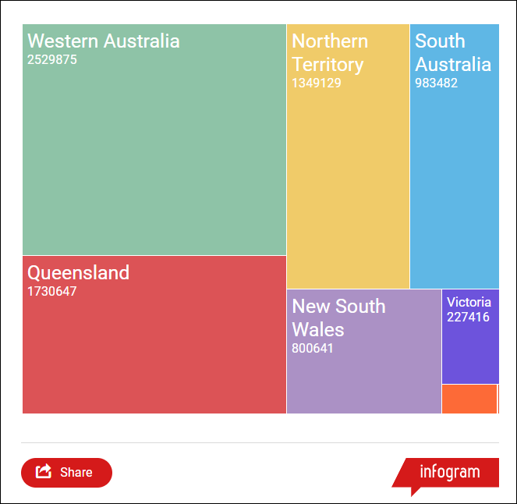

**11. Click** ‘settings’ and **set** the chart height to 700.

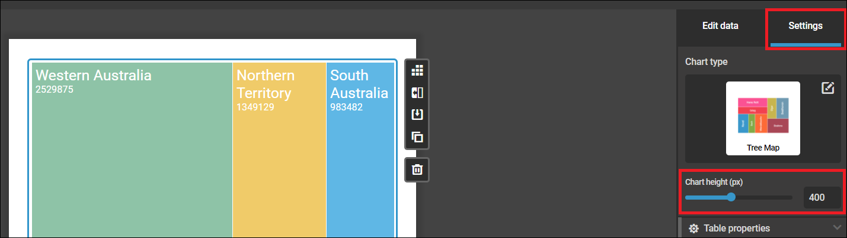

**12. Click** ‘settings’ and **set** download to in ‘table properties’.

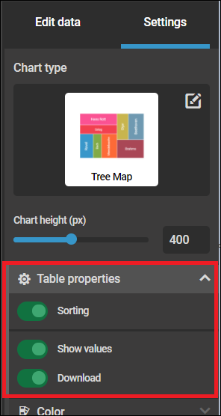

**13. Select** ‘text’ then **select** ‘H1’ and **drag** to the top of the graph. Name the chart ‘Australia’s size by state’.

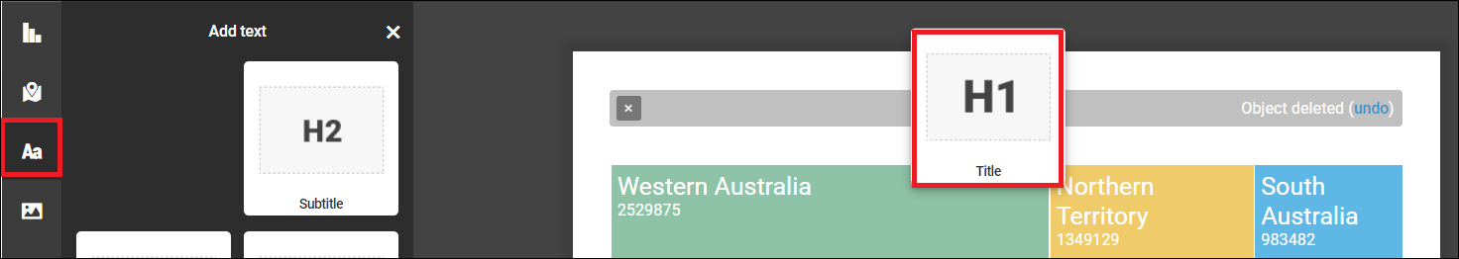

**Export the graph to a webpage**

**14. Click** ‘share’ then select ‘public’. Next, **select** ‘embed’ then **select** ‘fixed’. **Copy** the HTML code.

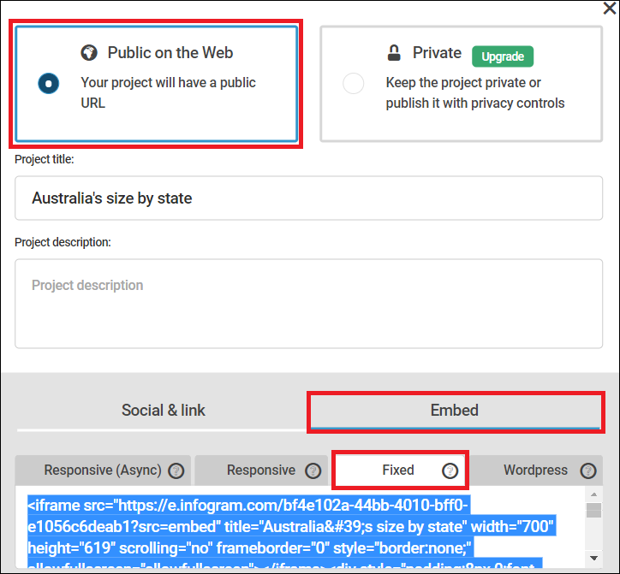

**15. Open** up Notepad or Notepad++ and **paste** the code into the document.

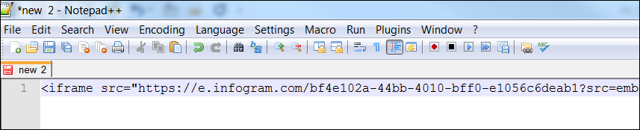

**16. Save** the file as AustraliaSizeByState.html.

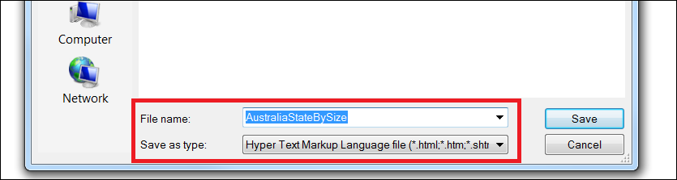

**17. Find** the file icon and double click to open in a web browser.

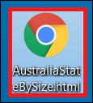

The chart should now appear in the web page.

