Content

- Titel
- Description
- Genre
- Camera
4.1Controls
- Room
5.1 Furniture
5.2 Details
- Cards
- Cardeffects
7.1 Special
- Board
- Basic rules
- Sound database
10.1 Winning Condition
10.2 Game Over Condition
- Credits

1. Titel:
Couching

2. Description:

Storyline/ „Intro Video“:

On a Friday Night, 2 Dude are sitting in the livingroom. One of them in an armchair, the other one on the couch. No Dates and absolutly motivated... not to move. The remote is on the table between those two. Exactly. In. The Middle.

Dude 1: „Hnnn... aahh, damn it. Can you reach it?“
Dude 2: „Hnnn... naah, and what do we do now?“
Dude 1: „Try to reach the remote with every thing you'll find“

Now both player have to reach the remote, with random Stuff within reach. Especially the Couchgap.

3. Genre:

Card-/Boardgame, Singleplayer,

4. Camera:

3D, Ego-Perspektive

The objects will be shown at the lower Desktopside.
Only the names of the objects will be schown. The effects / consequences are unclear.

4.1 Controls:

PC- Mouse

5. Room:

5.1 Furniture

Couch(es)
Armchair
Table
Carpet
Windows
Door(s)

5.2Details

remote
Pictures on the wall
Roomplants
Full rubbishcontainer
Scratchtree
Stereosystem
Playstation/N64
Ashtray
Cigarette
Rooflamp
Lavalamp
Blacklightlamp
Shelf
Pizza/Asiaimbiss-packages
empty Café/Teacup

6. Cards:

Cardeffects are displayed and will not be shown to the player, only the objects can be seen.

Banana on a shoelace

The fishingpole of the poor man.

1-5 R moves to player (3)
6-10 Hits enemy, play again Sound: „smashed“

Telekinesis (Auto sound: „Hnnn...“)

Use the supernatural force of laziness to create a miracle.

1-5 Nothing happens ----> Sound: „Fart“
6-7 R moves to enemy (1)
8-10 R moves to player (1)

Hoofmagnet (Auto sound: „magnet“)

oldfashioned but effective

1-10 R moves to player (1)

Fishing pole (Auto sound: „fishing pole“)

For more then just fishing

1-3 R moves to player (2)
4-6 Hits enemy, play again
7-8 Hits something in the room, draw card
9-10 nothing happens

Alien tractor beam (Auto sound: „tractor beam“)

I dont know what that is. Just use it already.

1-8 R moves to player (2)
9-10 Got an anal probe, wait 1 turn Sound: „Ohh shit!“

Treats (Chips) (Auto sound: „who's a good boy“)

Treats for a dog. Don't believe me? Use it!

1-2 Dog pokes the table, R moves to player (1)
3-8 Dog picks random item out of the room, draw a card
9-10 nothing happens

Corpse in the basement (Auto sound: „Screams below“)

What is happening to our neighbours?

Neighbours are screaming, running and jumping below the living room. Result = R moves

1-5 R moves to player (1)
6-10 R moves to enemy (1)

CD/Book (Auto sound: „throw“)

Who needs CDs and Books, if you can take control of the remote.

1-5 Hits enemy, play again
6-10 misses enemy, nothing happens

Saw (Auto sound: saw)

The table is to big!

1-6 reduces the maximum fields to the player (1), cut the table
7-10 player injures himself, wait 1 turn Sound: „Ohh shit!“

Dukt tape (Auto sound: „Dukttape“)

Sticky like hell and indestructable... perfect.

1-4 fixes the table on the enemies side, fix table
5-8 nothin happens
9-10 Sticky tape is sticky, wait 1 turn

Nokia

Picture: Brick with a picture of a nokia

Indestructable! What ever gets hit with that is definitly broken. FOREVER!

1 Nokia hits TV, Game Over
2-3 Nokia hits enemy, play again (2)
4-10 nothin happens

Glove

Picture: Condom

Advanced technlologie for getting more stuff.

The player is confident enough with this item to search for more items in the couchgap.

Draw card (2)

7. Cardeffects summary:

-R move to player/ enemy
-nothin happens
-wait 1 turn/ play again
-draw card

7.1 Special:

-Gameboard +1/-1 field
-Game Over

8. Board

- The Boardgame has 11 linear fields. 1 in the middle and 5 in 2 directions.
- In the middle is the remote.
- On each side is one player (2)

9. Basic rules:

In the middle of the Board is the remote placed.

Each player gets 3 cards (objects) on his hand.

Each player gets his turn and can play one card only.

Only if the „hand“ is empty you can pick form the couchgap, to get 2 cards. This counts as 1 turn.
But be warend, somthing cruel is in there:

1-7 Draw card (2)
8-9 Cat scratches the hand of the player, nothing happens
10 You are lucky, draw card (3)

10.1 Winning condition:

Player reaches the remote before the KI does.

10.2 Game Over condition for both:

KI reaches the remote beforePlayer does.
TV got destroid through Nokia.

10. Sound databank

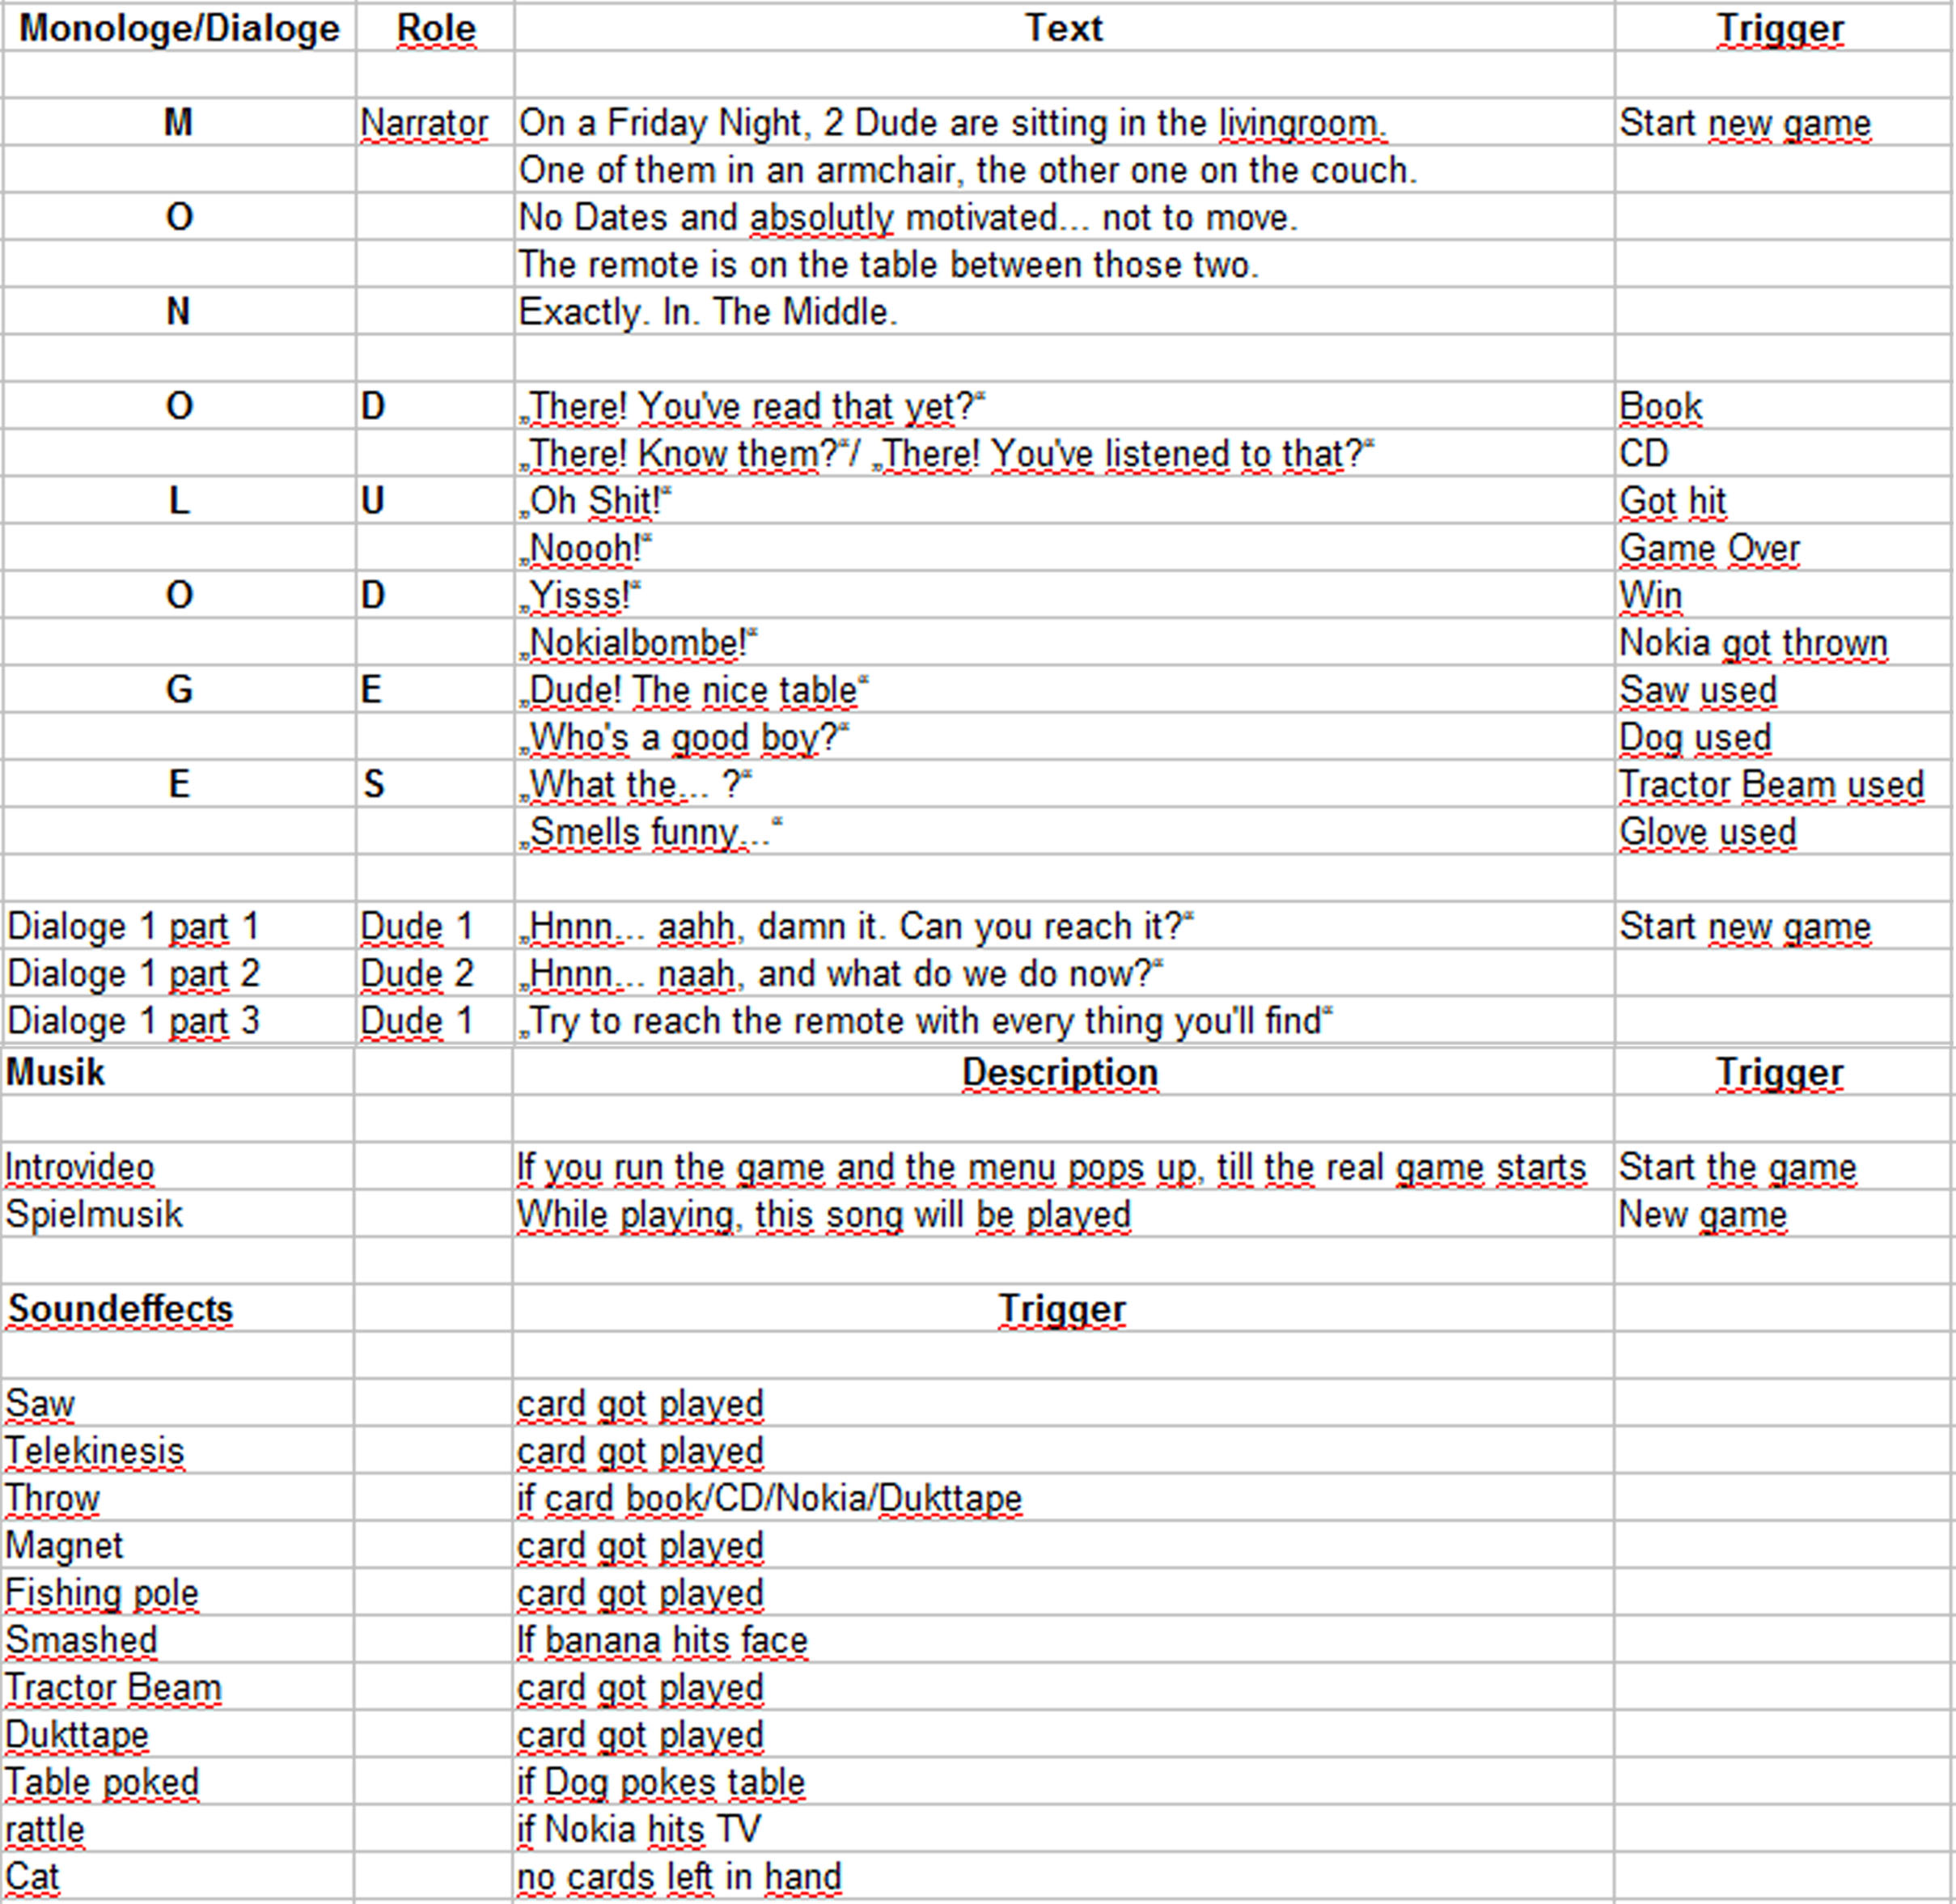
12. Credits:

Niko – Game Design
Benny – Texture Artist
Tom – 3D Modeling/Artist
Svenja – Coderin/Programmer
Nico Reitmeier – Musik
Zeiss Vrone- Sprecher

