Midterm Project: QA Implementation and Empirical Analysis
Student: Dias Kazikhanov, Abzal Nurym, Amir Karataev
Group: CSE-2506M
Course: Advanced QA
Date: April 10, 2026
1. System Description
The system under test is Habaneras de Lino DRF API. It is an e-commerce backend that provides catalog browsing, cart handling, checkout, payment integration, pricing, and dashboard management features.
- Architecture: monolithic Django application with REST endpoints and server-rendered dashboard pages.
- Technologies used: Django, Django REST Framework, PostgreSQL, Docker, Docker Compose, Nginx, Stripe, pytest, requests, Playwright, GitHub Actions.
- Key functionalities: product catalog, collections, cart retrieval, order creation, pricing and tax calculation, payment processing, and dashboard administration.
Repository link: https://github.com/Svoppy/QA_drf-api
Component | Implementation
Backend framework | Django 4.0.6
API framework | Django REST Framework 3.13.1
Database | PostgreSQL
Containerization | Docker and Docker Compose
Reverse proxy | Nginx
Payments | Stripe
Unit and integration framework | pytest
Browser automation | Playwright

Baseline Metric | Value
Unit tests before midterm | 22 passed
Integration tests before midterm | 28 passed
E2E tests before midterm | 5 passed
Total before midterm | 55 passed
Coverage before midterm | 41.00%

2. Methodology
The methodology remained risk-based. High-risk modules from Assignment 1 were re-evaluated using empirical data taken from automation runs, test reports, coverage measurements, and observed defects from Assignment 2 and the current midterm iteration.
- Re-run the completed Assignment 2 suite to confirm the starting baseline.
- Re-evaluate the top 3-5 high-risk modules.
- Extract failed tests, flaky behavior, coverage gaps, and unexpected system behavior from automation evidence.
- Map the evidence to likelihood, impact, and detectability.
- Expand automation with 8 new tests across unit, integration, and E2E levels.
2.1 Re-evaluated High-Risk Components
Module | Original Risk Score | Observed Issues (A2/A3) | Updated Risk Score | Justification
M1 - Order and Checkout | 20 | D-004 duplicate-order risk still open; malformed JSON handled with controlled error; module coverage 72.00% | 18 | Impact remains critical, but detectability improved and no unhandled checkout crash was reproduced
M2 - Stripe Payment Integration | 15 | New unit tests cover token failure and charge failure rollback; no live payment success-path evidence; module coverage 66.67% | 15 | Risk remains unchanged because impact is critical and coverage is below 70%
M6 - Data Validation | 16 | D-005 zip code validation weakness; serializer and negative currency validation now covered; module coverage 81.08% | 14 | Validation remains important, but detectability improved after added tests
M8 - Tax Calculation | 12 | D-002 no active GlobalModel crash; D-003 multiple active GlobalModel crash; module coverage 94.74% | 16 | Empirical evidence showed two real high-severity crash modes in a pricing path
M3 - Cart Management | 12 | D-001 unknown token returns 200; concurrency test passed; module coverage 54.17% | 13 | No crash under repeated requests, but detectability remains low

2.2 Evidence from Automation Runs
A. Failed Test Cases
Test Name / ID | Module Affected | Failure Type | Frequency | Evidence Source | Status
test_valid_login_redirects_away_from_login | M7 | Environment/setup failure | 1 | Assignment 2 historical run | Fixed in CI by admin user creation
test_dashboard_shows_store_app_models | M7 | Environment/setup failure | 1 | Assignment 2 historical run | Fixed in CI by admin user creation
TC-MT-E2E-M8-01 | M8, admin_app | Authorization defect | 1 | Midterm local run before code fix | Fixed
TC-MT-E2E-M1-01 | M1, admin_app | Authorization defect | 1 | Midterm local run before code fix | Fixed

B. Flaky Tests
Test ID | Runs Observed | Passes | Failures | Flaky | Suspected Cause
TC-MT-IT-M1-01 | 5 | 5 | 0 | No | None observed
TC-MT-IT-M3-01 | 5 | 5 | 0 | No | None observed
TC-MT-E2E-M8-01 | 5 | 5 | 0 | No | None observed after fix
TC-MT-E2E-M1-01 | 5 | 5 | 0 | No | None observed after fix

C. Coverage Gaps
Module | Measured Coverage % | Threshold | Status | Untested Functions / Endpoints / Components
M1 - Order and Checkout | 72.00 | 70 | Pass | Paid order success path with real cart; full idempotency behavior with valid cart; production cost and profit branch
M2 - Stripe Payment Integration | 66.67 | 70 | Below threshold | Live Stripe success path; payment persistence branch; refund and webhook behavior
M6 - Data Validation | 81.08 | 70 | Pass | Some serializer and view combinations remain indirectly covered
M8 - Tax Calculation | 94.74 | 70 | Pass | No major gap found in current measurable unit path
M3 - Cart Management | 54.17 | 70 | Below threshold | Variation update and delete path; cart serializer nested branches; alternate retrieval branches

D. Unexpected System Behavior
ID | Module | Observation | Predicted in Assignment 1 | Status
D-001 | M3 | Unknown cart token returns 200 instead of a clear missing-cart response | Partially | Open
D-006 | M7 | Fresh environment lacked admin user, causing E2E authentication flow failure | No | Fixed
MT-DEF-01 | M1, M8, admin_app | Anonymous user could access dashboard pages without login | No | Fixed
PERF-01 | Whole suite | No performance anomaly observed in repeated midterm runs | No | Observed stable

2.3 Mapping Evidence to Risk Dimensions
Module | Likelihood | Impact | Detectability | Evidence Basis
M1 - Order and Checkout | Medium | Very High | Medium | Open duplicate-order risk, stable negative-path tests, 72.00% module coverage
M2 - Stripe Payment Integration | Medium | Very High | Medium-Low | Failure paths covered, but live payment success and refund behavior remain unverified
M6 - Data Validation | Medium | High | High | Added serializer and field validation tests, 81.08% module coverage
M8 - Tax Calculation | High | Very High | High | Two confirmed crash modes and 94.74% measurable coverage
M3 - Cart Management | Medium | High | Low | 54.17% module coverage and unresolved unknown-token behavior

3. Automation Implementation
The automation suite was extended strictly across the three required levels: unit, integration, and end-to-end. The pipeline remained GitHub Actions.
3.1 CI/CD Setup
Stage | Trigger / Dependency | Main Actions | Quality Gate / Output
Unit Tests + Coverage Gate | Every push or pull request | Install dependencies, run pytest tests/unit with coverage | 100% pass and coverage artifact
Integration Tests (Docker SUT) | After unit stage passes | Create .env, start Docker, wait for health, run tests/integration | 100% pass and integration JUnit artifact
E2E Tests (Playwright Chromium) | After integration stage passes | Create admin user, install Chromium, run tests/e2e | 100% pass and E2E JUnit artifact
CD - Push Docker image to GHCR | Push to main after all tests pass | Build and push image to GHCR | Deployment artifact

3.2 Test Structure
Layer | Framework / Tool | Scope
Unit | pytest + pytest-django | Model logic, serializer validation, Stripe failure-path rollback
Integration | pytest + requests | HTTP endpoints, malformed input handling, concurrency behavior
E2E | pytest-playwright | Browser-level access control and dashboard flow verification

3.3 Quality Gates Definition
Gate | Threshold | Current Result | Evaluation
Test pass rate | 100% | 63/63 passed locally | Appropriate
Total coverage | 70% | 74.41% | Appropriate
High-risk module coverage | 70% | M2 = 66.67%, M3 = 54.17% | Strict but useful because it exposes real gaps
Critical failures allowed | 0 | 0 open blocking failures after fixes | Appropriate

3.4 New Midterm Test Cases
Test ID | Target Module | Scenario Type | Input Data | Expected Output | Actual Result
TC-MT-UT-M2-01 | M2, M1 | Failure | Valid order payload; stripe.Token.create mocked to raise AuthenticationError | HTTP 400, payment error message, no Order or Payment saved | Observed HTTP 400 with rollback; test passed
TC-MT-UT-M2-02 | M2, M1 | Failure | Valid order payload; stripe.Token.create succeeds; stripe.Charge.create mocked to raise APIConnectionError | HTTP 400, payment error message, no Order or Payment saved | Observed HTTP 400 with rollback; test passed
TC-MT-UT-M6-01 | M6 | Edge | AddressSerializer input with zip_code = 123456 | Serializer invalid; zip_code validation error returned | zip_code error observed; test passed
TC-MT-UT-M6-02 | M6 | Invalid input | GlobalModel with mx_value = -1.0000 | ValidationError on mx_value | ValidationError observed; test passed
TC-MT-IT-M1-01 | M1 | Failure | POST /store/orders/ with malformed JSON body | Controlled client error, not HTTP 500 | Controlled client error observed; test passed
TC-MT-IT-M3-01 | M3 | Concurrency | Five parallel GET requests to /store/cart/<same_token>/ | Only controlled responses; no HTTP 500 | Parallel requests completed without HTTP 500; test passed
TC-MT-E2E-M8-01 | M8, admin_app | Invalid user behavior | Anonymous browser navigation to /dashboard/global-configs/ | Redirect to /dashboard/accounts/login/ | Redirect observed after fix; test passed
TC-MT-E2E-M1-01 | M1, admin_app | Invalid user behavior | Anonymous browser navigation to /dashboard/orders/ | Redirect to /dashboard/accounts/login/ | Redirect observed after fix; test passed

3.5 Evidence Links and Test Mapping
Artifact | Link or Location
Repository | https://github.com/Svoppy/QA_drf-api
Workflow file | https://github.com/Svoppy/QA_drf-api/blob/main/.github/workflows/ci.yml
Pipeline run | https://github.com/Svoppy/QA_drf-api/actions/runs/24211718046
Unit tests | tests/unit/test_midterm_order_failures.py and tests/unit/test_midterm_validation.py
Integration tests | tests/integration/test_midterm_resilience.py
E2E tests | tests/e2e/test_midterm_dashboard_access.py
Fixed application file | sut/habaneras-de-lino-drf-api/admin_app/views.py

Test ID | System Behavior Verified
TC-MT-UT-M2-01 | Order payment token failure is handled without leaving partial persistence
TC-MT-UT-M2-02 | Charge failure branch rolls back the order creation path cleanly
TC-MT-UT-M6-01 | Address validation blocks oversized postal codes at serializer level
TC-MT-UT-M6-02 | Negative currency configuration is rejected by model validation
TC-MT-IT-M1-01 | Orders endpoint returns controlled client error for malformed JSON
TC-MT-IT-M3-01 | Cart endpoint remains stable under parallel requests for the same token
TC-MT-E2E-M8-01 | Restricted dashboard global configuration pages require authentication
TC-MT-E2E-M1-01 | Restricted dashboard order pages require authentication

4. Results
4.1 Metrics Tables
Metric | Before Midterm | After Current Midterm Iteration | Change
Unit tests | 22 | 26 | +4
Integration tests | 28 | 30 | +2
E2E tests | 5 | 7 | +2
Total automated tests | 55 | 63 | +8
Total coverage (store_app) | 41.00% | 74.41% | +33.41 pp
Unit runtime | 2.18s | 1.77s | -0.41s
Integration runtime | 1.11s | 1.15s | +0.04s
E2E runtime | 5.82s | 9.17s | +3.35s
Total local runtime | 9.11s | 12.09s | +2.98s

Module | Risk Level | Defects Found | Current Count
M1 | Critical | D-004, MT-DEF-01 | 2
M2 | Critical | No live defect reproduced | 0
M6 | Critical | D-005 | 1
M8 | High | D-002, D-003, MT-DEF-01 | 3
M3 | High | D-001 | 1
M7 | Medium | D-006 | 1

Pipeline Element | Started | Completed | Duration | Status
Workflow run #13 | 2026-04-09 20:27:38 UTC | 2026-04-09 20:32:18 UTC | 4m 40s | Success
Unit Tests + Coverage Gate | 20:27:42 UTC | 20:28:22 UTC | 40s | Success
Integration Tests (Docker SUT) | 20:28:26 UTC | 20:30:02 UTC | 1m 36s | Success
E2E Tests (Playwright Chromium) | 20:30:06 UTC | 20:32:17 UTC | 2m 11s | Success
CD - Push Docker image to GHCR | 20:32:17 UTC | 20:32:17 UTC | 0s | Skipped on pull_request

4.2 Graphs
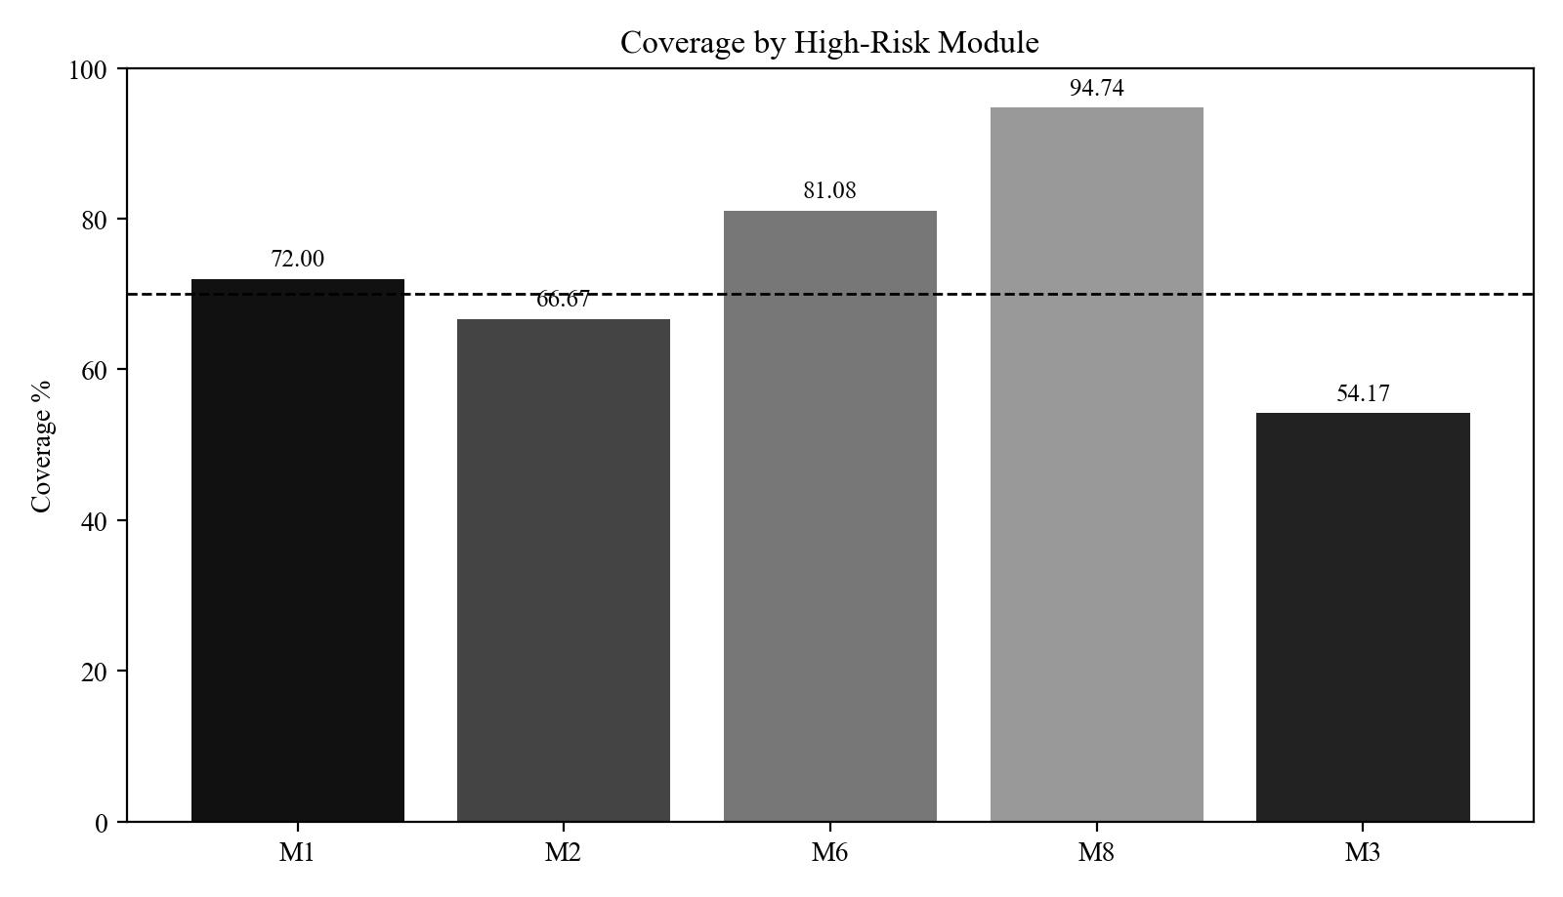
Figure 1. Coverage by high-risk module
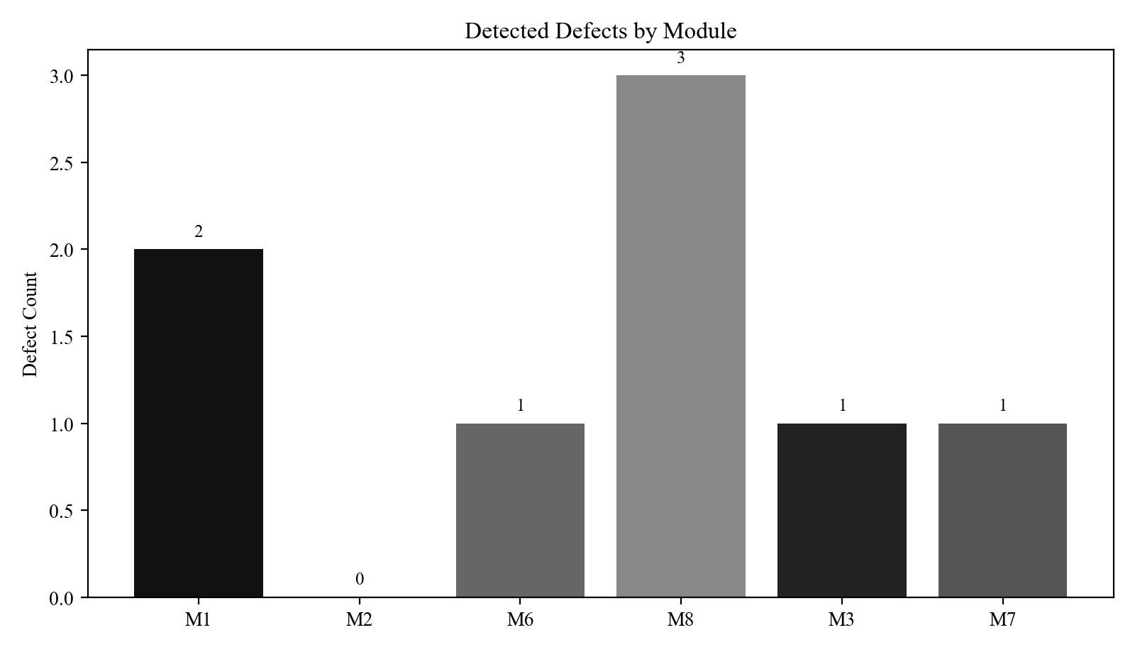
Figure 2. Detected defects by module
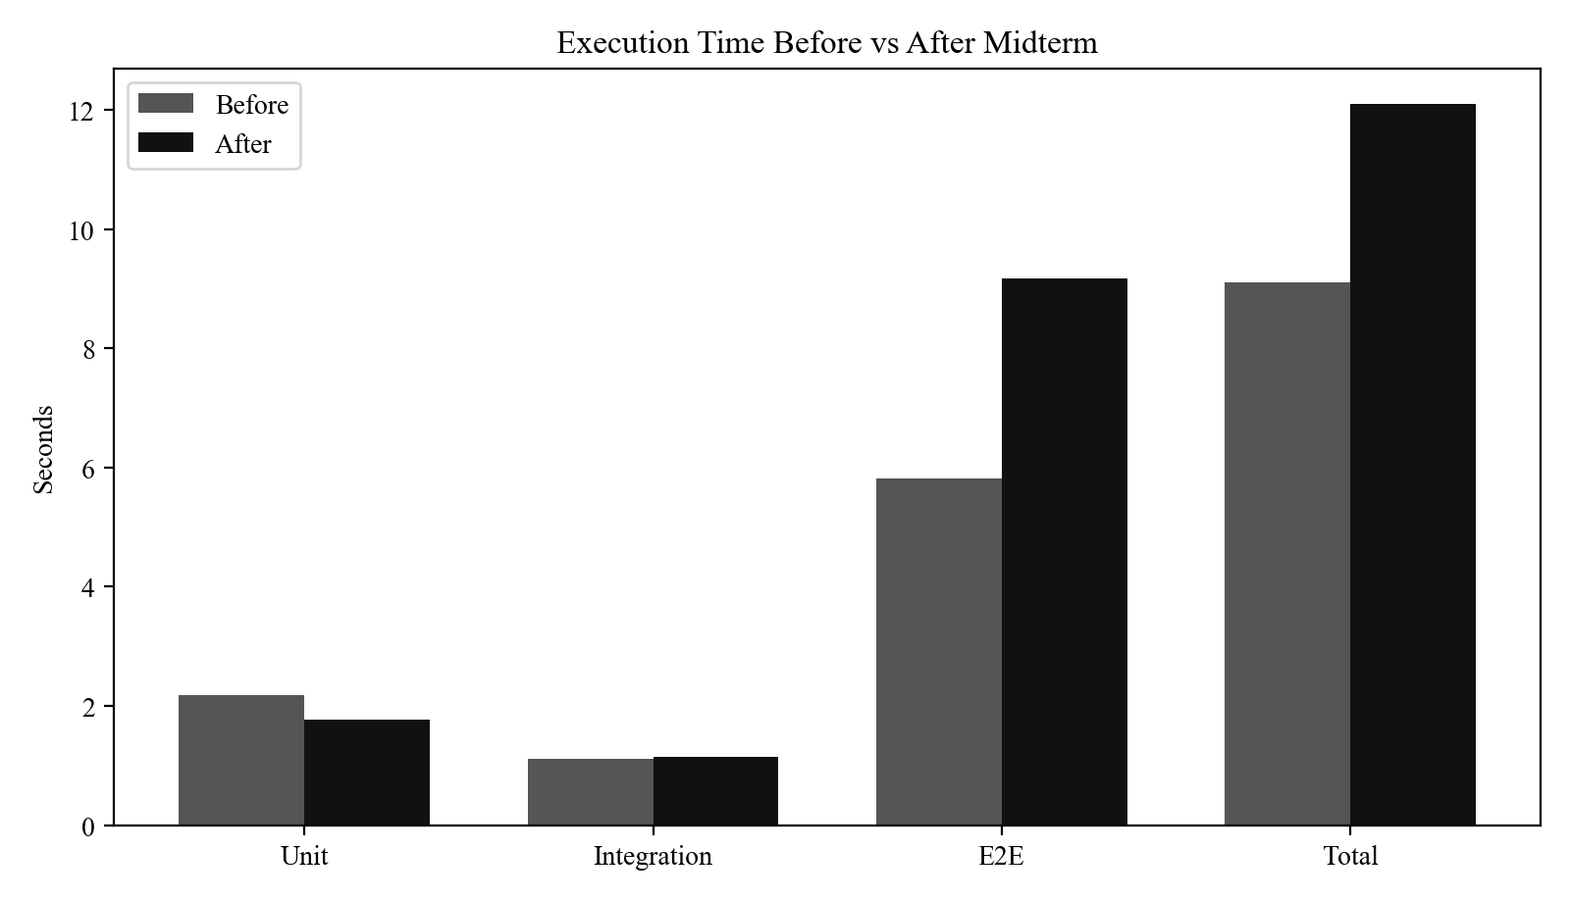
Figure 3. Execution time before vs after midterm
4.3 Pipeline Screenshots and Logs
Pipeline run URL: https://github.com/Svoppy/QA_drf-api/actions/runs/24211718046
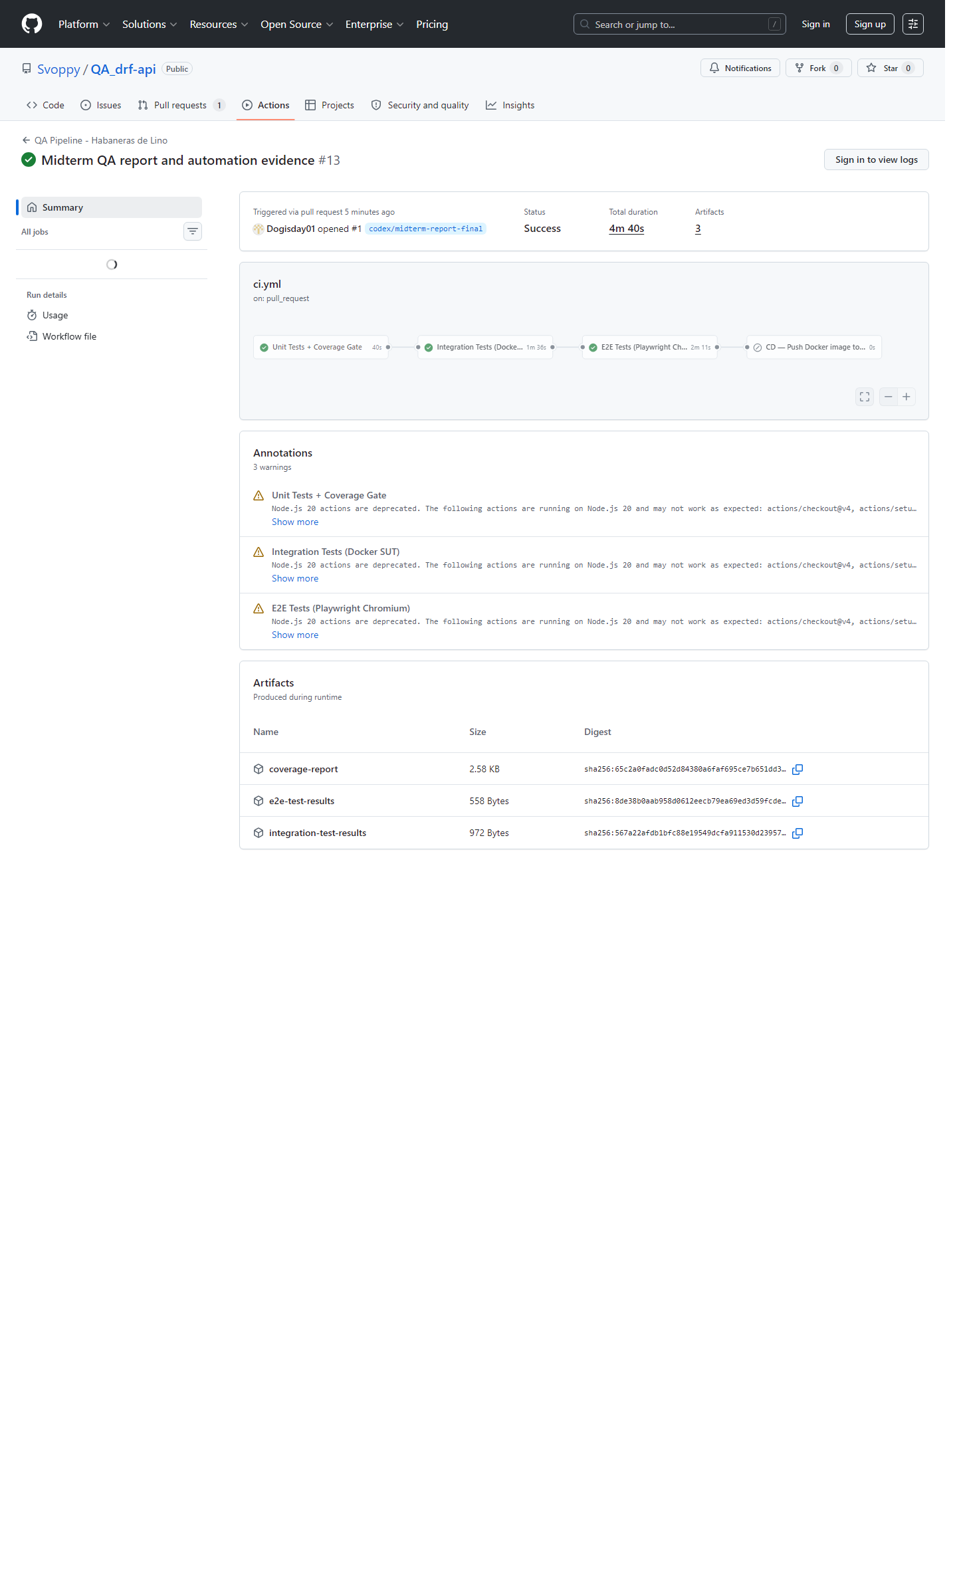
Figure 4. GitHub Actions pipeline run #12
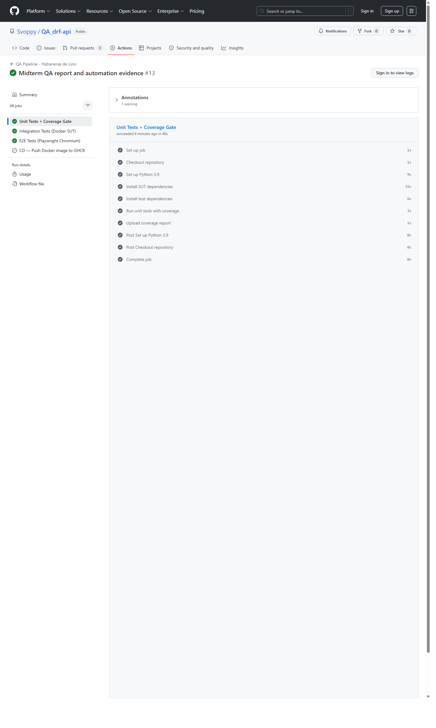
Figure 5. Unit job page from pipeline run #12
Source | Evidence
GitHub Actions run #13 | Run status = completed, conclusion = success, artifacts = coverage-report, integration-test-results, e2e-test-results
integration-results.xml | tests="28" failures="0" time="1.117"
e2e-results.xml | tests="5" failures="0" time="5.818"
Midterm local suite | 26 unit, 30 integration, 7 E2E, total 63 automated tests, total coverage 74.41%

4.4 Planned vs Actual
Aspect | Planned (A1) | Actual (A2/A3) | Gap
Coverage target | 60% overall | 41% in A2, 74.41% after midterm iteration | A2 missed the target; midterm iteration exceeded it
Stripe automation | Mocks or test keys | Only mock-based failure-path coverage added so far | Success path and refund flow remain missing
Cart lifecycle depth | Full create, add, retrieve, checkout | Retrieval and resilience covered; checkout-linked cart path remains shallow | Partial fulfillment
Admin access coverage | Admin smoke only | Midterm found and fixed anonymous dashboard access defect | Scope expanded beyond original plan
Pipeline evidence | CI on every commit | Workflow exists and successful PR run #13 is documented for the current midterm snapshot | Current report includes matching pipeline evidence
Defect expectation | Highest-risk modules should yield most defects | Highest-risk modules did yield most defects | Planning assumption confirmed

5. Discussion
The midterm iteration improved detectability and evidence quality, but it also showed that some planning assumptions from Assignment 1 and Assignment 2 were incomplete.
5.1 Quality Gate Evaluation
Gate | Threshold | Current Result | Evaluation
Test pass rate | 100% | 63/63 passed locally | Appropriate
Total coverage | 70% | 74.41% | Appropriate
High-risk module coverage | 70% | M2 = 66.67%, M3 = 54.17% | Strict but useful because it exposes real gaps
Critical failures allowed | 0 | 0 open blocking failures after fixes | Appropriate

Question | Answer
Were the thresholds too strict or too lenient? | Overall pass-rate and total-coverage thresholds were appropriate. The 70% high-risk module threshold was strict for the current state, but it was useful because it exposed real M2 and M3 gaps.
Did the system fail due to poor code quality? | Yes, partly. The anonymous dashboard access defect and the GlobalModel singleton crash modes were code-quality issues in high-impact paths.
Did the system fail due to insufficient tests? | Yes. M2 and M3 remained under-observed until the midterm expansion introduced focused failure and concurrency checks.
Did the system fail due to unrealistic thresholds? | No for the overall gates. Only the per-module 70% threshold was aggressive, but it still served as a valid diagnostic target rather than an unrealistic one.

5.2 Required Insights
Insight Type | Finding
Incorrect assumptions in planning | Assignment 1 underestimated the pricing risk in M8 because singleton GlobalModel failure modes were not weighted strongly enough.
Missing test scenarios | Stripe success path, refund behavior, cart variation update branches, and dashboard access control were not covered early enough.
Inefficient automation design | Earlier evidence relied too heavily on broad smoke checks and did not isolate high-risk failure branches in Stripe and dashboard authorization.
Improvements for next phase | Add Stripe success-path mocks or sandbox integration, expand cart branch coverage, and keep module-level coverage targets visible in CI analysis.

5.3 What Worked / What Did Not
- What worked: the pipeline structure, repeatability of the selected midterm tests, and the rapid discovery of a real dashboard authorization defect.
- What did not work: early coverage concentration was too model-heavy, leaving M2 and M3 with low detectability at the start of the midterm.
- Unexpected findings: M8 pricing risk increased after confirmed crash reproduction, and dashboard access control was weaker than expected.
- Improvements for next phase: add Stripe success-path coverage, expand cart branch coverage, and keep per-module evidence visible alongside total coverage.

