Weekly Spotify Wrapped
M122E Final Documentation
Python automation project for weekly music reports

1. Introduction and Context
Weekly Spotify Wrapped is a Python automation project for module M122E. The script automates the weekly analysis of personal music listening data and creates a personal recap instead of manually checking Last.fm, Spotify and email every week.
Last.fm is used as the main listening-history source because it provides recent scrobbles for a selected period. Spotify enriches this data with track durations, Spotify links, album covers and artist images. SQLite stores the listening history locally so that the current week can be compared with the previous week. The final report is generated as a dark Spotify-style HTML file and can be sent automatically by Gmail SMTP.
- load and validate .env configuration
- fetch weekly Last.fm listening data
- enrich tracks with Spotify metadata
- store track plays in SQLite and prevent duplicates
- calculate weekly statistics and week-over-week comparison
- generate an HTML report and send it by email
- optionally update a Spotify playlist

2. How I Worked
I worked through the project in the waterfall phases required by the assignment. First I clarified the automation scope and improved the proposal requirements so they were measurable and prioritized. After that I planned the modules, database table and external systems before implementing the script.
During implementation I tested the important parts step by step: configuration loading, Last.fm data loading, Spotify enrichment, SQLite duplicate handling, report generation and email sending. When Spotify playlist updates returned HTTP 403 because of permissions, I kept the feature optional and made sure the main report still completed. This made the project more reliable and easier to explain.
After the core workflow worked, I improved the email report design, added week-over-week comparison using the stored database history and created the diagrams and test protocol for the final submission.

3. Project Plan
Phase | Planned Work | Result
Requirements Analysis | Define project goal, systems and prioritized requirements. | Requirements were documented with MoSCoW priorities.
Design | Design workflow, modules, database and APIs. | UML, flowchart and ER diagrams were created.
Development | Implement configuration, API clients, database, report and email sending. | A working modular Python automation script was implemented.
Testing | Create unit tests and live workflow tests. | 35 pytest tests pass and live email delivery was verified.
Documentation | Prepare final documentation, README, proposal update and test protocol. | Final documentation package is stored in docs/.
Deployment | Plan weekly execution. | Windows Task Scheduler instructions are documented in the README.

Project plan file: M122E_Project_Plan_Spotify_Wrapped.xlsx

4. Functional Requirements
ID | Priority | Requirement | Implementation | Status
FR-01 | Must | Load configuration values from .env. | config.py | Fulfilled
FR-02 | Must | Validate required values and show clear errors. | config.py, main.py | Fulfilled
FR-03 | Must | Fetch Last.fm tracks from the last 7 days. | lastfm_client.py | Fulfilled
FR-04 | Must | Store listening data in SQLite. | database.py | Fulfilled
FR-05 | Must | Prevent duplicate track plays. | SQLite UNIQUE rule | Fulfilled
FR-06 | Must | Calculate top songs, top artists, total tracks and listening time. | report_generator.py | Fulfilled
FR-07 | Must | Generate an HTML report in output/. | report_generator.py | Fulfilled
FR-08 | Must | Send the weekly report by Gmail SMTP. | email_sender.py | Fulfilled
FR-09 | Should | Enrich tracks with Spotify metadata. | spotify_client.py | Fulfilled
FR-10 | Should | Continue if Spotify enrichment fails. | main.py, spotify_client.py | Fulfilled
FR-11 | Should | Log important workflow steps and errors. | main.py and clients | Fulfilled
FR-12 | Should | Compare current week with previous week. | SQLite history, report_generator.py | Fulfilled
FR-13 | Could | Create or update a Spotify playlist. | spotify_setup.py, spotify_client.py | Optional feature
FR-14 | Won't | No graphical desktop or web UI. | Out of scope | Fulfilled

5. Non-Functional Requirements
ID | Category | Requirement | Implementation | Status
NFR-01 | Security | Secrets must not be hardcoded in Python files. | .env, .env.example, .gitignore | Fulfilled
NFR-02 | Reliability | API, email and config errors must be handled clearly. | custom exceptions and logging | Fulfilled
NFR-03 | Maintainability | Code must be modular and easy to explain. | separate modules per responsibility | Fulfilled
NFR-04 | Testability | Core logic must be testable with pytest. | tests/ | Fulfilled
NFR-05 | Usability | The project must be easy to install and run. | README.md and short instructions here | Fulfilled
NFR-06 | Performance | A normal weekly run should finish in reasonable time. | paginated API calls, local SQLite | Fulfilled
NFR-07 | Portability | The script should run on a normal Windows Python setup. | Python plus requirements.txt | Fulfilled

6. System and Script Design

6.1 Module Overview
Module | Responsibility
main.py | Orchestrates the complete automation workflow.
config.py | Loads and validates environment variables.
lastfm_client.py | Fetches recent tracks from Last.fm.
spotify_client.py | Enriches tracks and optionally updates a playlist.
database.py | Creates and manages SQLite storage.
report_generator.py | Calculates statistics, comparisons and HTML report content.
email_sender.py | Sends the report through Gmail SMTP.
spotify_setup.py | One-time helper for Spotify refresh token and playlist values.

6.2 Workflow
- main.py loads the configuration.
- The database is initialized.
- Last.fm tracks are fetched.
- Spotify enrichment runs if credentials are available.
- Tracks are saved to SQLite and duplicates are skipped.
- Current and previous period data are loaded from SQLite.
- Statistics and comparisons are calculated.
- The HTML report is generated and saved.
- The email is sent if enabled.
- Playlist update is attempted only if enabled.

System Architecture Diagram
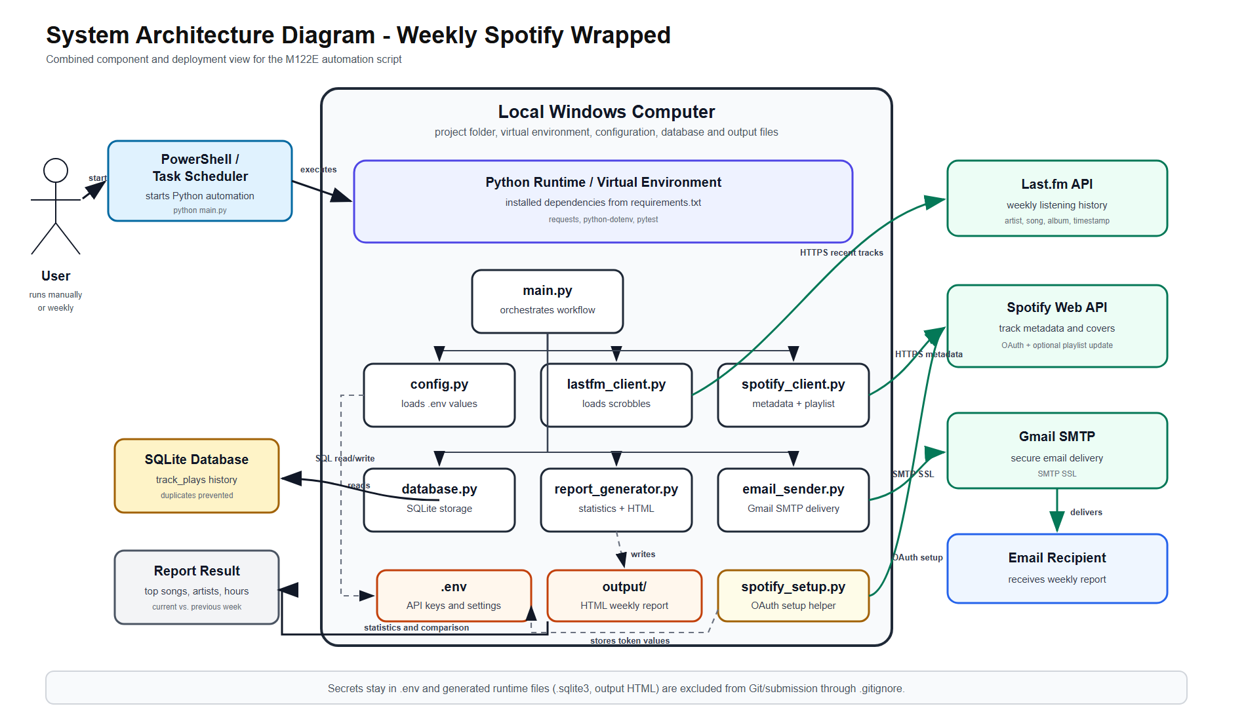

UML Activity Diagram
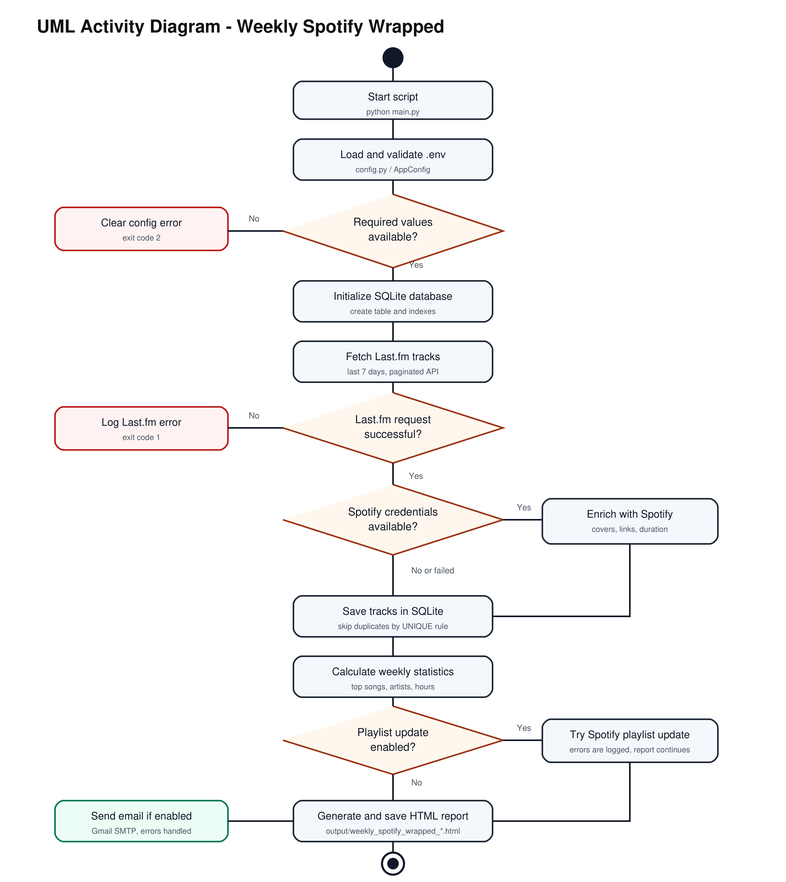

UML Class Diagram
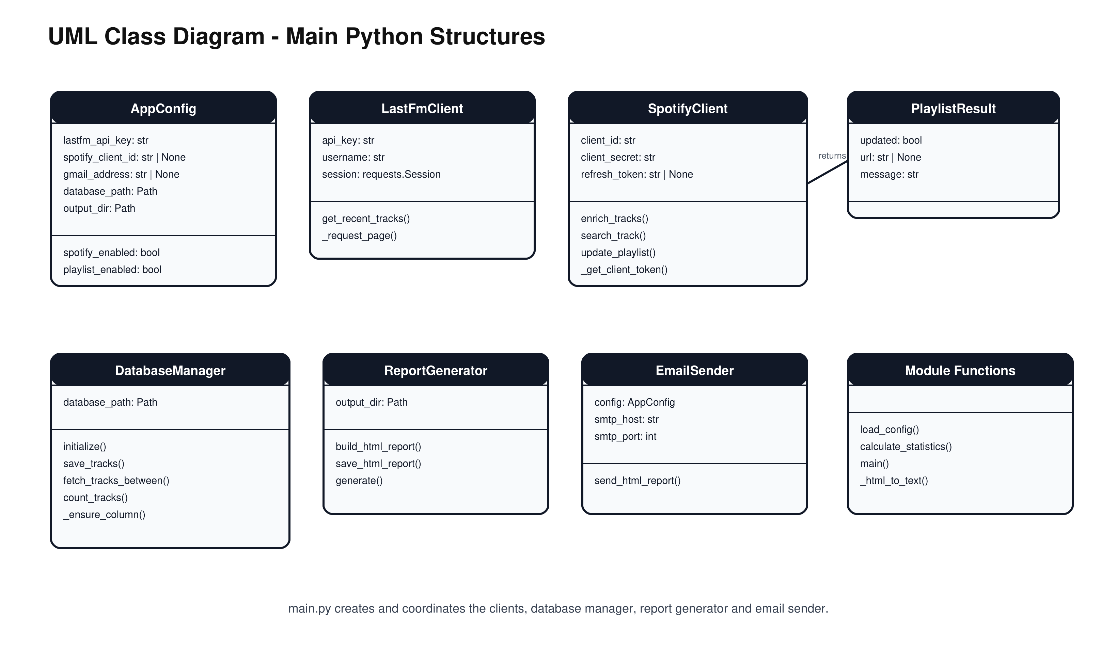

UML Component Diagram
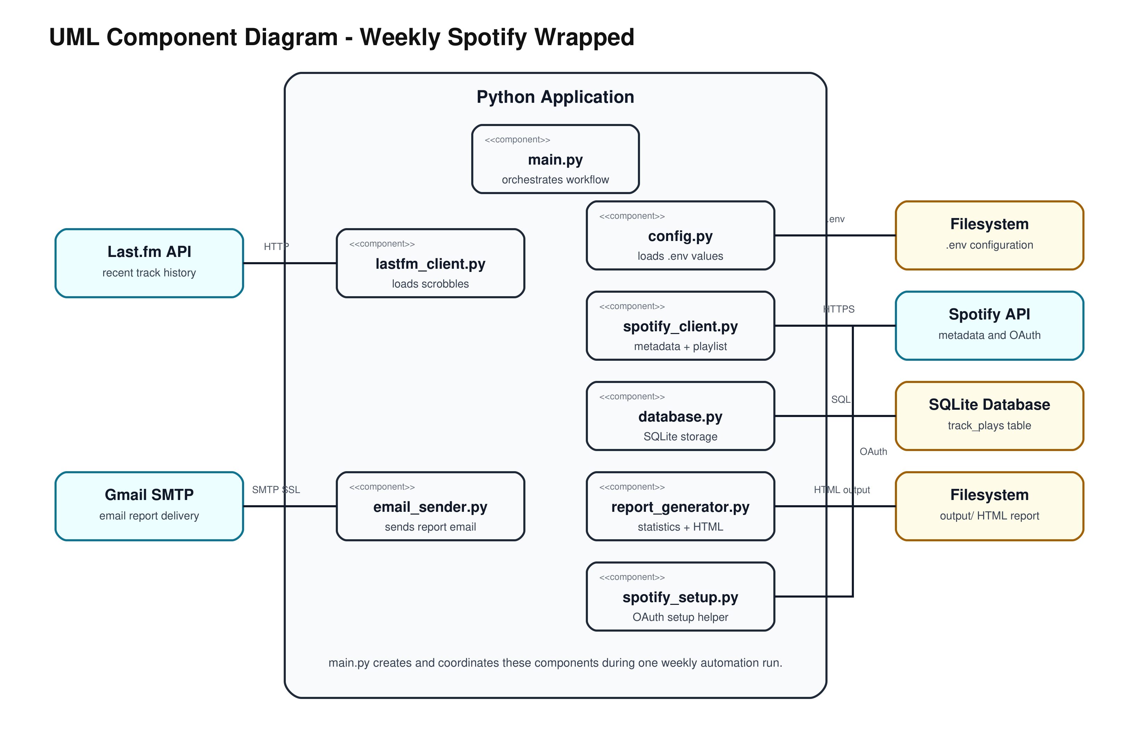

UML Deployment Diagram
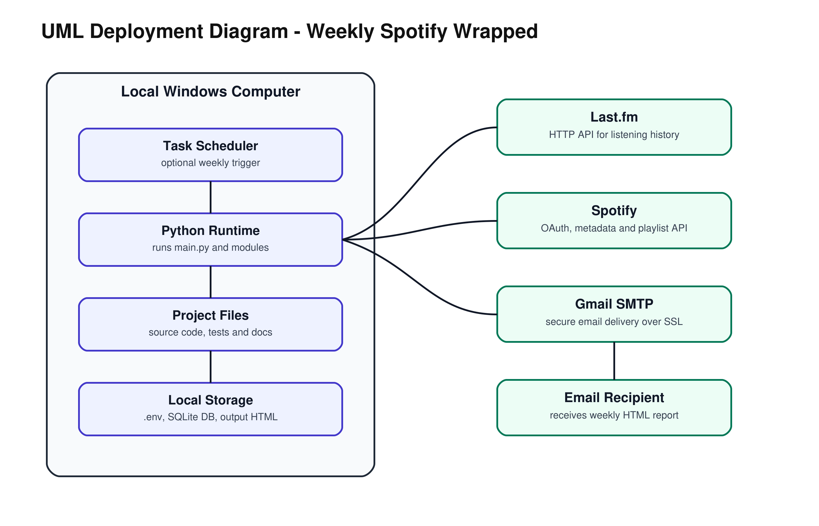

ER Diagram
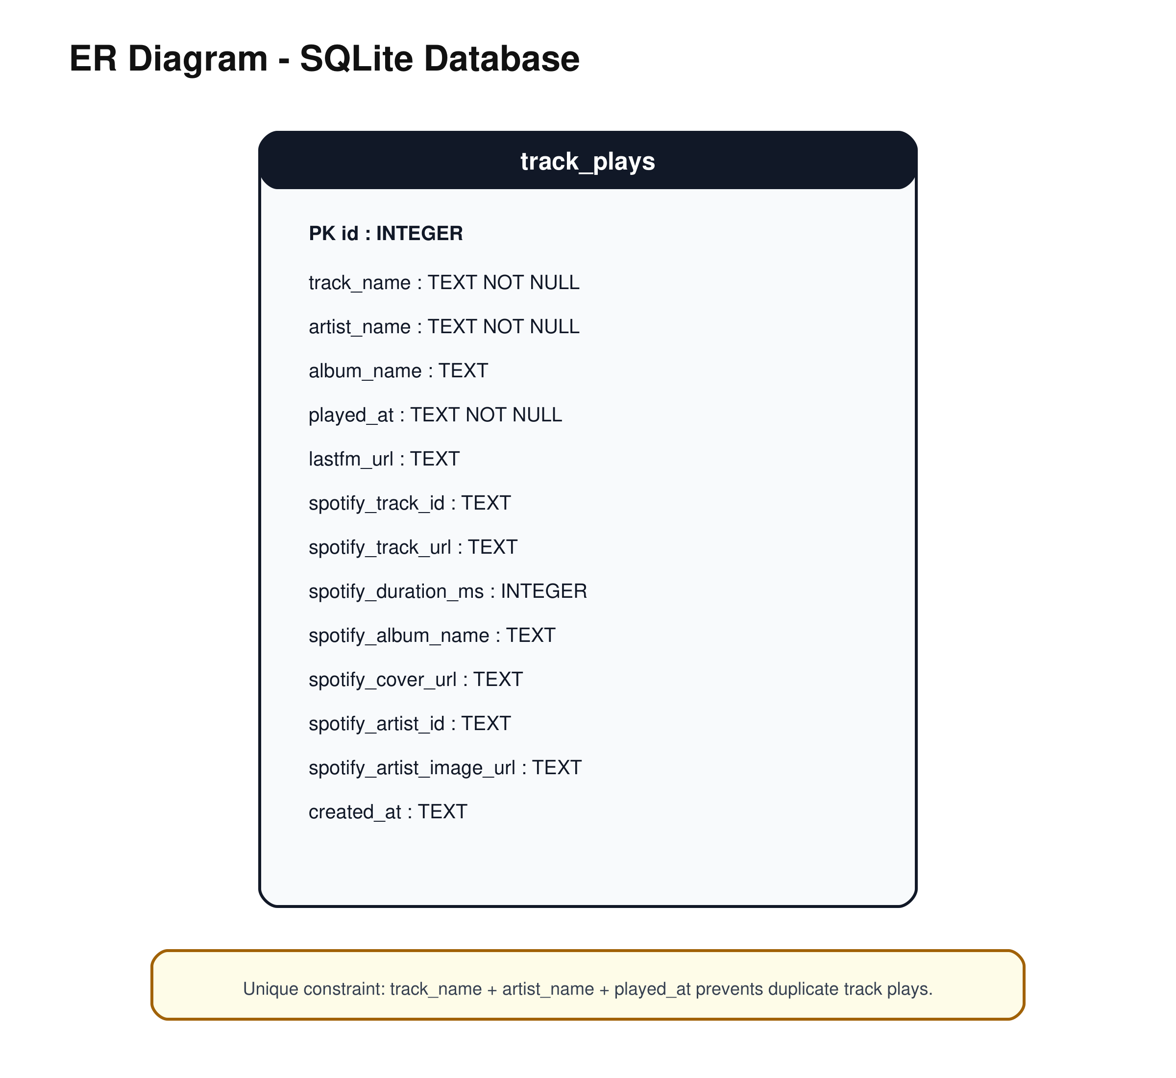

Flowchart
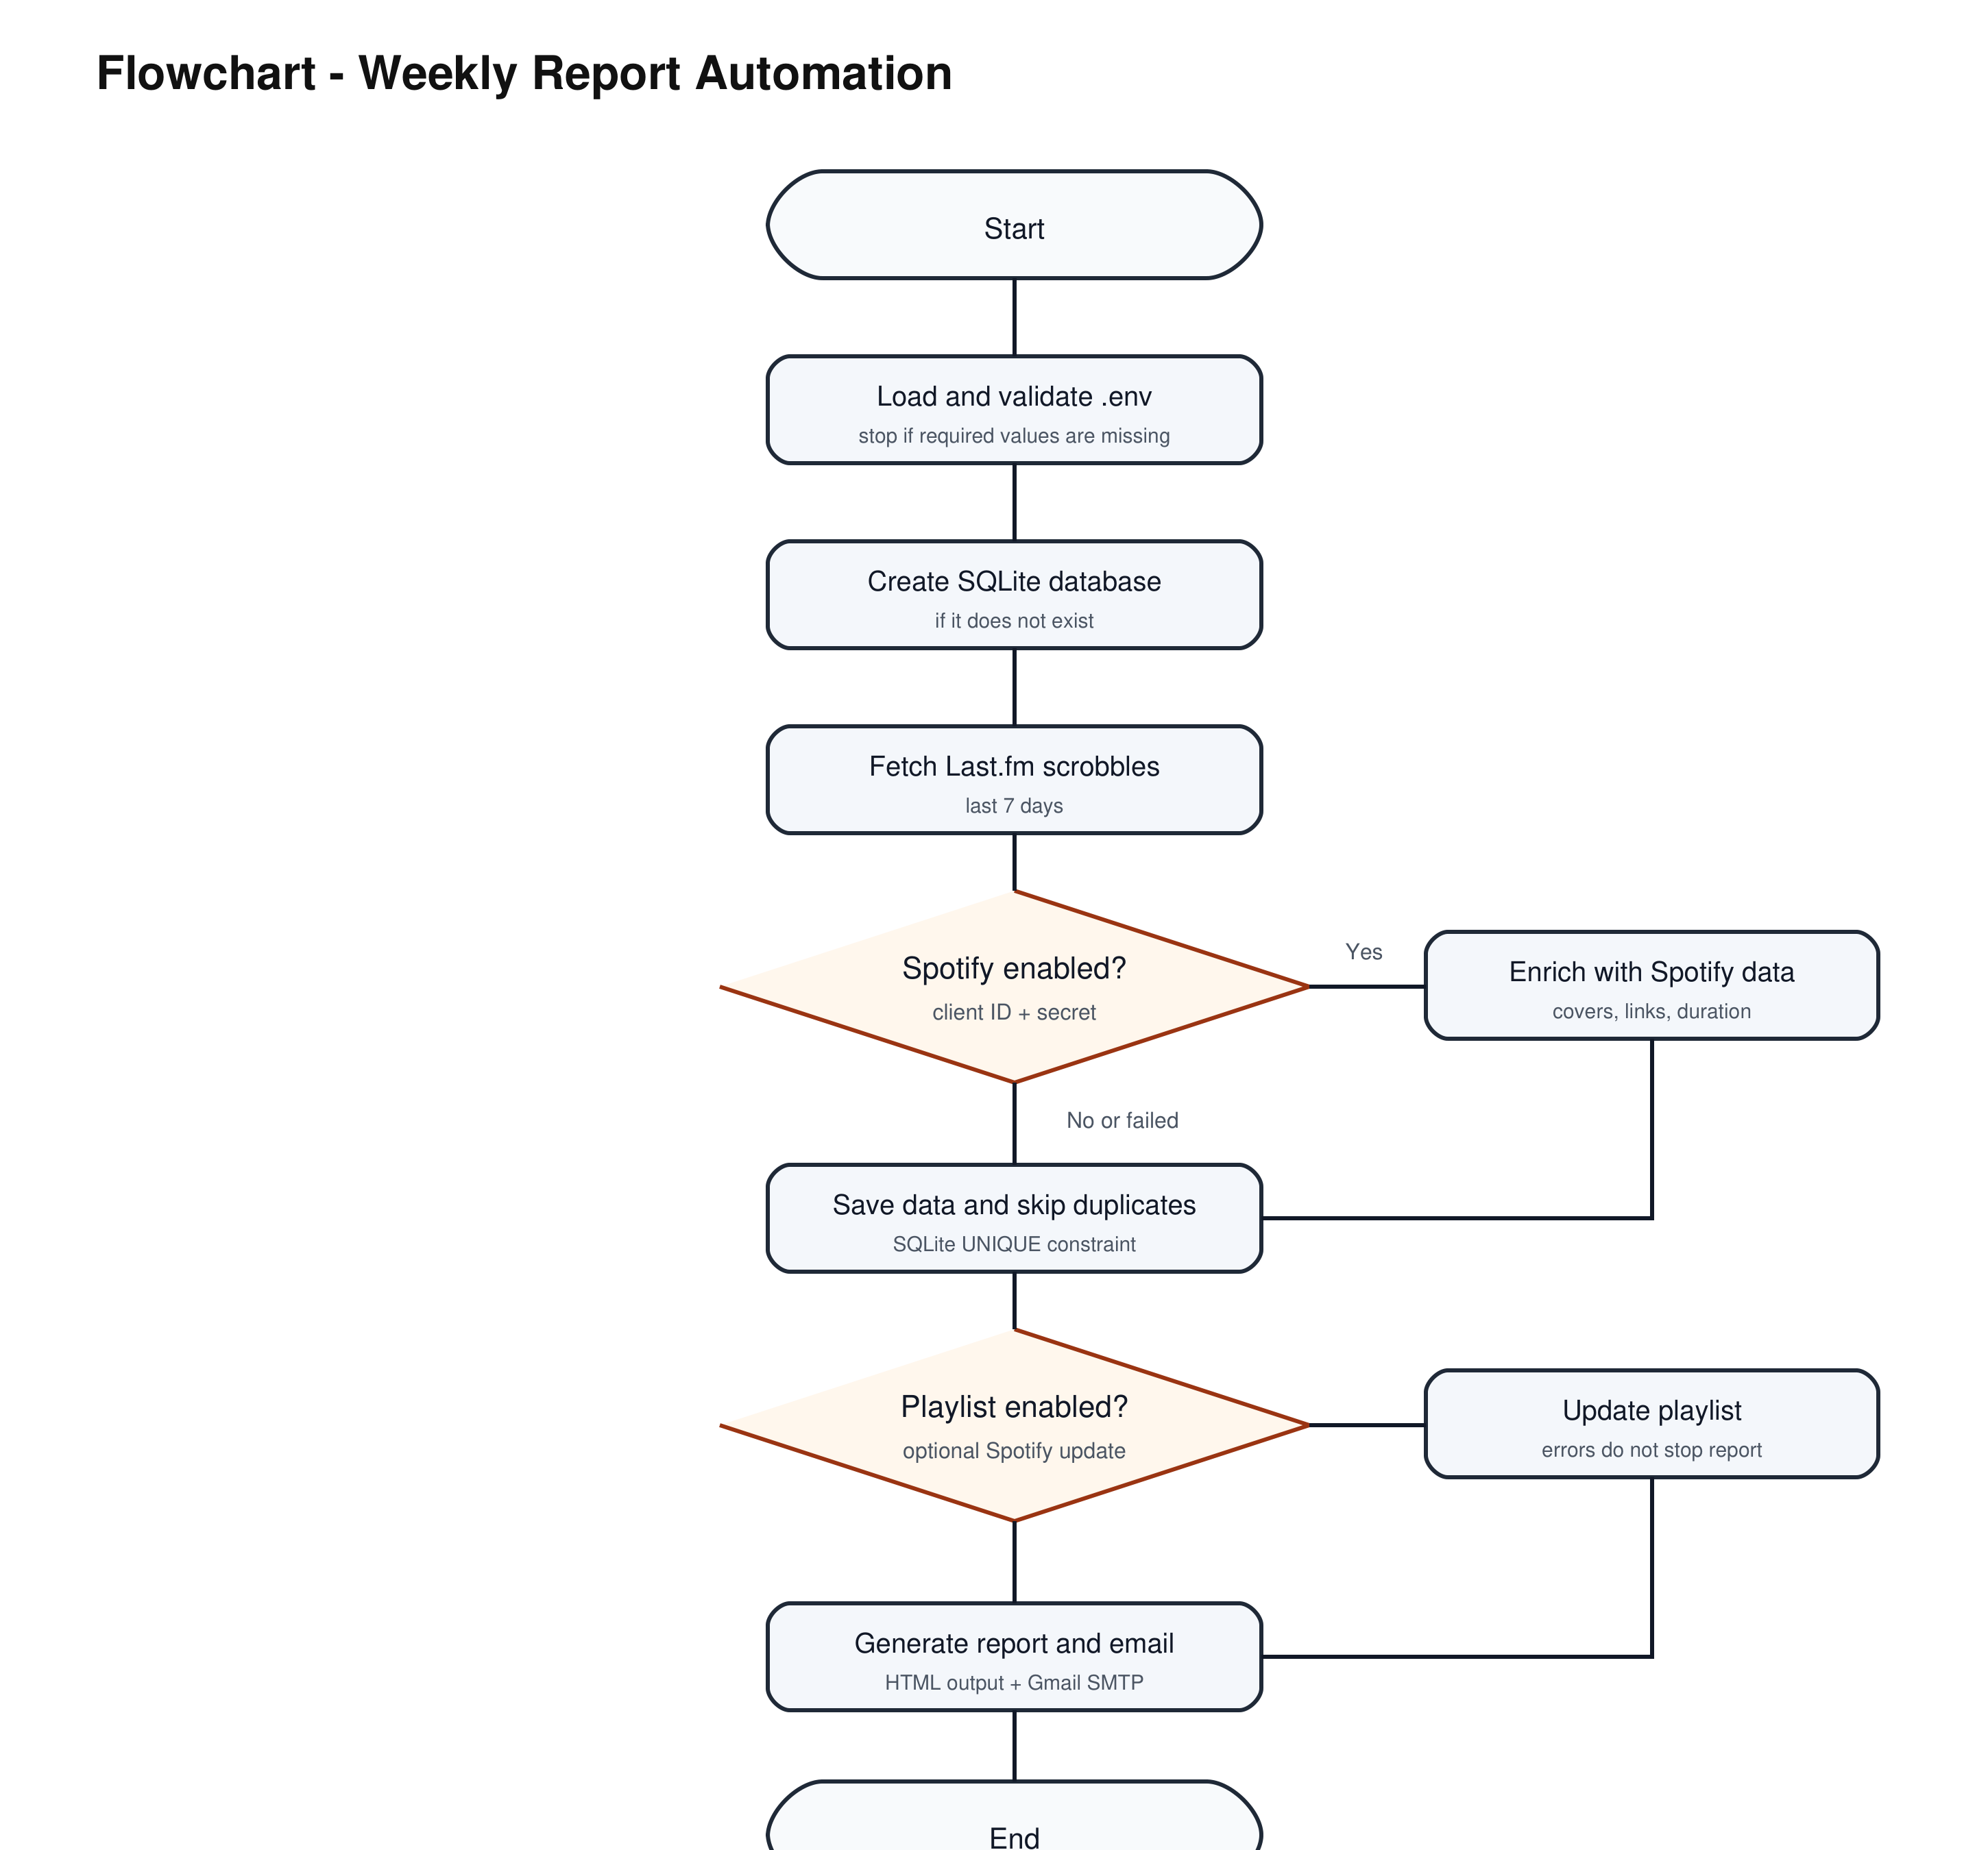

7. Database Design
The database uses one main table: track_plays. It stores historical track plays so the report can compare the current 7-day period with the previous 7-day period.
Column | Type | Description
id | INTEGER | Primary key
track_name | TEXT | Track title from Last.fm
artist_name | TEXT | Artist name
album_name | TEXT | Album from Last.fm if available
played_at | TEXT | UTC timestamp of the play
lastfm_url | TEXT | Last.fm track URL
spotify_track_id | TEXT | Spotify track ID
spotify_track_url | TEXT | Spotify track link
spotify_duration_ms | INTEGER | Track duration in milliseconds
spotify_album_name | TEXT | Spotify album name
spotify_cover_url | TEXT | Album cover URL
spotify_artist_id | TEXT | Spotify artist ID
spotify_artist_image_url | TEXT | Spotify artist image URL
created_at | TEXT | Insert timestamp

UNIQUE(track_name, artist_name, played_at)
The database is important because it keeps historical listening data. Without it, the program could create a weekly report but could not reliably compare the current week with the previous week.

8. Installation and Usage
Short setup:
cd C:\Users\voutats1\Documents\Gibz\Informatik\M122\M122ESpotifyProject\spotify_weekly_wrapped
python -m venv .venv
.\.venv\Scripts\Activate.ps1
python -m pip install -r requirements.txt
Copy-Item .env.example .env
python main.py
The detailed installation and usage guide is included below. The README contains the same steps in a shorter project-start format.

8.1 Prerequisites
- Windows with PowerShell
- Python installed
- Last.fm account with API key
- Spotify Developer app for optional enrichment and playlist features
- Gmail account with app password if email sending is enabled

8.2 Install Dependencies
cd C:\Users\voutats1\Documents\Gibz\Informatik\M122\M122ESpotifyProject\spotify_weekly_wrapped
python -m venv .venv
.\.venv\Scripts\Activate.ps1
python -m pip install -r requirements.txt
Copy-Item .env.example .env

8.3 Configure .env
The script must be configured through .env. No API keys or passwords are written directly into the Python files.
Value | Purpose
LASTFM_API_KEY | Required for reading Last.fm scrobbles.
LASTFM_USERNAME | Last.fm user whose recent tracks are loaded.
SPOTIFY_CLIENT_ID | Spotify app client ID for metadata enrichment.
SPOTIFY_CLIENT_SECRET | Spotify app client secret for metadata enrichment.
SPOTIFY_REFRESH_TOKEN | Needed only for playlist updates. It can be created with spotify_setup.py.
SPOTIFY_PLAYLIST_ID | Existing or generated playlist ID.
PLAYLIST_URL | Link to the generated playlist.
ENABLE_PLAYLIST | true updates the playlist, false disables playlist updates.
GMAIL_ADDRESS | Sender email address.
GMAIL_APP_PASSWORD | Gmail app password, not the normal Gmail password.
RECIPIENT_EMAIL | Receiver email address.
SEND_EMAIL | true sends the report, false only creates the HTML report.
LOOKBACK_DAYS | Default is 7.
DATABASE_PATH | Default is spotify_wrapped.sqlite3.
OUTPUT_DIR | Default is output.

8.4 API Setup

Last.fm:
- Create an API application at https://www.last.fm/api/account/create.
- Copy the API key into LASTFM_API_KEY.
- Add the Last.fm username to LASTFM_USERNAME.

Spotify:
- Create an app at https://developer.spotify.com/dashboard.
- Add http://127.0.0.1:8888/callback as redirect URI.
- Copy client ID and client secret into .env.
- Run python spotify_setup.py if playlist updates should be used.

Gmail:
- Enable 2-Step Verification in the Google account.
- Create a Google app password.
- Add the generated app password to GMAIL_APP_PASSWORD.

8.5 Start the Program
.\.venv\Scripts\Activate.ps1
python main.py
Expected result:
- SQLite database is created or updated.
- Last.fm tracks are loaded.
- Spotify metadata is added if Spotify is configured.
- HTML report is saved in output/.
- Email is sent if SEND_EMAIL=true.
- Playlist is updated only if ENABLE_PLAYLIST=true and permissions are valid.

8.6 Run Tests
python -m pytest

8.7 Weekly Automation
The script can be automated with Windows Task Scheduler.
Program:
C:\Users\voutats1\Documents\Gibz\Informatik\M122\M122ESpotifyProject\spotify_weekly_wrapped\.venv\Scripts\python.exe
Arguments:
main.py
Start in:
C:\Users\voutats1\Documents\Gibz\Informatik\M122\M122ESpotifyProject\spotify_weekly_wrapped

9. Test Protocol Summary
Unit tests are stored in tests/ and executed with python -m pytest.
35 passed
- Last.fm data was loaded.
- Spotify enrichment completed.
- SQLite stored data and skipped duplicates on repeated runs.
- Week-over-week comparison was generated from stored SQLite history.
- HTML report was generated.
- Email was successfully delivered.
- Optional Spotify playlist update returned HTTP 403 and was handled without stopping the report/email workflow.
Full protocol: M122E_Test_Protocol.md

10. Assignment Coverage
Assignment Requirement | Evidence
Script performs multiple actions | Fetch data, enrich data, store database rows, calculate statistics, generate report, send email.
Script is well-organized | Separate modules with clear responsibilities.
Environment variables are used | .env, .env.example, config.py.
requirements.txt exists | requests, python-dotenv, pytest.
Clear start command exists | python main.py, documented in README and this document.
Documentation includes context | Sections 1 and 2.
Documentation includes project plan | Section 3 and Excel project plan.
Requirements are prioritized | Sections 4 and 5.
Script design is documented | Section 6 plus diagrams.
Instructions are included | Section 8 and README.
Test protocol is executed | Section 9 and M122E_Test_Protocol.md.

11. Conclusion
The project fulfills the M122E automation assignment because it automates a realistic multi-step weekly task, uses multiple external systems, protects secrets through environment variables, stores historical data in SQLite, includes automated tests, handles expected errors and provides clear documentation. The implementation is also structured so that the workflow, database and modules can be explained with diagrams during the final submission.

