**Job Readiness Project:**

Food box

**Document contains:**

* Project and developer details
* Sprints planned and the tasks achieved in them
* Core concepts used in the project
* Links to the GitHub repository to verify the project completion

**Project and developer details**

**DESCRIPTION**

This project aims to design and develop an E-commerce website that lets people shop food items of different cuisines at affordable prices and deliver the products to their addresses. It was developed using Angular and Spring boot It was created as the Job Readiness Project for the Full Stack Java Developer course.

**Background of the problem statement:**

Food box is a restaurant chain that delivers food items of different cuisines at affordable prices. It was established in 2014 in Bengaluru, India. It had been serving fine all these years, however, the business analysts noticed a decline in sales since 2016. They found out that the online ordering of food items with companies, such as Swiggy and Foodpanda were gaining more profit by eliminating middlemen from the equation. As a result, the team decided to hire a Full Stack developer to develop an online food delivery web application with a rich and user-friendly interface.  
You are hired as the Full Stack Java developer and are asked to develop the web application. The management team has provided you with the requirements and their business model so that you can easily arrange different components of the application.

You are hired as the Full Stack Java developer and are asked to develop the web application. The management team has provided you with the requirements and their business model so that you can easily arrange different components of the application.

Features of the application:

1. Registration
2. Login
3. Payment gateway
4. Searching
5. Filtering
6. Sorting
7. Dynamic data
8. Responsive and compatible with different device

**Admin Portal:**

The admin portal deals with all the backend data generation and product information. The admin user should be able to:

* Add or remove different cuisines to or from the application to build a rich product line
* Edit food item details like name, price, cuisine, description, and offers to keep it aligned to the current prices
* Enable or disable the food items

**User Portal:**

**It deals with the user activities. The end-user should be able to:**

* **Sign-in to the application to maintain a record of activities**
* **Search for food items based on the search keyword**
* **Apply filters and sort results based on different cuisines to get the best deals**
* **Add all the selected food items to a cart and customize the purchase at the end**
* **Perform a seamless payment process**
* **Get an order summary details page once the payment is complete.**

**Developer Details**: Sadhu Venkata Sai Kumar

[svsai97@gmail.com](mailto:svsai97@gmail.com)

7780556763

**Sprints planned and the tasks achieved in them**

There are four sprints for this project

Sprint-1: Studied the Features of application and created Git Repository. Sprint-2: Medicare backend created using spring boot and tested backend API

Sprint-3: Medicare frontend created using spring boot and connected with backend. Sprint-4: Medicare application all features is tested.

**Recommended technologies**

Database management: MySQL

Backend development: Java programming, Eclipse, Spring Boot Frontend development: JSP, Angular, Bootstrap, HTML/CSS.

# Output

1. **Flow Chart of Application.**

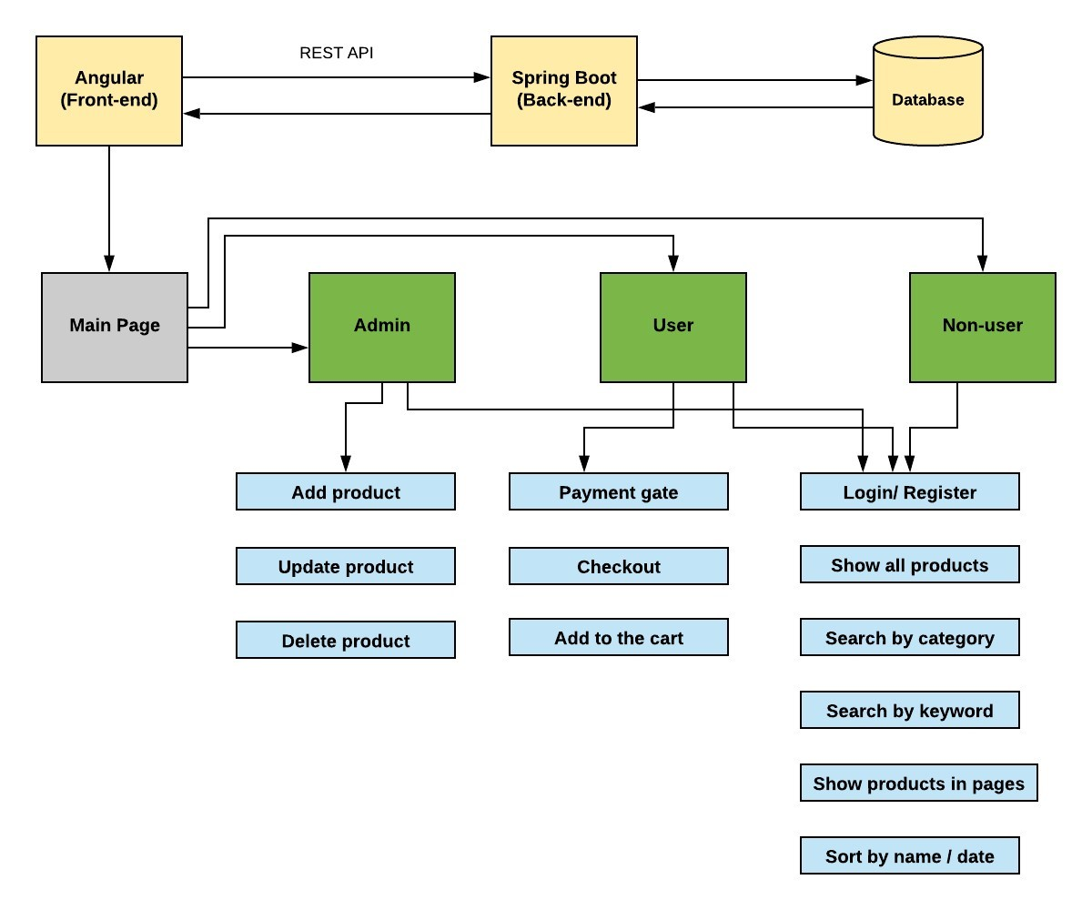

1. **Deployment of application.**

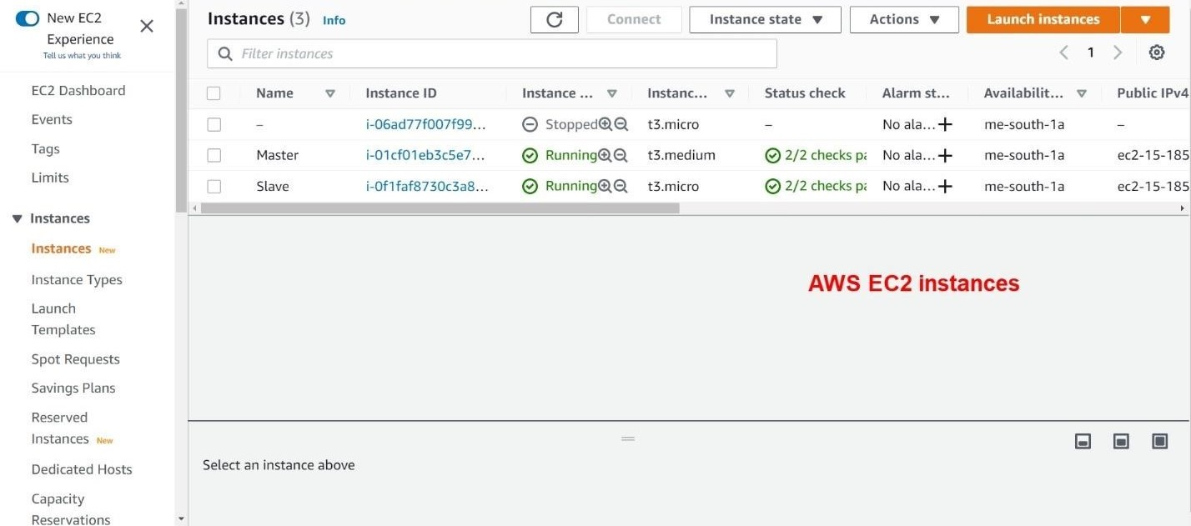

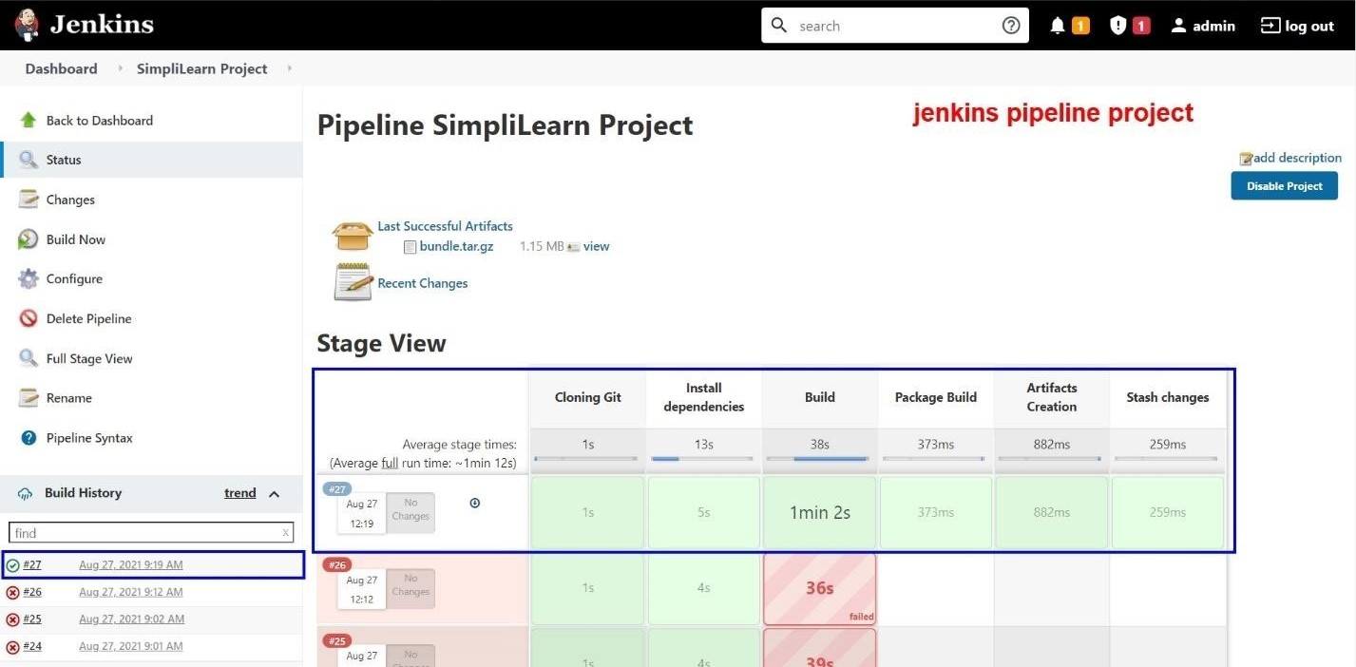

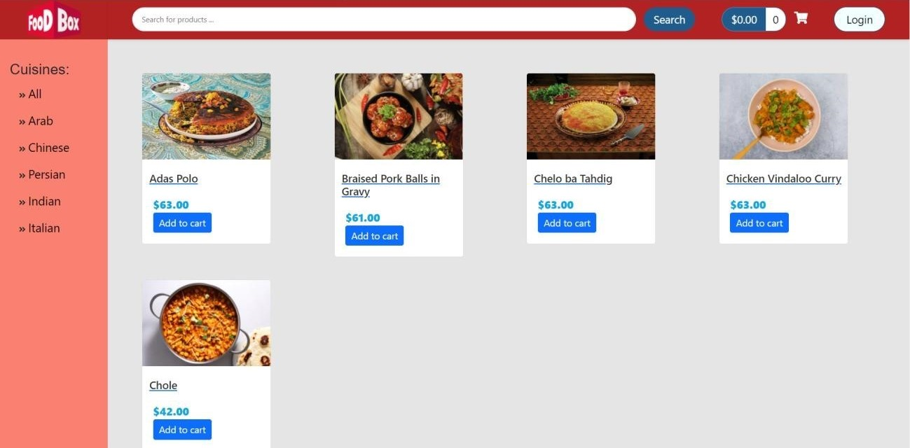

1. **Running localhost:4200/user home url and Home page is opened.**

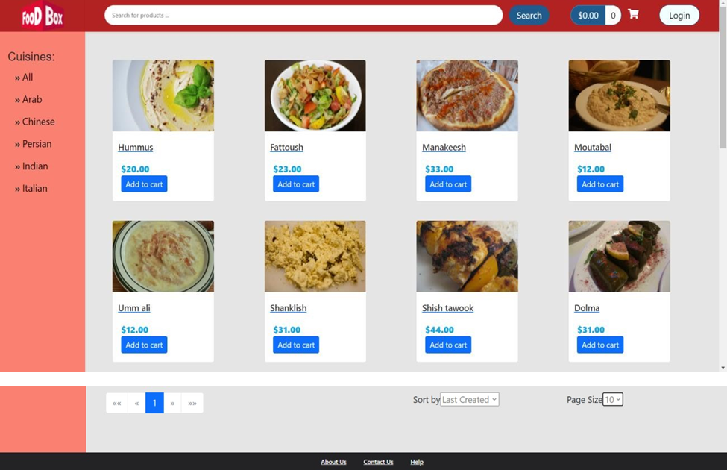

1. **All the products are shown in the website application.**

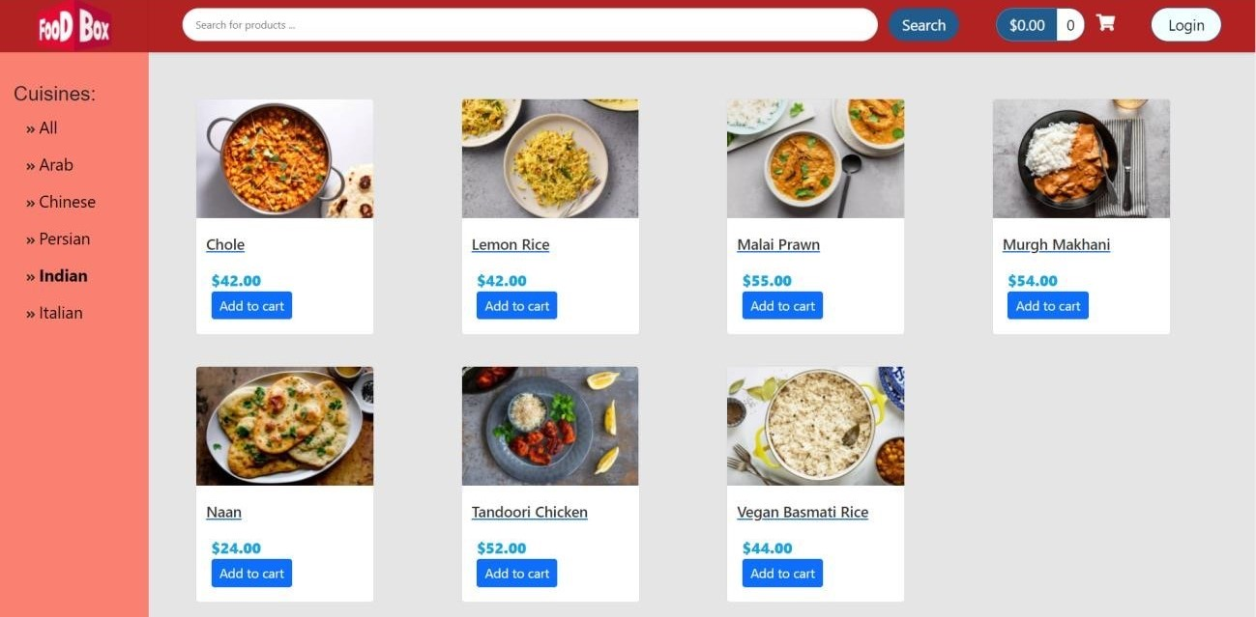

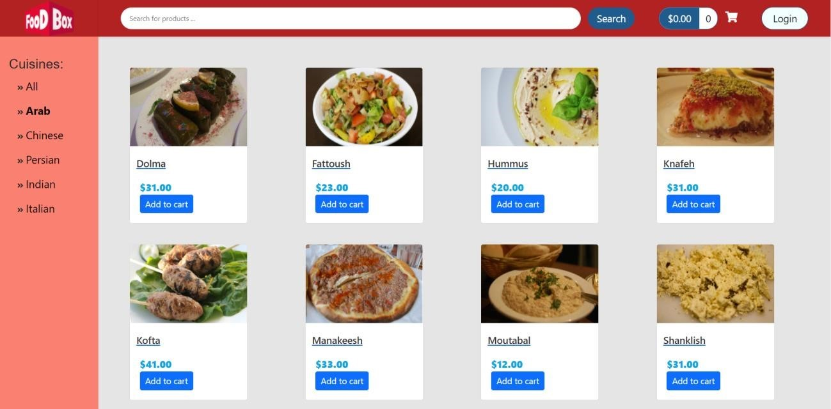

1. **Using filtering and sorting options.**

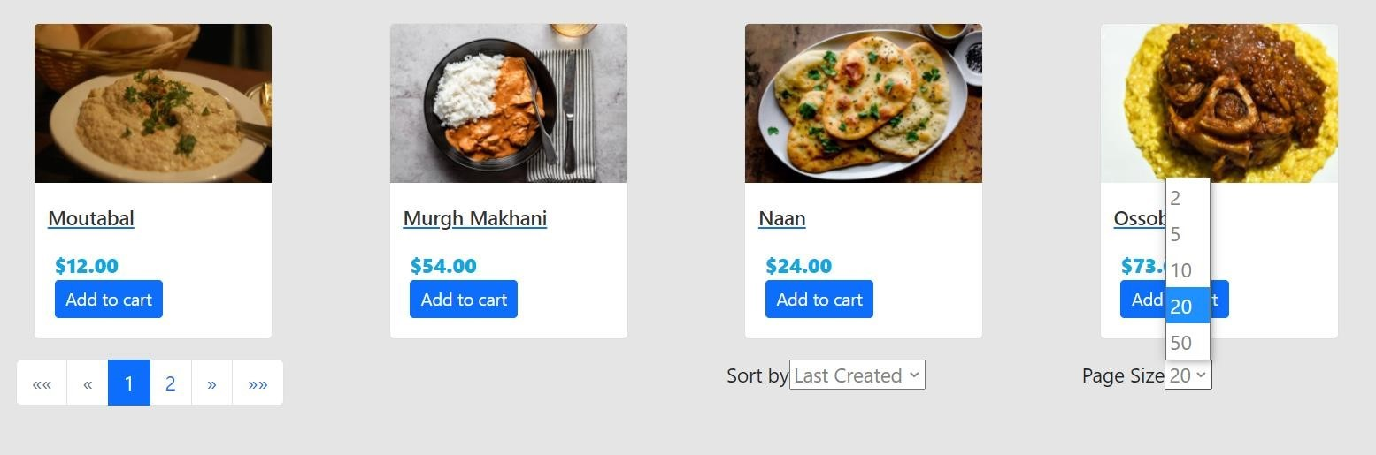

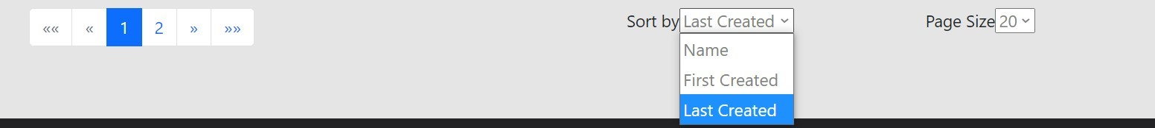

1. **Sorting by name.**

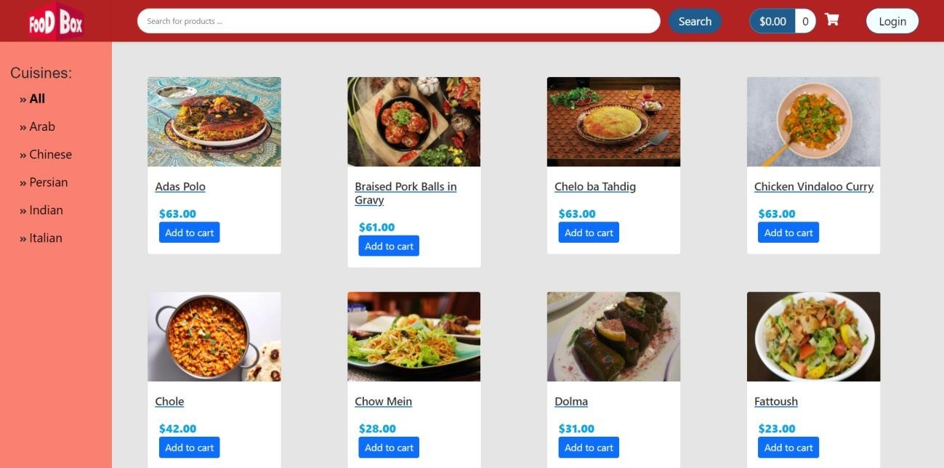

1. **Sort By Page no.**

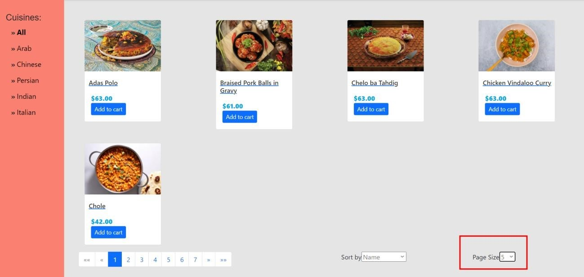

1. **Adding products to carts without login shows error.**

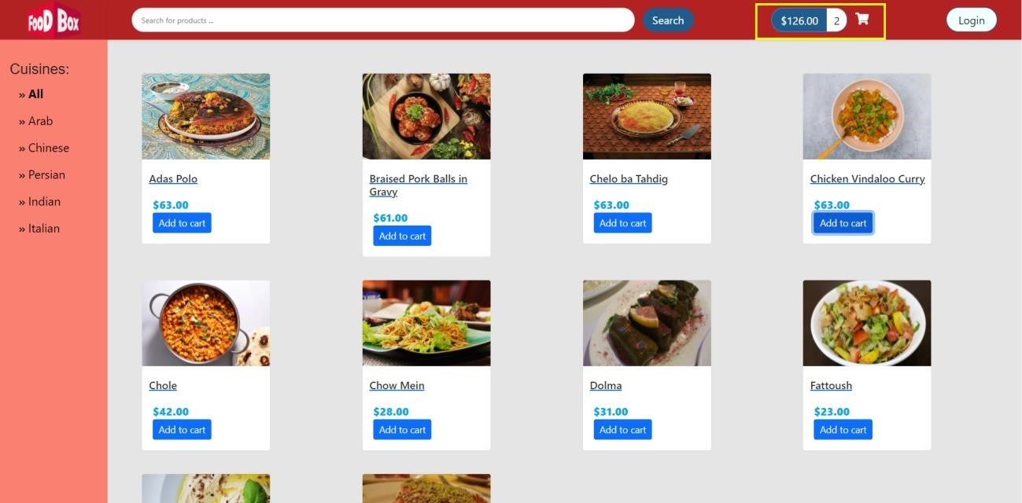

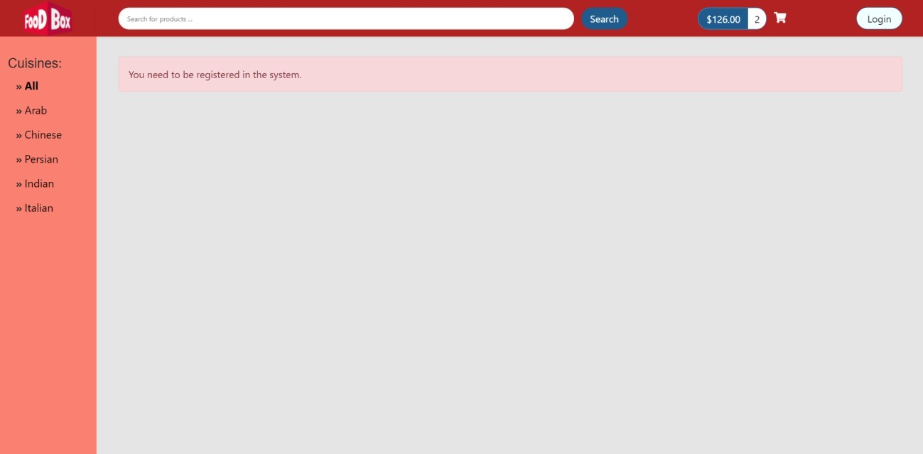

1. **Registering a new user**

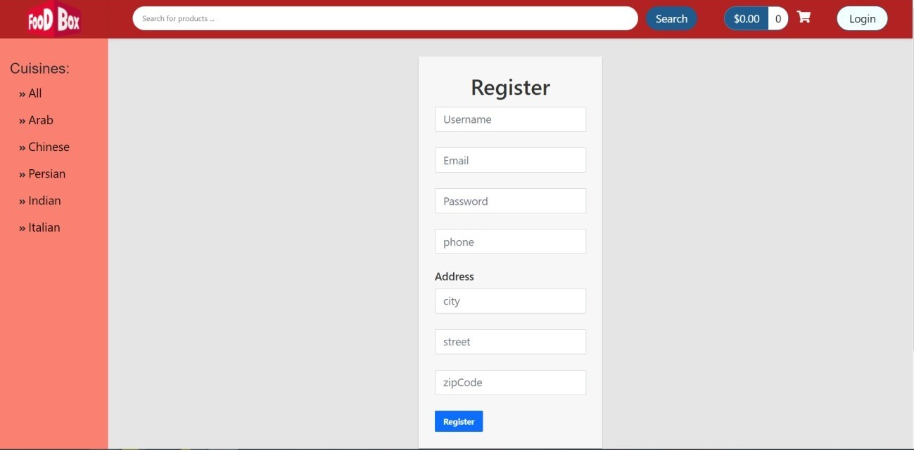

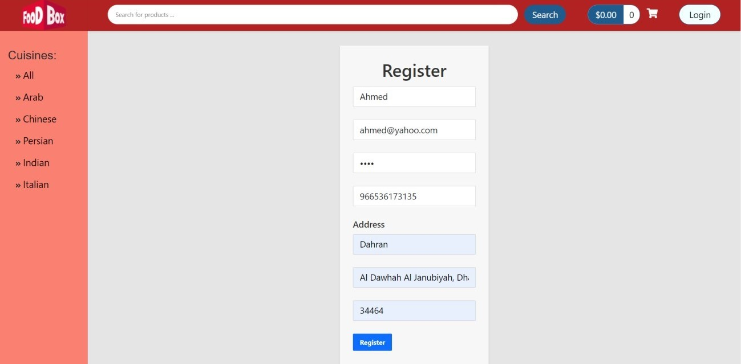

1. **Login of registered user**

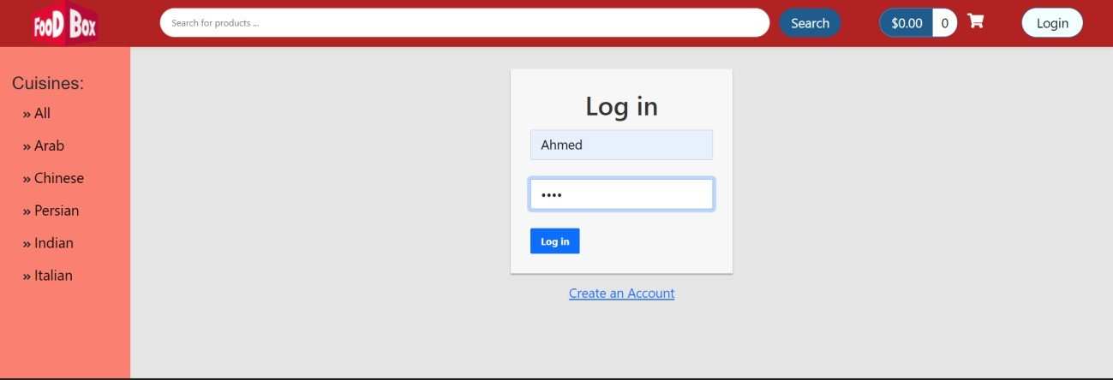

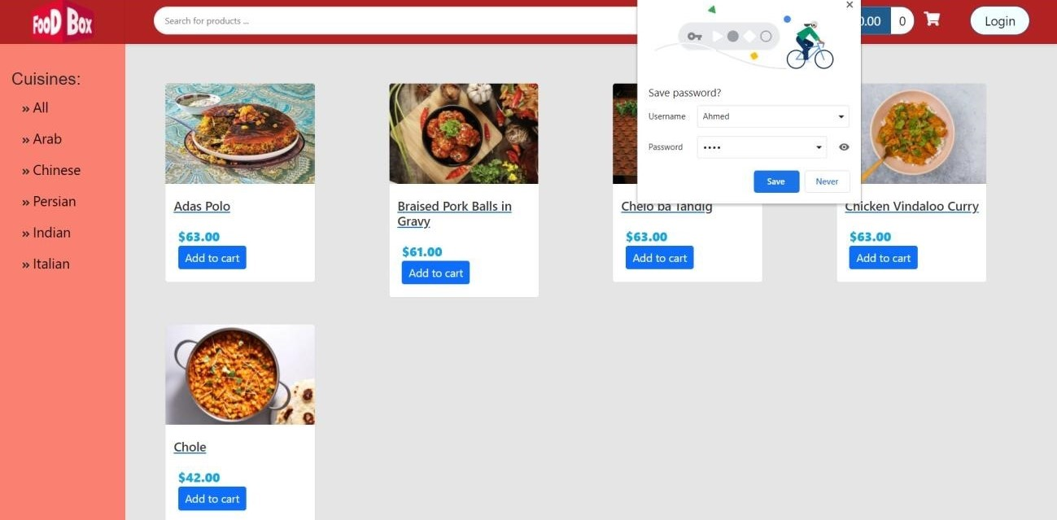

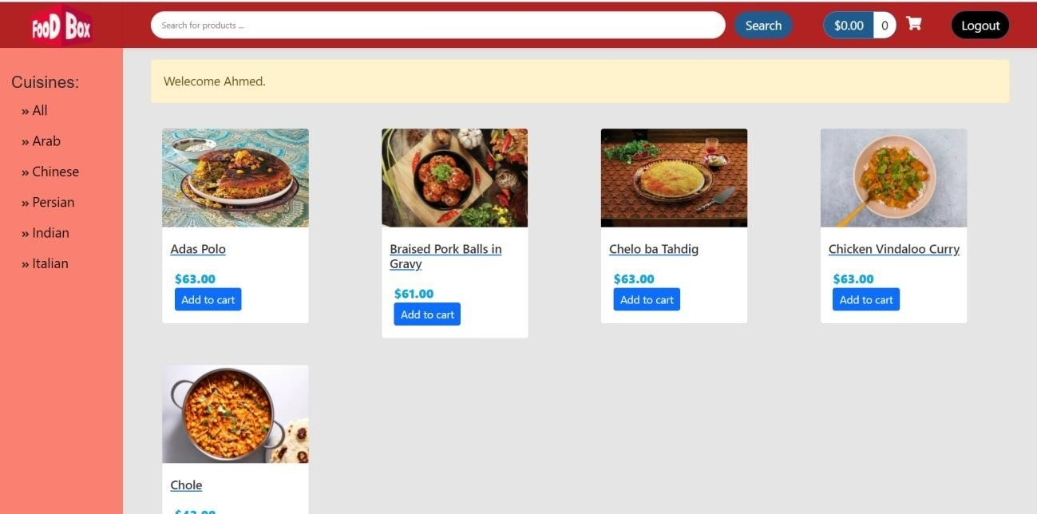

1. **Adding products to cart**

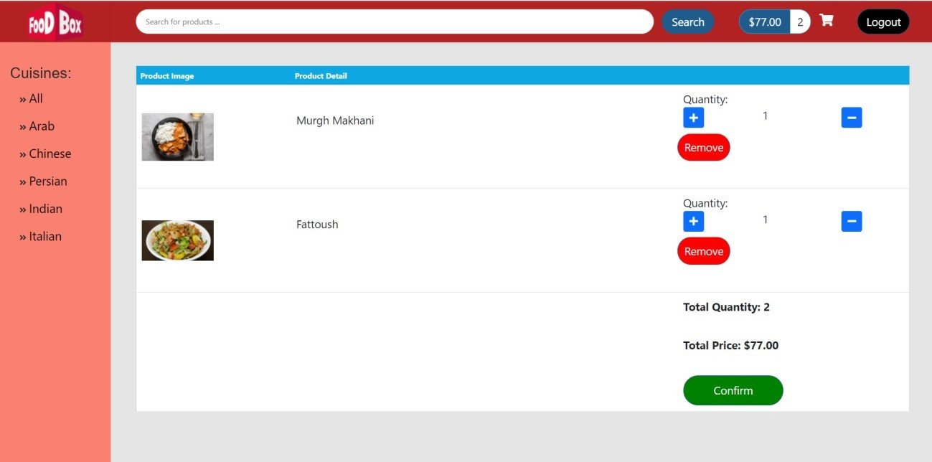

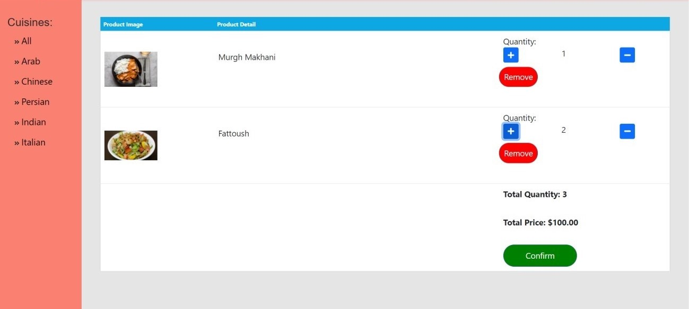

1. **Admin login.**

**Username: admin**

**Password: admin**

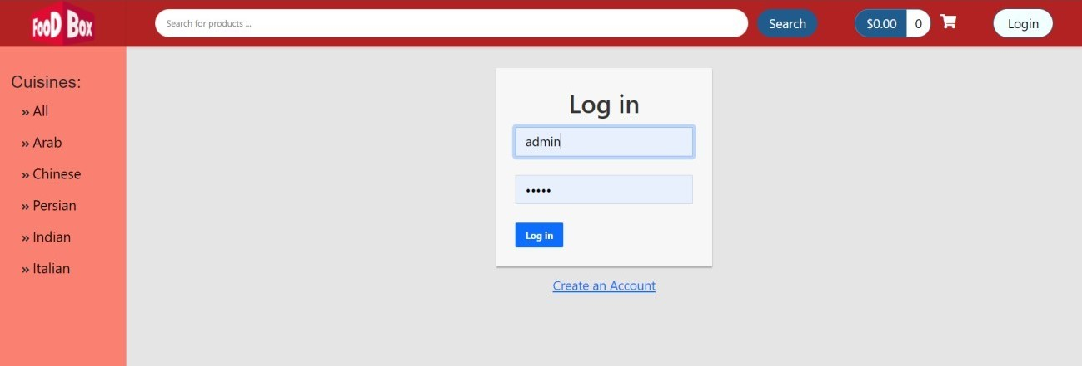

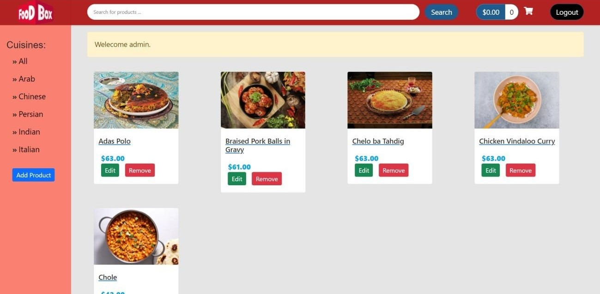

1. **Admin can add products to application**

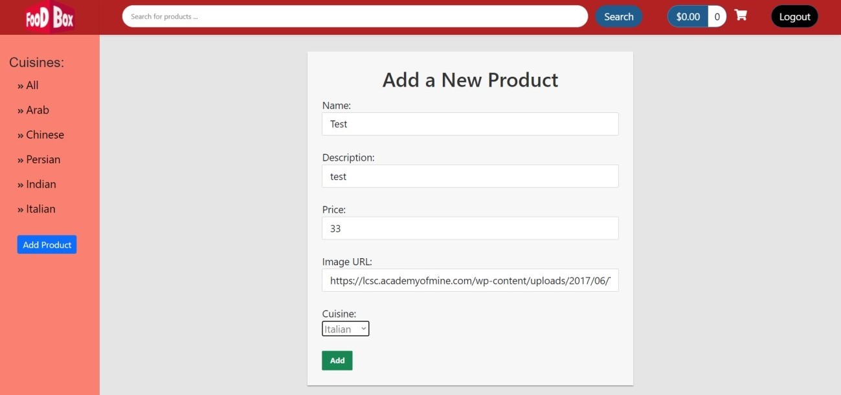

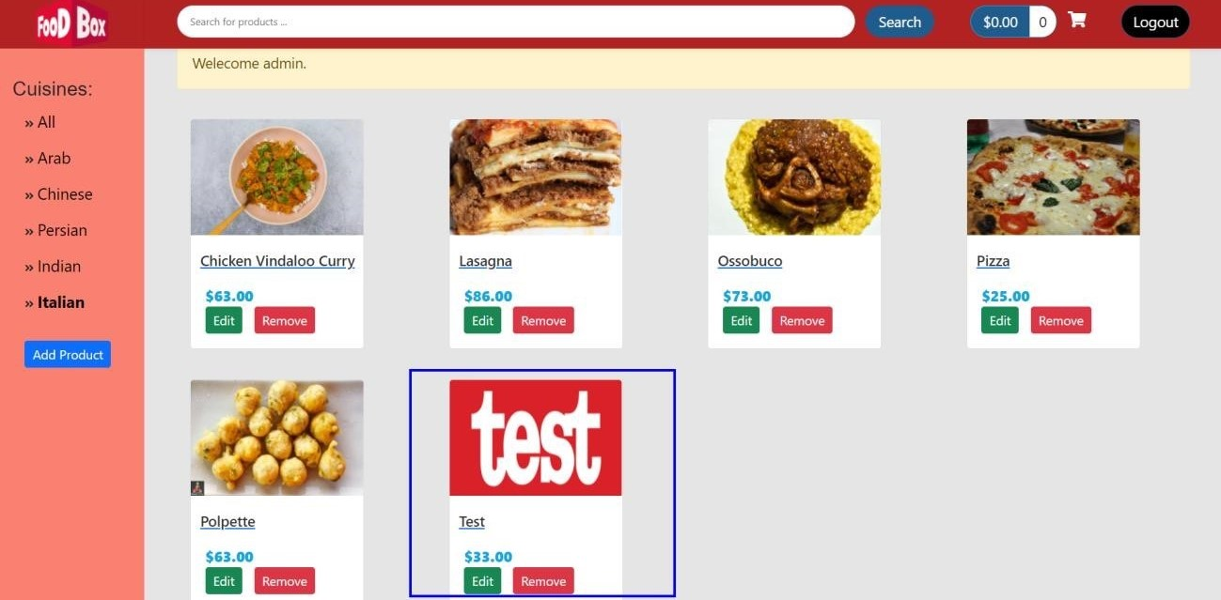

1. **Admin can change price of product.**

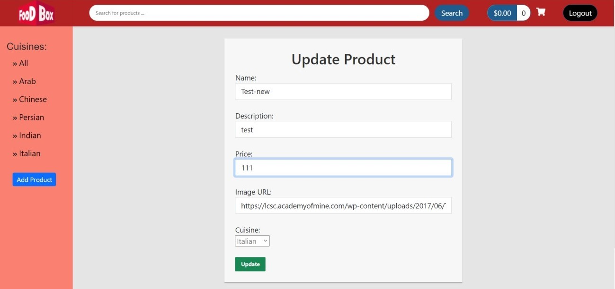

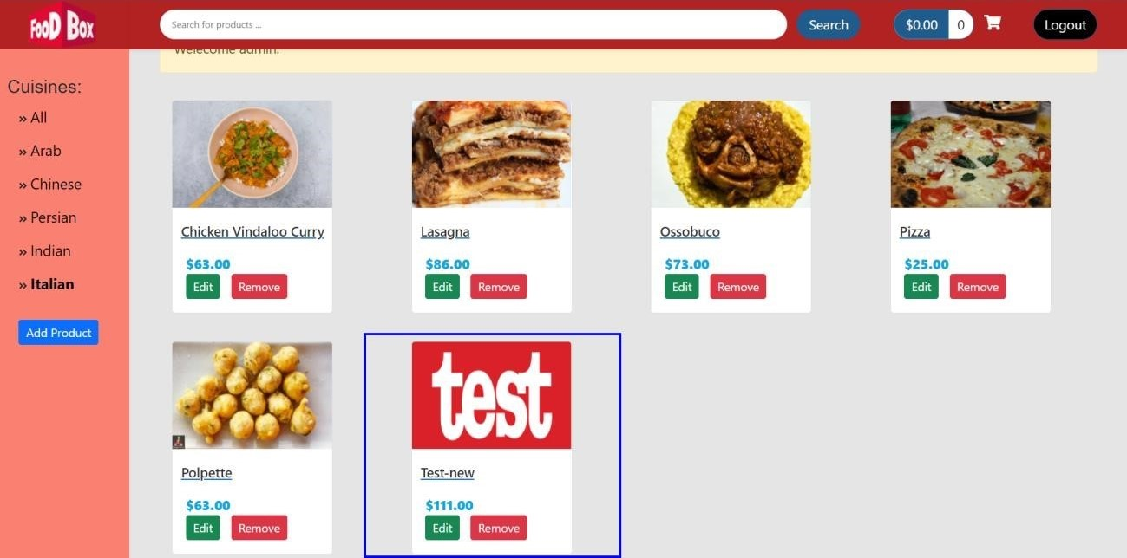

# Links to the GitHub repository to verify the project completion

For source code please use GitHub link.

[**https://github.com/Svsai97/Project_Foodbox_JobReadiness.git**](https://github.com/Svsai97/Project_Foodbox_JobReadiness.git)