

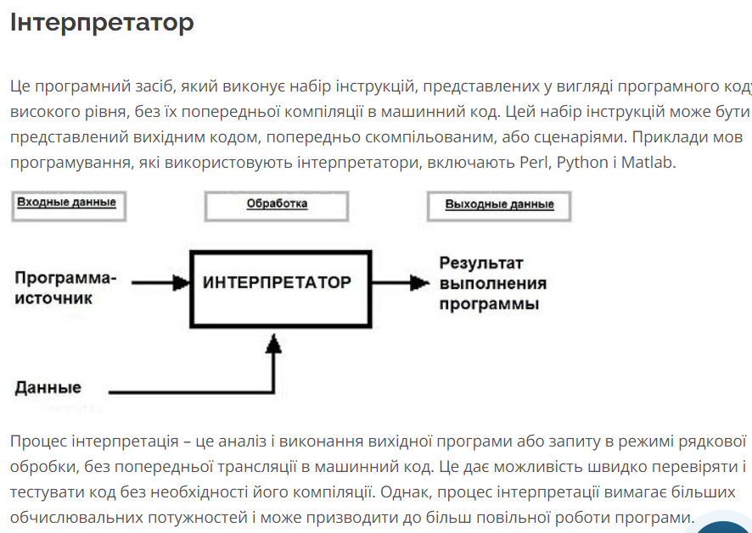

https://foxminded.ua/kompiliator-ta-interpretator/

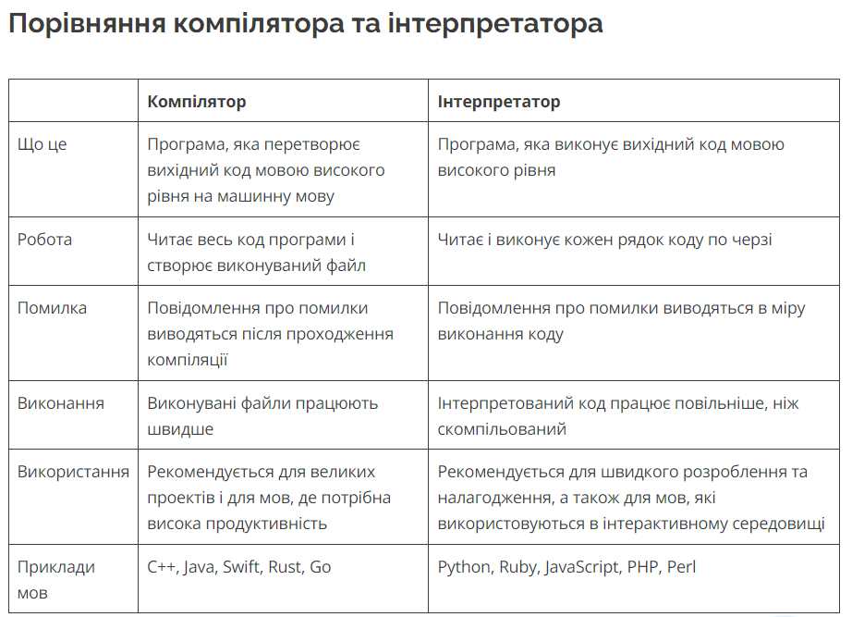

var x = "hello world"

console.log(x)

x = 89

console.log(x)

function f (x, y) {

    console.log(x)

    console.log(y)

    return x > y;

}

console.log(f(9,0,9))

var a = 2;

{

    let a = 3;

    console.log(a);

}

console.log(a)

{

    const ARR = [5, 6];

    console.log(ARR);

    ARR.push(7);

    console.log(ARR);

    // ARR = 10;

    // console.log(ARR);

    ARR[0]=3;

    console.log(ARR)

}

function A (){

    var x = 7;

    function B(){

        console.log(x);

    }}

var x = 5;

A();

function B(){

    console.log(x);

}

var message = "in global";

var a = function () {

    var message = "inside a";

    console.log(message);

    b();

}

function b () {

    console.log("b ->  " + message)

}

a();

var message = "in global";

var a = function () {

    var message = "inside a";

    console.log(message);

    function b () {

        console.log("b ->  " + message)

    }

    b();

}

a();

x = 9

console.log(x)

var x = 6;

const a = 0

console.log(a);

var a = 8

console.log(a);

alert(3 + 1

    + 2);

const a = 2;

const b = 3;

console.log(`5 =  ${a}

    + ${b} `)

console.log(9/3)

console.log(undefined/3)

function test1 (a){

    console.log(a/5)

}

test1()

var x = 4, y = 4;

if(x == y){

    console.log("x = 4 is equal to y = 4")

}

x = "4";

if(x == y){

    console.log("x = 4 is equal to y = 4")

}

if(x !== y){

    console.log("x = 4 is NOT equal to y = 4")

}

if ( false || null || undefined || "" || 0 || NaN){

    console.log("this line never execute")

}

else{

    console.log("everething is fine")

}

if(true && "hello" && 1 && -1 && "false") {

    console.log("All is true!")

}

function b()

{

    return

    {

        name: "Mira"

    };

}

function a(){

    return{

        name: "Mira"

    };

}

console.log(b())

console.log(a())