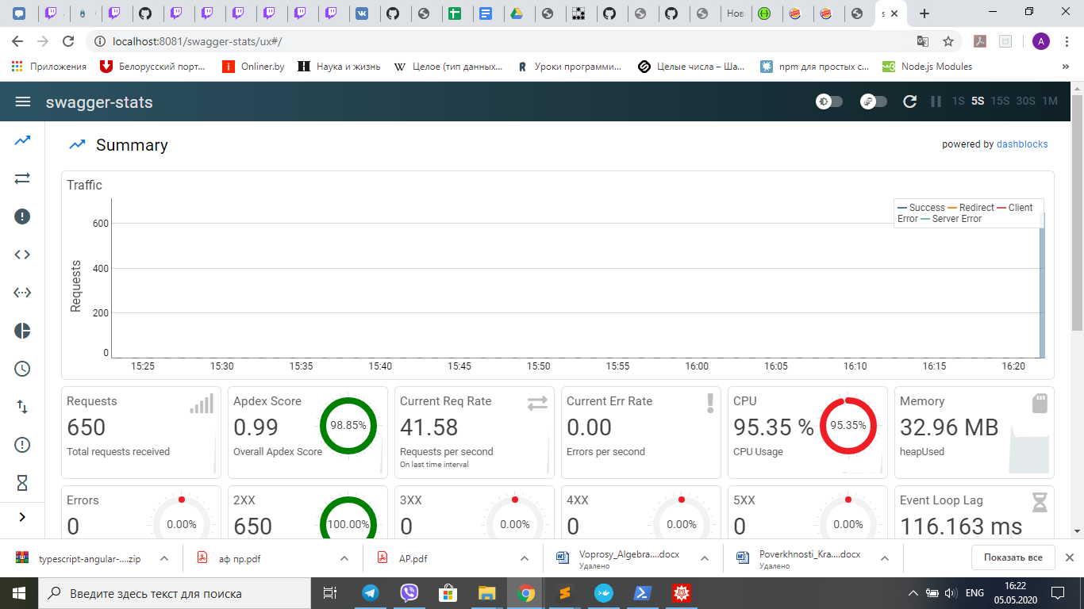

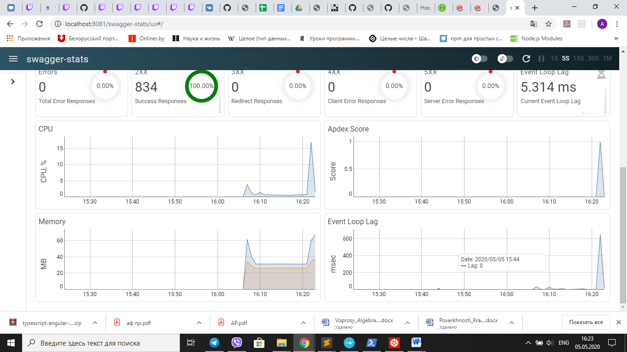

Running 10s test @ http://fp-medicines:8081/api/v1/medicines/list

5 threads and 30 connections

Thread Stats Avg Stdev Max +/- Stdev

Latency 375.23ms 165.71ms 1.05s 88.03%

Req/Sec 20.30 13.55 50.00 65.73%

804 requests in 10.02s, 258.07KB read

Requests/sec: 80.22

Transfer/sec: 25.75KB

