Learning Module 4: Probability Trees and Conditional Expectations
Q.300 An investor owns shares of both Apple and Microsoft. He assumes that the probability of Apple's share price declining by more than 5% this year is 0.4, while the probability of Microsoft's share price declining by more than 5% is 0.3. The probability that either Apple or Microsoft's share prices will decline in price by more than 5% this year is closest to;
A. 0.12
B. 0.58
C. 0.70
The correct answer is B.
These are non-mutual exclusive events. The probability of Apple’s share price declining is not in any way dependent on the probability of Microsoft’s share declining. Both events can occur simultaneously.
For non-mutual exclusive evens, the probability that either event will happen is given by the formula:
P(A or B) = P(A) + P(B) −P(AB)
P (AB) = P(A) × P(B)
⇒P (A or B) = 0.4 + 0.3 −(0.4 × 0.3) = 0.58
A is incorrect. This is illustrated in the below workings.
P(AB) = P(A) × P(B) = 0.4 × 0.3 = 0.12
C is incorrect..This is illustrated in the below workings.
P(AB) = P(A) + P(B) = 0.4 + 0.3 = 0.70
CFA Level 1, Quantitative Methods, Learning Module 4: Probability Trees and Conditional Expectations, LOS (c) Calculate and interpret an updated probability in an investment setting using Bayes’ formula.
112
© 2014-2024 AnalystPrep.

Q.310 Suppose A and B are mutually exclusive events, and P(A)=0.2, P(B)=0.5. The probability P(A and B) is closest to:
A. 0
B. 0.01
C. 0.7
The correct answer is A.
If two events, A and B, are mutually exclusive, only one of the events can occur at any particular time. The two events cannot both occur at the same time.
The probability of occurring of 2 mutually exclusive events is 0.
B is incorrect. It assumes that both events occur at the same time (0.2*0.5)
C is incorrect. It assumes that P(A and B) = 0.2 + 0.5 = 0.7
CFA Level 1, Quantitative Methods, Learning Module 4: Probability Trees and Conditional Expectations, LOS (c) Calculate and interpret an updated probability in an investment setting using Bayes’ formula.
113
© 2014-2024 AnalystPrep.

Q.313 You own shares of Corp. A and Corp.B. You think that the probability of Corp. A to go bankrupt this year is 0.15, and Corp.B to go bankrupt is 0.25. The companies going bankrupt are independent of each other. The probability that at least one of these two companies will go bankrupt this year is closest to
A. 0.0375
B. 0.3625
C. 0.4
The correct answer is B.
From the information given,
P(A or B) = P(A) + P(B) - P(AB)
= P(A) + P(B) - P(A)×P(B)
= 0.15 + 0.25 −0.15 × 0.25
= 0.3625
A is incorrect. It denotes the probability calculation as (0.15*025). C is incorrect. It denotes the probability calculation as (0.15+0.25).
CFA Level 1, Quantitative Methods, Learning Module 4: Probability Trees and Conditional Expectations, LOS (c) Calculate and interpret an updated probability in an investment setting using Bayes’ formula.
114
© 2014-2024 AnalystPrep.

Q.412 There is a 40% chance that the economy keeps sinking into recession next year and a 60% chance that it will rebound. If the economy rebounds, Company ABC will hire 2,000 employees. If the economy keeps sinking, there is an 80% probability that it will cut 1,000 jobs and a 20% chance to go bankrupt and cut 9,000 jobs. The firm's expected job hires/cut is closest to:
A. -2,600 employees
B. +160 employees
C. +2,000 employees
The correct answer is B.
From the information given in the question, denote the expected job hires/cut by X so that:
X = (0.6 × 2, 000) + 0.4 × ((0.8 × −1, 000) + (0.2 × −9, 000)) = 1, 200 + 0.4 × (−800 + −1, 800)
= 1, 200 + 0.4 × 2,600
= 1, 200 −1, 040
= 160
A is incorrect. It results from ( | 80% × −1, 000 + 20% × 9,000 | ).
C is incorrect. It assumes the company will hire 2,000 employees.
CFA Level 1, Quantitative Methods, Learning Module 4: Probability Trees and Conditional Expectations, LOS (a) Calculate expected values, variances, and standard deviations and demonstrate their application to investment problems.
115
© 2014-2024 AnalystPrep.

Q.415 You have been given the following probabilities:
P(A) = 35%
P(B) = 65%
P(B | A) = 65%
The probability that Event A and Event B occur is closest to:
A. 22.75%
B. 35%
C. 65%
The correct answer is A.
Since P(B|A) = P(B) , we know that A and B are independent events. This means that P(A and B) = P(A) × P(B) . Thus,
P(A and B) = 0.65 × 0.35 = 0.2275 = 22.75%
B is incorrect. It indicates only the probability of A occurring. C is incorrect. It indicates only the probability of B occurring.
CFA Level 1, Quantitative Methods, Learning Module 4: Probability Trees and Conditional Expectations, LOS (c) Calculate and interpret an updated probability in an investment setting using Bayes’ formula.
116
© 2014-2024 AnalystPrep.

Q.2714 Which of the following is the most appropriate term used for events that cover all the possible outcomes?
A. Exhaustive events.
B. Independent events.
C. Mutually exclusive events.
The correct answer is A.
Exhaustive events are events that cover all possible outcomes. In probability theory and logic, a set of events is jointly or collectively exhaustive if at least one of the events must occur. For example, when rolling a six-sided die, the outcomes 1, 2, 3, 4, 5, and 6 are collectively exhaustive, because they encompass the entire range of possible outcomes.
B is incorrect. Independent events are events that are not affected by the outcome of previous events; for instance, when tossing a coin, the probability of getting head or tail does not in any way depend on whether you got head or tail on the first toss.
C is incorrect. Mutually exclusive events are events that cannot both occur simultaneously; for example, when tossing a coin, you can get either head or tail, there is no possibility of getting both head and tail simultaneously.
CFA Level 1, Quantitative Methods, Learning Module 4: Probability Trees and Conditional Expectations, LOS (c) Calculate and interpret an updated probability in an investment setting using Bayes’ formula.
117
© 2014-2024 AnalystPrep.

Q.2715 If the probability that students use preparation materials for the CFA Level 1 exam is
80% and the probability that the students will pass the CFA Level 1 exam given that they use
preparation materials is 54%, then the joint probability of using preparation materials and
passing the CFA Level 1 exam is closest to:
A. 43.2%
B. 80.0%
C. 90.8%
The correct answer is A.
Let
p(A)=0.8 (the probability that the students use preparation materials for the CFA Level 1 exam is
And
p(P|A)=0.54 (the probability that the students will pass the CFA Level 1 exam given that they use
To get the joint probability p(PA), we need to use the multiplication rule.
p(PA) = p(P|A) × p(A) = 0.8 × 0.54 = 0.432 = 43.2
B is incorrect. It assumes the multiplication rule of probability is used to determine the joint
probability of two events as follows:
P(AB) = P(A | B) × P(B) [ | 0.8 | × 0.54 ]0.80 80.0%
= | 0.54 | ==
C is incorrect. It assumes the addition rule of probability is used to determine the probability
that at least one of two events will occur:
P(A or B) = P(A) + P(B) − P(AB) = (0.8 + 0.54) −(0.8 × 0.54) = 0.908 = 90.8
CFA Level 1, Quantitative Methods, Learning Module 4: Probability Trees and
Conditional Expectations, LOS (c) Calculate and interpret an updated probability in an
investment setting using Bayes’ formula.
118
© 2014-2024 AnalystPrep.

Q.2716 The probability that the Eurozone economy will grow this year is 48%, and the probability that the European Central Bank (ECB) will loosen its monetary policy is 50%. Assuming that the joint probability that the Eurozone economy will grow and the ECB will loosen its monetary policy is 40%, then the probability that either the Eurozone economy will grow or the ECB will loosen its the monetary policy is closest to:
A. 40%.
B. 48%.
C. 58%.
The correct answer is C.
The addition rule of probability is used to solve this question:
P(E) = 0.48 (the probability that the Eurozone economy will grow is 48%)
p(M) = 0.50 (the probability that the ECB will loosen the monetary policy is 50%)
p(E ∩M) = 0.40 (the joint probability that Eurozone economy will grow and the ECB will loosen its monetary policy is 40%)
The probability that either the Eurozone economy will grow or the central bank will loosen its the monetary policy:
p(E ∪M) = p(E) + p(M) −p(E ∩M)
= 0.48 + 0.50 −0.40
= 0.58
A is incorrect. It indicates the joint probability that the Eurozone economy will grow and the ECB will loosen its monetary policy.
B is incorrect. It indicates the probability that the Eurozone economy will grow.
CFA Level 1, Quantitative Methods, Learning Module 4: Probability Trees and Conditional Expectations, LOS (c) Calculate and interpret an updated probability in an investment setting using Bayes’ formula.
119
© 2014-2024 AnalystPrep.

Q.2717 Which of the following statements regarding the probability rules is least likely accurate?
A. Joint probability: p(X|Y) * p(Y)
B. Addition rule : p(T) + p(U) - p(TU)
C. For independent events: p(K|L) = p(L)
The correct answer is C.
A and B are Independent independent events if the occurrence of event A does not in any way affect the occurrence of event B. An example of independent events would be the probability of picking a red ball from a bag after picking a blue ball on the first round. Events K and L are independent events only if p(K|L) = p(K).
A is incorrect. A is a true statement. The joint conditional probability (the probability that an
event occurs given that another event has already occurred) is | P (AB) = P(A) × P(B/A) | .
B is incorrect. B is a true statement. For any two events, A and B, the probability of either A or B is the sum of the two events minus the shared probability between the two events. P (A or B) = P (A) + P (B) −P(AB) .
CFA Level 1, Quantitative Methods, Learning Module 4: Probability Trees and Conditional Expectations, LOS (c) Calculate and interpret an updated probability in an investment setting using Bayes’ formula.
Q.2718 A company which produces 5G communication equipment has two factories, A and B. 40% of the equipment are made in factory A, 60% in factory B. It has been established that 90% of the equipment produced by factory A meets specifications while only 75% of the equipment produced by factory B meets specifications. If a Telco buys the equipment, the probability that it meets specifications is closest to:
A. 0.40
B. 0.76
C. 0.81
The correct answer is C.
This question can be solved; (1) using a tree diagram
120
© 2014-2024 AnalystPrep.

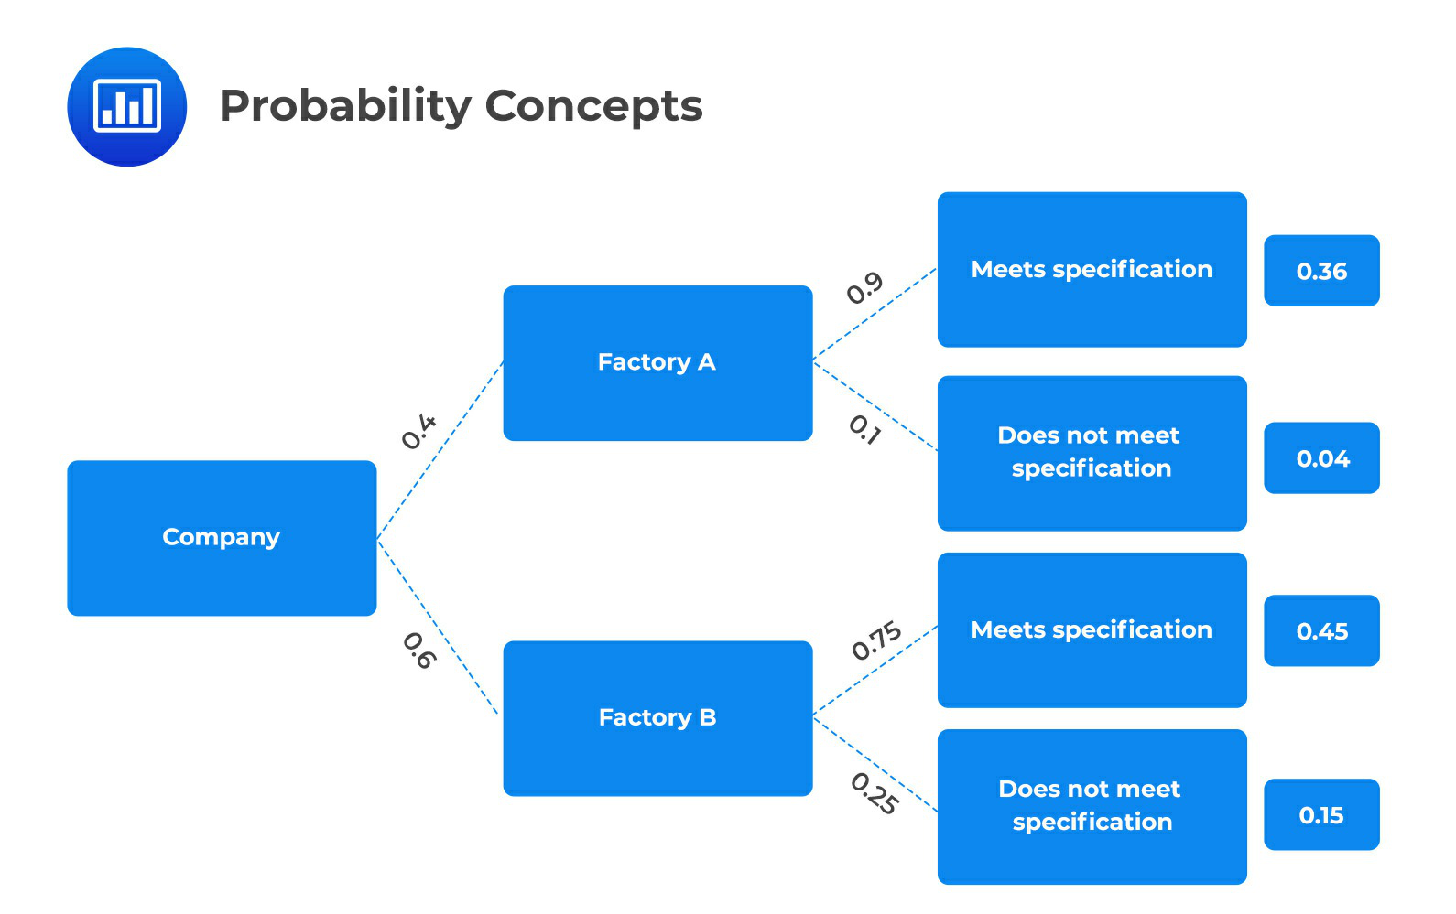
We want to find the probability that a piece of equipment bought from the company meets specifications (as shown in bold on the tree diagram),
The equipment might have been bought either from factory A or from factory B. Therefore, the probability that the equipment meets specifications is 0.36+0.45 = 0.81.
(2) Using the total probability rule. Let us define the following events: M - meets specifications
A - produced by A
B - produced by B
Thus,
P(A) = 0.4, P(B) = 0.6, and P(M|A) = 0.9, P(M|B) = 0.75
We wish to find P(M), and we can do that by applying the total probability rule: P(M) = P(M|A)P(A) + P(M|B)P(B)
P(M) = 0.9 × 0.4 + 0.75 × 0.6 = 0.81
A is incorrect. It assumes the multiplication rule of probability is used to determine the joint probability of two events as follows;
P(AB) = P(A | B) × P(B) [ | 0.4 | × 0.6] 0.40
= | 0.6 | =
B is incorrect. It assumes the addition rule of probability is used to determine the probability
121
© 2014-2024 AnalystPrep.

that at least one of two events will occur:
P(A or B) = P(A) + P(B) − P(AB) = (0.4 + 0.6) −(0.4 × 0.6) = 0.76
CFA Level 1, Quantitative Methods, Learning Module 4: Probability Trees and Conditional Expectations, LOS (c) Calculate and interpret an updated probability in an investment setting using Bayes’ formula.
122
© 2014-2024 AnalystPrep.

Q.2720 An analyst at Hampton Investments Company is calculating the expected value dividend to be received on Healthcare Co. shares.
Analysts | Dividend Forecast | Probability
PICO  Stock Ninja  Hermes Smith John Kenen  Hira Ahmed | $1.80  $8.60  $5.00  $2.22  $0.95 | 0.27  0.10  0.09  0.35  0.19
As an analyst, using the forecasts of different analysts and their probabilities given in the following table, the estimated value of Healthcare's dividend is closest to:
A. $0.55
B. $0.86
C. $2.75
The correct answer is C.
To solve this problem, we simply need to multiply the expected dividend by the probability. Then we take the sum from all of those, as shown in the following table:
Analysts | Dividend Forecast | Probability | Expected Value
PICO  Stock Ninja  Hermes Smith John Kenen  Hira Ahmed | $1.80  $8.60  $5.00  $2.22  $0.95 | 0.27  0.10  0.09  0.35  0.19 | $0.49  $0.86  $0.45  $0.78  $0.18
Sum of Expected Values |  |  | $2.75
A is incorrect. It is an average of the expected value of the dividends, i.e., 2.75/5. B is incorrect. It is the expected dividend value for Stock Ninja.
CFA Level 1, Quantitative Methods, Learning Module 4: Probability Trees and Conditional Expectations, LOS (a) Calculate expected values, variances, and standard deviations and demonstrate their application to investment problems.
123
© 2014-2024 AnalystPrep.

Q.2721 If event C and event D are mutually exclusive, then which of the following statements is the least likely appropriate?
A. Event D could not occur.
B. Only event C could occur.
C. Event C and D could occur together.
The correct answer is C.
If the two events are mutually exclusive, then they can never occur together.
B is incorrect. Mutual exclusive events cannot both occur at the same time. Event C could occur if event D does not occur.
A is incorrect. If event C occurs, then event D will not occur.
CFA Level 1, Quantitative Methods, Learning Module 4: Probability Trees and Conditional Expectations, LOS (b) formulate an investment problem as a probability tree and explain the use of conditional expectations in investment application.
Q.2722 Assume you are a financial analyst at an investment management firm where you're given the task to estimate the dispersion of a specific equity price around its forecasted value.
Probability | Equity Value
0.33  0.39  0.28 | $62.15  $60.75  $63.00
As a financial analyst, the variance of equity value using the data provided in the following table is closest to:
A. 0.495
B. 0.872
C. 0.934
The correct answer is B.
Variance measures the squared deviation of each outcome from its expected value and multiplies it by its weight (probability).
124
© 2014-2024 AnalystPrep.

Variance = | n | P(Xi = x)(X −¯X)2
Variance = | ∑ | P(Xi = x)(X −¯X)2
Variance = | i=1 | P(Xi = x)(X −¯X)2
Now,
¯X = | n | x. P(Xi = x) = 0.33 × 62.15 + 0.39 × 60.75 + 0.28 × 63.00 = 61.84
¯X = | ∑
¯X = | i=1
Thus
Variance = 0.33(62.15 −61.84)2+ 0.39(60.75 −61.84)2+ 0.28(63 −61.84)2= 0.872
A is incorrect. It indicates the variance of the first two equity values:
0.33(62.15 −61.84) + 0.39 (60.75 −61.84) = 0.495
C is incorrect. It indicates the standard deviation:
√0.872 = 0.934
CFA Level 1, Quantitative Methods, Learning Module 4: Probability Trees and Conditional Expectations, LOS (a) Calculate expected values, variances, and standard deviations and demonstrate their application to investment problems.
125
© 2014-2024 AnalystPrep.

Q.2723 Assume you are an associate at an investment management firm where you're given the task to estimate the dispersion of a specific equity price around its forecasted value. The forecasted values and probabilities associated with them are given in the following table:
Probability | Equity Value
0.33  0.39  0.28 | $62.15  $60.75  $63.00
Using the given data, the standard deviation is closest to:
A. 0.50
B. 0.87
C. 0.93
The correct answer is C.
Variance measures the squared deviation of each outcome from its expected value and multiplies it by its weight (probability).
Variance = 0.33(62.15−61.84)2+ 0.39(60.75 −61.84)2+ 0.28(63 −61.84)2= 0.87
⇒Standard deviation = Variance0.5= 0.93
A is incorrect. It indicates the variance of the first two equity values as follows;
0.33(62.15 −61.84) + 0.39 (60.75 −61.84) = 0.495
B is incorrect. It indicates the variance.
CFA Level 1, Quantitative Methods, Learning Module 4: Probability Trees and Conditional Expectations, LOS (a) Calculate expected values, variances, and standard deviations and demonstrate their application to investment problems.
Q.2724 Suppose there is a 65% probability that the Gross Domestic Product (GDP) of Trivia Land will grow this year. If the GDP grows, there is a 75% probability that the GDP will be $5.5 trillion and a 25% probability that the GDP will be $5.1 trillion. On the other hand, there is a 35% probability that the GDP will fall, and if it falls, there is a 55% probability that the GDP will be $4.7 trillion and only a 45% probability that the GDP will be $4.0 trillion.
Using the given assumptions, the unconditional probability that the expected GDP will be $4.0 trillion is closest to:
126
© 2014-2024 AnalystPrep.

A. 15.75%
B. 35%
C. 45%
The correct answer is A.
We can use a tree diagram to visualize this problem:
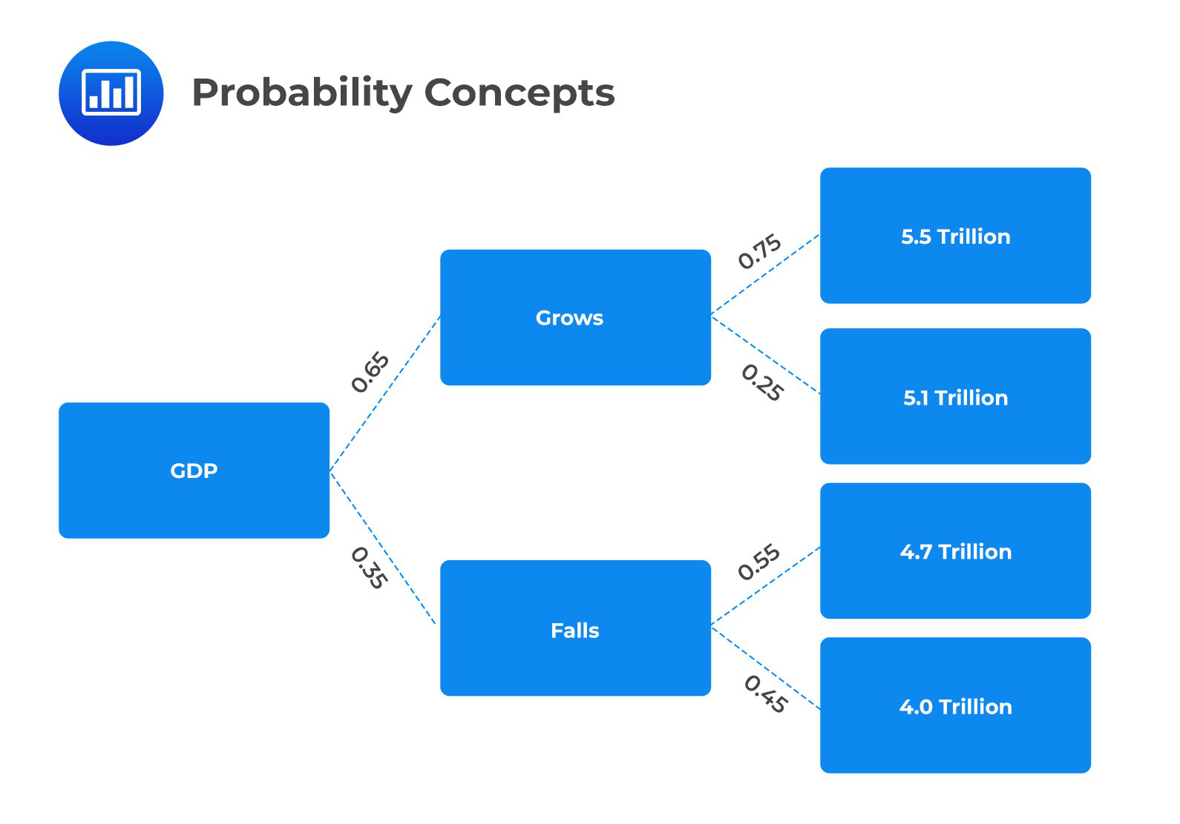
There is only a 45% probability that the expected GDP will be $4.0 trillion, given that the GDP will fall. Therefore, the unconditional probability of GDP being $4.0 trillion
= 35% × 45% = 0.1575
B is incorrect.It only indicates the probability that the GDP will fall.
C is incorrect. It only indicates the probability that the expected GDP will be $4.0 trillion, given that the GDP will fall
CFA Level 1, Quantitative Methods, Learning Module 4: Probability Trees and
127
© 2014-2024 AnalystPrep.

Conditional Expectations, LOS (c) Calculate and interpret an updated probability in an investment setting using Bayes’ formula.
Q.2725 Suppose there is a 65% probability that the Gross Domestic Product (GDP) of Trivia Land will grow this year. If the GDP grows, there is a 75% probability that the GDP will be $5.5 trillion and a 25% probability that the GDP will be $5.1 trillion. On another hand, there is a 35% probability that the GDP will fall, and if it falls, there is a 55% probability that the GDP will be $4.7 trillion and only a 45% probability that the GDP will be $4.0 trillion. Using the given assumptions the expected GDP of Trivia Land given that the GDP will grow is closest:
A. $5.40 trillion
B. $5.10 trillion
C. $5.50 trillion
The correct answer is A.
We will use a tree diagram to visualize this question.
128
© 2014-2024 AnalystPrep.

As shown in bold in the above tree diagram, if GDP grows, it has a 75% chance of growing up-to 5.5 trillion and a 25% chance of growing up-to 5.1 trillion.
The expected GDP if the GDP grows = 0.75 × ($5.5 trillion) + 0.25 × ($5.1 trillion) = $5.4 trillion
B is incorrect. It indicates only the probability of a 25% chance of the GDP growth up to $5.1 trillion.
C is incorrect. It indicates a75% chance of GDP growing up to $5.5 trillion.
CFA Level 1, Quantitative Methods, Learning Module 4: Probability Trees and Conditional Expectations, LOS (c) Calculate and interpret an updated probability in an investment setting using Bayes’ formula.
Q.2727 Suppose there is a 65% probability that the Gross Domestic Product (GDP) of Trivia Land will grow this year. If the GDP grows, there is a 75% probability that the GDP will be $5.5 trillion and a 25% probability that the GDP will be $5.1 trillion. On the other hand, there is a 35% probability that the GDP will fall, and if it falls, there is a 55% probability that the GDP will be $4.7 trillion and only a 45% probability that the GDP will be $4.0 trillion. Using the given assumptions, the conditional variance of GDP in the environment where the GDP is expected to grow is closest to:
A. 0.03
B. 0.04
C. 0.173
The correct answer is A.
Expected GDP in GDP growth environment = 0.75($5.5) + 0.25($5.1) = $5.4 trillion.
So that,
Variance = 0.75(5.5 −5.4)2+ 0.25(5.1 −5.4)2= 0.03
B is incorrect. It indicates the variance assuming the GDP falls.
C is incorrect. It's the resulting standard deviation of the GDP in the GDP growth environment
CFA Level 1, Quantitative Methods, Learning Module 4: Probability Trees and Conditional Expectations, LOS (a) Calculate expected values, variances, and standard deviations and demonstrate their application to investment problems.
129
© 2014-2024 AnalystPrep.

Q.3438 At the University of Alabama, a portfolio management test has ten questions, and each question has four option choices, out of which only one is correct. James Sigh selects a random option for each of the ten questions. The probability that all his answers are correct is closest to:
A. ( ) 1  4 |  | 10
B. ( | 1 | ) | 4
 | 10 | )
C. 1
4
The correct answer is A.
The number of ways in which the test can be answered is 410 .
The number of ways in which all correct options can be selected is 1.
Therefore, the probability of all correct answers is = ( | 1 | 10  )
 | 4
B is incorrect. It's the inverse of the probability of all the correct answers.
C is incorrect. It does not include the power of 10.
CFA Level 1, Quantitative Methods, Learning Module 4: Probability Trees and Conditional Expectations, LOS (b) Formulate an investment problem as a probability tree and explain the use of conditional expectations in investment application.
130
© 2014-2024 AnalystPrep.

Q.3445 Box A contains 20 red balls, while Box B contains 10 white balls. A box is randomly selected, and a ball is drawn out. The probability that the ball is white is closest to:
A. 0.33.
B. 0.50.
C. 0.67.
The correct answer is B.
Probability of selecting box B = 1
2
Once Box B is selected, the probability of picking up a white ball = 1(1 since all balls within box
B are white) p (selecting white ball)
p (selecting white ball) = | 1 | × 1 1/2.
 | 2 | =
A is incorrect. It assumes one chance in thirty that a white ball will be drawn.
C is incorrect. It assumes two chances in thirty that a red ball will be drawn.
CFA Level 1, Quantitative Methods, Learning Module 4: Probability Trees and Conditional Expectations, LOS (b) Formulate an investment problem as a probability tree and explain the use of conditional expectations in investment application.
131
© 2014-2024 AnalystPrep.

Q.3451 Three events (A, B, and C) are independent of each other. The probability of occurrences of each event is 0.30, 0.25, and 0.20, respectively. The probability that all the events occur simultaneously is closest to:
A. 0.015
B. 0.735
C. 0.750
The correct answer is A.
As the events are independent of each other, the probability that all the events occur simultaneously is:
p (all occurs simultaneously) = 0.30 × 0.25 × 0.20 = 0.015
B is incorrect. It indicates the probability of either one event occurring as follows;
P(A or B or C) = (0.30 + 0.25 + 0.20) −(0.30 × 0.25 × 0.20) = 0.735
C is incorrect. It indicates the total sum of all the probabilities, i.e., = 0.30+0.25+0.20=0.750.
CFA Level 1, Quantitative Methods, Learning Module 4: Probability Trees and Conditional Expectations, LOS (c) Calculate and interpret an updated probability in an investment setting using Bayes’ formula.
Q.3452 An equity analyst tracks a stock and has forecasted the price of stocks under various conditions, as given in the following exhibit.
Exhibit: Stock price given different events - March 2016
Event | Probability
The stock index rises | 40%
The stock index falls | 60%
The price of the stock increases given that the stock index rises | 20%
The price of the stock increases | 40%
Given that the stock index fell in March 2016, the probability that the price of the stock increased is closest to:
132
© 2014-2024 AnalystPrep.

A. 0.20
B. 0.53
C. 0.60
The correct answer is B.
The total probability rule states that:
P(A) = P(A|X1)*P(X1) + P(A|X2)*P(X2) + ….. P(A|Xn)*P(Xn) Where X1, X2… are mutually exclusive and exhaustive events.
Let us define the events:
A = the stock price increases
X1 = the stock index rises
X2 = the stock index falls
P(A) = P(A|X1)*P(X1) + P(A|X2)*P(X2)
0.40 = 0.20 * 0.40 + P(A|X2) * 0.60
0.40 = 0.08 + P(A|X2)*0.60
P(A|X2) = 0.53=53%
A is incorrect. It indicates the probability that the price of the stock increases, given that the stock index rises.
C is incorrect. It indicates the probability that the stock index falls.
CFA Level 1, Quantitative Methods, Learning Module 4: Probability Trees and Conditional Expectations, LOS (c) Calculate and interpret an updated probability in an investment setting using Bayes’ formula.
Q.3456 The research team of an investment bank makes the following predictions:
Rate cut by the central bank
Probability (60%)
Sub Event | Probability
Stock market rises Stock market falls | 70%  30%
133
© 2014-2024 AnalystPrep.

No rate cut by the central bank
Probability (40%)
Sub Event | Probability
Stock market rises Stock market falls | 40%  60%
The probability that the stock market will rise, irrespective of a rate cut or not, is closest to:
A. 42%.
B. 58%.
C. 82%.
The correct answer is B.
Using the total probability rule:
P(stock market increase) = P (stock market increase/rate cut)× P(rate cut) + P (stock market increase/no rate cut)× P(no rate cut)
P (stock market increase) = 0.70×0.60 + 0.40×0.40 = 0.58 = 58%
Using a tree diagram
134
© 2014-2024 AnalystPrep.

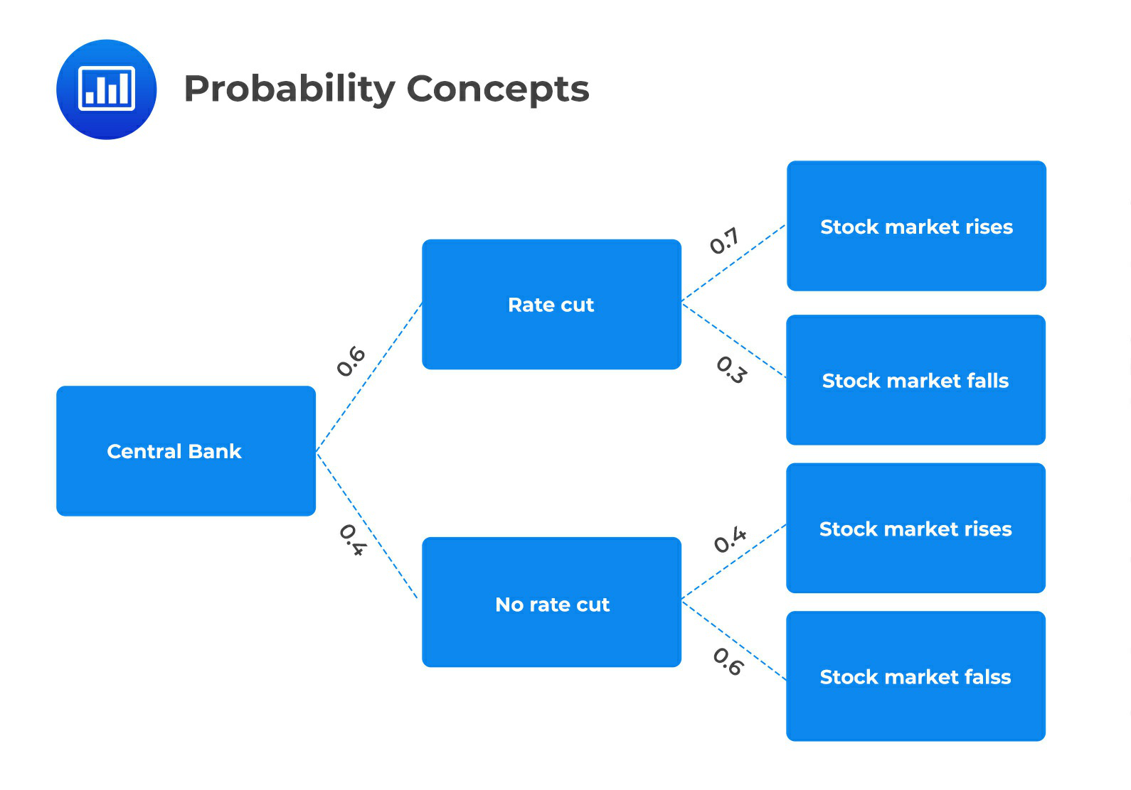
The stock market, as shown in bold in the above tree diagram, As shown in bold in the above tree diagram, the stock market can rise regardless of whether the rate is cut or not. If the rate is cut, the market will rise by a probability of 0.7 and by a probability of 0.4 if the rate is not cut. The probability that the stock market will rise is, therefore; (0.6 × 0.7) + (0.4 × 0.4) = 0.58
A is incorrect. It indicates the probability that the stock market will fall irrespective of a rate cut or not as follows;
P (stock market falls) = (0.3 × 0.6) + (0.6 × 0.4) = 0.42 = 42%
C is incorrect. It indicates the probability that the stock market will rise whether the rate is cut or not as follows;
P (stock market rise) = (0.7 + 0.4) −(0.7 × 0.4) = 0.82 = 82%
CFA Level 1, Quantitative Methods, Learning Module 4: Probability Trees and Conditional Expectations, LOS (c) Calculate and interpret an updated probability in an investment setting using Bayes’ formula.
135
© 2014-2024 AnalystPrep.

Q.3459 A portfolio manager has the mandate of creating portfolios by including two
pharmaceutical stocks and one engineering stock. If the portfolio manager has the option to
select from ten pharmaceutical and four engineering stocks, respectively, then the maximum
number of portfolios that can be created is closest to:
A. 180
B. 270
C. 360
The correct answer is A.
This is a combination counting problem. It involves the selection of given items where order does
not matter.
The number of ways in which two pharmaceutical stocks can be selected out of ten i.e.,
10C2 = 45. Number of ways in which one engineering stock can be selected out of four stocks i.e.,
4C1 = 4 .The number of ways in which a portfolio can be created 45 × 4 = 180 .
Steps using BAII Plus Pro calculator is as follows;
Press 10, then press 2ND + (nCr in yellow), then press 2 to get 45
Press 4, then press 2ND + (nCr in yellow), then press 1 to get 4.
Then multiply 45 by 4 to get 180.
B is incorrect. It indicates the total number of ways a portfolio can be created = 45 × 6 = 270 ,
taking into account the number of ways in which two pharmaceutical stocks can be selected out
of ten i.e., 10C2 = 45 and the number of ways in which two engineering stocks can be selected
out of four stocks i.e., 4C2 = 6.
C is incorrect. It indicates the total number of ways a portfolio can be created = 120 × 3 = 360 ,
considering the number of ways in which three pharmaceutical stocks can be selected out of ten
i.e., 10C3 = 120 and the number of ways three engineering stocks can be selected out of one i.e.,
3C1 = 3 .
CFA Level 1, Quantitative Methods, Learning Module 4: Probability Trees and
Conditional Expectations, LOS (c) Calculate and interpret an updated probability in an
investment setting using Bayes’ formula.
136
© 2014-2024 AnalystPrep.

Q.3463 An equity research analyst forecasts the share price of Equidor Inc.’s stock and the probability of achieving the price target. The forecast made by the analyst is given in the following exhibit.
Exhibit 1: Share Price Forecast
Probability  20%  25%  40%  15% | Share Price  $32.00  $28.00  $34.00  $40.00
The variance of Equidor Inc.’s stock price is closest to:
A. 3.77
B. 14.20.
C. 33.00
The correct answer is B.
Recall that:
V ar (X) = Px[X −E(X)]2
Probability | X | (X - E(x)) | P(x) * [X - E(x)]2
20%  25%  40%  15% | $32.00 $28.00 $34.00 $40.00 | 32 - 33 = -1 28 - 33 = -5 34 - 33 = 1 40 - 33 = 7 | 20% * 1 = 0.20 25% * 25 = 6.20 40% * 1 = 0.40 15% * 49 = 7.35
Variance |  |  | 14.20
A is incorrect. It indicates the standard deviation of Equido Inc.'s stock price. C is incorrect. It indicates the expected returns of the share price.
CFA Level 1, Quantitative Methods, Learning Module 4: Probability Trees and Conditional Expectations, LOS (c) Calculate and interpret an updated probability in an investment setting using Bayes’ formula.
137
© 2014-2024 AnalystPrep.

Q.3488 The probabilities that Bond A and Bond X will default in the next two years are 10% and 8%, respectively. The probability that both bonds will default simultaneously in the next two years is 5%. The probability that Bond A will default given that Bond X has already defaulted is closest to:
A. 10%
B. 17.2%
C. 62.5%
The correct answer is C.
P(X) = 8%
P(A) = 10%
P(X ∩ A) = 5%
As per the conditional probability:
P(A|X) = P(A ∩ X)/P(X) = 5%/8% = 62.5%
A is incorrect. It assumes the multiplication rule of probability is used to determine the joint probability of two events as follows;
P (AX) | 0.1 | × 0.08 0.1 10
= | 0.08 | ==
B is incorrect. It assumes the addition rule of probability is used to determine the probability that at least one of two events will occur as follows;
P (A or B) = (0.1 + 0.08) −(0.1 × 0.08) = 0.172 = 17.20%
CFA Level 1, Quantitative Methods, Learning Module 4: Probability Trees and Conditional Expectations, LOS (c) Calculate and interpret an updated probability in an investment setting using Bayes’ formula.
138
© 2014-2024 AnalystPrep.

Q.3508 An analyst covers the international bonds market. The probability that Italy defaults and
Japan defaults are 0.01 and 0.02, respectively. Both events are independent of each other. The
probability that Italy defaults given that Japan has already defaulted is closest to:
A. 0.01.
B. 0.03
C. 0.118
The correct answer is A.
Let: P(A) =probability that Italy defaults and P(B) =probability that Japan defaults
As the events are independent of each other, the probability of occurrence of one event does not
affect the probability of occurrence of the other event. This can also be proved using the
conditional probability rule:
P(A|B) = P(AB)|P(B)
As the events are independent
P(AB) = P(A) * P(B)
P(A|B) = P(A)=0.01
B is incorrect. It assumes the events are mutually exclusive as follows;
P (AB) = 0.01 + 0.02 = 0.03
C is incorrect. It assumes the addition rule of probability is used to determine the probability
that at least one of two events will occur as follows;
P (A or B) = (0.1 + 0.02) −(0.1 × 0.02) = 0.118
CFA Level 1, Quantitative Methods, Learning Module 4: Probability Trees and
Conditional Expectations, LOS (c) Calculate and interpret an updated probability in an
investment setting using Bayes’ formula.
139
© 2014-2024 AnalystPrep.

Q.3509 An analyst covers two companies – Xela Ltd. and Yena Inc. Yena Inc. is a subsidiary of Xela. The probability that the return on equity (ROE) of Xela exceeds 20% this year is 0.10, while the probability that the ROE of Yena exceeds 30% is 0.05 for the same time period. If the probability that the ROE of Xela exceeds 20% and the ROE of Yena exceeds 30% is 0.02, then the probability that the ROE of Yena exceeds 30% given that the ROE of Xela has already exceeded 20% is closest to:
A. 0.05
B. 0.10.
C. 0.20
The correct answer is C.
Let us define two events:
Let us define two events:
Event A: ROE of Xela exceeds 20%
Event B: ROE of Yena exceeds 30%
Then:
P(A) = 0.10
P(B) = 0.05
P (A and B) = 0.02 (Events A and B happen together)
According to the conditional probability rule:
P (B|A) = P (A and B)/P(A)
P (B|A) = 0.02/0.10 = 0.20 (Event B happens given that A has already happened)
A is incorrect. It indicates the probability that the ROE of Yena exceeds 30%.
B is incorrect. It indicates the probability that the return on equity (ROE) of Xela exceeds 20%.
CFA Level 1, Quantitative Methods, Learning Module 4: Probability Trees and Conditional Expectations, LOS (c) Calculate and interpret an updated probability in an investment setting using Bayes’ formula.
140
© 2014-2024 AnalystPrep.

Q.3715 An empirical study of ABC stock listed on the New York Exchange reveals that the stock has closed higher on one-third of all days in the past few months. Given that up and down days are independent, the probability of ABC stock closing higher for six consecutive days is closest to:
A. 0.00137.
B. 0.088.
C. 0.776.
The correct answer is A.
From the information above, we can establish that the probability of closing higher = 1/3 Using independence, the probability of 6 consecutive "highs" = (1/3)6 = 0.00137
(The calculation above follows from the fact that if A and B are independent events, then P(A ᴖ B) = P(A) * P(B).)
B is incorrect. It assumes that the stock has not closed higher on one-third of all days in the past few months.
C is incorrect. It assumes the addition rule of probability is used to determine the probability that at least one of two events will occur as follows;
P (A or B) = (0.33 + 0.67) −(0.33 × 0.67) = 0.776
CFA Level 1, Quantitative Methods, Learning Module 4: Probability Trees and Conditional Expectations, LOS (c) Calculate and interpret an updated probability in an investment setting using Bayes’ formula.
Q.3716 A fruit juice shop allows customers to choose apple juice, mango juice or passion juice. The probability of a customer ordering passion juice is 0.45, mango juice and apple juice 0.19, passion juice and mango juice 0.15, passion juice and apple juice 0.25, passion juice or mango juice 0.6, passion juice or apple juice 0.84, and 0.9 for at least one of them.
The probability that a customer orders all three juices is closest to:
A. 0.10
B. 0.30
C. 0.64
The correct answer is A.
141
© 2014-2024 AnalystPrep.

Let:
A be the event that a customer chooses/orders apple juice
M be the event that a customer chooses mango juice
S be the event that a customer chooses passion fruit
We can easily establish that:
P(S) = 0.45
P(M ∩A) = 0.19
P(M ∩S) = 0.15
P(A ∩S) = 0.25
P(M ∪S) = 0.6
P(A ∪S) = 0.84
P(A ∪M ∪S) = 0.9
We need to determine P(A ∩M ∩S) :
Borrowing from the addition rule with three sets,
P(A ∪M ∪S) = P(A) + P(M) + P(S) −P(M ∩A) −P(M ∩S) −P(A ∩S) + P(A ∩M ∩S)
.................equation (I)
P(M ∪S) = P(M) + P(S) −P(M ∩S) ,
P(M) = 0.6 + 0.15 −0.45 = 0.3
Similarly, P(A ∪S) = P(A) + P(S) −P(A ∩S)
P(A) = 0.84 −0.45 + 0.25 = 0.64
Therefore applying equation (I),
0.9 = 0.64 + 0.3 + 0.45 −0.19 −0.15 −0.25 + P(A ∩M ∩S)
Which gives us P(A ∩M ∩S) = 0.1
B is incorrect. It is the result of;
P(M ∪S) = P(M) + P(S) −P(M ∩S) = 0.6 + 0.15 −0.45 = 0.3
142
© 2014-2024 AnalystPrep.

C is incorrect. It is the result of;
P(A ∪S) = P(A) + P(S) −P(A ∩S) = 0.84 −0.45 + 0.25 = 0.64
CFA Level 1, Quantitative Methods, Learning Module 4: Probability Trees and Conditional Expectations, LOS (c) Calculate and interpret an updated probability in an investment setting using Bayes’ formula.
143
© 2014-2024 AnalystPrep.

Q.3729 The punctuality of filing tax returns has been investigated by considering the number of citizens in different geographical regions. In the sample, 60% of respondents were from Africa, 20% Europe, and 20% South America. The probabilities of late filing of returns in Africa, Europe, and South America are 45%, 15%, and 20% respectively.
If a late submitter is picked at random from the area under study, the probability that they are from Africa is closest to
A. 0.45
B. 0.7941
C. 0.80
The correct answer is B.
Let 'A' be the event that an individual chosen at random comes from Africa. Let 'E' and 'S' have similar definitions for Europe and South America, respectively.
Define L' as the event that an individual chosen at random submits tax returns late.
Now, we wish to determine P(Africa | Late) = P(A | L) Applying Bayes' Theorem,
 | P(A) × P(L|A)
P(A|L) = | P(A) × P(L|A) + P(E) × P(L|E) + P(S) × P(L|S) 0.6 × 0.45
=  = | (0.6 × 0.45) + (0.2 × 0.15) + (0.2 × 0.20 0.27  0.27 + 0.03 + 0.04
= 0.7941
A is incorrect. It indicates the probability of late filing of returns in Africa.
C is incorrect. It assumes that the events are mutually exclusive, and when picked randomly, the submitter will be a late filer as follows;
P (Late submitter) = 0.45 + 0.15 + 0.20 = 0.80
CFA Level 1, Quantitative Methods, Learning Module 4: Probability Trees and Conditional Expectations, LOS (c) Calculate and interpret an updated probability in an investment setting using Bayes’ formula.
144
© 2014-2024 AnalystPrep.

Q.3732 An investment firm classifies capital projects into three different categories, depending on risk level: Standard, Preferred, and Ultra-preferred. Of the firm's projects, 60% are standard, 30% are preferred, and 10% are ultra-preferred. The probabilities of a project making a loss are 0.01, 0.005, and 0.001 for categories standard, preferred, and ultra-preferred respectively. If a capital project makes a loss in the next year, the probability that the project was standard is closest to;
A. 79%
B. 72%
C. 78%
The correct answer is A.
Let:
L = Event a project makes a loss
S = Event of a standard project
P1 = Event of a preferred project
U = Event of a ultra-preferred project
Using Baye's theorem, we wish to determine P(S | L)
 | (P(S) × P(L|S)
P(S|L) = | P(P1) × P(L|P1) + P(U) × P(L|U) (0.6 × 0.01)
=  = | (0.6 × 0.01) + (0.3 × 0.005) + (0.1 × 0.001) 0.006  0.006 + 0.0015 + 0.0001
= 0.7895 = 79%
B is incorrect. It assumes the indicated probability of a standard project making a loss given the event that an ultra-preferred project made a loss.
C is incorrect. It assumes the probability of a standard project making a loss given a preferred project made a loss.
CFA Level 1, Quantitative Methods, Learning Module 4: Probability Trees and Conditional Expectations, LOS (c) Calculate and interpret an updated probability in an investment setting using Bayes’ formula.
Q.3733 Upon arrival at a cancer treatment center, patients are categorized into one of four stages namely: stage 1, stage 2, stage 3, and stage 4. In the past year,
i. 10% of patients arriving were in stage 1
ii. 40% of patients arriving were in stage 2
145
© 2014-2024 AnalystPrep.

iii. 30% of patients arriving were in stage 3
iv. The rest of the patients were in stage 4
v. 10% of stage 1 patients died
vi. 20% of stage 2 patients died
vii. 30% of stage 3 patients died
viii. 50% of stage 4 patient died
Of the patients who survived, the probability that they arrived in stage 4 is closest to:
A. 13%
B. 14%
C. 12%
The correct answer is B.
Let:
D = Event of death of a cancer patient
C1 = event of stage 1 cancer
C2 = event of stage 2 cancer
C3 = event of stage 3 cancer
C4 = event of stage 4 cancer
Using Bayes' Theorem., we wish to determine P(C4 | D') where D' denotes survival
′ | P(C4) × P(D′|C4
P(C4|D) = | (P(C4) × P(D′|C4) + ((P(C1) × P(D′|C1) + (P(C2) × P(D′|C2) + (P(C3) × P(D′|C3) 0.2 × 0.5
= | (0.2 × 0.5) + (0.1 × 0.9) + (0.4 × 0.8) + (0.3 × 0.7) 0.1
= | (0.1 + 0.09 + 0.32 + 0.21)
= 14%
A is incorrect. It assumes the 30% probability that the rest of the arriving patients in stage 4 survive.
C is incorrect. It assumes the indicated rate of 50% of stage 4 patients survive.
CFA Level 1, Quantitative Methods, Learning Module 4: Probability Trees and Conditional Expectations, LOS (c) Calculate and interpret an updated probability in an investment setting using Bayes’ formula.
Q.3734 You are an analyst at a large mutual fund. After examining historical data, you establish
146
© 2014-2024 AnalystPrep.

that all fund managers fall into 2 categories: superstars (S) and ordinaries (O).
Superstars are by far the best managers. The probability that a superstar will beat the market in any given year stands at 70%. Ordinaries, on the other hand, are just as likely to beat the market as they are to underperform it. Regardless of the category in which a manager falls, the probability of beating the market is independent of year to year. Superstars are rare diamonds because only a meager 16% of all recruits turn out to be superstars.
During the analysis, you stumble upon the profile of a manager recruited 3 years ago, who has since gone on to beat the market every year.
The probability that the manager is a superstar is closest to:
A. 46%
B. 34%
C. 84%
The correct answer is B.
We need to determine P(S|3B) : The probability that the manager is a superstar, given that they have managed to beat the market in three consecutive years. As such, we need to apply Bayes' theorem.
P(S | 3B) = P(S) × |  |  | P(3B|S)
 |  |  | P(3B)
Now, we already have P(S) = 16% = |  | 4
 |  | 25
7 3  P(3B|S) = ( ) 10  343  =  1000 | (since performance is independent of one year to the next)
P(3B) = unconditional probability of beating the market in 3 consecutive years
= weighted average probability of 3 marketing-beating years over both superstars and ordi = P(3B|S) × P(S) + P(3B|O) × P(O)
( | 7 |  | 3 | × | 4 | + ( | 1 | 3 | × | 21
 |  |  |  |  |  |  |  | )) | × | 21
= | 10 |  |  |  | 25 |  | 2 |  |  | 25
 |  |  |  |  |  |  | 1 | × |  | 25
343  = ( × 1000  1372  = + 25000 |  |  |  |  | 4  ) + 25  21 |  | 1 | × | 21
 |  |  |  |  |  |  | 8 |  | 25
 |  |  |  |  | 200
= 16%
147
© 2014-2024 AnalystPrep.

Therefore,
16% × 34.3%
= 34.3% = 0.343
16%
A is incorrect. It assumes that the unconditional probability of beating the market in 3 consecutive years is equal to the weighted average probability of 3 marketing-beating years over superstars and ordinaries.
C is incorrect. It assumes the indicated probability that a superstar will beat the market in any given year.
CFA Level 1, Quantitative Methods, Learning Module 4: Probability Trees and Conditional Expectations, LOS (c) Calculate and interpret an updated probability in an investment setting using Bayes’ formula.
148
© 2014-2024 AnalystPrep.

Q.3735 A human health organization tracked a group of individuals for 5 years. At the commencement of the study, 25% were categorized as heavy smokers, 40% as light smokers and the remaining as nonsmokers. Results revealed that light smokers were twice as likely as nonsmokers to die during the half-decade study, but only half as likely as heavy smokers. During the period, a randomly selected group member passed on.
The probability that the individual who died was a heavy smoker is closest to:
A. 0.19.
B. 0.53.
C. 0.47.
The correct answer is C.
Let:
D = Event of death
L = Event of light smoker
H = Event of heavy smoker
N = Event of nonsmoker
We need to calculate P(H | D)
Now, we already know that:
P(D | L) = 2P(D | N) and P(D | L) = 1/2P(D | H)
Applying Bayes' theorem,
 | (P(H) × P(D|H))
P(H|D) = | (P(H) × P(D|H) + P(L) × P(D|L) + P(N) × P(D|N) (2P(D|L) × 0.25)
= | (2P(D|L) × 0.25) + P(D|L) × 0.4 + 1/2P(D|L) × 0.35 0.5
= | (0.5 + 0.175 + 0.4)
= 0.4651
A is incorrect. It's the indicative probability of nonsmokers.
B is incorrect. It's the indicative probability of light smokers.
CFA Level 1, Quantitative Methods, Learning Module 4: Probability Trees and Conditional Expectations, LOS (c) Calculate and interpret an updated probability in an investment setting using Bayes’ formula.
149
© 2014-2024 AnalystPrep.

Q.3819 The amount of the annual dividend paid by ART Enterprises to its shareholders depends on the profits available for distribution. There is a 30% probability that the company will generate profits less than $50,000. If the company generates less than $50,000, there is a 15% chance of the company paying a $3 dividend. There is a 70% probability that profits will exceed $50,000 and the company will pay a dividend per share of $6 with a probability of 45%. The expected dividend payment, given ART Enterprises generates profits of less than $50,000, is closest to:
A. 0.189
B. 0.45
C. 3
The correct answer is B.
Expected dividend per share if less than $50,000 are generated = 0.15 × $3.00 = $0.45 |  |  |  |  |  |  |  |  |  |  | to | be
A | is | incorrect. | It | assumes | the | probability | of | the | expected | dividend | to | be
(0.7 × 0.6 × 0.45) = $0.189 . |  |  |  |  |  |  |  |  |  |  | to | be
C is incorrect. It assumes the indicative dividend rate of $3 will be the expected dividend payment.
CFA Level 1, Quantitative Methods, Learning Module 4: Probability Trees and Conditional Expectations, LOS (a) Calculate expected values, variances, and standard deviations and demonstrate their application to investment problems.
150
© 2014-2024 AnalystPrep.

Q.3821 Lance Thackery is an equity analyst at Eve Scott Associates. Thackery is following the stock of a pharmaceutical company. She is attempting to analyze whether the upcoming launch of a Type-I diabetic drug will be successful and increase the market price of the pharmaceutical’s share. The probability that the stock price will increase given a successful drug launch, P (A|S), is 0.35. Thackery has summarized important forecast probabilities in the exhibit below:
 | Probability
Probability stock price increases | 0.40
Probability stock price is unchanged | 0.60
Probability drug launch is successful | 0.45
Probability drug launch is unsuccessful | 0.55
The probability that the stock price increases, given that the drug launch is unsuccessful, is closest to:
A. 0.44
B. 0.40
C. 0.55
The correct answer is A.
P (A) = Probability stock price increases
P (S) = Probability drug launch is successful
The probability, P (A ∣SC) , needs to be calculated.
P (A) = P (A ∣S)P (S) + P (A ∣S C) P (S C)
0.40 = 0.35(0.45) + P (A ∣SC) (0.55)
⇒P (A ∣SC) = 0.44
A is incorrect. It is the probability that the stock price increases. C is incorrect. It is probability that the drug launch is unsuccessful.
CFA Level 1, Quantitative Methods, Learning Module 4: Probability Trees and Conditional Expectations, LOS (c) Calculate and interpret an updated probability in an investment setting using Bayes’ formula.
151
© 2014-2024 AnalystPrep.

Q.3826 A financial risk manager has three routes to get to the office. The probability that she gets to the office on time using routes X, Y, and Z are 60%, 65%, and 70%. She does not have a preferred route and is therefore equally likely to choose any of the three routes. Given that she arrives to work on time, the probability that she chose route Z is closest to:
A. 0.36
B. 0.56
C. 0.52
The correct answer is A.
Define X to be the event “chooses route X.” Let Y and Z have similar definitions.
Define O to be the event that she arrives on time.
We wish to determine P(Z | O). Then:
P(Z ∣O) | (P(Z) × P(O ∣Z))
= | [P(Z) × P(O ∣Z) + P(Y) × P(O ∣Y ) + P(X) × P(O ∣X)]
= | ( |  |  |  | 1 | × 0.7)
 |  |  |  |  | 3
= | [( | 1 | × 0.7) + ( | 1 |  | × 0.65) + ( | 1 | × 0.6)]
= | [( | 3 | × 0.7) + ( | 3 |  | × 0.65) + ( | 3 | × 0.6)]
= | 0.2333
= | (0.2333 + 0.2167 + 0.2)
= 0.3589
B is incorrect. It excludes (P(Z) × P(O ∣Z)) |  |  | in the denominator so that:
P(Z ∣O) = |  |  | 0.2333  = 0.56  (0.2167 + 0.2)
C is incorrect. It excludes | P(Y ) × P(O ∣Y) | in the denominator so that:
P(Z ∣O) = |  |  | 0.2333  = 0.52  (0.2333 + 0.2)
CFA Level 1, Quantitative Methods, Learning Module 4: Probability Trees and Conditional Expectations, LOS (c) Calculate and interpret an updated probability in an investment setting using Bayes’ formula.
152
© 2014-2024 AnalystPrep.

