*A.S.B.*

*Anime Subscription Box*

Csct-282 System Analysis and Design

Spring 2019

**Keitha-Ann Desrosiers**

**Pedro Fuentes**

April 18,2019

1.Preliminary Analysis

1.1. Project Charter

1.1.1. Historical Context

1.1.2. Goals

1.1.3. Objectives

1.1.4. Scope

1.1.5. General System Requirements

1.1.6. Deliverables

2. Project Management

2.1. Cost/Benefit Analysis

2.2. Gantt Chart

2.3. Network Diagram

3. Detailed Analysis

3.1. Context Level Diagram

3.2. Data Dictionary

3.3. Data Flow Diagrams

3.3.1. Process Specifications

3.3.1.1. Create Account Process Specification

3.3.1.2. Edit Account Process Specification

3.3.1.3. Delete Account Process Specification

3.3.1.4. Receive Database Process Specification

3.3.1.5. Retrieve Customer Account Process Specification

3.3.2. Use Case Diagrams

3.3.2.1. Use Case Narratives

3.3.2.1.1. Create User Account

3.3.2.1.2. Delete Account

3.3.2.1.3. Log In

3.3.2.1.4. Log Out

3.3.2.1.5. View/ Purchase Products

3.3.2.1.6. Edit Account

3.3.3. Sequence Diagrams

3.3.3.1. Acceptable Ordering Sequence

3.3.3.2. Log in Error Sequence

3.3.3.3. Acceptable Streaming Service Sequence

3.3.4. Formalized ER Diagrams

3.3.5. Functional Requirements

3.3.6. Non-Functional Requirements

3.3.7. User Interface Storyboards

3.3.7.1. Main User Interface Storyboard

3.3.7.2. Build A Box Interface Storyboard

3.3.7.3. Streaming Service Interface Storyboard

3.3.8. State Diagrams

**1. Preliminary Analysis**

**1.1. Project Charter**

The Otaku Loot Box system combines both the ability to stream specific anime as well as a personalized loot box that is specific to every consumer. This system main objective is to deliver a tailored experience to every. The following sections will include the historical context, goals, objectives, general system requirements and deliverables. Additionally, the state diagrams and general mockups of the user interface storyboards have been included.

**1.1.1. Historical Context**

The Otaku Loot Box system is primarily designed to deliver a custom user experience. Many other streaming sites don't offer the ability to switch between a streaming service and a subscription box service. The subscription boxes are custom built by the user typically containing licensed merchandise from their favorite anime. These boxes can contain DVD or Blu-Rays, Rare collectibles, T-Shirts, Comic Books and more.

**1.1.2. Goals**

Otaku Loot Boxes’ main goal is to bridge that gap between a streaming service and a subscription box service by combining them into one system that is curated by the user. This system allows the user to watch their favorite shows as well as create their own personalized merch box that is delivered monthly.

**1.1.3. Objectives**

The systems main objective is to focus on distribution, publishing and licensing. As well as focusing on streaming Anime and providing monthly subscription boxes of anime and other related content.

**1.1.4. Scope**

This project has a wide scope being an online video streaming service available in Japanese and English Dubs as well as French, Spanish, Portuguese, German, Arabic, Italian and Russian subtitles. The only limitation of the project it that we do not ship our loot boxes internationally even though our streaming service is available in many other countries.

**1.1.5. General System Requirements**

The system will require maintained databases and servers on our end. The consumer will require a computer with an internet connection and in order to be able to stream High Definition (HD) video the computer will require a computer with these specifications of higher in the examples below.

**For 720p**

1. Example 1
   * Intel Pentium 4.2GHz processor (CPU).
   * A Graphics Card (GPU) that supports Adobe Flash's hardware acceleration.
   * 256MB of available system memory (RAM).
2. Example 2
   * Intel Core 2 Duo 2.5GHz processor (CPU).
   * A supported Graphics Card (GPU) is not required but would help.
   * 256MB of available system memory (RAM).

**For 1080p**

1. Example 1
   * Intel Core 2 Duo 2GHz processor (CPU).
   * A Graphics Card (GPU) that supports Adobe Flash's hardware acceleration.
   * 512MB of available system memory (RAM).
2. Example 2
   * Intel Core 2 Quad 2.5GHz processor (CPU).
   * A supported Graphics Card (GPU) is not required but would help.
   * 512MB of available system memory (RAM).

**1.1.6. Deliverables**

The primary deliverable of is to create an online video streaming platform that doubles as a streaming service and a monthly subscription box service. There will be online registration for new members and a shop where the user can build their loot boxes.

**2. Project Management**

**2.1. Cost/Benefit Analysis**

The benefit to this system is to bring the love for anime entertainment and products to one interface for easy access for the customer. The customer no longer needs to search hours for the right website to view the favorite show and order their favorite anime products. The time the customer would have spent searching the web for a website to fit all their needs, they would be subscribing to the loot box system and ordering product.

If we control the inventory from one site, we can accommodate each customer and third party. We would be allowed to monitor and control inbound and outbound inventory and adjust any inventory that may need done. We would be able to offer discounts to customers who are loyal customers and give discounts on discontinued items. This system would also save time when it would come time to update.

**2.2. Gantt Chart**

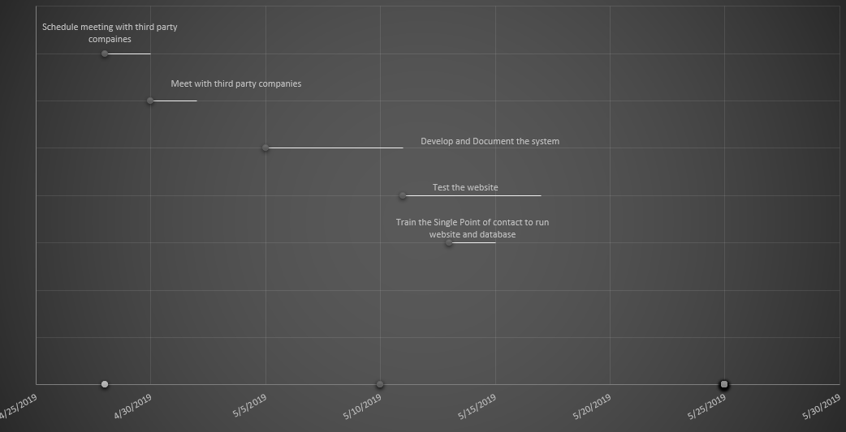

2**.3. Network Diagram**

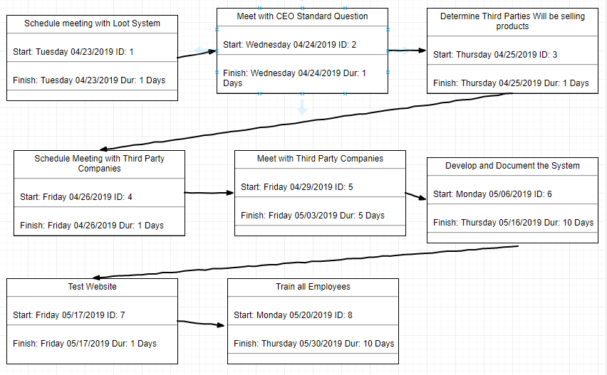

**3.Detailed Analysis**

**3.1. Context Level Diagram**

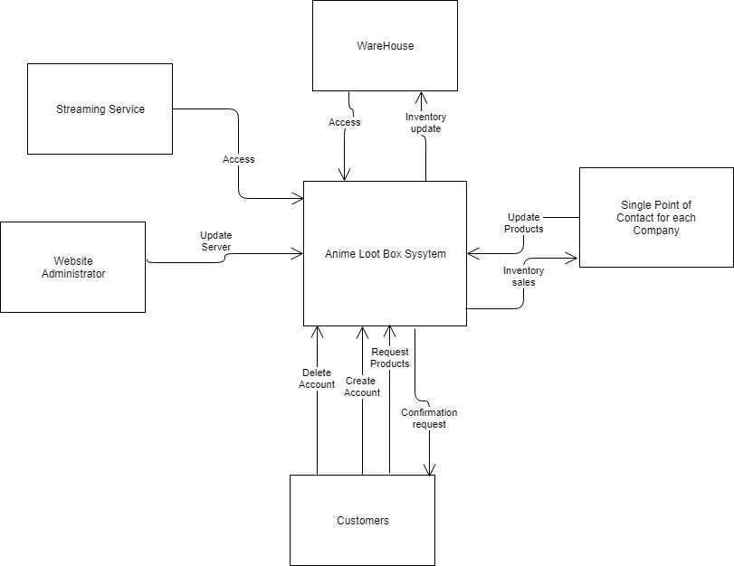

**3.2. Data Dictionary**

|  |  |  |  |
| --- | --- | --- | --- |
| Name | Field | Description | Type |
| Customer Number | CustomerNum | The identifying number for customer | Int |
| User Name | User | Customer custom user name | Varchar |
| Last Name | LastName | Customer’s Last Name | Varchar |
| First Name | FirstName | Customer’s First Name | Varchar |
| Billing Address | BillingAddress | Customer’s Full Billing Address | Varchar |
| Mailing Address | MailingAddress | Mailing address | Varchar |
| City | City | Customer’s City | Varchar |
| State | State | Customer’s State | Varchar |
| Zip Code | Zip | Customer’s Zip Code | Int |
| Phone Number | PNum | Customer’s Telephone number | Int |
| Date of Birth | DOB | Customer Date of Birth | Int |
| Gender | Gender | Customer Gender | Char (6) |
| Check | Check | Way of payment | Int |
| Debit Card | DCard | Way of payment | Int |
| Product Name | ProductName | Product Name | Varchar |
| Product Code | ProductNum | A way to order products | Int |
| Quantity of Product | QuantityInStock | Way to keep track of how much stock we have of a product | Int |
| Third Party Companies Number | CompanyNum | A unique number for each third-party company | Int |
| Warehouse | WarehouseNum | A unique number for a warehouse | Int |
| Steaming Video | VideoNum | A unique number for a steaming video | Int |
| Password | Password | Unique Password Created by the customer | Varchar (16) |
| IT service/Customer service employee number | EmployeeNum | Unique number for each employee | Int |
| Customer Email | Email | Customer’s Email | Varchar |
| Warehouse Address | WAddress | Warehouse address | Varchar |
| Warehouse Phone Number | WPhone | Warehouse Phone Number | Int |
| Warehouse state | WState | What state the warehouse is in | Char (2) |
| Warehouse zip | WZip | Warehouse zip code | int |
| Warehouse employees | WEmployeeNum | Warehouse employee’s unique id | Int |
| Company Name | ComName | Comapany name | Varchar |
| Company contact’s  First Name | SComFirstName | This is the single point of contact first name | Varchar |
| Company contact’s Last Name | SComLastName | This is the single point of contact last name | Varchar |
| Company phone number | SPhone | Single point of contact phone | Int |
| Company Email | SEmail | Single point of contact email | varchar |
| Company Address | ComAddress | Comapany’s Address | Varchar |
| Company’s State | ComState | Company’s State | Int (2) |
| Company’s City | ComCity | Company’s City | Varchar |
| Company’s Zip | ComZip | Campany’s Zip Code | Int (5) |
| Shipping Date | ShipDate | The day the product shipped | Time |
| Shipping type | ShipType | This is the type of shipping the customer chooses | Varchar |
| Membership | Membership | This is the type of membership the User/Customer chooses | Varchar |

**3.3. Data Flow Diagrams**

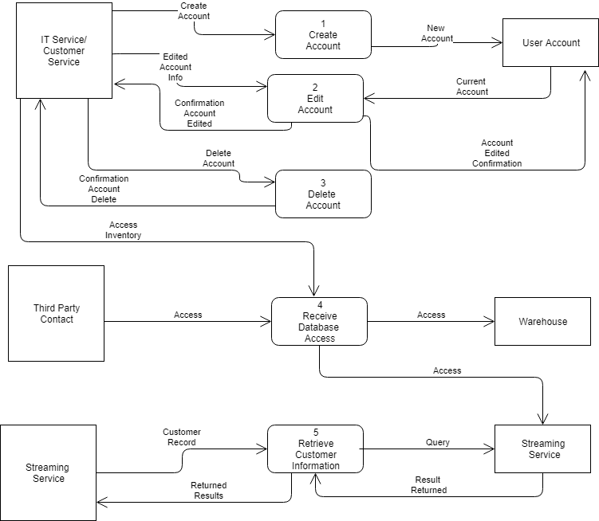

**3.3.1. Process Specifications**

**3.3.1.1. Create Account Process Specifications**

Number: 1

Name: Create Account

Description: To create a new user with access to the website and Streaming Service

Input:

New Account Info (Username, First Name, Last Name, Mailing Address, Billing Address, Phone Number, Payment Information, City, State, Zip Code, Password)

Output:

Confirmation Message

Type of Process:

[ ] Online [ ] Batch [X] Manual

Process Logic:

GET User Name

GET Password

GET First Name

GET Last Name

GET Mailing Address

GET Billing Address

GET Phone

GET Payment Information

GET City

GET State

GET Zip Code

Open User Account Database

Create New Account (Username, First Name, Last Name, Mailing Address, Billing Address, Phone Number, Payment Information, City, State, Zip Code, Password)

Close User Account Database

**3.3.1.2. Edit Account Process Specifications**

Number: 2

Name: Edit Account

Description: To edit a current users account to best suit their needs

Input:

Account Info (Username, First Name, Last Name, Mailing Address, Billing Address, Phone Number, Payment Information, City, State, Zip Code, Password)

Output:

Confirmation Message

Type of Process:

[ ] Online [ ] Batch [X] Manual

Process Logic:

GET User Name

GET Password

GET First Name

GET Last Name

GET Mailing Address

GET Billing Address

GET Phone

GET Payment Information

GET City

GET State

GET Zip Code

Open User Account

Where UserName = UserName

Password = New Password

MailingAddress = New MailingAddress

BillingAddress = New BillingAddress

Phone = New Phone

Payment Information = New Payment Information

Close User Account Database

**3.3.1.3. Delete Account Process Specification**

Number:3

Name: Delete Account

Description: To delete the existing user account

Input:

Account to be Deleted (UserName)

Output:

Confirmation Message

Type of Process:

[ ]Online [ ]Batch [X] Manual

Process Logic:

Get UserName

Open User Account Database

Delete record Where UserName = UserName

Close User Account Database

**3.3.1.4. Receive Database Access Process Specification**

Number:4

Name Receive Database Access

Description: Allows Third Party companies and IT Service/ Customer Service access to the Warehouse and Streaming Service Database

Input:

Access Information (EmployeeNum or CompanyNum)

Output:

Database Access

Type of Process:

[X] Online [ ] Batch [ ] Manual

Process Logic:

Get Access

Open Database

**3.3.1.5. Retrieve Customer Account Process Specification**

Number: 5

Name: Retrieve Customer Information

Description: To retrieve the customer account information

Input:

CustomerNum

Output:

All the customer’s information including all their Order History

Type of Process:

[X] Online [ ]Batch [ ]Manual

Process Logic:

Get UserName

Get CustomerNum

Open User Account

Read Record WHERE UsernName = UserName AND CustomerNum = CustomerNum

Display Record

**3.3.2. Use Case Diagrams**

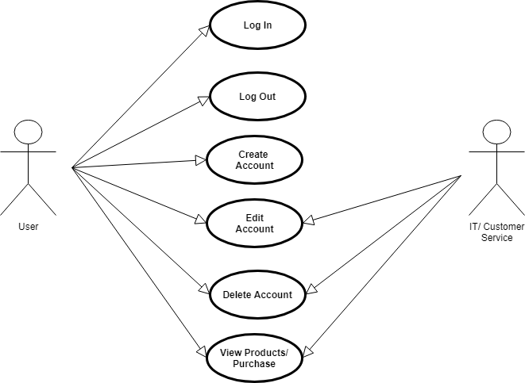

**3.3.2.1. Use Case Narratives**

**3.3.2.1.1. Create User Account**

Use Case Name: Create User Account

Actor: User/Customer

Description: Allows the user to create a new user in the system

Trigger Event: Click create account

Trigger Type: External

|  |  |
| --- | --- |
| Steps Performed | Information Needed |
| 1. User clicks on Create Account Button |  |
| 1. User enters new account information | UserName, Password, First Name, Last Name, Phone, Mailing Address, Billing Address, Payment Information, City, State, Zip, DOB, Gender, Email,MemberShip |
| 1. System create the new user in the User Account Database |  |

Pre-Conditions: There is no other user logged into the system and there is duplication in the User Account Database.

Post-Condition: The User/Customer is logged into the system.

Assumptions: That the User/Customer does not already have an account.

Requirements Met: User/Customer can access the system with their UserName and Password.

**3.3.2.1.2. Delete Account**

Use Case Name: Delete User Account

Actor: User/Customer, IT Service/Customer Service

Description: Allow the user or Customer Service to delete the account

Trigger Event: The User/Customer request their account to be deleted

Trigger Type: External

|  |  |
| --- | --- |
| Steps Performed | Information Needed |
| 1.User/Customer needs to request the account to be deleted | Username, Password |
| 2. User/Customer needs to press Enter on the Delete Account button |  |

Pre-Conditions: The User/Customer account already exist in the User Account Database

Post-Condition: The User/Customer no longer exists in the User Account Database

Assumptions: Has a working computer or telephone

Requirements Met: Allows the user to delete the account

**3.3.2.1.3. Log In**

Use Case Name: Log In

Actor: User/Customer, IT Service/Customer Service

Description: Allows the user to Log in to their account

Trigger Event: User/Customers attempts to access the system

Trigger Type: External

|  |  |
| --- | --- |
| Steps Performed | Information Needed |
| 1.User/Customer Enters website |  |
| 2. User Enters in UserName and Password | UserName, Password |
| 3.User Hits Enter | UserName, Password |
| 4.System checks for username and password in the user account database | UserName, Password |
| 5.User/customer either granted access or denied |  |

Pre-Conditions: There is no other user logged into the system.

Post-Condition: The User/Customer is logged into the system.

Assumptions: That the User/Customer already have an account created with the database.

Requirements Met: User/Customer can access the system with their UserName and Password.

**3.3.2.1.4. Log Out**

Use Case Name: Log Out

Actor: User/Customer

Description: The User/Customer Logs out of the system

Trigger Event: User Choice to log out

Trigger Type: External

|  |  |
| --- | --- |
| Steps Performed | Information Needed |
| 1. User Clicks on the Log Out button |  |
| 2.Session is terminated |  |

Pre-Conditions: User is logged in to their account

Post-Condition: The user is no logged signed in to the system

Assumptions: None

Requirements: Signs the user out

**3.3.2.1.5. View/ Purchase Products**

Use Case Name: View Products and Purchase

Actor: User/Customer

Description: User can view the products and has the option to purchase them.

Trigger Event: When the customer enters the store and clicks on a product

Trigger Type: External

|  |  |
| --- | --- |
| Steps Performed | Information Needed |
| 1.User Clicks on Store |  |
| 2.User Clicks on Product |  |
| 3. User Clicks purchase on a product | UserName, Billing Address, Mailing Address, Payment Information, Shipping |
| 4. User Confirms Purchase |  |

Pre-Condition: The User/Customer has an account and all the information that is needed to process the purchase.

Post-Condition: The gets a shipping date and the shipping details

Assumption: The User/Customer already has an account and all the information is correct and current

Requirements Met: Allows the user to purchase products

**3.3.2.1.6. Edit Account**

Use Case Name: Edit User/Customer Account

Actor: User/Customer

Description: Allows the user to edit their profile

Trigger Event: When user clicks on edit profile button

Trigger Type: External

|  |  |
| --- | --- |
| Steps Performed | Information Needed |
| 1. User clicks on Edit profile button |  |
| 1. User enters new account information | UserName, Password |
| 1. System edits whatever the User/Customer changes |  |
| 1. Saves new account information |  |
| 1. Sends conformation that the changes was made |  |

Pre-Conditions: The User/Customer already has an account and they know the correct information

Post-Condition: The User/Customer account is updated and saved.

Assumptions: That the User/Customer already has an account.

Requirements Met: User/Customer now has all the correct information on their account.

**3.3.3. Sequence Diagrams**

**3.3.3.1 Acceptable Ordering Sequence Diagram**

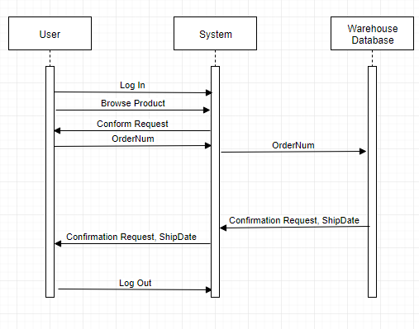

**3.3.3.2. Log in Error Sequence Diagram**

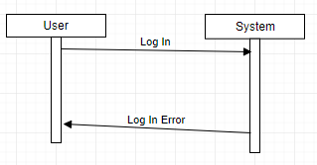

**3.3.3.3. Acceptable Steaming Sequence Diagram**

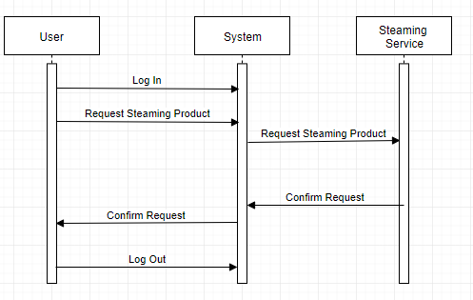

**3.3.4. Formalized ER Diagrams**

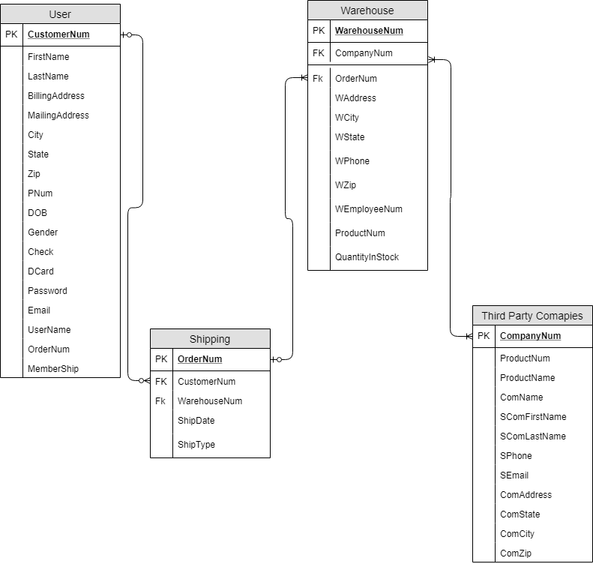

**3.3.5 Functional System Requirements**

**3.3.5. General**

The system will allow only the following functions:

* Only valid users can login to user created accounts.
* Only valid users can create their loot boxes.
* Only valid users can view and edit their own shows.
* Only valid admins can edit existing accounts.
* Only valid admin can edit existing loot box orders.
* Only valid administrators can delete existing accounts.

**3.3.5 Data Stores**

* User information will be stored in an Accounts database.
* Order information will be stored in a Records database.
* Only valid administrators have access to these databases.
* Anime shows will be stored on a server and aren't able to be downloaded by users.

**3.3.6 Non-Functional System Requirements**

* The systems appearance will be user friendly and easy to navigate.
* The user interface to build the loot box will be simple and based on their show preferences
* The system will be able to stream High Definition video if there is a fast connection speed.
* The system will have security against bots trying to create fake accounts and fake data.

**3.3.7. User Interface Storyboards**

**3.3.7.1. Main Screen Interface Storyboard**

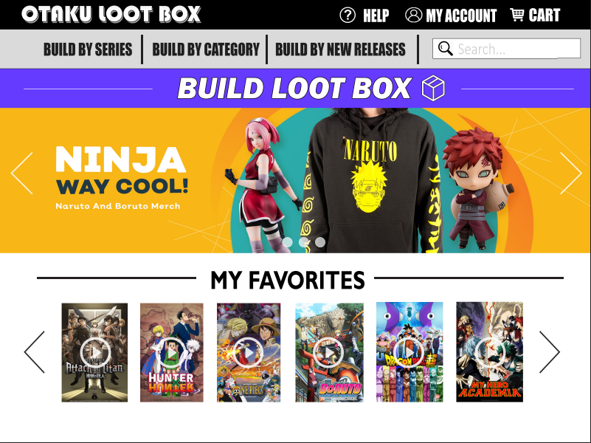

**3.3.7.2. Build A Box Interface System**

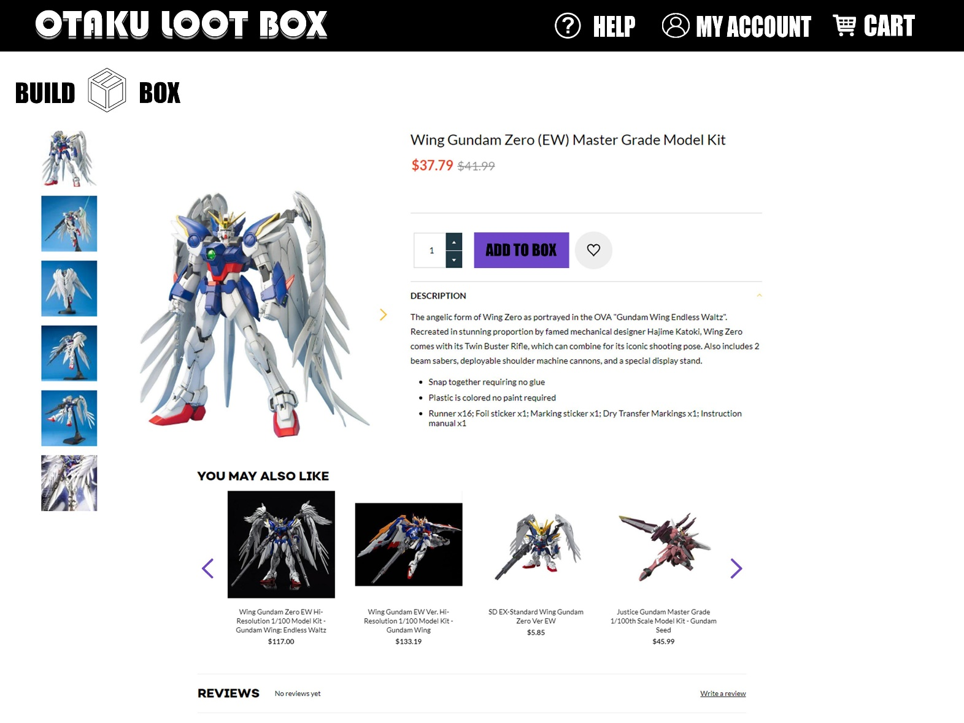

**3.3.7.3. Streaming Service Interface Storyboard**

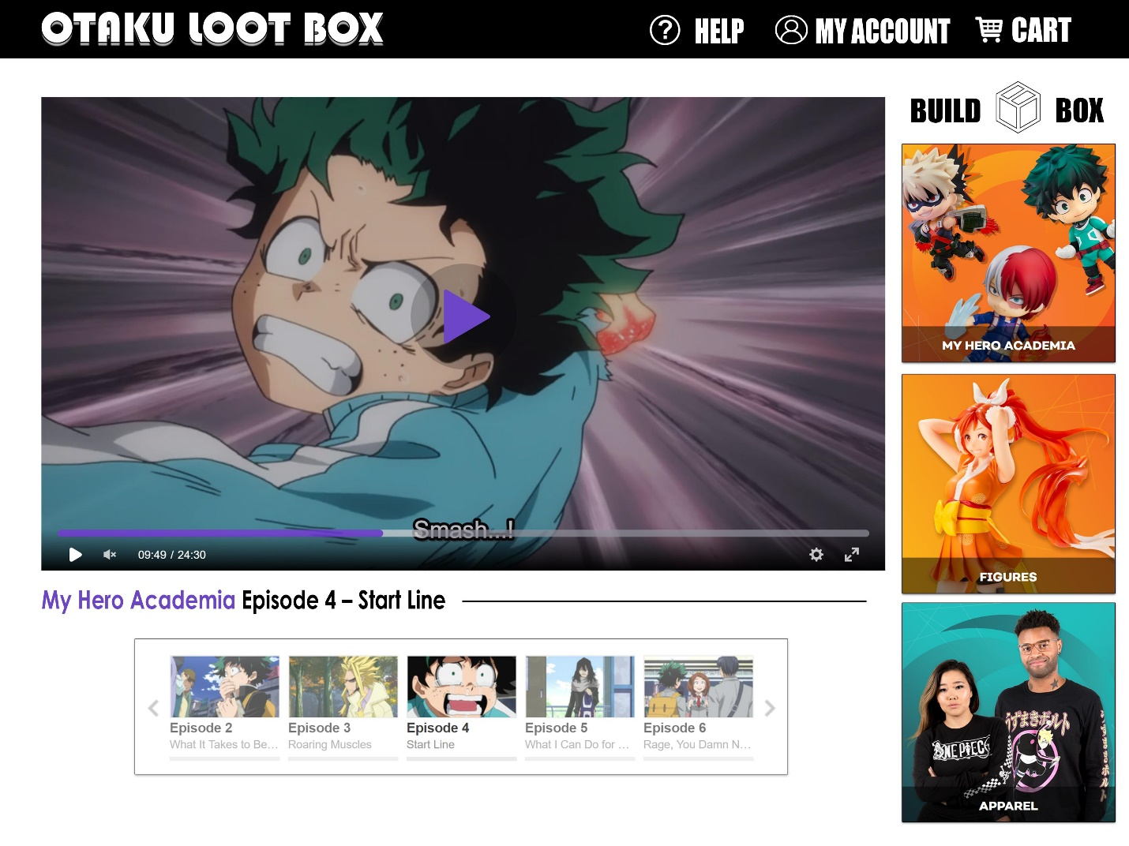

**3.3.8. State Diagram**

