Multilingual Retrieval Fairness
Measuring and mitigating the English / Hindi / Malayalam gap in a public-services RAG assistant
Technical report | Author: [Your Name] | Course: Big Data Systems & Responsible AI Engineering | Topic 39

1. Problem and approach
A public-services assistant must serve citizens in English, Hindi and Malayalam equally well. This project measures how much retrieval and answer quality drop for Hindi and Malayalam, and compares three mitigations (hybrid search, translation, fine-tuning) by gain and compute cost. The responsible-AI component is fairness across languages. The big-data component is the compute and storage cost of running these pipelines at scale (Section 6).
Dataset substitution. The suggested sets (FLORES-200, MIRACL, IndicQA, Samanantar) do not provide parallel documents, queries and relevance labels together, and MIRACL does not include Malayalam as far as we know. We used Belebele (facebook/belebele), which is built on FLORES-200 passages: 488 passages and 900 questions per language, fully parallel. Each question links to its source passage, which gives relevance labels. Because every language has identical content, any measured gap comes from the language or the model, not from the data.

2. Pipeline
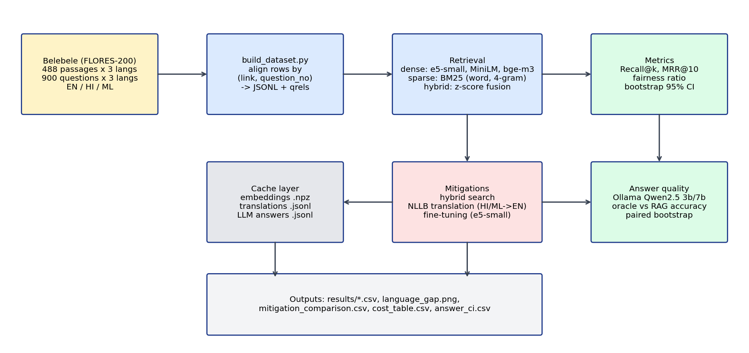
Figure 1. Pipeline architecture. Every expensive step writes to a cache so reruns are resumable.
Embedding models: multilingual-e5-small, paraphrase-multilingual-MiniLM-L12-v2 and BAAI/bge-m3, run on CPU. Retrieval is exact cosine search over 488 passages, so no approximate index was needed. Metrics are Recall@1/5/10 and MRR@10, with bootstrap 95% intervals (2,000 resamples for retrieval, 5,000 for answer quality). The fairness ratio is worst-language Recall@1 divided by best-language Recall@1. Answer quality uses the Belebele multiple-choice questions with Qwen2.5 (3b and 7b) through Ollama, in two conditions: oracle (gold passage supplied) and RAG (passage retrieved by bge-m3). Comparing the two separates the retrieval gap from the generator gap.

Two bugs found and fixed
- Row misalignment. Raw Belebele rows are not in the same order across languages, which broke our first alignment check. We now join on (link, question_number).
- Tokenizer. Our first BM25 used a regex word split that shatters Hindi and Malayalam words at combining marks. Results from that run were discarded; all reported hybrid numbers use whitespace tokenization or character 4-grams.

3. Language gap in retrieval
Model | EN R@1 | HI R@1 | ML R@1 | EN MRR@10 | ML MRR@10 | Fairness ratio
bge-m3 | 0.913 | 0.823 | 0.846 | 0.944 | 0.888 | 0.901
e5-small | 0.908 | 0.789 | 0.769 | 0.937 | 0.829 | 0.847
MiniLM | 0.770 | 0.536 | 0.026 | 0.830 | 0.039 | 0.033
Table 1. Baseline dense retrieval, all 900 queries per language.
Every model is worst on a non-English language. The gap is smallest for bge-m3 and catastrophic for MiniLM on Malayalam (Recall@1 of 2.6%), which lacks Malayalam coverage in its training. Bootstrap intervals for bge-m3 Recall@1 are EN 0.894 to 0.931, HI 0.798 to 0.848 and ML 0.821 to 0.868: English does not overlap either language, but Hindi and Malayalam overlap each other, so we make no claim about which is worse. Encoding is also costlier for Indic text: bge-m3 took 168 s for English, 214 s for Hindi and 235 s for Malayalam on CPU.

4. Answer-quality gap
LLM | Lang | Native RAG acc. | Translated RAG acc. | Translate minus native (paired) | Native oracle
Qwen 3b | EN | 0.82 (0.74-0.89) | n/a | n/a | 0.88
Qwen 3b | HI | 0.59 (0.49-0.69) | 0.60 (0.50-0.69) | +0.01 (-0.11 to 0.13) | 0.65
Qwen 3b | ML | 0.40 (0.31-0.49) | 0.56 (0.46-0.65) | +0.16 (0.02 to 0.29) | 0.43
Qwen 7b | EN | 0.86 (0.79-0.92) | n/a | n/a | 0.91
Qwen 7b | HI | 0.59 (0.50-0.68) | 0.67 (0.57-0.76) | +0.08 (-0.03 to 0.19) | 0.68
Qwen 7b | ML | 0.45 (0.35-0.55) | 0.59 (0.49-0.68) | +0.14 (0.02 to 0.26) | 0.51
Table 2. Answer accuracy, n = 100 questions per language (same sample for all rows). Random guessing is 0.25.
Main finding: retrieval is not the main bottleneck. With bge-m3, the right passage is retrieved for 83% of Malayalam questions (sample), almost as often as Hindi, yet the 3b model answers only 43% correctly even when given the correct passage. The answer-level gap to English (about 40 points) is far larger than the retrieval gap (about 9 points) and comes mostly from the generator. Moving from 3b to 7b did not measurably help native Hindi or Malayalam (overlapping intervals).

5. Mitigations
Model | Lang | Baseline dense | Hybrid w0.7 | Translate + dense | Translate + hybrid | Gap to EN dense, best
e5-small | HI | 0.789 | 0.829 | 0.797 | 0.838 | 0.070
e5-small | ML | 0.769 | 0.880 | 0.828 | 0.843 | 0.028
bge-m3 | HI | 0.823 | 0.849 | 0.847 | 0.862 | 0.051
bge-m3 | ML | 0.846 | 0.906 | 0.851 | 0.872 | 0.008
Table 3. Recall@1 by mitigation (hybrid uses 4-gram BM25). English dense: e5-small 0.908, bge-m3 0.913.
- Hybrid search (BM25 on character 4-grams fused with dense scores) is the best retrieval fix for Malayalam, cutting the e5-small gap from 0.139 to 0.028 for seconds of CPU. A likely reason is that Malayalam is agglutinative, so exact word matching fails while character n-grams share stems; we did not test this directly. Hindi barely benefits: the best Hindi result still leaves a 5 to 7 point gap. The fusion weight was compared on the same queries we report, so these gains are slightly optimistic, and the best weight (0.7) was at the edge of the grid we tried.
- Translation (NLLB-200 distilled 600M, Hindi and Malayalam to English) gives a small retrieval gain (+5.9 points for e5-small Malayalam, within noise for bge-m3) but a larger answer-quality gain for Malayalam: +14 to +16 points, with paired intervals that exclude zero only narrowly. For Hindi the answer gain is not statistically supported. Translated Malayalam (0.59) still trails English (0.86). Translation errors, for example a mistranslated technical term, are a likely cause but were not quantified.
- Fine-tuning e5-small for one epoch on 1,893 question-passage pairs (passage-level split, 342 train / 146 test passages) produced no measurable gain: Recall@1 was unchanged for English and Hindi and 0.019 lower for Malayalam (within noise at about 269 queries). We did not try more epochs, other learning rates or hard negatives, so this is a null result for a light attempt, not evidence that fine-tuning cannot work.

6. Cost, scale and systems considerations
Step | CPU time | Note
e5-small encode (3 languages) | ~55 s | baseline
bge-m3 encode (3 languages) | ~620 s | about 10x e5-small
BM25 / hybrid | seconds | no model required
Translate 900 queries (per language) | ~1,400 s | about 1.5 s per query
Translate corpus, Hindi (488) | 3,277 s | about 6.8 s per passage
Translate corpus, Malayalam (488) | ~3,500 s (est.) | log inflated by a laptop suspend; estimated from pre-stall rate
Fine-tune e5-small, 1 epoch | 663 s | no measurable gain
LLM per question, native ML (3b / 7b) | 10.6 s / 23.9 s | long Malayalam prompts
LLM per question, translated ML (3b / 7b) | 1.6 s / 3.6 s | excludes translation time
Table 4. Compute cost on a single laptop CPU (timings are single measurements).
Cost-benefit summary: hybrid search is by far the cheapest mitigation and the most effective for Malayalam retrieval. Translation removes the Malayalam generator penalty and cuts LLM time per question by roughly 6x, but adds a one-off corpus translation of about an hour per language plus roughly 1.5 s per incoming query, so it pays off only when query volume is high relative to corpus size. The pipeline is batch-oriented and resumable: embeddings, translations and LLM answers are cached on disk (NumPy and JSONL), so reruns do not repeat work.
Scale limitation. This study is small by design (488 passages per language, CPU only). We did not run distributed or streaming experiments. Throughput figures above suggest that translating and encoding a corpus 1,000 times larger would take weeks on one CPU, which would motivate GPU batching, sharded encoding and an approximate-nearest-neighbour index; these are extrapolations, not measurements.

7. Responsible-AI notes and limitations
- Answer-quality results use n = 100 per language, giving intervals of roughly ±10 points; differences under about 10 points should not be over-read.
- Belebele is multiple-choice reading comprehension built from translated text, so it is cleaner than real citizen queries. Real public-services questions, dialects and code-mixed text may widen the gap.
- The generator evaluated is one model family (Qwen2.5). A stronger or Malayalam-specialised LLM is the obvious next test.
- Greedy decoding was used for translation without comparing output quality to beam search. Machine translation may drop or distort legal terms; a human-checked sample is advisable before deployment.
- Fairness here means equal retrieval and answer accuracy across languages. We did not measure other harms such as dialect bias or differences in response tone.

8. Recommendation
Use hybrid search with character n-grams for Malayalam retrieval first, since it is nearly free and closes most of the retrieval gap. Add translation only where the generator is the bottleneck, as it is for Malayalam, and monitor translation quality. Treat Hindi as unresolved: no mitigation here closed its gap. Next steps are a stronger multilingual generator, a larger answer-quality sample, and tuning the fusion weight on a held-out split.
Reproducibility. All code, results tables and the data card are in the project repository; the README lists the run order.

