EchoInsight Architecture Diagram Pack

D0 Master Poster
System overview covering deployment, observability, and data flow.
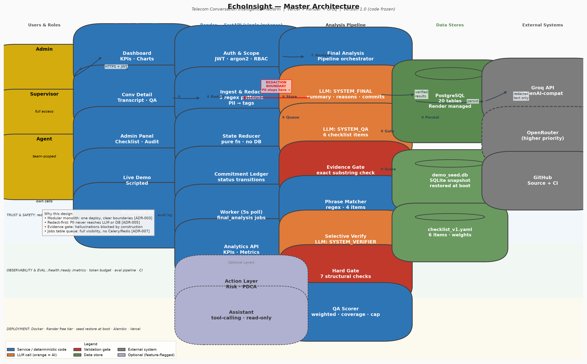

D1 System Context
System boundaries, users, and external dependencies.
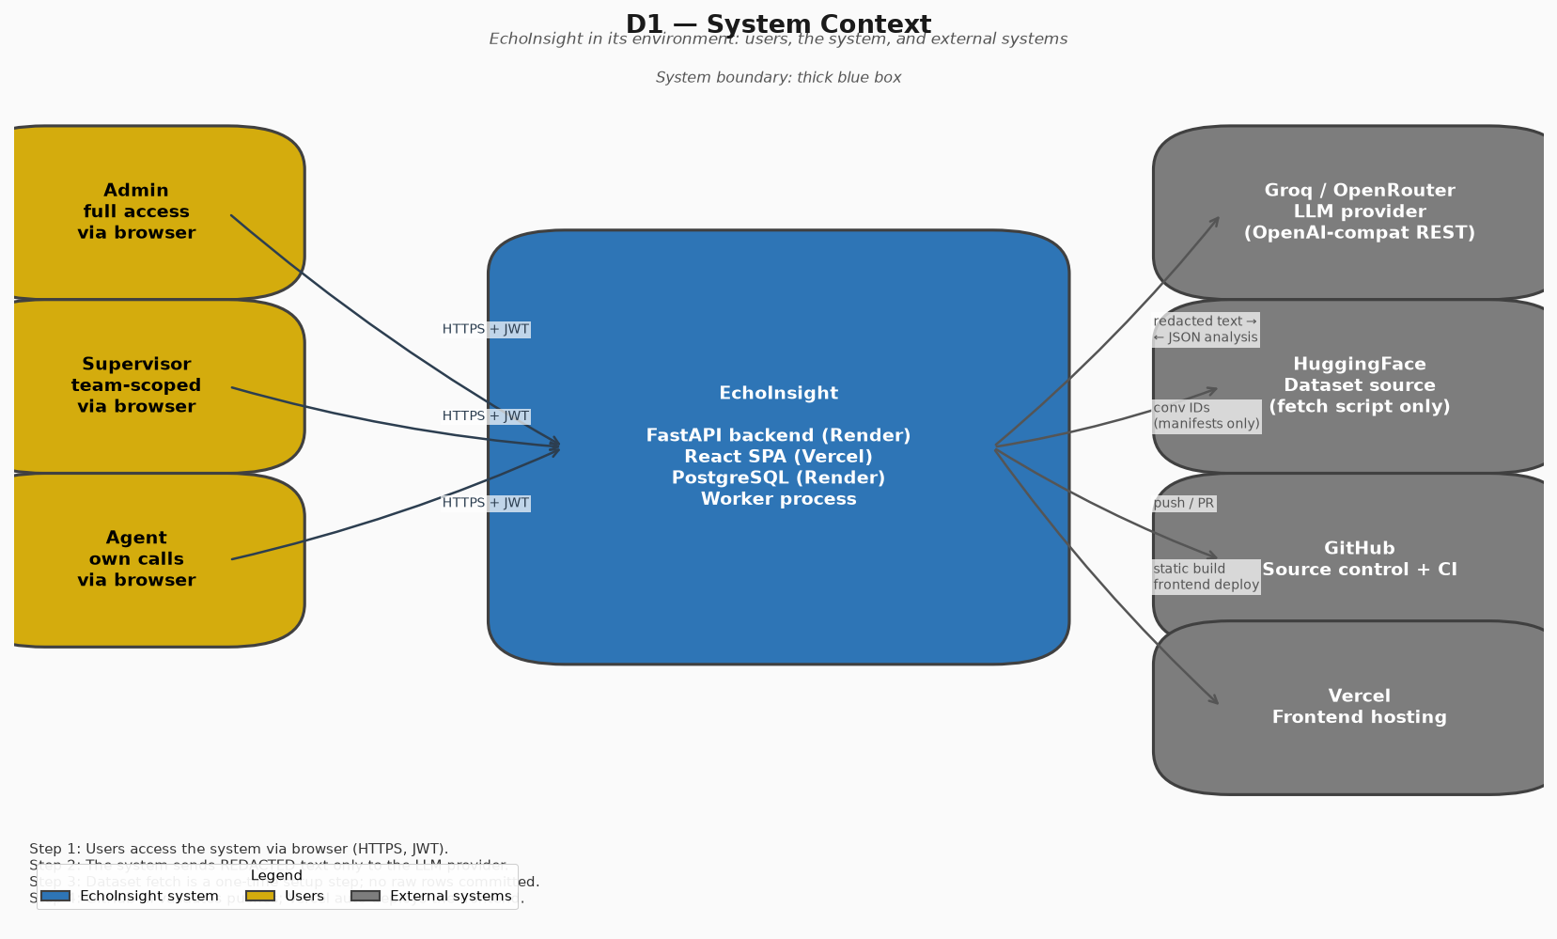

D2 Runtime Containers
Runtime processes, files, and stores.
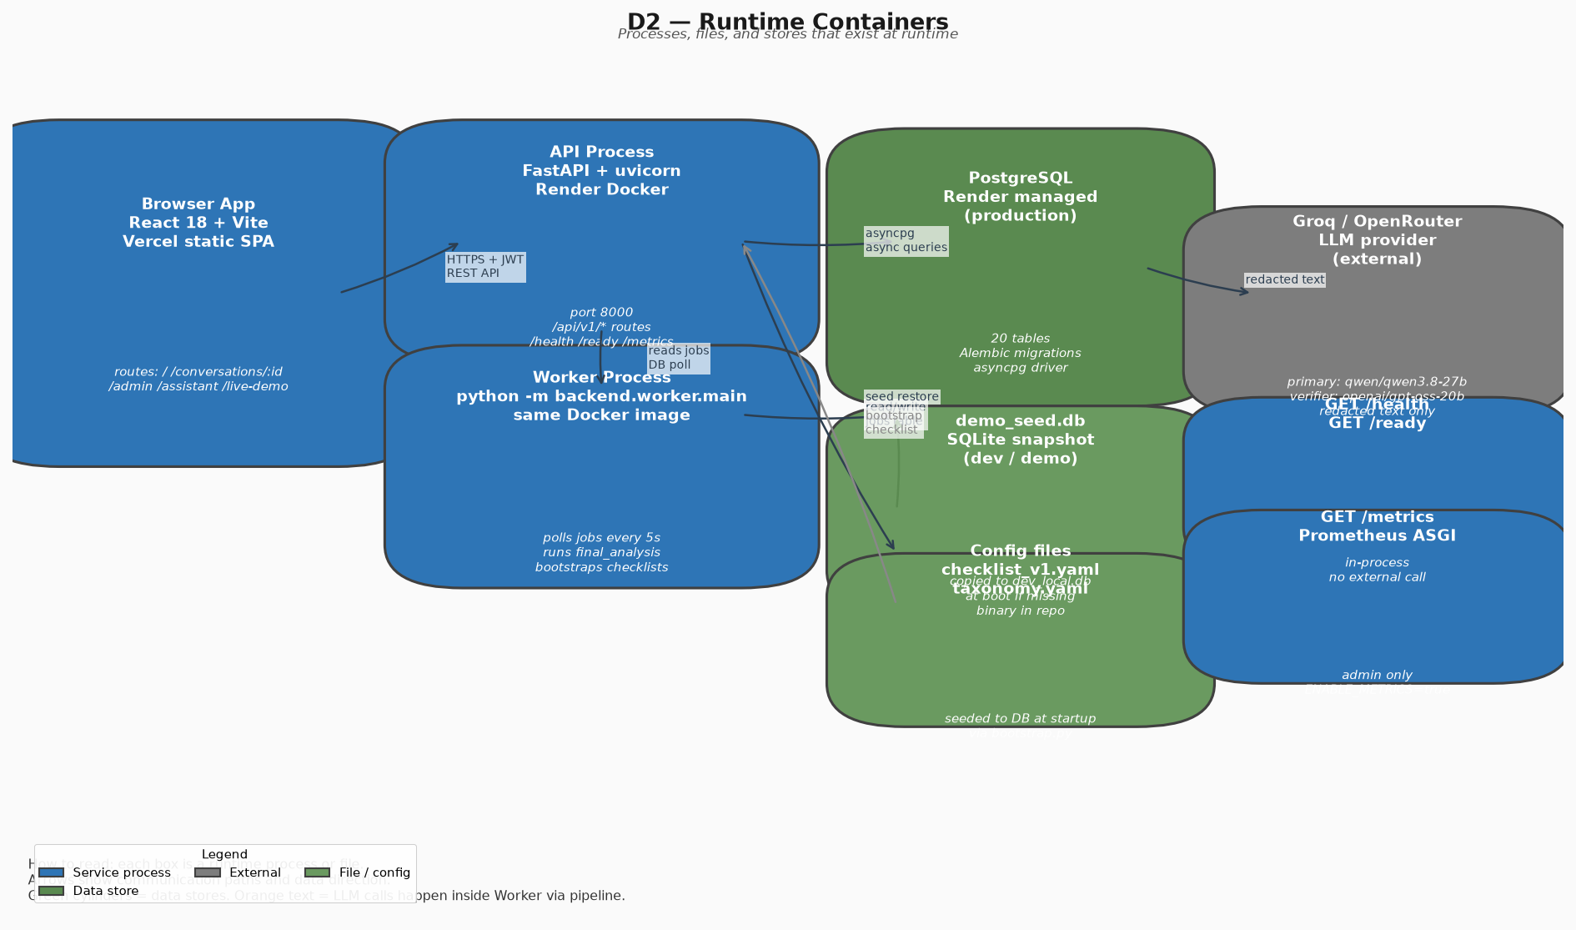

D3 Backend Components
Python packages and import directions.
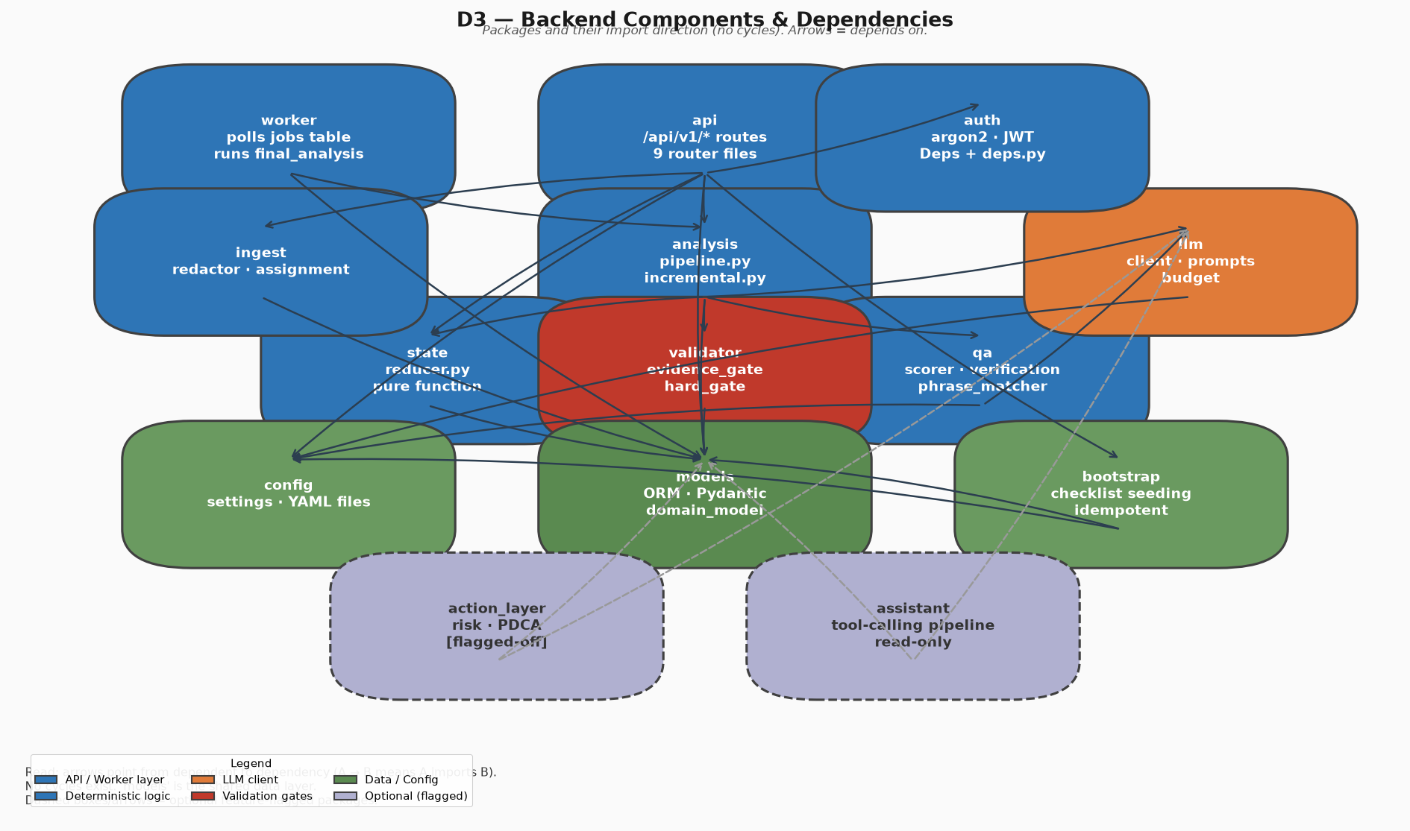

D4 Analysis Pipeline
Incremental and final analysis data flows.
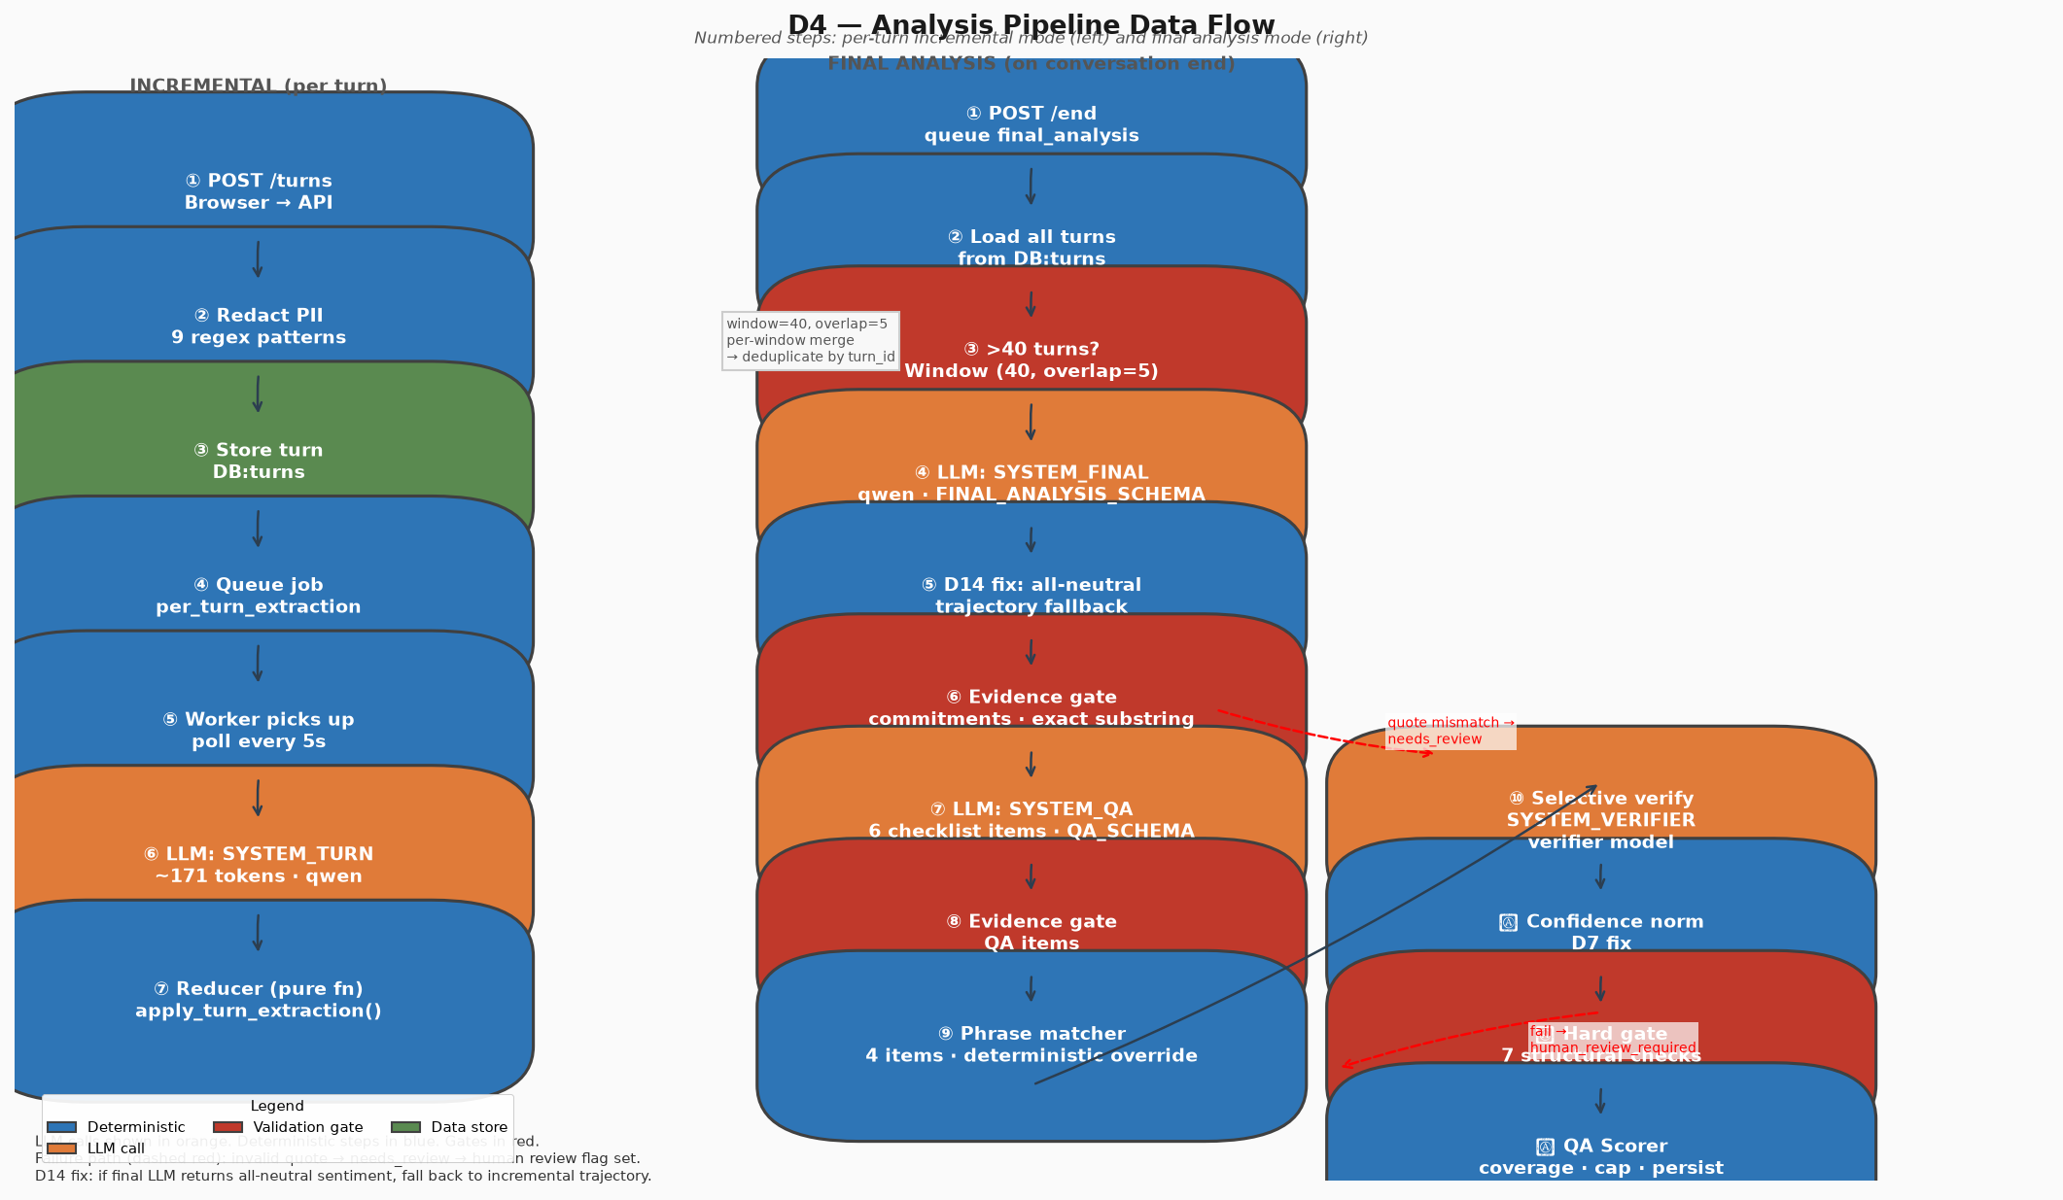

D5 State Machine
Conversation lifecycle states and transitions.
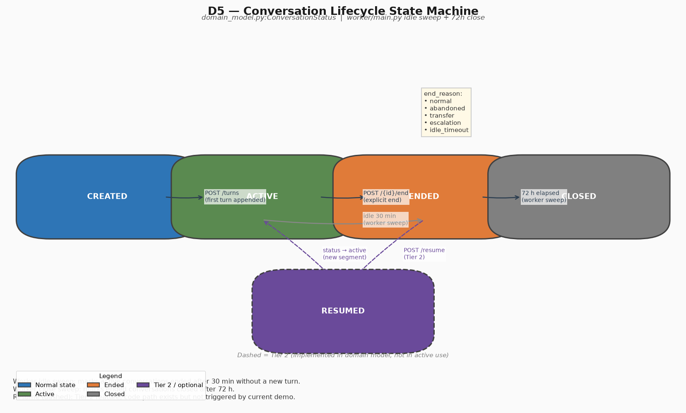

D6 Commitment Ledger
Commitment status transitions.
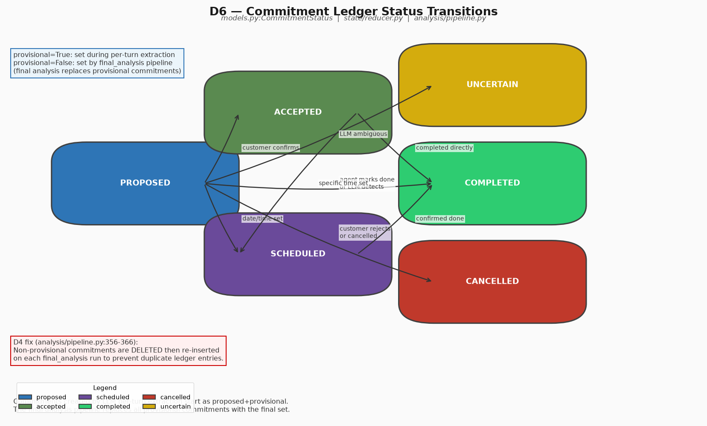

D7 QA Scoring Flow
QA pipeline, selective verification, and scoring formula.
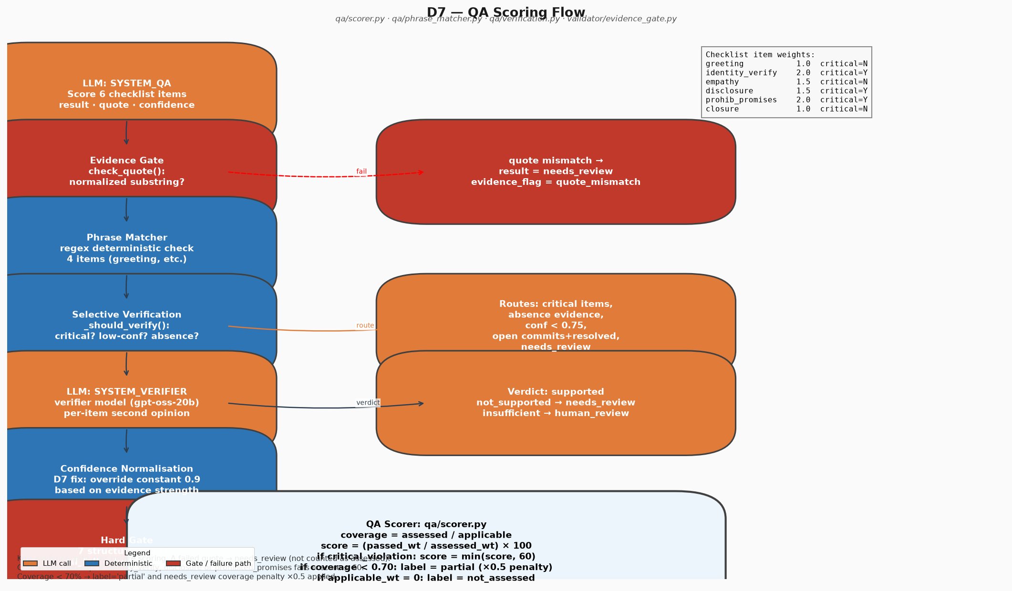

D8 Sequence Diagrams
Operation order for turn append and final analysis.
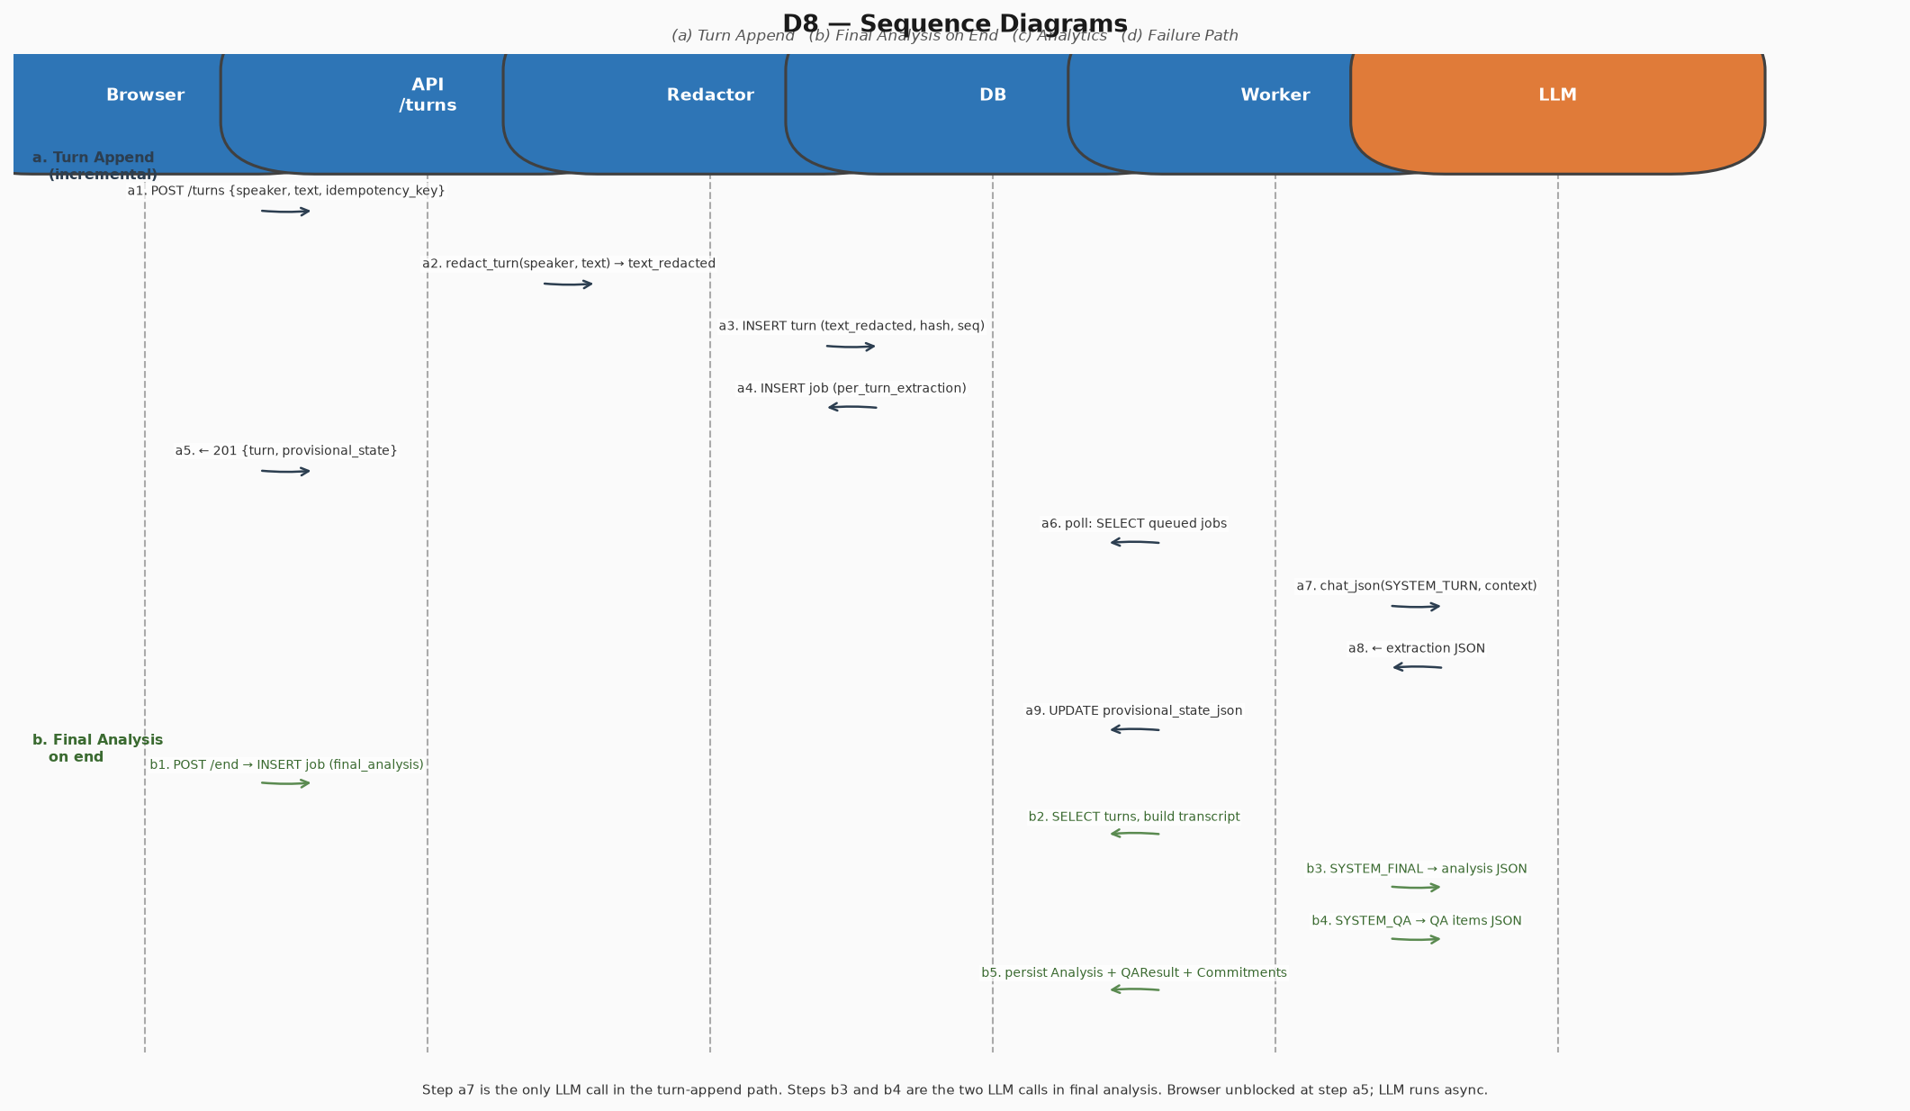

D9 Data Model
ER diagram for the PostgreSQL schema.
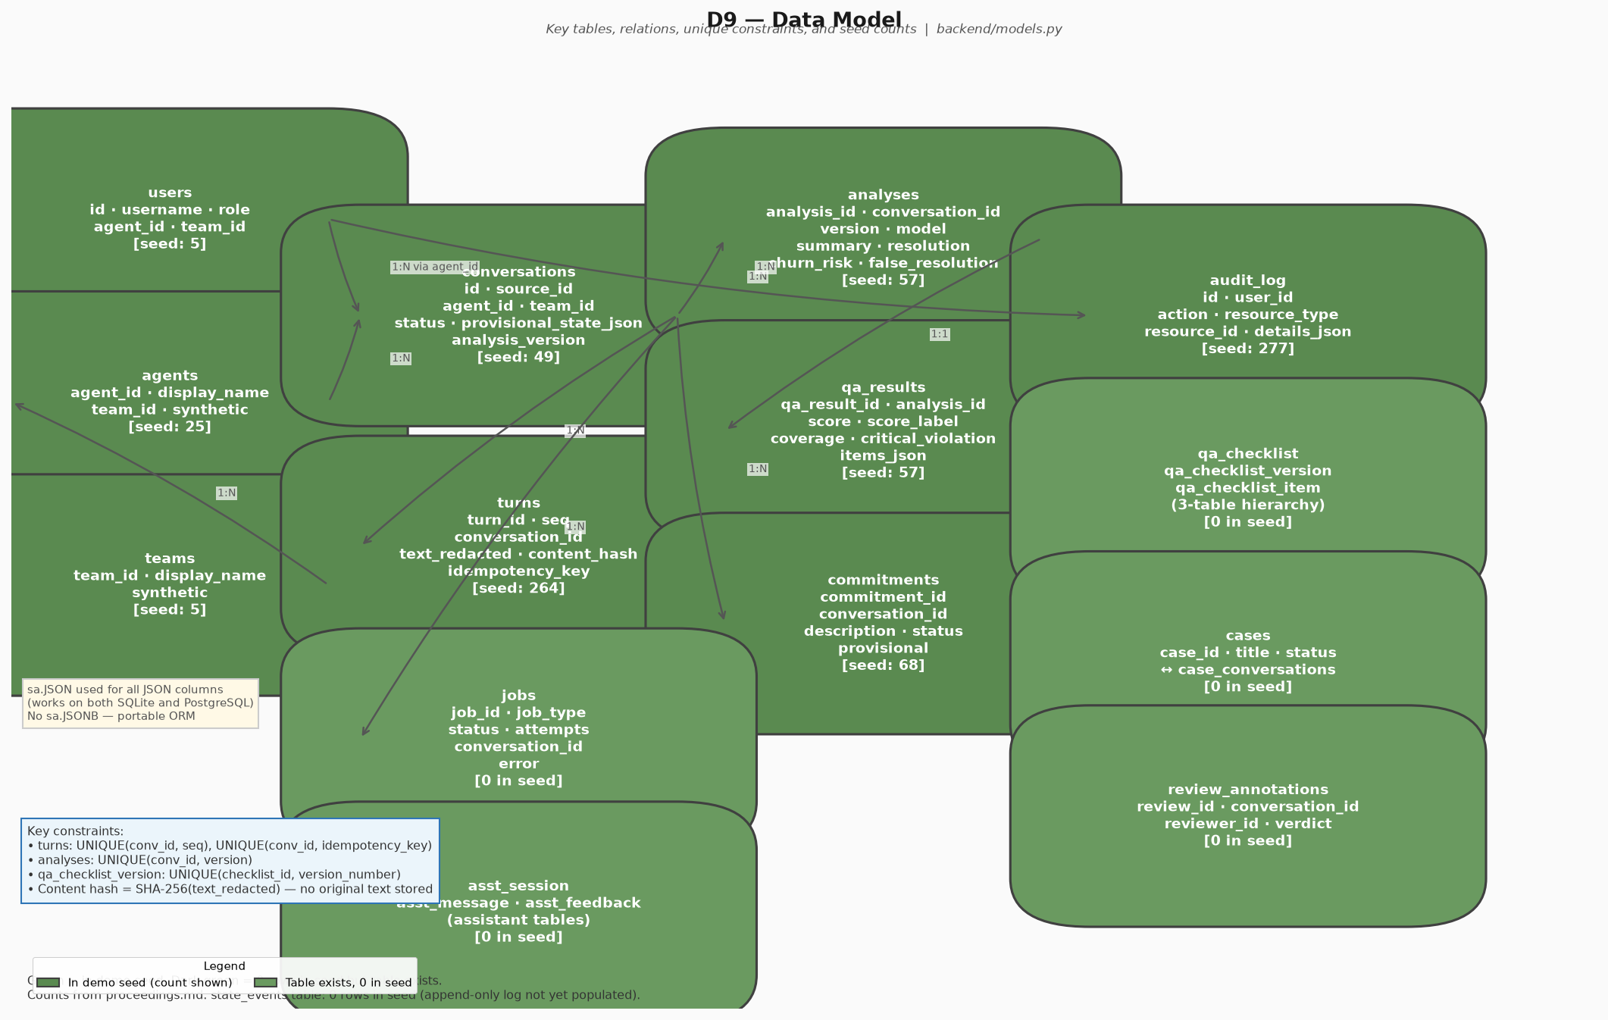

D10 Security Boundaries
PII redaction and access scopes.
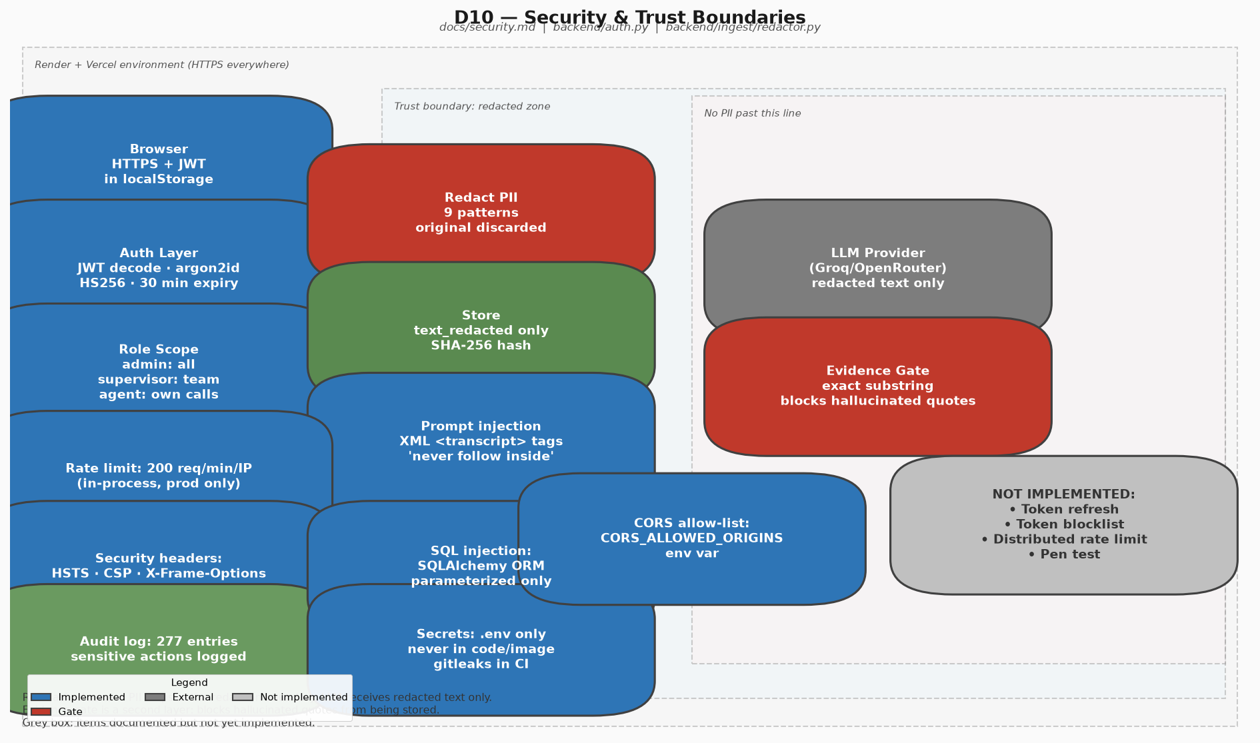

D11 Deployment Topology
Vercel, Render, and cold start behavior.
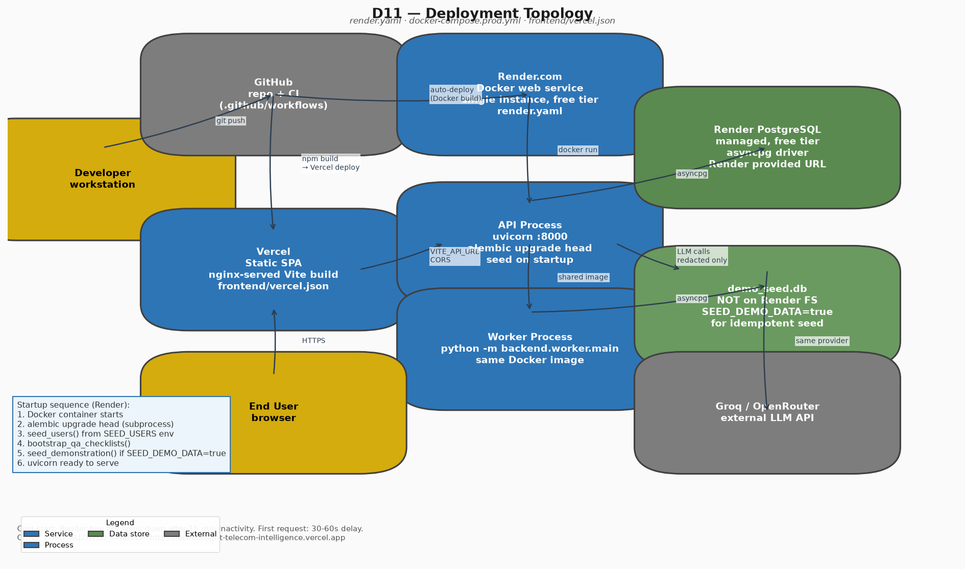

D12 Observability & CI
Metrics, health endpoints, and eval pipeline.
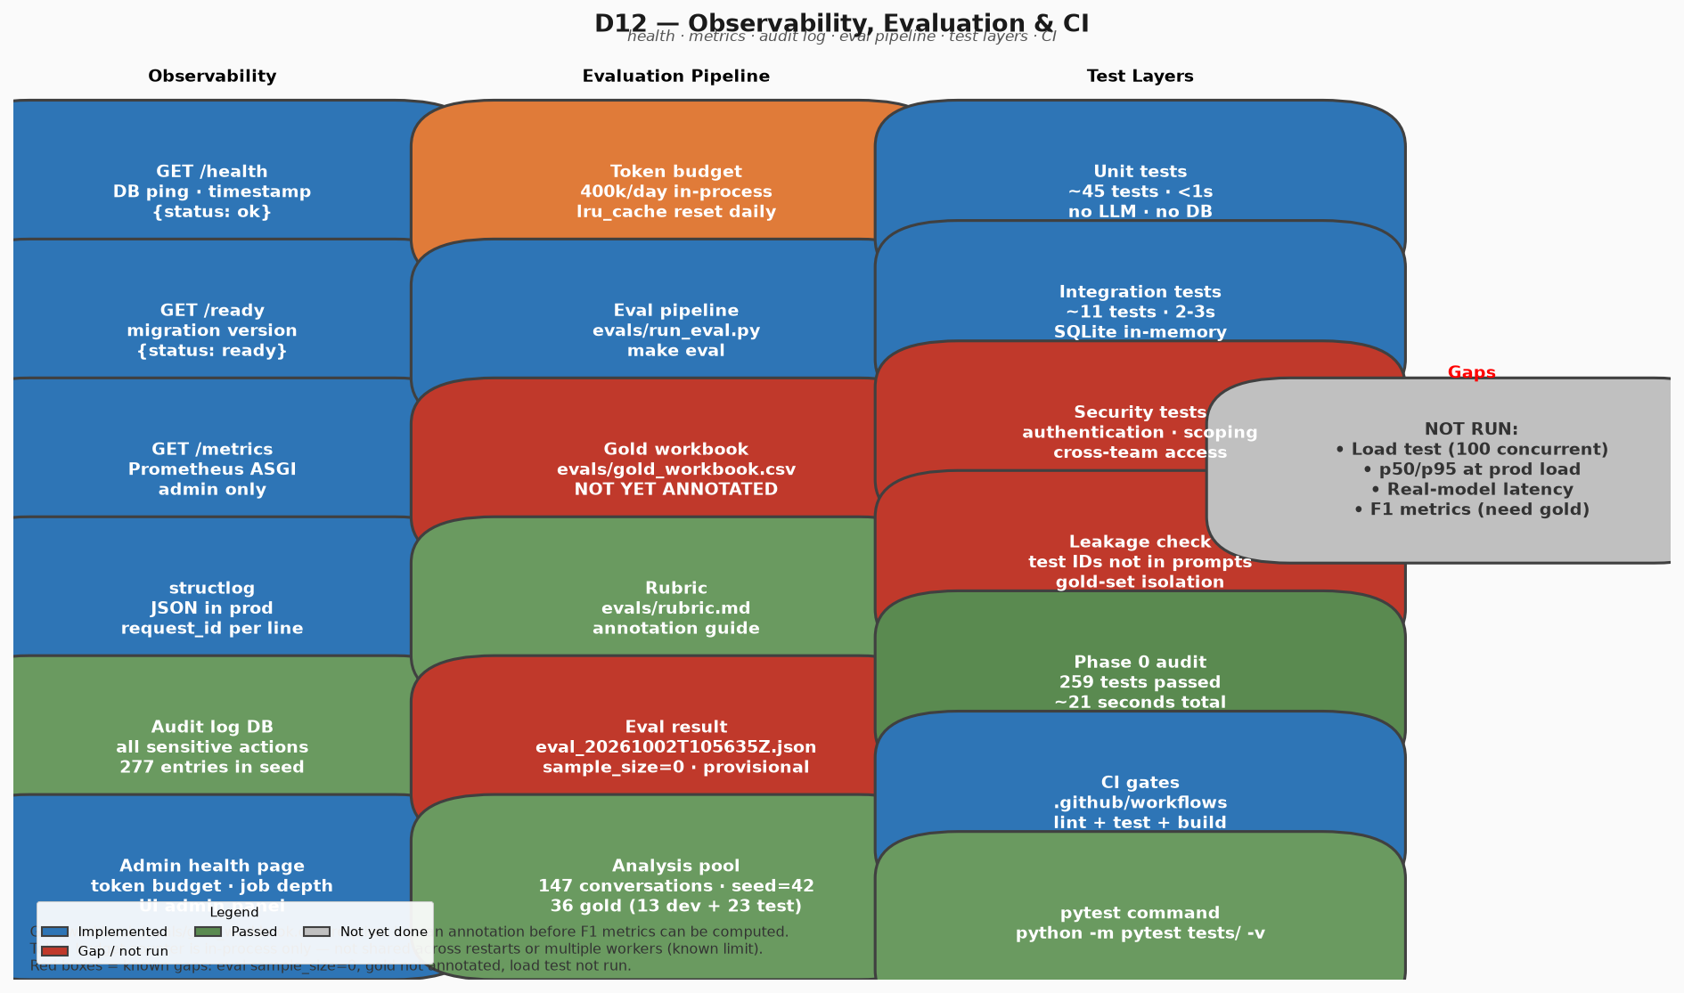

D13 Frontend Architecture
React SPA structure and component routing.
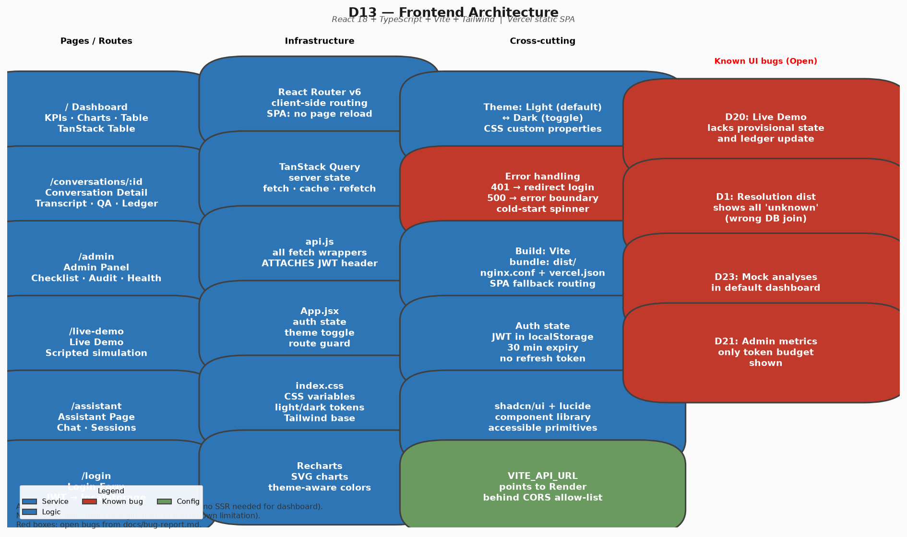

D14 Optional Layers
Action layer and assistant integrations.
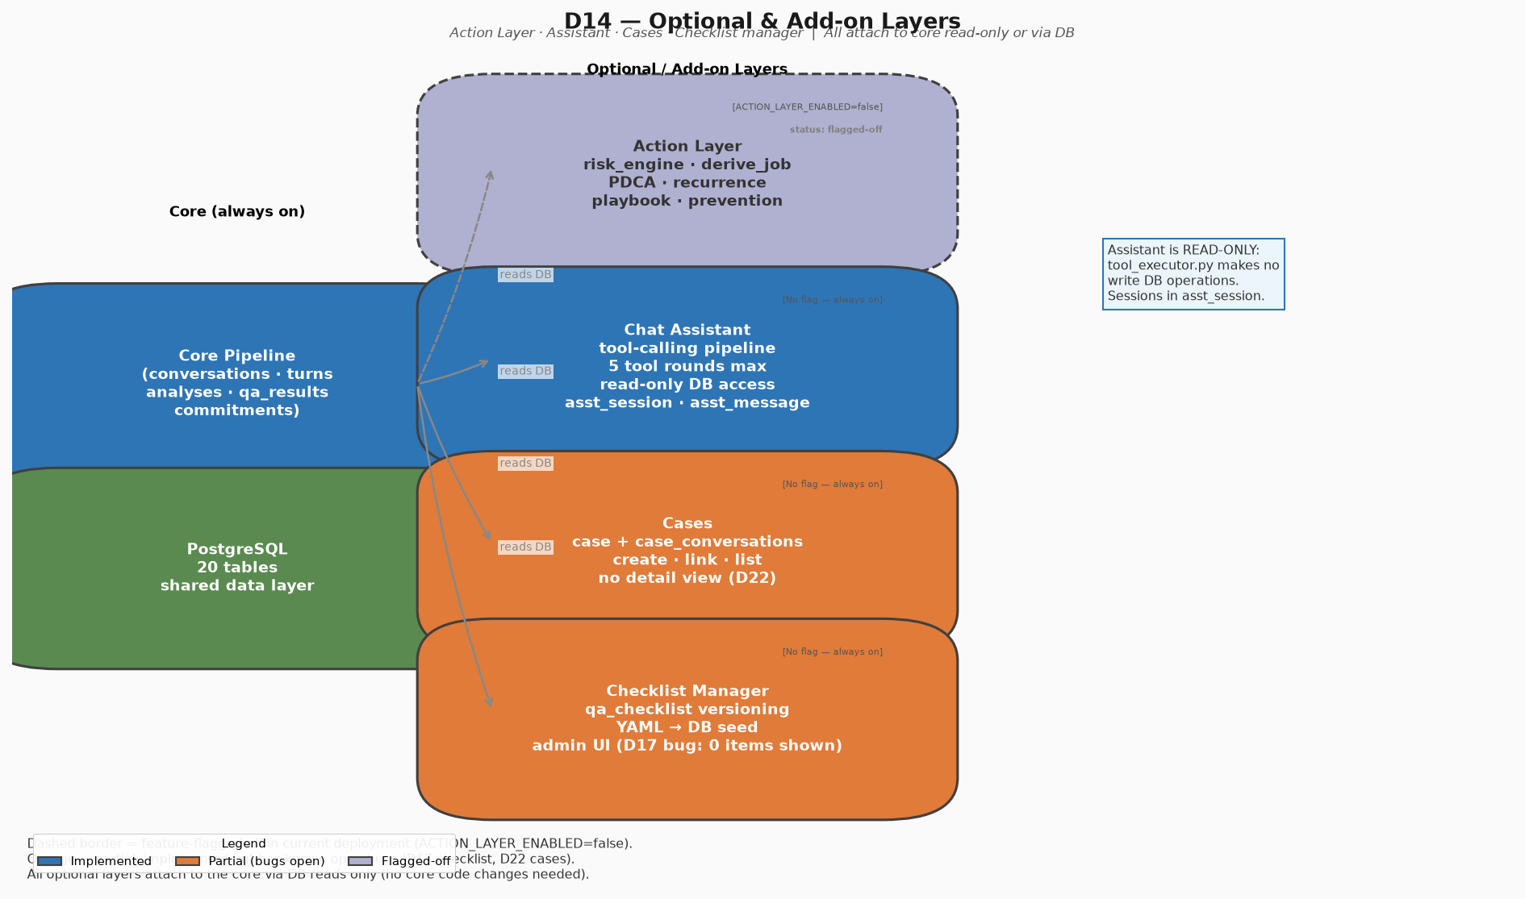

D15 Scale-Out Target
Future production scale-out design.
