EchoInsight Architecture
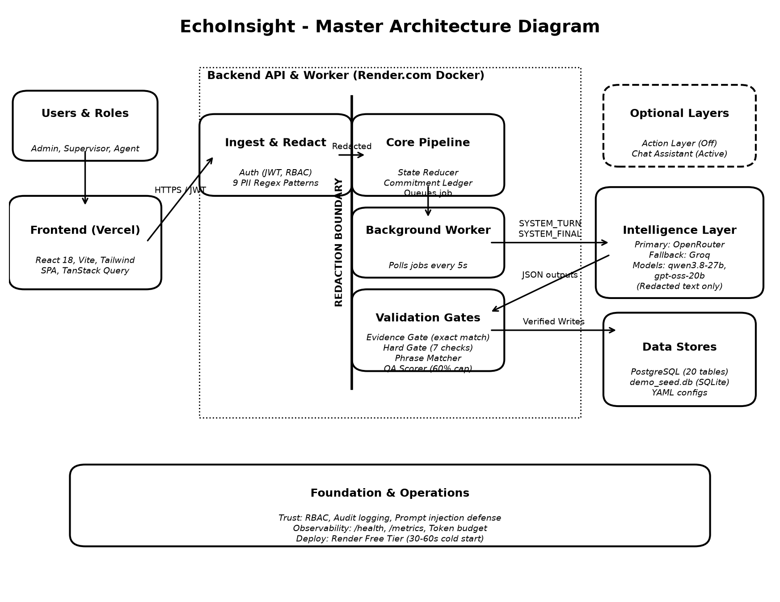

Architecture Summary
1. Frontend (Vercel): React 18 SPA using Vite and Tailwind. Connects to backend via HTTPS with short-lived JWTs. Includes views for Dashboard, Conversation Detail, and Admin Panel.
2. Backend API (Render.com Docker): FastAPI Modular Monolith. Contains the Core Pipeline (Ingest, State Reducer, Commitment Ledger). A strict REDACTION BOUNDARY uses 9 regex patterns to remove PII before data is stored or sent to the LLM.
3. Validation Gates: Prevents hallucinations. Includes an Evidence Gate (exact substring match), a Hard Gate (structural checks), and a QA Scorer (with a 60% critical violation cap).
4. Intelligence Layer: Primary provider is OpenRouter, with Groq as fallback. Uses qwen3.8-27b for extraction and gpt-oss-20b for selective verification. Only ever receives redacted text.
5. Data Stores: PostgreSQL for production. Uses demo_seed.db (SQLite) restored at boot if the DB is empty on Render's ephemeral free tier.

