**Manuscript ISJEM template, Bold, Times New Roman ,Size 16, 1.5 Line Spacing**

**First Author1, Second Author2, Third Author3  Font Size 12**

1First Author Department & College

2Second Author Department & College

3Third Author Department & College

---------------------------------------------------------------------***---------------------------------------------------------------------

**Abstract -** This document expressions the mandatory format and appearance of a essay prepared for SPIE e-journals. The abstract should consist of a solo paragraph containing no more than 200 words. It should be a summary of the paper and not an starter. Because the immaterial may be used in abstracting and indexing databases, it should be self-sufficient (i.e., no numerical references) and essential in nature, presenting concisely the intentions, organisation used, results found, and their connotation. A list of up to six keywords ought to immediately follow, with the keywords disconnected by commas and culmination with a period.

***Key Words*:** optics, photonics, light, lasers, stencils, journals

**1.INTRODUCTION** *( Size 11, Times New roman)*

This article shows the suggested setup and attendance of a manuscript organized for ISJEM monthlies. Established papers will be for a living typeset. This template is intended to be a tool to improve manuscript clarity meant for the referees. The final layout of the typeset paper will not match this template layout.

## 2. Body of Paper

The body of the broadside consists of add up to sections that present the main outcomes. These sectors should be organized to best existent the material.

It is often central to refer back (or forward) to vague sections. Such locations are made by designating the slice number, for case, “In Sec. 2 we exposed…” or “Section 2.1 contained a portrayal….” If the word Segment, Reference, Equation, or Figure starts a judgment, it is implied out. When occurring in the intermediate of a sentence, these disputes are abbreviated Sec., Ref., Eq., and Fig.

At the first manifestation of an contraction, spell it out followed by the acronym in additions, e.g., charge-coupled diode (CCD).

**Table -1:** Sample Table format

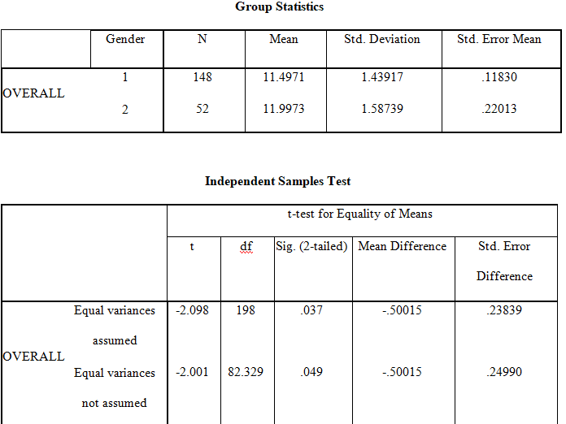

ISJEM sample model format ,Define acronyms and acronyms the first spell they are used in the writing, even after they have been well-defined in the abstract. Shortenings such as IEEE, SI, MKS, CGS, sc, dc, and rems do not have to be demarcated. Do not use condensations in the title or bonces without they are unavoidable.



**Fig -1**: Figure

Charts

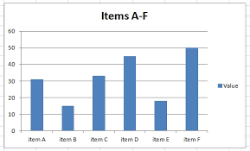

**3. CONCLUSIONS**

The online variety of the dimensions will be offered in LNCS Online. Members of establishments subscribing to the Sermon Notes in Computer Science successions have entree to all the pdfs of all the available publications. Non-subscribers can only read as far as the abstracts. If they try to go ready there this point, they are routinely asked, whether they would like to order the pdf, and are given directions as to how to do so.

**ACKNOWLEDGEMENT**

The caption should be dried as a 3rd level header and should not be dispersed a number.

**REFERENCES**

1. Maldonado, M., Chang, C.-C.K., Gravano, L., Paepcke, A.: The Stanford Digital Library Metadata Style. Int. J. Digit. Libr. 1 (1997) 108–121

2. Bruce, K.B., Carcelle, L., Pierce, B.C.: Linking Object Encodings. In: Abadi, M., Ito, T. (eds.): Notional Aspects of CPU Software. Lecture Notes in Computer Science, Vol. 1281. Springer-Verlag, Berlin Heidelberg New York (1997) 415–438

3. van Leeuwen, J. (ed.): Computer Skill Today. Recent Trends and Developments. Lecture Proceedings in Supercomputer Science, Vol. 1000. Springer-Verlag, Berlin Heidelberg New York (1995)

4. Michalewicz, Z.: Genetic Systems + Data Structures = Evolution Programs. 3rd edn. Springer-Verlag, Berlin Heidelberg New York (1996)

**BIOGRAPHIES (Optional not mandatory )**

|  |  |
| --- | --- |
| 1’st Author  Photo | Description about the author1  (in 5-6 lines) |
|  |  |
|  |  |