Maven

Archetype=>maven-archetype-quickStart

Maven => artifactid==Project Name

Maven=> GroupId+artifactId== Package name

To schedule job in Jenkins- (cron job)

Cofigure setting=> Build Periodically=>Schedule= 55 14 21 5 1=>55 min,14hr,date=21,month=4,Mon=1.. and ***** =>every minute

To Run eclipse project from cmd-

->cd project path

->set classpath=projectPath/bin;projectPath/lib/*;

->java org.testng.TestNG testing.xml

To Run Batch file from Jenkins-

Inside eclipse project folder-

1. Create testing.xml batch file to run multiple test cases into eclipse.
2. Create lib folder inside project folder and keep all the jar files inside it
3. Create run.bat file inside project folder with text as below-

java -cp bin;lib\* org.testng.TestNG testng.xml

Inside Jenkins-

1. Project=>Advances=>Display Name= path of eclipse project
2. Build Periodically=>Schedule= 55 14 21 5 1=>55 min,14hr,date=21,month=5,Mon=1.. and ***** =>every minute
3. Add build setup=>Command =cd..

cd..

D:

cd D:\Amazon_Test\JenkinsDemo

run.bat

1. Add post build Action =>Publish TestNG Results or Email Notification

How can you setup Jenkins Job-

1. Select new Item from menu
2. After that enter a name for the job and either select free style job or select Maven project job to create maven project(select configure maven option then build automatically then paste complete path of pom.xml then save the jab) thereafter save it to redirect to configure job page.
3. By Configure job option we can do multiple settings.

Various ways to schedule job in Jenkins-

1. Downstream – after completion of other builds
2. Source code commits
3. Scheduled to run at specified time
4. Manual build (build now)

Difference Between Maven, Ant and Jenkins-

Maven and ant – Build technologies

Jenkins- Continuous Integration

What is Continuous Integration-

-Continuous Integration is strategy of constantly merging development work with master/branch

Sothat we can test that those changes work with other changes.

-Automated process to each piece of code is performed on daily basis sothat all our code get tested.

Which SCM tools does Jenkins support?

-CVS

-Subversion

-Git

-Mercurial

-Perforce

-ClearCase

-RTC

* -Hudson was earlier name and version of Jenkins.
* To move or copy of Jenkins from one server to other-

1. Copy related job directory and slide a job from one installation of Jenkins to another.
2. Make a copy of already existing job by making clone of a job directory by a different name.
3. Renaming existing job by rename a directory.

Advantages of Jenkins-

1. Automatic build for each code commit.
2. Large number of plugin support.
3. At integration stage, build features are cached.
4. Bugs Tracking
5. Achieve continuous integration agile development

Steps to add Eclipse project to git Repository-

1. Create Github Account and signin
2. Start a project=Create a repository
3. Start Eclipse
4. Go to Git Perspective in eclipse and click on add get repo (clone)
5. Create a project in eclipse , do right click on project >team>shareProject>add to git repo
6. Commit and push project to repository for every change
7. Add staged project
8. Refresh repo to check if project available

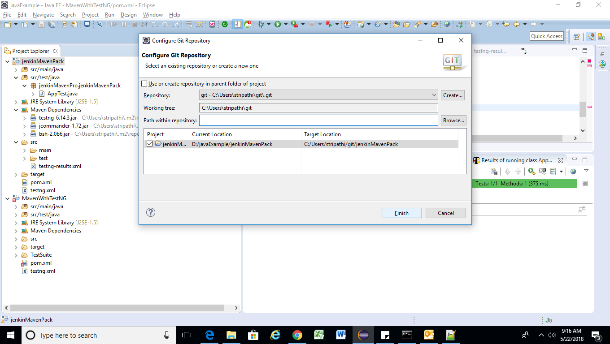

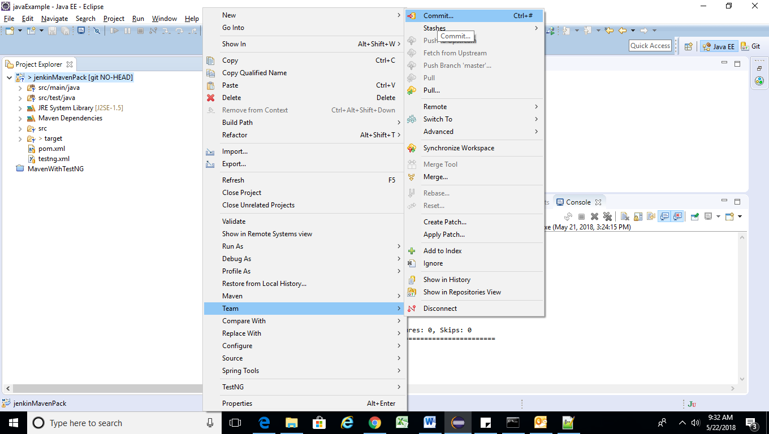

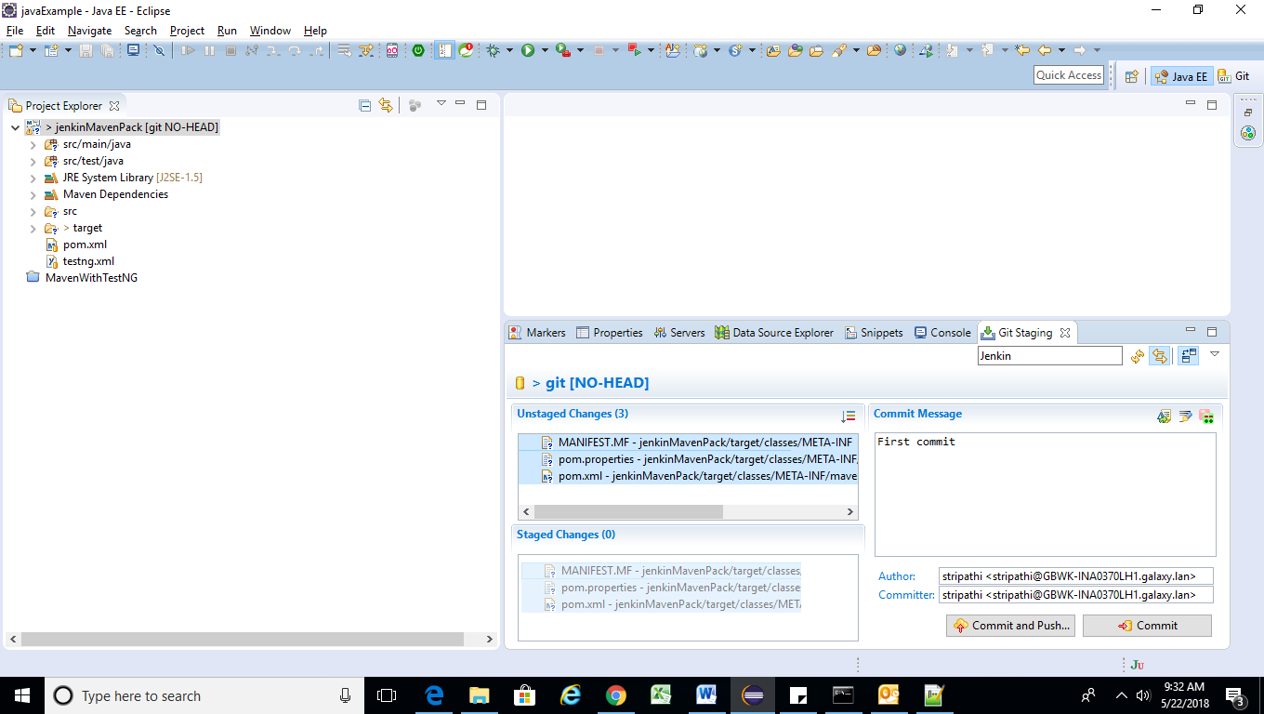

Click on commit and push button paste all the details-

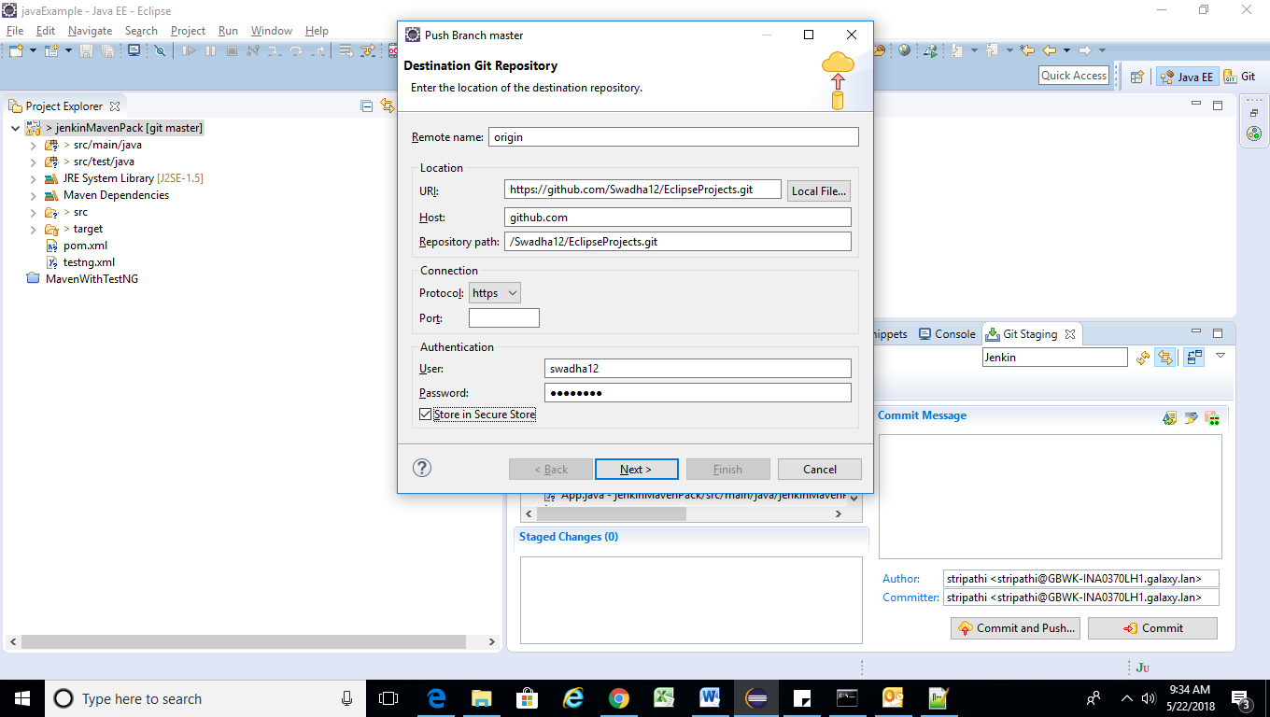

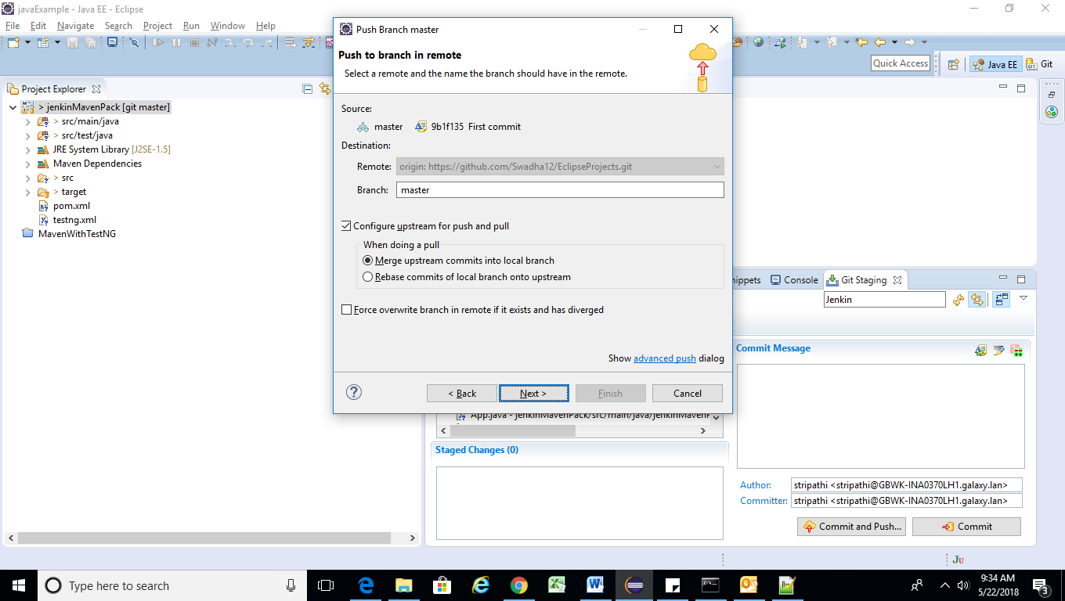

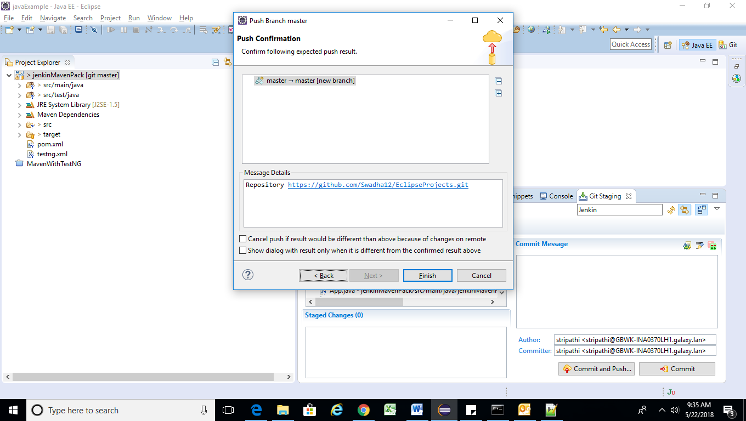

Refresh Git Repository –

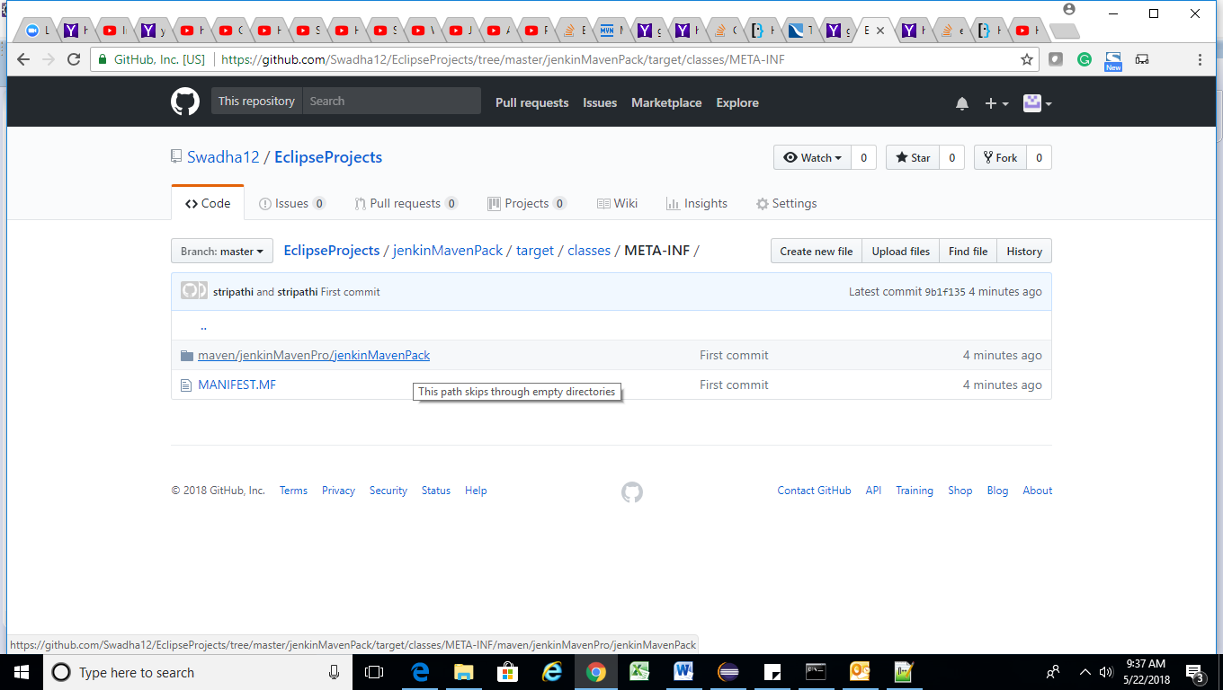

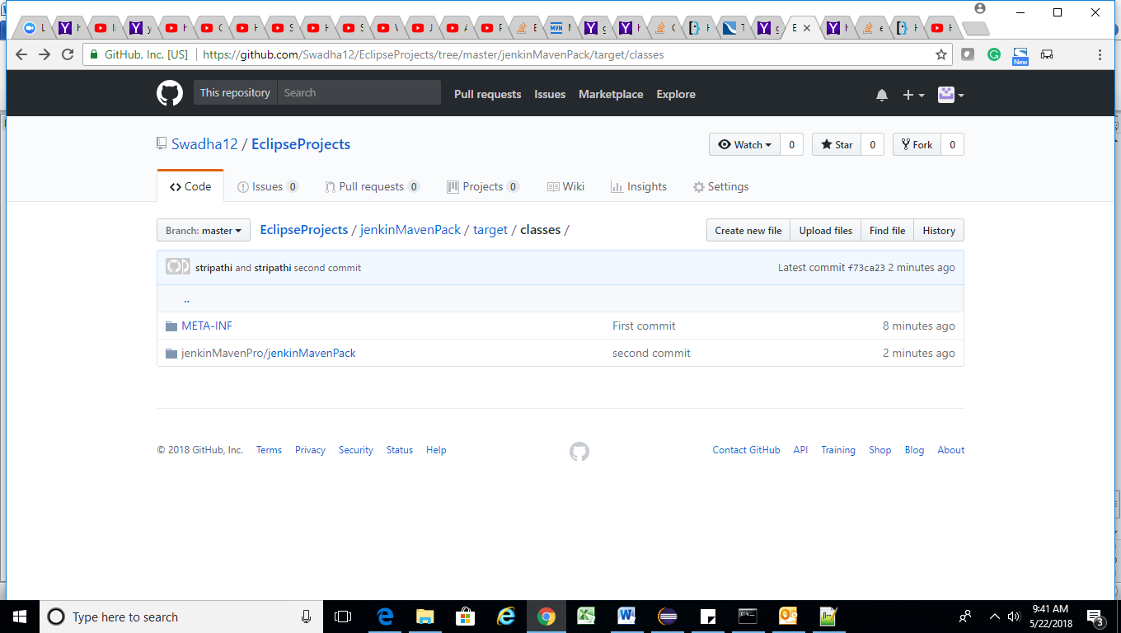

Run Jenkins for each build commit

ManageJenkins > ManagePlugin >install Git hub Integration >create Project and configure setting to provide github repository path-

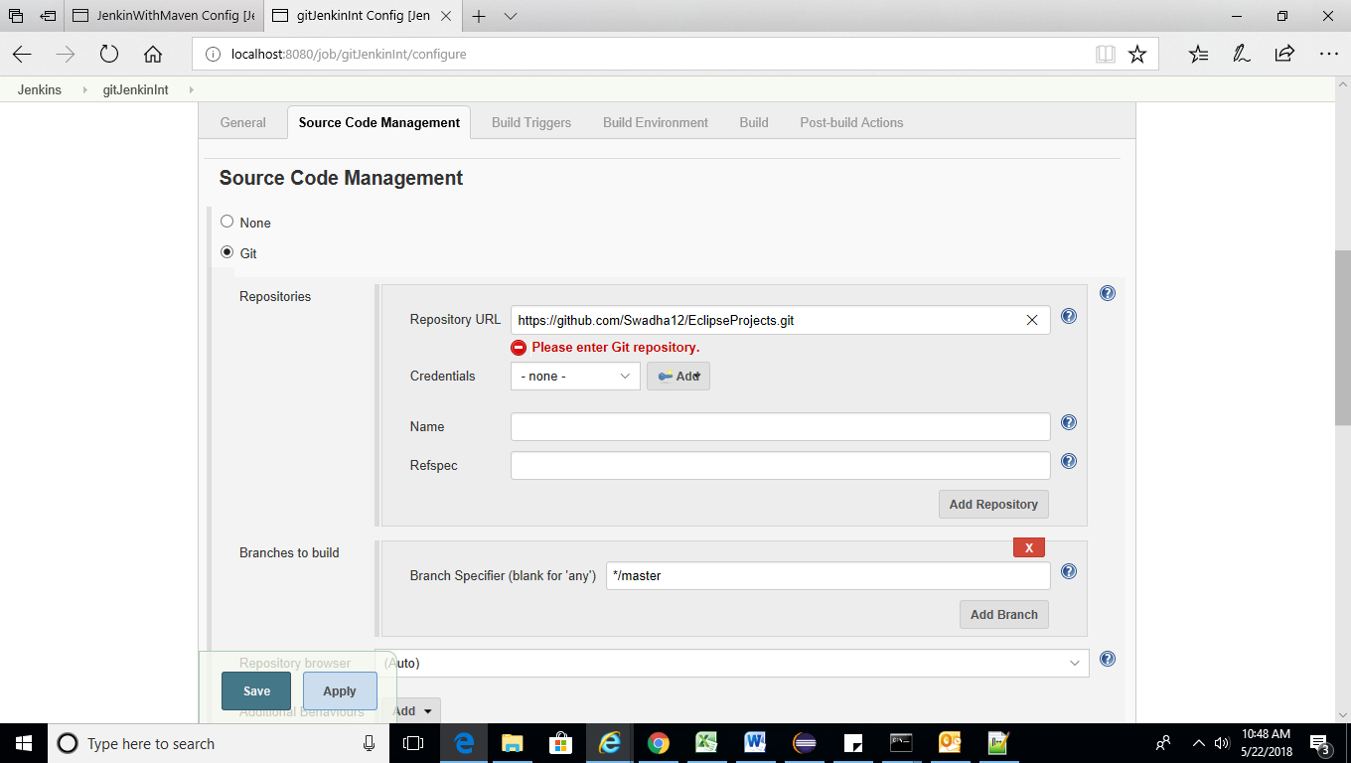

In github we will add webhook to provide Jenkins path and condition in which Jenkins task will be triggered.

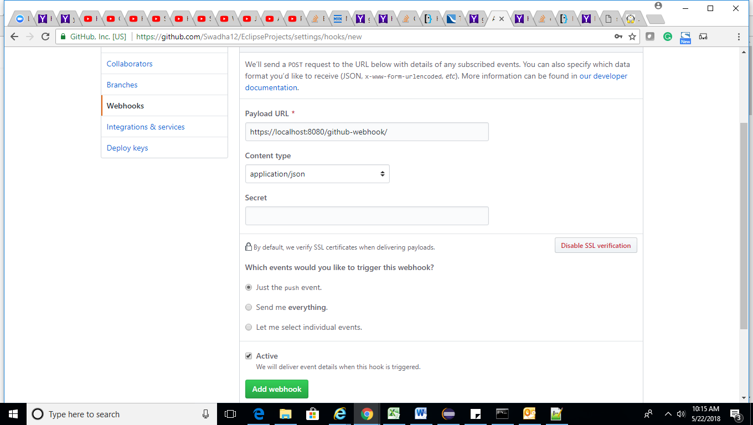

Explain Java Dynamic class loading ? Java Interview Questions and Answers ?   
  
Loading classes using Class.forName () method. Dynamic class loading is done when the name of the class is not known at compile time  
  
Dynamic Java Class loading is an important feature of the Java Virtual Machine because it provides the Java platform with the ability to install software components at run-time.   
  
It allows you to build your applications so that key external dependencies are not compiled into the application source-code.  
  
String str = "InterviewDot";  
Interface clazz = null;   
try { clazz = (Interface )Class.forName(str).newInstance();   
} catch (Exception e) { e.printStackTrace();   
}  
if (clazz != null) { clazz.foo();   
}

You can submit your resume for right Job  
[http://www.interviewdot.com/upload-re...](http://www.interviewdot.com/upload-resume/uploadresume.htm)  
For more Interview questions and answers - logon to [www.InterviewDot.com](http://www.InterviewDot.com)  
[http://www.interviewdot.com](http://www.interviewdot.com/) [http://www.interviewdot.com](http://www.interviewdot.com/) [http://www.interviewdot.com](http://www.interviewdot.com/)

<http://www.geeksforgeeks.org/data-structures/linked-list/>

<https://www.hackerrank.com>

<http://www.java2novice.com/java-interview-programs/>

<http://codingbat.com/java>

<https://www.mkyong.com/java/java-object-sorting-example-comparable-and-comparator/>

Selenium grid Architecture-

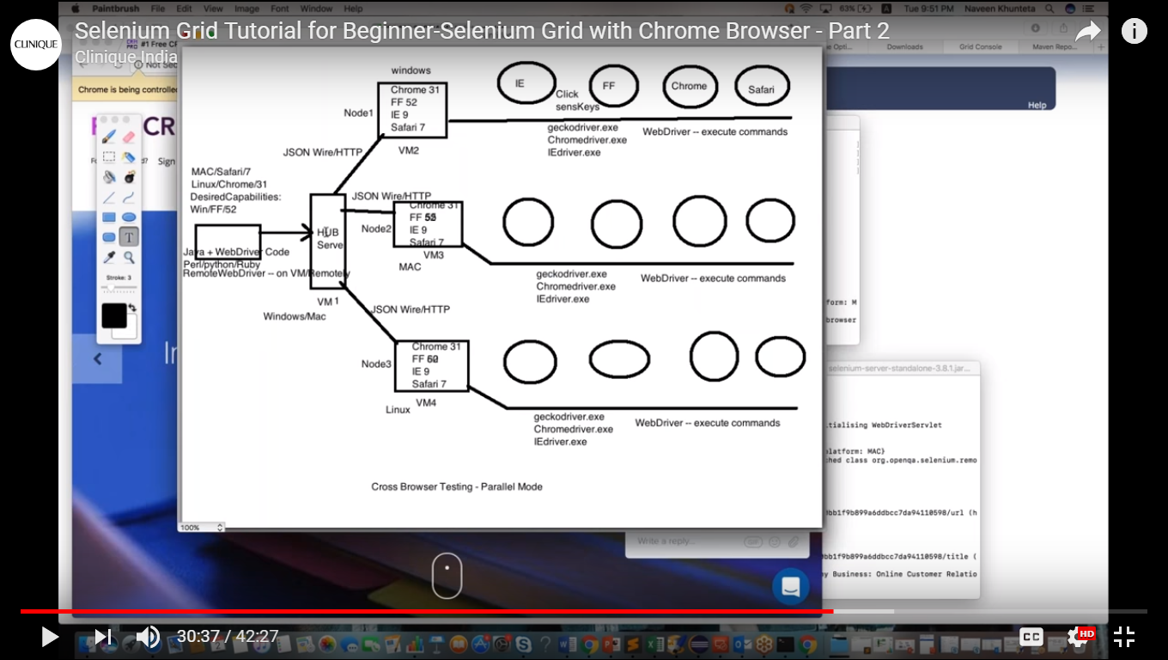

Open cmd and go to path where selenium standalone jar available and fire below command-

java -jar selenium-server-standalone-3.0.0.jar -role hub

to verify its started type the url provided in cmd in browser and check as below –

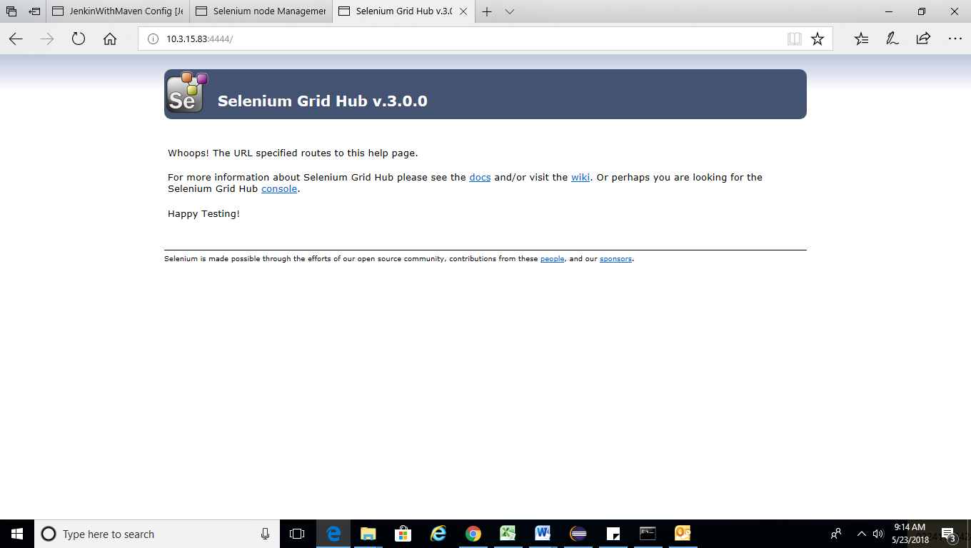

Hub is created without node.

Now to add node for this hub – open new cmd and type below command-

java –Dwebdriver.chrome.driver=”C:\Users\stripathi\Desktop\selenium\chromedriver” -jar selenium-server-standalone-3.0.0.jar –role node –hub <http://10.3.15.83:4444/grid/register/>

* java -–Dwebdriver.chrome.driver=path of chrome driver –jar selenium_server_jar –role node –hub hub_server url

Hub Registered a node <http://10.3.15.83:5555> => msg from hub cmd

If we refresh hub it will show node details also-

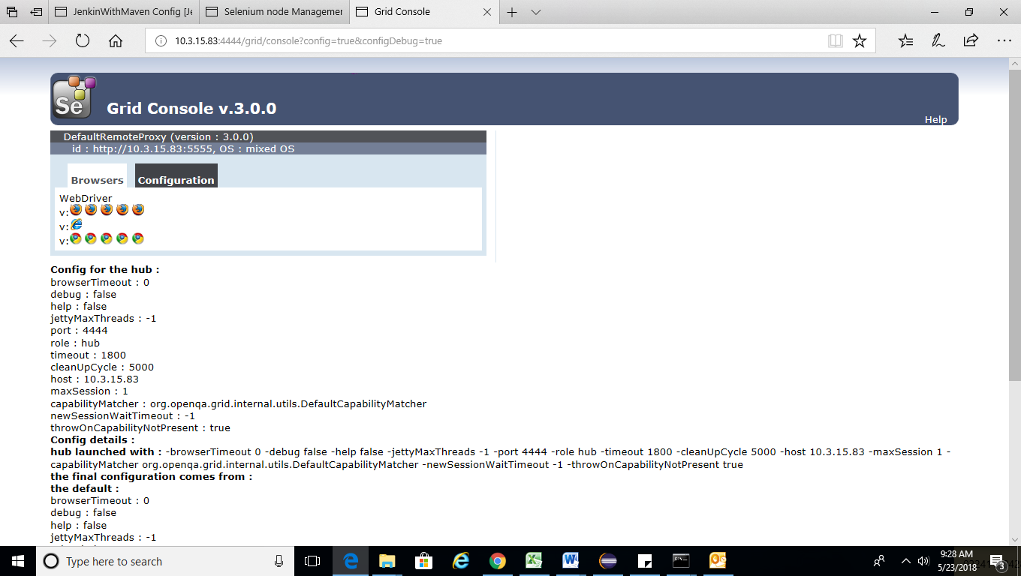

Now we create java class to run it-

1. Define desired capabilities

DesiredCapabilities cap = new DesiredCapabilities();

cap.setBrowserName(“chrome”);

cap.setPlatform(Platform.win10);

1. Define ChromeOptions (applicable after selenium 3.7)

ChromeOptions options=new ChromeOptions();

Options.merge(cap);

1. Create RemoteWebdriver() object and pass the hub url and chrome option

String hubUrl=” <http://10.3.15.83:4444/wd/hub>”;

WebDriver driver = new RemoteWebDriver(new URL(hubURL),options);

(Instead of option we can pass cap if we don’t want chromeoptions but better to pass options)

1. Navigate to website and start testing-

driver.get(“https:www.gmail.com”);

sysout(driver.getTitle());

driver.quit();

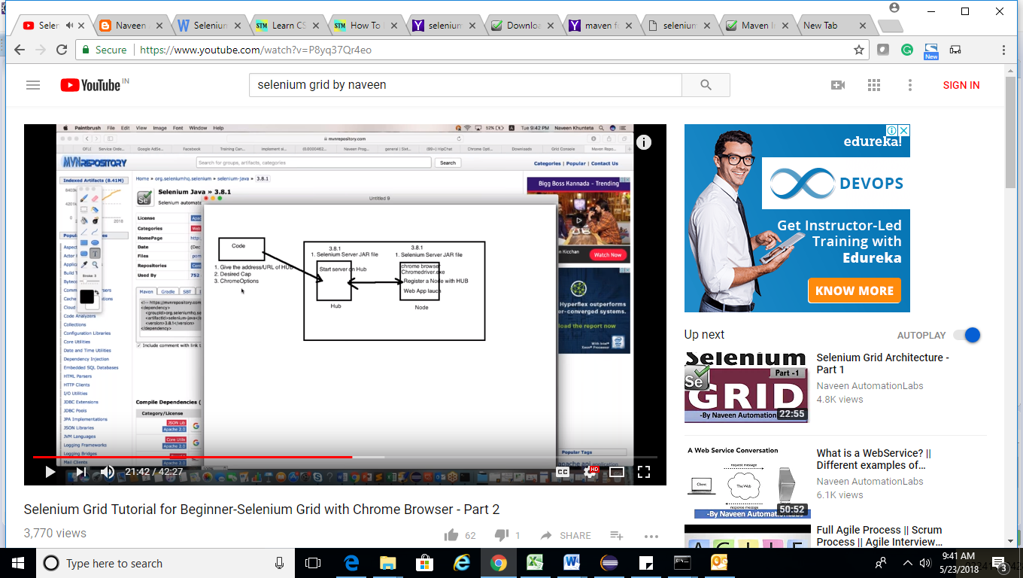

Once we run code written – it will send request to hub and hub will check which one node fulfill requirement that node will be executed as per requirement.

If we want to stop hub and node we need to type ^C .

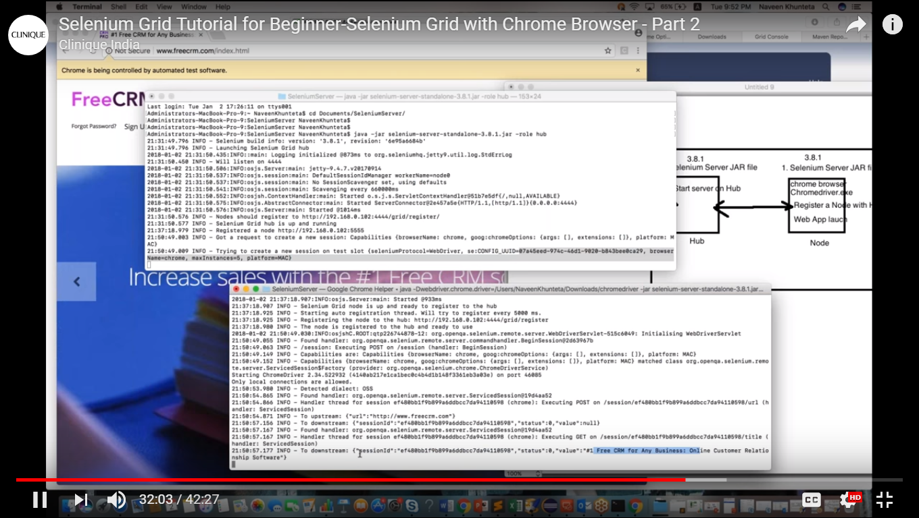

If we want to start one node we will open new cmd and run the same command with different node-

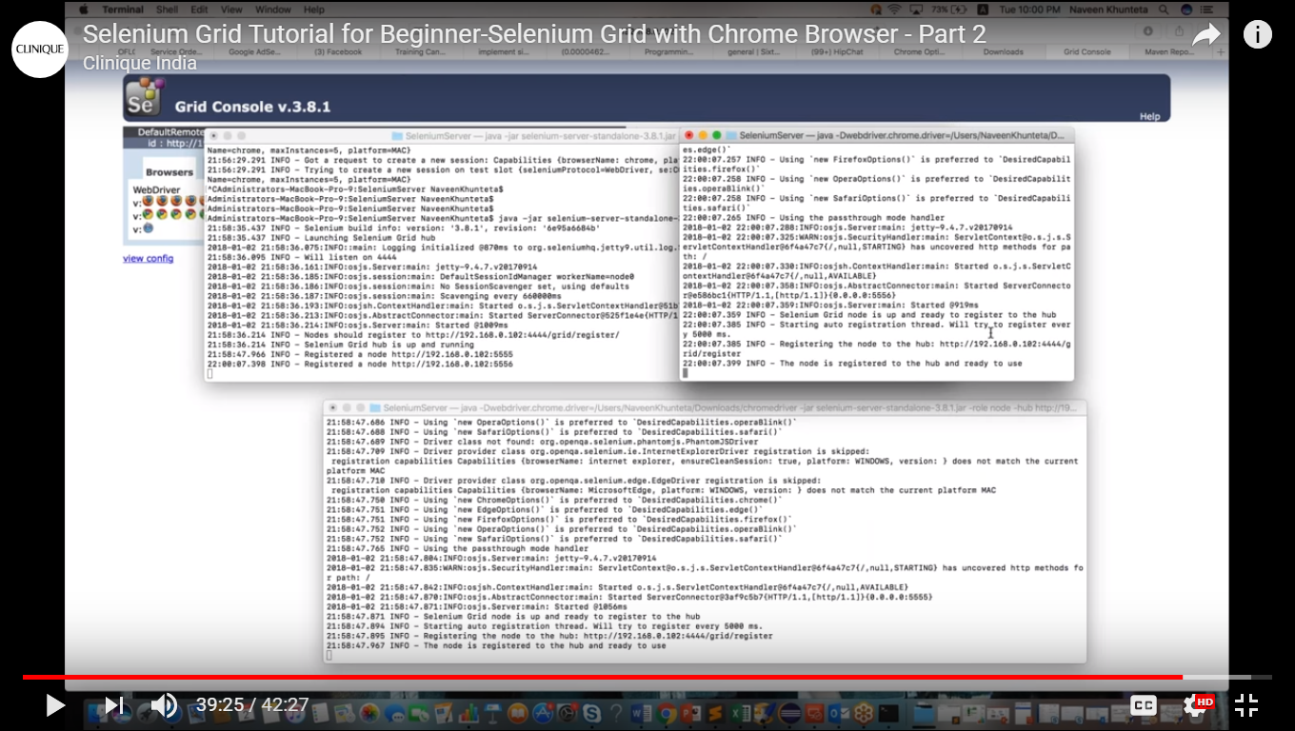

If we refresh the hub url now it will be show two nodes as below –

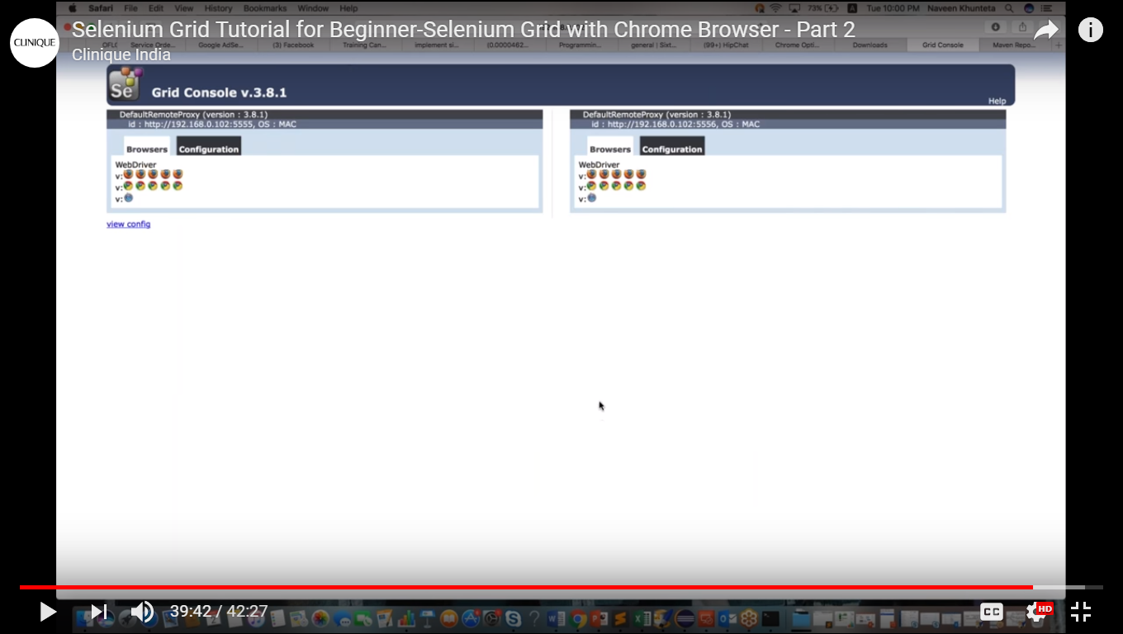

So instead of running script in different VMs here we have created different node with different port in the same machine.