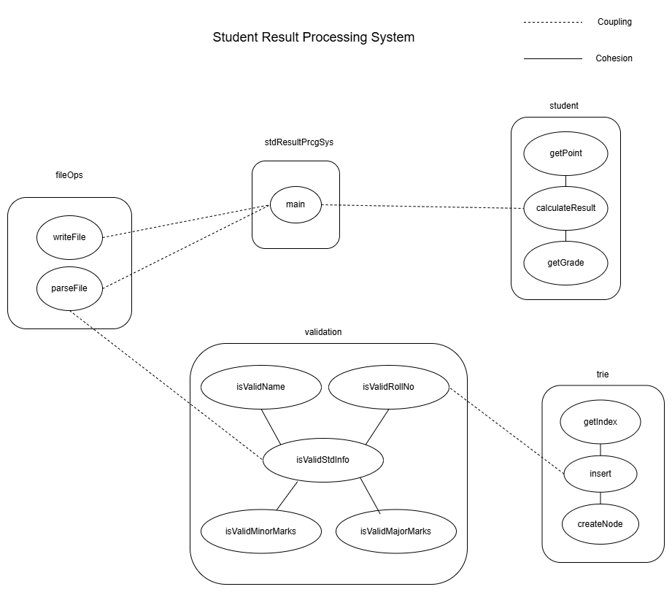

Module Name: stdResultPrcgSys
Input: Command line arguments (Input Filename, Output Filename)
Precondition: Input File must be available
Logic:
- Parse the input file using parseFile
- Calculate the results using calculateResult
- Write the results to file using writeFile
Output: Console message "Done processing student information" and a generated result file

Module Name: fileOps
parseFile
Input: File containing student information
Precondition: File must be available
Logic:
- Read the input file line by line
- Convert each line to tokens
- Using the tokens, convert the data into structured student data
- Check whether the student data is valid using isValidStdInfo
- If student information is valid, link it to stdList
Output: Parsed student data as linked list stdList

writeFile
Input: Processed student results data
Precondition: The results processing should be done and the processed student information is available along with class statistics
Logic:
- Parse through processed student result data
- Iterate through each student and print each student information to output file
- Write class statistics (average, high, low percentage and grade counts) to output file
Output: Output file with processed student results data

Module Name: Student
getPoint
Input: Marks
Precondition: Marks in the range [0,100]
Logic:
- Calculate value = marks / 5
- Use a switch statement: 18-20 maps to 10; 17 to 9; 15-16 to 8; 13-14 to 7; 12 to 6; 11 to 5; 10 to 4; others to 0
Output: return the point value as grade point

getGrade
Input: Marks
Precondition: Marks in the range [0,100]
Logic:
- Calculate value = marks / 5
- Map value to Letter Grades: 18-20 (O); 17 (A+); 15-16 (A); 13-14 (B+); 12 (B); 11 (C); 10 (D); others (F)
Output: return the Letter Grade

calculateResults
Input: Parsed student data
Precondition: parsed student data is valid
Logic:
- Initialize sClass summary structure with INT_MIN for high and INT_MAX for low percentage.
- Iterate through each student:
- Calculate total = minor + major per subject
- Compute GPA by averaging points across 5 subjects
- Determine overall percentage and grade
- Update sClass for high/low scores and increment grade-specific counters
- Calculate the final class average percentage
Output: Processed student result information along with class statistics

Module Name: Validation
isValidName
Input: Student Name
Precondition: Parsed student data
Logic: Check the student name contain only alphabetic characters
Output: if valid return true else false

isValidRollNo
Input: Student RollNo
Precondition: Parsed student data
Logic: Calls Trie insert to check if the roll number is alphanumeric and unique
Output: if valid return true else false

isValidMinorMarks
Input: Student Minor Marks
Precondition: Parsed student data
Logic: Check if marks in the range [0,40]
Output: if valid return true else false

isValidMajorMarks
Input: Student Major Marks
Precondition: Parsed student data
Logic: Check if marks in the range [0,60]
Output: if valid return true else false

isValidStdInfo
Input: Student Data
Precondition: Parsed student data
Logic: Check if the student record has validName, roll no, minor and major marks.
Output: if valid return true else false

Module Name: Trie
getIndex
Input: Character
Precondition: Student roll no string
Logic:
- If character is numeric return 26 + numeric value of character
- Else convert the character to lower case and return difference between ascii value of character and ‘a’.
Output: Integer index value

Insert
Input: student roll no
Precondition: parsed student record
Logic:
- Traverse the Trie character by character using indices from getIndex
- If a node doesn't exist for a character, create it
- If the end of the string is reached and isEnd is already true, it is a duplicate
Output: Returns 0 for successful unique insertion, 1 for duplicate or invalid character

createNode
Input: None
Pre-condition: Called during trie insertion
Logic: Create a new trie node
Output: Trie node object

