Run query to get the output

It is 112 as the data inserted in the table twice

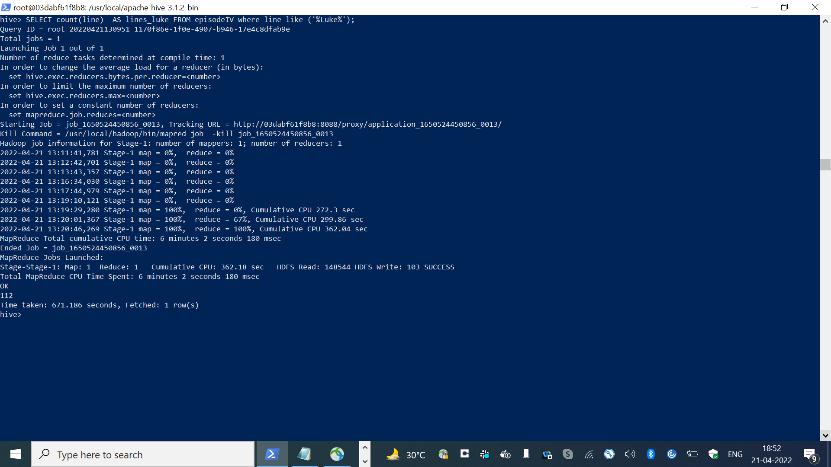

Export the output

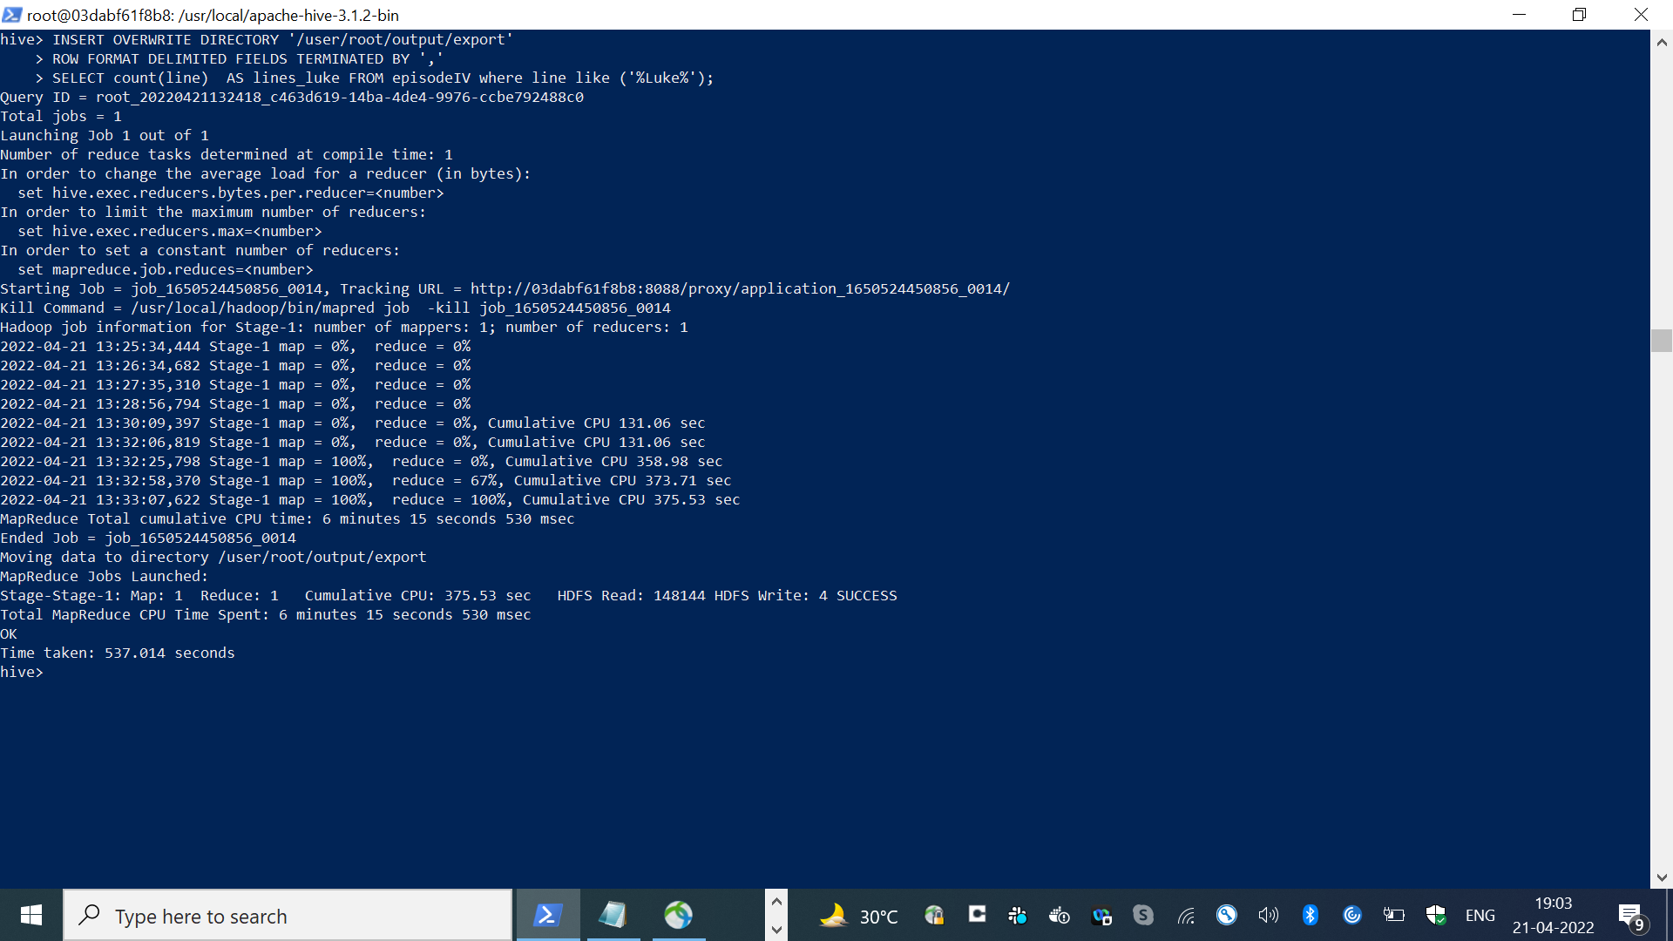

Output

It is 112 as the data inserted in the table twice

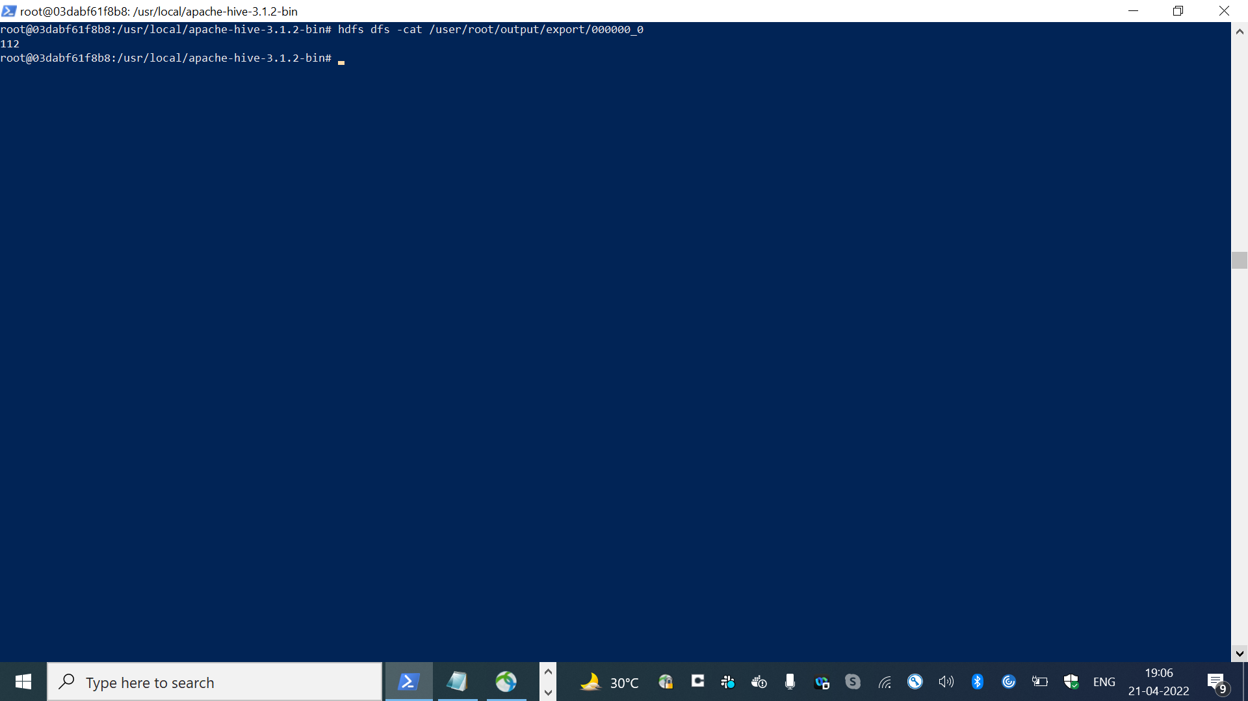

Exporting the output file to host machine

