

CS 3733 - Software Engineering

*“Get There” -* Iteration 1

Submitted By:

Team Ocho (Team 8)

[*teamocho@wpi.edu*](mailto:team-ocho@wpi.edu)

[*https://github.com/SwagTeamOcho/WPINav.git*](https://github.com/SwagTeamOcho/WPINav.git)

November 18, 2015

Professor Wilson Wong

Class diagram:

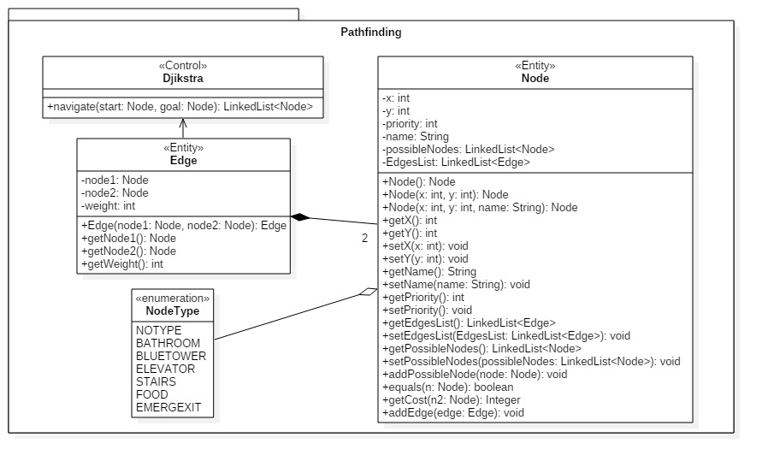

Sequence diagram:

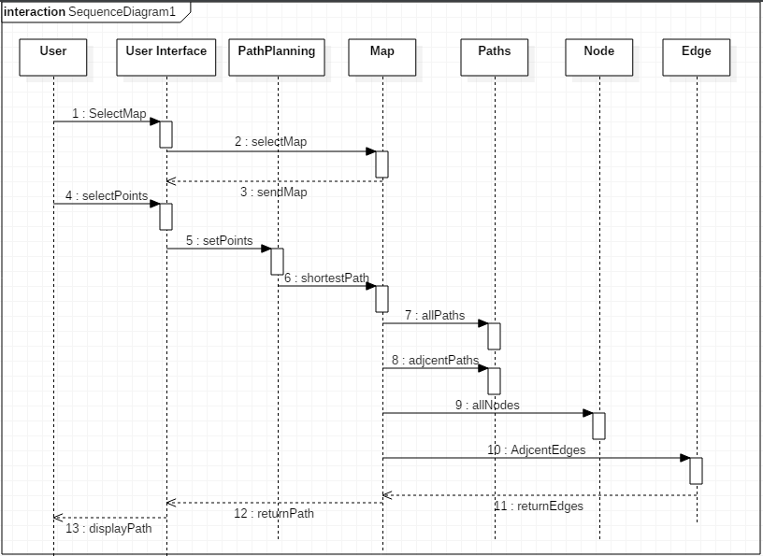

Pathfinding Application User Stories:

|  |  |
| --- | --- |
| **Priority** | **User Stories** |
| 1 | As a student, I want to get to a classroom to attend my class.   * As a student I want a User Interface to enter my locations.   + Size Estimation: XL   + Tasks:     - Create UI objects       * Add start/end points/text area box (M)       * Search Button (M)       * Map display Panel (S)       * Display Path Panel (L)   + All completed by Lumbini Parnas * As a student, I want to generate a route from my starting point to my ending point so that I have directions.   + Size estimation: XL   + Tasks:     - Implement Node / Path / Map (M)       * Done by Jeffrey Chaves, Marc Touma & Paul Peterson     - Implement pathfinding algorithm (XL)       * Done by Paul Peterson and Marc Touma     - Return shortest path information to UI (S)       * Done by Lumbini Parnas * As a student, I want to enter my starting /ending location so that the program knows where I start and end my route.   + Size estimation: (M)   + Tasks:     - Send the entry to the algorithm       * Done by Lumbini Parnas, Joe Kaiser, and Chris Griffin * As a student, I want to see the navigational path.   + Size estimation: (M)   + Tasks:     - Draw in the desired path (Path Overlay)       * Done by Lumbini Parnas |

Map Tool User Stories:

|  |  |
| --- | --- |
| **Priority** | **User Stories** |
| 1 | As a developer, I want to be able to upload maps into the map tool so that I can enter nodes and paths.   * As a developer, I want to upload maps   + Size Estimation: S   + Tasks:     - Enable functionality to upload map images (S)   + Done by Billy Sullivan * As a developer, I want to add nodes   + Size Estimation: M   + Tasks:     - Create Nodes (S)     - Save/Export nodes (M)     - Determine Scaling between nodes (S)   + All done by Billy Sullivan * As a developer, I want to visually draw and erase paths between nodes   + Size Estimation: (XXL)   + Tasks:     - Create an edge (S)     - Display edge (M)     - Erase Edge (XL)   + Done by Billy Sullivan and Chris Griffin * As a developer, I want to export the node and edge information   + Size Estimation: (L)   + Task:     - Determine syntax to export and import info. (S)       * Done by Joe Kaiser and Chris Griffin     - Implement export / import (L)       * Done by Billy Sullivan and Chris Griffin |

Paycheck:

|  |  |  |
| --- | --- | --- |
| **Developer** | **Salary (Total 120W)** | **Contribution to Iteration 1** |
| Chaves, Jeffrey J. | 18.57 | Object design, Djikstra’s Algorithm testing, Delegation of tasks, Completed Object Diagram, Use Case Diagram (Visual & Textual), User Stories |
| Griffin, Christopher S | 12.256 | Worked on reading and writing files that contain node and edge information |
| Kaiser, Joseph T | 8.57 | Object diagram first draft, DevGUI data export/import, assistance with DevGUI, subsystem organization |
| Parnas, Lumbini | 20.7 | Entire UI Design , Entire UI Implementation, Path Algorithm and UI Integration. |
| Peterson, Paul W | 15.7 | Path Planning Algorithm, Dynamic Models |
| Ruggiero, Alexander N | 7.84 | Reformatting maps of buildings / building floors for GUI and devGUI, maintaining Github |
| Sullivan, William | 17.14 | Wrote User stories. Helped layout GUIs. Worked on making the DevGUI able to import, construct, and export nodes and edges. |
| Touma, Jean Marc A | 19.28 | Implemented Djikstra’s algorithm, Wrote test cases for the algorithm. Wrote textual use cases, pseudo requirements. Helped where needed. |