#Solution-1:

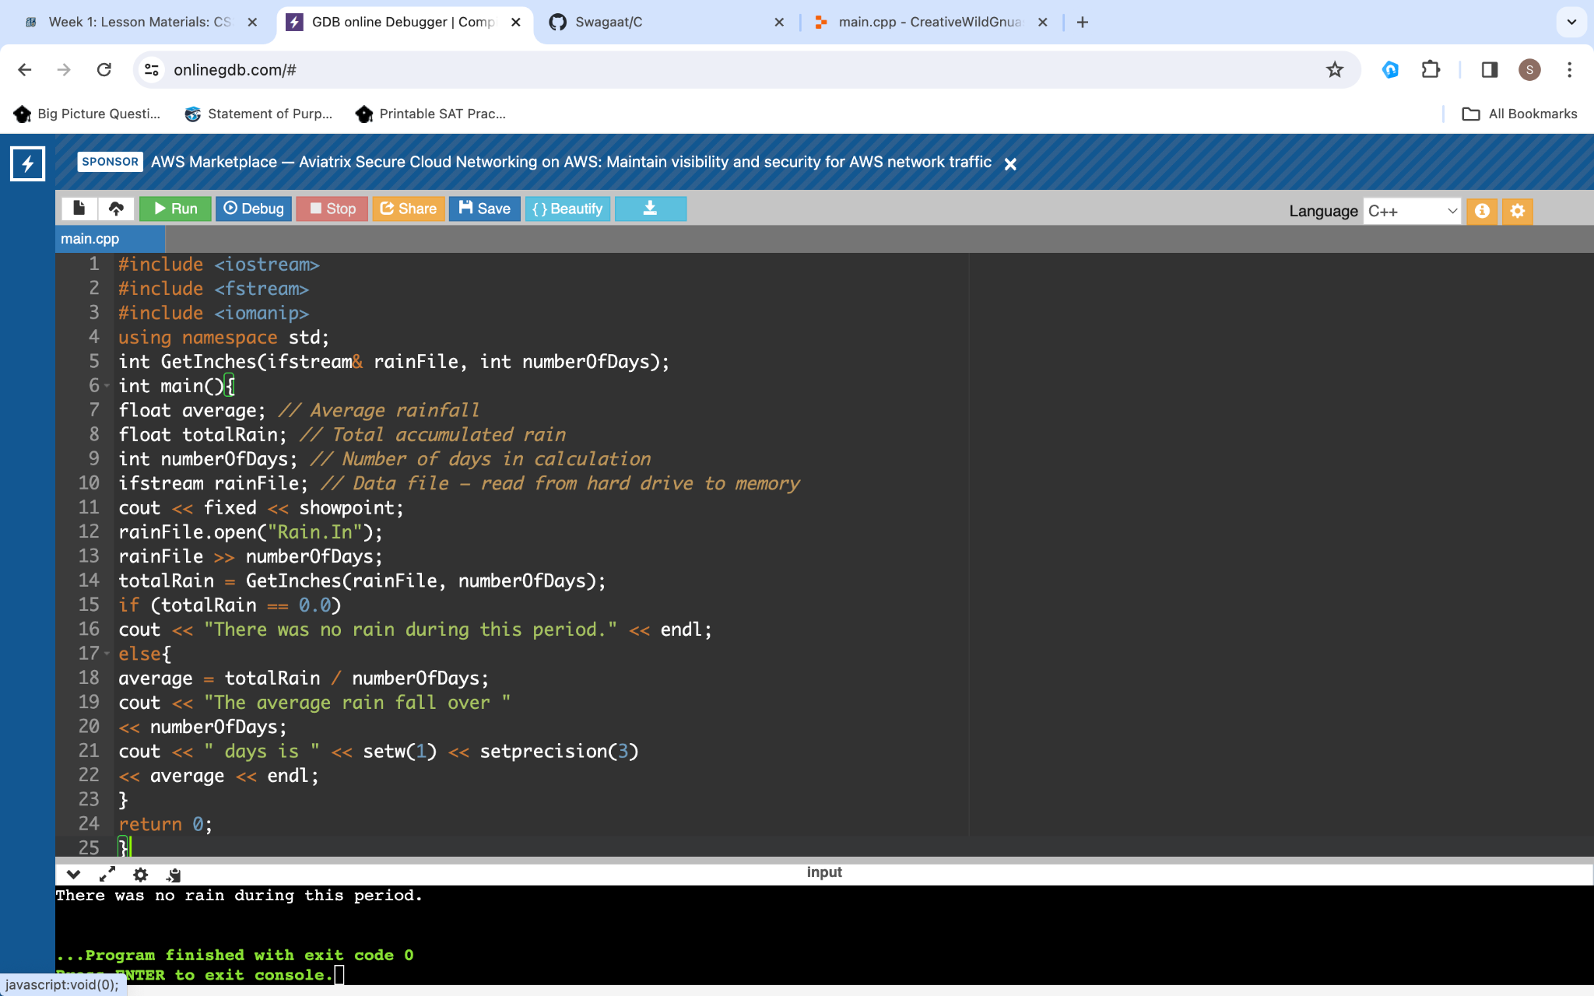

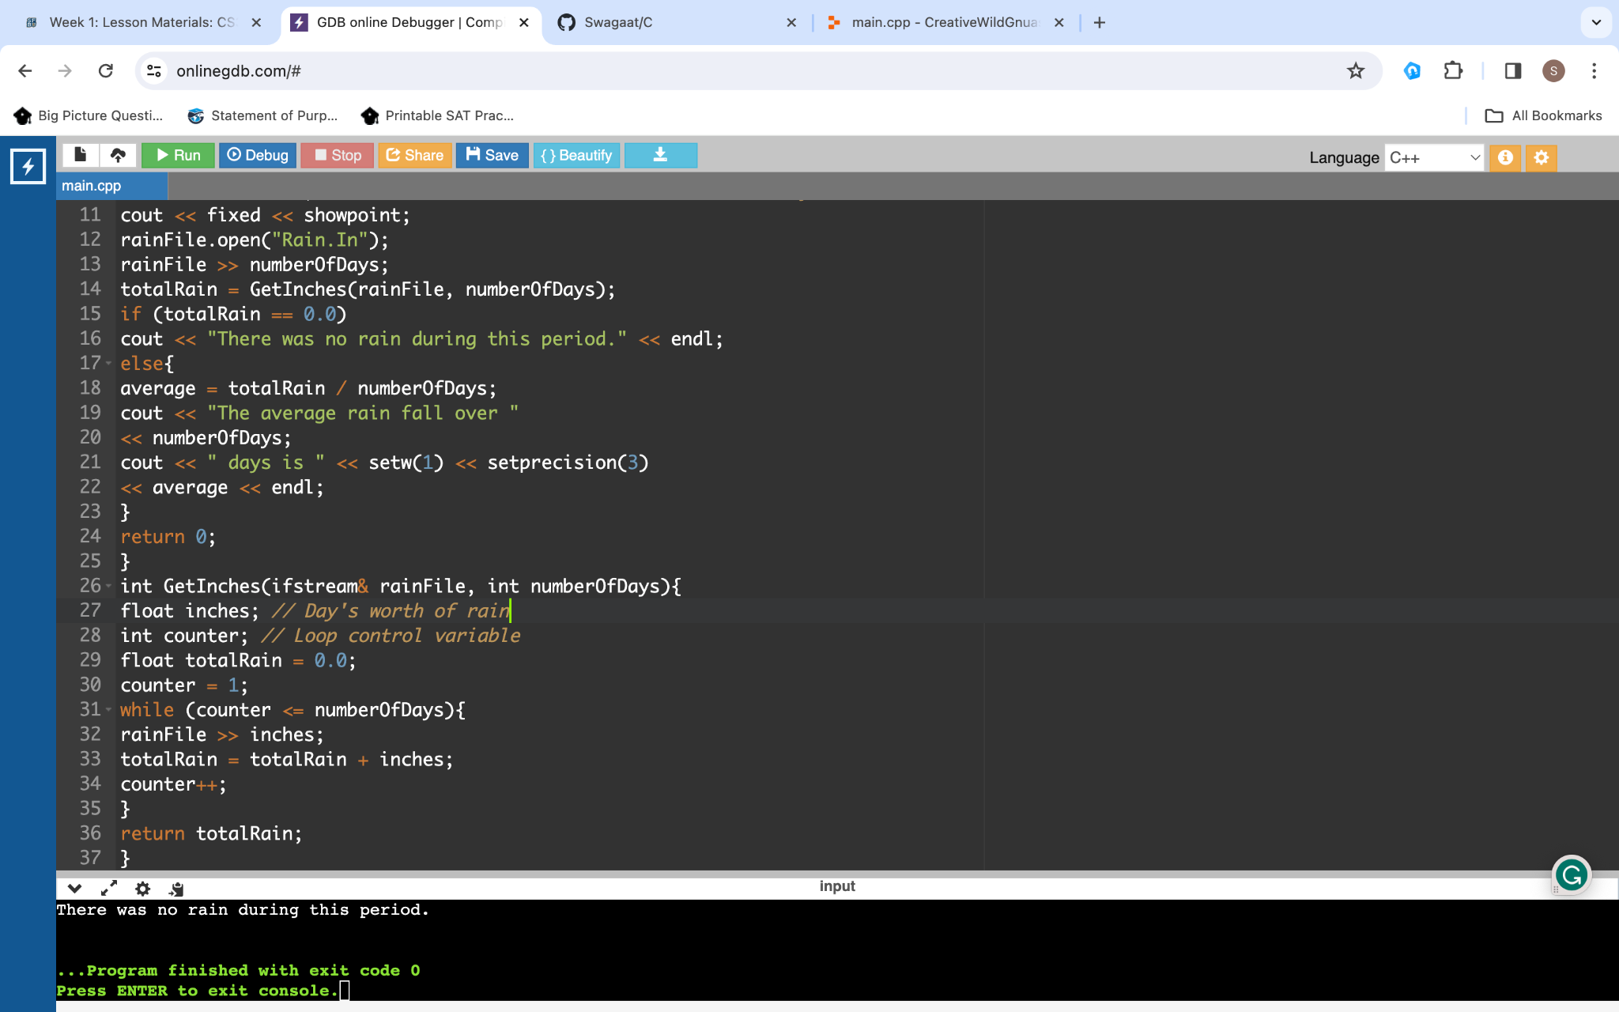

\

#Solution-2:

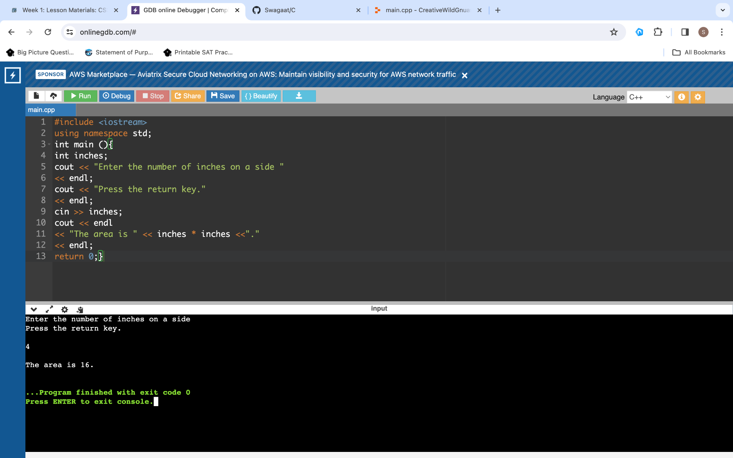

* **#include <iostream>:** This line includes the standard input/output stream library, which is necessary for input and output operations.
* **using namespace std;:** This indicates that the code will use the std namespace. The standard C++ library functions and objects.
* **int main() {:** This line marks the beginning of the main function, which is the entry point of every C++ program.
* **int inches;:**  This is the line that declares an integer variable named inches to store the length of one side of the square.
* **cout << "Enter the number of inches on a side " << endl;:** This is the prompt asking the user to enter the length of one side of the square in the output. The << endl is used to move the cursor to the next line.
* **cout << "Press the return key." << endl;:** Outputs an additional instruction to press the return key after entering the side length.
* **cin >> inches;:** This helps to take input from the user for the length of one side and stores it in the inches variable.
* **cout << endl << "The area is " << inches * inches << "." << endl;:** This line calculates and outputs the area of the square, which is the square of the length of one side (inches * inches). The result is displayed with a message.
* **return 0;:**  At last, this indicates that the program has executed successfully, and 0 is returned to the operating system.
* **}:** This marks the end of the main function.

#Solution-3:

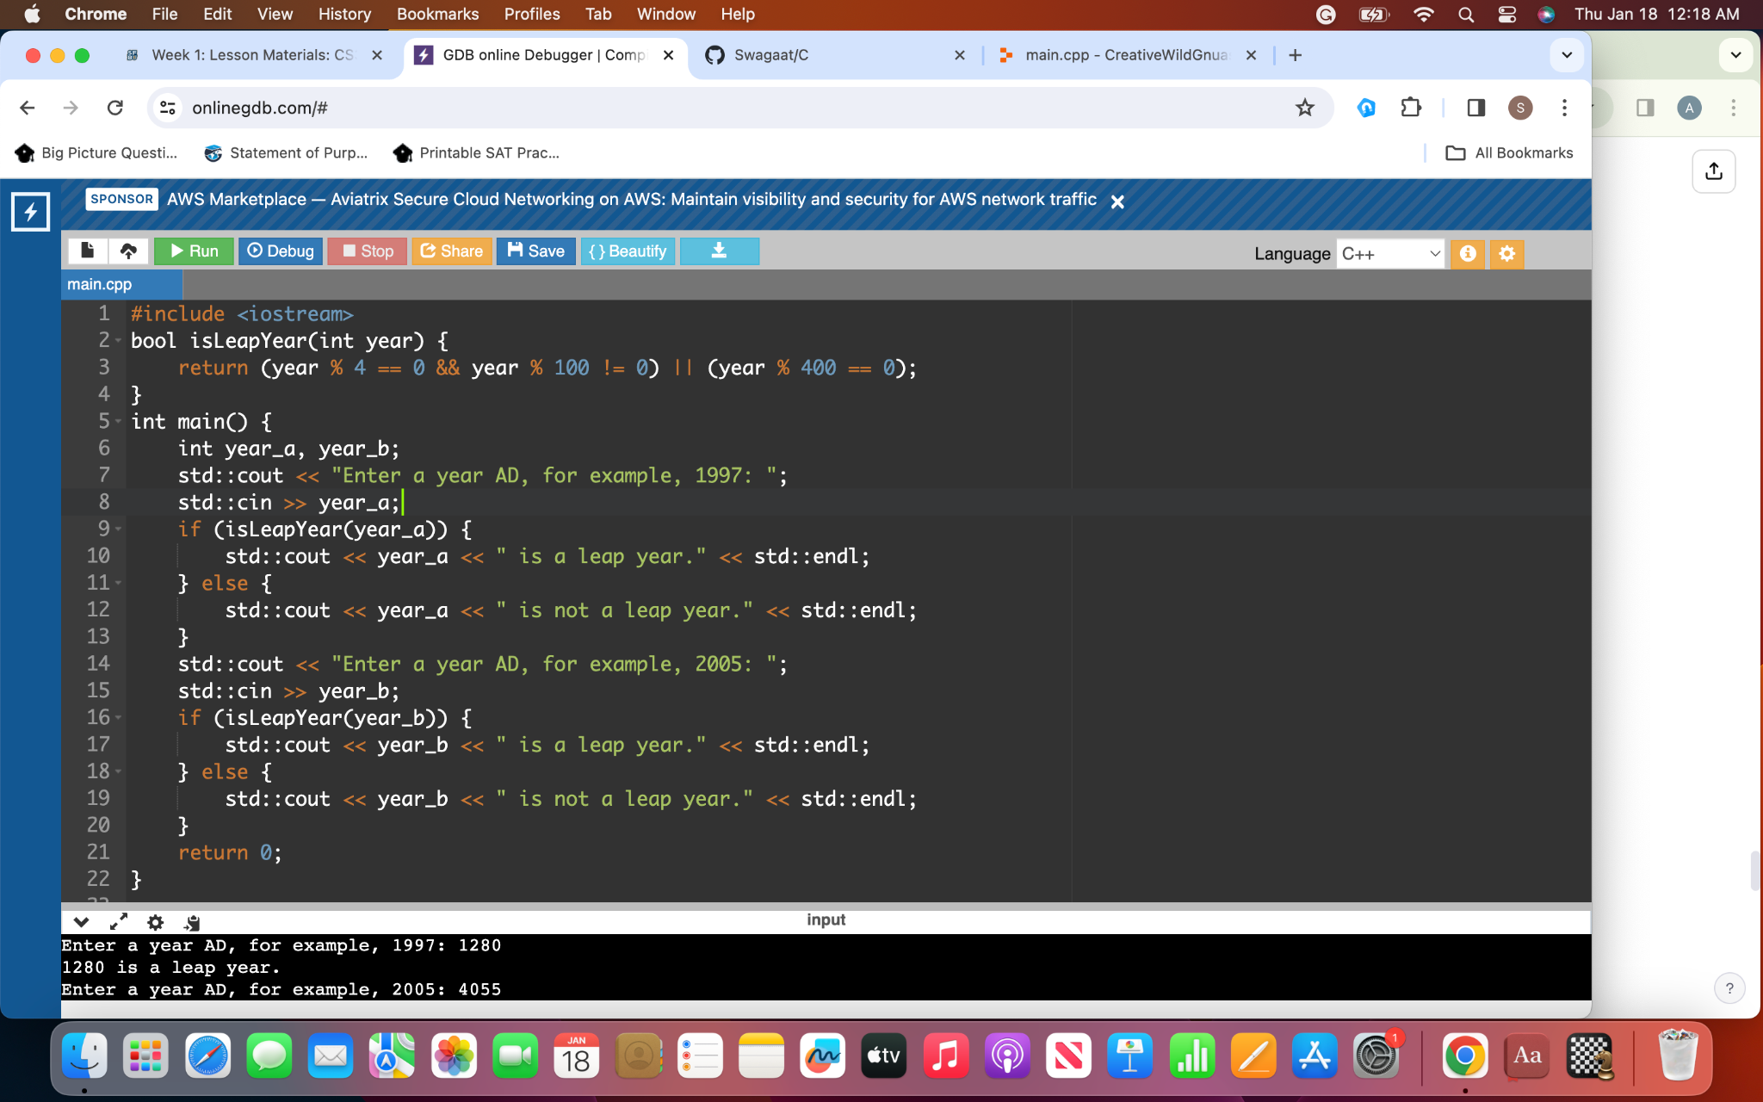

#Solution-4:

