Question-1:

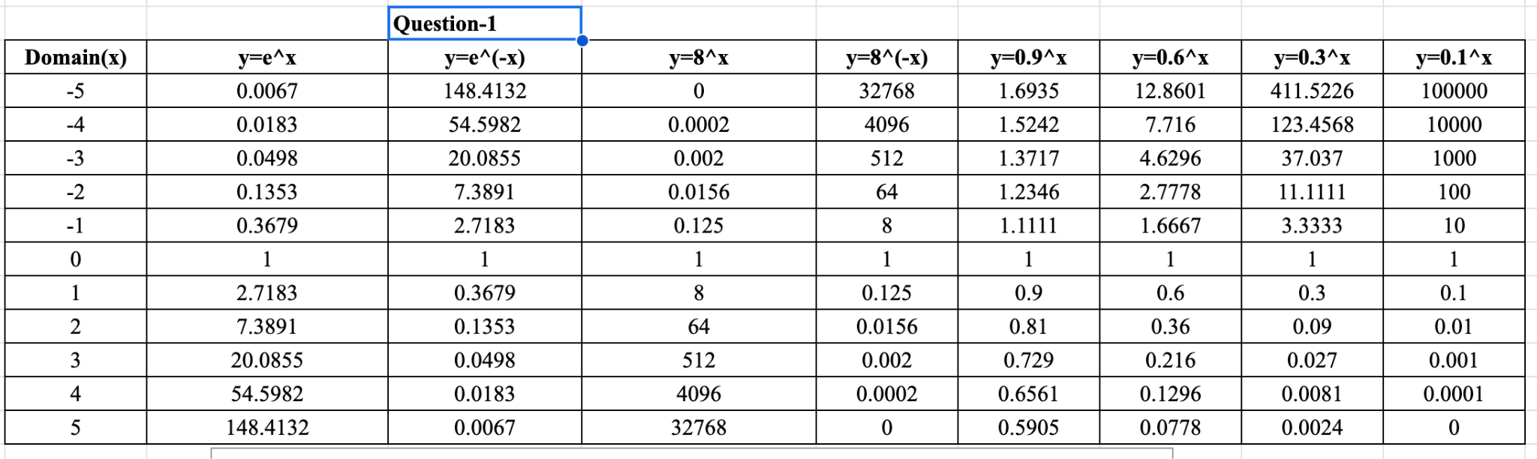

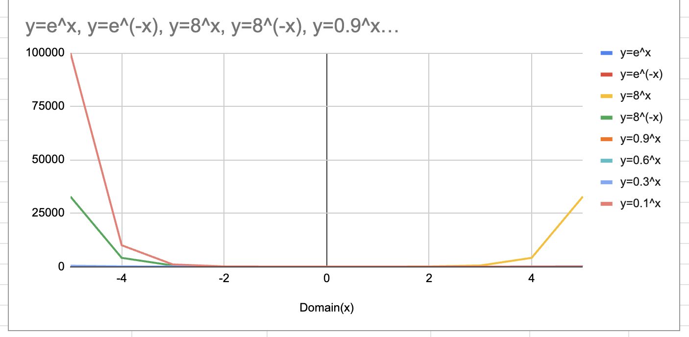

**Question-2:**

We’ve given that f(x)=

To prove,

= ()

Here, taking LHS

= ( Since, f(x)= )

=

=

Hence, LHS = RHS

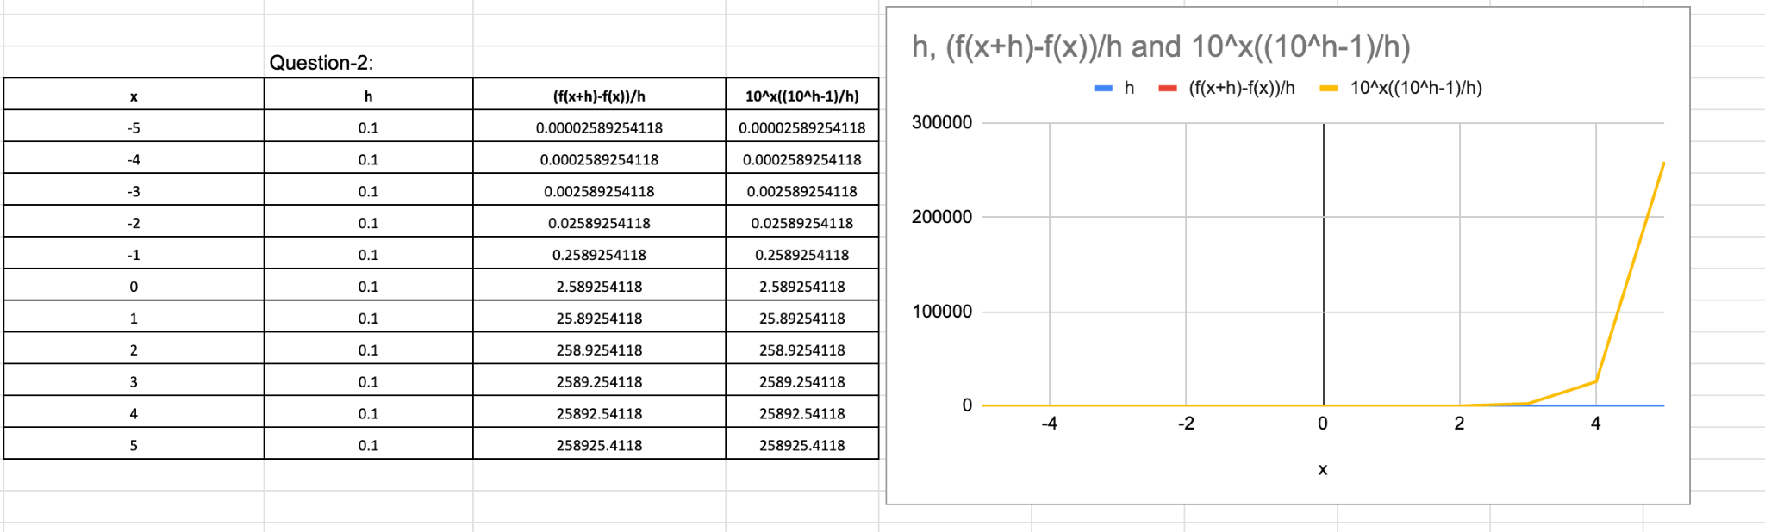

Question-3:

To compare the functions f(x) = x^5 and g(x) = 5^x and determine which grows more rapidly when x is large, we can plot their curves in Excel and observe their behavior.

Let's create a table in Excel with the x-values ranging from, for example, 0 to 10. In the adjacent column, we can calculate the corresponding y-values for each function using the formulas f(x) = x^5 and g(x) = 5^x.

After inputting the formulas and generating the values, we can select the data and create a scatter plot in Excel. The x-values will be plotted on the horizontal axis, and the corresponding y-values will be plotted on the vertical axis.

Upon examining the graph, we can observe that both curves start at the point (0, 0) since f(0) = 0^5 = 0 and g(0) = 5^0 = 1. As x increases, the function f(x) = x^5 grows rapidly but still follows a polynomial growth pattern. On the other hand, the function g(x) = 5^x grows even more rapidly and exhibits an exponential growth pattern.

We can compare their derivatives to prove mathematically that g(x) = 5^x grows more rapidly than f(x) = x^5 as x becomes large.

The derivative of f(x) = x^5 can be calculated as follows: f'(x) = 5x^4 The derivative of g(x) = 5^x can be determined using the chain rule and logarithmic differentiation:

g'(x) = 5^x * ln(5)

When evaluating these derivatives, it becomes evident that the rate of change of f(x) is dependent on the value of x and is limited by the power of x^4. As x approaches infinity, the derivative will tend to infinity but remain constrained by the power term.

However, the derivative of g(x) = 5^x includes the function value 5^x itself, multiplied by the natural logarithm of 5. This implies that the rate of change of g(x) is directly proportional to its function value, resulting in exponential growth. As x becomes large, no limiting factor restricts the growth of g(x).

Therefore, based on the mathematical analysis, we can conclude that g(x) = 5^x grows more rapidly than f(x) = x^5 when x is large.

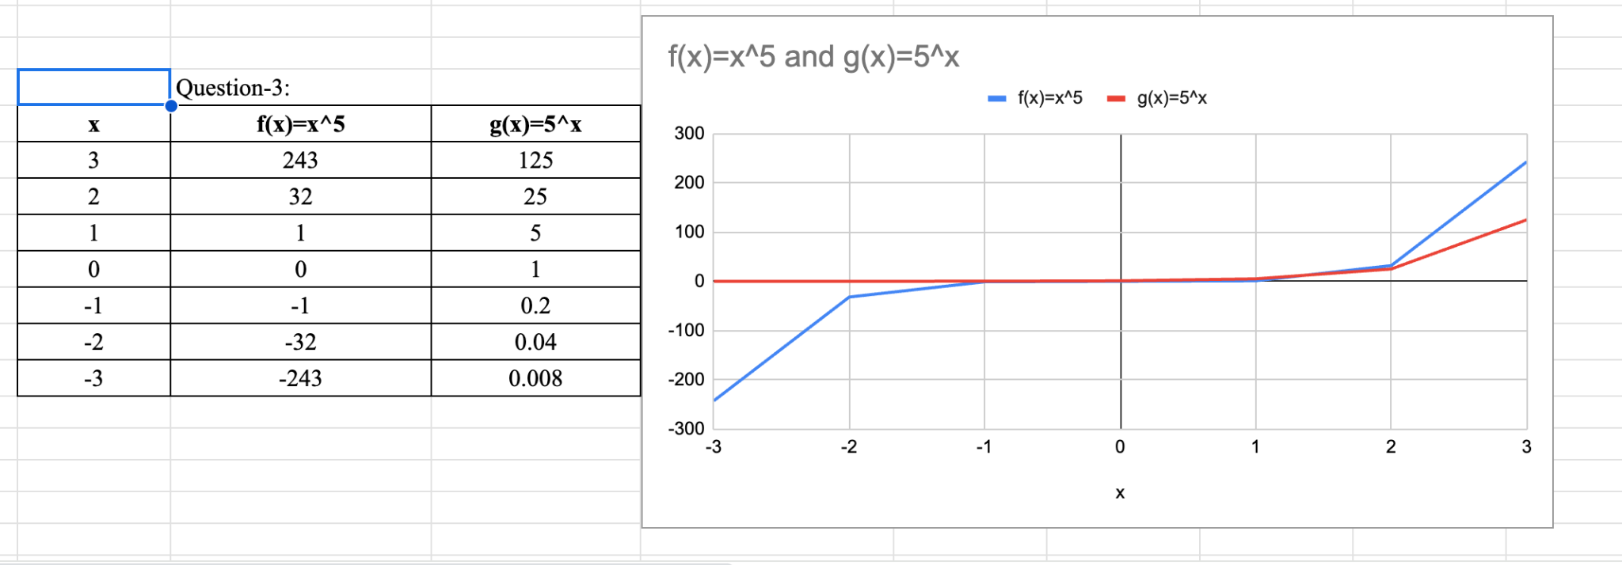

Question-4:

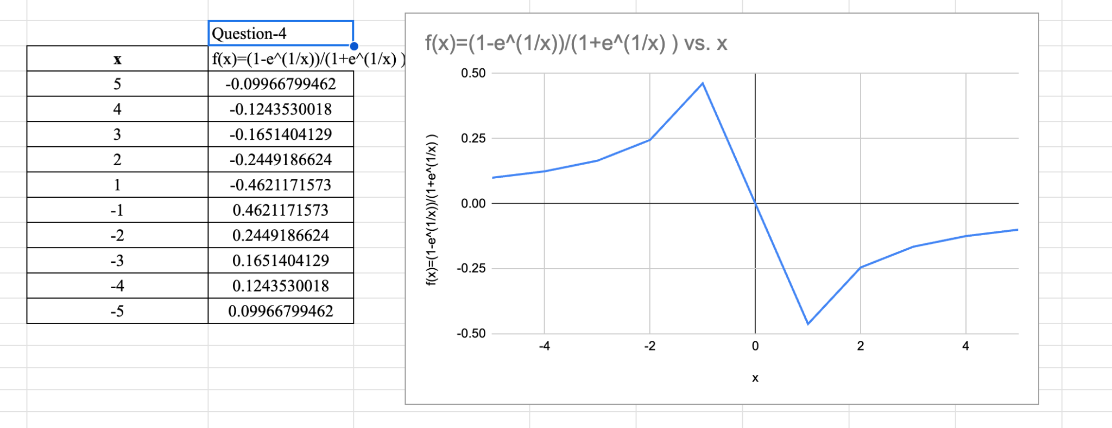

Question-5:

Answer for a: The graph f(x) becomes steeper as b increases when the value of a > 0.

Answer for b: As, a increases, the amplitude of graph f(x) increases.

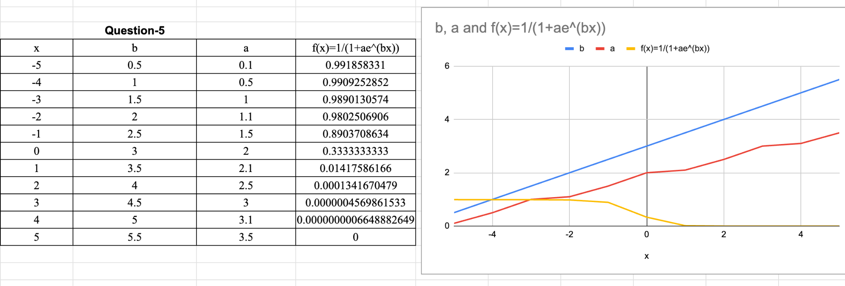

**Question-6:**

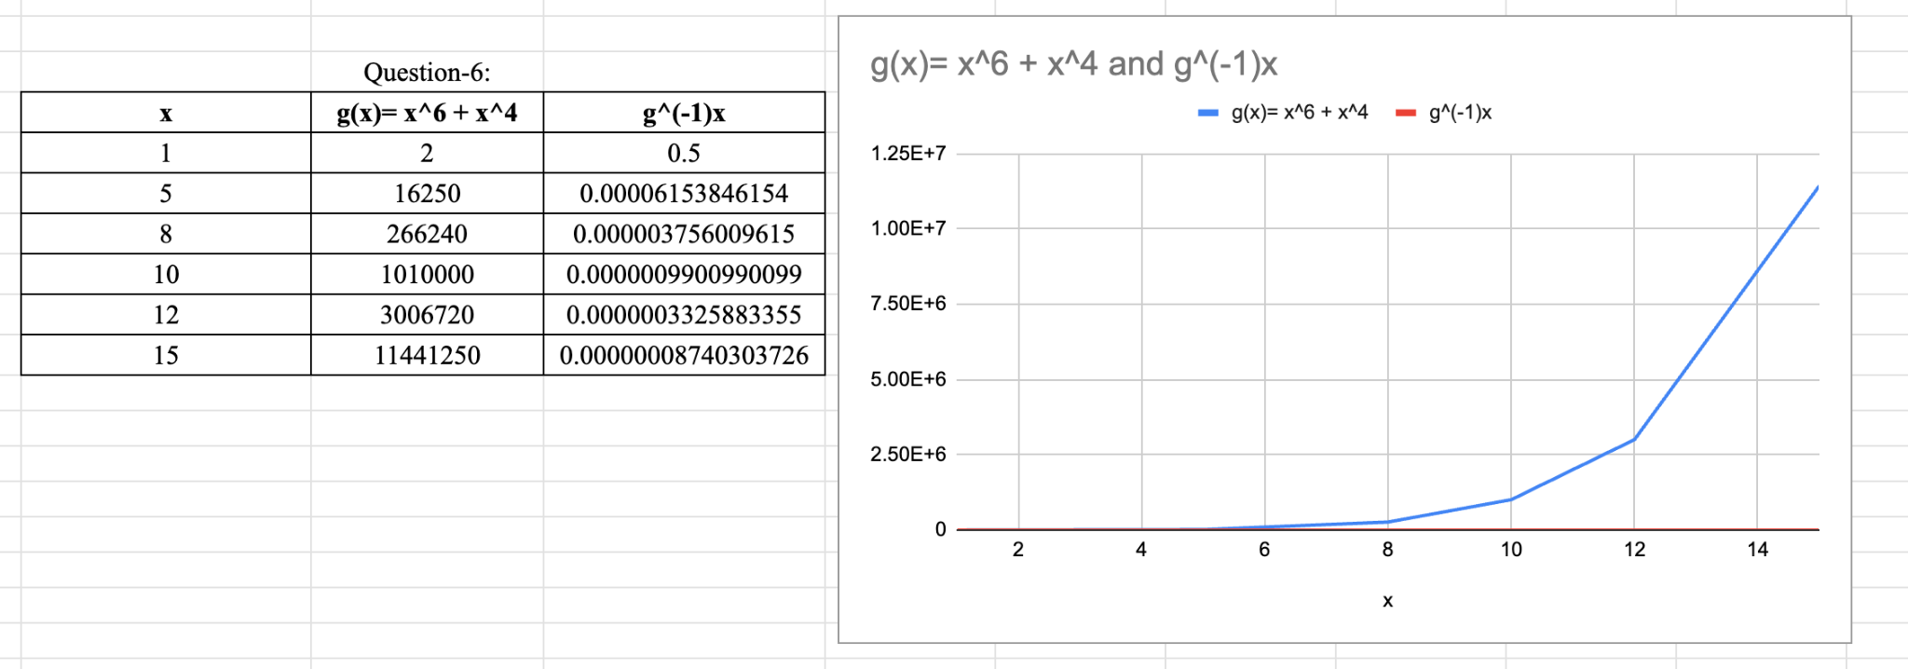

**Question-7:**

**#Solution-a**

We’ve Given that,

Q(t) = (1- )

= 1-

Rearranging the equation we get,

1- =

Taking log on both sides, we get

In (1- ) = -

t= -a * In (1- ) (eqn -1)

Therefore, Q’ (t) = -a * In (1- )

**#Solution-b:**

Given:

a = 2

Q(t) = 0.9Q0 (90% capacity represented by 0.9 times Q0)

Substituting these values into the equation:

t = -2 * ln(1 - 0.9)

t = -2 * ln(0.1)

t = -2 * (-2.3)

t = 4.6 seconds.