**#Solution-1:**

**(a) Find the average velocity over the given time intervals:**

To find the average velocity over the given time intervals, we need to calculate the rock's displacement during each interval and divide it by the interval's duration.

*(a) Average velocity over the given time intervals:*

**(i) [1, 2]:**

We can find the average velocity from time t = 1 to t = 2, by subtracting the initial position (t = 1) from the final position (t = 2) and dividing it by the time interval (2 - 1 = 1).

Initial position (t = 1):

y(1) = 10(1) - 1.86(1^2)

= 10 - 1.86

= 8.14 m

Final position (t = 2):

y(2) = 10(2) - 1.86(2^2)

= 20 - 7.44

= 12.56 m

Displacement: y(2) - y(1)

= 12.56 - 8.14

= 4.42 m

Average velocity: Displacement / Time interval

= 4.42 m / 1 s

= 4.42 m/s

**(ii) [1, 1.5]:**

Similarly, for the time interval from t = 1 to t = 1.5:

Initial position (t = 1):

y(1) = 8.14 m (from the previous calculation)

Final position (t = 1.5):

y(1.5) = 10(1.5) - 1.86(1.5^2)

= 15 - 4.185

= 10.815 m

Displacement: y(1.5) - y(1)

= 10.815 - 8.14

= 2.675 m

Average velocity: Displacement / Time interval

= 2.675 m / 0.5 s

= 5.35 m/s

**(iii) [1, 1.1]:**

For the time interval from t = 1 to t = 1.1:

Initial position (t = 1):

y(1) = 8.14 m (from the previous calculation)

Final position (t = 1.1):

y(1.1) = 10(1.1) - 1.86(1.1^2)

= 11 - 2.0466

= 8.7494 m

Displacement: y(1.1) - y(1)

= 8.7494 - 8.14

= 0.6094 m

Average velocity: Displacement / Time interval

= 0.6094 m / 0.1 s

= 6.094 m/s

**(iv) [1, 1.01]:**

For the time interval from t = 1 to t = 1.01:

Initial position (t = 1):

y(1) = 8.14 m (from the previous calculation)

Final position (t = 1.01):

y(1.01) = 10(1.01) - 1.86(1.01^2)

= 10.1 - 1.8666

= 8.2027 m

Displacement: y(1.01) - y(1)

= 8.2027 - 8.14

= 0.0627 m

Average velocity: Displacement / Time interval

= 0.0627 m / 0.01 s

= 6.27 m/s

**(v) [1, 1.001]:**

For the time interval from t = 1 to t = 1.001:

Initial position (t = 1):

y(1) = 8.14 m (from the previous calculation)

Final position (t = 1.001):

y(1.001) = 10(1.001) - 1.86(1.001^2)

= 10.01 - 1.86603

= 8.1463 m

Displacement: y(1.001) - y(1) = 8.1463 - 8.14 = 0.0063 m

Average velocity: Displacement / Time interval = 0.0063 m / 0.001 s = 6.3 m/s

**#Solution-1b):**

**Estimate the instantaneous velocity in Excel when 𝑡 = 1:**

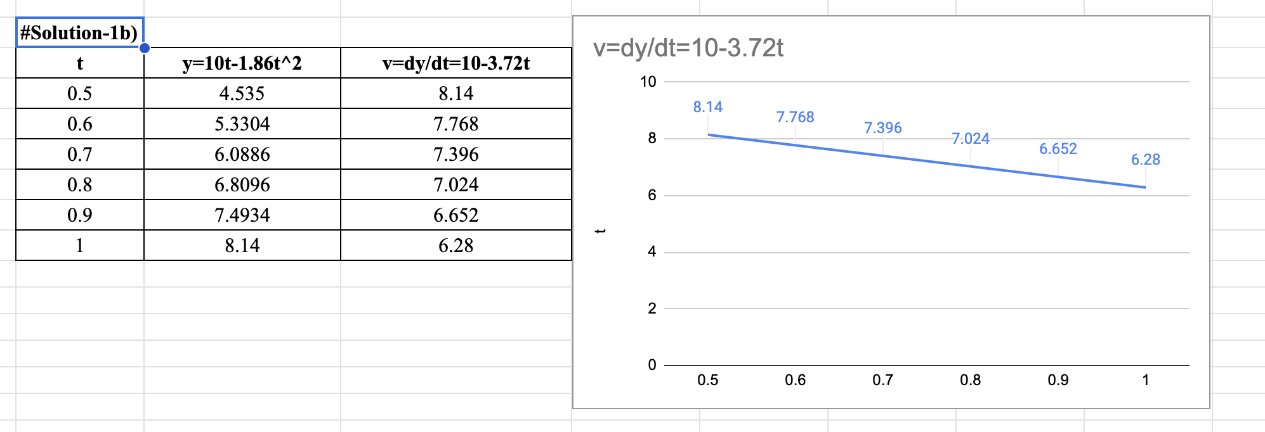

**#Solution-2a):**

**(a) Find the average velocity during each time period:**

Here, Given:

𝑠 = 2sin (𝜋𝑡) + 3cos (𝜋𝑡)

**(i) [1, 2]**

At t=1,

s (1) = 2 sin (𝜋*1) + 3 cos (𝜋*1)

s (1) = 2 sin (𝜋) + 3 cos (𝜋)

s (1) = 2 (0) + 3 (-1)

s (1) = -3 cm

At t=2,

s (2) = 2 sin (𝜋*2) + 3 cos (𝜋*2)

s (2) = 2 sin (2𝜋) + 3 cos (2𝜋)

s (2) = 2 (0) + 3 (1)

s (2) = 3 cm

Displacement during the interval is,

Δs = s (2) -s (1)

Δs = 3-(-3)

Δs = 6cm

The time duration of the interval (Δt) is 2-1=1 sec.

So, average velocity= Δs/Δt

= 6/1

=6 cm/s

**(ii) [1, 1.1]**

At t=1,

s (1) = -3 cm

At t=1.1,

s (1.1) = 2 sin (𝜋*1.1) + 3 cos (𝜋*1.1)

s (1.1) = 2 sin (1.1𝜋) + 3 cos (1.1𝜋)

s (1.1) = -3.4712 cm

Displacement during the interval is,

Δs = s (1.1) -s (1)

Δs = -3.4712- (-3)

Δs = -0.4712 cm

The time duration of the interval (Δt) is (1.1)-1=0.1 sec.

So, average velocity= Δs/Δt

= -0.4712/0.1

=-4.712 cm/s

**(iii) [1, 1.01]**

At t=1,

s (1) = -3 cm

At t=1.01,

s (1.01) = 2 sin (𝜋*1.01) + 3 cos (𝜋*1.01)

s (1.01) = 2 sin (1.01𝜋) + 3 cos (1.01𝜋)

s (1.01) = -3.06134 cm

Displacement during the interval is,

Δs = s (1.01) -s (1)

Δs = -3.06134- (-3)

Δs = -0.06134 cm

The time duration of the interval (Δt) is (1.01)-1=0.01 sec.

So, average velocity= Δs/Δt

= -0.06134/0.01

=-6.134 cm/s

**(iv) [1, 1.001]**

At t=1,

s (1) = -3 cm

At t=1.001,

s (1.001) = 2 sin (𝜋*1.001) + 3 cos (𝜋*1.001)

s (1.001) = 2 sin (1.001𝜋) + 3 cos (1.001𝜋)

s (1.001) = -3.006268 cm

Displacement during the interval is,

Δs = s (1.001) -s (1)

Δs = -3.006268- (-3)

Δs = -0.006268 cm

The time duration of the interval (Δt) is (1.001)-1=0.001 sec.

So, average velocity= Δs/Δt

= -0.006268/0.001

=-6.268 m/s

**Solution-2b):**

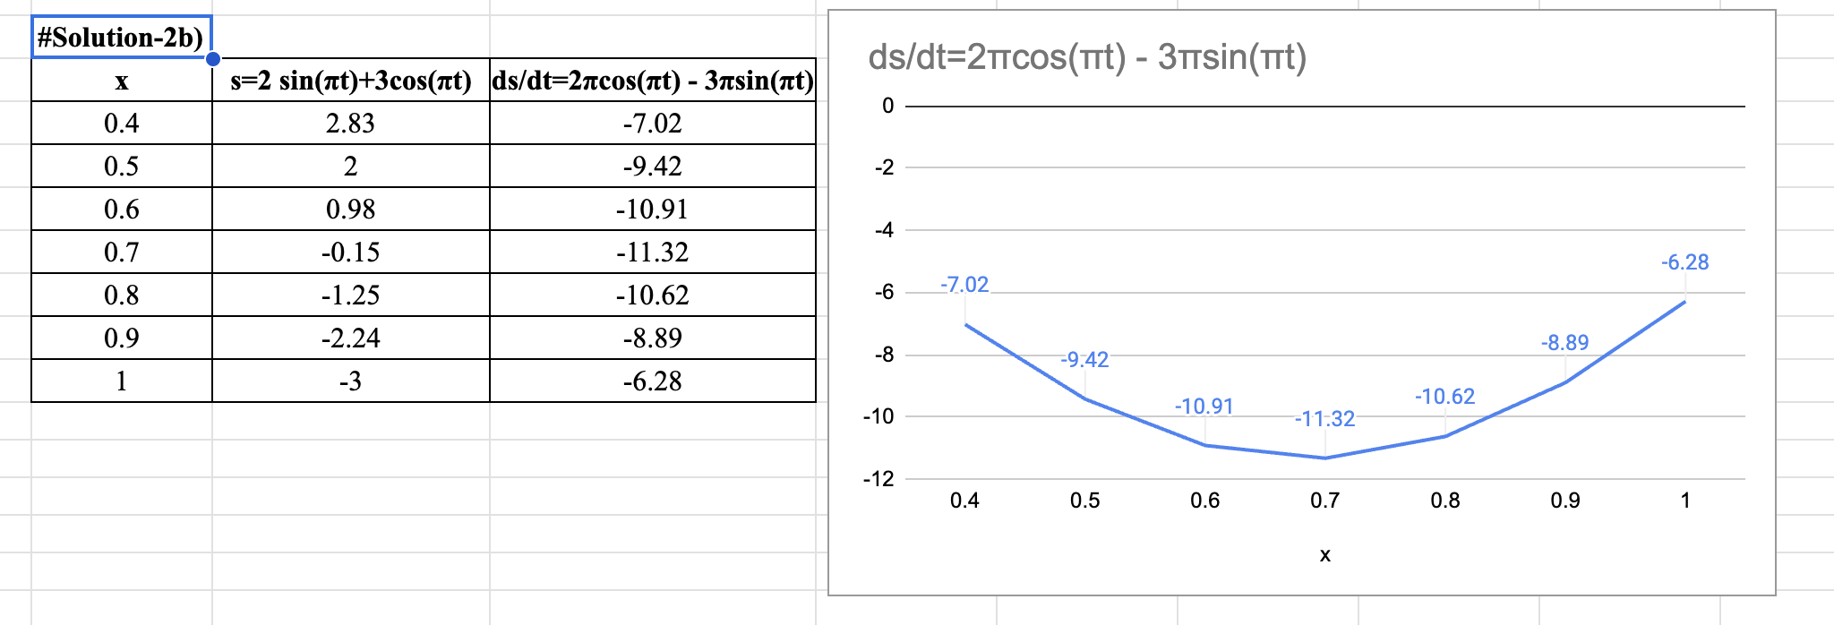

**#Solution-3a)**

Here we can see that (0/0) is indeterminate from now we can apply the L’hospital rule.

L= $\lim_{x→0}$ $\frac{sin(x)}{sin(πx)}$

= $\lim_{x→0}$ $\frac{\frac{d}{dx}sinx}{\frac{d}{dx}sin(πx).π}$

= $\frac{cos(x)}{cos(πx).π}$

= $\frac{1}{π}$ [$\frac{cos(0)}{cos(0)}$]

= $\frac{1}{π}$ $× 1$ = $\frac{1}{π}$

= 0.32

Solution-3b)

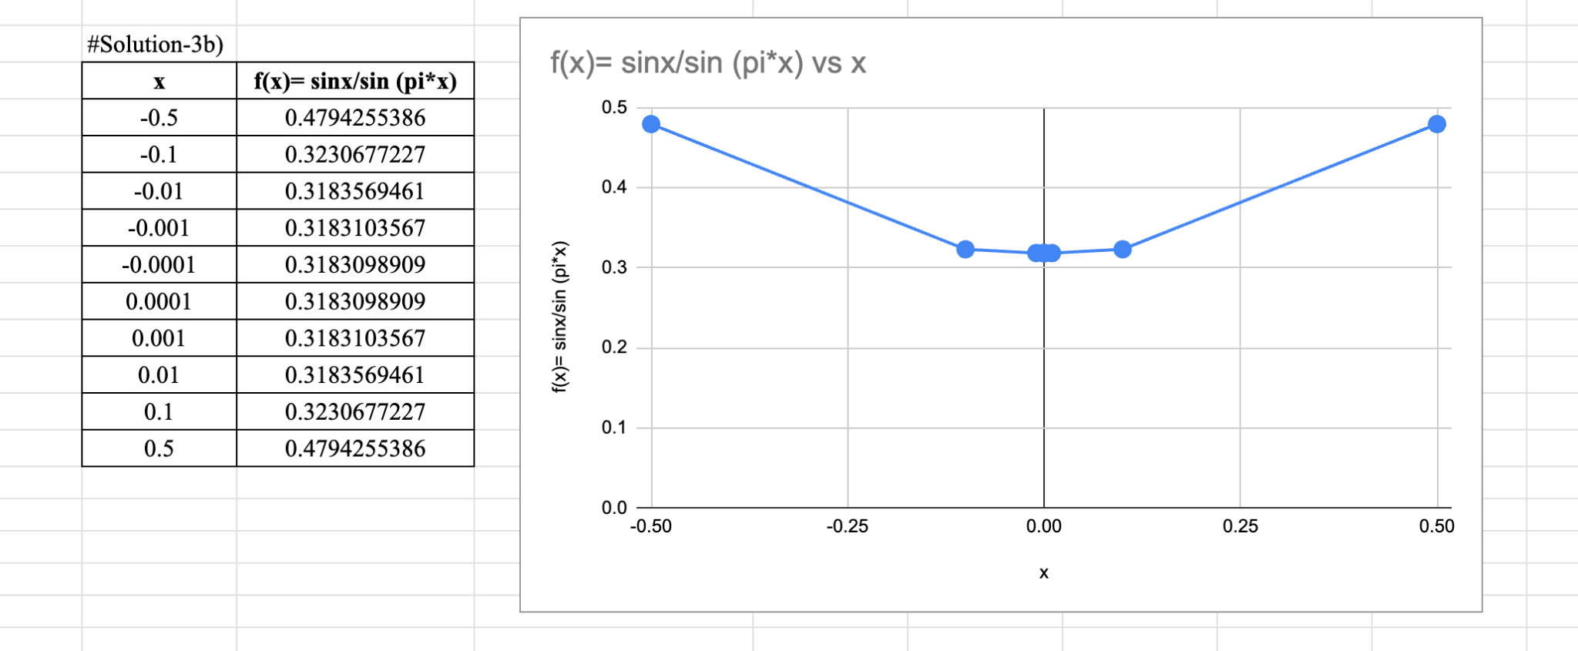

**Solution-4a):**

$\lim_{x→0}$ ${(1+x)}^{\frac{1}{x}}$

= $\lim_{x→0}$ [1+1+ $\frac{1(1-x)}{2!}x^{2} + \frac{1-(1-x)(1-2x)}{3!}{ x^{3} +.........] }^{}$

=[ $1+1+\frac{1}{2!}$ + $\frac{1}{3!}$ + $\frac{1}{4!}$ + ……………]

=e=2.71

Using the binomial expression function, we get:

$(1+x)^{n} = 1+nx+\frac{n(n-1)}{2!}x^{2} +\frac{n(n-1)(n-2)}{3!}x^{3}+.......$

**#Solution-4b)**

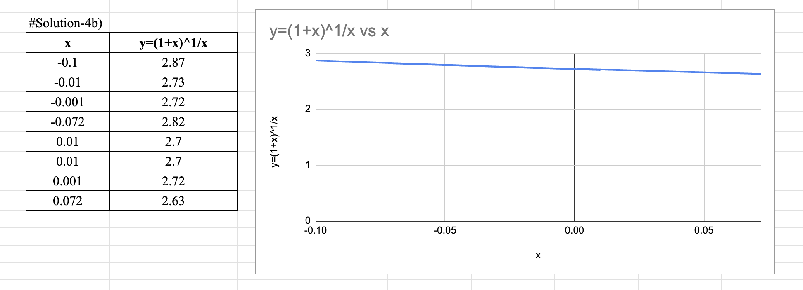

**#Solution-5a)**

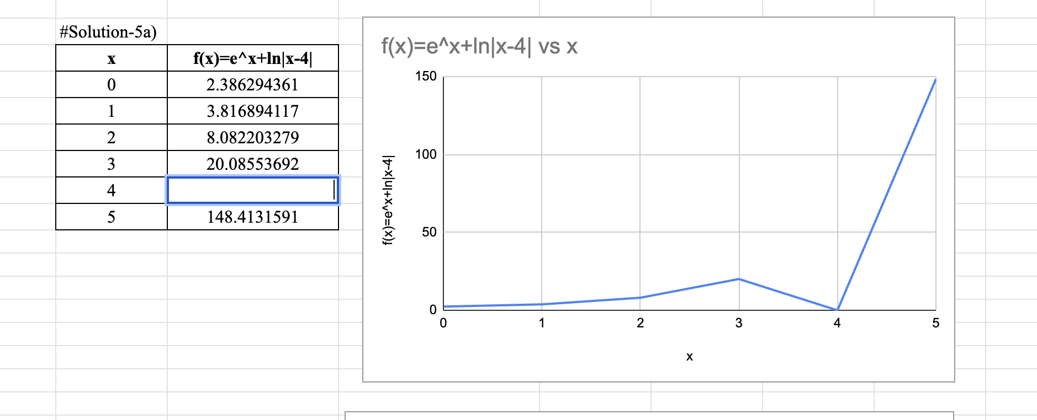

**#Solution-5b)**

To get a graph that represents the function better, we can specify the domain over

the range of 3.8 ≤ x ≤ 4.15 as shown below.

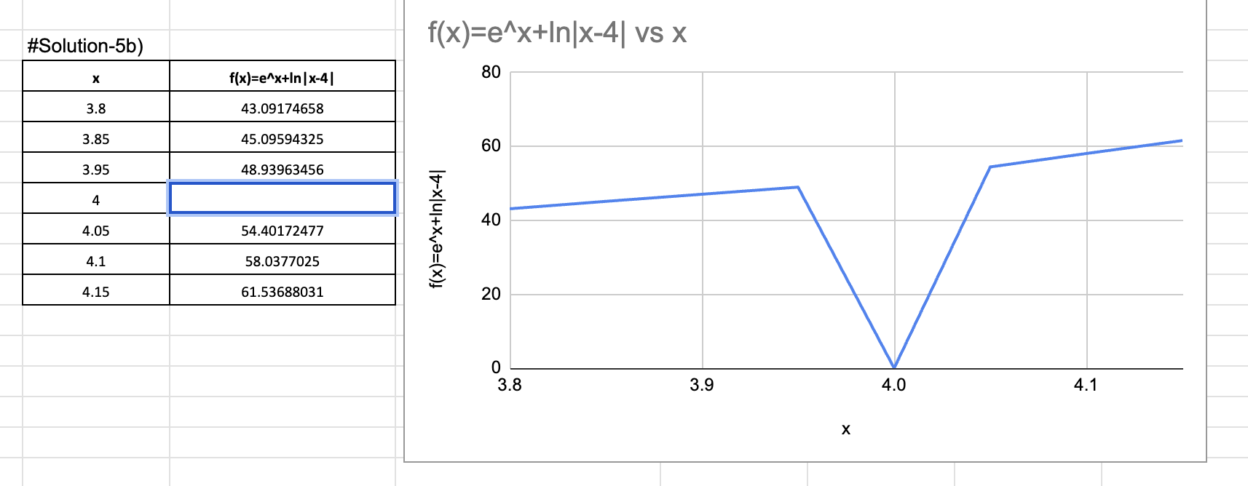

**Solution-6a)**

$\lim_{x→1}\frac{x^{3} - 1}{\sqrt{x} -1}$

⇒ $\lim_{x→1}\frac{x^{3} - 1}{\sqrt{x} -1}$

⇒ $\lim_{x→1}\frac{(x - 1)(x^{2}+x_{1})(\sqrt{x} +1)}{(\sqrt{x} +1)(\sqrt{x} +1)}$

⇒ $\lim_{x→1}\frac{(x - 1)(x^{2}+x+1)(\sqrt{x} +1)}{({\sqrt{x})}^{2} +1}$

⇒ $\lim_{x→1}\frac{(x - 1)(x^{2}+x+1)(\sqrt{x} +1)}{x -1}$

⇒ $\lim_{x→1}$ $x^{2}+x+1)(\sqrt{x} + 1)$

⇒ $(1^{2}+1+1)(1+1)$

⇒3*2

⇒6

⇒ $\lim_{x→1}\frac{x^{3} - 1}{\sqrt{x} -1}$

⇒6

**#Solution-6b)**

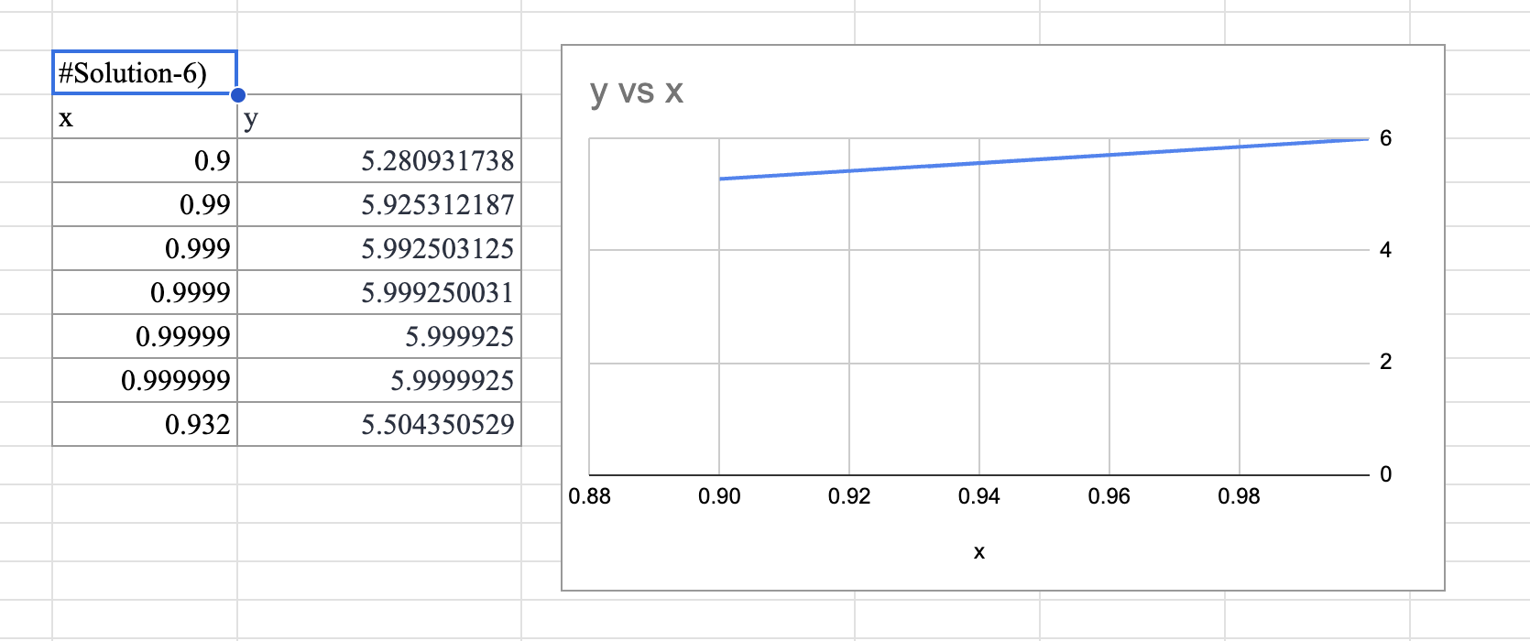

From⁡ the⁡ graph, ⁡we ⁡can ⁡see ⁡that ⁡x ⁡has ⁡to ⁡be ⁡approx.⁡0.932 ⁡to ⁡be ⁡with a ⁡distance ⁡of ⁡0.5 ⁡from⁡ the⁡ limit.