**#Solution-1:**

A.

Assume the following prototype is declared in class Time:

**void ~Time( int );**

* The destructor (which is denoted by a tilde ~) is mistakenly used in the prototype. A destructor does not have a return type and should not be declared with parameters. To correct this, we should remove the tilde and the parameter list- **void Time();**

B. Assume the following prototype is declared in class Employee:

**int Employee( string, string);**

-The function name “Employee” is used as a constructor. However, constructors do not have a return type, and their name must match the class name. To fix this, we can change the function name to match the class name (assuming the class is named “Employee”):

**Employee( string, string );**

C. The variable data is inaccessible within the static member function getCount(). To fix this, we can either make the data static or remove the reference to it in the getCount() function. Static member variable count is declared but not initialized. Initialize it to an appropriate value.

**Corrected Solution:**

#include <iostream>

class Example {

public:

Example(int y = 10): data(y) {

}

int getIncrementedData() const {

return ++data;

}

static int getCount() {

return count;

}

private:

int data;

static int count;

};

**#Solution-2:**

Output:

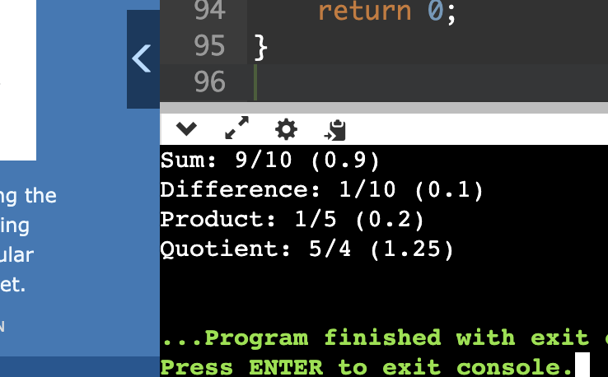

**Solution-3:**

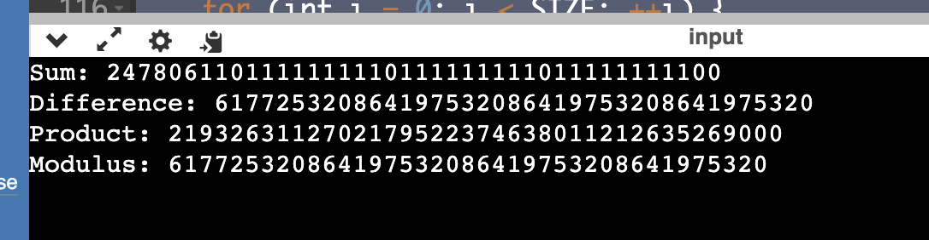

**#Solution-4:**

