**1) Look.**

**Solution 1.**

Command- look excl

output:

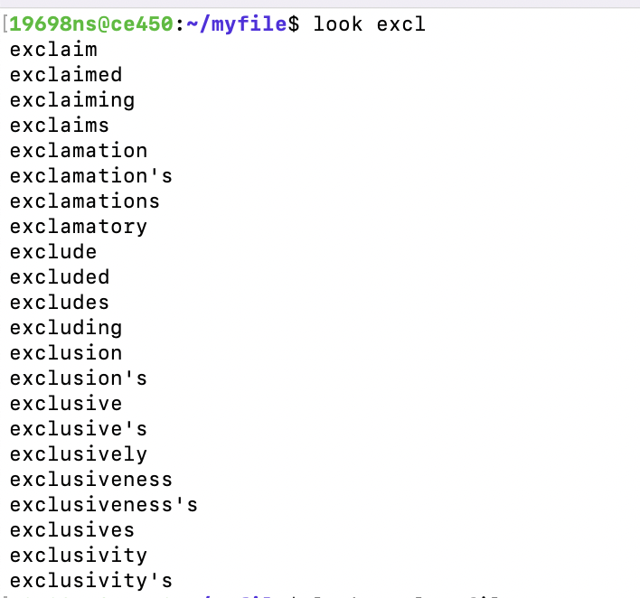

**Solution 2)**

command - look excl myfile

output:

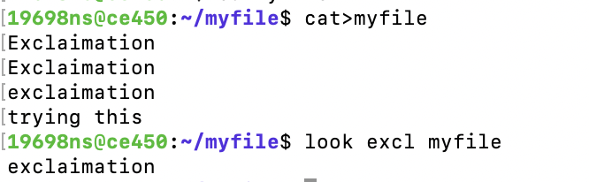

**Solution-3)**

Command- grep e ⇒ changed the color of the first word

Command- wc -w myfile⇒

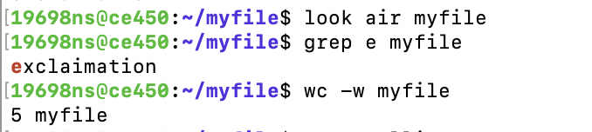

**2- Spell:**

**Solution-1)**

Written given sentence.

Command- aspell -c spelling.

output:

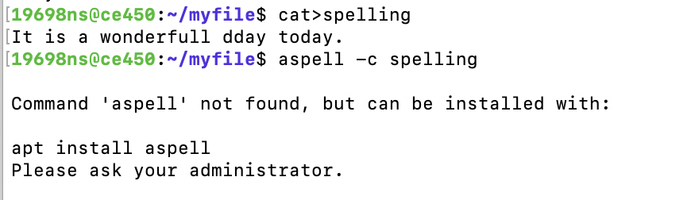

**3. Set and Unset:**

**Solution-1).**

Command to enter in c shell- exec /bin/csh

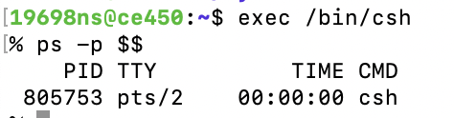

**Solution-2**

Command- echo $AA

Output⇒ 20

command - echo AA

Output⇒ AA

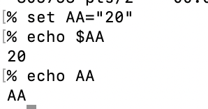

**Solution:**

The difference between no 3 and 4 is that no3(echo$AA) gave AA value whereas no4 (echo AA) printed the same AA.

**Solution-3)**

Command unsent cleared the variable.

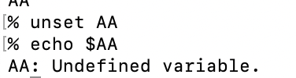

**Solution-4)**

Command used to change shell is - cat /etc/shells.

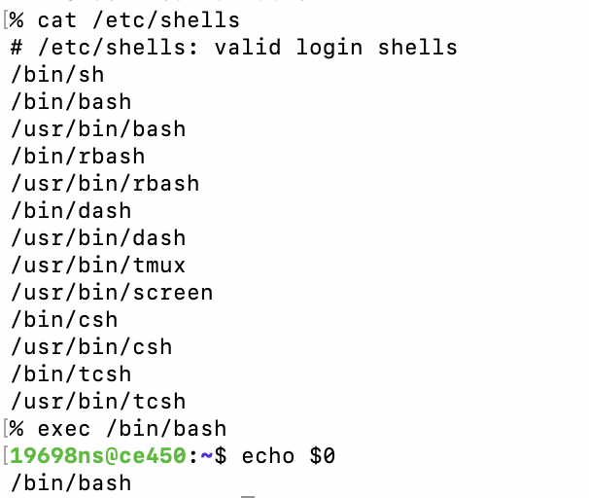

**Solution:**

**4) setenv and unsetenv**

**Solution;**

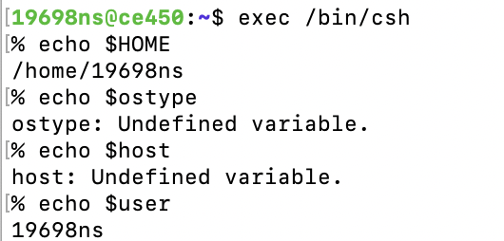

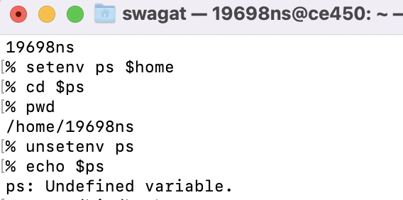

**5) export**

**Solution:**

command - echo $a⇒ printed the value of a

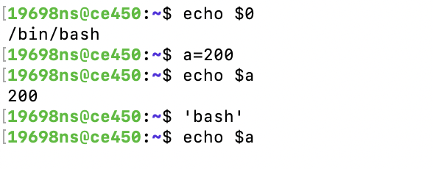

**solution)**

When entered in bash and echo $a the output is nothing because the local variable can’t access the local variable.

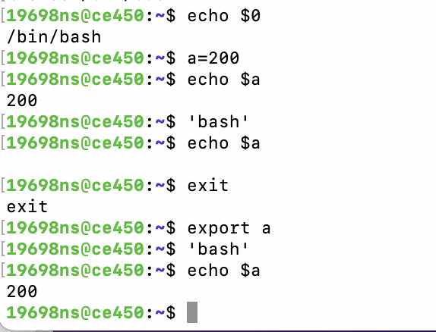

**Solution**:

The export command helps to get the value back from a shell by making it a global variable in each new shell.

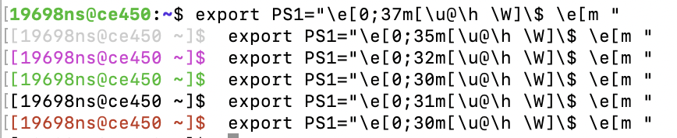

**6) Write:**

**Solution:**

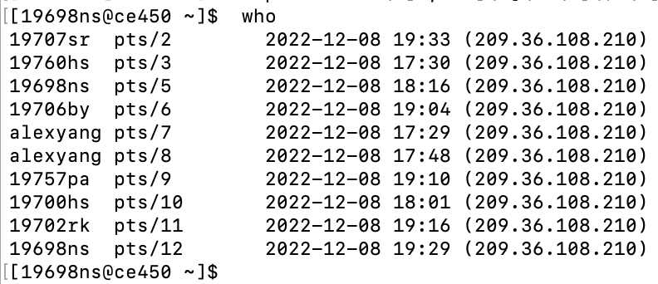

**Solution:**

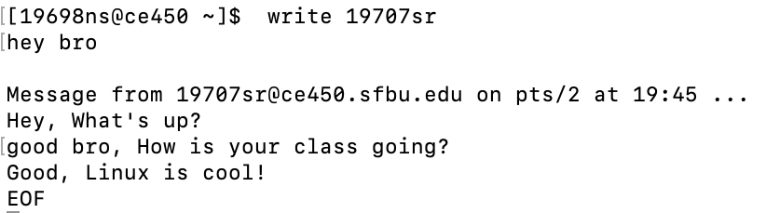

**7) Mail**

**Solution**)

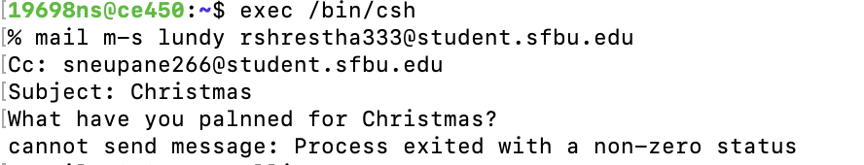

**Solution)**

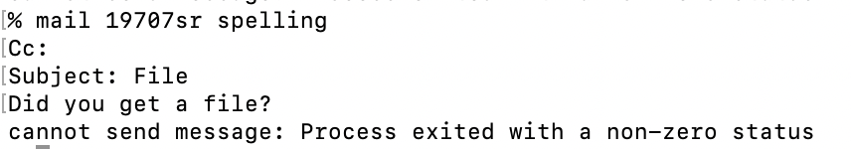

**8) alias and unalias**

**Solution;**

Command ll - listed all the directory and files.

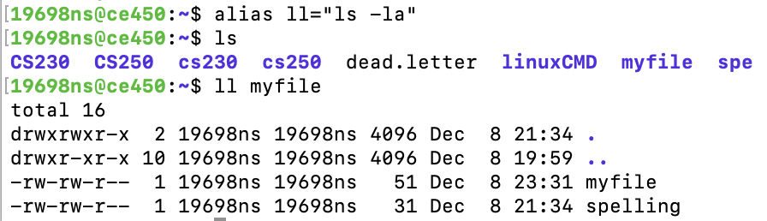

**Solution:**

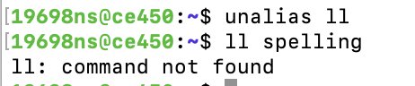

**9) tty:**

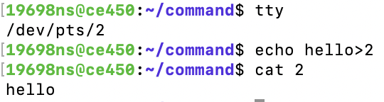

**Solution:**

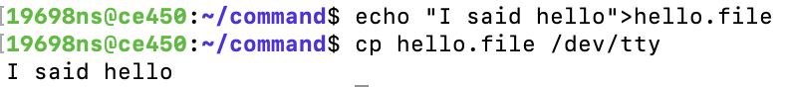

**10) ps**

**Solution:**



**Solution:**

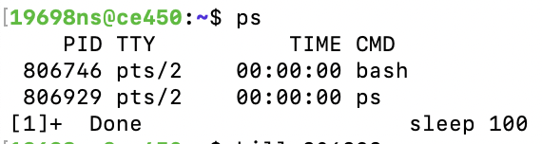

11-Solution):

The size of the file is 10240 bytes.

