Machine Learning-Based Transformer Fault Classification

A PROJECT REPORT
submitted by
CB.EN.U4ELC24035 Sanjith M P
CB.EN.U4ELC24046 Vedhanth M R
CB.EN.U4ELC24043 Swetraj Ravishwaran
CB.EN.U4ELC24042 Swagat A

in partial fulfillment of

BACHELOR OF TECHNOLOGY

IN

ELECTRICAL AND COMPUTER ENGINEERING



AMRITA SCHOOL OF ENGINEERING, COIMBATORE

AMRITA VISHWA VIDYAPEETHAM

COIMBATORE- 641112

March 2026

AMRITA SCHOOL OF ENGINEERING, COIMBATORE
AMRITA VISHWA VIDYAPEETHAM
COIMBATORE CAMPUS


BONAFIDE CERTIFICATE

This is to certify that the project entitled “Machine Learning-Based Transformer Fault Classification” submitted by
CB.EN.U4ELC23035 Sanjith M P
CB.EN.U4ELC23046 Vedhanth M R
CB.EN.U4ELC23043 Swetraj Ravishwaran
CB.EN.U4ELC23042 Swagat A

in partial fulfillment of the requirements for the subject 23ELC212- MACHINE LEARNING in Bachelor of Technology in ELECTRICAL & COMPUTER ENGINEERING is a bonafide record of the work carried out under my guidance and supervision at the Department of Electrical and Electronics Engineering, Amrita School of Engineering, Amrita Vishwa Vidyapeetham, Coimbatore Campus.

Mr. Nakkeeran M
Faculty In-Charge,
Assistant Professor (OC),
Department of Electrical and Electronics Engineering,
Amrita Vishwa Vidyapeetham, Coimbatore Campus,
India.

This project report was evaluated by us on………………(date)

INTERNAL EXAMINER EXTERNAL EXAMINER
Contents
List of Figures vi
List of Tables vii
Abbreviations viii
List of symbols ix
Abstract x
1. Introduction 1
1.1 Background 1
1.2 Problem Statement 1
1.3 Objectives of the Project 2
1.4 Research Gap 2
1.5 Contributions 2
1.6 Paper Organization 2
2. Related Works 3
2.1 Review of Existing Studies 3
2.2 Comparison 4
2.4 Justification 4
3. Proposed Approach 6
3.1 Proposed Framework 6
3.2 Dataset Details 6
3.3 Approach 8
4. Methodology 9
4.1 Techniques 9
4.2 Data Source 9
4.3 Implementation Steps 9
4.4 Evaluation Metrics 11
5. Implementation Details & Results 12
5.1 Setup 12
5.2 Dataset Preprocessing 12
5.3 Procedure 12
5.4 Results 12
5.5 Analysis 12
5.6 Comparison 12
6. Result Discussion 13
6.1 Insight 13
6.2 Implications 13
6.3 Limitations 13
7. Conclusion and Future Work 14
7.1 Conclusion 14
7.2 Future Work 14
Appendix A 15
References 16

List of Figures
1.1 This is my figure . . . . . . . . . . . . . . . . . . . . . . . . . . . . . . . . . . . 2
2.1 This is my figure . . . . . . . . . . . . . . . . . . . . . . . . . . . . . . . . . . . 5

List of Tables

1.1 This is my table . . . . . . . . . . . . . . . . . . . . . . . . . . . . . . . . . . . . . . . . . . . . . 2

2.1 This is my figure . . . . . . . . . . . . . . . . . . . . . . . . . . . . . . . . . . . . . . . . . . . . . 10

Abbreviations
TT – Truth Table
ANF – Algebraic Normal Form

List of symbols
F_{q} – Finite field with q elements
⊕ – Exclusive or (XOR)

Abstract
Transformer failures in power systems can result in significant economic losses, operational disruptions, and reduced reliability of electricity supply, making effective condition monitoring an important requirement for modern power networks. Power transformers are critical and expensive components of electrical systems, and their failure can cause long outages and costly repairs, therefore there is a growing need for automated and intelligent methods that can assess transformer condition and predict potential failures at an early stage. This study focuses on developing a machine learning based automated predictive monitoring system to determine the Health Index (HI) of oil-immersed transformers, where the health index represents the overall condition of the transformer by combining various operational and oil analysis parameters. The dataset used in this research is obtained from the publicly available Mendeley dataset (rz75w3fkxy), which includes several parameters related to transformer oil characteristics and operational conditions that provide useful information about the internal condition of the transformer. The collected dataset is first preprocessed to remove inconsistencies, handle missing values, and normalize the data so that the machine learning models can perform more effectively, and feature selection techniques are applied to identify the most relevant parameters that influence transformer health. Several machine learning algorithms including Random Forest Regressor, Decision Tree, Logistic Regression, Linear Regression, Multiple Linear Regression, and XGBoost are implemented to analyze the dataset and predict the transformer health index. The dataset is divided into training and testing sets in order to evaluate the performance, accuracy, and reliability of the developed models. During the training phase the algorithms learn patterns and relationships within the transformer condition data, and during the testing phase the predictive capability of each model is evaluated and compared. The results show that machine learning techniques are capable of effectively analyzing transformer condition data and providing reliable predictions of transformer health status, with ensemble learning models such as Random Forest and XGBoost demonstrating improved prediction accuracy and better handling of complex relationships between input variables. In conclusion, the proposed machine learning based predictive monitoring system provides an efficient and intelligent approach for assessing transformer health, enabling early detection of potential faults, improving maintenance planning, reducing unexpected transformer failures, and enhancing the overall reliability, safety, and operational efficiency of electrical power systems.
Keywords: Transformer Health Index, Machine Learning, Predictive Maintenance, Dissolved Gas Analysis, Power Transformers, Condition Monitoring.

Chapter 1

Introduction

1.1 Background
Power transformers are important and expensive parts of electrical power systems. They help send electricity from one place to another by changing the voltage levels. This makes sure that the electricity is delivered in a way that's efficient. Power transformers work all the time. Are under a lot of stress because of electricity, heat and the environment. Over time this stress can cause the insulation in the transformers to break down which can lead to problems or even failures. If a power transformer fails suddenly it can cause a lot of trouble like power outages, high costs to fix and problems with getting electricity to people.
To stop these failures from happening people use techniques to check the condition of the transformers. One of the common ways to do this is by using something called Dissolved Gas Analysis. This is where they look at the gases that are dissolved in the oil inside the transformer. These gases are made when the insulation breaks down or when there are problems. By looking at these gases, like hydrogen, methane and others people can get an idea of what is going on inside the transformer.
The old way of looking at these gases was to use rules and to have experts look at the results.. This way of doing things is not very good at handling complex problems. Now with the help of Machine Learning it is possible to use computers to look at the data and predict how healthy the transformer is. Machine Learning can find patterns in the data that people might miss and make the system for checking the condition of transformers reliable.

1.2 Problem Statement
Even though people use Dissolved Gas Analysis to check the condition of transformers the old way of looking at the data is not very good. It relies much on rules and on experts to look at the results. This can lead to mistakes. Can make it hard to find problems with the transformer. Also looking at the data by hand can take a time and is prone to human error.
Another problem is that there is much data coming from the power systems that it is hard to handle. This is why there is a need for a system that can look at the data automatically and predict how healthy the transformer is. Machine Learning can help with this by looking at the data and finding patterns.

1.3 Objectives of the Project

The main goal of this project is to make a system that uses Machine Learning to predict how healthy a power transformer is. The specific goals are:

To look at the data from the Dissolved Gas Analysis.

To get the data ready for the Machine Learning model.

To try out Machine Learning models to see which one is best at predicting the health of the transformer.

To compare the models to see which one is the most accurate.

To find the model for predicting the health of the transformer

1.4 Research Gap
A lot of research has been done on using methods and Machine Learning to diagnose problems with transformers and predict their health.. Many of these methods rely too much on rules or focus only on making the predictions more accurate without thinking about how to make the system more efficient. Some models need a lot of data. Are too complex which can make them hard to use in real-time systems.
There is also a lack of research that compares Machine Learning models to see which one is best at predicting the health of transformers. This is why there is a need for research in this area to find the best way to predict the health of transformers.

1.5 Contributions
The main things that this project will contribute are:
- Making a system that uses Machine Learning to predict the health of power transformers.
- Using the data from the Dissolved Gas Analysis to predict the health of the transformer.
- Trying out Machine Learning models to see which one is best.
- Comparing the models to see which one is the most accurate.
Giving insights into how Machine Learning can be used to make the system for checking the condition of transformers

1.6 Paper Organization
This report is organized in the way:
- Chapter 1 introduces the project, including the background, problem statement, goals, research gap and contributions.
- Chapter 2 looks at research that has been done in this area and talks about previous work on diagnosing problems with transformers and predicting their health.
- Chapter 3 explains the methods that were used in this project including describing the data getting the data ready and implementing the Machine Learning models.
- Chapter 4 presents the results of the experiments. Evaluates the performance of the Machine Learning models.
- Chapter 5 concludes the study and talks about future work to improve the system, for predicting the health of transformers.
Chapter 2

Related Works

2.1 Review of Existing Studies
Several studies have looked at using Dissolved Gas Analysis and machine learning techniques to diagnose faults and predict the health of power transformers. Gouda and his team investigated ways to improve the accuracy of Dissolved Gas Analysis techniques like the Dornenburg ratio Rogers ratio, IEC ratio and Duval triangle. These traditional methods diagnose transformer faults by looking at the ratios of gases in transformer oil. However they often fail to provide decisions for certain fault cases that do not match predefined codes.
The researchers used Artificial Intelligence methods like Fuzzy Logic and Artificial Neural Networks to overcome this limitation. Their results showed that Artificial Intelligence techniques significantly improved the accuracy of diagnoses with Fuzzy Logic achieving accuracy levels to 89 percent. Despite these improvements the study found that Artificial Intelligence models rely heavily on training data and can be complicated to implement in large-scale monitoring systems.
Another study by Azmi and his team focused on improving fault classification using machine learning techniques. They addressed the issue of datasets, which can negatively affect classification performance. The researchers applied data balancing techniques, including Random Under Sampling Edited Nearest Neighbor, NearMiss Random Over Sampling and ADASYN. These techniques were combined with machine learning classifiers like Support Vector Machine, Decision Tree and Random Forest.
The results showed that the combination of Edited Nearest Neighbor and Support Vector Machine achieved the performance with an accuracy of approximately 88 percent. However the researchers noted that certain sampling techniques may remove information or introduce overfitting, which can impact the models ability to generalize.
Ibrahim and Hebala proposed a machine learning framework for predicting the health of power transformers using Dissolved Gas Analysis data. Their study focused on estimating the transformer Health Index, which provides a measure of transformer condition. The researchers evaluated machine learning algorithms, including Linear Regression, Ridge Regression, Lasso, Support Vector Regression, Decision Trees, Random Forest, Gradient Boosting, XGBoost, LightGBM and CatBoost.
They introduced an ensemble model that combined LightGBM and CatBoost with SHAP-based feature selection to improve model interpretability and reduce feature complexity. The proposed approach achieved improved prediction accuracy and better transparency in identifying features. However the model required benchmarking and hyperparameter tuning, which may increase computational complexity during real-time deployment.
Overall these studies demonstrate that machine learning techniques have significantly improved transformer fault detection and health prediction compared to diagnostic methods. However challenges like complexity, dataset imbalance and scalability remain important research concerns.

2.2 Comparison

The reviewed studies use techniques for transformer fault diagnosis and health prediction. Traditional Dissolved Gas Analysis-based techniques rely on gas ratio calculations and predefined rules making them simple but often less accurate for fault patterns. Artificial Intelligence methods like Fuzzy Logic and Neural Networks improve accuracy by learning patterns from historical data.
Machine learning classifiers like Support Vector Machine, Decision Trees and Random Forest provide classification performance especially when combined with data balancing techniques to address dataset imbalance. Ensemble learning models like LightGBM and CatBoost have also demonstrated predictive performance by capturing nonlinear relationships within transformer condition data. However these advanced models may require computational resources and careful parameter tuning compared to traditional techniques.2.3 Gap Analysis

Although significant research has been conducted in transformer fault detection using Dissolved Gas Analysis and machine learning techniques several limitations still exist. Many traditional diagnostic techniques fail to provide results for complex or mixed fault conditions. Some machine learning approaches focus mainly on improving classification accuracy without considering interpretability or computational efficiency.

Dataset imbalance is another issue that affects the reliability of predictive models. Advanced Artificial Intelligence models require datasets and high computational power, which may limit their use in real-time monitoring systems. These gaps highlight the need, for machine learning frameworks that balance predictive accuracy, interpretability and computational efficiency.

2.3 Gap Analysis
Although significant research has been conducted in transformer fault detection using Dissolved Gas Analysis and machine learning techniques several limitations still exist. Many traditional diagnostic techniques fail to provide results for complex or mixed fault conditions. Some machine learning approaches focus mainly on improving classification accuracy without considering interpretability or computational efficiency.
Dataset imbalance is another issue that affects the reliability of predictive models. Advanced Artificial Intelligence models require datasets and high computational power, which may limit their use in real-time monitoring systems. These gaps highlight the need, for machine learning frameworks that balance predictive accuracy, interpretability and computational efficiency.

2.4 Justification
Based on the limitations identified in studies there is a need to develop improved machine learning models that can accurately predict transformer health conditions while maintaining computational efficiency. The proposed approach aims to address these challenges by applying machine learning algorithms and optimized data preprocessing techniques to analyze Dissolved Gas Analysis data.
By using machine learning models and effective feature analysis methods the proposed system seeks to improve prediction accuracy while ensuring that the model remains practical for real-world transformer monitoring applications. This approach will focus on Dissolved Gas Analysis and machine learning techniques to diagnose transformer faults and predict health conditions. The goal is to develop a system that can accurately predict health conditions using Dissolved Gas Analysis data and machine learning techniques.

Chapter 3

Proposed Approach

3.1 Proposed Framework
The proposed framework aims to predict the Health Index (HI) of power transformers using machine learning techniques based on transformer oil analysis parameters. The framework integrates multiple stages including dataset preparation, data preprocessing, feature analysis, model training, and performance evaluation. This structured workflow enables accurate prediction of transformer health conditions and assists in early detection of possible transformer faults.
The process begins with collecting and preparing the transformer oil analysis dataset. The dataset is then preprocessed to remove irrelevant attributes and handle inconsistencies in the data. After preprocessing, feature analysis is performed to study relationships between transformer oil parameters and the health index. Machine learning models are then trained using the processed dataset. Finally, the trained models are evaluated using standard performance metrics to determine the most effective model for predicting transformer health.
The overall workflow of the proposed system is illustrated in the process flow diagram, which includes the following stages:
- Dataset Collection
- Data Preprocessing
- Feature Analysis
- Model Training
- Model Evaluation
This framework ensures systematic processing of transformer oil data and improves the reliability of health index prediction using machine learning techniques.
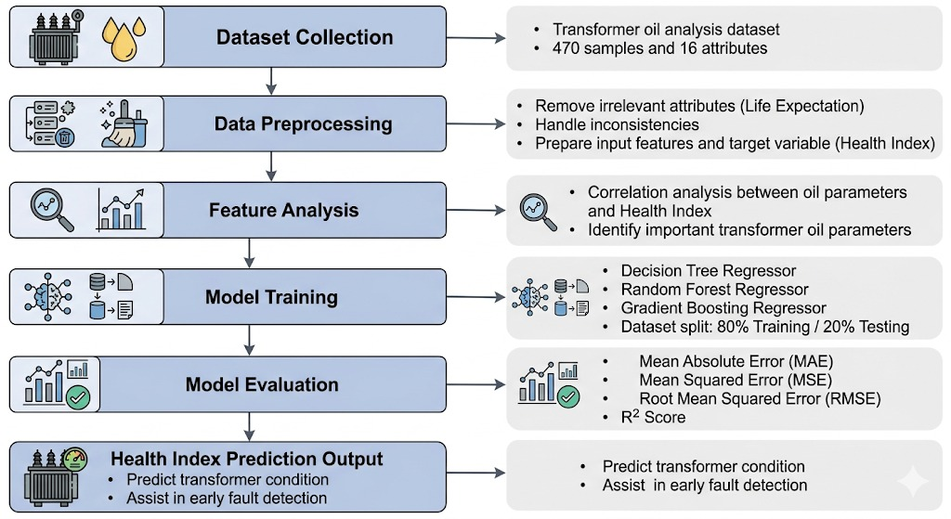
Fig 1:Framework

3.2 Dataset Details
The dataset used in this study consists of transformer oil analysis data collected from oil-immersed power transformers. The dataset contains 470 transformer samples and 16 attributes, including various dissolved gas analysis (DGA) gases and oil quality parameters that indicate the operational condition of transformers.
The dataset includes the following parameters:
- Hydrogen (H₂)
- Oxygen (O₂)
- Nitrogen (N₂)
- Methane (CH₄)
- Carbon Monoxide (CO)
- Carbon Dioxide (CO₂)
- Ethylene (C₂H₄)
- Ethane (C₂H₆)
- Acetylene (C₂H₂)
- DBDS
- Power Factor
- Interfacial Voltage
- Dielectric Rigidity
- Water Content
- Health Index
- Life Expectation

These parameters represent the chemical composition and physical properties of transformer insulation oil. Dissolved gases such as hydrogen, methane, ethylene, and acetylene are commonly used indicators of electrical and thermal faults occurring inside transformers. Monitoring these gases helps in identifying insulation degradation and potential transformer failures.
Among these attributes, the Health Index (HI) represents the overall health condition of the transformer and is used as the target variable in this study. The Life Expectation attribute is excluded during model training because it is derived from the health index and may introduce bias in the prediction model.

3.3 Approach
The proposed research approach follows a quantitative and experimental methodology for predicting transformer health index using machine learning techniques. The study involves analyzing transformer oil parameters and applying machine learning algorithms to learn patterns that represent transformer health conditions.
Initially, the dataset is prepared and preprocessed by removing unnecessary attributes and organizing the data into input features and target variables. Feature analysis is then conducted using correlation techniques to identify the most influential parameters affecting transformer health.
After preprocessing and feature analysis, machine learning regression models are applied to predict the health index. In this study, three machine learning models are used due to their ability to capture nonlinear relationships within the dataset:
- Decision Tree Regressor
- Random Forest Regressor
- Gradient Boosting Regressor
The dataset is divided into training and testing sets using an 80:20 split to ensure proper evaluation of model performance. The models are trained using the training data and tested on unseen data to evaluate their prediction capability.
Model performance is evaluated using regression performance metrics including:
- Mean Absolute Error (MAE)
- Mean Squared Error (MSE)
- Root Mean Squared Error (RMSE)
- R² Score
Through this experimental process, the model with the highest prediction accuracy and lowest error values is identified as the most suitable model for predicting transformer health index.

Chapter 4

Methodology

4.1 Techniques
This study uses machine learning regression techniques to predict the Health Index of power transformers based on transformer oil analysis parameters. The algorithms used include Simple Linear Regression, Multiple Linear Regression, Polynomial Regression, Ridge Regression, Lasso Regression, Elastic Net Regression, Support Vector Regression (SVR) K-Nearest Neighbors (KNN) Regression, Decision Tree Regression, Random Forest Regression, AdaBoost Regression, Gradient Boosting Regression and XGBoost Regression.
These machine learning models were implemented using the Python programming language and the Scikit-Learn library. Each model was trained using diagnostic parameters as input features and the Health Index as the target variable. The goal is to compare the prediction performance of these models and identify the one that provides the accurate estimation of transformer health using Health Index.

4.2 Data Source
The dataset used in this study was obtained from oil analysis data. This data contains diagnostic parameters used for assessing transformer condition. The dataset includes gas concentrations and oil quality indicators such as Hydrogen, Oxygen, Nitrogen, Methane, Carbon Monoxide (CO) Carbon Dioxide (CO₂) Ethylene, Ethane, Acetylene, DBDS, Power Factor, Interfacial Voltage, Dielectric Rigidity, Water Content and Life Expectation.
These parameters are commonly used in diagnostics to identify insulation degradation and internal faults. The target variable used for prediction is the Health Index, which represents the condition of the transformer. The dataset was. Analyzed using Python-based data analysis libraries such as Pandas, NumPy and Scikit-Learn.

4.3 Implementation Steps
The implementation of the machine learning framework was carried out through the following steps:
- Data Loading: The dataset was imported into the Python environment using Pandas.
- Data Preprocessing: Column names were. The dataset was inspected for missing or inconsistent values.
- Feature Selection: Transformer diagnostic parameters were used as input features while the Health Index was used as the target variable.
- Data Splitting: The dataset was divided into training and testing sets using an 80:20 ratio.
- Feature Scaling: For models to feature magnitudes, such as Support Vector Regression and Elastic Net Regression feature scaling was applied.
- Model Training: Multiple regression algorithms were trained using the training dataset.
- Hyperparameter Tuning: Some models were fine-tuned to determine hyperparameter values.
- Prediction: The trained models were used to predict the Health Index for the testing dataset.
- Performance Evaluation: The predictions were evaluated using performance metrics.

4.4 Evaluation Metrics

The performance of the implemented machine learning models was evaluated using several statistical metrics that measure prediction accuracy. These metrics include Mean Absolute Error (MAE), Mean Squared Error (MSE), Root Mean Squared Error (RMSE), and the coefficient of determination (R²).

Mean Absolute Error (MAE) measures the average magnitude of prediction errors without considering their direction.

MAE = (1/n) * Σ|Actualₜ - Predictedₜ|

Mean Squared Error (MSE) measures the average squared difference between predicted and actual values.
MSE = (1/n) * Σ (yᵢ - ŷᵢ)²

Root Mean Squared Error (RMSE) is the square root of MSE and represents prediction error in the same units as the target variable.
RMSE=√(1/n∑(yi-^yi)²)

Coefficient of Determination (R²) measures how well the model explains the variance in the target variable.
R²=1- SS_{res}/ SS_{tot}
SS_{res} (Residual Sum of Squares): Σ(yᵢ - ŷᵢ)²
SS_{tot}(Total Sum of Squares): Σ(yᵢ - $\overline{y}$_{i})²

Chapter 5

Implementation Details & Results

5.1 Setup
I used Google Colab to do my machine learning experiments. Google Colab is a tool because it lets me work on machine learning on the cloud. I did all my work using the Python programming language and some other helpful tools that people often use for data science.
Here are the tools I used:
- Pandas to load and get my data
- NumPy to do math and numbers stuff
- Scikit-Learn to make regression algorithms and check how good they are
- Matplotlib to make pictures of my results
- XGBoost library to make an XGBoost regression model
I did a lot of experiments where I trained regression algorithms to try to guess the Health Index of transformers. I used some numbers from oil analysis to help me make these guesses, about the Health Index of transformers. The goal was to see if I could use machine learning to predict the Health Index of transformers using these numbers. I was working with machine learning and the Health Index of transformers to get results.

5.2 Dataset Preprocessing
Before training the machine learning models we made sure the dataset was clean and reliable.
First we loaded the dataset using Pandas. Checked for any formatting problems and missing values. We also made the column names consistent so they would work well with the machine learning algorithms.
- The dataset has parameters that help diagnose transformer oil, including:
- Hydrogen
- Oxygen
- Nitrogen
- Methane
- Carbon Monoxide (CO)
- Carbon Dioxide (CO₂)
- Ethylene
- Ethane
- Acetylene
- DBDS
- Power Factor
- Interfacial Voltage
- Dielectric Rigidity
- Water Content
- Life Expectation
We used these parameters as input features. The Health Index was what we were trying to predict.
We split the dataset into two parts: 80% for training the models and 20% for testing them.
For some algorithms like Support Vector Regression and Elastic Net Regression we had to adjust the feature values so they were all, on the scale. We used StandardScaler to do this.

5.3 Procedure

Before we start training the machine learning models we need to make sure the dataset is consistent and reliable.

First we load the dataset using the Pandas library and check for any formatting issues and missing values. We also make sure the column names are standard so they work with the machine learning algorithms.

The dataset has a lot of oil diagnostic parameters, including Hydrogen, Oxygen, Nitrogen, Methane, Carbon Monoxide, Carbon Dioxide, Ethylene, Ethane, Acetylene, DBDS, Power Factor, Interfacial Voltage, Dielectric Rigidity, Water Content and Life Expectation.

We use these variables as input features for the machine learning models. We use the Health Index as the target variable.

We split the dataset into two parts: a training set and a testing set. We use 80 percent of the data for training the models and 20 percent for testing how well they work.

For some algorithms like Support Vector Regression and Elastic Net Regression we need to scale the features so they're all on the same level. We use something called StandardScaler to do this.

The machine learning workflow we use is like a recipe.

First we load the dataset. Clean it up.

Next we separate the input features from the target variable.

Then we split the dataset into training and testing sets.

We train a lot of regression models using the training dataset. For some of these models we need to adjust the settings called hyperparameters to get the results. We use something called GridSearchCV to find the settings.

After we train the models we use them to make predictions on the testing dataset.

Finally we compare the predicted values, with the Health Index values using some statistical metrics.

We use a lot of regression algorithms including:

Linear Regression

Polynomial Regression

Ridge Regression

Lasso Regression

Elastic Net Regression

Support Vector Regression

K-Nearest Neighbors Regression

Decision Tree Regression

Random Forest Regression

AdaBoost Regression

Gradient Boosting Regression

XGBoost Regression

5.4 Results

The performance of the machine learning models was checked using metrics like Mean Absolute Error, Mean Squared Error, Root Mean Squared Error and the coefficient of determination.

Table 5.1 summarizes how all the machine learning models did based on the testing dataset.
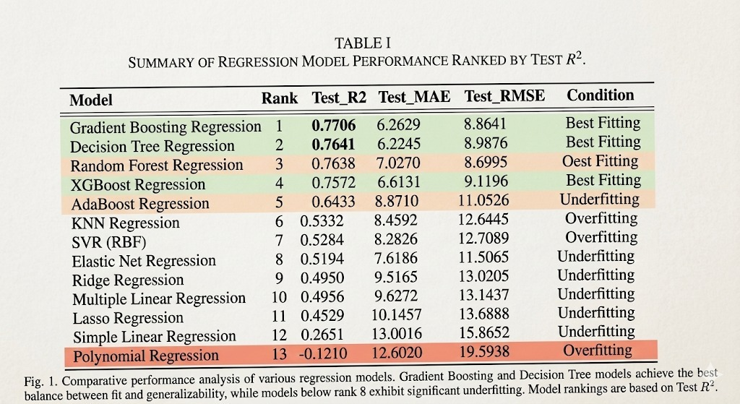

Table 5.1 Performance Comparison of Machine Learning Models
Model | Train R² | Test R² | MAE | RMSE | Model Behavior
Gradient Boosting Regression | 0.8140 | 0.7706 | 6.26 | 8.86 | Best Fitting
Decision Tree Regression | 0.7475 | 0.7641 | 6.22 | 8.98 | Best Fitting
Random Forest Regression | 0.9453 | 0.7638 | 6.03 | 8.99 | Overfitting
XGBoost Regression | 0.8391 | 0.7572 | 6.61 | 9.12 | Best Fitting
AdaBoost Regression | 0.7378 | 0.7228 | 7.20 | 9.74 | Best Fitting
KNN Regression | 1.0000 | 0.5332 | 8.45 | 12.64 | Overfitting
SVR | 0.8042 | 0.5284 | 8.28 | 12.70 | Overfitting
Elastic Net Regression | 0.5029 | 0.5194 | 9.55 | 12.82 | Underfitting
Ridge Regression | 0.5046 | 0.4970 | 9.62 | 13.12 | Underfitting
Multiple Linear Regression | 0.5046 | 0.4956 | 9.62 | 13.14 | Underfitting
Lasso Regression | 0.4798 | 0.4529 | 10.14 | 13.68 | Underfitting
Simple Linear Regression | 0.2054 | 0.2651 | 13.00 | 15.86 | Underfitting
Polynomial Regression | 0.7882 | -0.1210 | 12.60 | 19.59

The results show that the Gradient Boosting Regression model did the best. It got the testing R² value of 0.7706. This means the Gradient Boosting Regression model was the best at making predictions. The Gradient Boosting Regression model was better, than all the machine learning models.

5.5 Analysis
The results of our experiment show that traditional methods like Linear Regression and Ridge Regression do not work well. This is because these methods think that the relationships between the variables are simple and straight but the data from the transformer diagnostics is actually very complicated.
We tried using some methods like Lasso and Elastic Net to make the models a bit more stable but they still did not work perfectly.
The models that use trees like Decision Tree and Random Forest worked better because they can understand the relationships between the variables.
Out of all the models we tried Gradient Boosting Regression worked the best. It was good at making predictions based on the training data and the testing data, which means it is very good at understanding the diagnostic data. Gradient Boosting Regression is really good at finding a balance, between the training and testing accuracy, which's a great thing.

5.6 Comparison
The results obtained in this study indicate that ensemble learning methods outperform traditional regression techniques for transformer Health Index prediction.
Models such as Random Forest, Gradient Boosting, and XGBoost provide higher prediction accuracy due to their ability to combine multiple weak learners and capture complex relationships in the data.
Among these models, Gradient Boosting Regression achieved the highest testing accuracy and demonstrated the most stable prediction performance, making it the most suitable model for transformer health prediction in this study.

Chapter 6

Result Discussion

6.1 Insight
The experimental results show that machine learning techniques can really predict the Health Index of transformers using the parameters from the transformer oil. Several regression models were tried out to see which one was the best at predicting the condition of the transformers.
Among all the models that were tested the Gradient Boosting Regression model did the best at predicting the Health Index with a testing R² value of 0.7706. This means it was better at understanding the relationship between the oil parameters and the Health Index than the other models. The Decision Tree Regression and Random Forest Regression models also did well with testing R² values of 0.7641 and 0.7638.
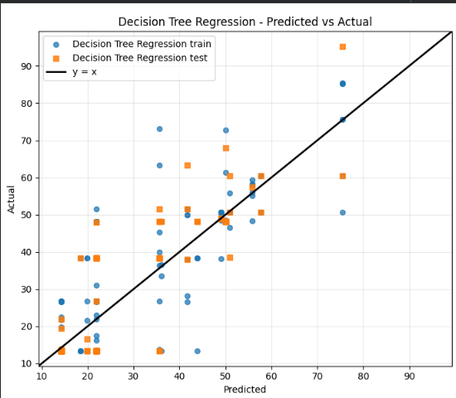
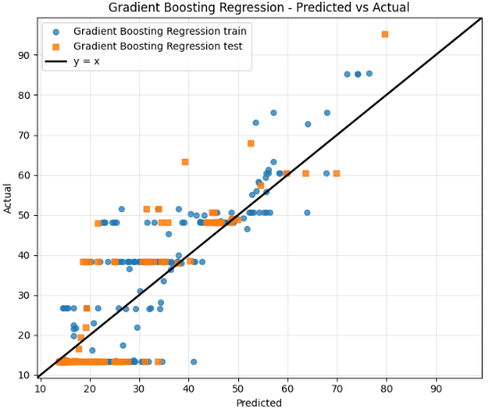

The results show that ensemble learning methods are generally better than regression models at predicting the Health Index of transformers. Simple regression techniques like Linear Regression and Multiple Linear Regression were not as good at predicting the Health Index because they assume that the relationships between the variables are linear.. The data from the transformer condition often does not have linear relationships because of the complex interactions between the gas concentrations and the insulation properties and the operating conditions of the transformers.
The Gradient Boosting model is good at capturing the patterns and the interactions between the different features. This means it can model the health of the transformers effectively. Also using GridSearchCV to tune the hyperparameters helped improve the performance of the models by finding the configurations for the parameters.
The analysis also showed that some models like the K-Nearest Neighbors Regression and the Random Forest Regression were overfitting. This means they were too good at fitting the training data but not good enough at predicting the testing data. On the hand some models like the Ridge and the Lasso and the Elastic Net Regression were underfitting. This means they were not complex enough to capture the relationships in the data.
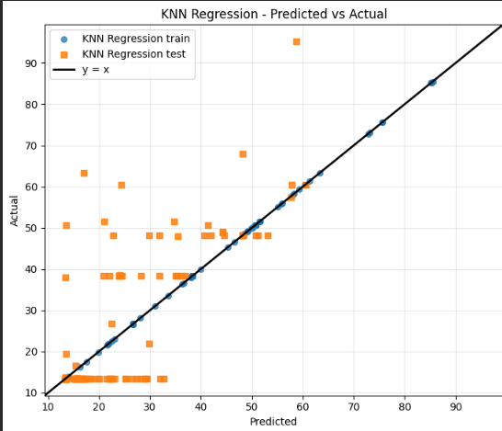
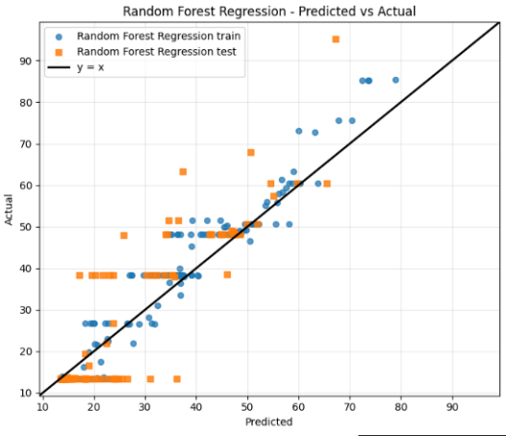

Overall the results show that machine learning models can successfully analyze the data from the transformers and provide accurate predictions of the Health Index of the transformers. Machine learning models are really good, at predicting the Health Index of transformers using the oil diagnostic parameters.

6.2 Implications
The results of this study are really important for checking the condition of transformers and predicting when they might need maintenance in power systems.
- First using machine learning models helps analyze data from diagnostics automatically. This reduces the need for experts to manually look at the data. As a result assessing the condition of transformers becomes more efficient and accurate.
- The use of machine learning models enables automated analysis of diagnostic data. This can significantly improve the efficiency and accuracy of condition assessment.
- Second, accurately predicting the health index of a transformer allows power companies to plan maintenance ahead of time.
- Of doing maintenance on a fixed schedule actions can be planned based on the actual condition of the transformer. This approach can lower maintenance costs make the system more reliable and prevent transformer failures.
- Accurate prediction of transformer Health Index allows utilities to implement maintenance strategies.
- Third ensemble learning models like Gradient Boosting can capture relationships between diagnostic parameters.
- This shows that advanced machine learning techniques have a lot of potential in power system applications.
- These techniques can be added to monitoring systems.
- They continuously evaluate health and provide early warnings of potential faults.
- The ability of learning models such as Gradient Boosting to capture complex relationships between diagnostic parameters demonstrates the potential of advanced machine learning techniques, in power system applications.
These techniques can be integrated into monitoring systems to continuously evaluate transformer health and provide early warnings of potential faults.

6.3 Limitations
Despite the promising results obtained in this study, several limitations should be acknowledged.
First, the dataset used in this study is relatively limited in size, which may affect the generalization capability of the machine learning models. Larger datasets containing more transformer operational data would help improve model accuracy and reliability.
Second, the models were trained using a specific set of transformer oil diagnostic parameters. Additional features such as transformer load conditions, environmental factors, and operational history could further improve prediction performance.
Third, although several regression algorithms were evaluated, other advanced machine learning techniques such as deep learning models or hybrid ensemble methods were not explored in this study.

Finally, the results are based on offline analysis of historical data. In practical applications, real-time monitoring systems would be required to continuously collect and analyze transformer condition data.

Future research can address these limitations by incorporating larger datasets, additional features, and more advanced machine learning techniques to further improve transformer health prediction accuracy.

Chapter 7

Conclusion and Future Work

7.1 Conclusion

This project was about predicting the Health Index of power transformers. We used machine learning models that looked at the oil in the transformers. The oil analysis parameters came from Dissolved Gas Analysis. Power transformers are very important in power systems. If they fail it can cause a lot of problems. Cost a lot of money. So we need ways to monitor the condition of the transformers and predict when they might fail.

We tried out a few machine learning models to see which one was best at predicting the Health Index. These models included Gradient Boosting Regression, Decision Tree Regression and Random Forest Regression. We also looked at some traditional regression models. We trained these models using the oil parameters. Then checked how well they did using things like R² score, Mean Absolute Error and Root Mean Square Error.

The results showed that Gradient Boosting Regression was the best at predicting the Health Index. It had the R² value, which means it was really good at predicting. Decision Tree Regression and Random Forest Regression also did well. Gave us reliable predictions.. Some of the simpler models, like linear and polynomial regression did not do as well because they could not handle the complicated relationships in the data.

Overall we found that machine learning can be very useful for predicting the Health Index of power transformers. The framework we developed can help with maintenance. Make the transformers more reliable.

The main things we did in this research are:

We made a machine learning approach to predict the Health Index of power transformers using oil analysis data.

We tried out a lot of regression models to see which one was best.

We showed that some machine learning models like Gradient Boosting and Random Forest are better than regression models.

We made a framework that can help with monitoring and maintaining power transformers.

We helped to show that machine learning can be used in power system asset management and predictive maintenance.

The important things we learned from this study are:

Machine learning models can predict the Health Index of power transformers using oil analysis parameters.

Some machine learning models are better at handling relationships in the data.

Gradient Boosting Regression was the model we tried.

Using machine learning to predict the Health Index can help power utilities to be more proactive with maintenance.

Machine learning can help to make the power system more reliable and reduce failures.

7.2 Future Work
The proposed system can be made better in the future. We need to make it work well be reliable and be useful, in life. One thing we can do is use an more varied set of data. This can help the machine learning models be more accurate and work better in situations. We can also look for ways to choose the important oil parameters. This can help cut out information and make the models work more efficiently. The proposed system and the machine learning models can benefit from this.
There are a things we could do to make our system better:
- We could use an more diverse dataset to make our models more accurate.
- We could use techniques to select the most important oil parameters.
- We could try out things to optimize our models.
- We could improve our data preprocessing to handle missing values and noise.
- We could use cross-validation to make our models more reliable.
- There are a ways we could extend this research:
- We could try using advanced machine learning models like Artificial Neural Networks or Convolutional Neural Networks.
- We could integrate our machine learning models with real-time monitoring systems.
- We could use types of data like temperature and vibration data in addition to oil analysis data.
- We could make a maintenance system that can make decisions on its own.
- We could try our approach with data from power utilities to make our models more robust.
There are a challenges we might face in the future:
- It can be hard to get datasets to train and validate our models.
- Sometimes the data can be imbalanced, which can make it hard to train our models.
- The environment that the transformers are, in can be different which can make it hard to get data.
- Some machine learning models can be complicated and hard to use in real-time systems.
- We need to make sure that our models are interpretable so that engineers and operators can understand and trust them.

Appendix A

References
- J. Lin, L. Y. Yeo, H. Nabipour Afrouzi, M. M. Ektesabi, and J. Tavalaei, “From limited data to reliable diagnosis: an interpretable deep learning framework for transformer fault analysis,” , 2025[Crossref]
- R. A. Prasojo, M. A. A. Putra, E. Ekojono, M. E. Apriyani, A. N. Rahmanto, S. S. M. Ghoneim, K. Mahmoud, M. Lehtonen, and M. M. F. Darwish, “Precise transformer fault diagnosis via random forest model enhanced by synthetic minority over-sampling technique,” Electric Power Systems Research, vol. 220, 2023[Crossref]
- P. A. R. Azmi, M. Yusoff, and M. T. M. Sallehud-din, “Improving transformer failure classification on imbalanced DGA data using data-level techniques and machine learning,” Energy Reports, vol. 13, pp. 264–277, 2025.[Crossref]
- M. S. Ali, A. H. Abu Bakar, A. Omar, A. S. A. Jaafar, and S. H. Mohamed, “Conventional methods of dissolved gas analysis using oil-immersed power transformer for fault diagnosis: A review,” Electric Power Systems Research, vol. 216, 2023.[Crossref]
- Suwarno, H. Sutikno, R. A. Prasojo, and A. Abu-Siada, “Machine learning based multi-method interpretation to enhance dissolved gas analysis for power transformer fault diagnosis,” Heliyon, vol. 10, 2024[Crossref]
- Q. Min, Z. Hong, D. Zou, H. Sun, Q. Chen, B. Peng, and T. Zhao, “A dissolved gas prediction method for transformer on-load tap changer oil integrating anomaly detection and deep temporal modeling,” Energies, vol. 18, no. 5079, 2025[Crossref]
- B. C. Mateus, M. Mendes, J. T. Farinha, and A. Martins, “Hybrid deep learning for predictive maintenance: LSTM, GRU, CNN and dense models applied to transformer failure forecasting,” Energies, vol. 18, no. 5634, 2025[Crossref]
- A. Nanfak, E. Samuel, I. Fofana, F. Meghnefi, M. G. Ngaleu, and C. H. Kom, “Traditional fault diagnosis methods for mineral oil-immersed power transformer based on dissolved gas analysis: Past, present and future,” IET Nanodielectrics, vol. 7, pp. 97–130, 2024.[Crossref]
- A. Wajid et al., “Comparative performance study of dissolved gas analysis (DGA) methods for identification of faults in power transformer,” International Journal of Energy Research, 2023.[Crossref]
CONTRIBUTION TO SUSTAINABLE DEVELOPMENT GOALS

Title of the Project :
Project Member(s) Name & Register Number : Sanjith.M.P- CB.EN.U4ELC24035
Swagat.A- CB.EN.U4ELC24042
Vedhanth.M.R- CB.EN.U4ELC24046
Swetraj Ravishwaran- CB.EN.U4ELC24043

Guide Name & Designation : Mr. Nakkeeran M
SDGs | Justification to the Contribution
7-Affordable and clean energy | Improves reliability and efficiency of electricity supply through predictive transformer fault detection.
9-Industry,Innovation and Infrastructure | Improves energy efficiency and reduces environmental impact from transformer failures.
12-Responsible Consumption and Production | Enables predictive maintenance and reduces equipment waste.



