Adaptive Multi-Sensor Shipment Integrity Monitoring System: Project Report
Oct 29, 2026 · @Jarvis

Abbreviations
Each abbreviation is also expanded in full at its first use in the text.
Abbreviation | Full form
ADC | Analogue-to-Digital Converter
ARM | Advanced RISC Machine (processor architecture)
CHK | Check value (hash-chain field of a log line)
CMSIS | Cortex Microcontroller Software Interface Standard
CRC | Cyclic Redundancy Check
DWT | Data Watchpoint and Trace
ETA | Predicted time to reach a limit (estimated time of arrival at the limit)
EXTI | External Interrupt
FIFO | First-In, First-Out
FPU | Floating-Point Unit
GCC | GNU Compiler Collection
GPIO | General-Purpose Input/Output
GPS | Global Positioning System
HAL | Hardware Abstraction Layer
HSI | High-Speed Internal (oscillator)
HTML | Hypertext Markup Language
I2C | Inter-Integrated Circuit
LCD | Liquid Crystal Display
LDR | Light-Dependent Resistor
LED | Light-Emitting Diode
MKT | Mean Kinetic Temperature
NMEA | National Marine Electronics Association
PLL | Phase-Locked Loop
PWM | Pulse-Width Modulation
RH | Relative Humidity
RMS | Root Mean Square
RTC | Real-Time Clock
RTOS | Real-Time Operating System
SEQ | Sequence number (field of a log line)
USART | Universal Synchronous/Asynchronous Receiver-Transmitter
USB | Universal Serial Bus
USP | United States Pharmacopeia

List of tables
Table | Title
3.1 | Operating states of the firmware
3.2 | Limits of the three cargo profiles
4.1 | Component selection and alternatives considered
4.2 | Excursion budgets (scaled down for the demonstration)
4.3 | Shock fusion rules
4.4 | Accuracy of the hand-written routines
5.1 | Peripherals, configuration and protocol
5.2 | Software tools
6.1 | Interrupt handlers
6.2 | Fields of a sample line
7.1 | Test results obtained on a PC using the firmware's own code
7.2 | Hardware demonstration steps and results
7.3 | Measured cycle cost of each algorithm
7.4 | Alternatives and scaling options

List of figures
Figure | Title
3.1 | Block diagram of the shipment integrity monitor
6.1 | Per-sample processing pipeline

1. Introduction

1.1 Background and problem statement
Goods in transit can be warmed, dropped, tilted, exposed to light or opened without anyone noticing until delivery. At that point nobody can say when the damage happened or who was responsible. Cold-chain products such as vaccines are the clearest case: a pharmaceutical product that leaves its labelled temperature range may be unsafe even though it looks unchanged [1], [2].
This project builds an embedded data-logging unit, the Adaptive Multi-Sensor Shipment Integrity Monitoring System, that travels inside a shipment from sealing to delivery. It measures temperature, relative humidity (RH), acceleration, orientation, light and lid state, stamps every record with the time from a real-time clock (RTC) and the position from the Global Positioning System (GPS), and sends the record to a laptop over Bluetooth.

1.2 Justice and compliance relevance
The unit is designed as an evidence trail, which is the justice and compliance side of the topic:
- Accountability. Every breach is latched in firmware and cannot be cleared during transit. Each one is logged with a timestamp and a position, so a shipper, carrier, receiver or regulator can see whether the agreed handling rules were followed and where they were broken.
- Protection for consumers. Spoiled or damaged goods, such as medicines whose cold chain was broken, are identified before they reach a patient.
- Protection for honest carriers. A carrier who handled the shipment correctly holds a timed record that rebuts a false damage claim.
- Tamper evidence. Each log line carries a sequence number and a cyclic redundancy check (CRC) value that covers every earlier line, so an edit made after the trip is detectable.
- Adaptive limits. The same unit applies different rules to medicine, electronics and fresh produce, because the fair standard depends on what is inside the box.

1.3 Scope
The system is a complete embedded solution: sensing, on-board computation, actuation (a fan, a buzzer and a light-emitting diode (LED) indicator), a local display, a wireless log and a laptop dashboard. The main controller is an ARM Cortex-M4F microcontroller (STM32F411CEU6), programmed in bare-metal C at register level, with no vendor Hardware Abstraction Layer (HAL) and no real-time operating system (RTOS).

1.4 Report organisation
Chapter 2 states the objectives. Chapter 3 gives the system overview. Chapter 4 explains the methodology and algorithms. Chapter 5 lists the tools and systems used. Chapter 6 describes the hardware and software implementation. Chapter 7 presents results and analysis, and Chapter 8 concludes.

2. Objectives
The aim is to design, build and demonstrate an ARM-based embedded system that records how a shipment was handled and produces trustworthy evidence of any breach. The specific objectives are:
- Select an ARM Cortex-M microcontroller and interface at least four unique peripherals as sensors and actuators.
- Monitor temperature, humidity, shock, drop, tilt, vibration, light and lid opening throughout a trip.
- Apply different limits for different cargo through selectable profiles (Pharma-Cold, Electronics, Produce).
- Run real computation on the microcontroller: filtering, Mean Kinetic Temperature (MKT), a least-squares trend with time-to-limit prediction, an excursion budget, free-fall drop height, tilt geometry and two-sensor fusion.
- Act on the result: start a cooling fan early when a limit is about to be reached, show the status on a display and LED, and sound a buzzer on a new breach.
- Produce a timestamped, hash-chained log so that editing the record afterwards is detectable.
- Keep the firmware robust: every bus wait has a time-out, and a failed sensor is flagged instead of freezing the system.
- Demonstrate every feature on hardware and measure the processor cost of each algorithm.

3. System Overview

3.1 Architecture
The system is a battery-powered box built around one STM32F411CEU6 "Black Pill" board. Seven input devices feed the microcontroller, and five output devices carry its decisions back out. Figure 3.1 shows the block diagram, with each interface and pin. The devices connect through the Inter-Integrated Circuit (I2C) bus, an analogue-to-digital converter (ADC), universal synchronous/asynchronous receiver-transmitter (USART) ports, pulse-width modulation (PWM) timers, external interrupt (EXTI) lines and general-purpose input/output (GPIO) pins. The light sensor is a light-dependent resistor (LDR).
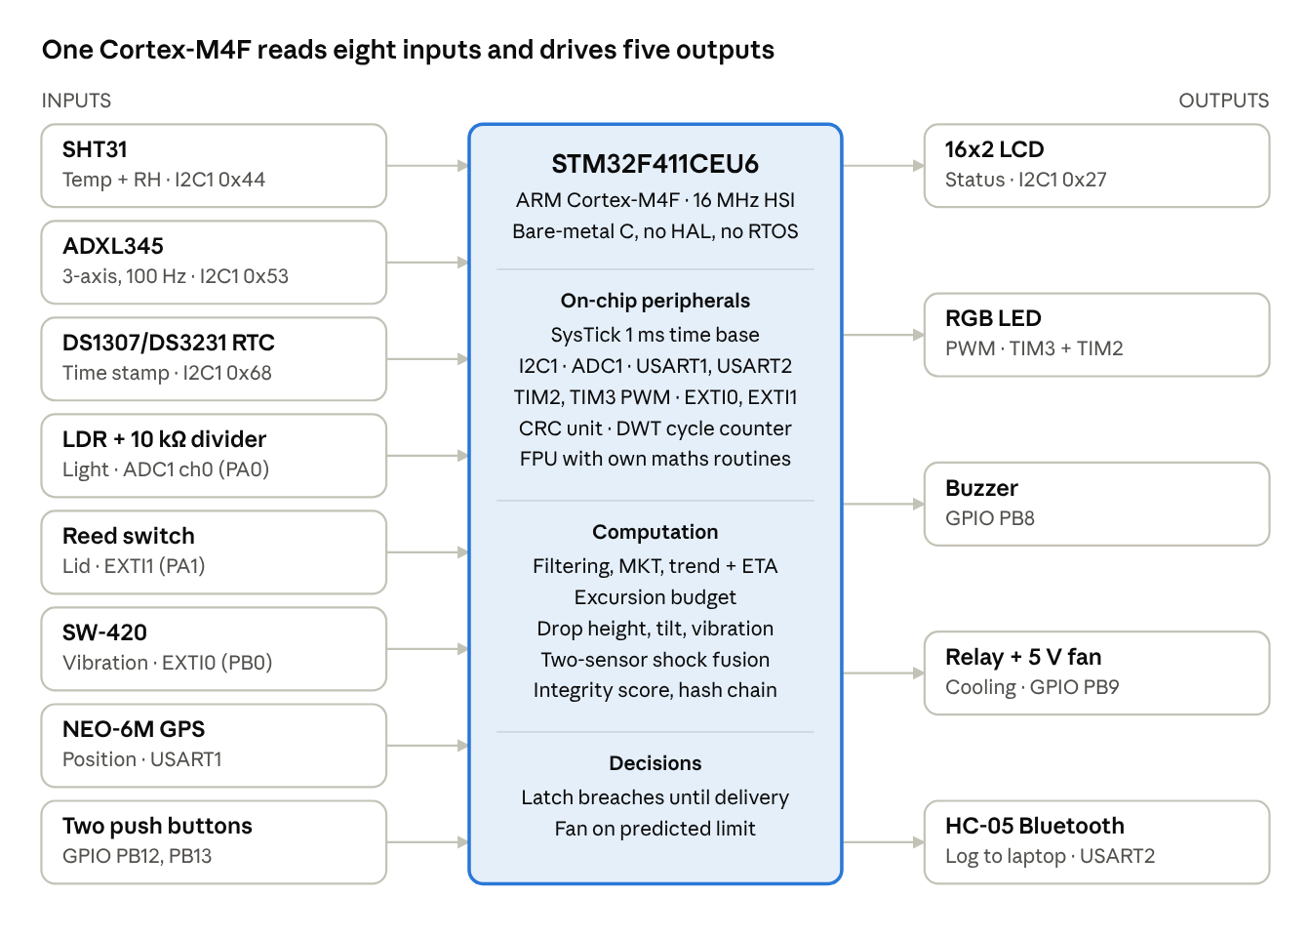
Figure 3.1 · system block diagram, 8 inputs and 5 outputs
Figure 3.1: Block diagram of the shipment integrity monitor. Inputs enter on the left, the STM32F411 computes and decides in the centre, and outputs leave on the right.

3.2 Operating states
A shipment passes through four states. The firmware is a super-loop with a state variable, so exactly one state is active at a time (Table 3.1).
Table 3.1: Operating states of the firmware
State | What happens | Leaves when
Menu | The Liquid Crystal Display (LCD) shows a profile name; button A cycles profiles | Button B confirms
Wait seal | LCD asks to close the lid | Reed switch reads closed for more than 0.5 s; button A returns to the menu
In transit | Once per second: sense, compute, check limits, latch breaches, drive outputs, log | Both buttons held for 2 s
Delivered | DELIVERED, SUMMARY and BENCH lines written; LED turns blue | Power cycle, or button B for a new shipment
At sealing the firmware calibrates the accelerometer, records the light baseline, resets every running computation and starts the log hash chain. A 3 s arming delay follows, during which readings are logged but no breach can latch, so that closing and moving the box does not cause false alarms.

3.3 Adaptive profiles
A profile is a set of limits and enabled checks. The profile is chosen once, before sealing (Table 3.2).
Table 3.2: Limits of the three cargo profiles
Check | Pharma-Cold | Electronics | Produce
Temperature range (°C) | 2.0 to 8.0 | −10.0 to 45.0 | 0 to 25.0
Humidity limit (%RH) | 60 | 85 | 95
Shock limit (g) | 1.5 | 1.3 | 2.5
Tilt limit from sealed orientation | 45° | 45° | off
Light tamper (LDR) | on | on | off
Lid open (reed switch) | on | on | on
Pharma-Cold is strict on temperature, Electronics on shock, and Produce tolerates more of both. Lid opening, GPS and vibration logging are always on.
A room is not a refrigerator, so a compile-time option (DEMO_MODE) re-centres the Pharma-Cold and Produce limits on the room's readings at the moment of sealing. Pharma-Cold then allows 5.0 °C below to 1.5 °C above the sealing temperature, and humidity 15 %RH above the sealing value. Produce allows 10.0 °C below to 8.0 °C above. Electronics keeps its real limits. The SEALED log line records the limits actually used.

4. Methodology

4.1 Component selection and alternatives
The main controller had to be ARM-based, have a floating-point unit (FPU) for the on-board mathematics, and offer enough peripherals to avoid external glue logic. The STM32F411CEU6 (Cortex-M4F) meets all three [3], [4]. Table 4.1 lists each choice with the alternatives considered.
Table 4.1: Component selection and alternatives considered
Function | Chosen | Alternatives | Reason for the choice
Microcontroller | STM32F411CEU6, Cortex-M4F | STM32F103 (Cortex-M3, no FPU); ESP32 (not ARM) | Hardware FPU, hardware CRC unit, enough timers and UARTs, ARM as required
Temperature and humidity | SHT31 (I2C) | DHT22; DS18B20; analogue LM35 | Digital, factory-calibrated, CRC-protected readings [5]
Motion | ADXL345 (I2C) | Analogue accelerometer; MPU6050 | ±16 g range for impacts and a 32-sample FIFO read in bursts [6]
Shock switch | SW-420 | Piezo film | Low cost; independent second opinion for sensor fusion
Light | LDR on ADC1 | Photodiode; digital light sensor | Exercises the ADC; enough to detect a lid opening
Lid | Reed switch and magnet | Micro-switch; Hall sensor | No contact wear; interrupt on both edges
Clock | DS1307/DS3231 RTC (I2C) | Internal RTC | Independent timekeeping for log stamps [7]
Position | NEO-6M GPS (UART) | None | Position per log line; needs open sky [8]
Wireless link | HC-05 (UART) | BLE module; LoRa; cellular modem | Simple serial link to a laptop; cellular would suit a real product
Display | 16x2 LCD with PCF8574 | OLED | Two shared I2C wires instead of six parallel pins
Actuator | Relay and 5 V fan | Peltier cooler | Simple corrective action for the demonstration
Four devices share one I2C bus [9], so a stuck device could block the others. The firmware therefore puts a time-out on every bus wait and flags the failed device instead of hanging.

4.2 Filtering
The temperature uses an exponential moving average with weight 1/4:
T_f[k] = T_f[k-1] + \frac{T[k] - T_f[k-1]}{4}
The light sensor uses the median of five back-to-back conversions, so a single spike cannot look like light in the box. Both filters stop noise from causing false breaches.

4.3 Mean Kinetic Temperature (MKT)
Chemical degradation speeds up exponentially with temperature, so one hot hour does more harm than one cold hour undoes. MKT is the single steady temperature that would cause the same total degradation as the recorded history, and it is the standard cold-chain measure [10], [11]:
T_{MKT} = \frac{\Delta H / R}{-\ln\left(\frac{1}{n}\sum_{i=1}^{n} e^{-\Delta H/(R\,T_i)}\right)}
Here T is in kelvin and ΔH/R = 10 000 K (an activation energy of 83.14 kJ/mol). The running sum is computed relative to 25 °C so that it stays close to 1, and Kahan summation limits rounding error over long trips. For 23 h at 20 °C and 1 h at 40 °C, the plain average is 20.83 °C, but MKT is 22.45 °C, which better reflects the damage done by the hot hour. MKT is logged every sample and compared with the profile's upper limit at delivery. The United States Pharmacopeia (USP) chapter <1079.2> limits the period of data that should feed an MKT calculation and warns that MKT cannot undo irreversible degradation caused by a hot period [12], so the system uses MKT beside the limit checks, not instead of them.

4.4 Trend and predicted time to limit
Every second sample is stored in a ring of 60 points (about 2 minutes). A least-squares line is fitted through them using the real time stamps, so uneven spacing does not matter:
m = \frac{\sum (t_i - \bar{t})(T_i - \bar{T})}{\sum (t_i - \bar{t})^2}
The fit needs at least 15 points and ignores slopes below 0.10 °C/min. The time to the limit the temperature is heading for is (limit − T) / m. When the box is warming and that time is under 120 s, the fan starts early and the LED turns amber.

4.5 Excursion budget
A brief touch of a limit is not the same as sustained abuse. The first crossing therefore logs TEMP_WARNING only. The excursion becomes a latched TEMP_EXCURSION breach when any one of three budgets is used up (Table 4.2).
Table 4.2: Excursion budgets (scaled down for the demonstration)
Budget | Value | Log reason
Total time outside the window | 30 s | WHY=TIME
Area outside the window (°C·min) | 0.50 | WHY=AREA
Distance beyond the limit | 3.0 °C | WHY=HARD
The numbers are demonstration values; real ones must come from the product's stability data.

4.6 Accelerometer analysis
The ADXL345 runs at 100 Hz, ±16 g, in first-in, first-out (FIFO) stream mode. At sealing the firmware measures the resting gravity vector from the calmest 16 samples. Its length defines 1 g for that particular sensor and its direction is the reference for tilt.
- Vibration is the root-mean-square (RMS) deviation of the acceleration magnitude from 1 g over each sample interval, logged as VIB in milli-g.
- Drop. Free fall is a magnitude below 0.4 g for 4 to 60 consecutive samples (10 ms each), followed by a 10-sample impact window. The equivalent drop height follows from the fall time t:
h = \tfrac{1}{2}\, g\, t^{2}
For 20 samples (t = 0.2 s) this gives 196 mm. A drop of 10 cm or more is logged as DROP and counts as a shock breach. It is an equivalent height, not a measured one.
- Tilt. The angle between the current gravity vector a and the sealed vector r is
\theta = \operatorname{atan2}\left(\lVert \mathbf{a} \times \mathbf{r} \rVert,\; \mathbf{a} \cdot \mathbf{r}\right)
Only quasi-static samples (0.8 to 1.2 g) are used, and two checks in a row must agree, so shaking is not read as tilt. Above the profile limit the firmware logs TILT_EXCEEDED, and INVERTED when the angle exceeds 135°.

4.7 Sensor fusion
The ADXL345 measures real acceleration but can glitch. The SW-420 is a simple switch that false-triggers. A shock is therefore confirmed only when both agree (Table 4.3).
Table 4.3: Shock fusion rules
What was seen | Result
ADXL345 over limit and SW-420 edge within 300 ms | SHOCK_CONFIRMED, breach
ADXL345 over limit only | SHOCK_ACCEL, breach
SW-420 only | VIBRATION_SUSPECT, logged at most once per 5 s, no breach
SW-420 only, ADXL345 failed | SHOCK_SWITCH, breach

4.8 Integrity score
A 0 to 100 score summarises each sample, with a penalty for each kind of fault (temperature up to 40, humidity 10, shock 25, tilt 15, light 30). The lowest score of the trip is kept as the worst score in the summary.

4.9 Tamper-evident log
After sealing, every log line ends with a sequence number (SEQ) and a check value (CHK). CHK is a CRC-32 (polynomial 0x04C11DB7) computed with the hardware CRC unit over the text of this line and of all earlier lines. The unit is not reset between lines, and the chain starts from a fixed key word. Editing a line breaks its own check and every later one. Deleting a line leaves a gap in SEQ, so lost data is distinguishable from an edit. A CRC is designed to detect accidental corruption [13], not deliberate forgery. The chain therefore shows tampering by an ordinary user, but it is not a digital signature: someone who knows the key and the algorithm could rebuild it.

4.10 Own mathematics routines
To keep the code small and to show the algorithms, the square root, exponential, natural logarithm and arctangent are written by hand and linked without a maths library. Each was checked on a PC against a reference (Table 4.4).
Table 4.4: Accuracy of the hand-written routines
Routine | Method | Error against reference
Square root | Newton iteration from a bit-trick start | 1.2e-7
Exponential | Range reduction and a degree-6 polynomial | 4e-6
Natural logarithm | atanh series | 2e-6
Arctangent (degrees) | Minimax polynomial | 0.0007°

5. Tools and Systems

5.1 Microcontroller platform
The STM32F411CEU6 "Black Pill" has a 32-bit ARM Cortex-M4F core with a single-precision FPU, and runs here from its internal 16 MHz High-Speed Internal (HSI) oscillator with no phase-locked loop (PLL). All baud-rate, I2C and timer values in the firmware assume this clock [3]. The board runs from a Universal Serial Bus (USB) power bank.

5.2 Peripherals used and how each is configured
Every peripheral is configured by writing registers directly. The only vendor file used is the Cortex Microcontroller Software Interface Standard (CMSIS) device header that names the registers, so no driver library is involved (Table 5.1).
Table 5.1: Peripherals, configuration and protocol
Peripheral | Type | Pins | Configuration and protocol | Connected device
I2C1 | Sensor and actuator bus | PB6 (SCL), PB7 (SDA), AF4 | 100 kHz standard mode, 7-bit addresses, open-drain, polled with time-outs and bus recovery | SHT31 0x44, ADXL345 0x53, RTC 0x68, LCD 0x27
ADC1 | 12-bit analogue input | PA0, channel 0 | Software-triggered, longest sample time, median of five conversions | LDR in a voltage divider
USART1 | Serial input | PA9, PA10, AF7 | 9600 baud, 8N1, receive interrupt into a 512-byte ring buffer | NEO-6M GPS (National Marine Electronics Association (NMEA) sentences)
USART2 | Serial output | PA2, PA3, AF7 | 9600 baud, 8N1, polled transmit | HC-05 Bluetooth
TIM3 and TIM2 | Pulse-width modulation (PWM) | PB4, PB5 (TIM3), PB3 (TIM2) | 1 MHz timer clock, 1 kHz PWM, 1000 duty steps per channel | RGB LED
EXTI0 | External interrupt | PB0 | Both edges; handler stores the edge time for fusion | SW-420 vibration switch
EXTI1 | External interrupt | PA1 | Both edges, internal pull-up; handler flags only the opening direction | Reed switch
GPIO output | Digital output | PB8, PB9 | Push-pull; safe level written before the pin is switched to output; relay is active-low | Buzzer, relay and fan
GPIO input | Digital input | PB12, PB13 | Internal pull-up, 30 ms software debounce | Profile and confirm buttons
SysTick | Core timer | none | 1 ms interrupt (reload 15 999 at 16 MHz) | Time base for the whole firmware
CRC unit | Hardware accelerator | none | CRC-32, polynomial 0x04C11DB7, with a self-test and software fallback | Log hash chain
DWT cycle counter | Debug counter | none | Cycle-accurate timing of each algorithm | BENCH log line
The system therefore uses far more than the required four peripherals: sensor interfaces on I2C, ADC, UART and GPIO interrupts, and actuator interfaces on GPIO, PWM and UART.

5.3 Software tools
Table 5.2: Software tools
Tool | Use
GNU Compiler Collection (GCC) for ARM (arm-none-eabi) | Compiles the firmware with zero warnings at several optimisation levels, hard and soft float, linked without a maths library
CMSIS device header (stm32f411xe.h) | Register names and bit masks only
Python | Models the CRC chain and checks the maths routines against reference values on a PC
Shipment Twin dashboard (Hypertext Markup Language (HTML) and JavaScript) | Live display over the Web Serial interface, log replay, and the chain check
The compute library in the firmware (square root, exponential, logarithm, arctangent, MKT, regression, drop height, tilt and software CRC) is pure mathematics with no hardware access, so the same source was compiled and tested on a PC.

6. Implementation

6.1 Hardware design
All devices connect directly to the Black Pill and run from a USB power bank (pin assignments are in Figure 3.1 and Table 5.1). The main design decisions were:
- One shared I2C bus. The SHT31, ADXL345, RTC and LCD share PB6 and PB7, which saves pins. The cost is that one stuck device can block the bus, which the software time-outs in Section 6.3 handle.
- Open-drain bus pins at high speed setting. PB6 and PB7 are set as open-drain alternate-function pins, as the I2C standard requires [9].
- Safe start-up levels for the actuators. The buzzer and relay pins have their idle level written before the pins become outputs, so the fan and buzzer do not pulse at power-up. The relay module is active-low.
- Light-emitting diode (LED) colours. Green means OK, amber a warning or a predicted breach, red a latched breach, and blue delivered.
- Interrupt-driven inputs. The reed switch and the SW-420 are wired to external interrupt lines, so a lid opening or a knock is caught instantly even while the main loop is busy.
- Buttons to ground. PB12 and PB13 use internal pull-ups, so no external resistors are needed.

6.2 Software architecture
The firmware is one bare-metal C file with no HAL and no RTOS. It is a super-loop driven by a state variable (Table 3.1) with four interrupt handlers. Interrupt handlers only set flags or store bytes; every decision is made in the main loop, which keeps the timing predictable and avoids the need for an RTOS scheduler for a task set this small.
The loop never blocks for long. The delay function and the Bluetooth print routine both call a background task that parses GPS sentences from the ring buffer and drains the accelerometer FIFO every 80 ms. The ADXL345 FIFO holds 32 samples (320 ms at 100 Hz), so polling every 80 ms loses no sample and every sample is exactly 10 ms apart [6].
Once per second, in the In transit state, the firmware runs the pipeline in Figure 6.1.
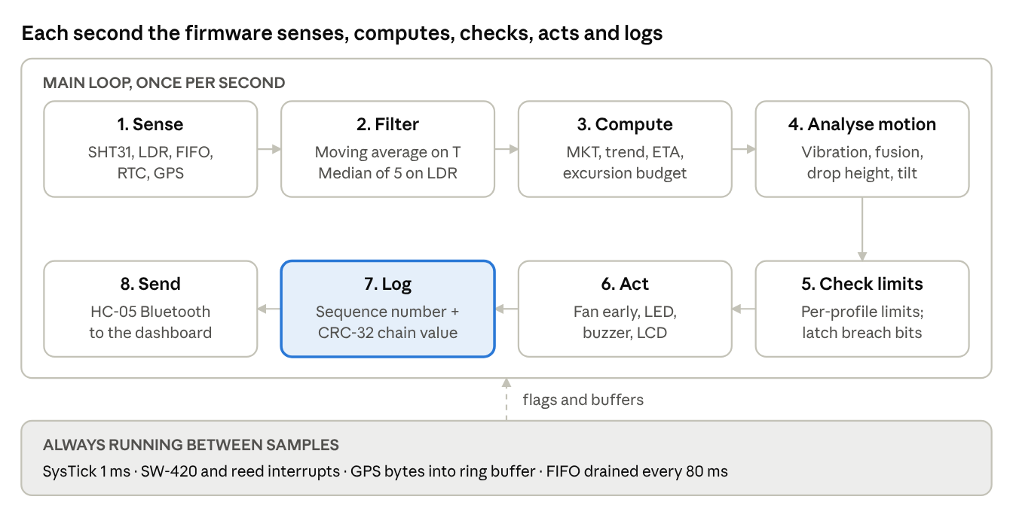
Figure 6.1 · per-sample pipeline, 8 steps
Figure 6.1: Per-sample processing pipeline. The log step is highlighted because it produces the hash-chained evidence.
Table 6.1: Interrupt handlers
Interrupt | Source | What the handler does
SysTick | Core timer, every 1 ms | Increments the millisecond counter used by millis()
EXTI0 | SW-420 on PB0 | Sets the shock flag and stores the time of the first edge (for fusion)
EXTI1 | Reed switch on PA1 | Sets the lid-open flag when the lid reads open
USART1 | Each GPS byte | Stores the byte in a 512-byte ring buffer

6.3 Robustness
- Time-outs. Every I2C wait is bounded. On failure the bus is reset (stop condition and software reset) and the read is skipped, so a loose wire cannot freeze the box.
- Sensor errors. A failed read sets a bit in the ERR field of the log (1 = SHT31, 2 = ADXL345; bit 4 is reserved for the RTC, whose failure currently shows as --:--:-- time stamps). If the SHT31 fails, temperature and humidity checks are skipped and old data are not integrated. If the ADXL345 fails or cannot calibrate, the tilt check is skipped and the SW-420 can latch a shock on its own.
- LCD. After three failed writes the LCD is skipped, and retried every 10 s, so a missing display does not slow the system.
- Boot self-test. The LCD shows S:Y A:Y R:Y for the SHT31, ADXL345 and RTC, and the serial feed reports the same. A second test compares the hardware CRC unit with a software model and falls back to the software CRC if they differ.
- Latching. Breaches are bits that cannot clear until delivery, so a fault cannot be hidden during transit.

6.4 Log format
The HC-05 sends one comma-separated line per sample and per event. Table 6.2 explains the fields. The lines below are an excerpt from a test log produced by the firmware code on a PC (not from the board):
14:21:21,EVENT=SHOCK_CONFIRMED,PEAK=2.15,SEQ=81,CHK=6083ED15
14:21:51,EVENT=DROP,HEIGHT_CM=19,FALL_MS=200,PEAK=4.95,SEQ=114,CHK=CED07845
14:22:32,EVENT=DELIVERED,SEQ=156,CHK=54ED261D
Table 6.2: Fields of a sample line
Field | Meaning
T, H | Temperature (°C) and humidity (%RH)
G, PEAK | Current and highest acceleration magnitude (g)
LDR | Light reading (ADC counts)
FIX, LAT, LON | GPS fix flag and position
SCORE | Integrity score, 0 to 100
BREACH | Latched bits: 1 temperature, 2 humidity, 4 shock or drop, 8 light, 16 opened, 32 tilt
ERR | Failed sensors: 1 SHT31, 2 ADXL345 (bit 4 reserved for the RTC)
MKT | Mean Kinetic Temperature so far (°C)
RATE, ETA | Temperature trend (°C/min) and seconds to the limit (0 if none)
EXC, DEG | Seconds outside the window, and area outside it (°C·min)
VIB, TILT | Vibration RMS (mg) and tilt angle (degrees)
SEQ, CHK | Sequence number and hash-chain check value
BREACH is read as a bit mask. For example, 37 is 1 + 4 + 32, so temperature, shock and tilt had all latched. At delivery the firmware also writes a SUMMARY line (duration, worst score, breach bits, shock and drop counts, MKT against its limit, time and area outside the window, maximum tilt, and a PASS or FAIL verdict) and a BENCH line with the average and maximum CPU cycles of each algorithm.

6.5 Dashboard
The Shipment Twin dashboard is a single HTML page. It connects to the HC-05 serial port from Chrome or Edge using the Web Serial interface, or replays a saved log. It shows a picture of the box with a mirror of the LCD, live readings, six on-board computation tiles (MKT, trend and predicted time to limit, excursion meters, motion, log integrity and the cycle-cost table), a trend chart with breach stamps, an event log and the GPS position. It repeats the same CRC chain in JavaScript, restarts the chain at each SEALED line, and reports how many lines were checked, missing or bad, marking the first bad line.

7. Results and Analysis

7.1 Verification on a PC
The pure-mathematics part of the firmware (Section 4) was compiled and tested on a PC against reference values before it was flashed. Table 7.1 summarises the results.
Table 7.1: Test results obtained on a PC using the firmware's own code
Item tested | Result
Compilation | Zero warnings at several optimisation levels, with hard and soft float; links without a maths library
MKT, constant 25 °C | 25.000 °C
MKT, 23 h at 20 °C and 1 h at 40 °C | 22.45 °C (reference 22.448 °C); plain average 20.83 °C
Trend line on a test ramp | Slope 0.503 against a true 0.500; a flat line gives no time to limit
Accelerometer, simulated data | 1.00 g at rest after calibration; a 20-sample fall gives 196 mm and a 4.95 g peak; a knock is detected; sensor faults and single hops are ignored
Tilt, simulated data | 30° not flagged, 60° flagged
Hash chain | The dashboard verified all 159 lines generated by the firmware code; its edit demonstration flagged the exact edited line (SEQ 40)
Dashboard | No page errors in a headless browser at desktop and phone width
Table 4.4 gives the accuracy of the hand-written maths routines against their references.

7.2 Demonstration on the hardware
The demonstration uses the Pharma-Cold profile, the only profile with every check enabled. Table 7.2 lists each step, the expected firmware response, and a column for what was observed on the board. Fill the last column during the rehearsal.
Table 7.2: Hardware demonstration steps and results
Step | Action | Expected response | Observed on the board
1 | Power on | LCD self-test S:Y A:Y R:Y; CRC HW OK in the serial feed | [ENTER]
2 | Select Pharma-Cold, close the lid, stay still | SEALED line with limits and ACAL; green LED | [ENTER]
3 | Warm the box slowly with a hair dryer | RATE rises, ETA counts down, amber LED, fan starts before the limit | [ENTER]
4 | Cross the limit for a few seconds, then stop | TEMP_WARNING only, no breach | [ENTER]
5 | Keep it above the limit | TEMP_EXCURSION with WHY=TIME after 30 s (or AREA, HARD); red LED; buzzer | [ENTER]
6 | Tap the box firmly | SHOCK_CONFIRMED with peak g | [ENTER]
7 | Flick only the SW-420 module | VIBRATION_SUSPECT, no new breach | [ENTER]
8 | Drop the box about 20 cm onto a cushion | DROP with HEIGHT_CM near 20 and FALL_MS near 200 | [ENTER]
9 | Tilt beyond 45° for 2 s, then invert | TILT_EXCEEDED, then INVERTED, with angles | [ENTER]
10 | Breathe on the SHT31, shine a torch, open the lid | HUMIDITY_EXCURSION, LIGHT_TAMPER, UNAUTHORIZED_OPEN | [ENTER]
11 | Hold both buttons for 2 s | DELIVERED, SUMMARY with VERDICT=FAIL, BENCH; blue LED | [ENTER]
12 | Save the log, replay it, press Demo: edit a log line | Chain check flags the edited line and every later one | [ENTER]

7.3 Processor cost
The Data Watchpoint and Trace (DWT) cycle counter times six operations and prints their average and maximum cycle counts in the BENCH line at delivery. At 16 MHz there are 16 000 000 cycles available per second and one microsecond is 16 cycles. Table 7.3 is to be filled from the first real BENCH line; the figures in the dashboard's sample run are illustrative only.
Table 7.3: Measured cycle cost of each algorithm (to be filled from the board)
Operation | Average cycles | Maximum cycles | Share of one second at 16 MHz
MKT update | [ENTER] | [ENTER] | [ENTER]
Trend fit | [ENTER] | [ENTER] | [ENTER]
Full computation step | [ENTER] | [ENTER] | [ENTER]
Full accelerometer sample | [ENTER] | [ENTER] | [ENTER]
Tilt | [ENTER] | [ENTER] | [ENTER]
Log CRC | [ENTER] | [ENTER] | [ENTER]
The maximum values include any interrupt that arrived while the operation was running.

7.4 Analysis of the design
- Why a warning before a breach. The excursion budget separates a brief touch of a limit from sustained abuse, which reduces false alarms without letting real abuse pass.
- Why two shock sensors. The ADXL345 measures real acceleration but can glitch, and the SW-420 false-triggers. Requiring both within 300 ms confirms a shock, and a single-sensor event is logged but does not latch a breach.
- Why MKT. The plain average understates the damage of a hot period; MKT weights it exponentially (22.45 °C against 20.83 °C in the worked example).
- Why a hash chain. Each line's check depends on every earlier line, so editing or removing one breaks all later checks, and the sequence number distinguishes lost data from an edit.

7.5 Limitations
- Tamper-evident, not tamper-proof. Someone who knows the key and the algorithm could rebuild the chain. A real product would use a digital signature.
- Drop height is an equivalent height worked out from free-fall time, not a measured height.
- Tilt reference is the orientation at sealing, so the box must be sealed upright and still.
- Budgets are scaled for the demonstration. Real limits must come from the product's stability data. MKT is computed over the whole trip, whereas USP <1079.2> restricts the data period used and treats MKT as a supplement to, not a replacement for, the labelled limits [12].
- GPS needs open sky; indoors the log shows FIX=0.
- Demonstration mode re-centres the Pharma-Cold and Produce limits on room conditions, because a room is not a refrigerator.
- Hardware verification. [ENTER the status of the hardware CRC unit, ADXL345 FIFO behaviour and GPS fix after testing on the board.]

7.6 Alternatives and scaling
Table 7.4: Alternatives and scaling options
Direction | Option
Smaller and cheaper | A low-power Cortex-M0+ or M4 part, one combined temperature, humidity and motion sensor, and a coin-cell supply
Longer trips | Store the log in battery-backed flash and sleep between samples, instead of relying on a live Bluetooth link
Wider coverage | A cellular or LoRa modem in place of the HC-05, so the record leaves the box without a laptop nearby
Stronger evidence | A keyed hash or digital signature in place of the CRC chain
More cargo types | New profiles are only a row in a table of limits and enabled checks
Real limits | Excursion budgets taken from the product's stability data

8. Conclusion
This project produced a complete ARM-based embedded system that records how a shipment was handled and keeps tamper-evident evidence of every breach. It meets the objectives of Chapter 2: the STM32F411 Cortex-M4F reads eight inputs, computes on them, and drives five outputs; three cargo profiles apply different limits; and every breach is latched with a time stamp and a hash-chained log line.
The computation goes beyond comparing readings with limits. The firmware filters noise, scores a trip with Mean Kinetic Temperature, predicts when a limit will be reached and starts the fan early, separates a brief touch of a limit from sustained abuse, measures drop height, tilt and vibration, and confirms a shock only when two independent sensors agree. The software is written at register level with no HAL and no RTOS, with time-outs on every bus wait so that one failed device cannot stop the rest.
The justice and compliance value lies in the record. A shipper, carrier, receiver or regulator can read when and where a rule was broken, and the sequence numbers and check values show whether the record was edited afterwards. The main limits are that the log is tamper-evident rather than tamper-proof, the budgets are scaled for a demonstration, and the cycle costs must be read from the board.
Future work is to replace the CRC chain with a keyed hash or digital signature, store the log in battery-backed flash, add a cellular or LoRa link, take excursion budgets from real stability data, and move to a lower-power part for long trips.

References
[1] World Health Organization, "Model guidance for the storage and transport of time- and temperature-sensitive pharmaceutical products," WHO Tech. Rep. Ser., no. 961, Annex 9, 2011. [Online]. Available: https://www.who.int/publications/m/item/trs961-annex9-modelguidanceforstoragetransport
[2] United States Pharmacopeial Convention, "<1079> Risks and mitigation strategies for the storage and transportation of finished drug products," in USP–NF, Rockville, MD, USA.
[3] STMicroelectronics, "RM0383 Reference manual: STM32F411xC/E advanced Arm-based 32-bit MCUs," Rev. 4, May 2025. [Online]. Available: https://www.st.com/resource/ja/reference_manual/dm00119316.pdf
[4] STMicroelectronics, "STM32F411xC STM32F411xE datasheet," DS10314, Rev. 8, Jan. 2024. [Online]. Available: https://www.st.com/en/microcontrollers-microprocessors/stm32f411ce.html
[5] Sensirion AG, "Datasheet SHT3x-DIS: Humidity and temperature sensor," Version 7, Dec. 2022. [Online]. Available: https://sensirion.com/file/datasheet_sht3x_digital
[6] Analog Devices, "ADXL345: 3-axis, ±2 g/±4 g/±8 g/±16 g digital accelerometer," Data Sheet, Rev. E.
[7] Maxim Integrated, "DS1307 64 × 8, serial, I2C real-time clock," Data Sheet.
[8] u-blox, "NEO-6 u-blox 6 GPS modules," Data Sheet GPS.G6-HW-09005.
[9] NXP Semiconductors, "UM10204: I2C-bus specification and user manual," Rev. 7.0, Oct. 1, 2021. [Online]. Available: https://www.nxp.com/docs/en/user-guide/UM10204.pdf
[10] International Conference on Harmonisation of Technical Requirements for Registration of Pharmaceuticals for Human Use, "Stability testing of new drug substances and products Q1A(R2)," ICH Harmonised Tripartite Guideline, Feb. 6, 2003. [Online]. Available: https://www.pmda.go.jp/files/000156241.pdf
[11] J. D. Haynes, "Worldwide virtual temperatures for product stability testing," J. Pharm. Sci., vol. 60, no. 6, pp. 927–929, 1971.
[12] United States Pharmacopeial Convention, "<1079.2> Mean kinetic temperature in the evaluation of temperature excursions during storage and transportation of drug products," in USP–NF, Rockville, MD, USA.
[13] P. Koopman, "32-bit cyclic redundancy codes for Internet applications," in Proc. Int. Conf. Dependable Syst. Netw. (DSN), 2002, pp. 459–468, doi: 10.1109/DSN.2002.1028931.

