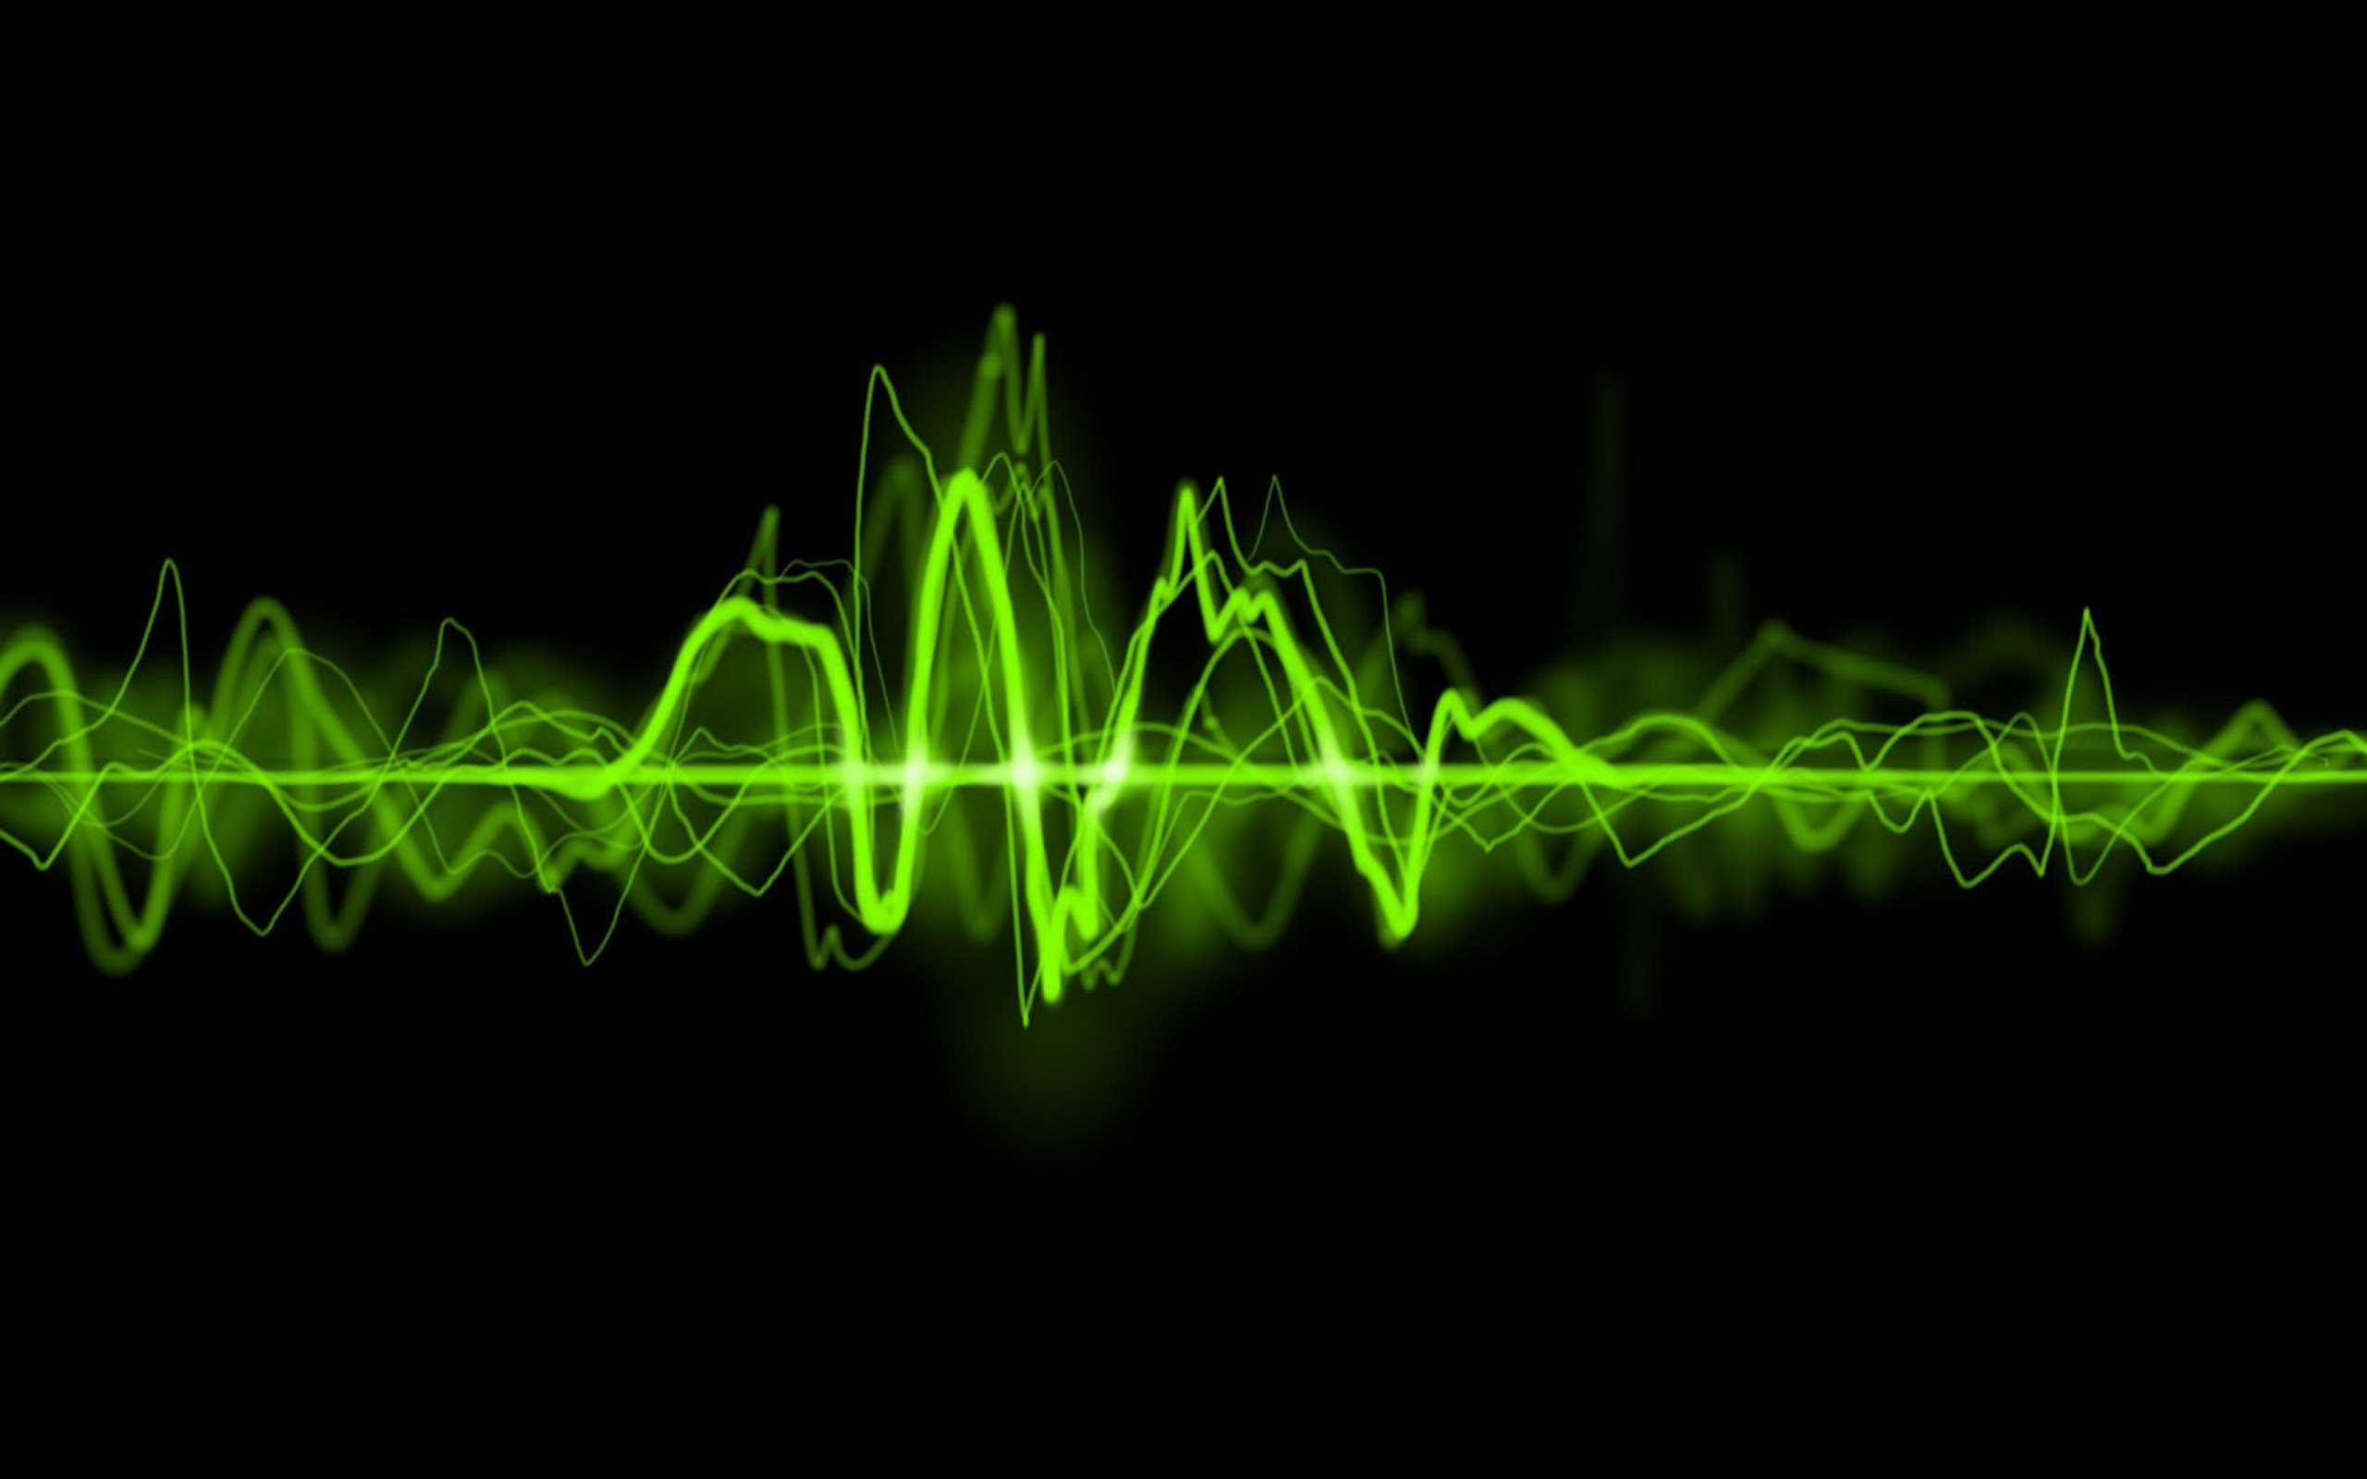

|  |
| --- |
| Properties of Discrete Fourier Transform (DFT), and Noise Reduction using DFT  Signal and Data Communication Project |
|  |
| July 4  SDC PROJECT GROUP no.: 15  18-1-5-059, 18-1-5-060  Sec: A SEM: IV |



SUBMITTED TO:

Dr. Anish Kumar Saha

Group no.: 15

* Swagat S. Bhuyan
  + Scholar ID: 1815059
  + Phone no.: 8473914443
  + Email: [swagatsbhuyan132@gmail.com](mailto:swagatsbhuyan132@gmail.com)
* Anamitra Saikia
  + Scholar ID: 1815060
  + Phone no.: 9577425342
  + Email: [anamitra.vkv@gmail.com](mailto:anamitra.vkv@gmail.com)

Project Name: Properties of Discrete Fourier Transform (DFT), and Noisy Waveform Restoration using DFT

Language Used: MATLAB, OCTAVE

Development: Open Source MATLAB code source with modification

Aim of the Project: To understand the properties of Discrete Fourier Transform and then using DFT to reduce noise from an input waveform to obtain original waveform on transmission.

Objective of the Project: Noisy Waveform Restoration using DFT (MATLAB)

Covering module in the syllabus for the project: Discrete Fourier Transform

Abstract: Noise reduction to recover a target signal from an input waveform is important in a number of fields. We usually use a frequency spectrum to remove noise from the input waveform. Although it is difficult to distinguish a signal from the noise in the time domain, this task tends to become easier in the frequency domain. We would be manually adding noise using Random Function coding and then trying to retrieve the original waveform by Noisy Waveform Restoration using DFT.

Images:

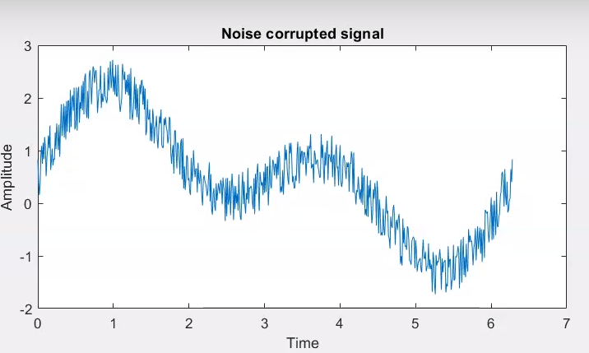

Noise infested signal

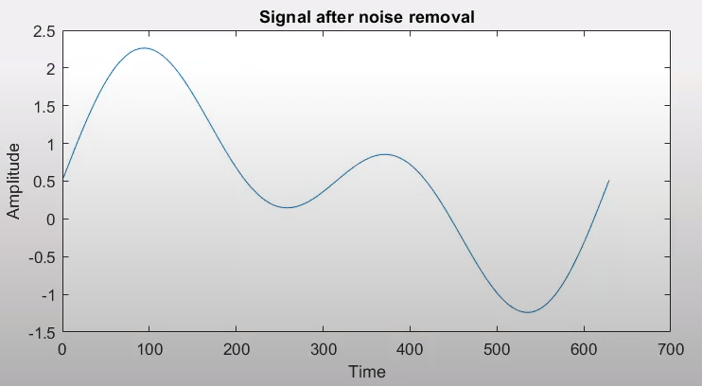

Original Waveform

References:

* Quora
  + <https://www.quora.com/What-are-the-best-projects-on-signal-processing-using-MATLAB>
* YouTube
  + <https://www.youtube.com/watch?reload=9&v=iTBWF9HA5yw&t=4s>