MLOPS CAPSTONE · PROJECT 4
From Raw Listings to a Monitored Model
An end-to-end MLflow pipeline that predicts house prices, refuses bad data and bad models, and keeps the previous model serving when anything fails.
Group 4 — Swagata Bhowmik (B053) · Sumit Kothari (B062)
Elective II: Machine Learning Operations · Dr. Santosh Kumar · 24 October 2026

±₹5.74 L  average error (validation) | ₹5.78 L  held-out test error | 8 · 2  pipeline stages · safety gates | 3 × 500  incoming listings monitored | 0 errors  in 300 live requests | 16 / 16  tests on Linux & Windows

Executive summary
A real-estate start-up prices new listings by hand, with no record of which data or code produced a model and nothing to stop a bad release. We built one automated pipeline that takes the supplied data to a live, monitored model.
Every run is tracked in MLflow; a data gate and a model gate stop bad inputs and weak models; every change is tested, released and deployed by CI/CD; and three later batches are monitored for drift. A live dashboard lets anyone try the model and trace it back to its code and data.
The chosen Ridge model is off by ₹5.74 lakh on average — about 9% of a typical ₹62-lakh listing — against ₹17.73 lakh for a naive guess. All eight requested deliverables are complete and evidenced.

Live dashboard  group4-mlflow-capstone.onrender.com/ | Code repository  github.com/Swagata-Bhowmik/group4-mlflow-capstone | API documentation  group4-mlflow-capstone.onrender.com/docs

Inside this report
 | Section | What you will find
1 | What we were asked to do | The brief, the eight deliverables with their status, and the success targets vs what we achieved
2 | How we built it | The architecture, its eight numbered steps mapped to the MLOps lifecycle, and our technology choices
3 | What we delivered | Each deliverable: what was asked, what we delivered, where to find it, with screenshots and evidence
4 | Team and conclusion | Who did what, and the overall result

1 What we were asked to do
Project 4: Capstone — End-to-End MLflow Pipeline from Raw Data to Monitored Deployment

The brief asked for one automated pipeline that takes raw listings to a live, monitored model and fails safely: when data or model quality is not acceptable, it must stop cleanly and keep the previous model in service. It had to use free tools, automate every stage, let only the pipeline change the production model, and keep secrets out of the repository.

■ Deliverables and status
Deliverable | Status | Main evidence
Repository: pipeline, configuration, tests, workflows, Dockerfile, README | ✓ Done | GitHub repository · section 3.1
Design note (max 2 pages) with architecture diagram | ✓ Done | design_note.pdf · section 3.2
Workflow graph, run history and registry screenshots | ✓ Done | output/screenshots · section 3.3
Evidence of two failing-gate scenarios | ✓ Done | live_safe_failures.json, PR #2 · section 3.4
Lineage demonstration (live) | ✓ Done | Dashboard Lineage tab, /lineage · section 3.5
CI history including at least one release | ✓ Done | GitHub Actions, Releases · section 3.6
Monitoring dashboard or report for the three batches | ✓ Done | Dashboard Monitoring tab, monitoring.html · section 3.7
Reflection (one page) | ✓ Done | reflection.pdf · section 3.8

■ Problem → solution → how
The problem  - Retraining and releases are manual  - No record of data, code or settings behind a model  - Nothing stops bad data or a worse model  - No warning when new listings change | Our solution  - One automated 8-stage pipeline  - Two quality gates; old model keeps serving  - Full tracking and lineage in MLflow  - Tested, released and deployed by CI/CD | How it works  - Git + one validated config.yaml  - PR checks run tests and the model gate  - Merge → image tagged by commit → release → deploy  - Monitoring alerts start a new gated change

■ Success targets and what we achieved
Measure | Target (config.yaml) | Achieved | Result
Average error (MAE) | ≤ ₹7.0 lakh | ₹5.74 lakh | ✓ Met
Large-error measure (RMSE) | ≤ ₹9.0 lakh | ₹7.52 lakh | ✓ Met
New model vs live model | ≤ 2% worse, or rejected | Enforced at evaluate | ✓ Enforced
Live request errors | ≤ 1% | 0 of 300 | ✓ Met
p95 latency | ≤ 200 ms | 213 ms (1 user) · 857 ms (5 users) | ⚠ Not met on free host
Reproducibility | MAE within 1e-6 | Identical on a fresh clone | ✓ Met

2 How we built it
Architecture mapped to the MLOps lifecycle
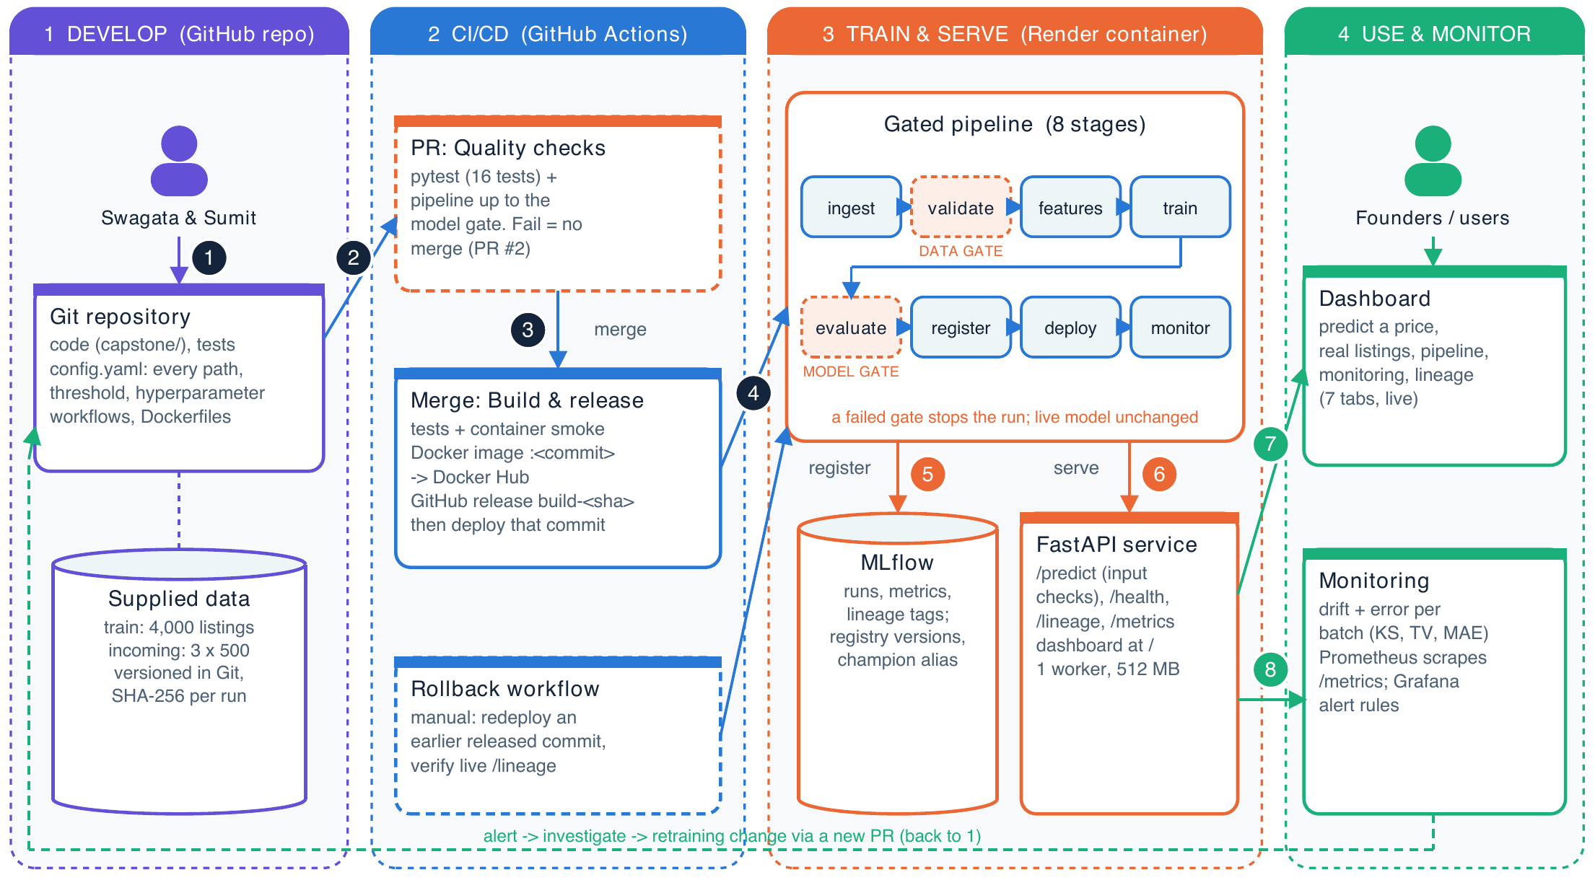
Figure 1 — Architecture: develop → CI/CD → train & serve → use & monitor. Numbers follow the steps below.
# | What happens | Lifecycle stage
1 | Code, config.yaml (validated on load), tests and the supplied data are versioned together in Git | Framing, data & configuration
2 | Every pull request runs the tests and the pipeline up to the model gate; a failure blocks the merge | Continuous integration
3 | A merge builds and tests a container, tags it with the commit, pushes it to Docker Hub and creates a release | Continuous delivery
4 | That exact commit is deployed to Render; the build runs the gated pipeline; rollback redeploys an earlier release | Deployment & orchestration
5–6 | Validate and evaluate are gates; passing models are registered in MLflow and served by the API | Validation, tracking, serving
7–8 | Founders use the live dashboard; batches are monitored, and an alert leads back to step 1 | Consumption, monitoring & feedback

■ Technology choices
Need | What we used and why
Orchestration | A small persisted DAG in capstone/core.py — explicit stages, artifact hashes and reruns without an extra service (instead of Prefect/ZenML)
Tracking & registry | MLflow 3: runs, metrics, lineage tags, registered versions with lifecycle tags and a champion alias
Serving | FastAPI with strict input checks, Prometheus metrics and a 7-tab dashboard
CI/CD & packaging | GitHub Actions, Docker, Docker Hub, GitHub releases, automatic deployment to Render (free)
Data versioning & drift | Git + SHA-256 snapshots for the small supplied CSVs (instead of DVC); SciPy effect sizes for drift (instead of Evidently)

3 What we delivered
Each deliverable: what was asked, what we delivered, where to find it

■ 3.1 Repository
What was asked | One repository with the pipeline, configuration, tests, workflows, Dockerfile and README.
What we delivered | - Pipeline: capstone/core.py — 8 stages with dependencies, hashes, logs, gates, promotion and rollback  - Configuration: one config.yaml, validated on load (no hard-coded paths, thresholds or hyperparameters)  - Tests: 16 automated tests, passing on Linux and Windows on every pull request  - Workflows: PR quality checks, build & release, rollback  - Dockerfiles and README: Docker Compose stack, Render image, and a README with setup for Windows, macOS and Linux
Where to find it | github.com/Swagata-Bhowmik/group4-mlflow-capstone

■ 3.2 Design note with architecture diagram
What was asked | A design note of at most two pages with an architecture diagram, numeric and justified success thresholds, and every component traced to a lifecycle stage.
What we delivered | - Exactly 2 pages: objective, success metrics with plain-language meaning, architecture diagram with 8 numbered steps, lifecycle mapping  - Gates, tracking and lineage, CI/CD and rollback, monitoring and alert response, tool choices and limits  - Every number is generated from the recorded evidence files, so the note cannot drift from the results
Where to find it | output/pdf/design_note.pdf

■ 3.3 Workflow graph, run history and registry screenshots
What was asked | Screenshots of the workflow graph, the run history and the model registry.
What we delivered | - Workflow graph of the live run, with both gates and the model-gate checks (dashboard Pipeline tab)  - MLflow run history showing passed and failed runs with their metrics  - MLflow registry: version 1 production with the champion alias, version 2 archived
Where to find it | output/screenshots/ (01, 02, 03, 04) · presentation slide 4
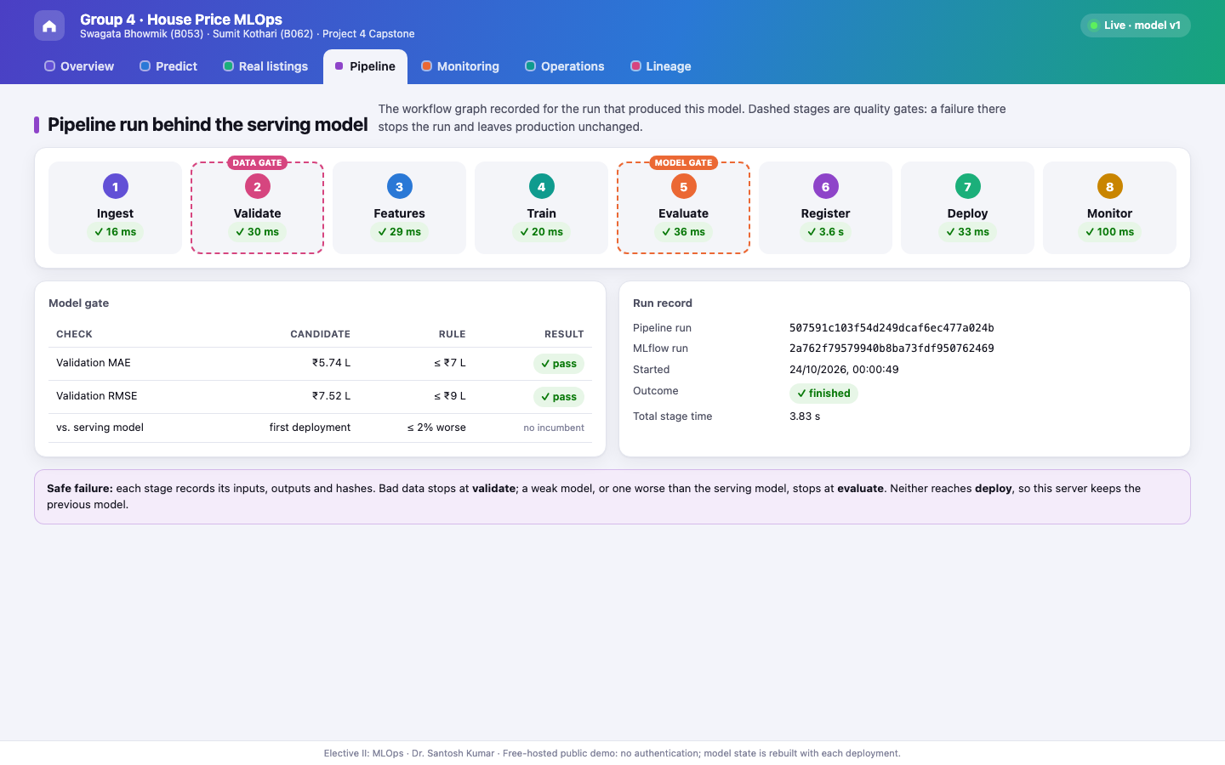
Figure 2 — Workflow graph of the run behind the live model (8 stages, data gate and model gate).
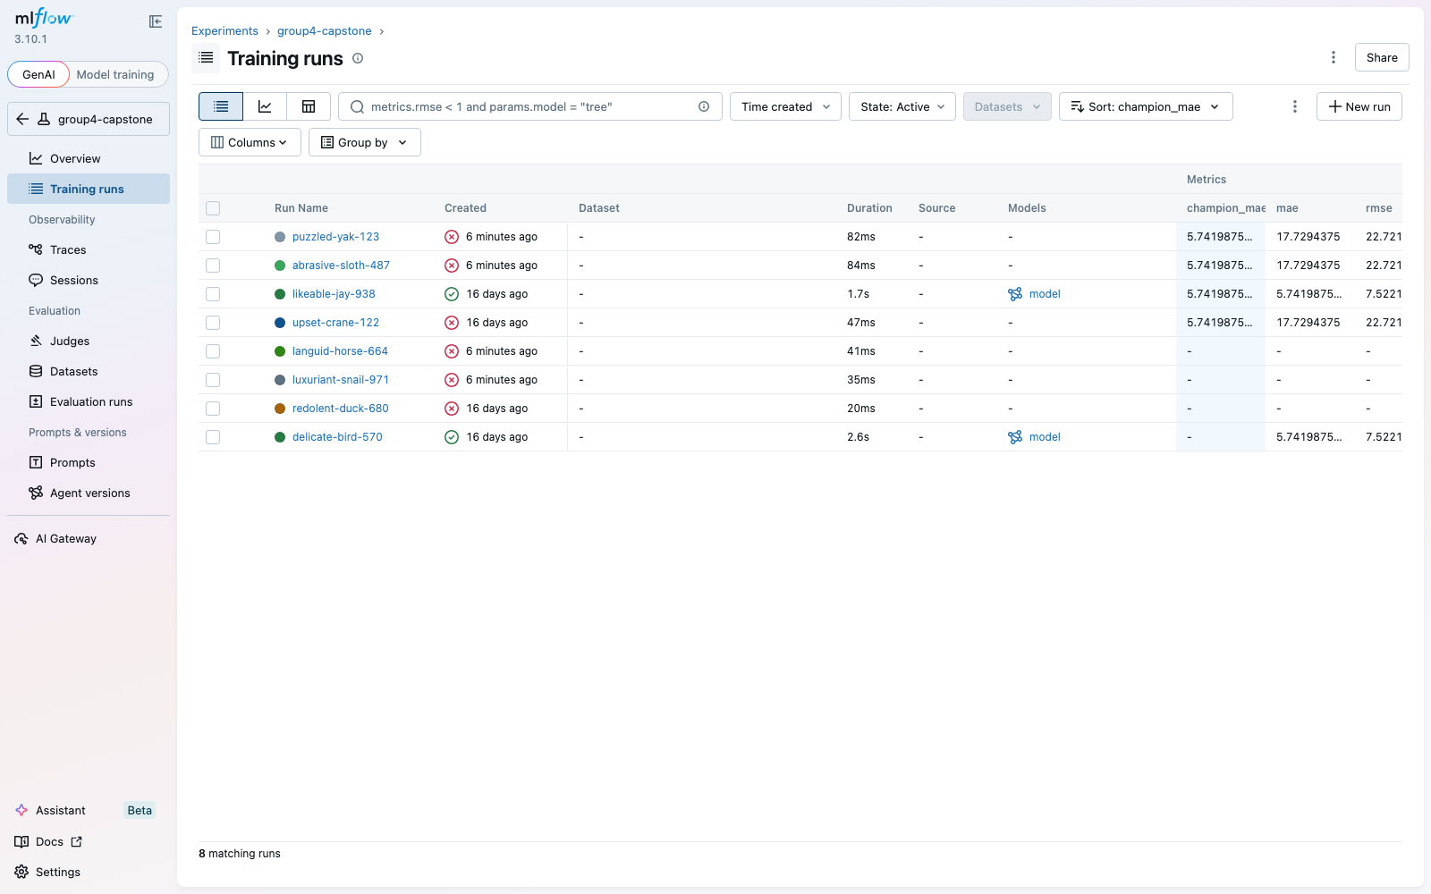  Figure 3 — MLflow run history | 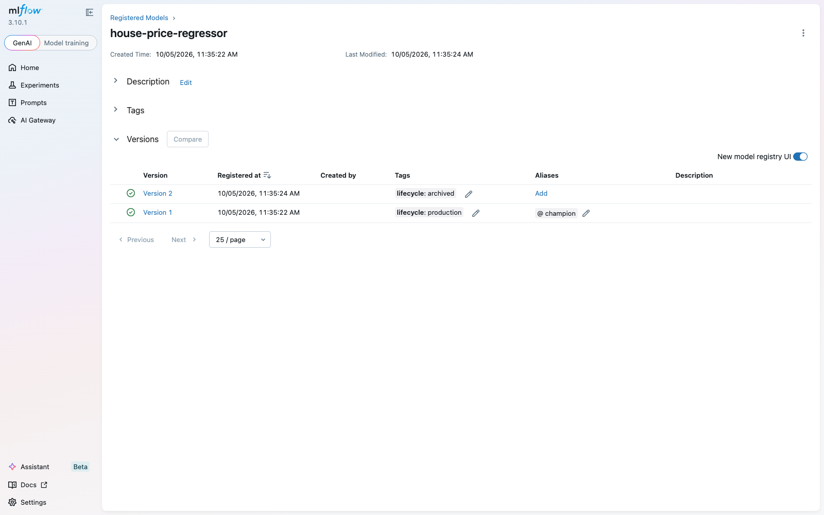  Figure 4 — MLflow model registry

■ 3.4 Evidence of two failing-gate scenarios
What was asked | At least two failing scenarios — a bad data batch and a model below the threshold — with the production model and endpoint unchanged after each.
What we delivered | - Ran both against a real HTTP server while it kept answering prediction requests  - Also showed a bad change blocked in CI (PR #2) and invalid input rejected by the live API
Where to find it | reports/live_safe_failures.json · scripts/live_safe_failure.py · PR #2

Scenario | Stopped at | Gate message | Live service during the run
Bad data: 20% of Age_Years blanked (limit 8%) | ✕ validate (data gate) | Age_Years: missing fraction exceeds limit | 56 requests · 0 errors · v1 unchanged
Bad model: median-only dummy, error ₹17.73 L | ✕ evaluate (model gate) | Candidate exceeds absolute error thresholds | 59 requests · 0 errors · v1 unchanged
Bad code change in PR #2: Ridge α = 1000, error ₹8.77 L | ✕ CI quality checks | Model gate rejected the candidate | Not merged until fixed (α = 10)
Invalid input: 0 bedrooms | ✕ API input checks (HTTP 422) | Bedrooms: outside allowed range | Model never called; unchanged

Why this matters
A failed gate stops the run before register and deploy, so the serving pointer and registry are never touched. The previous model keeps answering throughout — 115 live requests with zero errors across both failures.

■ 3.5 Lineage demonstration (live)
What was asked | A live lineage demonstration starting from the deployed model; run records must include data version and configuration.
What we delivered | - From the live model: Git commit → MLflow run → training-data SHA-256 → full configuration → model file hash  - Shown live on the dashboard Lineage tab and the public /lineage endpoint; the same tags are recorded on every MLflow run  - Registry changes (production, archived, champion) happen only through the pipeline's deploy and rollback functions
Where to find it | group4-mlflow-capstone.onrender.com/lineage · output/screenshots/05, 04
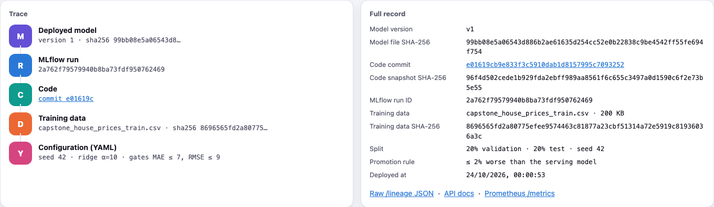
Figure 5 — Live lineage of the deployed model: trace (left) and full record (right).

■ 3.6 CI history including a release
What was asked | A pull request must trigger tests and a lightweight pipeline run; a merge to main must build a deployable image and release it; CI history must show a passing and a failing pull request and at least one release; rollback must be documented and tested once.
What we delivered | - Quality checks on every PR, on Ubuntu and Windows: tests plus the pipeline up to the model gate  - PR #2 failed on purpose (the model gate rejected α = 1000) and passed after the fix. CI also caught two real bugs: a test-collection error in PR #3 (fixed in the same PR) and a Windows text-encoding error in PR #8 (fixed in PR #9)  - Every merge: tests → container smoke test → Docker image tagged with the commit → GitHub release build-<sha> → deploy that commit to Render → verify /lineage  - Rollback workflow tested live: back to an earlier release and forward again, about 2 minutes each, both verified
Where to find it | GitHub Actions · Releases · reports/render_rollback.json · docs/OPERATIONS.md
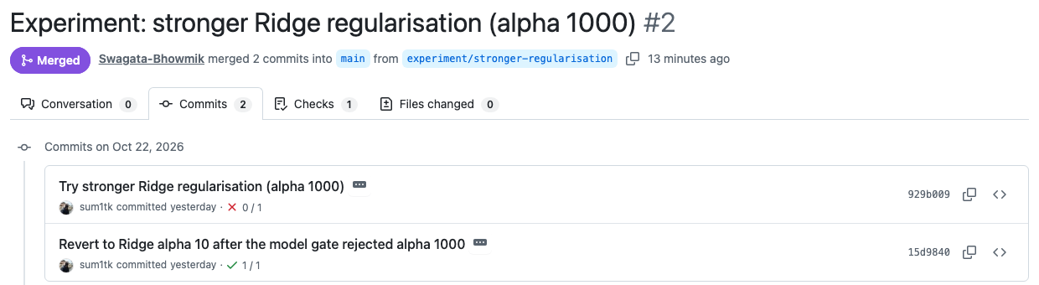
Figure 6 — PR #2: the α = 1000 commit failed CI (✕ 0/1), the fix passed (✓ 1/1).
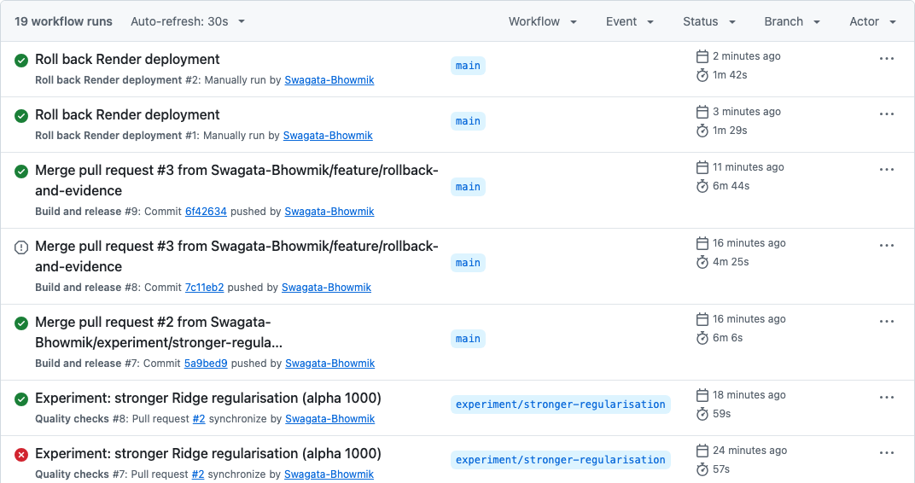
Figure 7 — GitHub Actions history: quality checks, build & release runs, and both rollback runs.

■ 3.7 Monitoring of the three incoming batches
What was asked | A dashboard or report showing operational metrics and drift over the three batches, justified alert thresholds, the batches that trigger them, and what the pipeline should do when an alert fires.
What we delivered | - Each batch compared with the training data (data drift) and scored against its real prices (performance drift)  - Alerts: numeric KS D or categorical total variation above 0.10; MAE above ₹7 L or 1.25 × validation error  - Operational metrics live on /metrics and the Operations tab; Prometheus rules and a Grafana dashboard for a Docker host
Where to find it | Dashboard Monitoring tab · reports/monitoring.html · live dashboard

Batch | Error (MAE) | Status | What changed
Batch 1 | ₹5.56 L | ✓ Stable | Nothing above threshold
Batch 2 | ₹6.87 L | ⚠ Data drift | Houses got smaller (area); error still under the limit
Batch 3 | ₹13.11 L | ✕ Performance alert | Area, bedrooms, bathrooms and city zone shifted; error doubled
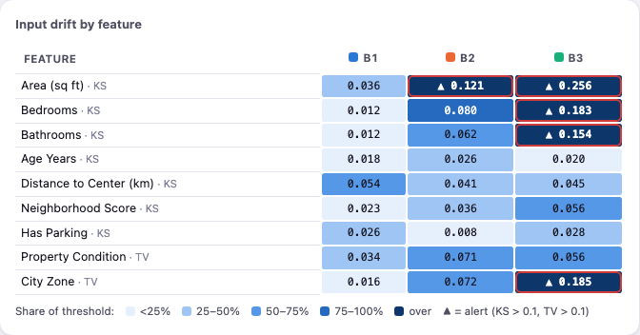
Figure 8 — Drift per feature; outlined cells are above the 0.10 alert threshold.
When an alert fires
Nothing is replaced automatically. The live model keeps serving while the team investigates and starts a new pipeline run with fresh labelled data; a retrained model goes live only if it passes the data gate, the error limits and the comparison with the live model.

300  live requests (load test) | 0  errors | 213 ms  p95, 1 user | 857 ms  p95, 5 users (target 200)

■ 3.8 Reflection: what we would improve
What was asked | A short reflection (one page) on what we would improve with more time.
What we delivered | - What worked: every release decision is automatic, explainable and traceable  - More serving power: more CPU and workers to meet the 200 ms target under load  - Persistent model store: compare every cloud release with the live model  - Safer releases: canary or blue/green deployment with automatic rollback  - Smarter alerts: calibrated thresholds, per-zone errors and notifications  - Scale the tooling: DVC for data and Prefect/ZenML for scheduling as the project grows
Where to find it | output/pdf/reflection.pdf

4 Team contributions and conclusion

Swagata Bhowmik (B053)  - Pipeline core, gates, promotion and rollback  - Serving API, monitoring and the live dashboard  - Docker, release workflow and automatic Render deployment  - Rollback workflow and live evidence (failing gates, load test, fresh clone)  - Screenshots, presentation and Windows support | Sumit Kothari (B062)  - Model comparison that selected Ridge (α = 10)  - Test suite and measured evidence  - Design note, reflection, demo and operations documents  - CI gate experiment (PR #2): α = 1000 rejected by the model gate, then fixed
Based on the commit history of the repository.
Conclusion
All eight deliverables are complete and evidenced. The system turns the supplied data into a live, monitored model through eight automated, re-runnable stages; two gates stop bad data and weak models while the previous model keeps serving; every model is traceable to its code, data and configuration; and every change is tested, released and deployed by CI/CD, with rollback tested on the live service.
The main open limit is serving speed on the free host under concurrent load, which is the first improvement we would make.

