

**e-Yantra Robotics Competition - 2017**

**Theme and Implementation Analysis – Planter Bot**

**#1108**

|  |  |
| --- | --- |
| **Team Members** | MOHAMMED ARFAN | SWAGATH BABU |
| **College** | BMS COLLEGE OF ENGINNERING |
| **Email** | [mdarfaneee@gmail.com](mailto:mdarfaneee@gmail.com), | [swagathb2826@gmail.com](mailto:swagathb2826@gmail.com) |
| **Date** | 09/01/2018 |

**Scope and Preparing the Arena**

**Q1. a. State the scope of the theme assigned to you.**

Farmers are increasingly under pressure to feed more people. The UN predicts that the world population will rise from 7.3 billion todays to 9.7 billion in 2050. Plus, there is overall push to make farming greener by using less water and pesticides.

These factors mean farmers need to produce more at higher quality and in a sustainable manner.

With the youth turning away from the profession there is also less labour available to drive the vision forward.

In such situation Robotics and farming is set to improve production yield, while reducing resources required and making farming an exciting high tech profession.

**(5)**

< Teams should briefly explain in their own words the theme assigned. What in your opinion is the purpose of such an application?

Answer format: Text, Word - limit: 100 words>

**b. Upload the Final Arena Images.**

**(20)**

< Prepare the arena according to the steps given in Section 3: Arena, of the Rulebook. Please follow the arena configuration shown in “Figure 1: *Basic elements of Arena*” and “Figure 7:

*Flex Design with dimensions*” of the rulebook.

Configuration for Zone Indicators and Color Markers associated with them are as per following Table:

|  |  |  |  |
| --- | --- | --- | --- |
| Zone Indicator Number | Cell number for Zone Indicator | Color Marker Type | Number of Color Markers |
| 1 | N3 | Red Circle | 3 |
| 2 | F7 | Green Triangle | 4 |
| 3 | O11 | Red Square | 1 |
| 4 | E16 | Blue Square | 2 |

In addition to this, place a Zone Indicator at Cell number J16. This has no Color Markers associated. Refer to Section 2: Theme Description and Section 6: Theme Rules of Rulebook for more information about this.

**Take 4 photos** of the completed arena from different angles such that the entire arena along with its components such as Terrains, Zone Indicators, Cells, etc., is clearly visible in the photos.

Answer Format: The four image files should be uploaded as **.jpg** along with this document as per instructions in Read Me for Task 3. >

**Building Modules**

**Q2. Identify the major components required for designing the robotic system for the theme assigned to you.**

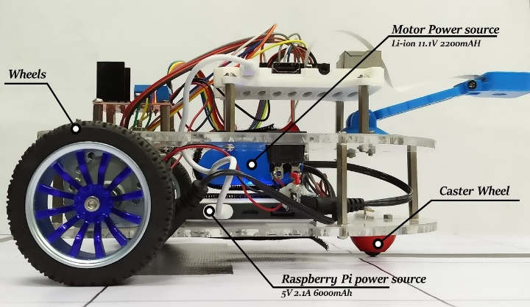

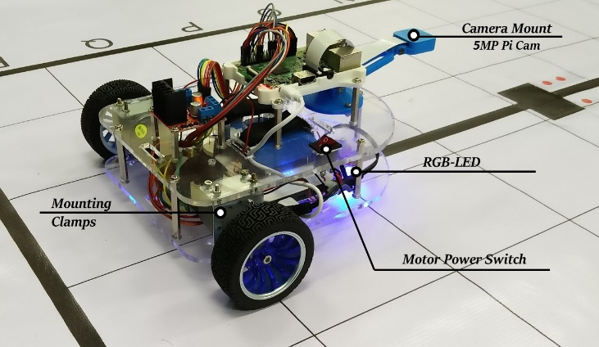

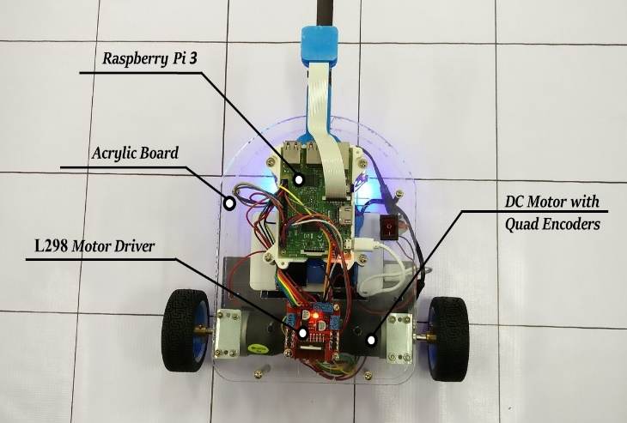

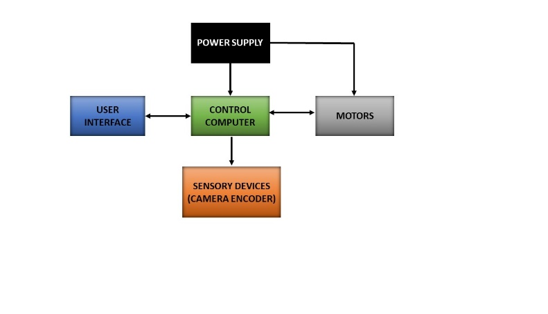

1. Motors and Wheels (with encoders)

2. Chassis

3. Motor driver

4. Raspberry pi

5. Camera (Pi Cam)

**(5)**

< Teams should classify the components into various categories: mechanical systems, electronic systems etc. and mention how these units will be used in the theme. You may draw diagrams/figures to illustrate your answer.

Answer format: Bulleted form

1. Component 1

2. Component 2

3. Component ….etc. >

**Power Management**

**Q3. a. Explain the power management system required for a robot in general and for the theme assigned to you in particular.**

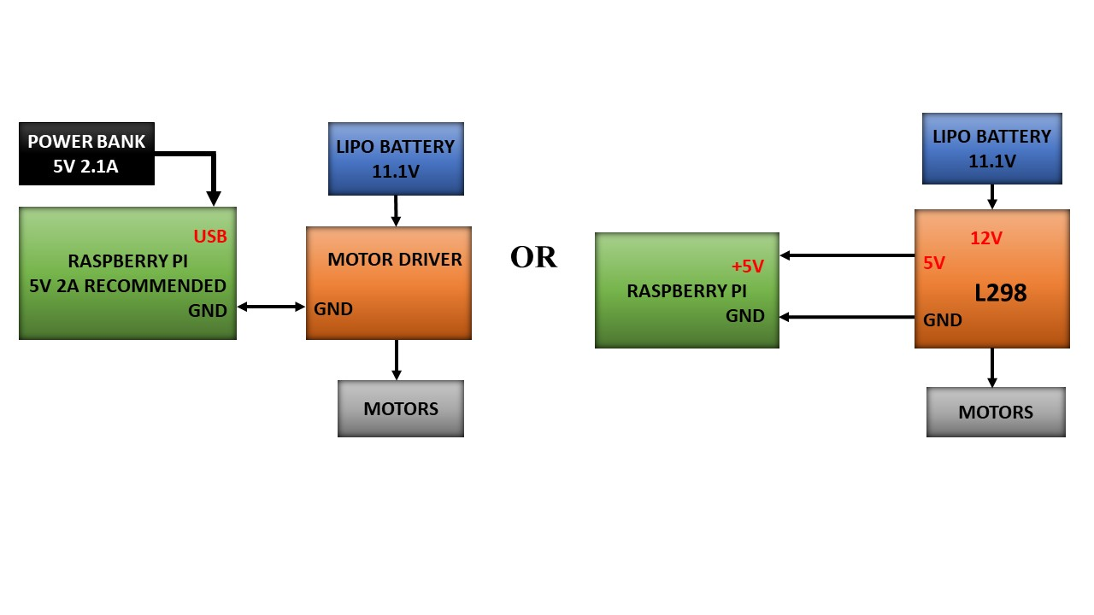**(5)**

The power requirement:

Raspberry pi3(headless mode) = (idle) 230mA(1.2W)

Motors x 2 = No load current x 2

= 140mA x2 = 280mA.

= Load current x 2

= 1A x 2 = 2A.

Since the Raspberry pi 3 is used in headless mode with HDMi off and driving few LED’s and outputs. The total power consumption would be

= 230mA(idle) + RGB LED’s power + Motor driver input + encoders power + CPU load

=230mA+ 60mA (max for white) + 50mA +50mA+ 4X100mA (4 CPU’s).

= 790mA = 0.8A (without camera and Wi-Fi)

So it is preferable to use a power supply around 2A which would be able to supply power for various other accessories.

Since the motor on load draws a maximum current of 1A each it is preferable to use a power source greater than 2000mAh.

As the motor used are 12V, a battery voltage required should provide voltage around 12V. As the Li-ion batteries available near 12V range is 11.1V can be used as the motor power supply.

Therefore, Raspberry Pi power supply= 5V, 2.1A 6000mAh power bank.

Motor power source= 2200mAh, 11.1V Li-ion battery.

< Teams should mention the power requirement of their system with current rating and voltage requirement. You can mention the mode (auxiliary/battery) you prefer to use in your system with necessary justification. You can also draw some diagrams/figures to illustrate your answer.

Please provide the answer in your own words.

Answer format: Text, Word-limit: 100 words>

**b. Can there be a single power supply for your robot? - Yes/No/Don’t know. Please elaborate/justify your answer choice.**

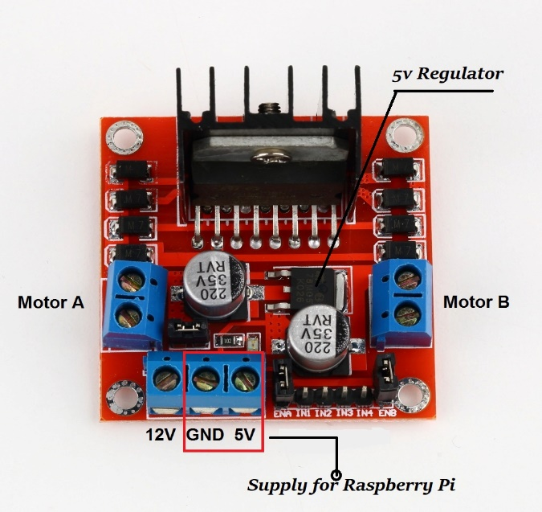

**Yes**, but we wouldn’t recommend it.

The L298N has a 5V regulator for powering the 5V MCU’s which are used along with it.

Using one supply the simple overall, one concern is electric motors can create a lot of electric noise. If not filtered, might get injected into the raspberry pi and may cause it to reboot or become unstable (temporarily).

Sometimes, if the motor power supply is under powered, when the motor changes the direction, taking maximum current, the power supply voltage might dip enough to cause the supply to raspberry pi to dip and reboot.

Therefore, if using a single power supply care should be taken the motor supply is not under powered and the supply for raspberry pi is filtered properly.

**(5)**

< Support your answer.

Answer format: Text, Word - limit: 200 words >

**Design Analysis**

**Q4.** **Teams have to design a robot which traverses the arena following a given path and simulate planting by overlaying image in GUI.**

**a. How will your robot traverse a field represented by the Arena given in the rulebook?**

**(5)**

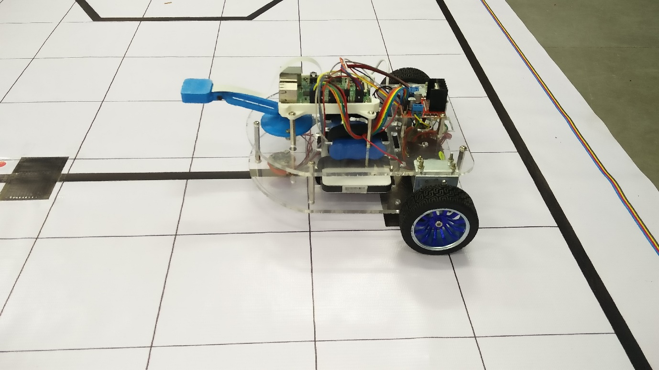

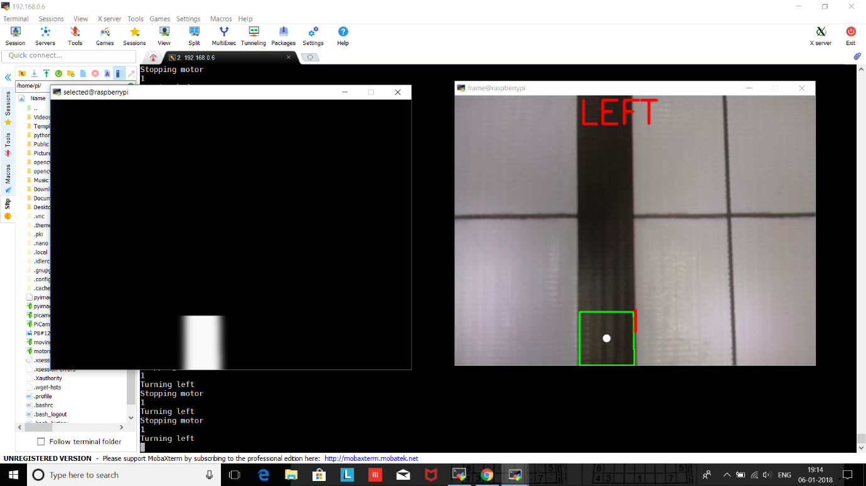

The Robot designed is as follow

1. Two motors (with quad encoders) and a caster wheel in the front.

2. Raspberry Pi as a control computer.

3. Equipped with a Pi Cam fitted onto the robot with stand.

The Pi Cam is placed such that the black line representing the path is clearly visible in the camera frame. This frame is subjected to various image processing techniques like thresholding, smoothing by Gaussian filters, noise reduction by erosions and dilation and then selecting the region of interest.

Then applying contour detection to find the contour as shown in the figure.

The centroid of the contour is calculated which decides the direction of the robot, thus the robot moves traversing the black line.

While robot encounters the zone indicator, the ROI selected is small such that no contour is detected in such case the robot is made to travel exactly by a distance such that the colour markers appear in the frame of the camera (with the help of the feedback from the encoders). As the distance of CM’s from the zone indicators is fixed and then the robot performs the another set image processing to identify the CM’s to decide the types of overlay.

< Explain your path planning technique(s). Clearly specifying the hardware components, inputs and outputs for your technique. You can explain multiple techniques.

Word-limit: 500 words. >

**b. If you were to implement this theme in the real-world scenario, what would be the actuators you will employ? Explain their purpose.**

**(5)**

< Justify your answer by stating the advantage(s) of the chosen actuator(s) over others. Actuators that will be required for movement, planting mechanism, etc.

Answer format: Text, Word - limit: 200 words>

**Environment Sensing**

**Q5. a. Explain how you will use the PiCam to decide the course of traversal.**

**(5)**

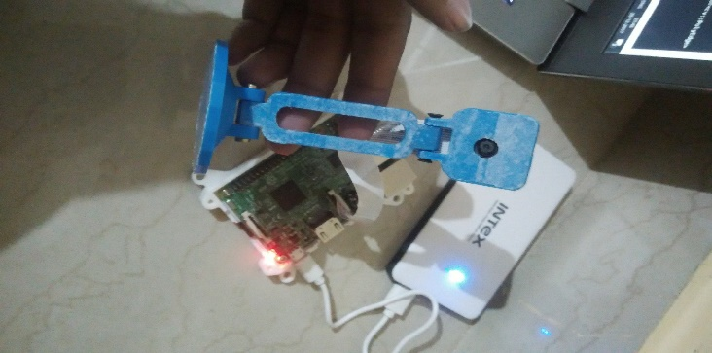

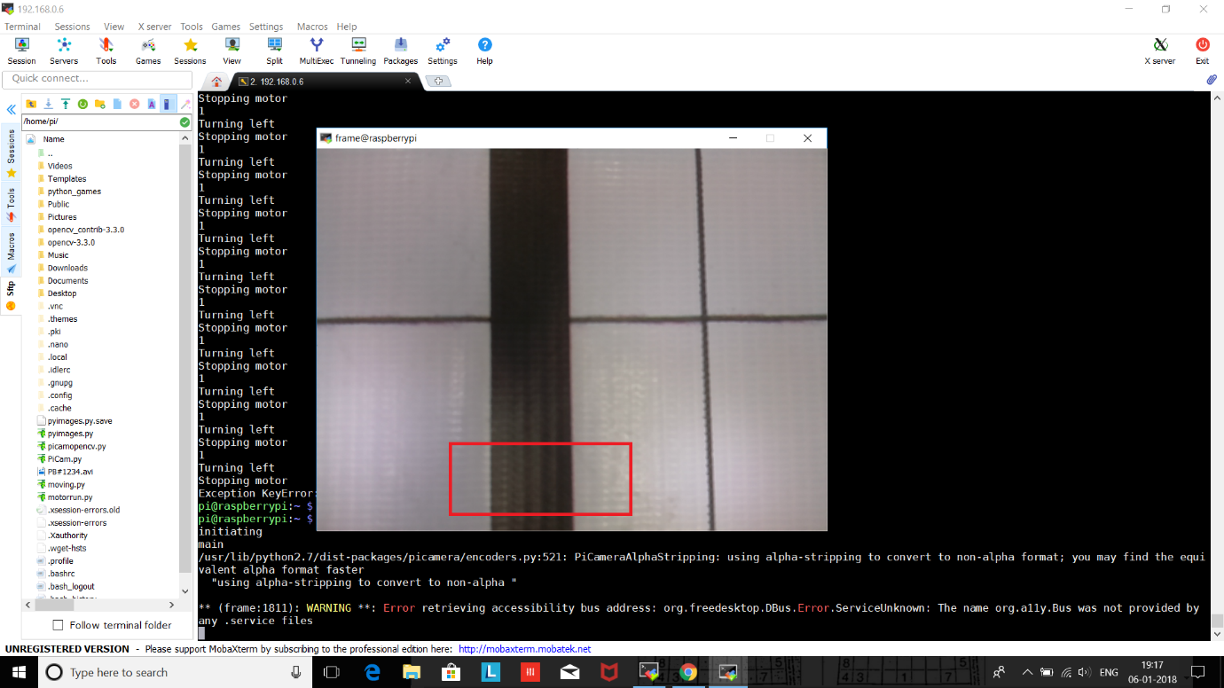

PI Cam is mounted in the front portion of the robot. The frame is continuously captured from the Pi Cam

* The incoming frame is converted to obtain a black and white image by filtering out the black colour in the input frame. By using **cv2.inRange()** function.
* The binary image is subjected to noise reduction by applying Gaussians filters, erosion and dilation.
* Then a small portion of image is selected by defining the vertices of the region of interest.
* The ROI is subjected to contour detection from which the centroid of the contour is calculated.
* Then the direction of robot is set based on the centroid of the contour.
* The centroid the contour detected in the incoming frame is continuously compared with the reference Centre of the frame.

The **error = centroid – frame** reference indicates the direction of the robot.

Thus the feed from the Pi Cam helps the robot traverse the black line on the arena.

< Team should explain in detail how they will use the mounted PiCam to sense the environment associated with the theme. Explain the role of Camera in providing important feedback during the Run.

Answer format: Text, Word - limit: 300 words>

**b. Would the webcam be a better choice of camera over the PiCam? Explain.**

Pi Camera is more preferable for the current application.

* The Pi Camera is ‘run’ by GPU and can dump full frames into RAM at 15fps, that is 7.5MB/frame, 15 frames at 112.5Mega Bytes per second or you can have full HD resolution 3 fps H264 encoded along with some simultaneous still photos all at virtually zero CPU loading.
* On the other hand, the USB web cam is run byte at time by the CPU and at the cost of 100% CPU loading you might a couple of hundred megabits per second. Webcam is not going to deliver that anyway.
* However, if it could, then you will be left with no CPU cycles to do anything with it.

So, unless CCTV resolution (320x240) are what you want, it has to be the Pi Camera.

**(5)**

< Think which a better option is: using a webcam or Picam? Support your answer by listing pros and cons of choosing each option.

Answer format: Text, Word - limit: 200 words >

**c. What other sensors will the robot require to complete its task successfully?**

**(5)**

1. Infrared sensors for efficient line following.
2. Colour sensor for detecting colour of the CM’s
3. LDR to measure light intensity of the environment to do adaptive thresholding by taking feedback from the LDR i.e. setting thresholds for getting the binary image.
4. Voltage sensor to monitor battery voltage

< Answer format: Bulleted form

1. Sensor 1

2. Sensor 2

3. Sensor 3 ….etc. >

**Testing your knowledge (Theme Analysis and Rulebook-related)**

**Q6. a. If a team has an overlay similar to one shown in the Figure 1, how many points will you score for the overlay in total. Specify score for accuracy, penalty if any and total. Elaborate on penalty if any - why it will be applicable?**

**(5)**

**Note: The team has selected the correct seedlings image upon detection of Color Marker and there are three such Color Markers at the Zone Indicator.**



**Figure 1: Overlay Example**

Overlay in total = (ZD*100) + (CMD*75) + (O*25) - (P*50)

= (1*100) + (3*75) + (1*25) - (2*50)

= 250

* There are 2 penalties hence total penalty = (2*50) =100.
* There are 2 partially hidden seedling image hence it will be penalized.
* Overlay in total will be 400 points if it is accurate, but in the given case 2 seedling images are penalized therefore now overlay in total will be 250 points.
* This will affect the total score by reduction of 150 points

< Analyse the formula provided in the rulebook and explain how it will affect the score.

Answer format: Text/Bulleted form >

**b. Name the different Terrains in the Arena.**

**(3)**

Terrains in the Arena:

* Hill Side Road(HR)
* Berms(BE)
* Cliff Road(CR)
* Inverted Plain(IP)

<Answer format: Bulleted form

1:

2:

3:…etc. >

**c. How many possible unique Color Markers can be made in this theme?**

**(3)**

9

< Answer format: Single number >

**d. If there are 3 Blue Triangle Color Markers placed in front of a Zone Indicator, how will you indicate this via hardware only?**

**(3)**

Blinking RGB LED 3 times in blue colour with a time interval of 1 second.

< Answer format: Text

Word-limit: 200 words >

**e. What are the different conditions that indicate end of a run?**

**(3)**

Conditions that indicates end of a run:

1. When the maximum time limit (600 seconds) for completing the task is reached.
2. If planter Bot (PB) requires a reposition after both repositions have already been used, then the timer is stopped indicating end of run.
3. The Planter Bot (PB) completes the task and blinks RGB LED at the shed from first to last in the same sequence of colour of Colour Markers (CMs) as they appeared at each plantation zone (PZ). Here RGB LED blinks just once for each plantation zone (PZ) with an interval of 1 second.

< Explain in your own words. Answer format: Bulleted form, word-limit: 300 words

Condition 1:

Condition 2:

Condition 3:…etc. >

**Algorithm Analysis**

**Q7. Draw a flowchart illustrating the algorithm you propose to use for theme implementation.**

**(10)**

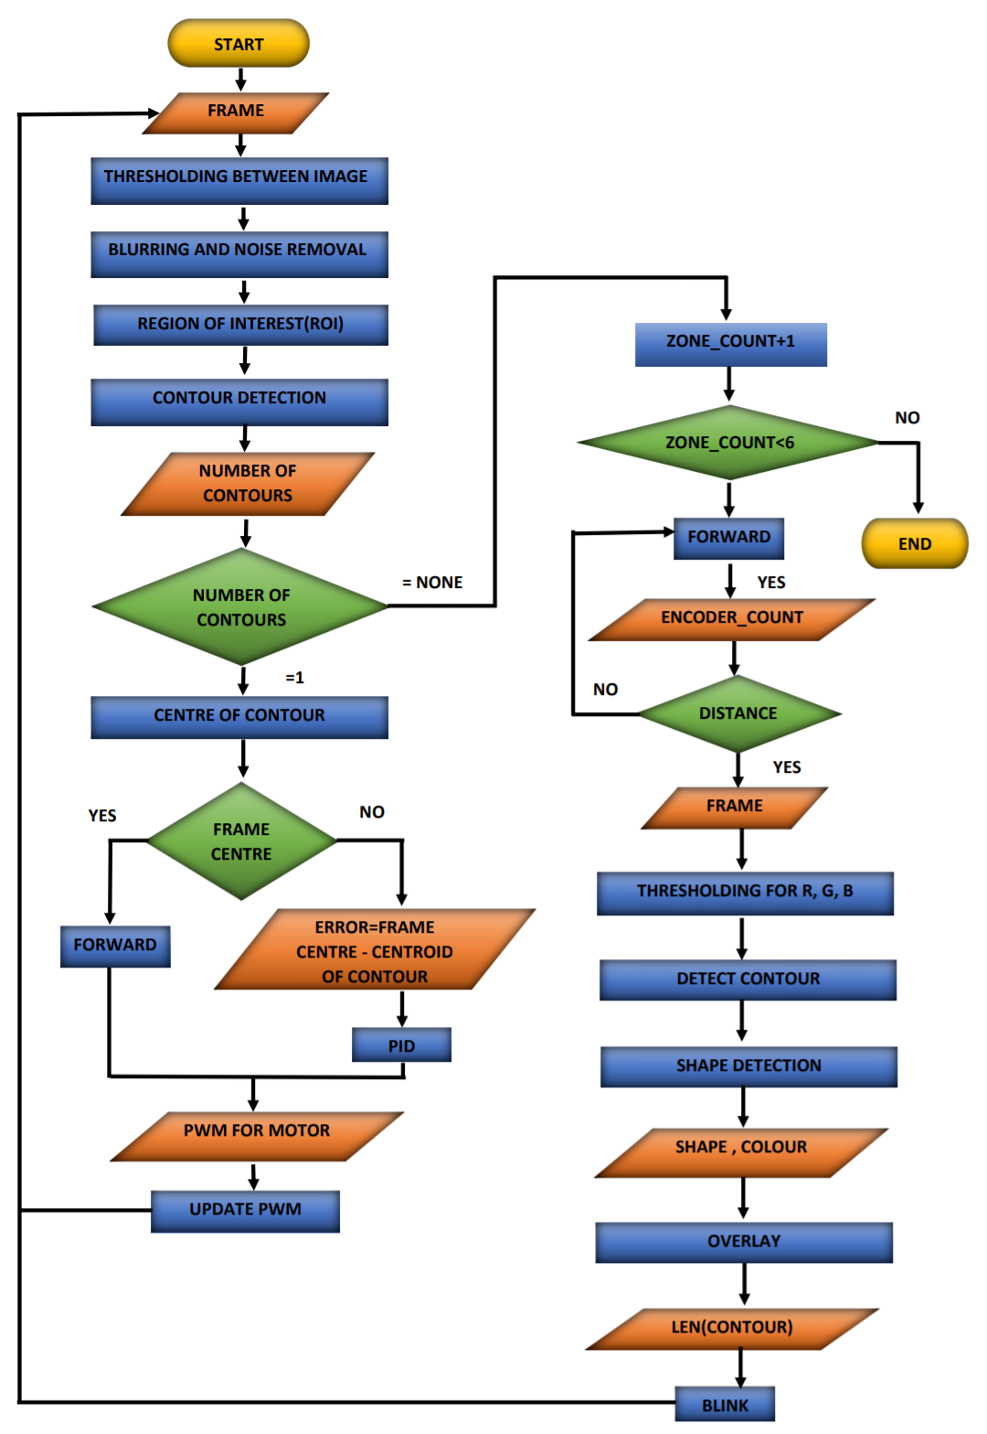

**Preparing the Input Frame**

* The input colour frame is converted into Gray scale using **cv2.cvtcolor** function.
* Then the grayscale is thresholded to convert into a binary image using **cv2.inRange** function.
* Then the binary image is blurred using a Gaussian filter by **cv2.GaussianBlur** function.
* The noise in the blurred image is removed by **cv2.erode** function such that only the track is visible.
* Then a small portion of the track is selected to find the contour by defining the region of interest using filter_region function.

**Black Line Detection**

* The selected portion of the frame is subjected to contour detection using **cv2.findContours**.
* Then the centroid of the detected contour is found by using **cv2.moment** function**.**

**Changing direction of Motor based on Centroid**

* Then the position of centroid of the contour is compared with the Centre of the camera frame i.e., (640/2, 480/2).
* If the centroid is offset from the Centre of the frame, then the error is calculated and using PID control loops the PWM for the motors required to correct the error is calculated and the motor PWM’s are changed accordingly.

**Detection of Zone Indicator**

* Suppose no contours are detected, this happens when zone indicator is encountered (as the region of interest is small, consists of a black portion only and the entire frame is black).
* When this happens the robot moves exactly 0.5inches forward (this is achieved by using the feedback from the encoders).
* The position of the colour markers is exactly 0.5inches from the zone indicator, thus when the robot moves forward by exactly 5inches, all the colour markers are visible in the camera frame.

**Detecting Colour Markers (CM’s) and Overlaying.**

* Then frame is subjected to thresholding for R, G, B and then to contour detection. Whichever thresholding results in non-empty list of contours decides the colour of the contour.
* Then the detected contours are subjected for shape detection by finding the number of vertices.
* Then the shape and colour of the contours decides the type of the flower to be overlaid on the given frame and the number of overlays is decided by the number of contours (colour markers) detected.
* The respective colour led is blinked as many times as the number of contours (colour markers) detected.
* This is repeated for 5 zones indicators and the number of zone indicator is monitored by a variable zone_count.
* It stops when the robot encounters 6th zone indicator which is the end of the track.

< The flowchart should elaborate on every possible function that you will be using for completing all the tasks in the assigned theme. Follow the standard pictorial representation used to draw the flowchart.

Answer format: Text, Word-limit: 1000 words >

**Challenges**

**Q8. What are the major challenges that you can anticipate in addressing this theme and how do you propose to tackle them?**

**(8)**

1. Effects due to varying light condition, we are facing issues due to the varying light conditions the thresholds set for one particular light doesn’t work well in some other environment.

We could solve this if we provide an additional constant source just above the camera.

1. Traversing through different terrains of the arena like Hillside, Berms, Cliff Road, Inverted plane.

Here we propose to solve this by using a PID. Control loop while traversing through parts of the arena like curve, zig-zag etc.

1. Errors due to the reflection of light at the certain portions of the arena (due to the use of cello tape to stick the zone indications etc.).

We could solve this by setting a threshold value that works for such conditions and applying certain filters and dilating the image.

In later stage we would look forward for better methods to solve this issue.

1. Power management

The provided Li-ion battery is sufficient enough but if the voltage drops below 10v or so the motors might get extremely slow.

Thus frequent checking of the battery voltage and charging it at proper time might element such issue.

< Answer format: Bulleted form

1. Challenge 1

2. Challenge 2

3. Challenge 3, etc. >