Requirements Specification

Swaggers:

Tianrui Peng (tp2522)

Jiangfeng Wang(jw3107)

Tiantian Yin (ty2346)

Zhekai Xing (zx2198)

Trello:

<https://trello.com/b/0Hp44FwJ/ase-swaggers>

1. Introduction:

Currently, traders are manually trading ETFs to optimize the price. However, due to the large amount of orders being executed every day, it is inconvenient and time-consuming for traders to manually manage all the orders. To help traders make their work more efficient, we will design a web application to help traders manage the trading process. The application allows traders to enter orders of ETFs, utilizes the designed algorithm to split up traders’ orders and executes the orders at most optimal price. The goal of this web application is to provide a convenient and intuitive user interface for

Trade ETF products.

be utilizing this web application.

2. Use cases:

Use Case 1: User Registration

Actor: Trader

Basic flow: The trader inputs basic information such as username and password, and registers to be able to use the web application.

Alternative Flow 1: The username has already being registered by other users. Inform user that this username has already been taken, and prompt user to enter another username.

Use Case 2: User login

Actor: Trader

Basic flow: The trader inputs account information such as username and password. The trader successfully login into the system.

Alternative Flow 1: The user provides wrong information, such as username does not exist or password incorrect. Inform user the problem and prompt user to enter the account information again.

Use Case 3: User logout

Basic flow: The user logout when he needs to leave the desk or he has completed order.

Use Case 4: Order management

Basic flow: The trader creates an order. He monitors the whole process of order execution.

3. Basic Workflow Diagram

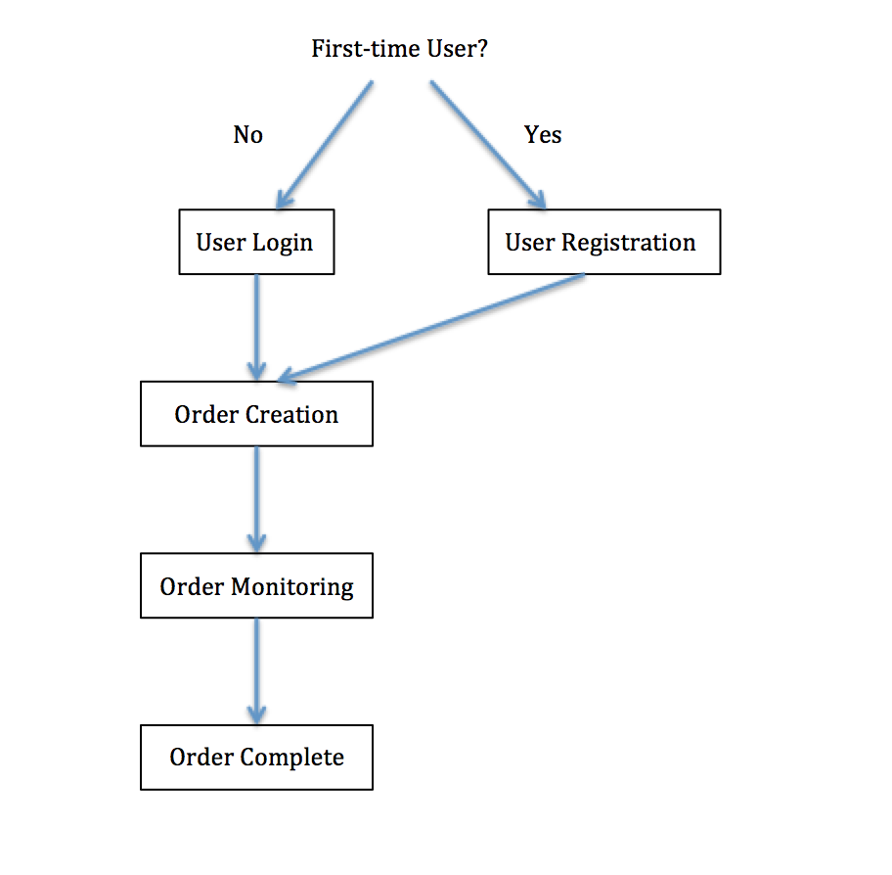

4. Wireframe

1. User registration

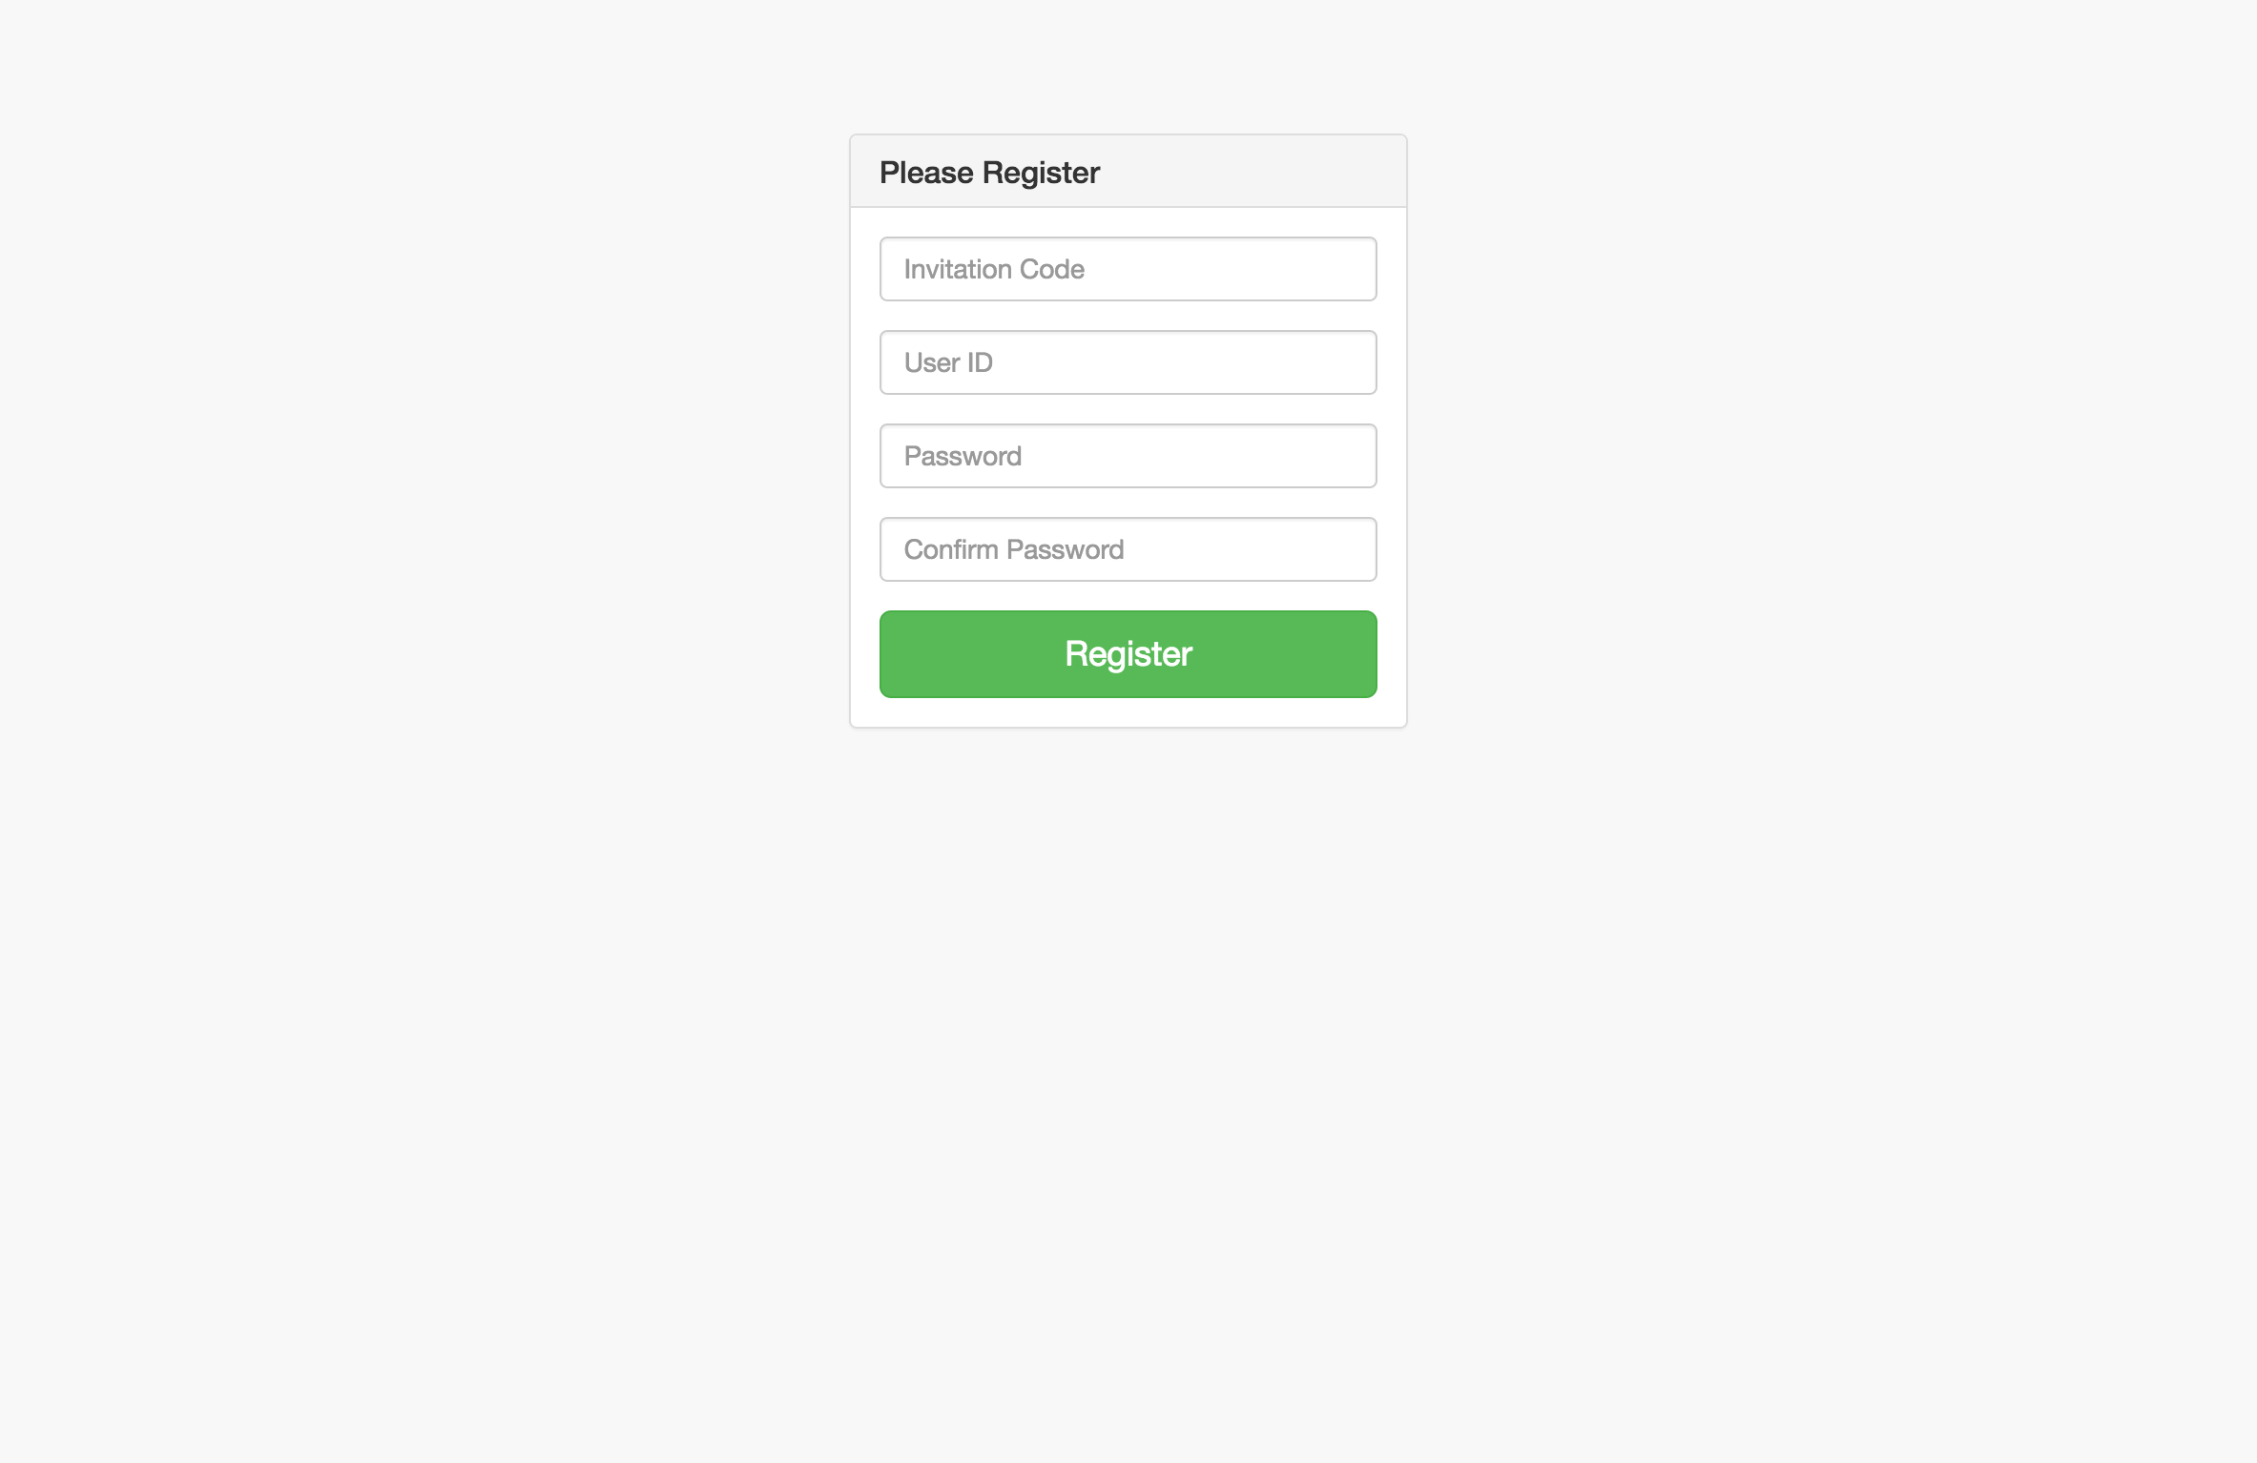

This is the user registration page. First-time users are required to register to use the application. The usernames cannot be the same with other registered users, as the application uses username to identify the user. All the 3 fields are required.

The usernames will be stored in the database and the actual password itself will never be stored. An encrypted representation will be stored which will be checked against every time that user goes to login. To continue registration, the user can click the “Register” button.

b) User login

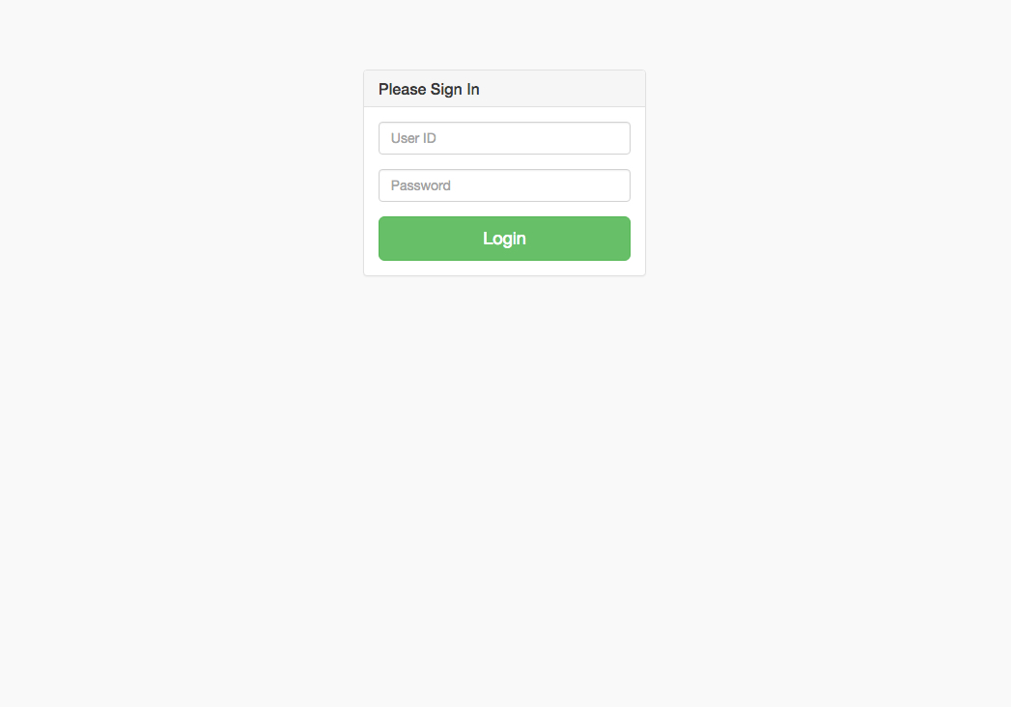

This is the login page. The user inputs his username and password. Both fields are required for login. The application will recognize the identity of user by reading their username and password. To continue logging in, the user can click the “Login” button. The user can exit the page by clicking the “Back” button.

c) Order Creation

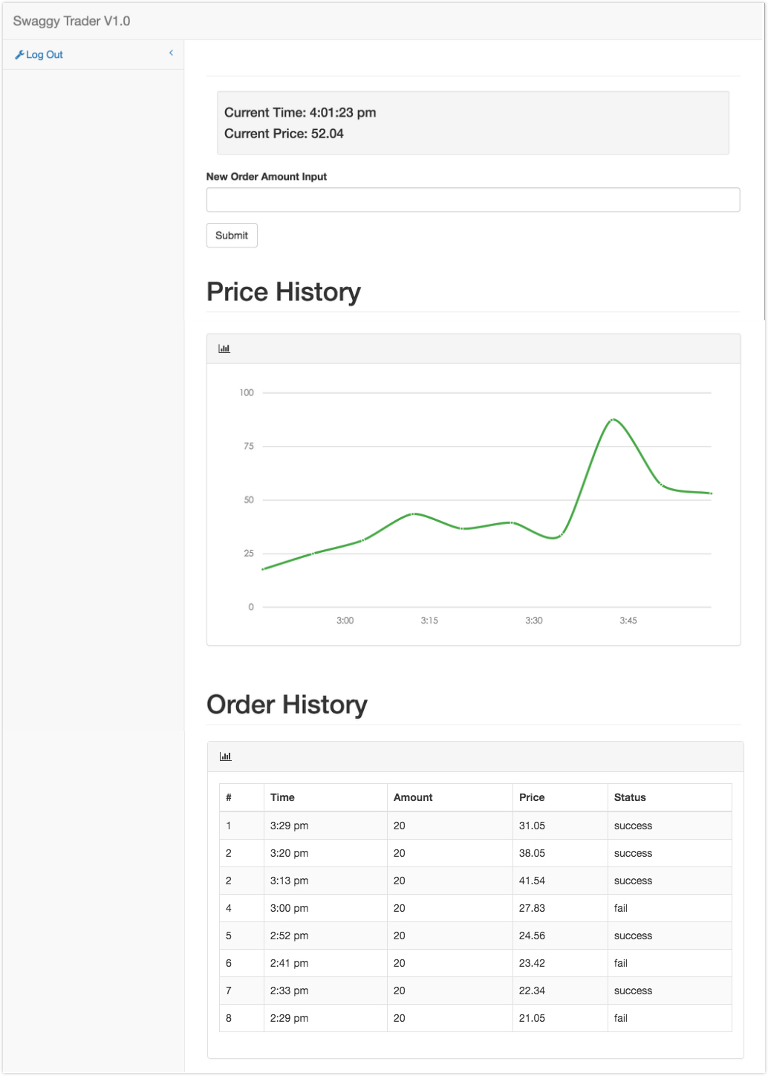

This is the order creation page. Once the user login, the application will show an input bar where the user can create an order by entering order amount. The application also shows current time and price on the top of the page. To submit order, the user can click the “Submit” button to confirm creating order. The user can also exit the application by clicking the “Log Out” button.

d) Order Monitoring



This is the order monitoring page. Once the user submits the order, the application would start splitting the order into several suborders and executing the suborders at different time.

The user can view the constant update of current price in the graph of price history.

The user can also monitor the trading history of his order throughout the day. It is a table of all the suborders executed that day, consisting of suborders id, execution time, amount, price executed, and order execution status.