Arctic Game

(logo not avaliable at the moment)

*“An open battlefield where every soldier is playable.”*

**Concept Document**

Version: 0.1

Kyler Lemery

Sign off

**Lead Artist:** Kyler Lemery

**Lead Designer:** Kyler Lemery

**Lead Programmer:** Kyler Lemery

**Lead Producer:** Kyler Lemery

Introduction

A near-future scenario where humanity is suffering from the effects of climate change and resource depletion, forcing the major superpowers to deploy their military presence in the artic circle, a last frontier for resources in the ground. In the process all major alliances dissolve and smaller countries get trampled over and harvested for their natural supplies.

Description

**Elevator Pitch:**

“Arctic Game” (working title) is a fast-paced, single-player, first / third person, shooter campaign where the player takes part in full scale battles on large maps, with tons of AI soldiers and vehicles with one key twist, every soldier is a playable character you can swap between.

**Genre:**

* Shooter
* Action
* Simulation

**Elements:**

* Shooting
* Driving
* Flying
* Skiing
* Dying
* Character Swapping

**Content:**

* Humor
* Action

**Theme:**

* “Near future exaggerated realism”

**Style:**

* Real

**Game Sequence:**

* Simulation / Linear storylines

**Player:**

* One player only

Game Reference

**Taxonomy:**

Arctic Game is a fictional near-future shooter simulation game with an exaggerated realism art style, with a modern military theme.

**Player Immersion:**

Fast paced take on tactical shooters.

**Reference:**

Battlefield 2042 modern military themes & class systems

Arma 3 tactical movement and medical system

Finnish ski soldiers from WW2

Watch Dogs Legion’s “every character is playable”

Game Technical

**Technical Form:**

Form (3D)

**View:**

Toggleable between first & third person

**Platform:**

PC

**Language:**

C#

**Device:**

PC

Game Sales:

**Consumer Group:**

Shooter & tactical game fans

**Payment:**

One-time payment in digital storefront

**Estimated Price:**

$15 - $20

**Game Atmosphere:**

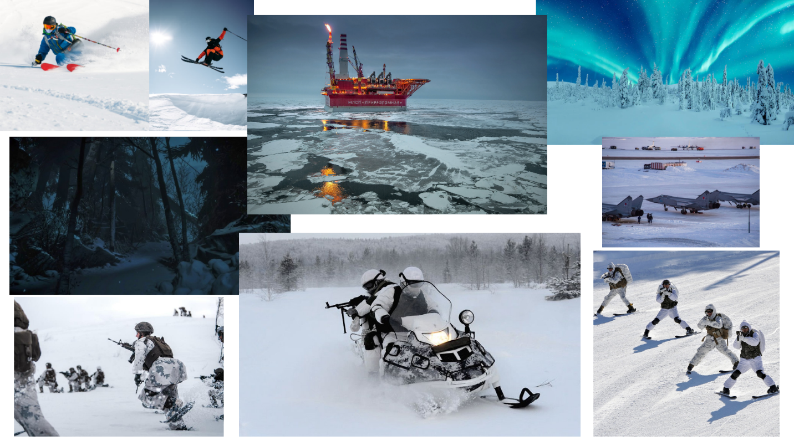

Game Play:

After starting a campaign and picking a side to fight for you are dropped into the first mission. As a random soldier, you for the first couple seconds watch from a first-person perspective the initial moments prior to battle, like a soldier waking up in a barracks to an alarm, or a spotter seeing enemies from a watchtower, whoever you are you get a brief moment of calm before the storm, context to battle, and the urge to fight. Depending on the mission the objective may change, but typically you are tasked with eliminating as many enemies as your side can to force them to retreat. With both sides starting with the same number of soldiers, you as a player and your allies work together to wither down the numbers until eventually a threshold is crossed and one side must fall back. During this process you engage in huge battles between large numbers of soldiers on both sides of the confrontation, you witness battles from far away, you hear distant engagements you know you’ll never be a part of, this will provide unmatched immersion and sense of scale as you swap between many soldiers on the battlefield.

Game Sales Continued:

**Key Features:**

Number of levels – (undecided) ~ 5 – 10

Number of characters – 20 exact (only 10 models, other half are reskinned)

Time of game play – N/A

Audio Specifications – Weapon, Vehicle, Character VO, Atmosphere, Generic, Music

Device Compatibility – Mouse & Keyboard & Gamepad (for PC)

Online Activities – N/A

Marketing Ideas – Online posts like dev logs, trailers, etc.

Unique Features – “Quick Swap”, All characters are playable, Skiing in a shooter

Replayability – Missions aren’t linear for you to win, you may lose and it’ll continue to the next, you won’t start as the same character every time, you will swap to different soldiers constantly, things will never happen twice

Number of Players – One

Number of Modes – Three planned objective types

Consumer Group – Fans of fast paced, action, shooter, tactical games

Merchandising – N/A

Selling Features:

“Quick Swap” to any character you see on screen to play as them

With random soldiers & starts, non-linear story campaign, and so much unexpected randomness, no mission or playthrough will be the same

Fun vehicles and equipment to use

Large scale action with a persistent battlefield no matter where you are

Ski-Marine

Mechanics:

There will be no “player controller” gameobject, the input from the player and the control of a character will be separated into separate scripts I will call “Player Brain”, “Character Brain”.

The Player Brain will be constantly taking inputs from the player, while the character brain will be handling specific actions to that character, like walking, shooting, reloading, etc.

The Player Brain has a reference to a character brain object in it, whenever it is set you will inhabit the body of that character. When it is not, as a fallback you will be put into a free-cam state, but assuming all systems function correctly this state will not be used.

The Character Brain has a Boolean toggle for when it’s possessed, if it is it’ll listen to inputs from the singular Player Brain in the scene, if it isn’t then it’ll handle bot navigation. The Character Brain will also have other states for whether it is animated or not, in a vehicle, etc. It may also be wise to lower the quality of certain processes in the Character Brain while not possessed.

A Vehicle Brain is deactivated until a Character Brain enters the vehicle object and activates it, it will then funnel inputs from the Character Brain to drive.

Design Guidelines:

* Main menu must feature settings for configuring basic options such as Field of View, Window Mode, Window Resolution, Unity’s Built-in graphics settings, etc.
* The player should be prompted prior to starting their first mission on a save slot to choose a side, this will not be changeable until they make a new save slot, adding replay value.
* Player movement should feel smooth
* Guns should feel snappy, exaggerated in animation, and powerful.
* Ski-Marine must exist
* Specific combat roles will have altered stats, and all will have access to designated sections of the weapon arsenal.
* A character loadout will include primary weapon, secondary weapon, limited ammunition, limited bandages, and an ability. Ability might include swapping out currently held weapon for another.
* Damage and medical systems should be broken down to a per-limb basis, allowing for specific damage states which alter movement/gun handling.

Game Definition:

When you start a level you possess a random soldier from the side you selected at the beginning of your playthrough, watching a brief intro animation from a first person perspective, then engage in battle.

You win a mission by completing the specific conditions of that mission’s objective, whether that’s eliminating enough enemies to cause a retreat, destroying critical objective markers, or having the most resources drilled.

Whenever you get to the end of all the campaign missions you will be given the results of the war, it’ll tally how many missions you’ve won and how many you’ve lost to find if your side won or not. It will also give you a rating from F – A+ on how well you did.

You lose a mission by failing to beat the enemy forces at a designated objective.

You lose a campaign whenever you get to the end, and you’ve lost more than half of the missions.

No matter if you win or lose a campaign you will be given a “select mission” like screen to allow you to redeploy to ones you want to replay. If you lost your campaign but replay enough missions to count for a win, your status will be updated accordingly, as well as the ranking.

Game Matrix:

“Quick Swap” referring to the player’s recharging ability to swap bodies

“Combat Role” referring to the class a character will be defined by

“Possess” referring to how the player controls characters

**-Classes / Combat Roles-**

“Medic” – Has slowly recharging bandages which they can give to teammates

“AT” – Has an unguided rocket launcher ability

“G-AT” – Has a guided rocket launcher ability

“Sniper” – Has a DMR / sniper primary with binocular ability

“Rifleman” – More agile, more ammo, recharging frag grenade ability

“Commander” – Followed by a squad of 2-6 soldiers which they can command

“Mechanic” – Can repair vehicles or place deployable covers when out of range

“Ammo Mule” – Slowly recharges ammo, which they can give to teammates

“Ski-Marine” – Slides with little friction, ability swaps between gun and ski poles

“Heavy” – Basically a juggernaut, heavy armor, big gun, shield ability.

**-Damage Status Effects-**

“Bleeding” – limb will slowly lose HP over time until treated

“Broken” – limb is permanently degraded its stats, but gets better when treated

“Scarred” – limb cannot be fully healed back to 100% HP

**-Objectives-**

“Domination” – Kill enough enemies to force them to retreat

“Demolition” – Destroy designated objectives to win

“Drill Operation” – Capture drills scattered across the environment

Game Flow Chart:

Player controls characters

Characters fight other characters

Characters may control vehicles

Vehicles fight characters and other vehicles

Player Elements:

Character (Character Brain)

Vehicle (Vehicle Brain)

Primary Weapon (Weapon1)

Primary Ammo (Weapon1.ammo)

Secondary Weapon (Weapon2)

Secondary Ammo (Weapon2.ammo)

Bandages (Bandages)

Ability (Ability)

Ability Delay (Recharge)

Head Health (HeadHP)

Head Armor (HeadAP)

Chest Health (ChestHP)

Chest Armor (ChestAP)

Left Arm Health (LArmHP)

Left Arm Armor (LArmAP)

Right Arm Health (RArmHP)

Right Arm Armor (RArmAP)

Left Leg Health (LLegHP)

Left Leg Armor (LLegAP)

Right Leg Health (RLegHP)

Right Leg Armor (RLegAP)

Player Definition:

Check page above, very similar in nature.

User Interface:

N/A

Heads Up Display:

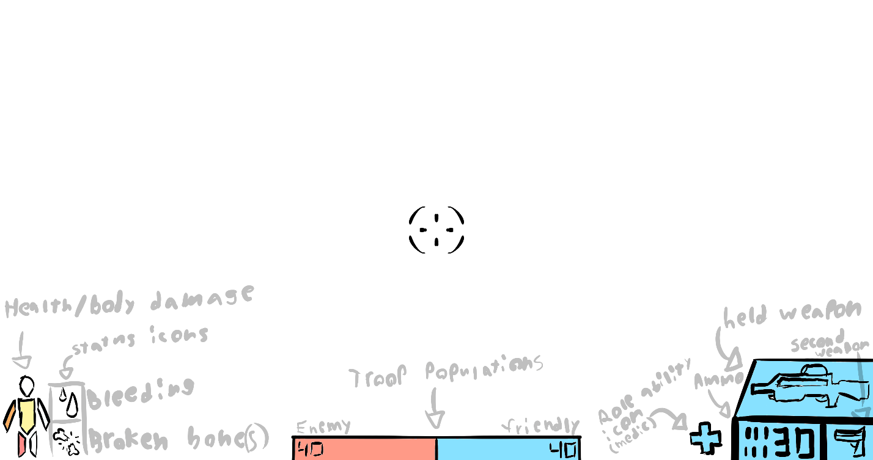

(Inspired by Battlefield 2042’s UI)

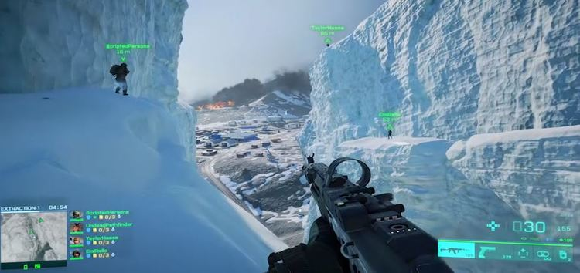

Player View:

Screenshot to be added once project is further in development

Artificial Intelligence:

**Animation State** – AI navigation is disabled so an animation sequence can complete

**Controlled State** – AI navigation is disabled so the player can control the biped

**Rush State** – Navigates towards the sound of gunfire or a pre-designated location

**Objective State** – Enters rush state with location set to closest objective marker

**Retreat State** – Runs in opposite direction of closest enemy, triggered especially at mission end

**Downed State** – When badly hurt the AI will stay in place with an injured animation set

**Combat State** – Upon seeing an enemy they will consistently engage until line of sight is broken

**Investigate State** – After leaving combat state move to last seen position of enemy

Global Game Elements:

Objects like trees, rocks, buildings, oil rigs, warehouses, airfields, etc to make up in map areas

Maps should be medium or large scale.

Background elements will typically consist of dense forests, mountains, bodies of water, glaciers.

Skies will vary from overcast, to clear & sunny, to night, and even northern lights

The Story:

**(In depth elements of the story have yet to be devised, as I believe gameplay comes first, and stories should be molded around them, but I have some primitive background elements in mind. Most are carried over from another game concept I had and may conflict with other things and are likely to change.)**

A war breaks out between virtually all major superpowers in a near future scenario where climate change and resource depletion has led to no other options left but all out modern conventional combat in the arctic circle. Alliances like NATO crumble as combat escalates, turning it into a every country for itself-like world war, with smaller nations being trampled over and occupied in the process. The ruthless and unforgiving environment forces militaries to adapt strategies and develop new equipment on the fly, soldiers adopting heavy jackets and white camo, and typical transport becoming unusable, requiring heavy air presence and vehicles with tracks or large wheels to traverse.

Concept Art:

Not a lot has been made yet.

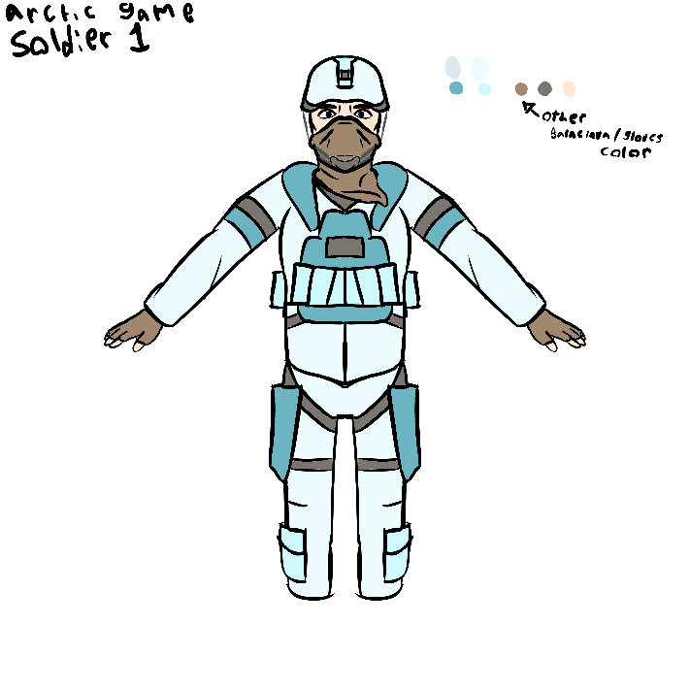

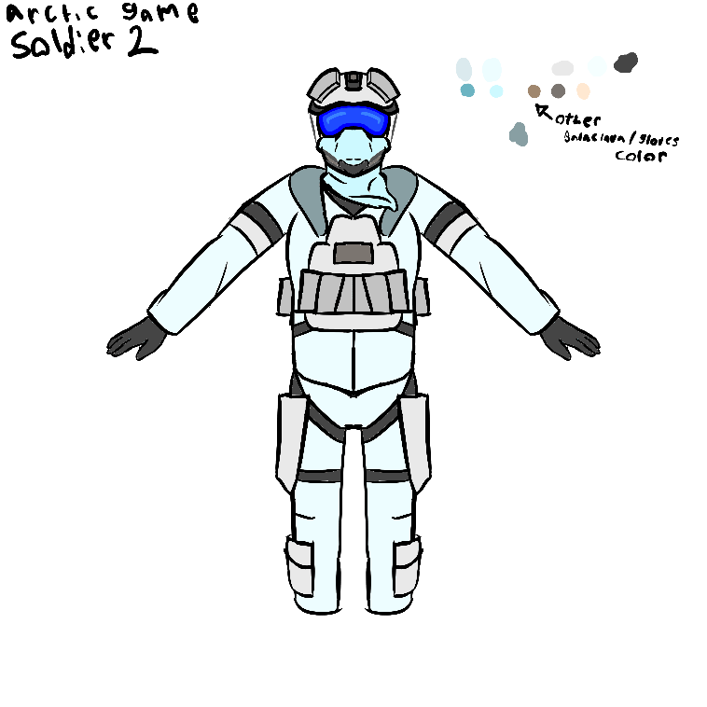

Level Design:

I have some missions in mind specifically for Arctic Game, but others may be brought over from a separate game idea as well, both will be listed but labeled separately.

**Arctic Game Levels:**

**Bootcamp A** – Very short introductory level to get used to controls (for Side A only)

**Bootcamp B** – Very short introductory level to get used to controls (for Side B only) -reskin-

**Invasion** – Side A’s base gets suddenly invaded in the early morning, Objective: Domination

**Downhill** – Side A counterattacks by assaulting one of Side B’s oil rigs, Objective: Demolition

**Escalation** – Side B’s airfield gets suddenly invaded in broad daylight, Objective: Domination

**Adsorption** – Side A’s oil field gets ransacked by Side B in the night, Objective: Drill Operation

**Boiling Point A** – Final largest mission for Side A, attacking a large Side B base, all objectives.

**Boiling Point B** – Final largest mission for Side B, attacking a large Side A base, all objectives.

Audio & Sound FX:

Various gun firing oneshots for different distances

Various gun reload interactions

Background ambience

Some basic music

UI bleep bloops

Small amount of combat dialogue

Small amount of introduction cinematic dialogue

Game Architecture:

Menu screen

Settings screen

Exit confirmation screen

Pick a side screen

Loading screens

Game Hud

Pause screen

Mission finished screen

Campaign finished screen

How To Play Copy:

In the initial bootcamp level the player will be introduced to basic controls, an option to skip training will be provided, and bootcamp will not introduce the various combat roles, to add an element of surprise and discovery while you’re playing.

**Controls:**

* WASD to move
* Alt + A/D to lean Left/Right
* Left Control to crouch
* Left Shift to sprint
* Q to Quick Swap
* E to interact
* F to melee
* R to reload
* Tab / 1-2 / mouse wheel to swap weapons
* Left Click to fire
* Right Click to aim
* Caps to use ability

System Requirements:

Medium – High end PCs, I’m currently targeting using HDRP and higher poly models. Though graphics quality options will be provided.

Visual Content:

General:

**File Size Restrictions:** -undecided-

**File Format Type:** Jpeg for opaque textures, png for transparent textures & atlases

**File Quality Type:** -undecided-

**Visual Scale:** -undecided-

Player Elements:

**Type of states:** Skiing, Normal, Injured, Downed, Driving.

**Amount Animation Frames:** -undecided-

Heads Up Display:

**-All other visual content is undecided-**

Audio Content:

**File Size Restrictions:** -undecided-

**File Format Type:** WAV for important audio with special timing, MP3 for rest

**File Quality Type:** Medium

Programming Content:

**File Format Type:** C#, Shaderlab

**For more specific order on Code Structure refer to the “Mechanics” page which briefly describes the main module run order for funneling player/ai inputs**

Resources:

Blender

Unity3D

Substance Painter

Audacity

XNConvert