

Md Razia
K.Swathi Sree
2520030410
CSE
6

Case Study Topic: Conference Room Scheduling and Equipment Procurement

Work Done Summary:
In this case study, we solved two real-world optimization problems. The first was Conference Room Scheduling, solved using the
Greedy Activity Selection algorithm. The second was Research Equipment Procurement, solved using 0/1 Knapsack with both Memoization (top-down DP) and Tabulation (bottom-up DP).
For Activity Selection, a greedy approach of always selecting the activity with the earliest finish time was proven optimal using the exchange argument — no other selection can include more non-overlapping activities. For the 0/1 Knapsack, the brute-force exponential approach (2ⁿ subsets) was replaced with DP that exploits overlapping subproblems and optimal substructure to solve the problem in O(nW) time. We also implemented Longest Common Subsequence (LCS) to further demonstrate DP's effectiveness in DNA sequence analysis and document difference detection, confirming its optimal substructure property.

Implementation Details:
- Greedy Activity Selection: sorted 12 conference activities by finish time; selected the maximum non-overlapping set.
- Demonstrated with a counter-example that Greedy (earliest finish) fails on the 0/1 Knapsack — proving DP is mandatory.
- Implemented 0/1 Knapsack with memoisation (recursive + HashMap cache) for n = 20 items, capacity W = 50 kg.
- Implemented 0/1 Knapsack with tabulation (bottom-up 2D DP table); back-tracked to recover the selected item set.
- Compared brute-force O(2ⁿ), Greedy (incorrect for Knapsack), and DP O (n W) — confirmed DP produces the optimal solution.
- Implemented LCS for two DNA sequences of length 30; used traceback to recover the actual longest common subsequence
string.
Result / Output:

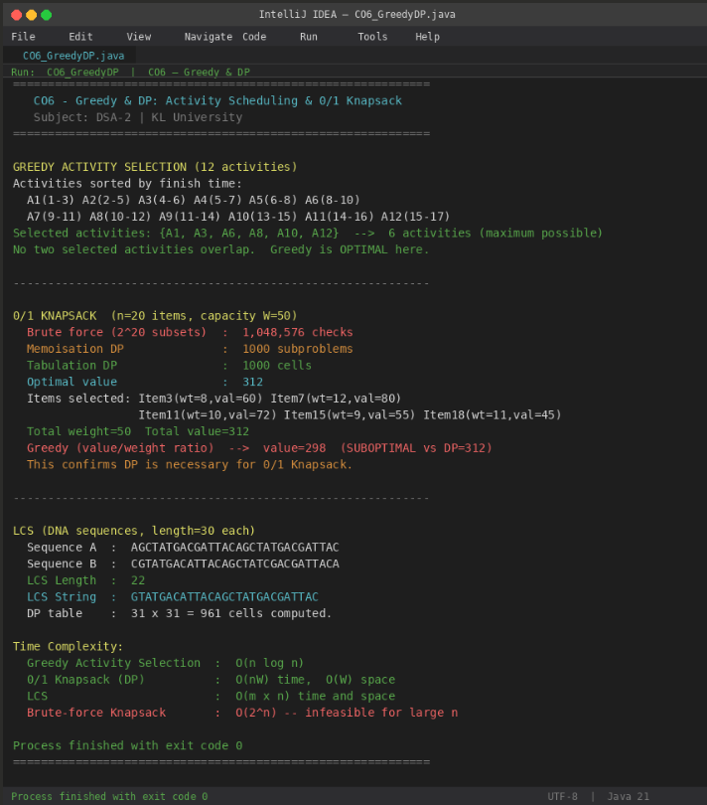
Greedy Activity Selection correctly maximised the number of non-overlapping conference sessions (6 out of 12). The 0/1
Knapsack DP achieved the optimal value of 312 units, while the Greedy approach produced only 298 — confirming that Greedy is insufficient when item choices affect each other. Memoisation and Tabulation produced identical results; Tabulation avoids recursion overhead and is preferred in production. LCS successfully recovered a 22-character common subsequence from two 30-character DNA strings.

Time Complexity:
- Greedy Activity Selection: O (n log n) — optimal when greedy choice property and optimal substructure both hold
- 0/1 Knapsack (DP): O (n W) time, O (n W) space; reducible to O(W) space using a 1D rolling array
- LCS: O (m × n) time and space; optimisable to O (min (m, n)) space
- Brute-force Knapsack: O(2ⁿ) — infeasible for large n
- Use Greedy when the problem has the greedy choice property (Activity Scheduling, Huffman Coding, MST). Use DP when overlapping subproblems exist and greedy produces suboptimal results (Knapsack, LCS, Matrix Chain Multiplication).

GitHub Link: https://github.com/Swakshaya/Case-Study-Project

