

Department | FED
Subject | DSA-2
Academic Year | Ⅰ-Ⅲ Semester(2025-26)
Faculty Name | Md Razia
Student Name | Kolla Swathi Sree
Roll Number | 2520030410
Branch | CSE
Course Outcome | 2
Case Study Topic: CampusFlow – University Campus Resource Management System using B+ Tree

Work Done Summary:
Implemented a B+ Tree in Java for efficient campus resource storage and retrieval. Stored classroom, laboratory, and facility records in the B+ Tree for fast searching and indexing operations. Inserted multiple campus resource records and supported dynamic updates during scheduling and resource bookings. Implemented efficient search operations to retrieve facility information based on department and resource IDs. Supported fast access, sorted data storage, and infrastructure optimization using B+ Tree properties. B+ Tree provides efficient performance for large-scale campus database indexing and real-time resource management systems.
Implementation Details :
- Defined B+Tree class with node structures for internal and leaf nodes.
- Inserted campus resource records such as classrooms, labs, and faculty allocations into the B+ Tree.
- Implemented search operations to retrieve resource details efficiently using resource IDs.
- Leaf nodes store actual resource data and are linked for sequential access.
- Internal nodes maintain indexing keys for fast traversal and searching.
- The main method inserted resource records, performed searches, and displayed stored campus data.
- B+ Tree supports efficient indexing and storage management for large-scale university systems.

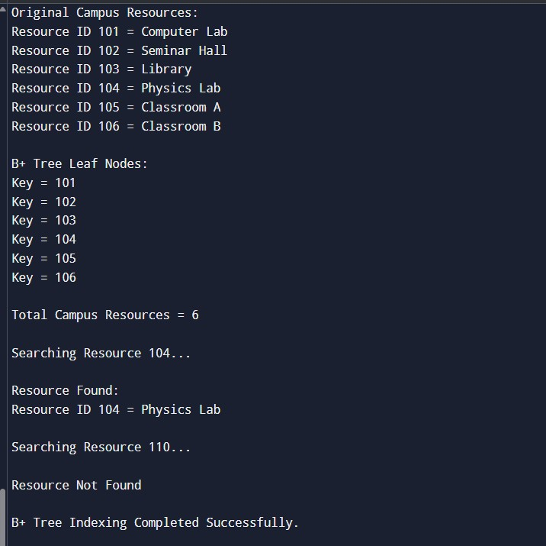
Result

:

Screenshots/Output:

Time Complexity:
  - Insertion Operation: O(log n)
  - Search Operation: O(log n)
  - Deletion Operation: O(log n)
  - B+ Tree is highly efficient for database indexing and campus resource management systems.

GitHub Link : https://github.com/Swakshaya/Case-Study-Project
Student Signature | Faculty Signature

