

Department | FED
Subject | DSA-2
Academic Year | Ⅰ-Ⅲ Semester(2025-26)
Faculty Name | Md Razia
Student Name | Kolla Swathi Sree
Roll Number | 2520030410
Branch | CSE
Course Outcome | 3
Case Study Topic: CampusFlow – University Campus Resource Management System using BFS

Work Done Summary:
Implemented Breadth First Search (BFS) in Java for campus infrastructure monitoring and resource traversal. Modeled classrooms, laboratories, faculty rooms, and campus facilities as graph nodes connected through edges. BFS traversal was used to monitor campus resources level by level and analyze facility connectivity efficiently.
Implemented classroom allocation monitoring, laboratory connectivity analysis, faculty scheduling traversal, student service request tracking, and campus route analysis using graph traversal techniques. Demonstrated BFS traversal for auditing connected campus facilities and analyzing campus resource flow efficiently. Compared BFS traversal with DFS — BFS is more suitable for level-wise monitoring and shortest-path based campus analysis.
Implementation Details :

- Created Graph class using adjacency list representation.

- addEdge() connects classrooms, laboratories, and campus facilities.
- BFS(startNode) uses Queue data structure for traversal.
- Visited array prevents duplicate traversal of nodes.
- BFS traversal monitors campus facilities level by level.
- Campus connectivity analysis performed using graph traversal techniques.
- The main method created a campus graph and demonstrated BFS traversal.
8.BFS ensures efficient campus monitoring and infrastructure management operations.

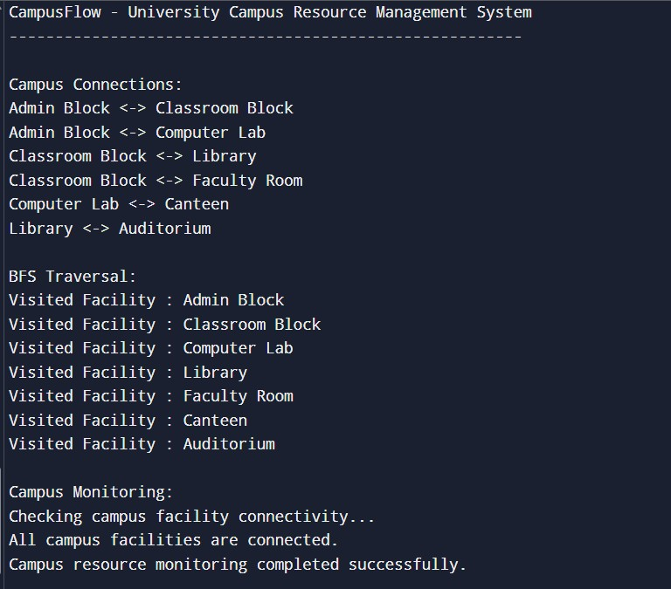
Result

:

Screenshots/Output:

Time Complexity:
  - BFS Traversal: O(V + E)
  - Graph Construction: O(E)
BFS is efficient for campus connectivity analysis, infrastructure monitoring, and campus resource management systems.
GitHub Link : https://github.com/Swakshaya/Case-Study-Project
Student Signature | Faculty Signature

