Name: Swaleha Shaikh

Roll No. 33374

--------------------------------------------------------------------------------------------------------------------------------------

Exercise 1: Create a webpage that prints your name to the screen.

**Code:**

<html>

    <head>

        <title>This is a webpage</title>

    </head>

    <body>

        <h1>Swaleha Shaikh</h1>

    </body>

</html>

**Output:**

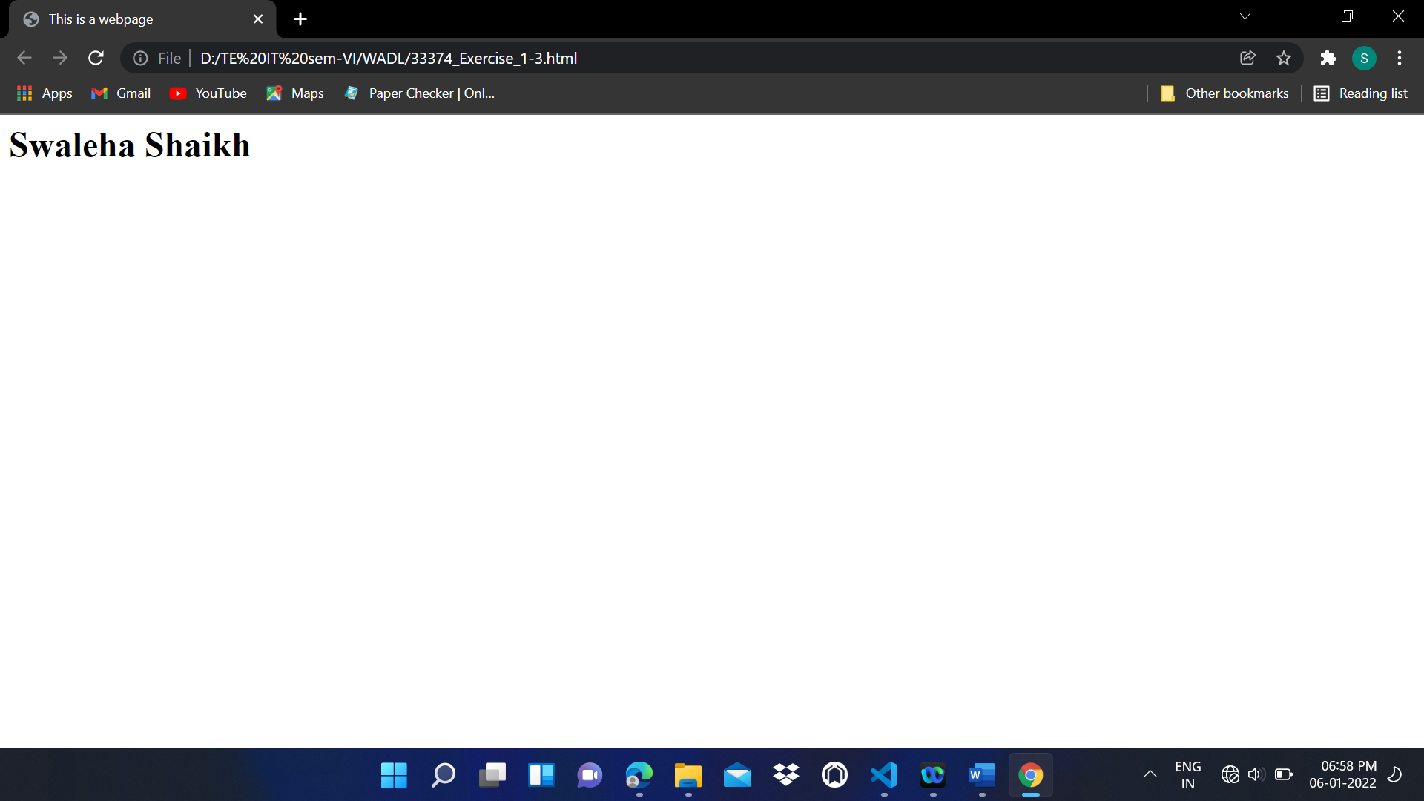

Exercise 2: Create a webpage that prints the numbers 1 - 10 to the screen.

**Code:**

<html>

    <head>

        <title>This is a webpage</title>

    </head>

    <body>

        <h3>1</h3>

        <h3>2</h3>

        <h3>3</h3>

        <h3>4</h3>

        <h3>5</h3>

        <h3>6</h3>

        <h3>7</h3>

        <h3>8</h3>

        <h3>9</h3>

        <h3>10</h3>

    </body>

</html>

**Output:**

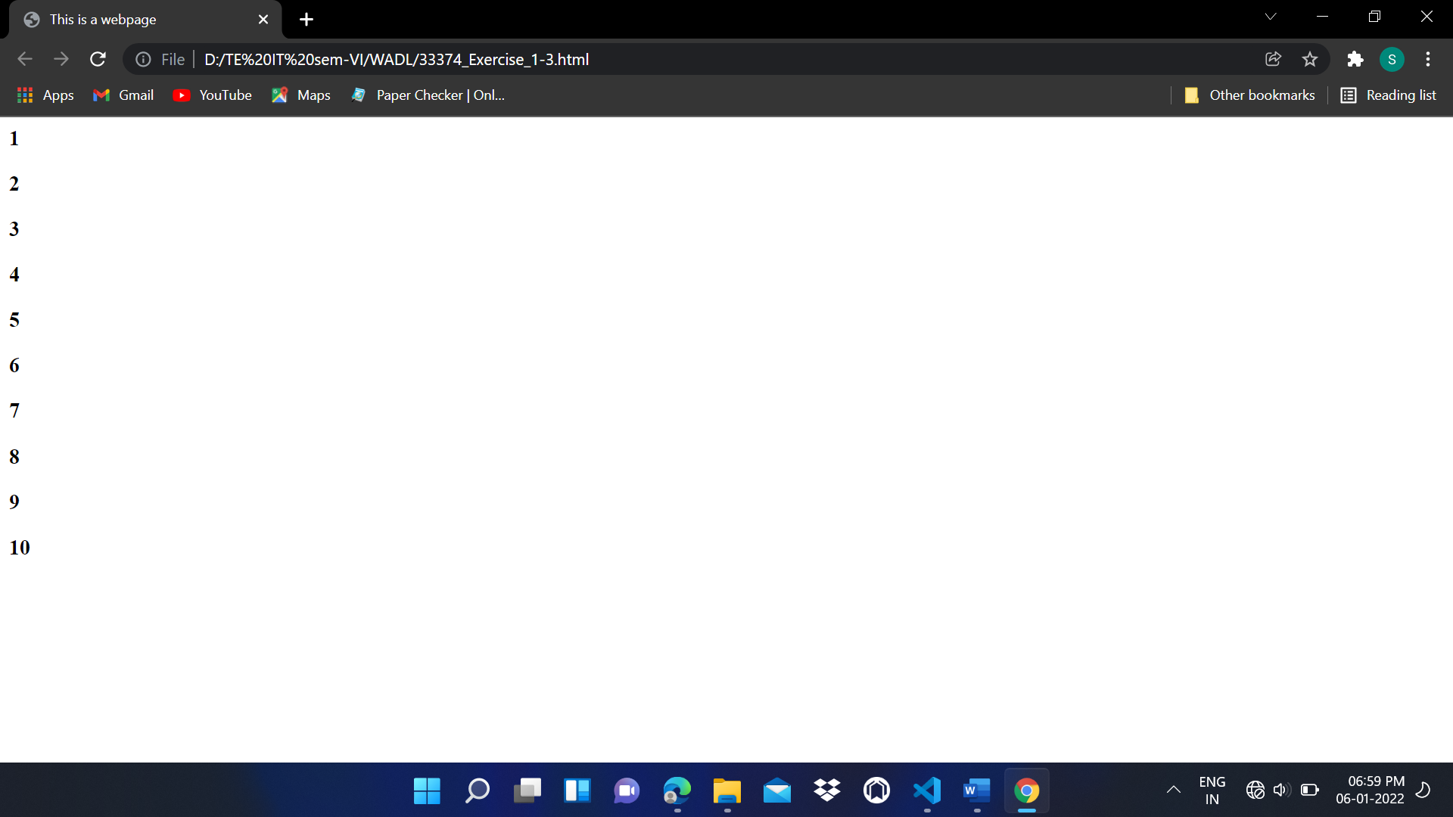

Exercise 3: Create a webpage and set its title to "This is a webpage"

**Code:**

<html>

    <head>

        <title>This is a webpage</title>

    </head>

    <body>

        <h1>Swaleha Shaikh</h1>

        <br>

        <h3>1</h3>

        <h3>2</h3>

        <h3>3</h3>

        <h3>4</h3>

        <h3>5</h3>

        <h3>6</h3>

        <h3>7</h3>

        <h3>8</h3>

        <h3>9</h3>

        <h3>10</h3>

    </body>

</html>

**Output:**

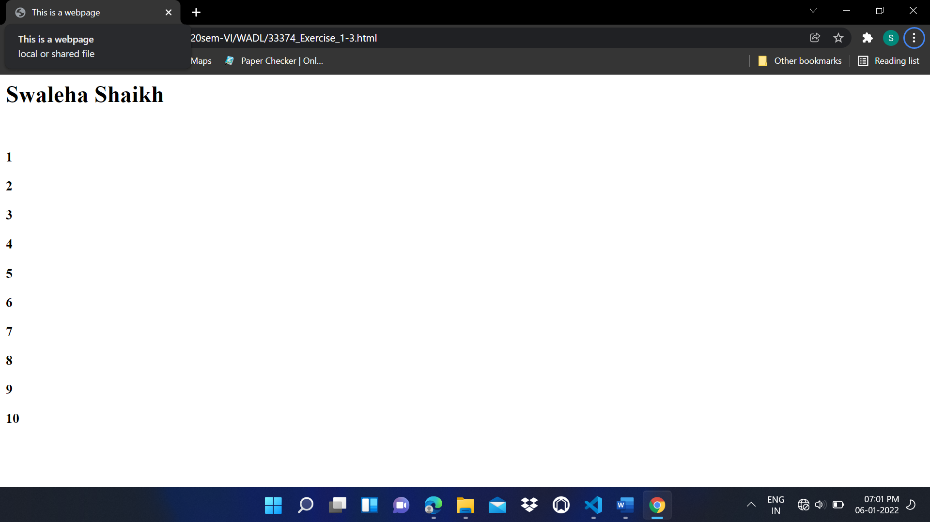

Exercise 4: Create a webpage that prints the message "When was this webpage created? Check page's title for the answer." to the screen, and set the title of the page to the current date.

**Code:**

<html>

    <head>

        <title>06-01-2022</title>

    </head>

    <body>

        <p>When was this webpage created? Check page's title for the answer.</p>

    </body>

</html>

**Output:**

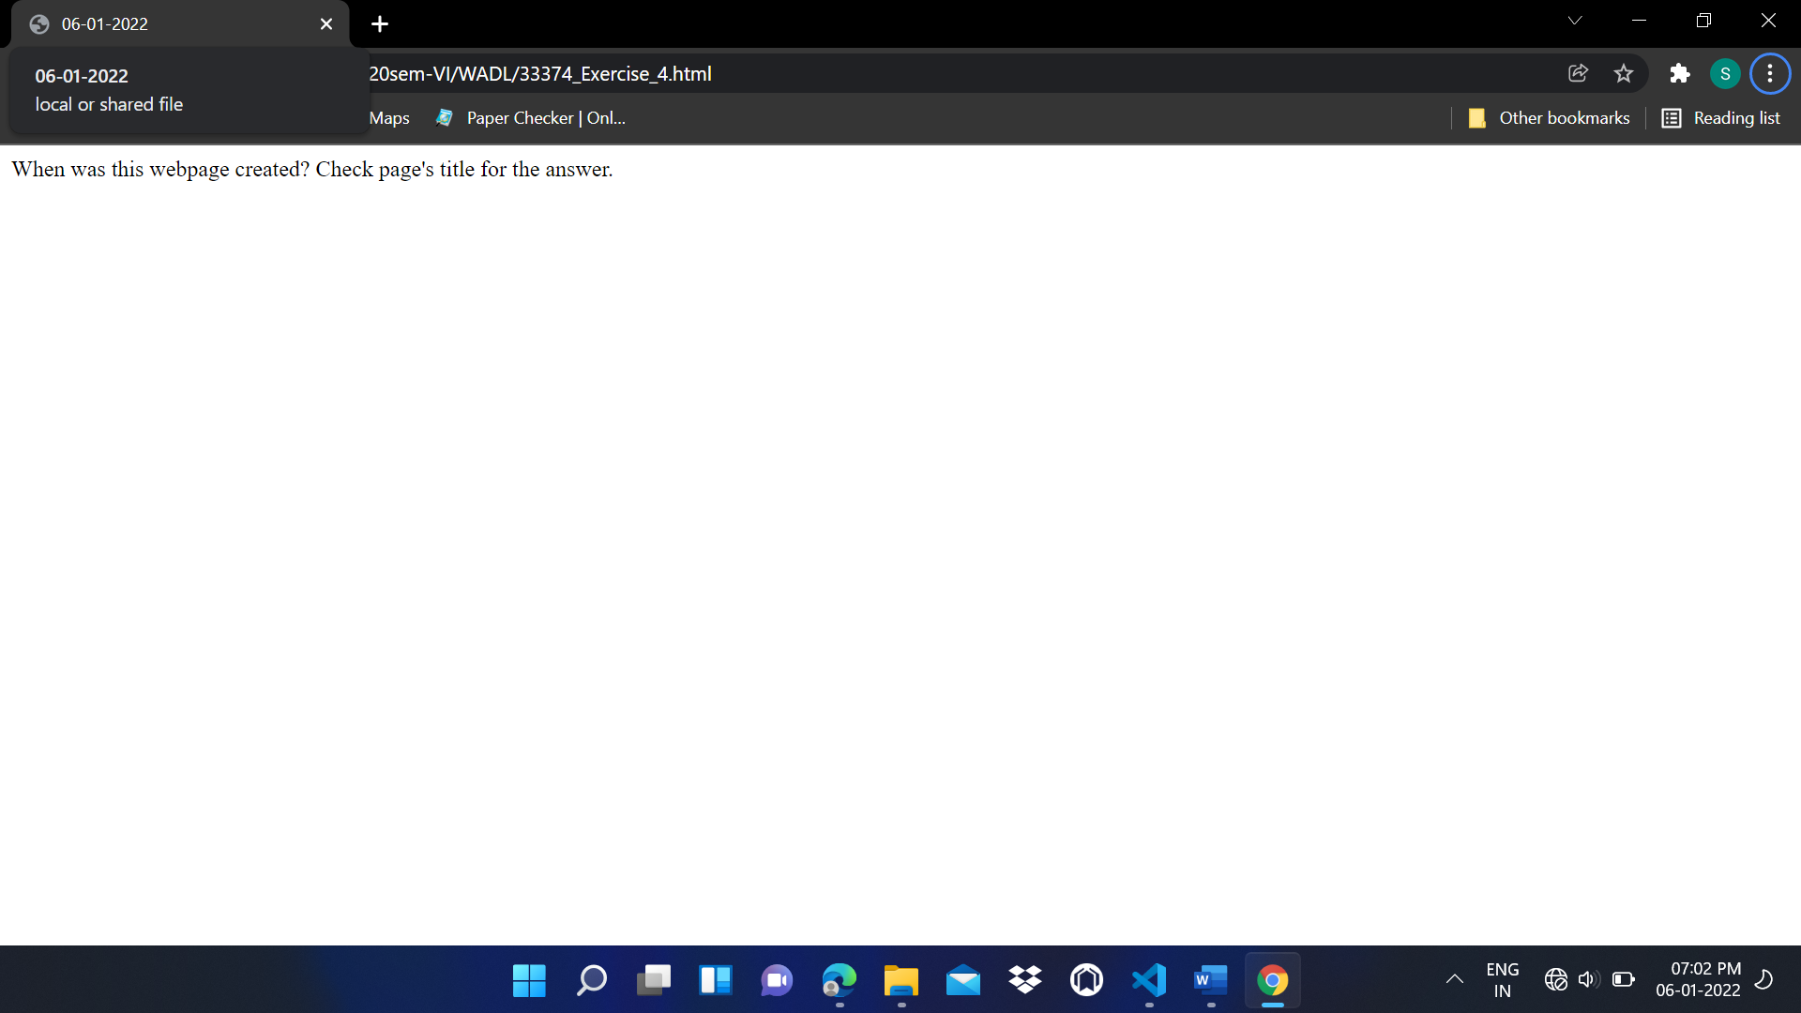

Exercise 5: Create a webpage that prints any text of your choosing to the screen, do not include a head section in the code.

**Code:**

<html>

<body>

    <p>

        Mathematical logic is the foundation on which the proofs and arguments rest.

        Propositions are statements used in mathematical logic, which are either true

        or false but not both and we can definitely say whether a proposition is true

        or false.</p>

    <p>

        In this chapter we introduce propositions and logical connectives. Normal

        forms for well-formed formulas are given. Predicates are introduced. Finally,

        we discuss the rules of inference for propositional calculus and predicate calculus

    </p>

</body>

</html>

**Output:**

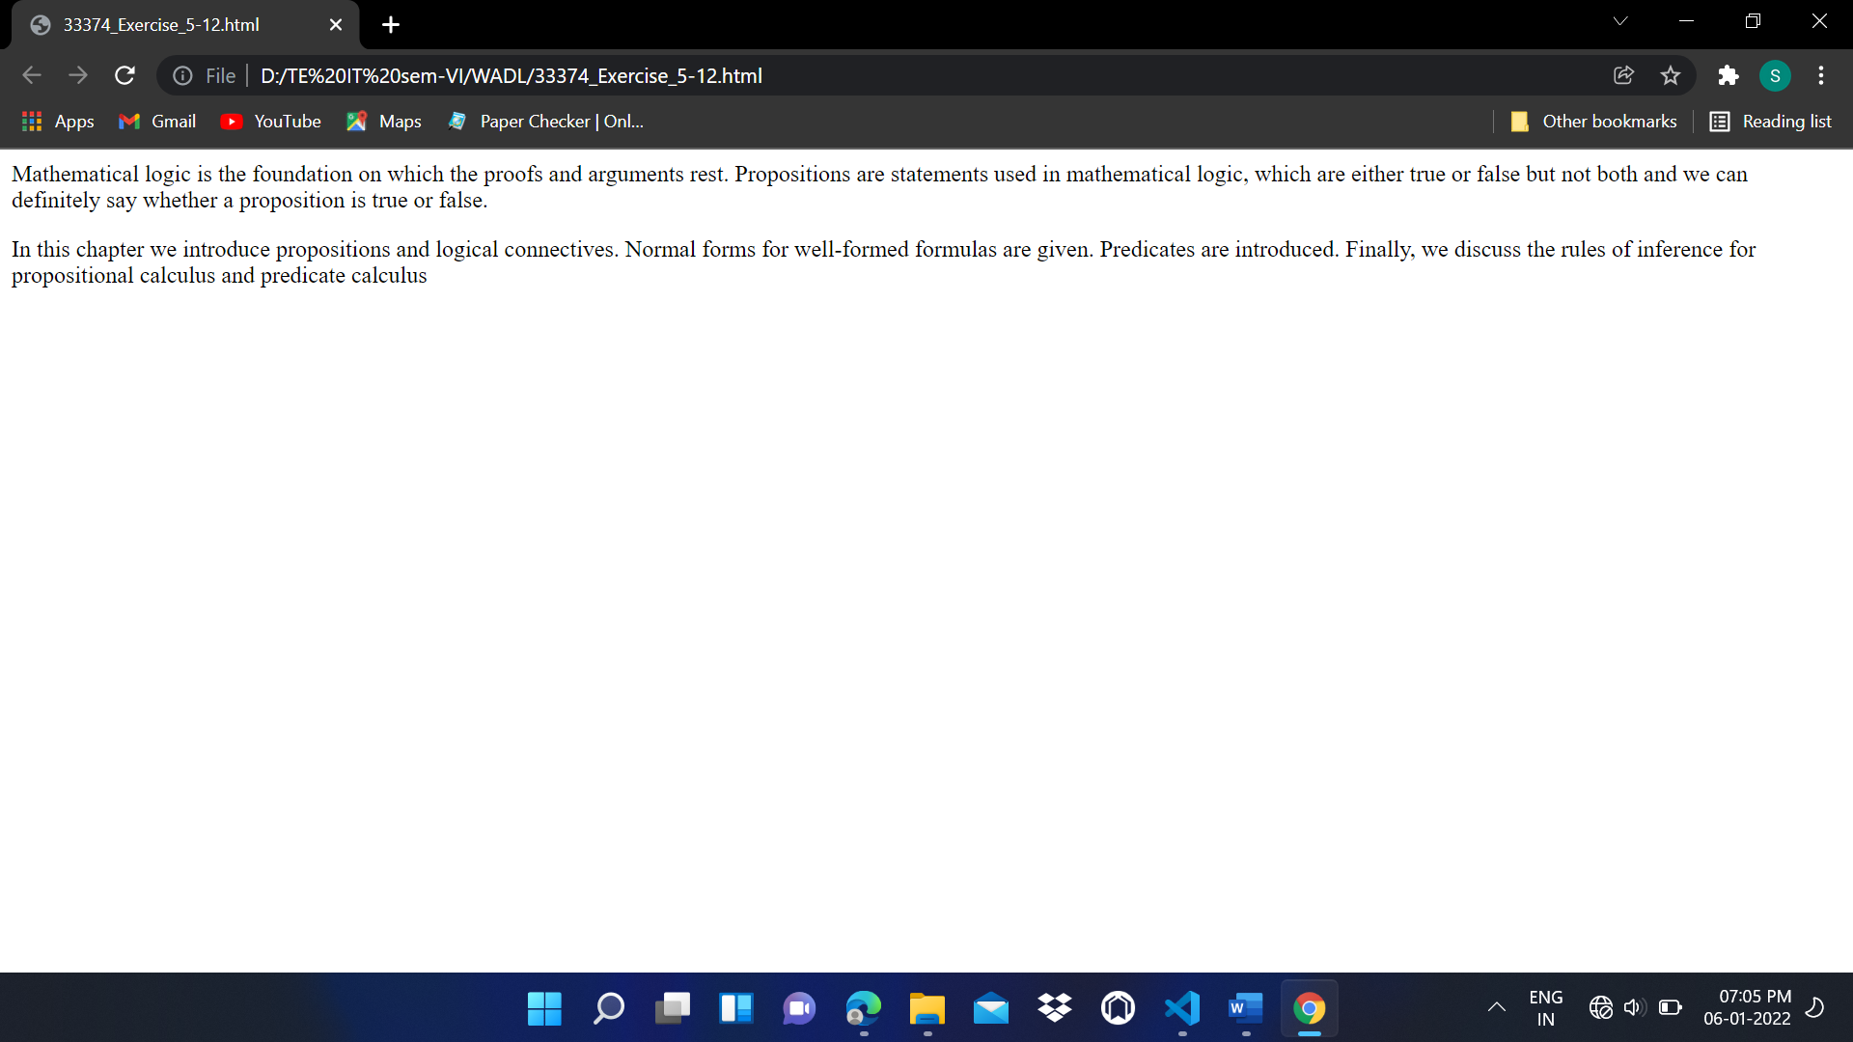

Exercise 6: Repeat exercise #5, but this time include a head section in the code.

**Code:**

<html>

<head>

    <title>Exercise 5</title>

</head>

<body>

    <p>

        Mathematical logic is the foundation on which the proofs and arguments rest.

        Propositions are statements used in mathematical logic, which are either true

        or false but not both and we can definitely say whether a proposition is true

        or false.</p>

    <p>

        In this chapter we introduce propositions and logical connectives. Normal

        forms for well-formed formulas are given. Predicates are introduced. Finally,

        we discuss the rules of inference for propositional calculus and predicate calculus

    </p>

</body>

</html>

**Output:**

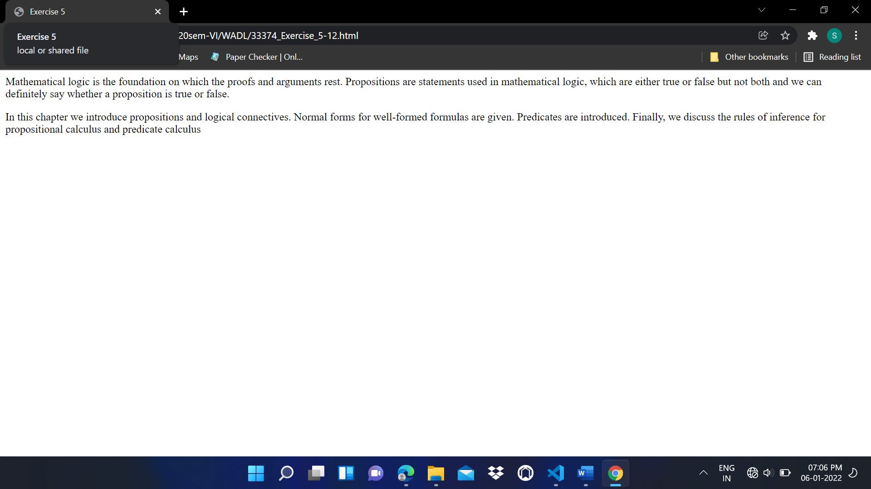

Exercise 7: Print the squares of the numbers 1 - 20. Each number should be on a separate line, next to it the number 2 superscripted, an equal sign and the result. (Example: 102 = 100)

**Code:**

<html>

<head>

    <title>Exercise 7</title>

</head>

<body>

    <h5>1<sup>2</sup> = 1</h5>

    <h5>2<sup>2</sup> = 4</h5>

    <h5>3<sup>2</sup> = 9</h5>

    <h5>4<sup>2</sup> = 16</h5>

    <h5>5<sup>2</sup> = 25</h5>

    <h5>6<sup>2</sup> = 36</h5>

    <h5>7<sup>2</sup> = 49</h5>

    <h5>8<sup>2</sup> = 64</h5>

    <h5>9<sup>2</sup> = 81</h5>

    <h5>10<sup>2</sup> = 100</h5>

    <h5>11<sup>2</sup> = 121</h5>

    <h5>12<sup>2</sup> = 144</h5>

    <h5>13<sup>2</sup> = 169</h5>

    <h5>14<sup>2</sup> = 196</h5>

    <h5>15<sup>2</sup> = 225</h5>

    <h5>16<sup>2</sup> = 256</h5>

    <h5>17<sup>2</sup> = 289</h5>

    <h5>18<sup>2</sup> = 324</h5>

    <h5>19<sup>2</sup> = 361</h5>

    <h5>20<sup>2</sup> = 200</h5>

</body>

</html>

**Output:**

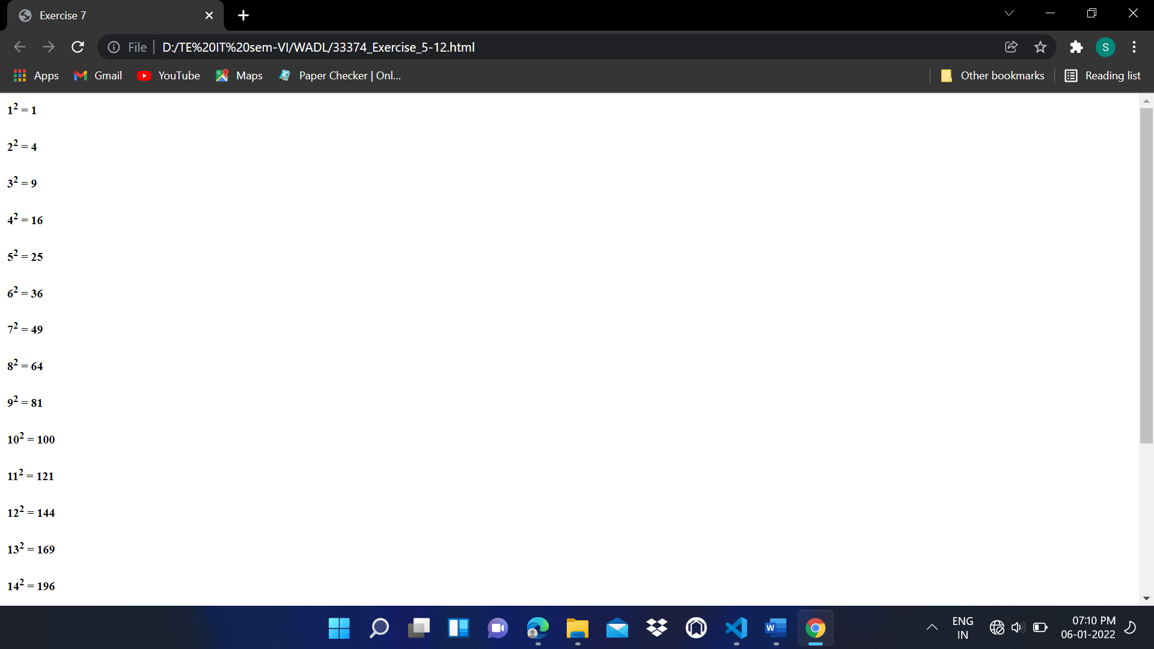

Exercise 8: Prints 10 names with a line break between each name. The list should be alphabetized, and to do this place a subscripted number next to each name based on where it will go in the alphabetized list. (Example: Alan1). Print first, the unalphabetized list with a subscript number next to each name, then the alphabetized list. Both lists should have an level heading.

**Code:**

<html>

<head>

    <title>Exercise 8</title>

</head>

<body>

    <h1>Unalphabetized List</h1>

    <ul>

        <h1>Michael<sub>8</sub></h1>

        <h1>Andy<sub>1</sub></h1>

        <h1>Bobby<sub>2</sub></h1>

        <h1>Henry<sub>5</sub></h1>

        <h1>Chris<sub>3</sub></h1>

        <h1>Nick<sub>9</sub></h1>

        <h1>Sachin<sub>10</sub></h1>

        <h1>Kapil<sub>7</sub></h1>

        <h1>David<sub>4</sub></h1>

        <h1>Jack<sub>6</sub></h1>

    </ul>

    <h1>Alphabetized List</h1>

    <ol>

        <h1>Andy<sub>1</sub></h1>

        <h1>Bobby<sub>2</sub></h1>

        <h1>Chris<sub>3</sub></h1>

        <h1>David<sub>4</sub></h1>

        <h1>Henry<sub>5</sub></h1>

        <h1>Jack<sub>6</sub></h1>

        <h1>Kapil<sub>7</sub></h1>

        <h1>Michael<sub>8</sub></h1>

        <h1>Nick<sub>9</sub></h1>

        <h1>Sachin<sub>10</sub></h1>

    </ol>

</body>

</html>

**Output:**

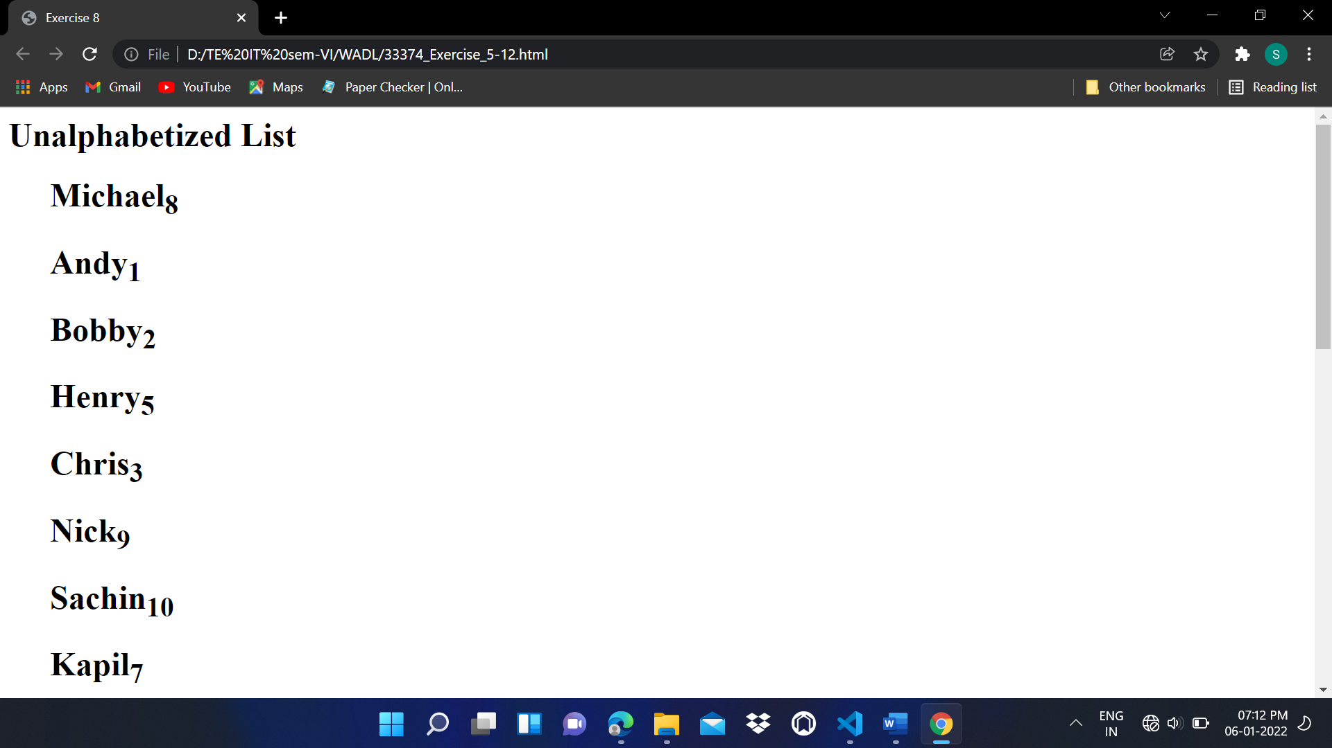

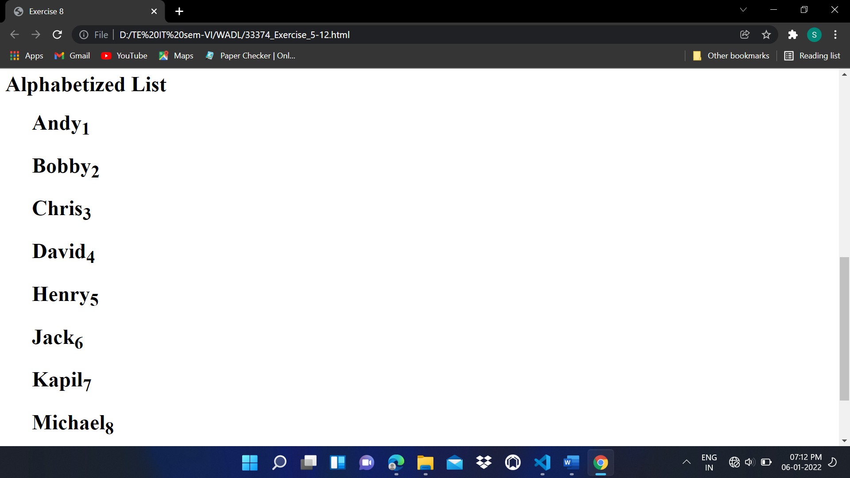

Exercise 9: Print two paragraphs that are both indented using the &nbsp; command.

**Code:**

<html>

<head>

    <title>Exercise 9</title>

</head>

<body>

    <p>

        &nbsp; A predicate formula is valid if for all possible assignments

        of values from any universe of discourse to free variables, the resulting

        propositions have the truth value T. Sometimes when we wish to derive some-conclusion from a given set of

        premises involving quantifiers. we may have to eliminate the quantifiers

        before applying the rules of inference for proposition formulas. Also, when

        the conclusion involves quantifiers, we may have to introduce quantifiers. The

        necessary rules of inference for addition and deletion of quantifiers

    </p>

</body>

</html>

**Output:**

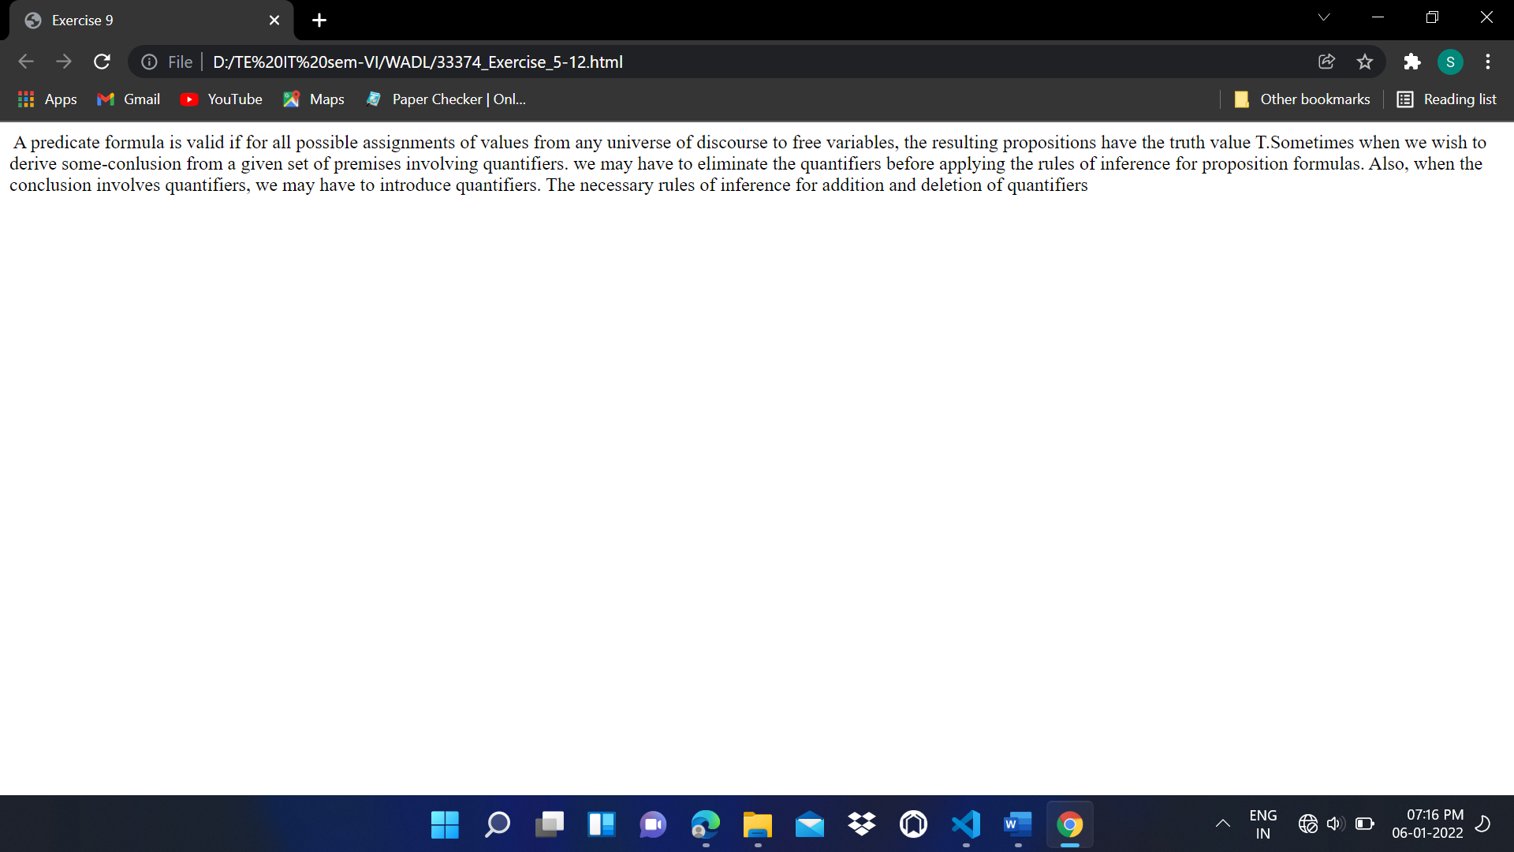

Exercise 10: Print two lists with any information you want. One list should be an ordered list, the other list should be an unordered list.

**Code:**

<html>

<head>

    <title>Exercise 10</title>

</head>

<body>

    <ul>

        <li>Mango</li>

        <li>Banana</li>

        <li>Apple</li>

        <li>Pine-apple</li>

        <li>Cherry</li>

    </ul>

    <ol>

        <li>Amol</li>

        <li>Chirag</li>

        <li>Himesh</li>

        <li>Saloni</li>

    </ol>

</body>

</html>

**Output:**

