AUTOMATIC KEYWORD EXTRACTION FROM TEXT DOCUMENTS

COURSE PROJECT REPORT
Submitted by

SWALIHA.C.A

ASI23CA061

Under the guidance of

Dr.SARIKA S

To
APJ Abdul Kalam Technological University
In partial fulfillment of the requirements for the award of the Degree of
Bachelor of Technology in Computer Science and Engineering (Artificial Intelligence)


Department of Artificial Intelligence and Data Science

ADI SHANKARA INSTITUTE OF ENGINEERING AND TECHNOLOGY, KALADY
OCTOBER 2026
AUTOMATIC KEYWORD EXTRACTION FROM TEXT DOCUMENTS

COURSE PROJECT REPORT
Submitted by

SWALIHA.C.A

ASI23CA061

Under the guidance of

Dr.Sarika S

To

APJ Abdul Kalam Technological University
In partial fulfillment of the requirements for the award of the Degree of
Bachelor of Technology in Computer Science and Engineering (Artificial Intelligence)

Department of Artificial Intelligence and Data Science

ADI SHANKARA INSTITUTE OF ENGINEERING AND TECHNOLOGY, KALADY
OCTOBER 2026

ADI SHANKARA INSTITUTE OF ENGINEERING AND
TECHNOLOGY, KALADY

DEPARTMENT OF COMPUTER SCIENCE AND ENGINEERING (ARTIFICIAL INTELLIGENCE )



CERTIFICATE

Certified that this is a bonafide record of the course project entitled

AUTOMATIC KEYWORD EXTRACTION FROM TEXT DOCUMENTS

Submitted by

SWALIHA.C.A

ASI23CA061

during the year 2024-25 in partial fulfillment of the requirement for the award of the degree of
Bachelor of Technology in Computer Science (Artificial Intelligence) and Engineering

Faculty in Charge
Dr.Sarika S

ACKNOWLEDGMENT

I would like to express my heartfelt gratitude to all those who contributed to the successful completion of this course project. I am sincerely thankful for the support, guidance, and assistance provided by various individuals and resources.

First and foremost, I extend my appreciation to Dr. Sarika S, whose expertise and unwavering support played a pivotal role in shaping my project. Her valuable insights and constructive feedback were instrumental in refining my ideas and enhancing the overall quality of my work.

I would also like to thank my fellow classmates for their encouragement and cooperation throughout the project.

Furthermore, I am grateful to the Department of Artificial Intelligence and Data Science for providing me with the necessary resources and a conducive learning environment. The facilities and access to research materials greatly facilitated the development of this project. In conclusion, this course project would not have been possible without the support of everyone involved.

ABSTRACT

The rapid growth of digital text has made it difficult for readers to identify quickly the most important terms in a document. Manual selection of keywords is time-consuming, subjective, and impractical for long or numerous documents. This project, Automatic Keyword Extraction from Text Documents, addresses this problem by providing a simple Natural Language Processing (NLP) based system that automatically identifies and ranks meaningful words and phrases from text entered by the user.
The system implements three keyword extraction approaches: Term Frequency–Inverse Document Frequency (TF-IDF) using unigrams and bigrams, a simplified RAKE-style phrase extraction method that uses stop words as phrase boundaries, and a Word Frequency method that ranks words by their relative frequency. The input text is first cleaned and normalised; candidate terms are then scored by the selected method, ranked, and limited to a user-specified number of top keywords. The system is implemented in Python using scikit-learn and is available as a Google Colab notebook, which presents results in tabular form using Pandas, and as a Flask web application with an HTML and CSS interface that also allows the results to be downloaded as a CSV file. The source code is maintained in a GitHub repository.
The system is intended as an educational and practical tool for quickly summarising the main topics of a text, supporting tasks such as document indexing, reading assistance, and preliminary content analysis. This report describes the design, implementation, and observed behaviour of the system and discusses its limitations. No formal accuracy evaluation has been carried out; evaluation on a labelled dataset is identified as future work.
Keywords: keyword extraction, natural language processing, TF-IDF, RAKE, word frequency, Flask, scikit-learn

TABLE OF CONTENTS

Sl. No. | Contents | Page No.
 | Abstract | 5
1 | Chapter 1: Introduction | 7
1.1 | Problem Statement | 7
1.2 | Objectives | 7
1.3 | Scope of the Project | 8
2 | Chapter 2: Methodology / System Design | 9
2.1 | Proposed Methodology | 9
2.2 | Tools and Technologies Used | 11
2.3 | System Architecture / Workflow | 12
3 | Chapter 3: Implementation and Results | 14
3.1 | Implementation Details | 14
3.2 | Results and Discussion | 17
3.3 | Testing and Screenshots | 19
4 | Chapter 4: Conclusion and Future Scope | 23
4.1 | Conclusion | 23
4.2 | Limitations | 23
4.3 | Future Scope | 24
 | References | 25

CHAPTER 1
INTRODUCTION

1.1 Problem Statement
Text documents such as articles, reports, research papers, web pages, and e-mails contain far more information than a reader can conveniently absorb at a glance. To understand what a document is about, a reader must normally read or scan it in full and decide which words and phrases best represent its content. This manual identification of important terms is time-consuming, depends on the judgement of the reader, and becomes impractical as the length or the number of documents increases.
Keywords are words or short phrases that capture the main topics of a document. They are widely used for indexing, searching, summarisation, and classification of text [1], [5]. Because different readers may select different words as important, manually chosen keywords can be inconsistent, and the effort required grows with the volume of text. There is therefore a need for an automatic method that can read a piece of text and return a ranked list of its most relevant terms.
The problem addressed by this project is to design and implement a simple, easy-to-use system that accepts text from a user, applies NLP techniques to clean and analyse it, and automatically identifies and ranks meaningful keywords and phrases. Automatic keyword extraction uses statistical properties of the text, such as how often a term occurs and how it co-occurs with neighbouring words, to estimate the importance of each candidate term. These properties can be computed quickly and consistently, so the same procedure can be applied to any input text without manual effort.

1.2 Objectives
The main objectives of the project are as follows:
- To automatically extract meaningful keywords and keyphrases from text entered by the user.
- To apply basic text preprocessing, including lowercase conversion, removal of web addresses and special characters, and stop-word filtering.
- To implement three keyword extraction methods: TF-IDF, a simplified RAKE-style phrase extraction method, and Word Frequency.
- To rank the extracted keywords using method-specific relevance scores and to let the user choose how many keywords are displayed.
- To present the ranked keywords in a readable form through a Google Colab notebook and a Flask web application.
- To allow the results to be downloaded as a CSV file in the Flask web application.

1.3 Scope of the Project
The project covers the development of a working prototype for keyword extraction from English text supplied directly by the user. The scope of the current implementation includes:
- accepting a paragraph or document entered by the user (through a text area in the Flask application or through the input cell in the Colab notebook);
- cleaning and normalising the text;
- extracting keywords using TF-IDF, simplified RAKE-style phrase extraction, and Word Frequency;
- selecting the top-N keywords and displaying them in ranked order together with their relevance scores; and
- exporting the ranked results as a CSV file.
The following are outside the scope of the current implementation: uploading PDF or DOCX files, corpus-level TF-IDF across multiple documents, graph-based or embedding-based methods such as TextRank and KeyBERT, processing of languages other than English, and quantitative evaluation against a labelled dataset. These are discussed as possible future enhancements in Chapter 4.
The remainder of the report is organised as follows. Chapter 2 describes the methodology, the tools used, and the system workflow. Chapter 3 presents the implementation, the observed results, and the testing. Chapter 4 concludes the report and outlines the future scope, and the references are listed at the end. The official source-code repository of the project is available at https://github.com/Swaliha-CA/Keyword-Extraction-System [11].

CHAPTER 2
METHODOLOGY / SYSTEM DESIGN

2.1 Proposed Methodology
The proposed system follows a simple pipeline. The user supplies text; the text is cleaned and normalised; candidate keywords and phrases are generated; the selected algorithm extracts and scores them; the scores are used to rank the keywords; and the top-N keywords are displayed. In the Flask version the user can additionally download the displayed results as a CSV file. Three extraction methods are provided so that their behaviour can be observed on the same text. The steps are described in the following subsections.

2.1.1 Input and Validation
The user enters a paragraph or document as plain text, selects one of the three methods, and chooses how many keywords should be returned. The input must contain at least three words; otherwise an error message asks the user to enter more text. The requested number of keywords is restricted to a fixed range (3 to 25 in the Flask application and 5 to 25 in the Colab notebook shown in the screenshots), and a default of 10 is used when the value is not a valid integer.

2.1.2 Text Preprocessing
Before any scoring, the text is normalised by a cleaning function. It converts all characters to lowercase, removes web addresses, replaces every character other than a letter, digit, whitespace, or hyphen with a space, and collapses repeated whitespace. Hyphens are retained so that hyphenated terms are preserved. Stop words, which are very common words such as “is”, “of”, and “the” that carry little topical information, are filtered using the English stop-word list provided by scikit-learn [4]. The filtering is performed inside each extraction method (by the vectorizer for TF-IDF and by explicit filtering for the other two) rather than as a separate step.

2.1.3 TF-IDF
Term Frequency–Inverse Document Frequency (TF-IDF) is a weighting scheme that scores a term by combining how often it appears in a document (term frequency) with how rare it is across a collection of documents (inverse document frequency) [1], [2]. A term that is frequent in a document but uncommon elsewhere receives a high weight. In the smoothed form used by scikit-learn by default, the inverse document frequency of a term t is
idf(t) = ln[(1 + n) / (1 + df(t))] + 1
where n is the number of documents and df(t) is the number of documents that contain t. The weight of a term in a document is tf(t, d) × idf(t), and the resulting vector is normalised to unit Euclidean length [4], [8]. In this project, TfidfVectorizer is configured with English stop-word removal and an n-gram range of (1, 2), so that both single words (unigrams) and two-word phrases (bigrams) are considered as candidates. The terms are sorted by score in descending order and the top-N terms with a non-zero score are returned.
An important limitation applies. The vectorizer is fitted on only the single text supplied by the user, so n = 1 and df(t) = 1 for every term, which makes idf(t) equal to 1 for all terms. The scores therefore depend only on the term frequencies within the text (after normalisation) and carry no corpus-level information about how rare a term is. This limitation, and the use of a larger corpus as a remedy, are discussed in Chapter 4.

2.1.4 RAKE-Style Phrase Extraction
Rapid Automatic Keyword Extraction (RAKE) is an unsupervised method that extracts multi-word keyphrases from individual documents by using stop words and phrase delimiters as boundaries between candidate phrases [3]. Each word in a candidate phrase is scored from its frequency freq(w) in the candidate phrases and its degree deg(w), which counts the words it co-occurs with in those phrases (including itself). The word score is deg(w) / freq(w), and the score of a phrase is the sum of the scores of its words, so words that occur in long phrases contribute higher scores [3].
The method implemented in this project is a simplified RAKE-style version and not a complete implementation of the original algorithm. The cleaned text is split into candidate phrases at stop words (and at tokens shorter than two characters); word scores are calculated as in RAKE; phrase scores are accumulated, so a phrase that occurs several times receives a higher total; and all scores are divided by the highest score, so the best phrase has a relevance score of 1.0. Because punctuation is removed during cleaning, candidate phrases are not split at punctuation marks such as full stops and commas as they are in the original algorithm, and the stop-word list is the scikit-learn English list rather than a RAKE-specific list.

2.1.5 Word Frequency
The Word Frequency method counts how often each word occurs after stop words and very short words (two characters or fewer) are removed. The relevance score of a word is its count divided by the total number of counted words, that is, its relative frequency. This is the simplest of the three methods and is easy to interpret, but it produces only single words and favours words that are repeated, which are not always the most meaningful ones.

2.1.6 Ranking and Output
Each method returns a list of keyword–score pairs, which is sorted by score, restricted to the top-N entries, and displayed in rank order. Scores are rounded to four decimal places. Because the three methods compute their scores differently (a normalised TF-IDF weight, a normalised phrase score, and a relative frequency), scores from different methods are not directly comparable and should be interpreted only within the ranking produced by a single method. Table 2.1 summarises the three methods.
Table 2.1: Comparison of the Three Keyword Extraction Methods
Feature | TF-IDF | RAKE-style | Word Frequency
Candidate units | Single words and two-word phrases | Multi-word phrases delimited by stop words | Single words
Scoring basis | TF-IDF weight (for one document, effectively the normalised term frequency) | Sum of word scores deg(w)/freq(w), divided by the highest phrase score | Word count divided by the total number of counted words
Score range | 0 to 1 | 0 to 1 (best phrase = 1.0) | 0 to 1
Main strength | Considers words and bigrams; can be extended to a document collection | Identifies multi-word keyphrases | Simple and easy to interpret
Main limitation | No corpus-level rarity information for a single document | Simplified; no punctuation boundaries | Favours repeated words; single words only

2.2 Tools and Technologies Used
The system is built entirely with freely available tools. Table 2.2 lists the technologies used and the role of each in the project.
Table 2.2: Tools and Technologies Used
Technology | Purpose in this project
Python | Core programming language used for all processing logic, including the standard-library modules re, collections, io, and csv [7].
Flask | Lightweight web framework that defines the routes, handles form submissions, renders the HTML page, and returns the CSV download [6].
scikit-learn | Provides TfidfVectorizer for TF-IDF scoring and the English stop-word list used by all three methods [4], [8].
HTML | Defines the structure of the web page, including the text input, method selection, keyword count, and results area [13].
CSS | Styles the web interface, including layout and appearance [13].
Pandas | Used in the Colab version to present the ranked results as a table with a rank index and to write the CSV file [9].
Google Colab | Cloud-based notebook environment used to develop and test the pipeline interactively [14].
GitHub | Used for source-code management and hosting of the project repository [11].

The Colab session shown in Chapter 3 reported Python 3.13 with Flask 3.1.3 and scikit-learn 1.6.1 installed. The Flask application can be run on a local machine with Python 3.10 or newer using the dependencies listed in the repository’s requirements.txt file.

2.3 System Architecture / Workflow
The complete workflow of the system is as follows:
- The user enters the text to be analysed.
- The text is preprocessed (lowercase conversion, removal of web addresses and special characters, and stop-word filtering).
- Candidate keywords and phrases are generated from the cleaned text.
- The selected algorithm (TF-IDF, RAKE-style, or Word Frequency) extracts and scores the candidates.
- The keywords are ranked by score and the top-N keywords are selected.
- The ranked keywords and their scores are displayed to the user.
- In the Flask version, the user can download the results as a CSV file.
Figure 2.1 shows the workflow of the keyword extraction system.
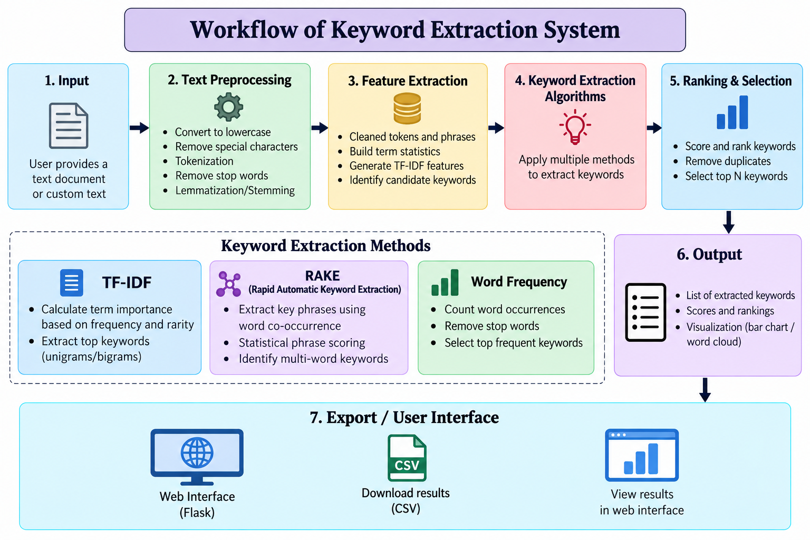
Figure 2.1: Workflow of Keyword Extraction System
The diagram groups the system into seven stages: input, text preprocessing, feature extraction, the keyword extraction algorithms, ranking and selection, output, and export through the user interface. The three algorithms shown in the dashed box correspond to the three methods described in Section 2.1. Architecturally, the system has three layers: a presentation layer made of the HTML template and CSS in the Flask application, an application layer made of the Flask routes that receive the user’s request and return the response, and a processing layer made of the Python functions that clean the text and compute the keyword scores.
The diagram describes the overall workflow of the system. In the current implementation, preprocessing consists of lowercase conversion, removal of web addresses and special characters, tokenisation, and stop-word removal. Lemmatisation or stemming and the graphical visualisations (bar chart or word cloud) shown in the diagram are not part of the current code, and they are listed as possible enhancements in Chapter 4.

CHAPTER 3
IMPLEMENTATION AND RESULTS

3.1 Implementation Details
This section describes the implementation of the system. The explanation is based on the source code of the Flask application (app.py) in the project repository [11] and on the Colab notebook screenshots presented in Section 3.3.

3.1.1 Project Structure
The repository contains the files and folders listed in Table 3.1.
Table 3.1: Files and Folders in the Project Repository
File / Folder | Role
app.py | Flask application containing the text-cleaning function, the three extraction functions, and the two routes.
templates/ | HTML template (index.html) rendered by the Flask application.
static/ | Static files used by the web interface, such as the stylesheet.
Keyword_Extraction_System.ipynb | Google Colab notebook version of the system.
requirements.txt | List of Python packages required to run the application.
README.md | Project description, instructions for running the system, limitations, and future enhancements.

3.1.2 Text Cleaning
The function clean_text() performs the normalisation described in Section 2.1.2. It is called at the start of every extraction function, so all three methods work on identically cleaned text. An excerpt (without the docstring) is shown below.
def clean_text(text):
text = text.lower()
text = re.sub(r"https?://\S+|www\.\S+", " ", text)
text = re.sub(r"[^a-z0-9\s-]", " ", text)
return re.sub(r"\s+", " ", text).strip()

3.1.3 Keyword Extraction Functions
The system has three extraction functions, each with the signature function(text, top_n=10). Each returns a list of dictionaries with the keys “keyword” and “score”, with the score rounded to four decimal places, and returns an empty list when no keyword can be produced. The Colab notebook uses functions with the same names, extract_tfidf, extract_rake, and extract_frequency, as seen in Figure 3.3.
extract_tfidf() cleans the text and fits a scikit-learn TfidfVectorizer on it as a single document. The vectorizer removes English stop words, generates unigrams and bigrams, and accepts tokens that start with a letter and are at least two characters long. The terms and their scores are sorted in descending order of score, and the top-N terms with a score greater than zero are returned. If the vectorizer cannot build a vocabulary (for example, when the text contains only stop words), a ValueError is caught and an empty list is returned.
vectorizer = TfidfVectorizer(
stop_words="english",
ngram_range=(1, 2),
token_pattern=r"(?u)\b[a-zA-Z][a-zA-Z0-9-]+\b"
)
matrix = vectorizer.fit_transform([cleaned])
terms = vectorizer.get_feature_names_out()
scores = matrix.toarray()[0]
ranked = sorted(zip(terms, scores), key=lambda x: x[1], reverse=True)
extract_frequency() tokenises the cleaned text, removes stop words and words of two characters or fewer, and counts the remaining words with collections.Counter. The score of each word is its count divided by the total number of counted words, and the most common words are returned.
extract_rake() is the simplified RAKE-style phrase ranker. It tokenises the cleaned text and starts a new candidate phrase whenever a stop word is met. For every word it records the frequency and the degree (the number of other words in the phrases in which it appears). The word score is (degree + frequency) / frequency, which equals deg(w) / freq(w) of Section 2.1.4, and the phrase score is the sum of its word scores, accumulated over repeated occurrences of the phrase. The phrases are ranked and the scores are divided by the highest score.

3.1.4 Flask Routes
The Flask application defines two routes, summarised in Table 3.2.
Table 3.2: Flask Routes of the Application
Route | HTTP methods | Role
/ | GET, POST | Function index(). On GET it displays the empty form. On POST it reads the form fields text, method, and top_n, validates them, calls the selected extraction function, and renders index.html with the text, method, top_n, results, and error values.
/download | POST | Function download(). Reads the posted rows (one keyword and score per line, separated by a tab), writes them to a CSV file with the header Keyword, Relevance Score, and returns it as the attachment extracted_keywords.csv.

In the index() route the number of keywords is limited to the range 3 to 25, with 10 used if the value is not an integer. If the text contains fewer than three words, the message “Please enter at least three words to extract useful keywords.” is shown, and if the chosen method returns no keywords, the message “No keywords found. Try entering a longer text.” is shown. The method values are “tfidf”, “rake”, and “frequency”; any other value falls back to TF-IDF.
if method == "rake":
results = extract_rake(text, top_n)
elif method == "frequency":
results = extract_frequency(text, top_n)
else:
method = "tfidf"
results = extract_tfidf(text, top_n)
The download() route builds the CSV in memory using the csv module and io.StringIO and encodes it as UTF-8 with a byte-order mark (utf-8-sig) so that spreadsheet programs open it correctly. It then returns the file with send_file().
writer.writerow(["Keyword", "Relevance Score"])
for line in rows.splitlines():
if "\t" in line:
keyword, score = line.split("\t", 1)
writer.writerow([keyword, score])
The application is started with app.run(debug=True), which runs Flask’s development server. Debug mode is suitable for development only and should be disabled when the application is deployed.

3.1.5 HTML/CSS Interface
The user interface is a single web page generated from the template index.html and styled with CSS from the static folder. According to the project documentation [11], the user enters text, chooses an extraction method, and clicks the Extract Keywords button. The form therefore submits the fields text, method, and top_n to the index() route. After processing, the template receives the results and error values from Flask and displays either the ranked keywords with their relevance scores or the error message. The results are also made available to the download() route, which receives them as tab-separated rows so that they can be saved as a CSV file.

3.1.6 Google Colab Version
The Colab notebook offers the same three methods in an interactive, cell-by-cell form, as shown in the screenshots in Section 3.3. The first cell installs the required packages. The second cell prints the heading “KEYWORD EXTRACTION SYSTEM”, reads lines of text until the user types END on a new line, joins them into a single string, and checks that at least three words were entered. The third cell imports Pandas and the IPython display tools, shows a menu (1. TF-IDF, 2. RAKE, 3. Word Frequency), reads the choice and the number of keywords (5 to 25, with 10 used for an invalid value), and calls the selected extraction function. The results are placed in a Pandas DataFrame with a Rank index starting at 1 and displayed under the heading “Extracted Keywords — TF-IDF” (or the chosen method). A further cell converts the results to a DataFrame with the columns Rank, Keyword, and Relevance Score, writes extracted_keywords.csv, and downloads it with google.colab.files.download(). Table 3.3 compares the two versions.
Table 3.3: Comparison of the Flask and Colab Versions
Aspect | Flask web application | Google Colab notebook
Text input | Text area in the HTML form | Lines typed in an input cell, ended by END
Method selection | Form field (tfidf, rake, frequency) | Menu choice 1, 2, or 3
Keyword count | 3 to 25 (default 10) | 5 to 25 (default 10)
Result display | HTML page rendered by Flask | Pandas DataFrame shown in the notebook
CSV export | /download route sends extracted_keywords.csv | Export cell using files.download()

3.1.7 Running the Application
As described in the project documentation [11], the Flask application is run as follows:
- Clone the repository using git clone and open the project folder.
- Install the dependencies using pip install -r requirements.txt.
- Start the application using python app.py.
- Open http://127.0.0.1:5000 in a web browser, enter text, choose a method, and click Extract Keywords.

3.2 Results and Discussion
The results discussed here are those visible in the supplied Colab screenshots (Section 3.3). The sample input was a three-sentence text of 24 words: “Machine learning is a branch of artificial intelligence. Natural language processing helps computers understand human language. Keyword extraction identifies important words from text documents.” The TF-IDF method was selected and ten keywords were requested. The ranked output shown in Figure 3.4 is reproduced in Table 3.4.
Table 3.4: TF-IDF Output Visible in Figure 3.4 for the Sample Text
Rank | Keyword | Relevance score
1 | language | 0.3123
2 | artificial | 0.1562
3 | artificial intelligence | 0.1562
4 | branch | 0.1562
5 | branch artificial | 0.1562
6 | computers | 0.1562
7 | computers understand | 0.1562
8 | documents | 0.1562
9 | extraction | 0.1562
10 | extraction identifies | 0.1562

The following observations can be made from this output.
- Highest-ranked term. The word “language” has the highest score (0.3123), which is twice the score of the other terms (0.1562). In the sample text “language” occurs twice (“natural language processing” and “human language”), whereas the other listed terms occur once. This is consistent with the fact that, for a single document, the inverse document frequency is the same for all terms, so the scores follow the term frequencies.
- Unigrams and bigrams. The output contains both single words (for example “artificial” and “documents”) and two-word phrases (for example “artificial intelligence”), which shows the effect of the n-gram range (1, 2). Because stop words are removed before bigrams are formed, some bigrams join words that were not adjacent in the original sentence, such as “branch artificial”, which comes from “branch of artificial intelligence”.
- Tied scores. Nine of the ten terms share the score 0.1562. They appear in alphabetical order, which is consistent with a stable descending sort over alphabetically ordered vocabulary terms. As a result, the tenth place is decided by the order of ties rather than by relevance, and other terms with the same score, such as “machine learning”, fall outside the top ten for this value of N.
- Column headings. In the Colab screenshot the table columns are labelled 0 and 1 instead of Keyword and Relevance Score, although the notebook code attempts to rename them. This suggests that the Colab extraction functions return pairs rather than dictionaries, whereas the Flask application returns dictionaries with the keys “keyword” and “score”. The exported CSV cell sets the column names explicitly, so it is not affected.
The screenshots supplied for this report show only the TF-IDF run in the Colab notebook. Runs of the RAKE-style and Word Frequency methods, and screenshots of the Flask web interface, were not available, so no observed results are reported for them. Based on the code, the RAKE-style method is expected to return multi-word phrases with the best phrase scored 1.0, and the Word Frequency method is expected to return single words scored by their relative frequency. As explained in Section 2.1.6, the scores of the different methods are not directly comparable.
No accuracy, precision, recall, or other performance measure has been computed for the system, and no claim is made that one method performs better than another. Such an evaluation would require documents with manually identified reference keywords and is proposed as future work in Chapter 4.
Within these limits, the observed behaviour shows that the system accepts user text, validates it, applies the chosen method, and returns a ranked list of terms with scores. The main limitations visible in the implementation are:
- TF-IDF fitted to a single document provides no corpus-level rarity information (Section 2.1.3).
- Frequent words are not always the most meaningful keywords, which affects the Word Frequency method in particular.
- The RAKE-style method is a simplified version, and punctuation is not used as a phrase boundary.
- The system is designed mainly for English text.
- Ties in scores are resolved by alphabetical order, which may exclude equally scored terms from the top-N list.

3.3 Testing and Screenshots
Table 3.5 lists the test cases considered for the system. The Status column distinguishes the tests whose outcome is visible in the supplied screenshots (“Observed”) from those for which only the expected result, derived from the source code, is given (“Expected only”). Expected results should not be read as executed tests.
Table 3.5: Test Cases and Their Status
Test Case | Input / Action | Expected Result | Status
T1: Package installation | Run !pip install flask scikit-learn in Colab | Required packages are available | Observed (Figure 3.1)
T2: Valid text input | Enter the 24-word sample text and type END | Text accepted; message “Text received successfully!” and word count 24 are printed | Observed (Figure 3.2)
T3: Method and count selection | Choose 1 (TF-IDF) and 10 keywords | TF-IDF method is selected and 10 keywords are requested | Observed (Figure 3.3)
T4: TF-IDF ranked output | Run TF-IDF on the sample text with N = 10 | A ranked list of up to 10 keywords with scores, highest first | Observed (Figure 3.4)
T5: Short input | Enter fewer than three words | Message asking the user to enter at least three words; no extraction | Expected only
T6: Invalid method choice | Enter a choice other than 1, 2, or 3 in Colab | Message asking to run the cell again and choose 1, 2, or 3 | Expected only
T7: Invalid keyword count | Enter a non-integer or an out-of-range number | Default of 10 for a non-integer; value limited to the allowed range otherwise | Expected only
T8: RAKE-style extraction | Select method 2 (or rake in Flask) | Multi-word phrases ranked by score; best phrase scored 1.0 | Expected only
T9: Word Frequency extraction | Select method 3 (or frequency in Flask) | Single words ranked by relative frequency | Expected only
T10: CSV export in Colab | Run the export cell after extraction | File extracted_keywords.csv with columns Rank, Keyword, Relevance Score is downloaded | Code observed (Figure 3.4); downloaded file not shown
T11: Flask form submission | Submit text, method, and count in the web form | Ranked keywords and scores are displayed on the page | Expected only
T12: CSV export in Flask | Use the download option after extraction | File extracted_keywords.csv with the header Keyword, Relevance Score is downloaded | Expected only

The screenshots in Figures 3.1 to 3.4 were taken from the Google Colab version of the system and are presented in the order in which the notebook cells were run.
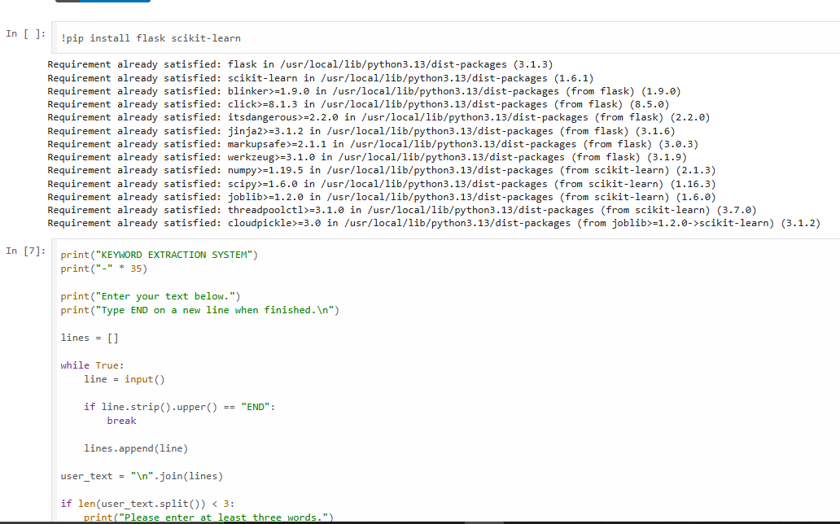
Figure 3.1: Package Installation and Start of the Input Cell in Google Colab
Figure 3.1 shows the first notebook cell, which runs !pip install flask scikit-learn. All requirements are reported as already satisfied in the Python 3.13 environment of the Colab session (Flask 3.1.3 and scikit-learn 1.6.1, together with dependencies such as Jinja2, Werkzeug, NumPy, and SciPy), so the environment is ready without further installation. The beginning of the input cell, which prints the heading “KEYWORD EXTRACTION SYSTEM” and the instructions for entering text, is also visible.
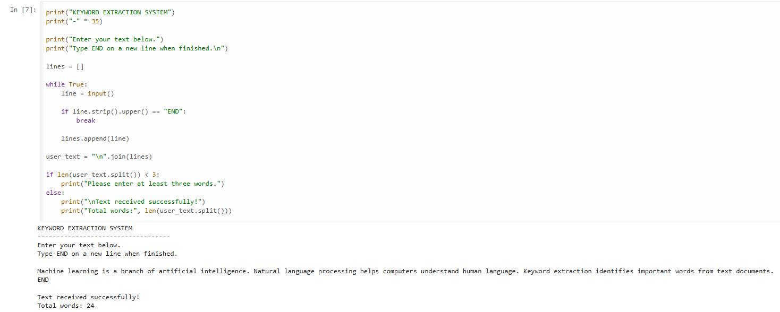
Figure 3.2: User Input Interface and Word-Count Validation
Figure 3.2 shows the input cell and its output. The code reads lines until the user types END, joins them into one string, and checks that at least three words were entered. In the screenshot the three-sentence sample text about machine learning, natural language processing, and keyword extraction was entered, and the program printed “Text received successfully!” and “Total words: 24”.
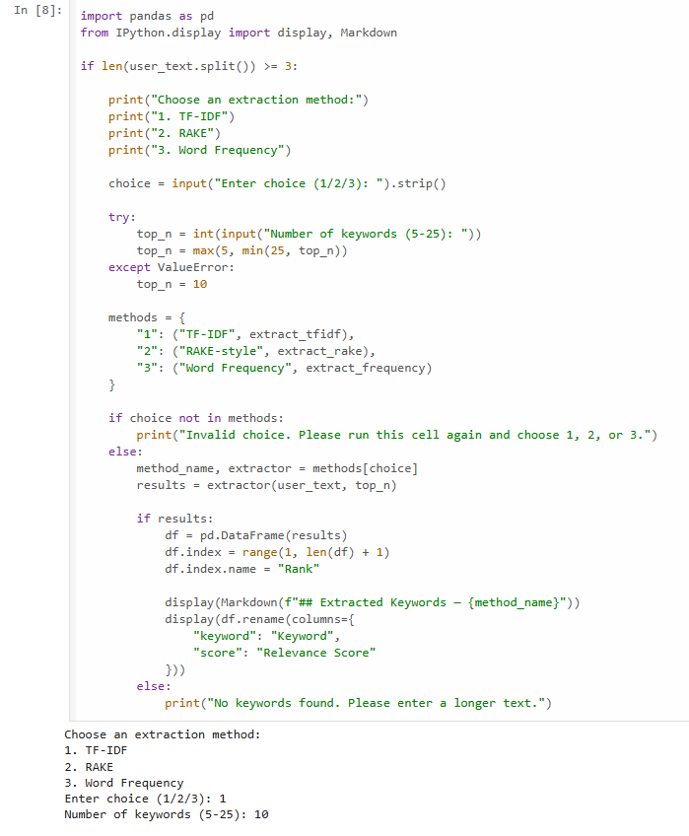
Figure 3.3: Selection of Keyword Extraction Method
Figure 3.3 shows the cell in which the user selects the extraction method. The menu offers 1. TF-IDF, 2. RAKE, and 3. Word Frequency, followed by a prompt for the number of keywords (5–25). The code maps each choice to one of the functions extract_tfidf, extract_rake, and extract_frequency, calls the selected function with the user text and the keyword count, and builds a Pandas DataFrame with a Rank index for display. In the screenshot, choice 1 (TF-IDF) and 10 keywords were entered.
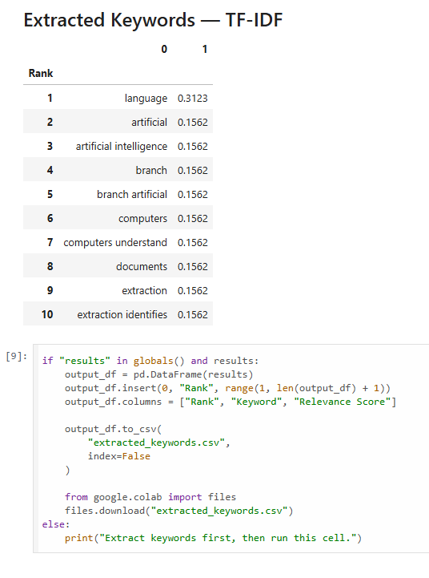
Figure 3.4: Ranked TF-IDF Keywords and CSV Export Cell
Figure 3.4 shows the output headed “Extracted Keywords — TF-IDF”, a ranked table of ten terms with their scores (discussed in Section 3.2), followed by the export cell. The export cell builds a DataFrame with the columns Rank, Keyword, and Relevance Score, saves it as extracted_keywords.csv without the index, and downloads it with files.download(); if no results exist, it asks the user to extract keywords first. The screenshot shows the code of this cell but not the downloaded file.
In summary, the supplied screenshots demonstrate the installation, input, validation, method selection, and TF-IDF ranking steps of the Colab version, and show the code of the CSV export step. The remaining test cases in Table 3.5 should be executed and documented, preferably with screenshots of the Flask web interface, before they are reported as observed results.

CHAPTER 4
CONCLUSION AND FUTURE SCOPE

4.1 Conclusion
This project developed a system for automatic keyword extraction from text documents. The purpose of the system is to replace the slow and subjective manual selection of important terms with an automatic procedure that returns a ranked list of keywords and phrases for any text entered by the user. The system cleans and normalises the input text, generates candidate terms, scores them with the selected method, and displays the top-N keywords with their relevance scores.
Three approaches were implemented and made available in a Google Colab notebook and a Flask web application: TF-IDF with unigrams and bigrams, a simplified RAKE-style phrase extraction method, and Word Frequency ranking. The Flask version also allows the results to be downloaded as a CSV file. Together, the three methods illustrate different ways of estimating keyword importance: weighting by term frequency, scoring multi-word phrases by word co-occurrence, and simple counting.
Automatic keyword identification offers several benefits. It saves the time that would be spent reading a document to find its key terms, it applies the same procedure consistently to every text, it requires no labelled training data, and it produces results that are easy to interpret because each keyword has an explicit score. Such keywords can support indexing, quick reading of long documents, and preliminary content analysis.
The project has some limitations, described in Section 3.2. In particular, TF-IDF fitted to a single document gives limited information, the RAKE-style method is simplified, scores from different methods cannot be compared directly, and no formal performance evaluation has been carried out. The system should therefore be regarded as a working prototype for learning and demonstration.

4.2 Limitations
- The system is designed mainly for English text.
- TF-IDF is fitted to a single input document, so it gives limited corpus-level inverse-document-frequency information.
- The RAKE-style method is a simplified educational implementation and not a full implementation of the original RAKE algorithm.
- Frequent words are not always the most meaningful keywords.
- PDF and DOCX uploads and semantic, embedding-based extraction are not included in the current implementation.
- The performance of the system has not been evaluated on a labelled dataset.

4.3 Future Scope
The following enhancements are proposed for future work. None of them has been implemented in the current version of the system.
- PDF and DOCX uploads. Allow users to upload documents in PDF and DOCX formats instead of pasting text, with text extraction before keyword extraction.
- Corpus-level TF-IDF. Fit the TF-IDF model on a collection of documents so that the inverse document frequency reflects how rare a term is across the collection.
- TextRank and KeyBERT. Add the graph-based TextRank algorithm [10] and the embedding-based KeyBERT method [12] for comparison with the existing methods.
- Malayalam and multilingual extraction. Extend preprocessing, stop-word handling, and tokenisation to support Malayalam and other languages.
- Evaluation. Evaluate the methods on documents with manually identified reference keywords using Precision@K, Recall@K, and F1-score.
- Improved visualisation and deployment. Add visual output such as bar charts or word clouds, add lemmatisation or stemming to preprocessing, and deploy the application on a hosting platform using a production-grade server.
For evaluation, Precision@K is the proportion of the top K extracted keywords that appear in the reference set, Recall@K is the proportion of the reference keywords found among the top K results, and the F1-score is the harmonic mean of precision and recall.

REFERENCES
[1] K. Spärck Jones, “A statistical interpretation of term specificity and its application in retrieval,” Journal of Documentation, vol. 28, no. 1, pp. 11–21, 1972.
[2] G. Salton and C. Buckley, “Term-weighting approaches in automatic text retrieval,” Information Processing & Management, vol. 24, no. 5, pp. 513–523, 1988.
[3] S. Rose, D. Engel, N. Cramer, and W. Cowley, “Automatic keyword extraction from individual documents,” in Text Mining: Applications and Theory, M. W. Berry and J. Kogan, Eds. Chichester, U.K.: John Wiley & Sons, 2010, pp. 1–20.
[4] F. Pedregosa et al., “Scikit-learn: Machine learning in Python,” Journal of Machine Learning Research, vol. 12, pp. 2825–2830, 2011.
[5] C. D. Manning, P. Raghavan, and H. Schütze, Introduction to Information Retrieval. Cambridge, U.K.: Cambridge University Press, 2008.
.

