Student Name: 李佳燕

Student ID: 0416039

Student email address: girlannie123@gmail.com

**[10%] Introduction [ at least 100 words]**

**WORD COUNT: 103 [ Must be filled or zero score]**

The object of the program is to do what user want to do. We show the menu about what user can ask the program to do first, then wait for user pressing the option. When user press one, we show some colors which one of them is the ship color for user to choose. When user press two, we show the frame of the game. When user press three, we play a game which have to move the ship from left to right. When user press four, we show the information of the author. When user press five, we exit the game finally.

**[10%] Structure Chart** [ at least 10 components]

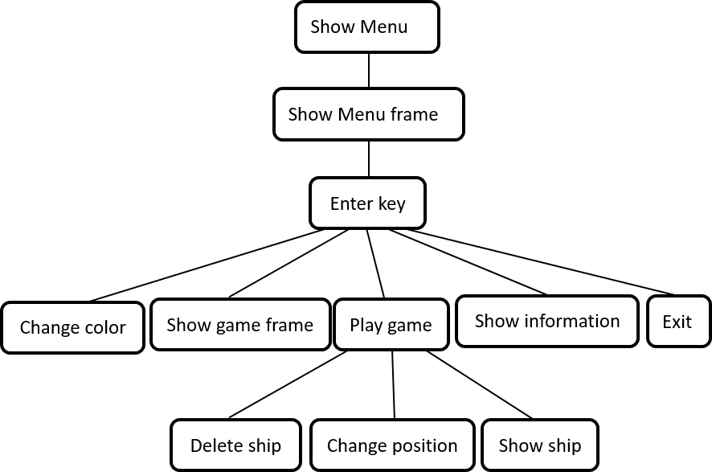

**[10%] Flow Chart**

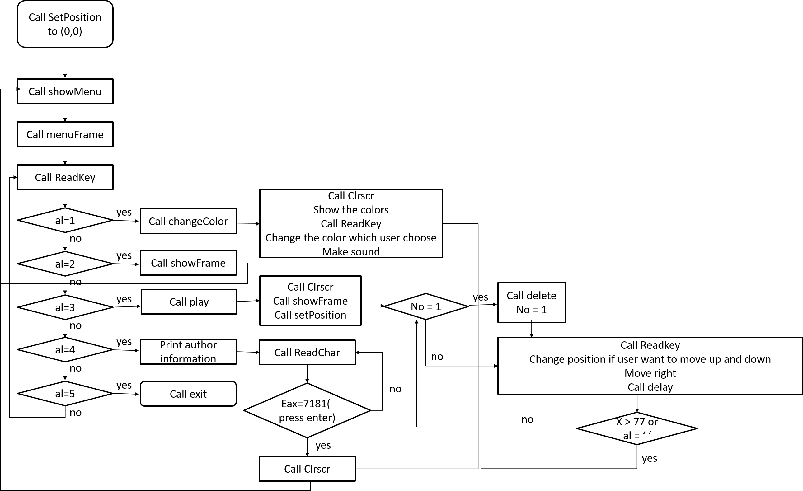

**[10%] System Architecture** [**at least 100 words]**

**WORD COUNT: 209 [ Must be filled or zero score]**

Of course, I show the menu first. After user press the number, I determined which option I have to work. If the work I have to do is option one (change the color), then I clear the screen, print the colors and numbers, and ask user to choose the color. After changing the ship color user wants, go back to the menu. If the work I have to do is option two (show the frame), then I show the frame of the game to the user, and show the menu after finishing showing the frame. If the work I have to do is option three (play game), then I clear the screen, show the frame of the game and the ship. The ship would move from left to right and user can move up and down during moving. When the ship move to right side or user press spacebar, quit the game and turn back to the menu. If the work I have to do is option four (show author information), then I show the information. After user press enter, the program would hide the information and turn back to the menu. If the work I have to do is option five (exit), then I turn of the program.

**[30%] The approach [ at least 300 words]**

**WORD COUNT: 303 [ Must be filled or zero score]**

It is easy to show the menu, just move the message into edx and call WriteString. But how to show the frame of the menu is a problem. Set the background color to the ship color then write the char ‘ ’ to each line. Write the line on the top first. When the x move to right side, turn down (increase y), and so on. Use call Readkey and cmp to determine which option the user press. When al equals to ‘1’, then call changeColor. Add shipColor 16 and 48 and draw the square first. After print the numbers, wait for user choosing the color. Then move the color to the shipColor. When al equals to ‘2’, then call showFrame. The way to show frame of the game is same as show the frame of the menu, but the size of frame of game is bigger. When al equals to ‘3’, then call play. Show the frame of game and ship first. Ship would move from left to right automatically (increase X when every round finish). When user press e or c during ship moving (use ReadKey and cmp to determine), increase/decrease Y to move up and down. Of course, we have to check out if the Y is at 0 or 20 to avoid moving out of range. When the ship move the right side or user press spacebar during the game, then quit the game. When al equals to ‘4’, then print the author information. Same as print the menu. Just move the message to edx and call WriteString. I add another function that when user press enter, the program would hide the information and show the menu again. The way to write this function is also use ReadChar and cmp. When al equals to ‘5’, then exit the program.

**[20%] Discussion/Experiments [ at least 200 words]**

**WORD COUNT: 217 [ Must be filled or zero score]**

The first problem I encounter is that I don’t know how to move the ship. But after I read the example teacher write on class, I found that it is quite easy but I didn’t think that way before. Just delete the older ship can create new one on new position. Then I met my second problem: It seems that my math is not pretty well so that I can delete the older ship clearly. After lots of test, I found the solution. Because I increase one more X when I create ship, I have to decrease X before deleting the ship. Oh! I also encounter the problem that I don’t know how to use ReadKey, but it is easy to find the solution. Just use the while loop to block it! The last problem I encounter is that I don’t know how to only press enter to exit the work instead of other character. Then I found that I can use ReadChar instead of Readkey, then use integer value of enter to cmp eax. It is the problem I met. Maybe I had met some other little problem but I solved them so quickly so that I forgot I met them. In summary, these are the main problem I met when I was doing the assignment.

**[10%] Conclusion [ at least 100 words]**

**WORD COUNT: 120Must be filled or zero score]**

When I knew this assignment, I thought it as a very difficult work because I never use program language to draw a picture, or show color. But after I finish assignment, I felt a sense of accomplishment. It is interesting to make the animation. I felt excited that the picture can move! It looks amazing! I think I learn a lot during the assignment. I also try to make some comments in the homework. It is very useful. Although I spend lots of time writing homework two, I think I have learnt something I want to learn, including improve my assembling language skill. I wish I would do more to make sure I learn the course perfectly in the future.