Student Name: 李佳燕

Student ID: 0416039

Student email address: girlannie123@gmail.com

**[10%] Introduction [ at least 100 words]**

**WORD COUNT:______214_______ [ Must be filled or zero score]**

This homework is to show the image on the screen and do something on the image. When user press ‘x’, the image would flip horizontally. When user press ‘y’, the image would flip upside down. When user press ‘i’ or ‘l’, it would show the sudent ID, and the student ID can move left to right and reserve the direction. When user press ‘1’, ‘2’, ‘3’, ‘4’, ‘5’, the pixel size would change. When user press ‘a’, the image would return to the initial one and the color would turn to purple. When user press ‘s’, the image would turn to the gray image and when user press again, it would turn back to the initial image. When user press ‘g’, it would turn to the game part, and when user press again, it would turn off the game part. User can change dimension of grid by pressing ‘8’, ‘9’, ‘0’. Then user can use the mouse. When user move the mouse, the grid which user move to will blinking. When user click, the grid which user choose would be chosen. When user choose another part of grid, it could change the image of that part. And when user press ESC, the program will show the information of programmer and turn off the game.

**[10%] Structure Chart** [ at least 10 components]

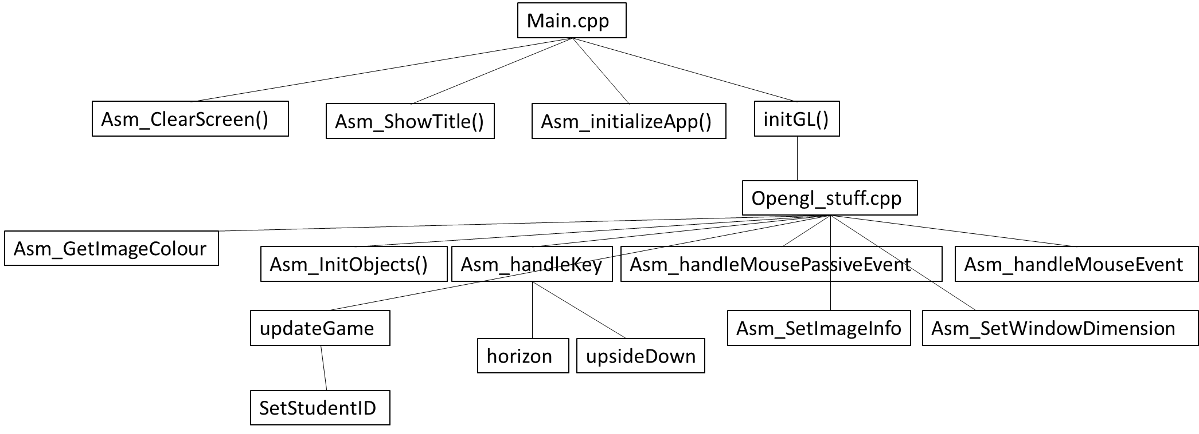

**[10%] Flow Chart**

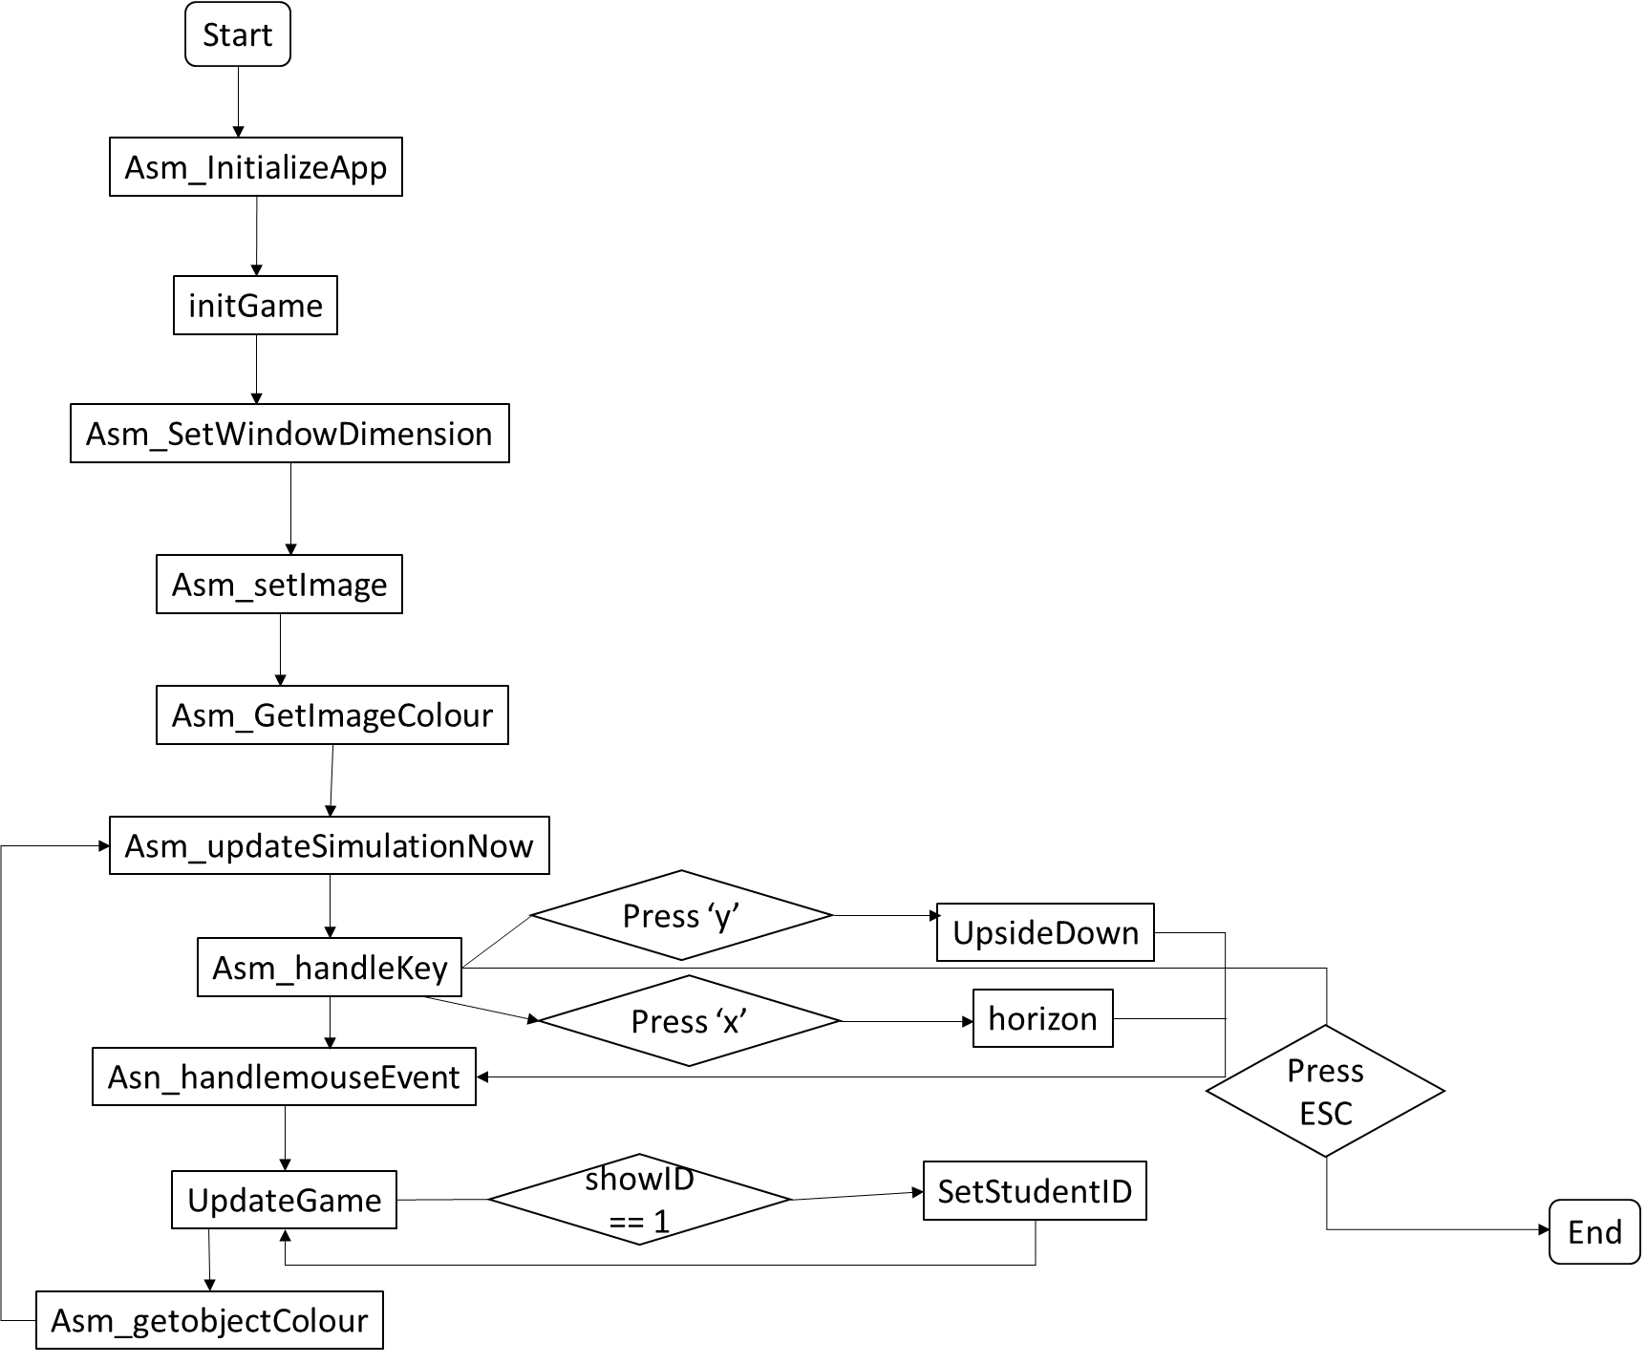

**[10%] System Architecture** [**at least 100 words]**

**WORD COUNT:______247_______ [ Must be filled or zero score]**

The program will show the information of the programmer and the key usage on the keyboard and how to use it at the beginning of the program. Then user can enter the speed of the spheres, the spheres space of x and y. Then start the program. The program has following function: flip the image, change image color, mouse event, show student ID, show grid, change part of image. And user can press different key on the keyboard to call the function. Press ‘x’ to flip image horizontally. Press ‘y’ to flip image upside down. Press ‘i’ or ‘l’ to show the student ID. Press ‘a’ to turn the image to the initial one and turn the color of the image to purple gradually. Press ‘s’ to change the image to gray one and the initial one. Press ‘1’, ‘2’, ‘3’, ‘4’, ‘5’ to change the image pixel size to 1, 2, 3, 4, 5, respectively. Press ‘g’ to show the grid. And press ‘8’, ‘9’, ‘0’ to change the dimension of grid to 4*2, 8*4, 8*8 respectively. When the grid is showed, user can use the mouse event. The grid which user move to will be marked. And when user click the mouse, the grid user click will be chosen. When user click another grid, two part of image would be changed and the mark will be canceled. When user press ‘ESC’, the program will show the information of the programmer and close the program finally.

**[30%] The approach [ at least 300 words]**

**WORD COUNT:_______629______ [ Must be filled or zero score]**

First, let start from the easy part: press ‘1’, ‘2’, ‘3’, ‘4’, ‘5’ to change the pixel size of image. It is very easy, just move the number 1, 2, 3, 4, 5 into mImagePixelPointSize respectively. And in the asm_GetImagePixelSize, the program will give the pixel size to the image. Next how to change the image color? It is a little bit harder, but not so hard. After searching internet, we know that there is a formula to change color into gray: Gray = (R*299 + G*587 + B*114 + 500) / 1000. So just put the rgb into the formula and return, we can get the gray color of the image. How about change color to purple gradually? We know that the purple of rgb is that the content of r is equal to b. So use a counter, if b + counter is not equal to r, plus it, and counter++. If b + counter is equal or larger than r, that b equal r, then counter++. Repeat this until counter is equal 256 because the range between b and r is never bigger than 256. How to flip the image? If we want to flip the image upside down, just change the mimageptr upside down, and we finish flipping. It is same to flip the image horizontally. That’s show the student ID! Write the bitmap about my student ID first. Then trace the bitmap. If the place I trace is equal to 1, give a sphere one this place and give the sphere a random color. After tracing the bitmap, we finish show student ID, then how to move it? We have save the position of the spheres in the objPosX and objPosY, so if we want to move left, just minus the value in objPosX. If the left most sphere touches the left side boundary, change the direction to move right. It is just plus the value in the objPosX, and when the right most sphere touch the right side boundary, change the direction to move left. After finish showing student ID, try to show the grid. Determined we have the split image into how many part first. Then do the division ( image width / how many part we have to split & image height / how many part we have to split), and do the record of the place we have to split. When ix or iy equal the result we do before, change the image color into white and we finish drawing grid. So we enter the mouse event. When user move the mouse, we will get the position user move to. Change the position into which part of grid the user is move into and recorded it. Then determined this is which part of grid, then give it a random color, because asm_GetImageColour will enter almost every time, it give random color every time like it is blinking. The following function I didn’t do it, but I have some idea. When user click the mouse, we will get the position of user choose, change the position into which part user click just like moving the mouse then do the record. When ix, iy is the side of the grid, give it a random color, and when the program enter asm_GetImageColour every time it gave it a random color just likei blinking. And how tow change two part of image user click? I think we can store part of the mimageptr into a temp variable. Just remember we have to store the initial mimagepr into another so that when we press ‘a’, we can change the image to initial. So just change the mimageptr between temp variable and the part of image we want to change then we can finish this part.

**[20%] Discussion/Experiments [ at least 200 words]**

**WORD COUNT:_____235________ [ Must be filled or zero score]**

This program is not easy to implement. The biggest problem I met is I didn’t know how to implement the program at the beginning. But after discussion with my friends, I have lots of idea of how to implement. Although I didn’t have enough time to finish all of the task of this homework, I think I know how to implement it. The second problem I met is that I forgot to use USES key word so that at the beginning of implement image, I felt trouble that I can put the image at the background and I can’t find what is the problem that can implement image on HW3 but can’t implement on final project until my friend ask me whether I write USES key or not. I also met the problem understanding OpenGL. I think OpenGL is an interesting things but I can’t understand the whole things of how OpenGL doing, what does OpenGL do and why OpenGL can get this affect. Maybe in the future I will try to get more understanding about OpenGL. I also met the problem about rgb color, but when I search the internet about rgb, I get lots of information. The longest time I implement is show student ID. I think I still have problem of using bitmap, but after these homework of assembly language, I know that bitmap is a useful thing to drawing by programming.

**[10%] Conclusion [ at least 100 words]**

**WORD COUNT:______110_______ [ Must be filled or zero score]**

I get a sense of accomplishment during this homework. Every time I finish a part of assignment. I felt excited and play the function a little time. It is seem that I have lots of interesting about the animation or do some interactive between computer and people. It is funny and amazing that I can write something to play a game. Although the game is seemed boring to some people. But I spend lots of time implement it. So Although some people say the program is nothing, I see the program as something. I think it is a sign of growing. After this assignment, I think I growing a lot.