Report for the Assignment Completion :

1) Installation steps :

1) Installed the virtualbox which helps to run different systems on a single computer .

2) Downloaded the ubuntu iso file from their official website

3) Created a new operating system in the virtualbox and added the settings needed in it along with the iso file downloaded from their official website

4) Completed the ubuntu installation process .

5) Then I installed qemu using ubuntu terminal with command : “sudo apt-get install qemu-system-x86”

6) Installed git using the command : “sudo apt-get install git”

7) Then I cloned the xv6 repo using the command : “git clone https://github.com/mit-pdos/xv6-public”

8) Installed make using the command :
“sudo apt-get install build-essential
sudo apt-get install gcc-multilib
sudo apt-get install make”

9) Then I executed make using the command : make

10) Then entered the command : make qemu-nox

11) if all goes well , then xv6 will start

12) I got the following error after running the last command

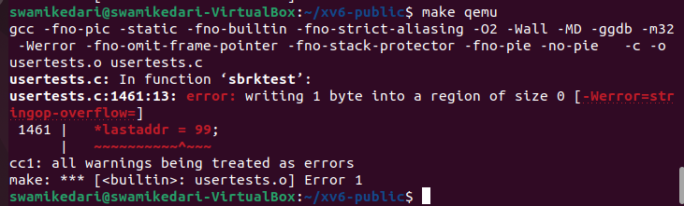

This error resolved when I deleted all the contents of the usertests.c

13) After the above error got resolved , xv6 started successfully.

14) Then I created a file named cs20b048.c which is the helloworld.c file asked in the question.

15) I wrote the c program to print my name and my roll no in the terminal

16) I ran the command make qemu-nox again and typed cs20b048

17) Got the following output in the terminal :
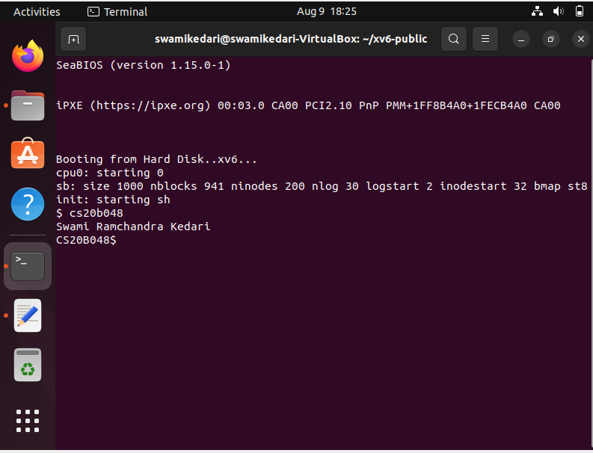

Challenges faced by me :

1) Just installing make using the command “sudo apt-get install make” was giving me error , resolved it by installing the build-essential and gcc-multilib packages.

2) I got this error after running “make qemu-nox”

Resolved this error by deleting the contents of usertests.c file.

3) I was getting compilation error when using stdio.h as the header file , this error got resolved after changing the header file .
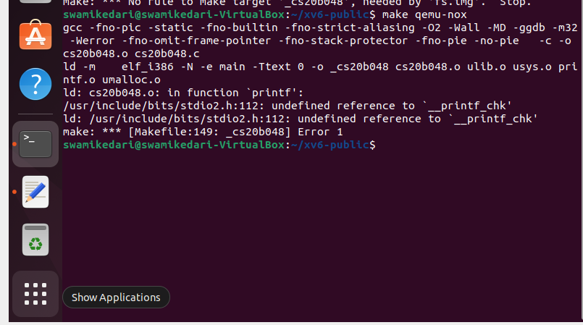
All the commands to reproduce the implementation :

1) sudo apt-get install qemu-system-x86

2) sudo apt-get install git

3) git clone https://github.com/mit-pdos/xv6-public

4) sudo apt-get install build-essential

5) sudo apt-get install gcc-multilib

6) sudo apt-get install make

7) make

8) make qemu-nox

// got a error as mentioned above at this point , resolved it by deleting the contents of usertests.c

9) Then created a text file named cs20b048.c in the xv6-public folder and again ran the command “make qemu-nox”

10) cs20b048 (entered this file name when xv6 started)

// The terminal printed my name and my rollno successfully in the terminal .

Output:

Other Difficulties faced by me:
I faced difficulty while sending the folder from the virtual machine to the host operating system.
I was not able to drag and drop the files created in the vm from their to the main operating system.

