PYTHON PROGRAMMING
10 Programs with Flowcharts, Algorithms
and Pseudocode
A structured practical record

Contents
- Program 1: Find the Highest, Lowest, and Difference of Prices
- Program 2: Validate a Student Email and ID
- Program 3: Run-Length Encoding of a String
- Program 4: Print a Symmetric Number Pattern
- Program 5: Run-Length Encoding Using a Different Variable Name
- Program 6: Find Repeated Words in a Sentence
- Program 7: Check Product Stock Availability
- Program 8: Track Passenger Count with a Capacity Limit
- Program 9: Calculate Total and Average Waste
- Program 10: Find the Highest, Lowest, and Difference of Prices

Program 1: Find the Highest, Lowest, and Difference of Prices

1. Program
prices = [100, 120, 90, 150, 130]
highest = max(prices)
lowest = min(prices)
print("Highest Price:", highest)
print("Lowest Price:", lowest)
print("Difference:", highest - lowest)

2. Flowchart
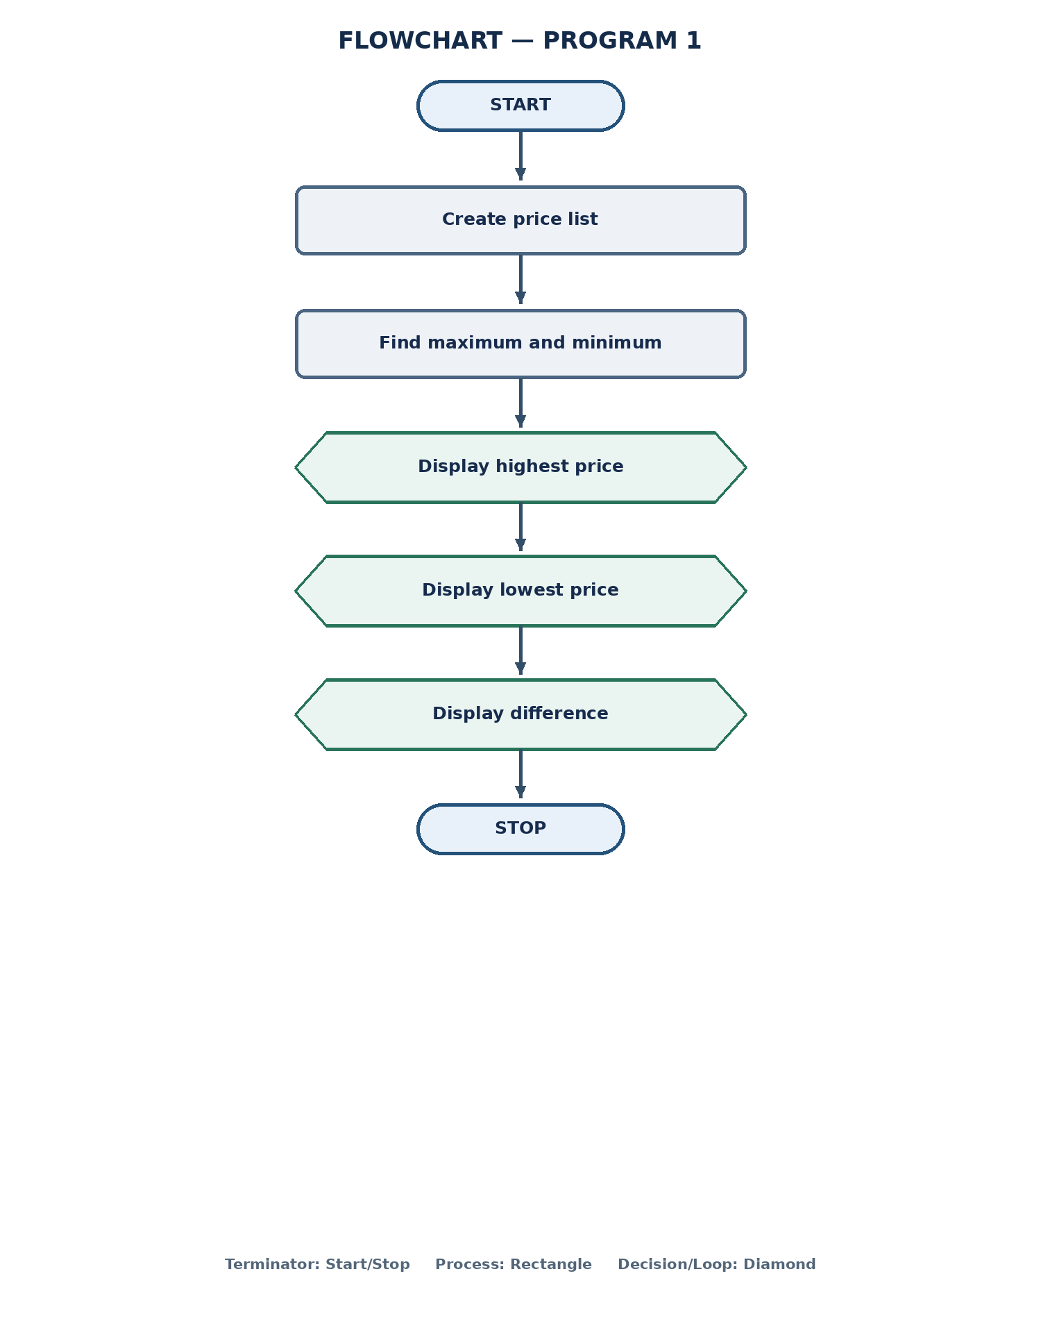

3. Algorithm
- Start the program.
- Create a list containing the five prices.
- Find the maximum value in the list and store it in highest.
- Find the minimum value in the list and store it in lowest.
- Display the highest price.
- Display the lowest price.
- Subtract the lowest price from the highest price and display the difference.
- Stop the program.

4. Pseudocode
BEGIN
prices ← [100, 120, 90, 150, 130]
highest ← MAX(prices)
lowest ← MIN(prices)
OUTPUT highest
OUTPUT lowest
OUTPUT highest - lowest
END

Program 2: Validate a Student Email and ID

1. Program
email = input()
student_id = input()
email_valid = email.endswith("nRI@college.edu")
id_valid = len(student_id) == 8 and student_id.isdigit()
if email_valid and id_valid:
print("Valid Student Record")
else:
print("Invalid Student Record")

2. Flowchart
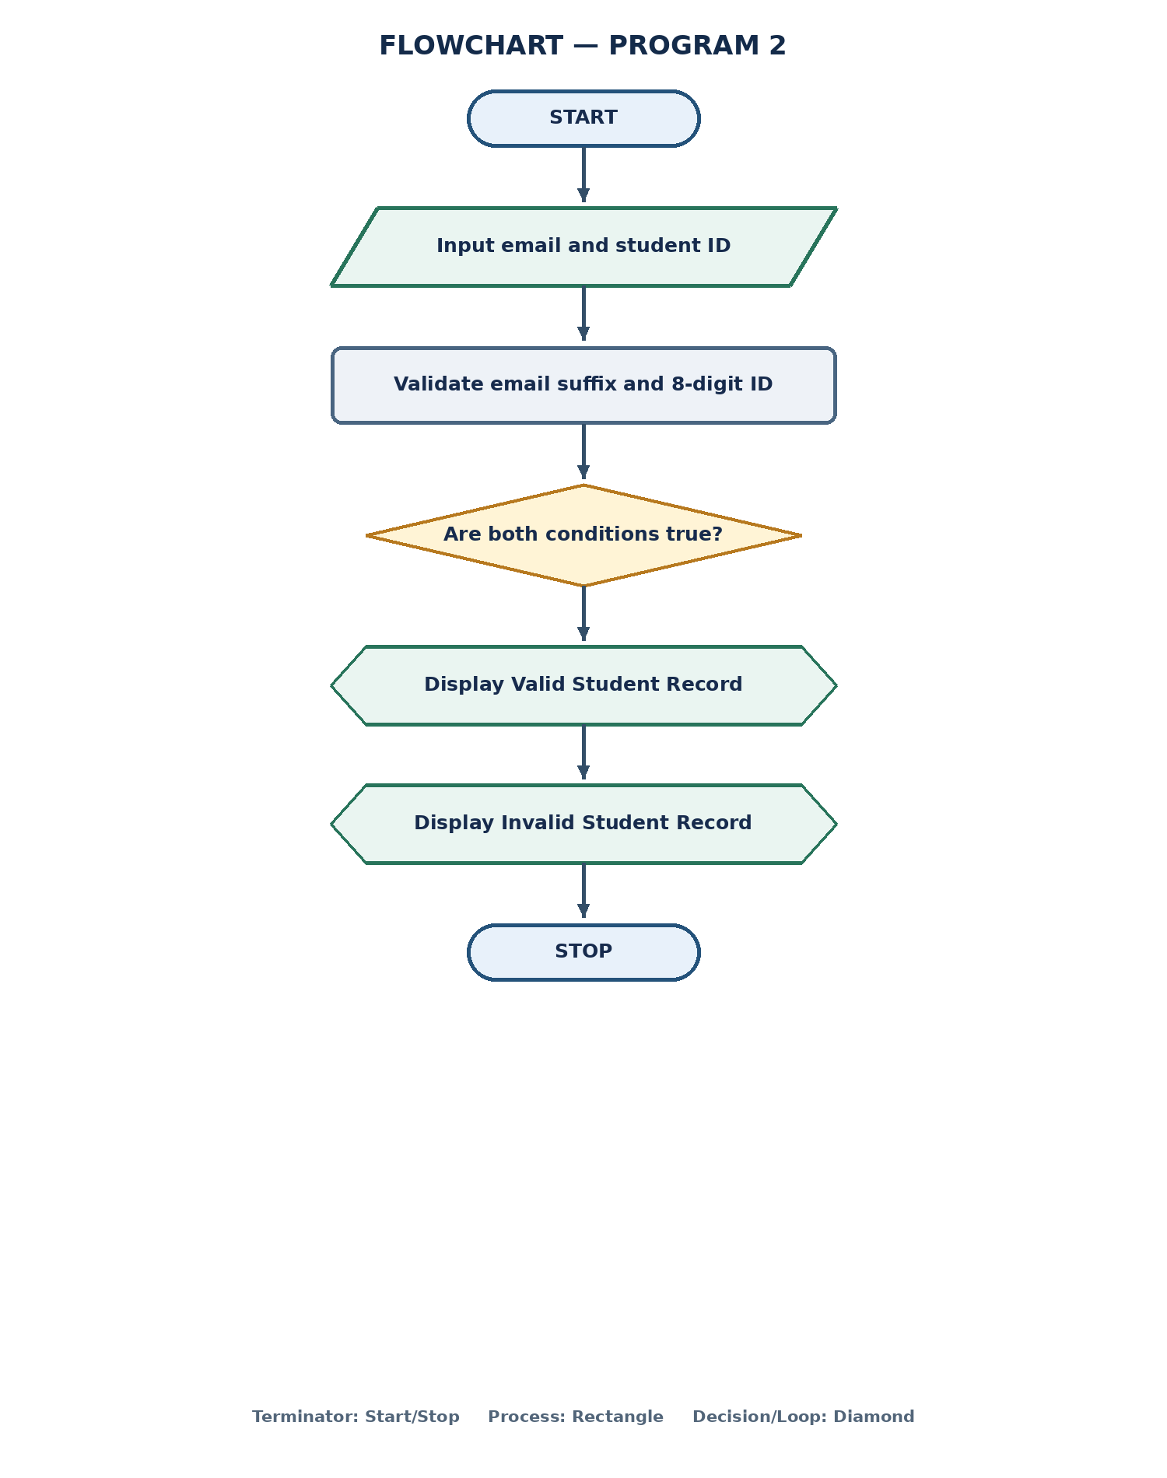

3. Algorithm
- Start the program.
- Read the student's email address.
- Read the student's ID.
- Check whether the email ends with the required text, "nRI@college.edu".
- Check whether the ID contains exactly 8 characters and all characters are digits.
- Check whether both validation conditions are true.
- If both are true, display "Valid Student Record".
- Otherwise, display "Invalid Student Record".
- Stop the program.

4. Pseudocode
BEGIN
INPUT email
INPUT student_id
email_valid ← email ENDS WITH "nRI@college.edu"
id_valid ← (LENGTH(student_id) = 8) AND (student_id contains only digits)
IF email_valid AND id_valid THEN
OUTPUT "Valid Student Record"
ELSE
OUTPUT "Invalid Student Record"
END IF
END

Program 3: Run-Length Encoding of a String

1. Program
text = input()
compressed = ""
count = 1
for i in range(1, len(text)):
if text[i] == text[i - 1]:
count += 1
else:
compressed += text[i - 1] + str(count)
count = 1
compressed += text[-1] + str(count)
print(compressed)

2. Flowchart
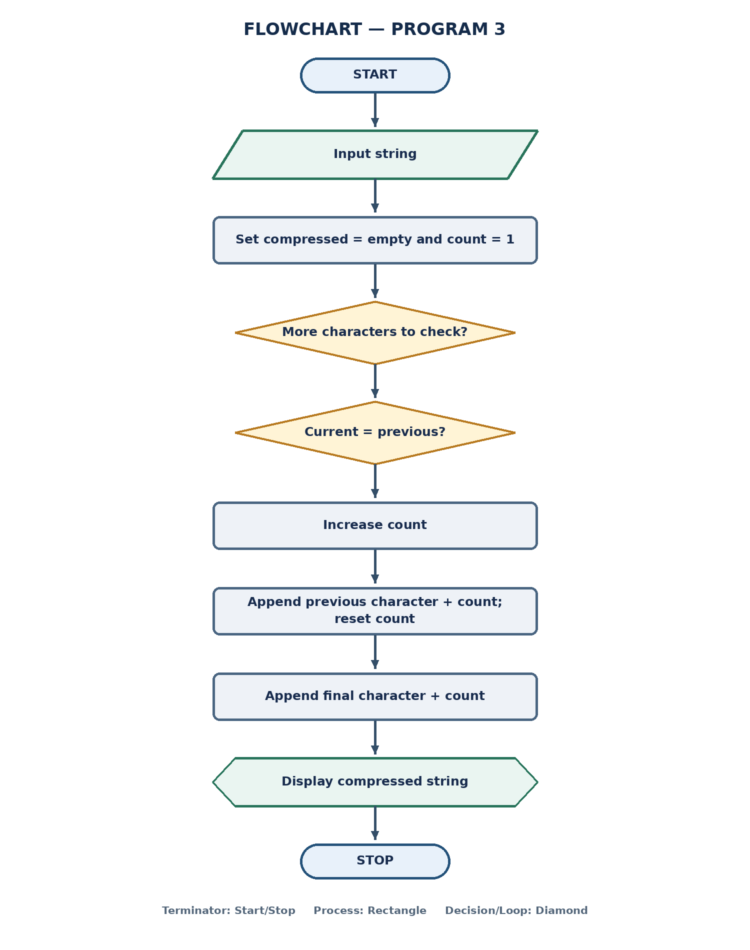
The flowchart shows the loop and its two comparison outcomes; after all characters are processed, the final character group is appended.

3. Algorithm
- Start the program and read a string.
- Initialize compressed as an empty string and count as 1.
- Start a loop from the second character to the last character.
- Compare the current character with the previous character.
- If they are equal, increase count by 1.
- Otherwise, append the previous character and its count to compressed, then reset count to 1.
- After the loop, append the last character and its count to compressed.
- Display the compressed string.
- Stop the program.

4. Pseudocode
BEGIN
INPUT text
compressed ← ""
count ← 1
FOR i ← 1 TO LENGTH(text) - 1
IF text[i] = text[i - 1] THEN
count ← count + 1
ELSE
compressed ← compressed + text[i - 1] + STRING(count)
count ← 1
END IF
END FOR
compressed ← compressed + text[last] + STRING(count)
OUTPUT compressed
END

Program 4: Print a Symmetric Number Pattern

1. Program
n = int(input("enter an odd number of rows:"))
if n <= 0 or n % 2 == 0:
print("Invalid dimension! Please enter a positive odd number.")
else:
mid = n // 2
for i in range(mid + 1):
print(" " * (mid - i), end="")
for j in range(1, i + 2):
print(j, end="")
for j in range(i, 0, -1):
print(j, end="")
print()
for i in range(mid - 1, -1, -1):
print(" " * (mid - i), end="")
for j in range(1, i + 2):
print(j, end="")
for j in range(i, 0, -1):
print(j, end="")
print()
Code note: The uploaded file had indentation errors: the invalid-input print statement was not indented under its IF, and the lower-half loop was nested inside the upper-half loop. The code shown here corrects only those indentation/placement issues so the intended pattern is produced.

2. Flowchart
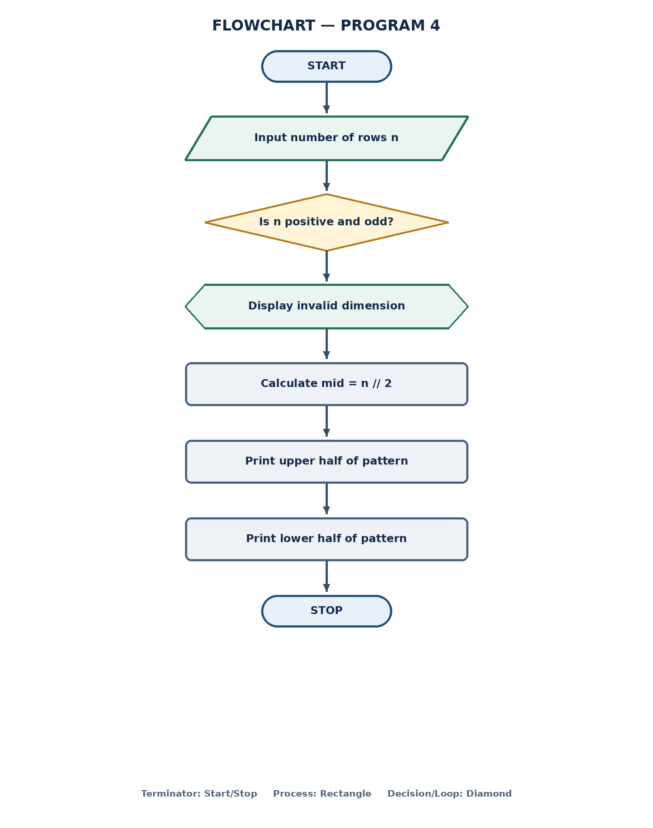

3. Algorithm
- Start the program.
- Read the number of rows n.
- Check whether n is positive and odd.
- If n is not positive or is even, display an invalid-dimension message.
- Otherwise, calculate mid = n // 2.
- Print the upper half, including the middle row: for each row, print leading spaces, increasing numbers, then decreasing numbers.
- Print the lower half in reverse row order using the same number pattern.
- Stop the program.

4. Pseudocode
BEGIN
INPUT n
IF n <= 0 OR n MOD 2 = 0 THEN
OUTPUT "Invalid dimension"
ELSE
mid ← n DIV 2
FOR i ← 0 TO mid
OUTPUT (mid - i) spaces
OUTPUT numbers 1 TO i + 1
OUTPUT numbers i DOWN TO 1
END FOR
FOR i ← mid - 1 DOWN TO 0
OUTPUT (mid - i) spaces
OUTPUT numbers 1 TO i + 1
OUTPUT numbers i DOWN TO 1
END FOR
END IF
END

Program 5: Run-Length Encoding Using a Different Variable Name

1. Program
s = input()
result = ""
count = 1
for i in range(1, len(s)):
if s[i] == s[i - 1]:
count += 1
else:
result += s[i - 1] + str(count)
count = 1
result += s[-1] + str(count)
print(result)

2. Flowchart
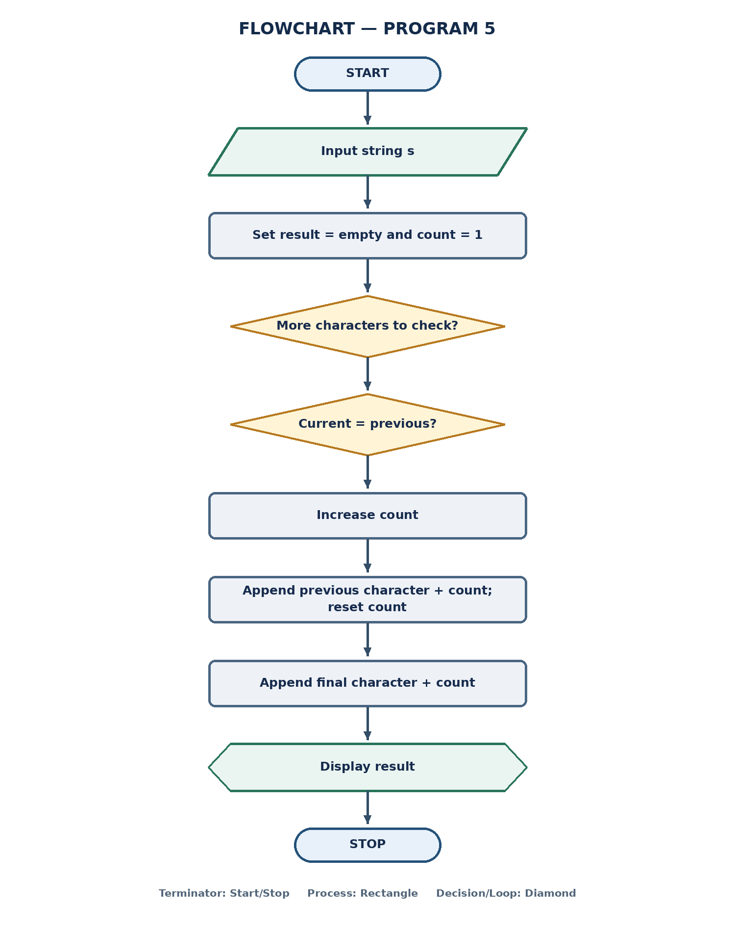
This performs the same run-length encoding operation as Program 3; the variable names are result and s instead of compressed and text.

3. Algorithm
- Start the program and read a string s.
- Initialize result as an empty string and count as 1.
- Loop through the string from its second character.
- Compare the current character with the previous character.
- If they match, increase count.
- Otherwise, add the previous character and its count to result, then reset count to 1.
- After the loop, add the final character and its count to result.
- Display result and stop.

4. Pseudocode
BEGIN
INPUT s
result ← ""
count ← 1
FOR i ← 1 TO LENGTH(s) - 1
IF s[i] = s[i - 1] THEN
count ← count + 1
ELSE
result ← result + s[i - 1] + STRING(count)
count ← 1
END IF
END FOR
result ← result + s[last] + STRING(count)
OUTPUT result
END

Program 6: Find Repeated Words in a Sentence

1. Program
text = input().lower()
words = text.split()
repeated = []
for word in words:
if words.count(word) > 1 and word not in repeated:
repeated.append(word)
print(repeated)

2. Flowchart
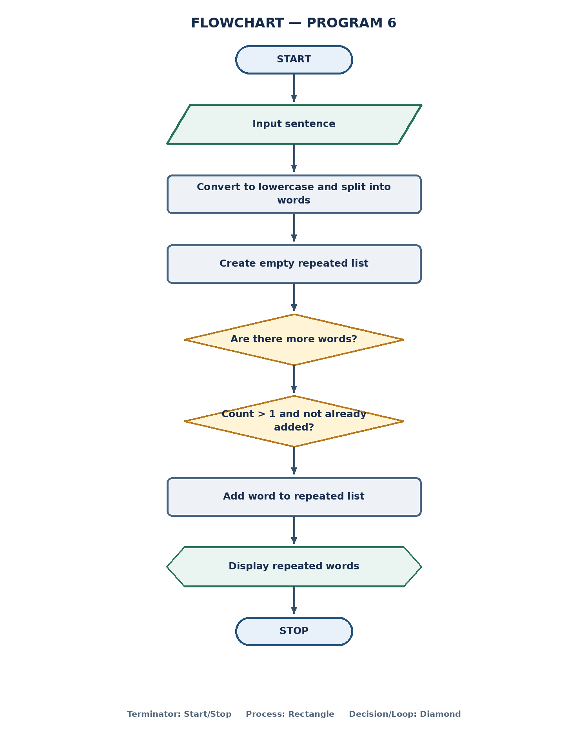

3. Algorithm
- Start the program.
- Read a sentence and convert it to lowercase.
- Split the sentence into a list of words.
- Create an empty list named repeated.
- Visit each word in the words list.
- Check whether the word occurs more than once and is not already in repeated.
- If both conditions are true, add the word to repeated.
- After checking all words, display the repeated-word list.
- Stop the program.

4. Pseudocode
BEGIN
INPUT text
text ← LOWERCASE(text)
words ← SPLIT(text)
repeated ← empty list
FOR EACH word IN words
IF COUNT(words, word) > 1 AND word NOT IN repeated THEN
APPEND word TO repeated
END IF
END FOR
OUTPUT repeated
END

Program 7: Check Product Stock Availability

1. Program
products = (("Laptop", 50000, 10),
("Mobile", 20000, 0),
("Tablet", 15000, 5)
)
for name, price, stock in products:
if stock == 0:
print(name, "- Out of Stock")
else:
print(name, "- In Stock")

2. Flowchart
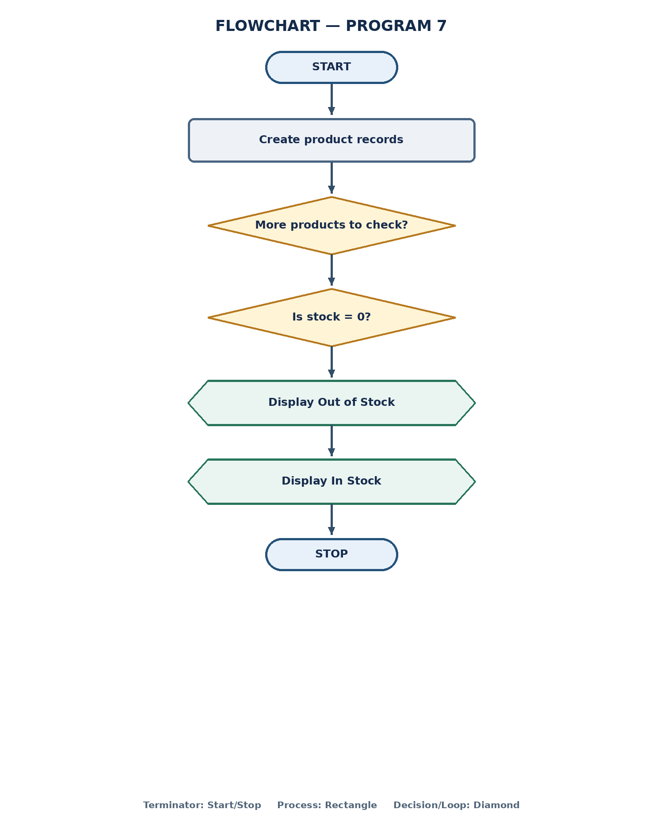

3. Algorithm
- Start the program.
- Create a tuple containing each product name, price, and stock quantity.
- Visit each product record in the tuple.
- Read the product name, price, and stock quantity for the current record.
- Check whether stock is equal to zero.
- If stock is zero, display the product name with "Out of Stock".
- Otherwise, display the product name with "In Stock".
- Repeat until all products have been checked.
- Stop the program.

4. Pseudocode
BEGIN
products ← (product records)
FOR EACH (name, price, stock) IN products
IF stock = 0 THEN
OUTPUT name, "- Out of Stock"
ELSE
OUTPUT name, "- In Stock"
END IF
END FOR
END

Program 8: Track Passenger Count with a Capacity Limit

1. Program
capacity = 50
passengers = 0
for i in range(3):
boarded = int(input())
left = int(input())
passengers = passengers + boarded - left
if passengers > capacity:
passengers = capacity
print("Passengers:", passengers)

2. Flowchart
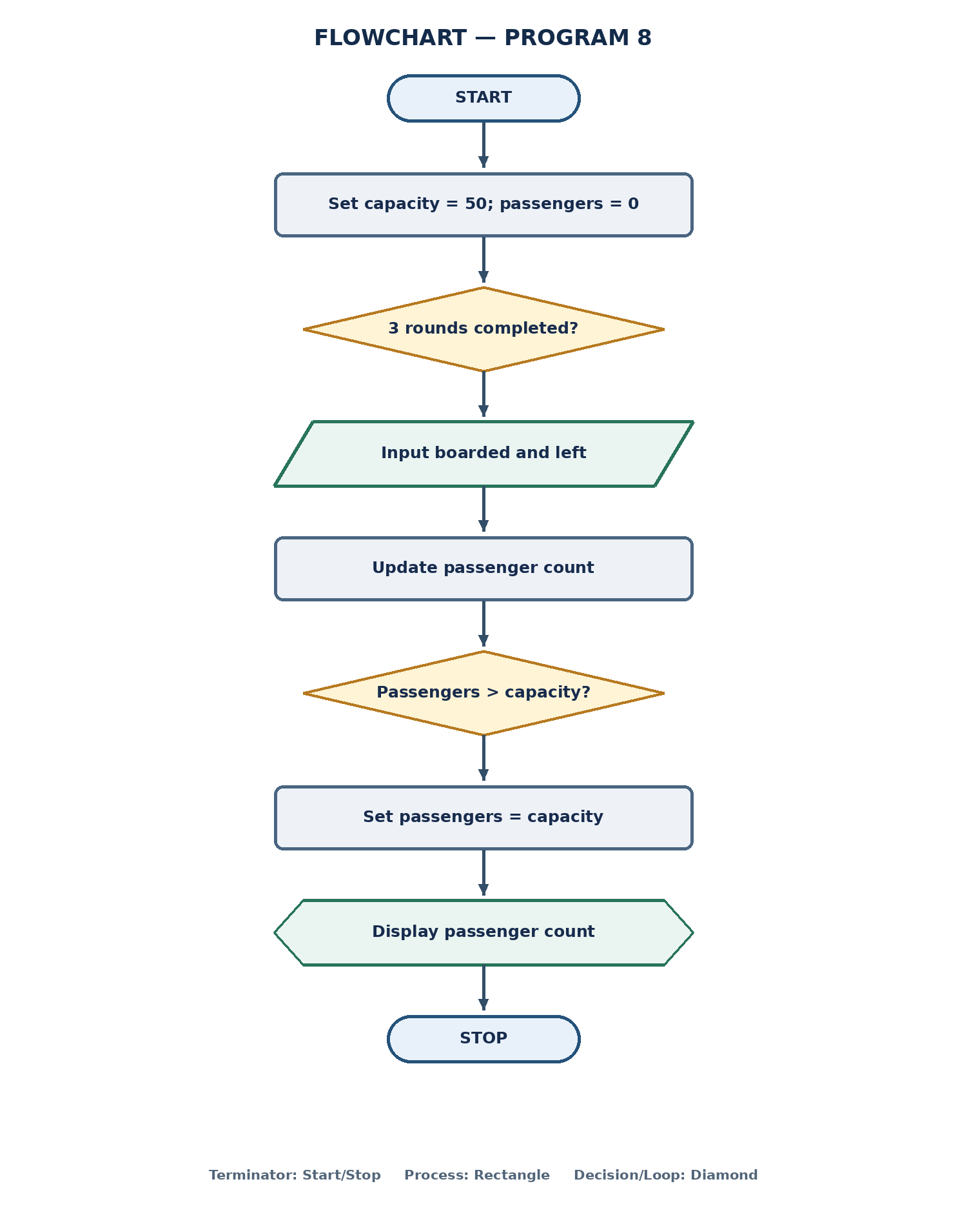

3. Algorithm
- Start the program.
- Set the vehicle capacity to 50 and the initial passenger count to 0.
- Repeat the boarding process three times.
- Read the number of passengers who boarded.
- Read the number of passengers who left.
- Update the passenger count by adding boarded and subtracting left.
- Check whether the passenger count exceeds the capacity.
- If it exceeds 50, set the passenger count to 50.
- After three rounds, display the final passenger count.
- Stop the program.

4. Pseudocode
BEGIN
capacity ← 50
passengers ← 0
REPEAT 3 TIMES
INPUT boarded
INPUT left
passengers ← passengers + boarded - left
IF passengers > capacity THEN
passengers ← capacity
END IF
END REPEAT
OUTPUT passengers
END

Program 9: Calculate Total and Average Waste

1. Program
waste = [12, 8, 15, 5, 10]
total_waste = sum(waste)
average_waste = total_waste / len(waste)
print("Total Waste:", total_waste)
print("Average Waste:", average_waste)

2. Flowchart
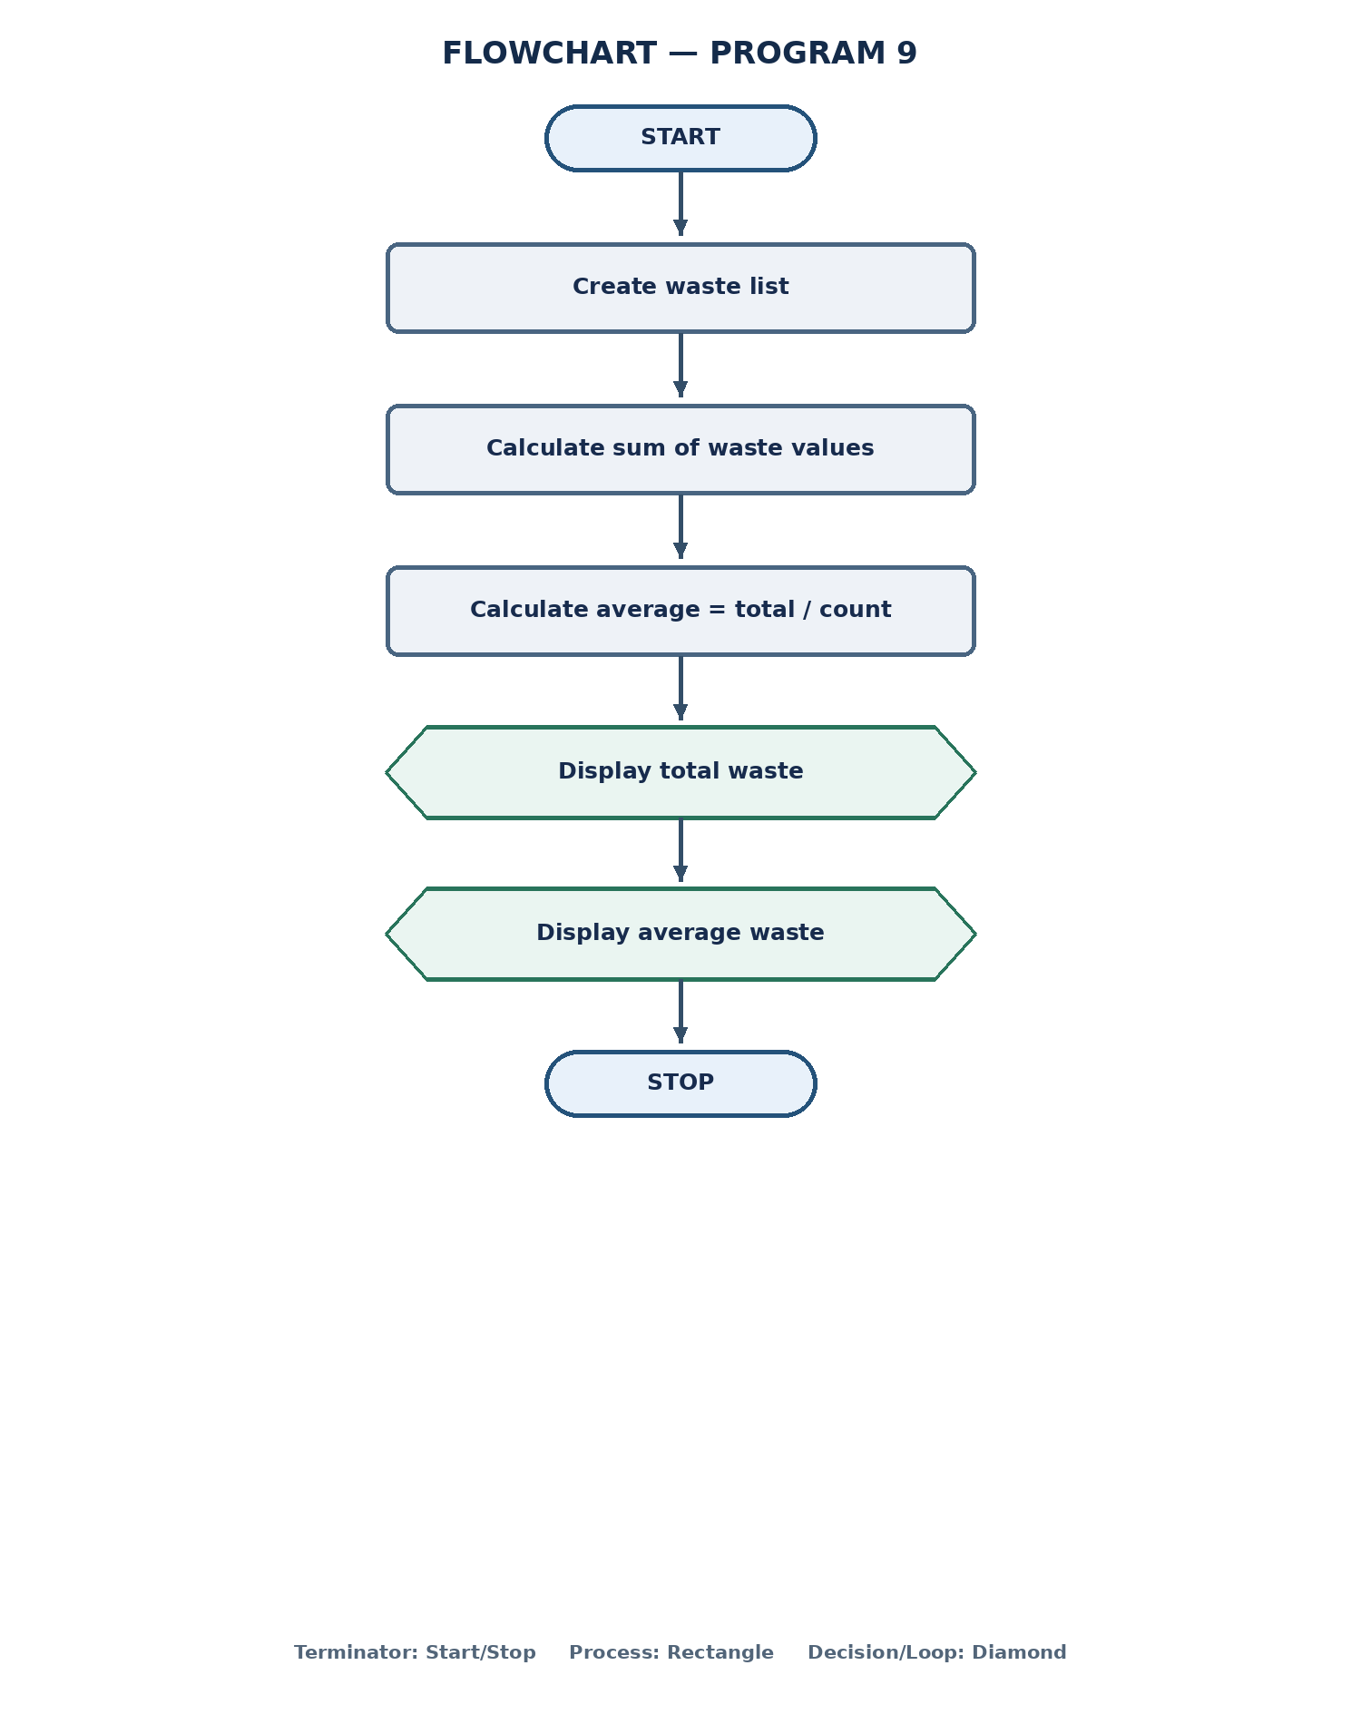

3. Algorithm
- Start the program.
- Create a list containing the waste values.
- Calculate the total of all values using sum().
- Calculate the number of values using len().
- Divide total_waste by the number of values to get average_waste.
- Display the total waste.
- Display the average waste.
- Stop the program.

4. Pseudocode
BEGIN
waste ← [12, 8, 15, 5, 10]
total_waste ← SUM(waste)
average_waste ← total_waste / LENGTH(waste)
OUTPUT total_waste
OUTPUT average_waste
END

Program 10: Find the Highest, Lowest, and Difference of Prices

1. Program
prices = [100, 120, 90, 150, 130]
highest = max(prices)
lowest = min(prices)
print("Highest Price:", highest)
print("Lowest Price:", lowest)
print("Difference:", highest - lowest)

2. Flowchart
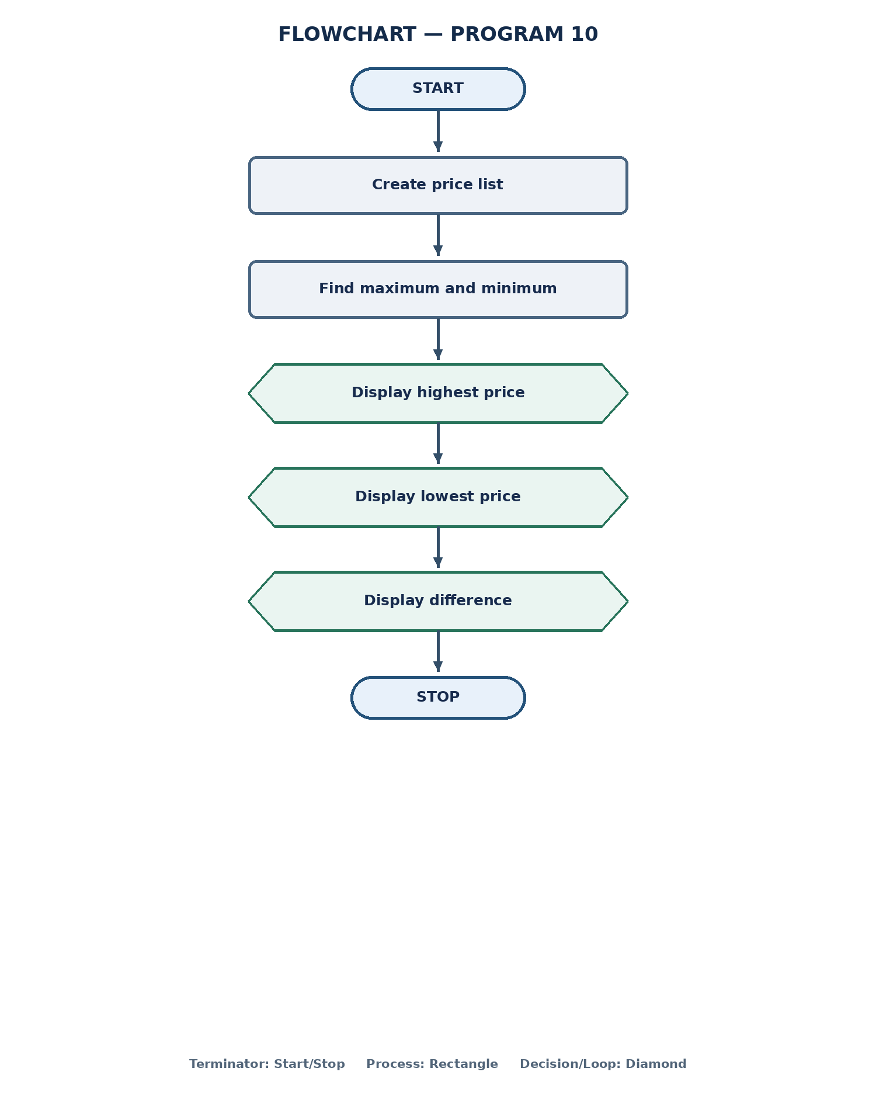
This program is identical to Program 1 in the uploaded files.

3. Algorithm
- Start the program.
- Create a list containing the five prices.
- Find the maximum value in the list and store it in highest.
- Find the minimum value in the list and store it in lowest.
- Display the highest price.
- Display the lowest price.
- Subtract the lowest price from the highest price and display the difference.
- Stop the program.

4. Pseudocode
BEGIN
prices ← [100, 120, 90, 150, 130]
highest ← MAX(prices)
lowest ← MIN(prices)
OUTPUT highest
OUTPUT lowest
OUTPUT highest - lowest
END

