[Hospital Logo]
NURSEQUEST
PROGRESS UPDATE & NEW FEATURES
Overview of Curriculum Organization, Advanced Quiz Question Types, and UX Enhancements Added Post-Web-Preview
JUNE 9, 2026
SREC · TECHNICAL PLATFORM DEVELOPMENT

EXECUTIVE SUMMARY
Since the publication of the initial 'NurseQuest Web Preview' document, the platform has undergone significant architectural expansion and user-experience polishing. This Progress Update documents the features, pages, database schema modifications, and question formats implemented since then to transition the project from a basic quiz system into a full-scale, structured clinical training environment.
What is NOT in the original Web Preview document:
- Interactive Landing Page & Guest Join Flow: A pre-authorization homepage with theme toggles, detailed Host vs. Player experience grids, and an interactive phone mockup demonstrating friction-free 6-digit room PIN joins.
- Curriculum-Based Learning Modules: A core hierarchy grouping quizzes into clinical subjects (e.g., Fundamentals of Patient Care, Pharmacology) rather than simple text categories. Includes a dedicated Module Manager for teachers and Module View with progress indicators for students.
- Advanced Question Formats (Slider & Matching Pairs): Moving beyond multiple choice to support clinical vital range inputs (via Sliders) and term relationships (via Matching Pairs) both in single-player and Socket.io multiplayer.
- Light / Dark Theme Support: Full stylesheet token integration supporting real-time visual mode switches.
- Expanded Database Schema: Creation of the `modules` relational table and extension of the `questions` table with fields for slider constraints and matching pairs JSON arrays.

1. INTERACTIVE LANDING PAGE & GUEST JOIN FLOW
A major UX gap in the original web preview was the lack of an introductory page. The platform now features a high-impact landing page at the root route (`/`) which introduces the application to guests, explains the features, and provides a comparative review of Host vs. Player experiences.
Core Enhancements on this Page:
- Guest Joining: Students do not need to register. They can click 'Enter Code' directly on the landing page, opening a modal to submit a 6-digit room PIN and choose a nickname.
- Nickname Generator: A casino-style random nickname generator is built into the join flow, combining safe prefixes and clinical terms (e.g., 'MightyPulse38') and checking against a blocked list of words to ensure classroom safety.
- Theme Toggle: A navbar controller allows users to switch between Light Mode and a sleek dark layout instantly.
- Parallax Design: Interactive background blur blobs track mouse movements, giving the landing page a premium, dynamic feel.
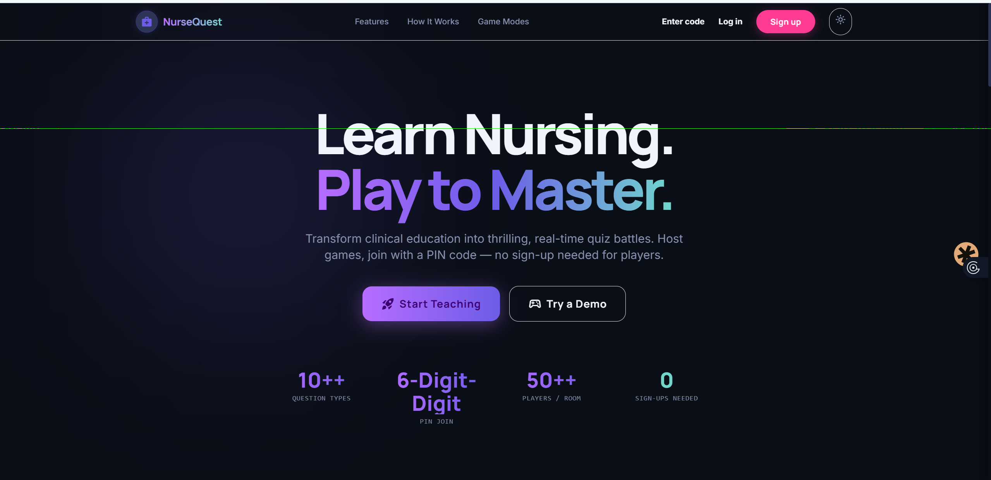
Figure 1: Interactive Landing Page (/) featuring phone join mockup, theme switch, and statistics counters.
2. LEARNING MODULES — TEACHER VIEW
To structure learning pathways, we implemented a relational Learning Modules system. Instead of quizzes being loosely categorized by text strings, they are now child elements of defined Course Modules. Teachers manage this via the new Module Manager (`/modules`).
Module Manager Features:
- Module Creation & Metadata: Teachers can define a Module Title and Description, select an appropriate icon (from 12 Material Icons), and choose a unique accent color (from 10 pre-curated color tokens) to color-coordinate the module's styling.
- Drafting and Publishing: Toggle switches determine whether a module is a Draft (invisible to students) or Published (live on student dashboards).
- Drill-Down Quiz Management: Expanding a module's row displays all quizzes assigned to that module, their draft/published states, question counts, and allows direct quiz editing or previewing.
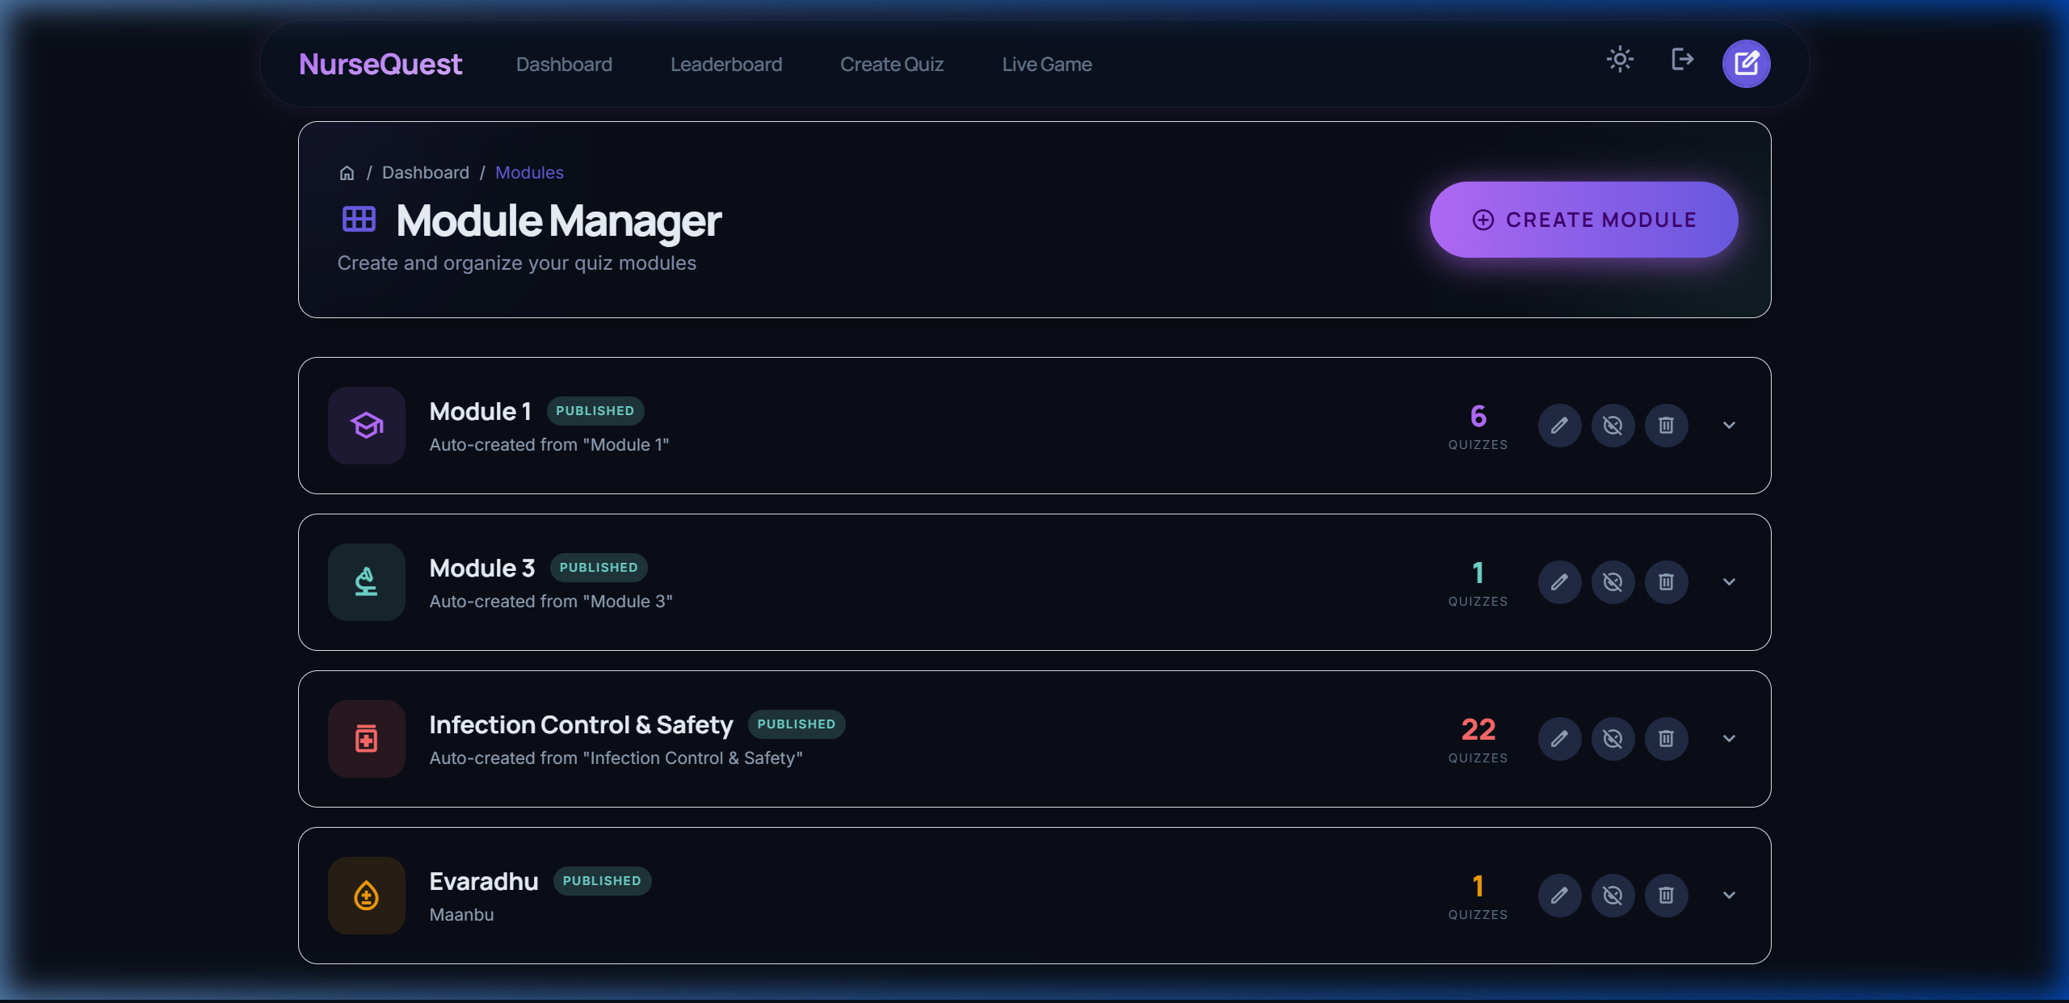
Figure 2: Teacher Module Manager (/modules) displaying the interactive module editor modal and quiz drill-down.

3. LEARNING MODULES — STUDENT VIEW
For students, modules provide a structured, gamified learning map. When a student clicks on a module from their dashboard, they are navigated to the dedicated Module View (`/modules/:id`), styled with the module's specific accent color.
Student Module Cockpit Features:
- Animated Progress Tracking: A linear progress bar dynamically calculates and displays the percentage of quizzes completed within the module (e.g., '2/3 Quizzes Completed · 67%').
- Visual Completion States: Quizzes that have been attempted show a checkmark status icon and display the student's highest score. Unattempted quizzes show a numeric index and a 'Start' CTA.
- Color-Themed UI Glows: The entire UI adaptively updates its buttons, progress fills, and background glows to match the accent color designated by the teacher for that specific module.
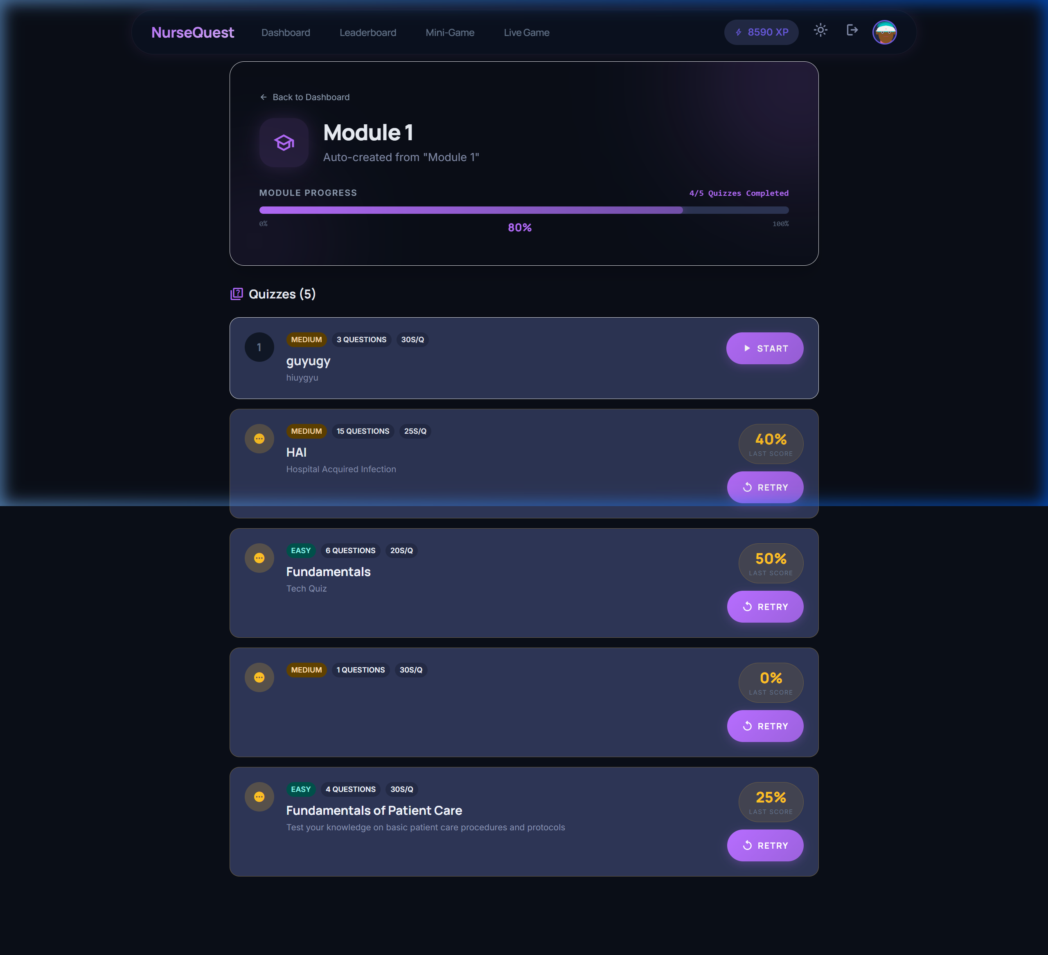
Figure 3: Student Module View (/modules/:id) showing the color-coordinated progress bar, completion ticks, and quiz list.
4. CLINICAL QUESTION TYPES
To better simulate clinical scenarios, the Quiz Builder and Player have been expanded with two advanced question types: Sliders and Matching Pairs. These allow nursing students to interact with continuous numerical vital ranges and relational data.
Enhancement A: Slider Questions (Continuous Numeric Input)
Used for questions requiring numeric values (e.g. vital signs, drug dosages). Teachers configure the minimum value, maximum value, step size, unit (e.g., 'mmHg', 'bpm', '°C'), and the correct numeric answer. Students drag a custom-styled slider to submit their answer, which is checked against the database.
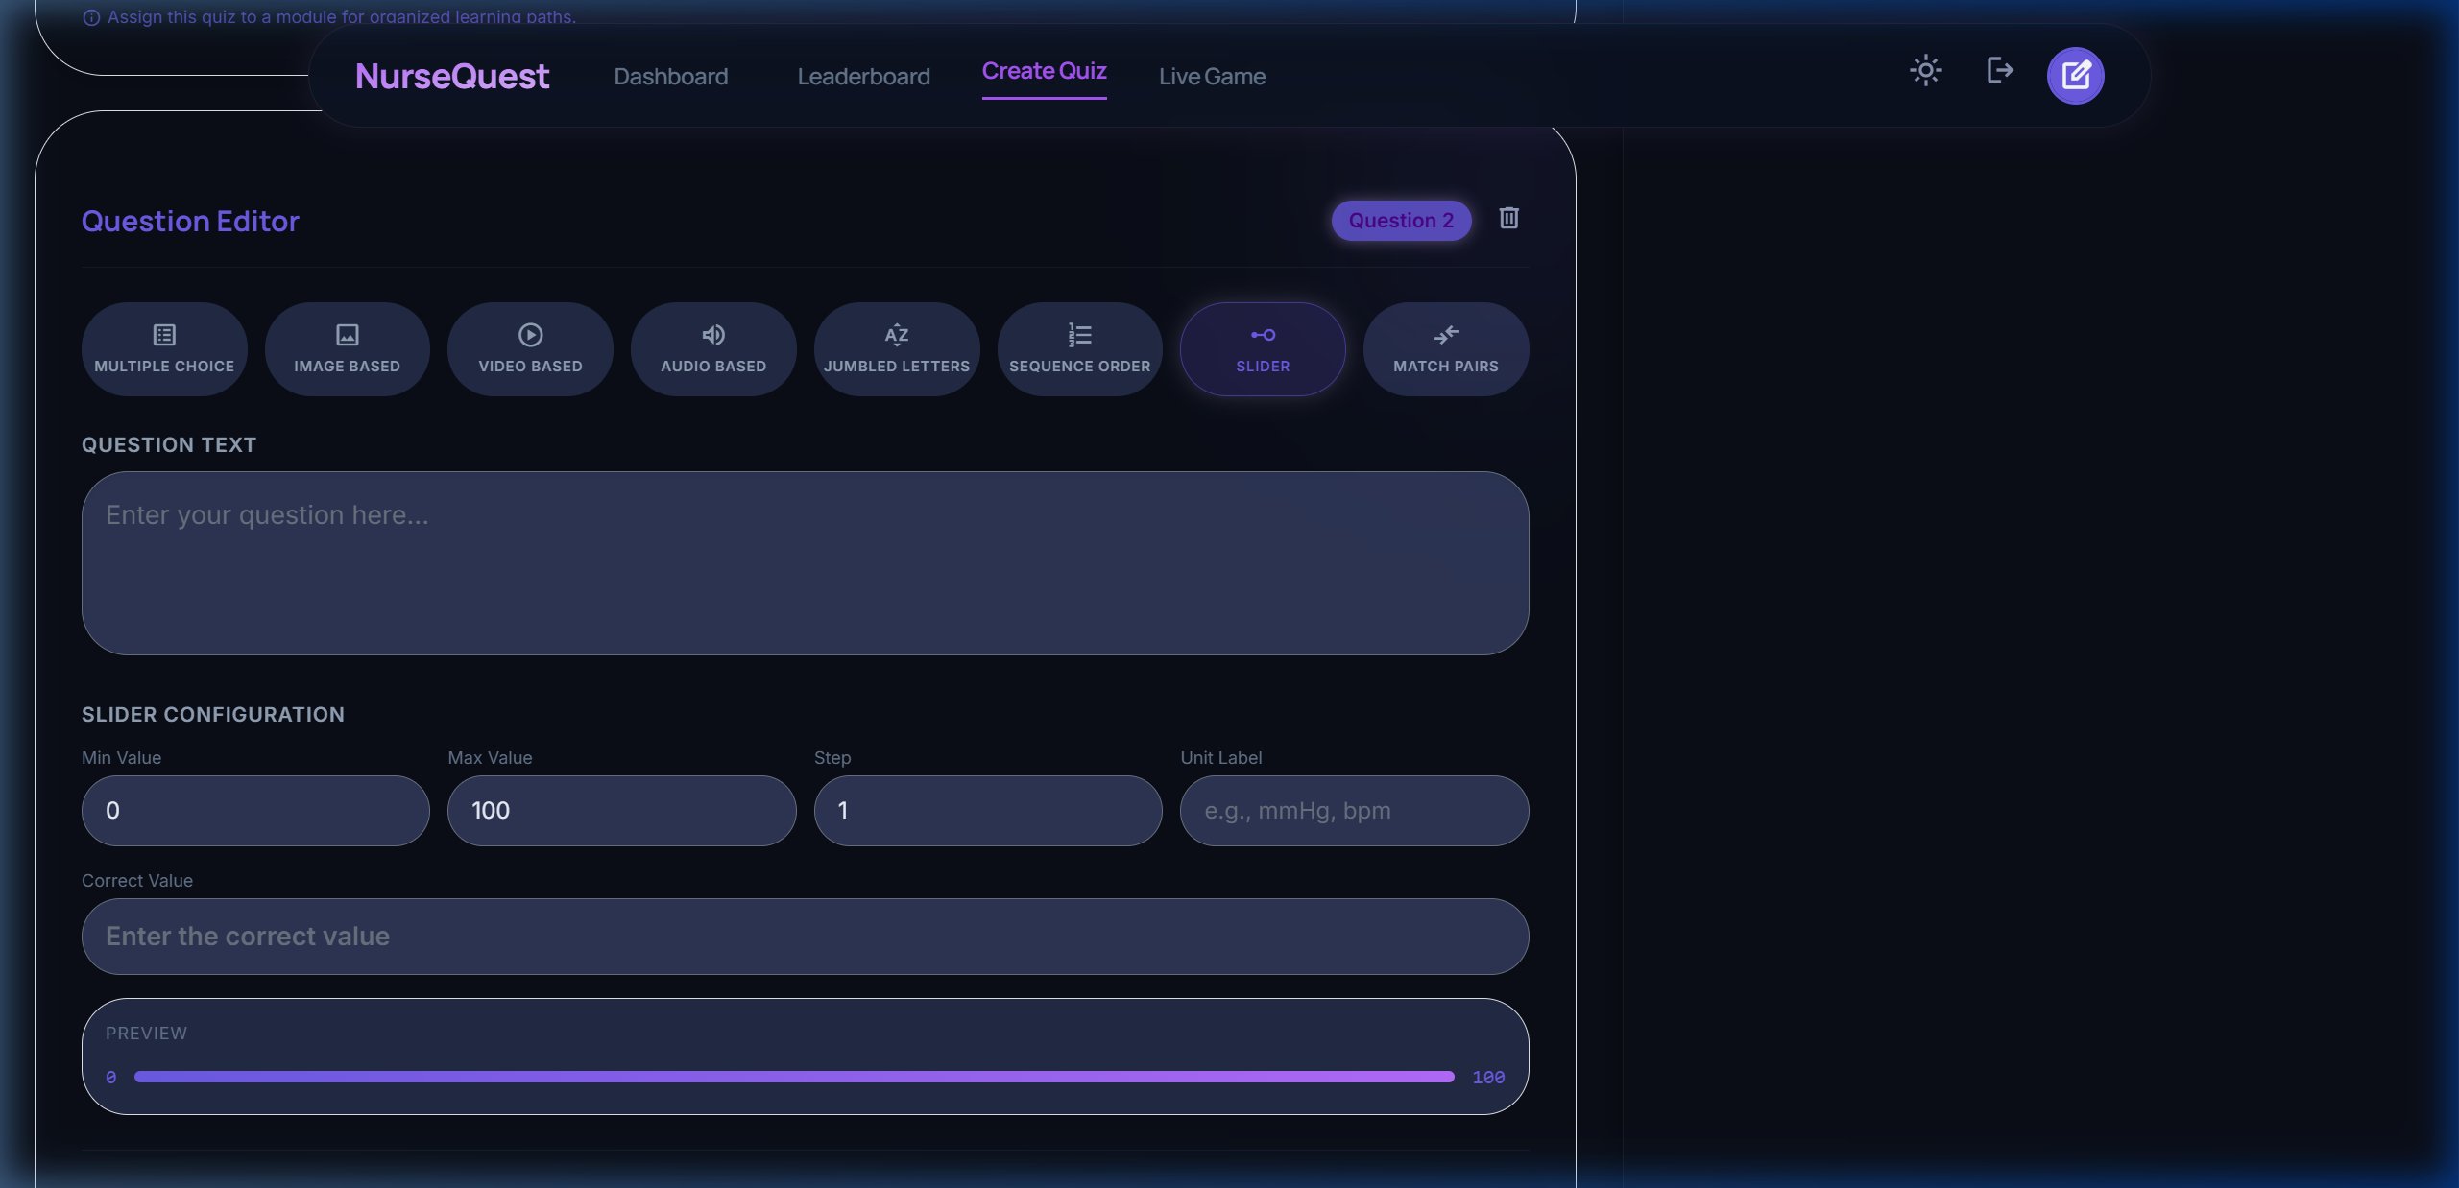
Figure 4: Quiz Builder — Slider Question configuration interface (setting min, max, step, unit, and answer).
Enhancement B: Matching Pairs (Relational Clinical Mapping)
Used to map symptoms to clinical diagnoses, or drugs to side effects. Teachers add list pairs. Students click left-side blocks and right-side blocks to form pairs, rendered with visual connection states. The scoring engine verifies all pairs on submit. Fully supported in both self-paced and live multiplayer.
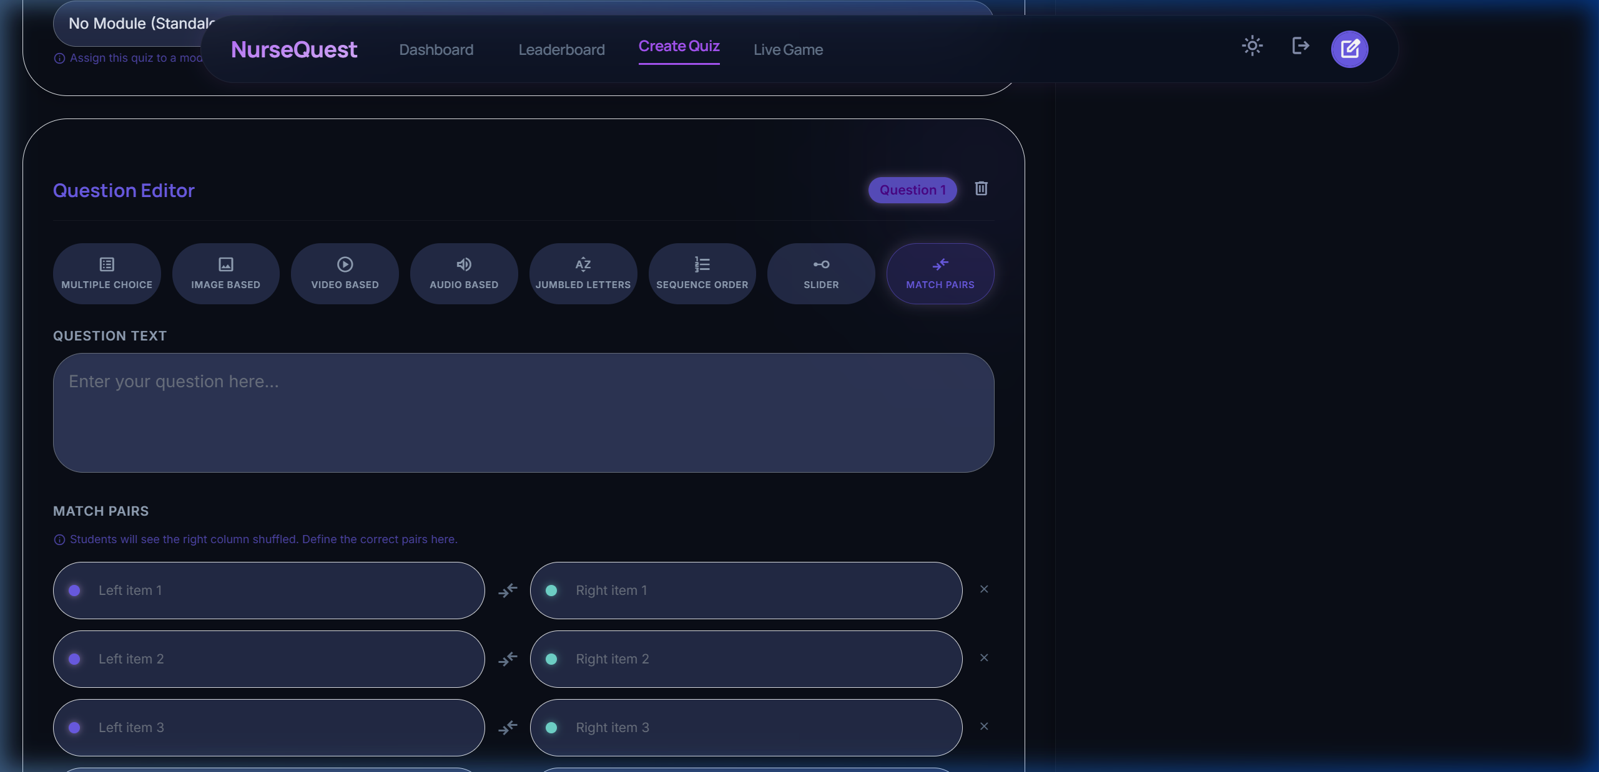
Figure 5: Quiz Builder — Matching Pairs Question creation section.
5. DATABASE SCHEMA UPDATES
To support these features, the SQLite schema was expanded from the original 9 tables to 10 tables, and new columns were appended to existing tables. Below is the updated relational structure.
Table Name | Structure & Foreign Keys | Added Columns / Purpose
Table Name | Structure & Primary Key | Added Columns / Purpose
modules | id (TEXT PK) | title (TEXT), description (TEXT), icon (TEXT), color (TEXT), order_index (INT), created_by (TEXT FK), is_published (INT). Groups quizzes into clinical categories.
quizzes | id (TEXT PK) | Added module_id (TEXT FK to modules). Links quizzes dynamically to modules rather than text categories.
questions | id (TEXT PK) | Added type check: allows 'slider' and 'matching'.  Added: slider_min (REAL), slider_max (REAL), slider_step (REAL), slider_unit (TEXT), matching_pairs (TEXT - JSON).
Migration and Seed Integrations:
- db/migrate_modules.js: A script to auto-generate the `modules` table, alter `quizzes` to add the foreign key, and cluster old loose quizzes into default modules.
- db/migrate_new_types.js: Re-creates the `questions` table schema with the slider-min/max/step/unit/matching-pairs columns and a CHECK constraint allowing 'slider' and 'matching' types.
- db/seed.js: Seeds three modules (Fundamentals, Anatomy & Physiology, Pharmacology) and populates multi-format questions (MCQ, Image, Video, Audio, Jumbles) with achievements and mock leaderboard data.

6. Bug Fixes(Patches) and improvements:
- Now the Multimedia(audio, video, image) questions will work properly and Teachers can choose file from their local directory
- Live quiz session’s timers are fixed
- Theme is introduced
- Login attempts in same computer does not direct you to the same page in another tab. Each time you have to login.
- ‘+’ button in the top right corner is changed into a create quiz button

