🏥
NURSEQUEST
WEB PREVIEW
Gamified Interactive Learning for Nursing Excellence
APRIL 29, 2026
SREC
SRINIVASAN

NURSEQUEST WEBSITE
This is a gamified nursing education platform designed to help nursing students learn clinical concepts through interactive quizzes, real-time multiplayer sessions, and a competitive leaderboard system. The platform supports two roles — Teachers and Students — with role-based dashboards, XP progression, achievements, and avatar customization.
Tech Stack:
- Frontend: React 19, Vite, Tailwind CSS
- Backend: Node.js with Express 5
- Database: SQLite (via better-sqlite3)
- Real-time: Socket.io (WebSocket)
- IDE: VSCode and Antigravity
Flow with Images:
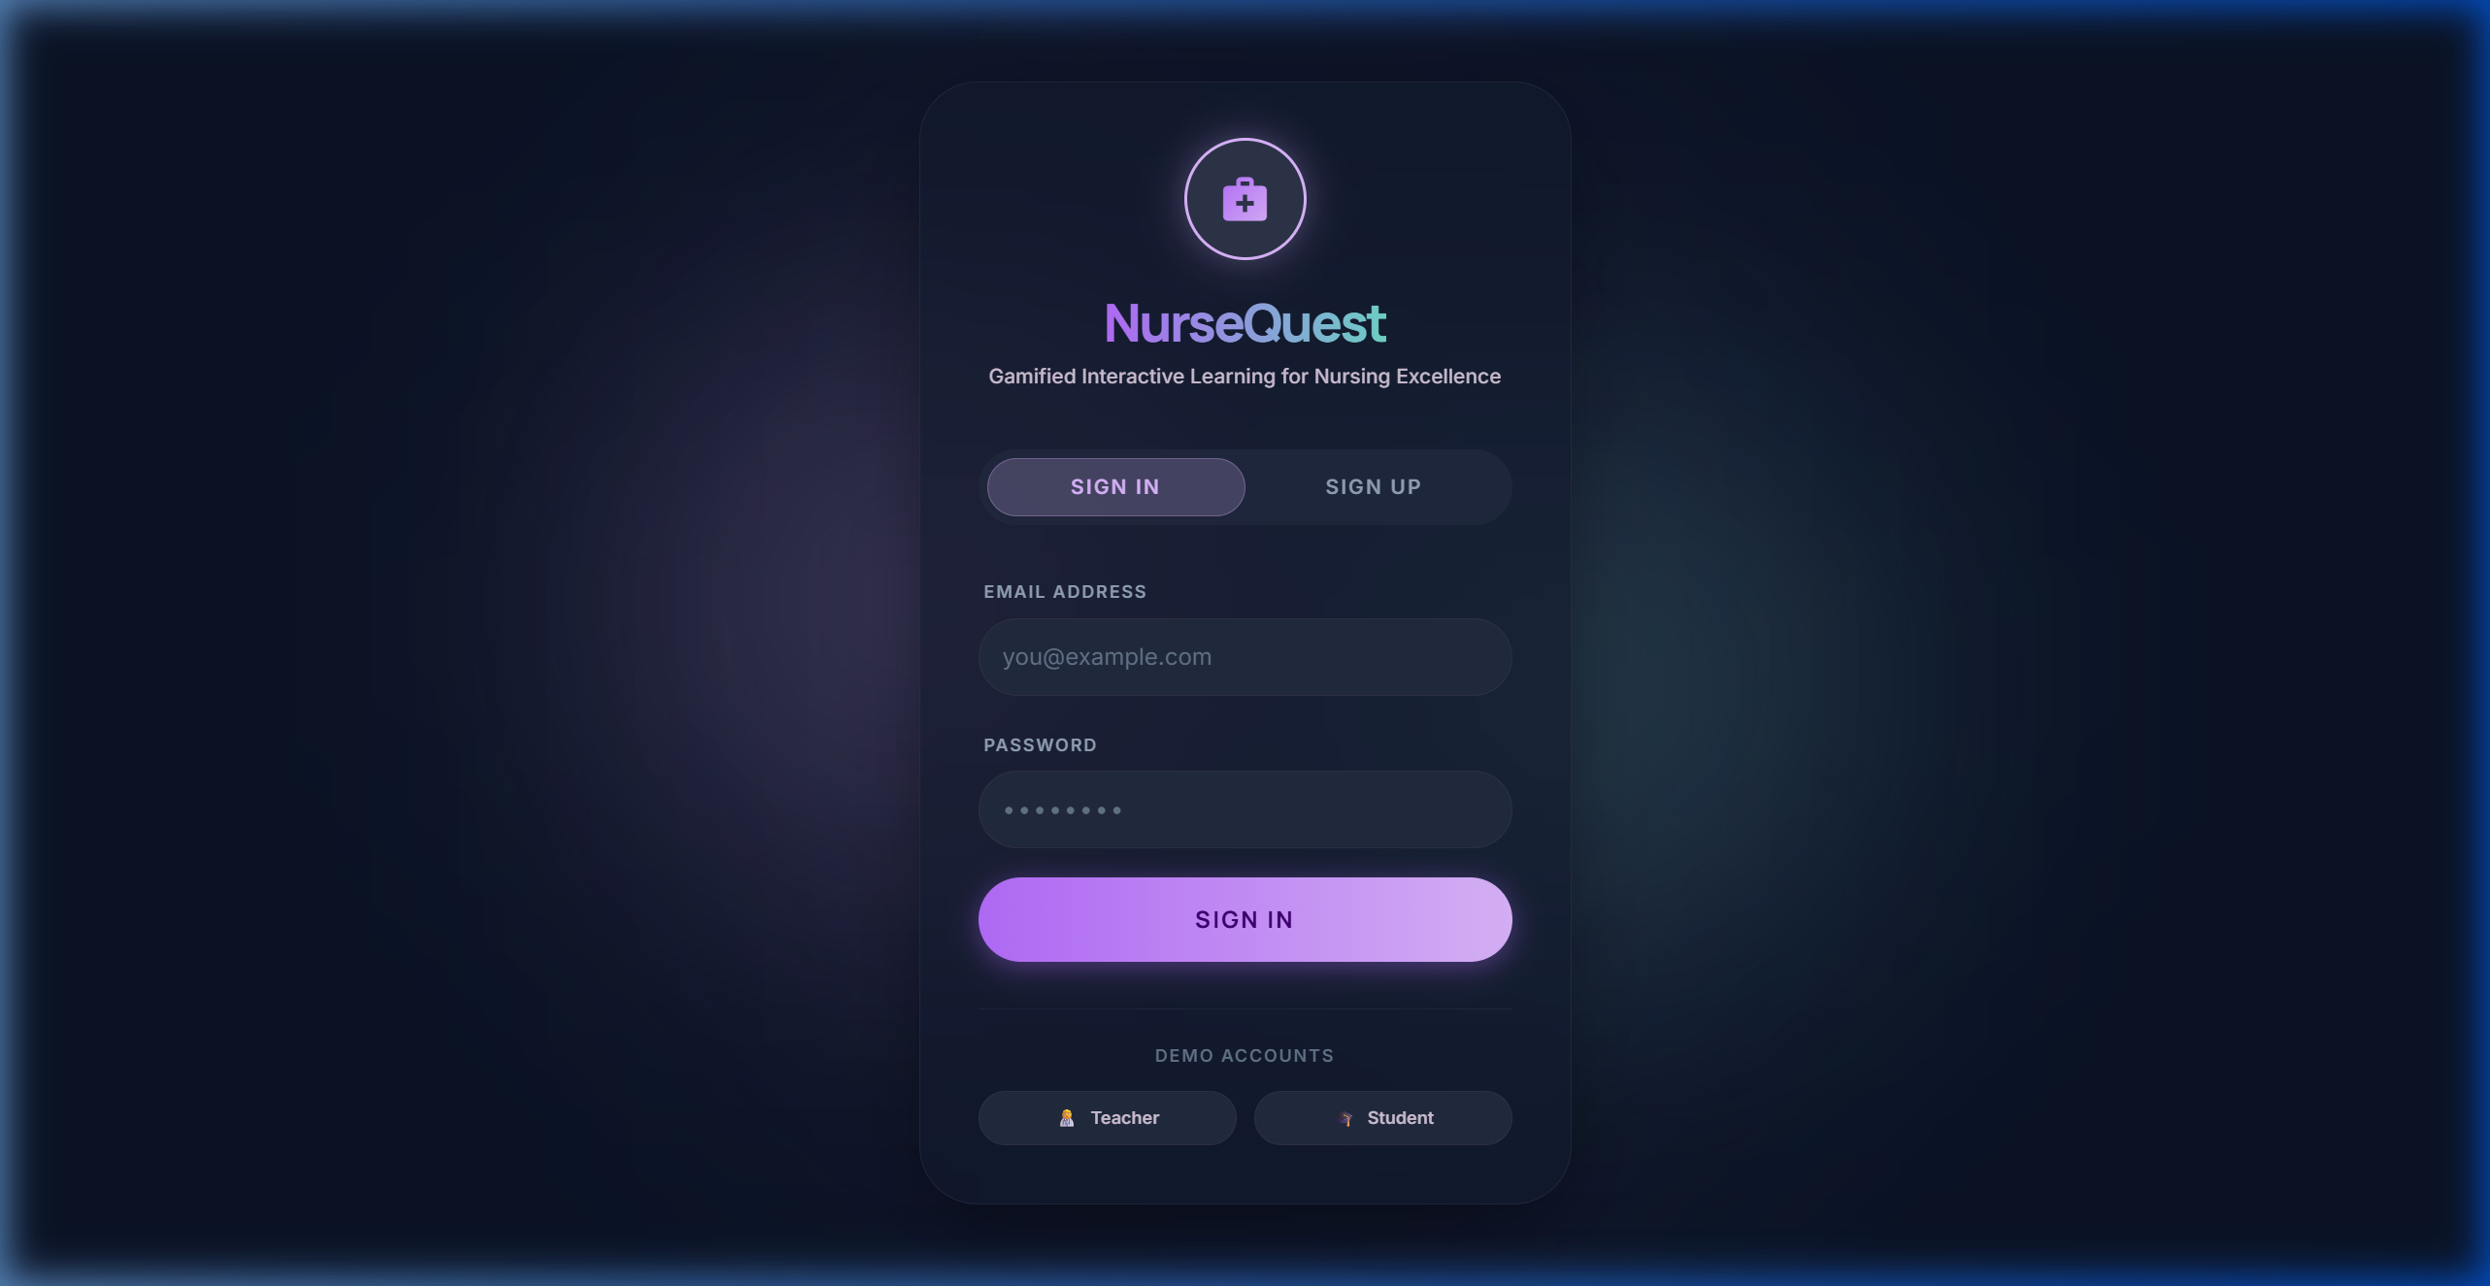
Auth Page — Sign In / Sign Up (/auth)

Application Flow Diagram:
┌─────────────────┐
│ User Opens │
│ NurseQuest │
└────────┬────────┘
│
┌────────▼────────┐
│ Auth Page │
│ /auth │
│ Sign In/Sign Up │
└────────┬────────┘
│
┌────────────┼────────────┐
│ │
┌───────▼───────┐ ┌────────▼────────┐
│ TEACHER │ │ STUDENT │
│ Dashboard │ │ Dashboard │
│ /teacher │ │ /student │
└───────┬───────┘ └────────┬────────┘
│ │
┌──────────┼──────────┐ ┌─────────┼──────────┐
│ │ │ │ │ │
┌────▼───┐ ┌───▼────┐ ┌──▼──┐ ┌──▼──┐ ┌──▼───┐ ┌──▼──┐
│ Create │ │ Host │ │View │ │Quiz │ │Lead- │ │Mini │
│ Quiz │ │ Live │ │Board│ │Play │ │board │ │Game │
│/builder│ │ /live │ │ │ │/quiz│ │/lead │ │/mini│
└────────┘ └────────┘ └─────┘ └─────┘ └──────┘ └─────┘
- Teacher signs in → Teacher Dashboard → Create Quiz / Host Live / View Leaderboard
- Student signs in → (First time: Avatar Setup) → Student Dashboard
- Student Dashboard → Take Quiz / Join Live Game / View Leaderboard / Launch Mini-Game
- Quiz Completed → XP Earned → Level Up → Leaderboard Updated
- Live Game → Teacher hosts → Students join with 6-char code → Real-time sync via Socket.io

Student Dashboard
The Student Dashboard displays personalized stats including Quizzes Taken, Average Score, Best Streak, Total XP, and the current nursing rank. Students can browse available quizzes, launch the IV Stabilization mini-game, and view top student rankings.
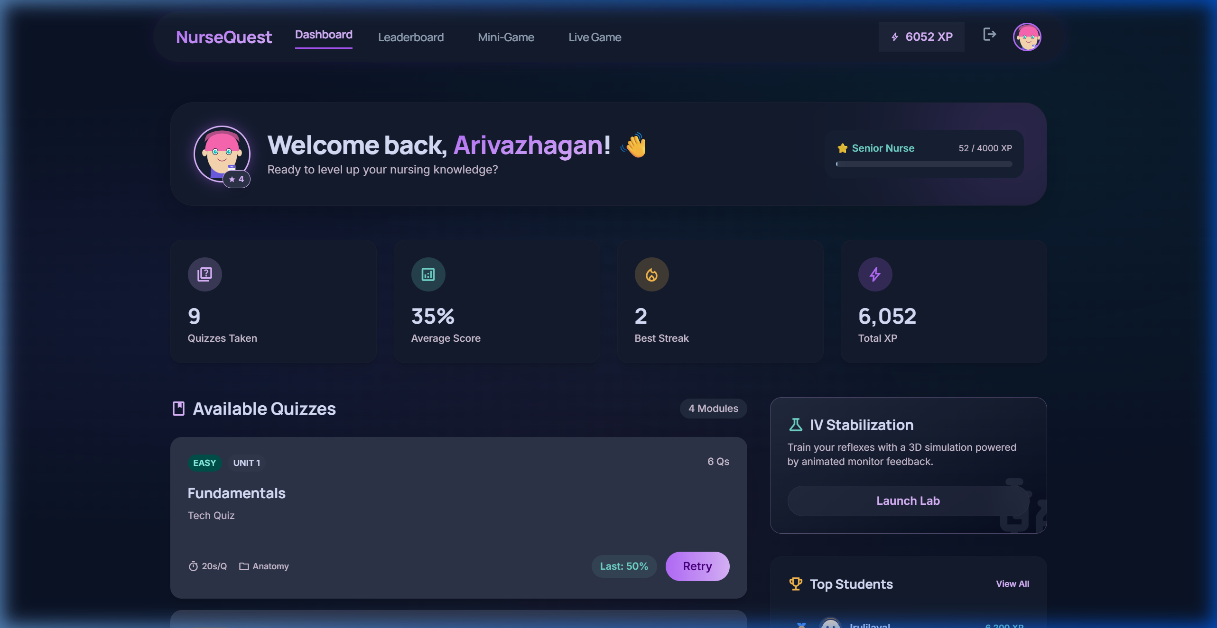
Student Dashboard (/student)

Teacher Dashboard
The Teacher Dashboard provides an overview of Total Students, Quizzes Created, Total Attempts, and Average Score. Teachers can create new quizzes, edit existing ones, publish/unpublish, host live sessions, and view individual student performance metrics.
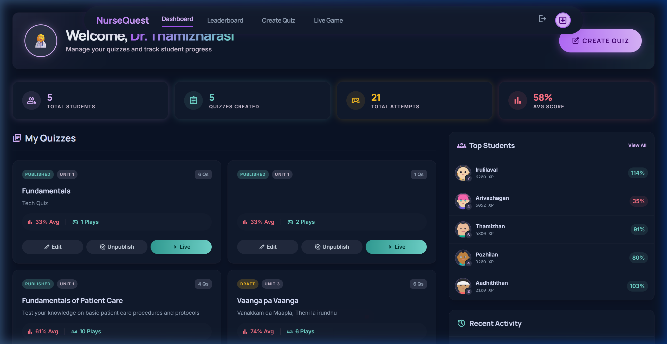
Teacher Dashboard (/teacher)

Quiz Builder
The Quiz Builder allows teachers to create quizzes with 6 question types: Multiple Choice (MCQ), Image-Based, Video-Based, Audio-Based, Jumbled Letters, and Sequence Order. Each question includes configurable time limits, explanations, and point values.
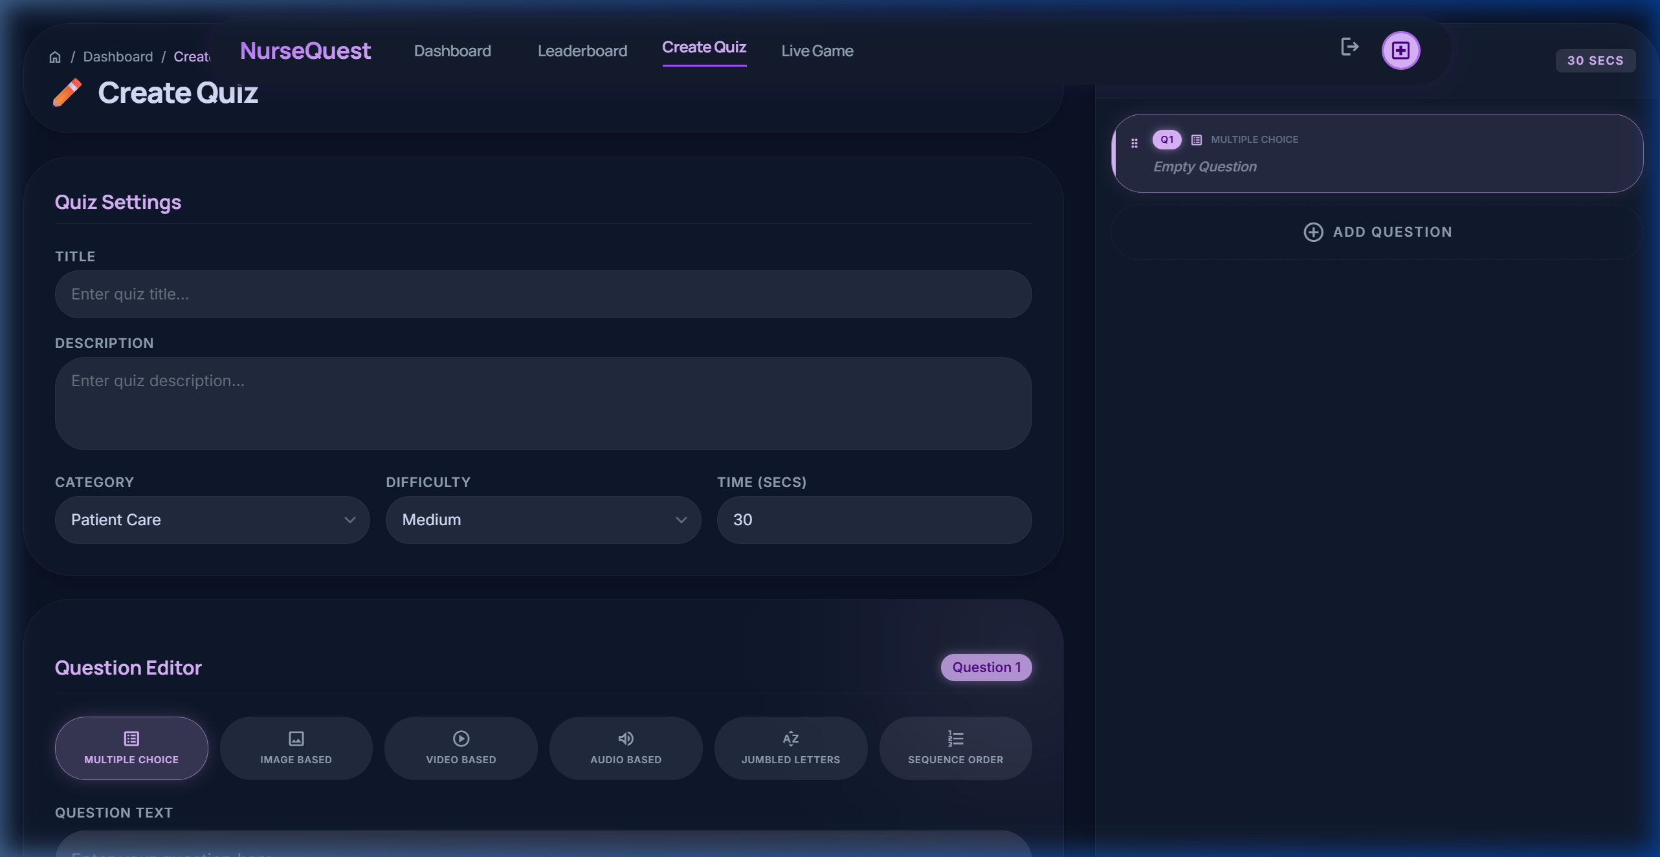
Quiz Builder — Create Quiz (/quiz-builder)

Leaderboard — The Arena
The Arena displays global rankings with a podium for Top 3 students. It shows each student's rank, avatar, level, quizzes taken, average score, and total XP. The sidebar displays the logged-in user's status, their target to overtake, rare achievements, and personal statistics.
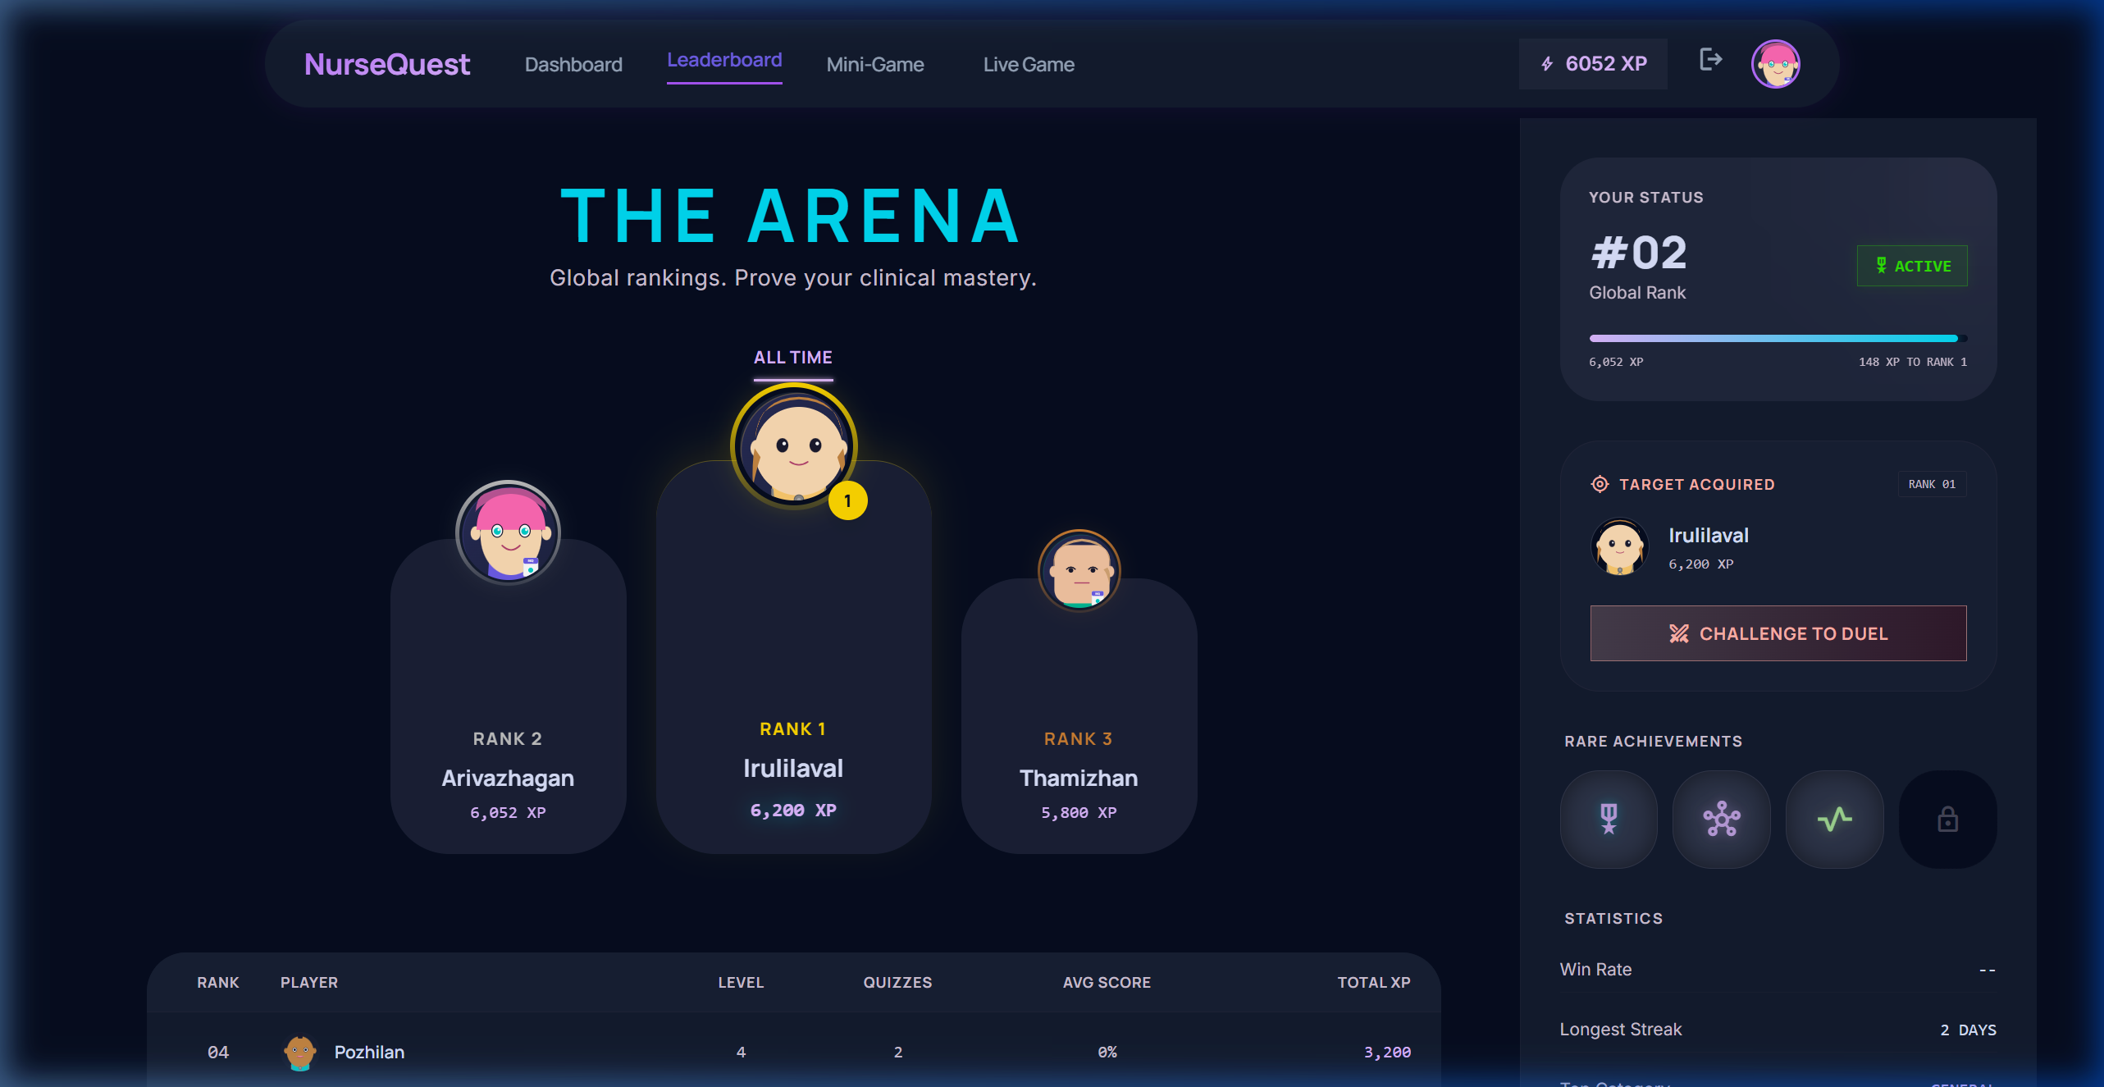
Leaderboard — The Arena (/leaderboard)

Live Game — Real-Time Multiplayer
The Live Game feature enables Kahoot-style real-time multiplayer quiz sessions. Teachers select a quiz and create a session with a 6-character join code. Students join using the code. Questions are synchronized across all participants using Socket.io, with time-based scoring and live leaderboard updates after each question.
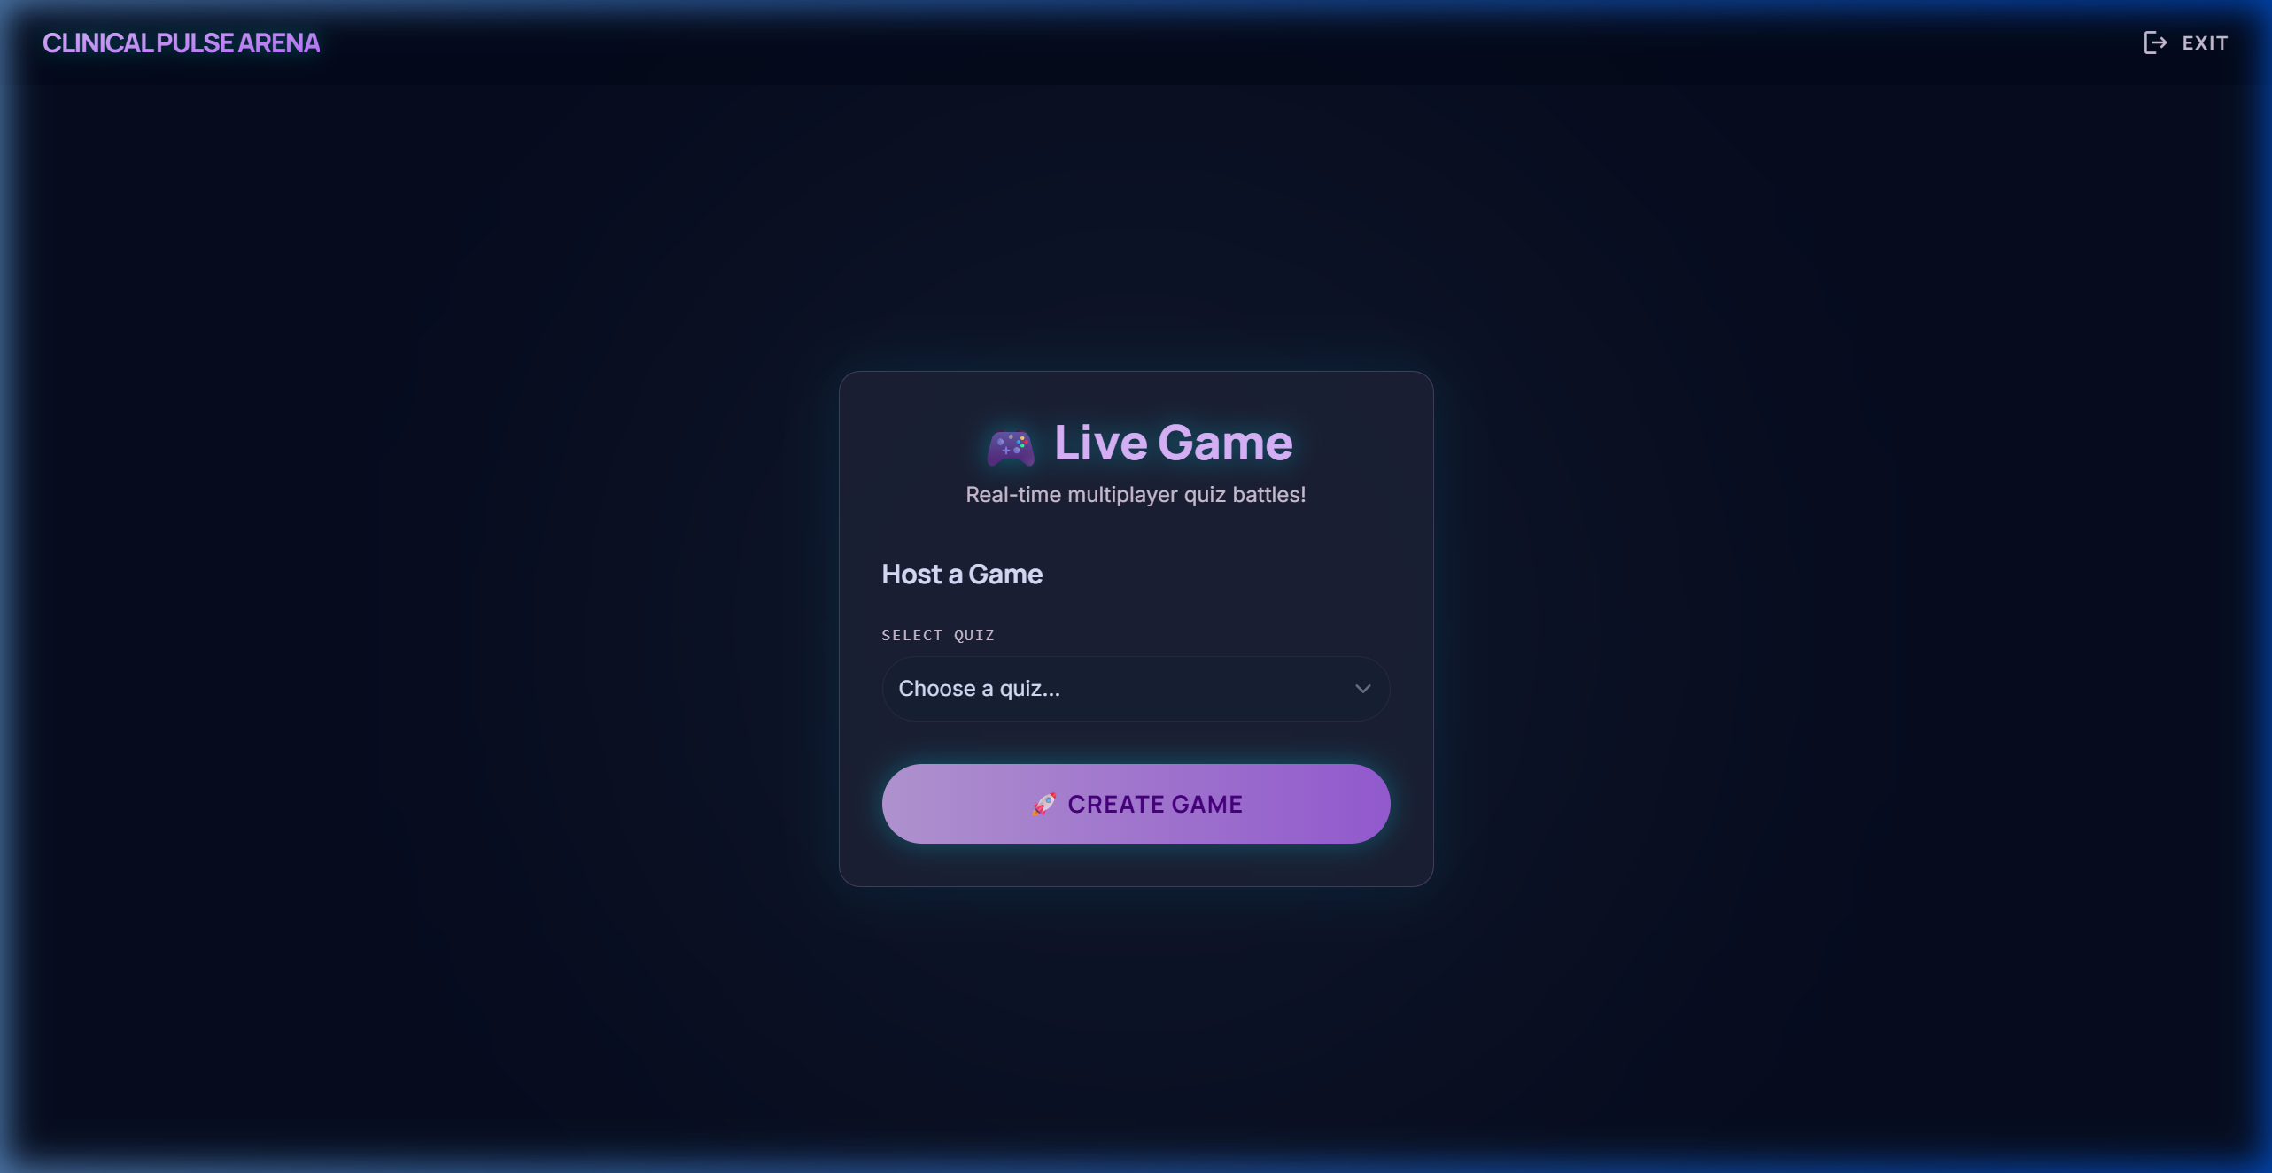
Live Game — Host View (/live)

Database Schema (SQLite)
The application uses SQLite with 9 relational tables. All data is stored locally in a single .db file using the better-sqlite3 driver for synchronous, fast queries.
Table Name | Purpose | Key Columns
users | Student & Teacher accounts | id, email, name, role, xp, level, streak, avatar_config
quizzes | Quiz metadata | id, title, category, difficulty, time_per_question, is_published
questions | Individual questions | id, quiz_id, type, question_text, options, correct_answer
quiz_attempts | Student quiz submissions | id, quiz_id, user_id, score, correct_count, streak_max
question_answers | Per-question answers | id, attempt_id, question_id, is_correct, points_earned
live_sessions | Multiplayer sessions | id, quiz_id, host_id, join_code, status
live_participants | Session players | id, session_id, user_id, score, streak, rank
achievements | Badge definitions | id, name, requirement_type, requirement_value
user_achievements | Earned badges | id, user_id, achievement_id, earned_at

Scoring & XP Engine
Self-Paced Quiz Scoring:
- Base Score: 1000 points (for a correct answer)
- Time Bonus: round(timeRemaining / totalTime × 500) → 0 to 500 pts
- Streak Bonus: min(streak, 5) × 100 → 0 to 500 pts
- Total per question: 1000 to 2000 points max
- Incorrect answer: 0 points, streak resets to 0
Live Game Scoring (Kahoot-Style):
- points = round(maxPoints × (1 − 0.5 × elapsed / totalTime))
- Fastest correct answer gets ~1000 pts, slowest gets ~500 pts
- Incorrect answer always scores 0
XP Calculation:
- Base XP = score × 0.1
- 100% Accuracy → +500 XP bonus
- ≥ 80% Accuracy → +200 XP bonus
- ≥ 60% Accuracy → +100 XP bonus
- Speed Ratio ≥ 0.9 → +150 XP bonus
Level Progression:
Level | Title | Min XP | Icon
Level 1 | Nurse Intern | 0 XP | 🩺
Level 2 | Junior Nurse | 1,000 XP | 💉
Level 3 | Nurse | 3,000 XP | 🏥
Level 4 | Senior Nurse | 6,000 XP | ⭐
Level 5 | Head Nurse | 10,000 XP | 🌟
Level 6 | Nurse Specialist | 15,000 XP | 💎
Level 7 | Chief Nurse | 25,000 XP | 👑

POINTS TO NOTE:
- This platform uses a gamified approach inspired by Kahoot for nursing education. Quizzes support 6 question types including MCQ, Image-Based, Audio, Video, Jumbled Letters, and Sequence Order.
- Real-time multiplayer sessions use Socket.io WebSockets for synchronization. Teacher hosts the game, students join using a 6-character code.
- DB is Relational (i.e.) all information is stored in table structure using SQLite. 9 tables handle users, quizzes, attempts, answers, live sessions, and achievements.
- The scoring engine uses a Kahoot-style time-bonus algorithm. Faster answers earn more points. Streak bonuses reward consecutive correct answers up to 5x.
- XP and Level progression system has 7 nursing ranks from 'Nurse Intern' (0 XP) to 'Chief Nurse' (25,000 XP).
- For further enhancement, AI-powered question generation, video/audio media playback, and cloud deployment can be integrated.

