PROJECT TITLE -FONT SIZE TIMES NEW ROMAN 18 WITH LINE SPACING 1.5

COURSE CODE – COURSE NAME
PROJECT REPORT

Submitted by
NAME OF THE STUDENT – UNIQUE ID

In partial fulfilment for the award of the degree of
BACHELOR OF TECHNOLOGY
in
COMPUTER SCIENCE AND ENGINEERING
(Cyber Security & Internet of Things)
Sri Ramachandra Faculty of Engineering and Technology
Sri Ramachandra Institute of Higher Education and Research, Porur, Chennai -600116

MONTH, YEAR

PROJECT TITLE -FONT SIZE TIMES NEW ROMAN 18 WITH LINE SPACING 1.5

COURSE CODE – COURSE NAME
PROJECT REPORT

Submitted by
NAME OF THE STUDENT – UNIQUE ID

In partial fulfilment for the award of the degree of
BACHELOR OF TECHNOLOGY
in
COMPUTER SCIENCE AND ENGINEERING
(Cyber Security & Internet of Things)
Sri Ramachandra Faculty of Engineering and Technology
Sri Ramachandra Institute of Higher Education and Research, Porur, Chennai -600116

MONTH, YEAR

BONAFIDE CERTIFICATE

Certified that this project report “TITLE OF THE PROJECT” is the bonafide record of work done by “NAME OF THE STUDENT – UNIQUE ID” who carried out the internship work under my supervision.

Signature of the Supervisor Signature of Programme Coordinator

Name of Supervisor  Assistant Professor,  Department of Cyber Security and Internet of Things  Sri Ramachandra Faculty of Engineering and Technology,  SRIHER, Porur, Chennai-600 116. | Dr. Jayanthi G  Associate Professor and Program Coordinator  Department of Cybersecurity and Internet of things  Sri Ramachandra Faculty of Engineering and Technology,  SRIHER, Porur, Chennai-600 116.
Evaluation Date:

INTERNAL EXAMINER EXTERNAL EXAMINER

Plagiarism Report
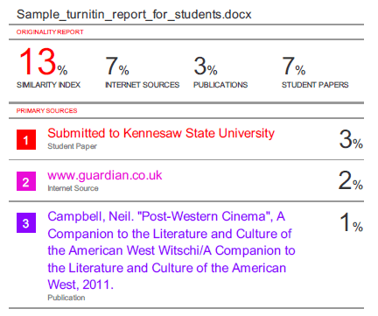
Signature of the Internship Coordinator Signature of the Supervisor

ACKNOWLEDGEMENT
I take this opportunity to express my gratitude to Prof. T. Ragunathan, Dean, Prof. A.Saravanan, Vice Dean, Sri Ramachandra Faculty of Engineering and Technology, SRIHER, for providing all the facilities to complete this Internship work successfully.
I express my sincere gratitude to Dr. G. Jayanthi, Programme Coordinator, Department of Cybersecurity & Internet of Things, SRET, for their support and for providing the required facilities for carrying out this study.
I wish to thank my faculty supervisor(s), NAME OF THE SUPERVISOR, Department of Cybersecurity and Internet of Things, SRET and INDUSTRY MENTOR, DESIGNATION -IF APPLICABLE, for extending help and encouragement throughout the project. Without his/her continuous guidance and persistent help, this project would not have been a success for me.
I am grateful to all the members of the Sri Ramachandra Faculty of Engineering and Technology, my beloved parents and my friends for extending their support, which helped us to overcome obstacles in the study.
TABLE OF CONTENTS

CHAPTER NO. | TITLE | PAGE NO.
 | ABSTRACT | v
 | LIST OF TABLES | vi
 | LIST OF FIGURES | vii
 | LIST OF SYMBOLS | viii
1 | INTRODUCTION | 1
 | - Subheading | 1
 | 1.2 Subheading | 2
 | 1.2.1 Subheading under 1.2 | 3
2 | LITERATURE REVIEW | 5
3 | PROPOSED METHODOLOGY | 13
4 | IMPLEMENTATION | 30
5 | RESULTS AND DISCUSSIONS | 45
6 | CONCLUSION AND FUTURE WORK | 50
 | APPENDICIES | 55
 | Appendix-1: Code – Technical detail | 55
 | Appendix-2: Screenshots | 60
 | REFERENCES | 63
 | WORKLOG | 68
 | CERTIFICATE OF COMPLETION | 75

