ROS Task Documentation – Exercises
- Swaminathan S K (AGV Software Team)

Exercise 2:
http://wiki.ros.org/ROS/Tutorials/WritingPublisherSubscriber%28c%2B%2B%29
https://www.youtube.com/watch?v=v9RgXcosuww

- Created a new workspace called smb_ex_2
- downloaded the zip folder for smb_high_level_controller
- changed the SmbHighlevelController.cpp to include a subscriber.
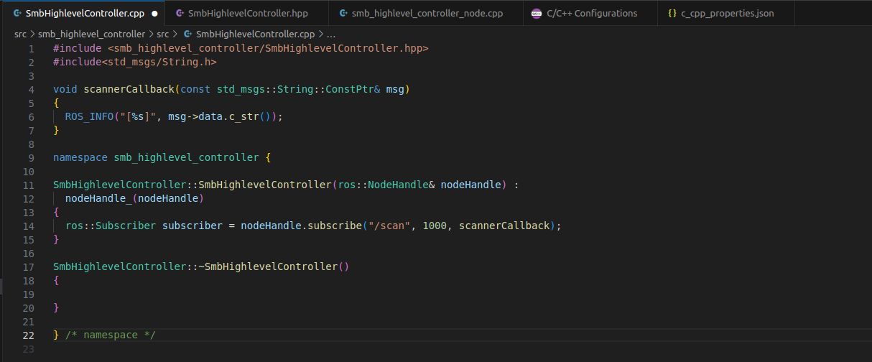
Errors and Fixes:
There was an error with the subscribe function whenever the callback function didnt take any arguments. Keeping the argument of callback function as msg fixed this issue.

As per the given exercise, sensor_msgs/LaserScan.h was supposed to be imported, since the message that the subscriber receives is of that form. To go through the values that the message offers, this link was referred.

http://docs.ros.org/en/api/sensor_msgs/html/msg/LaserScan.html

Thus the modified object oriented code is given below:

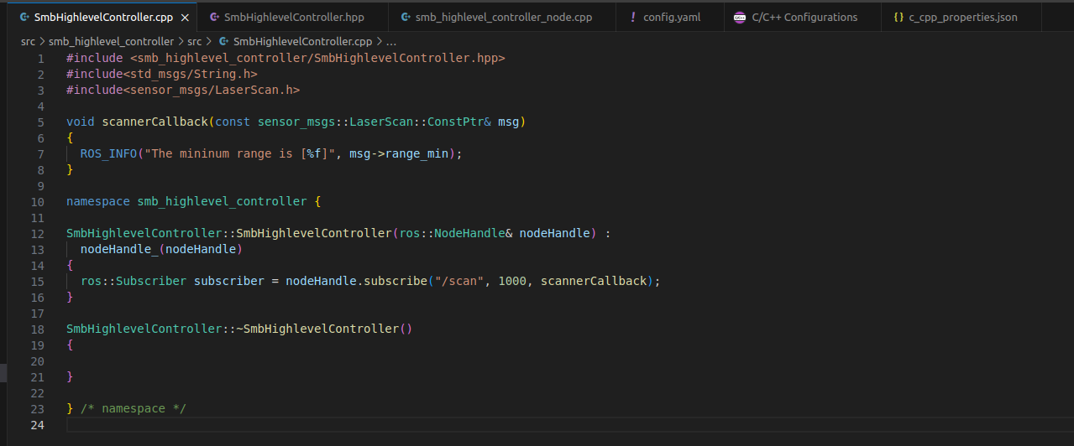
This is the changed Launch File:
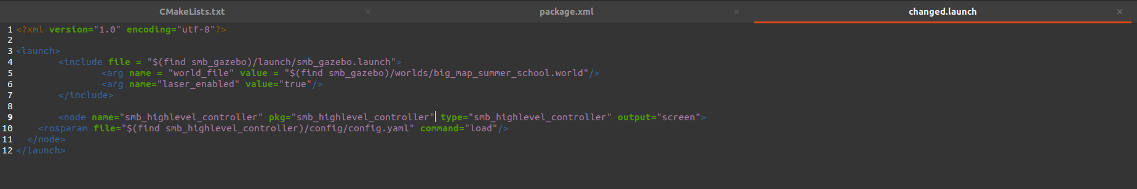
Upon running the launch file, these rostopics including the /scan were found:
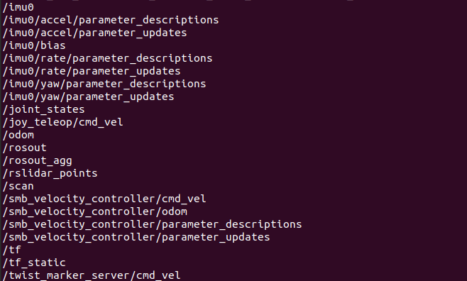
(This is not exhaustive, there were more topics displayed.)

Errors and Fixes:
While using rViz, an error was encountered. To fix it, the Fixed Frame option had to be set to odom.
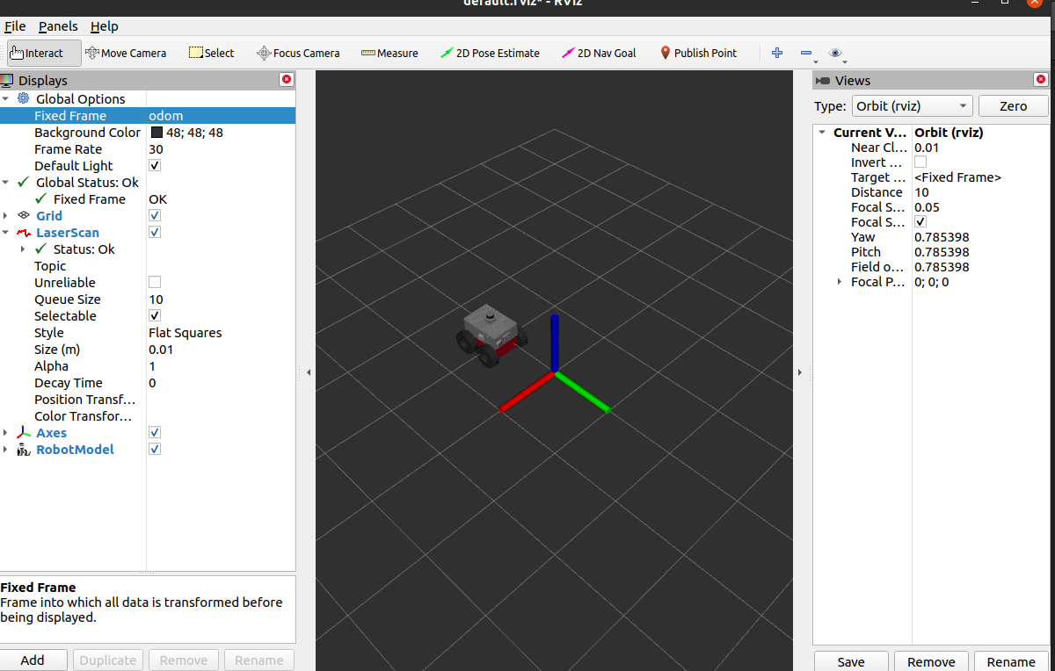
To show the bot, RobotModel had to be added. The LaserScan topic was also added.

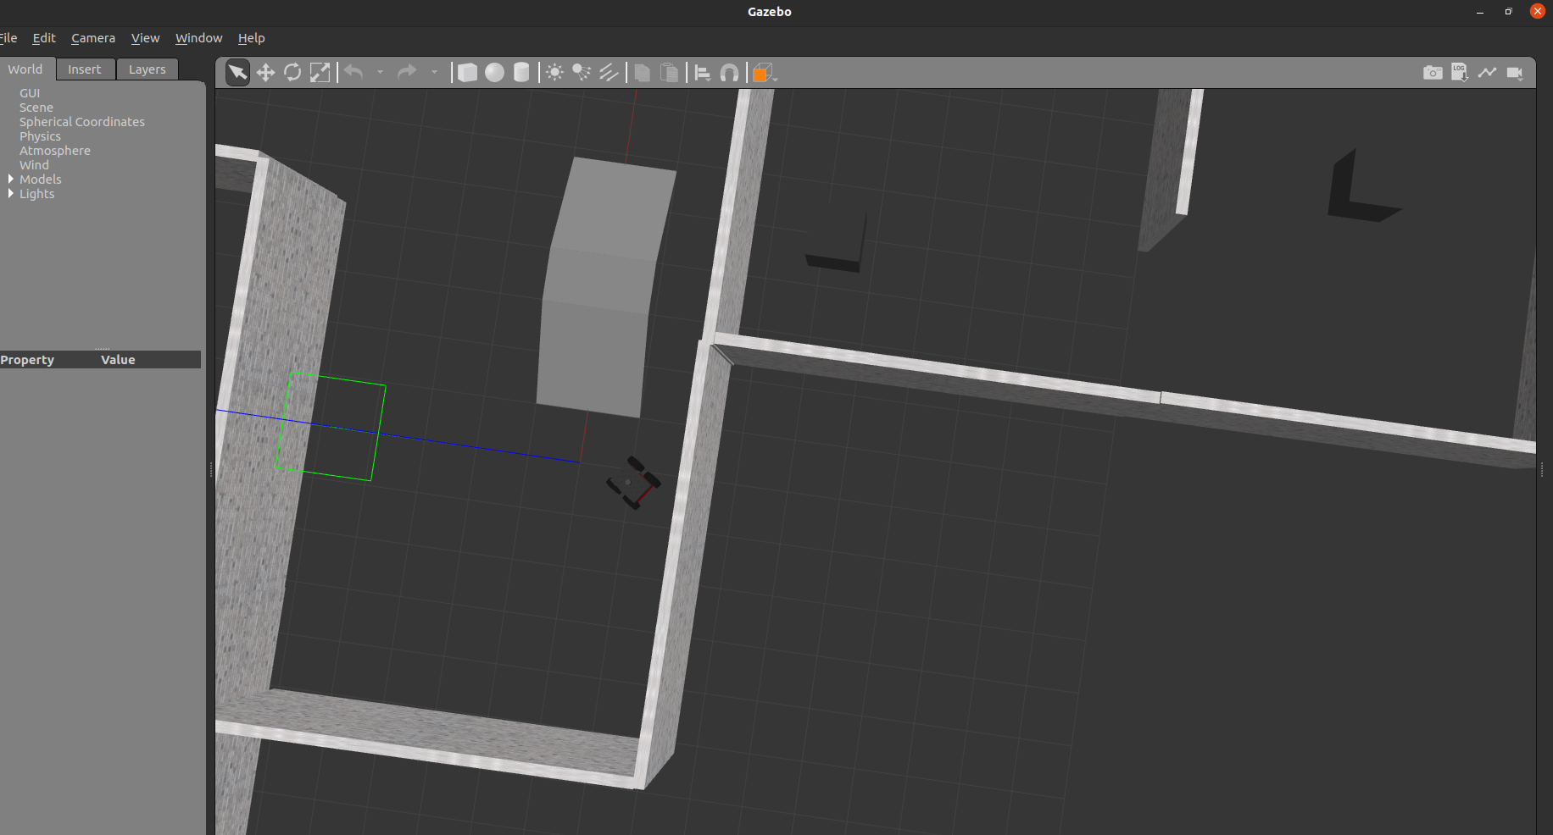
Errors and Fixes:
Failed to write to default.rviz. This is because we don’t have permission to write to the opt/ros/noetic folder. Hence, to fix this, fault the default.rviz file in the current workspace folder.
Now to run the newly saved rviz file:
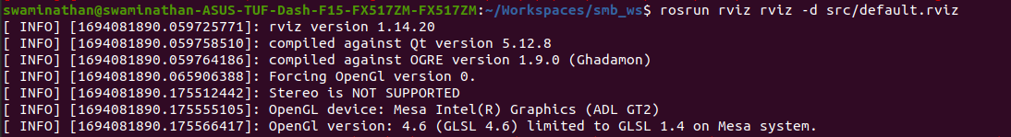
The laser_scan points were not showing. To fix this, whenever laser_scan was included in rviz, we have to set its topic to /scan.
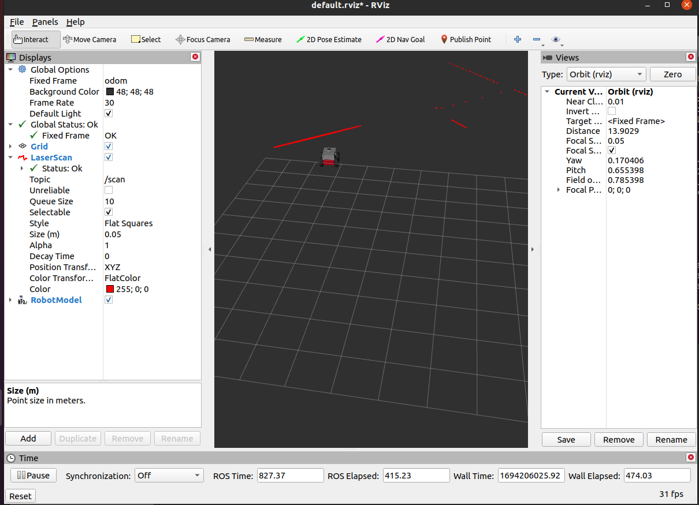
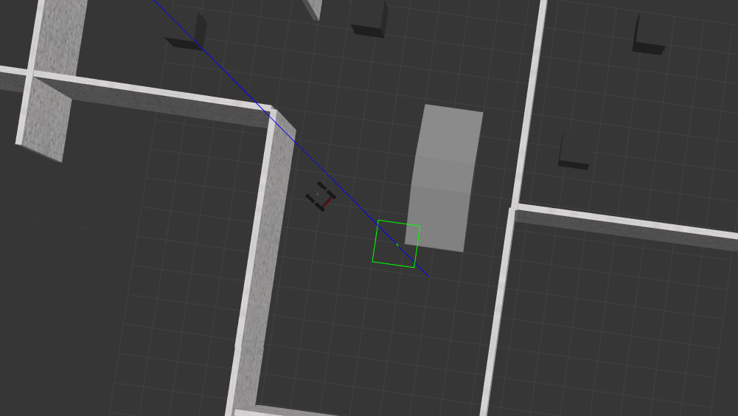
The above image is the gazebo simulator.

Point Cloud Node:
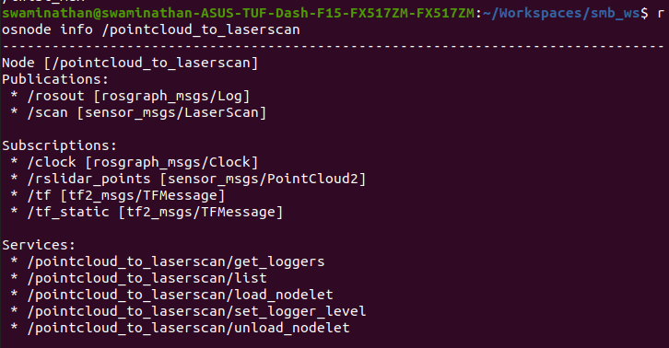
Add Point_cloud2 to rviz and set the topic to /rslidar.
