ROS Documentation Task – 1
Sources:
http://wiki.ros.org/rospy_tutorials/Tutorials/WritingPublisherSubscriber
http://wiki.ros.org/ROS/Tutorials/CreatingPackage

- Created a workspace named task_ws
- cd to the {workspace}/src and created a package called stringtask using catkin_create_pkg command with dependencies std_msges rospy.
- updated the Cmake file accordingly.
- added the talker.py and listener.py as executables
- Results:
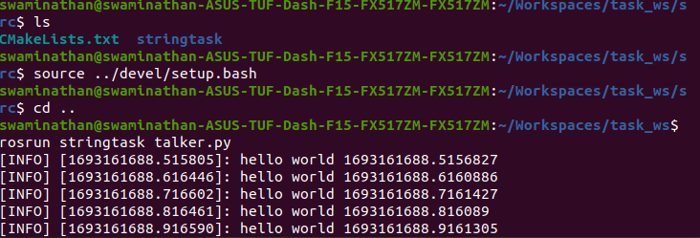
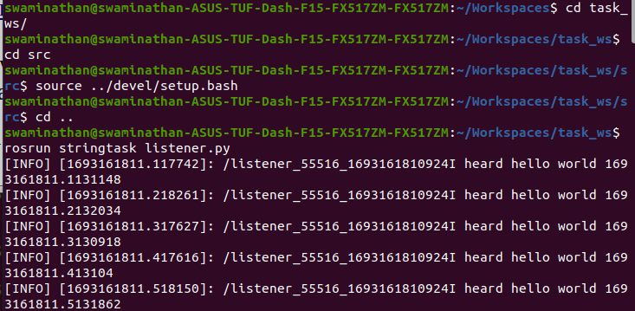
Errors and Fixes:
None

