ROS Task Documentation
- Swaminathan S K (AGV Software Team)

Resources:
http://wiki.ros.org/ROS/Tutorials/InstallingandConfiguringROSEnvironment
http://wiki.ros.org/ROS/Tutorials/NavigatingTheFilesystem

Filesystem Tools:

rospack:

$ rospack find [package_name]

Example:
$ rospack find roscpp
- Code is spread across many ROS packages. Navigating with command-line tools such as ls and cd can be very tedious which is why ROS provides tools to help you.

roscd:

$ roscd <package-or-stack>[/subdir]

Example:
$ roscd roscpp
- roscd is part of the rosbash suite. It allows you to change directory (cd) directly to a package or a stack.
Note that roscd, like other ROS tools, will only find ROS packages that are within the directories listed in your ROS_PACKAGE_PATH. To see what is in your ROS_PACKAGE_PATH, type:

$ echo $ROS_PACKAGE_PATH

rosls:
$ rosls <package-or-stack>[/subdir]

Example:
$ rosls roscpp_tutorials

- rosls is part of the rosbash suite. It allows you to ls directly in a package by name rather than by absolute path.
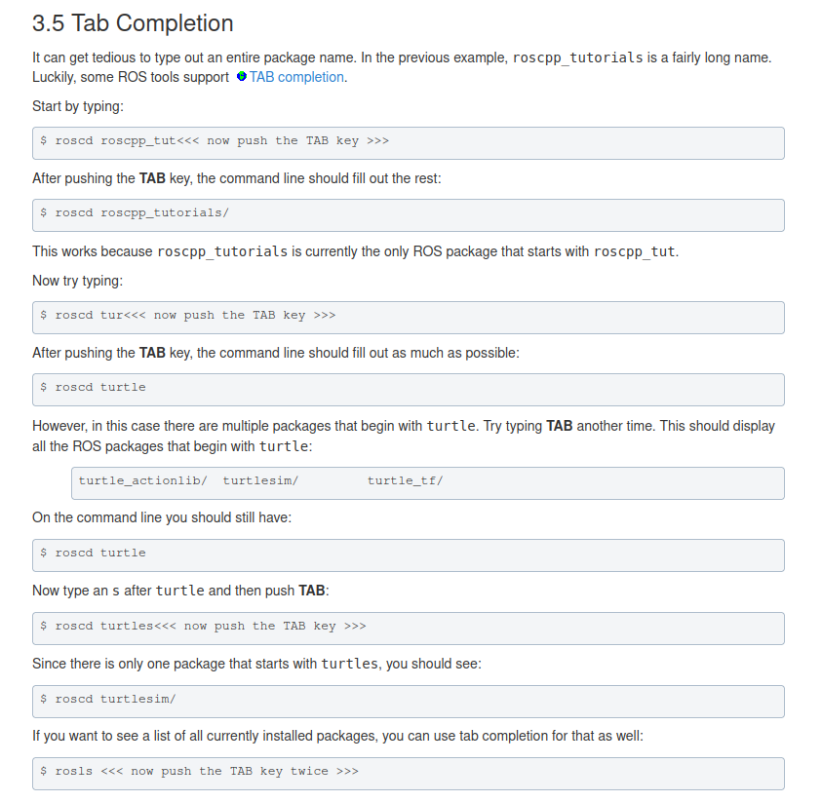

Creating a ROS package:

http://wiki.ros.org/ROS/Tutorials/CreatingPackage

For a package to be considered a catkin package it must meet a few requirements:
- The package must contain a catkin compliant package.xml file.
- That package.xml file provides meta information about the package.
- The package must contain a CMakeLists.txt which uses catkin. If it is a catkin metapackage it must have the relevant boilerplate CMakeLists.txt file.
- Each package must have its own folder. This means no nested packages nor multiple packages sharing the same directory.

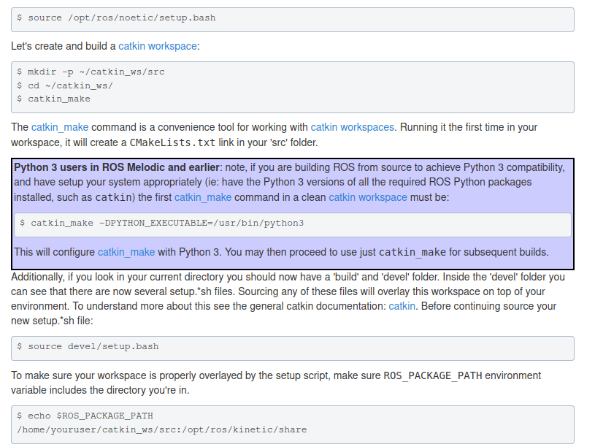
First change to the source space directory of the catkin workspace you created in the Creating a Workspace for catkin tutorial:

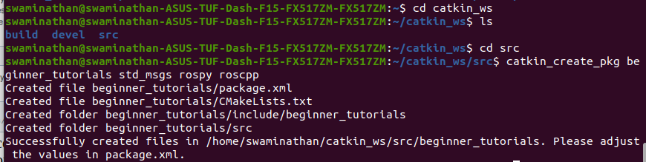
Now use the catkin_create_pkg script to create a new package called 'beginner_tutorials' which depends on std_msgs, roscpp, and rospy:

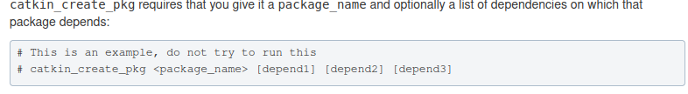
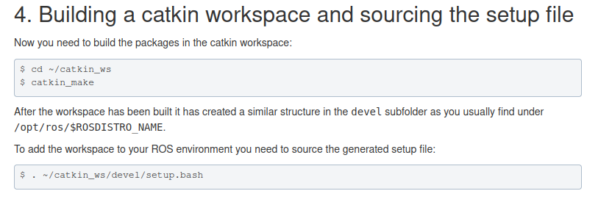
First Order Dependencies:

We provided a few dependencies earlier. These can be checked for by using rospack depends1 {package-name}
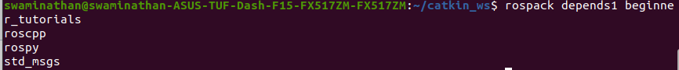
Note: in the package.xml file, we have the dependencies tags:
dependencies tags

The next set of tags describe the dependencies of your package. The dependencies are split into build_depend, buildtool_depend, exec_depend, test_depend. Since we passed std_msgs, roscpp, and rospy as arguments to catkin_create_pkg, the dependencies will look like this:
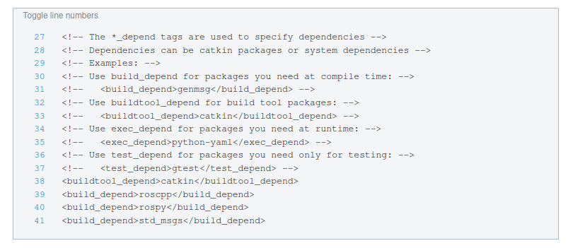
Building Packages:
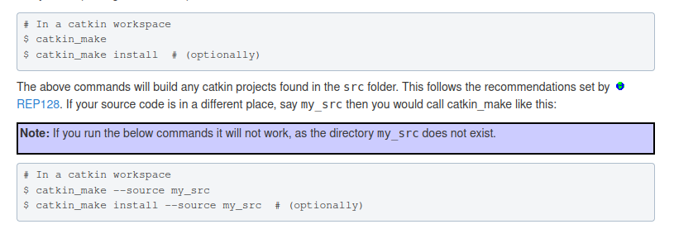

ROS Nodes:
http://wiki.ros.org/ROS/Tutorials/UnderstandingNodes
https://www.youtube.com/watch?v=aL7zLnaEdAg

Some terms and definitions:
- Nodes: A node is an executable that uses ROS to communicate with other nodes.
- Messages: ROS data type used when subscribing or publishing to a topic.
- Topics: Nodes can publish messages to a topic as well as subscribe to a topic to receive messages.
- Master: Name service for ROS (i.e. helps nodes find each other)
- rosout: ROS equivalent of stdout/stderr
- roscore: Master + rosout + parameter server (parameter server will be introduced later)

roscore -> creates the master and a node called /rosout. After initializing open a new terminal and type:
$ rosnode list

This will list the present nodes. Running a process or a node:
$ rosrun turtlesim turtlesim_node

This opens a new window to display the turtlesim (which is again a node). Now, typing rosnode list in the terminal would give two nodes. We can close the process or the node by closing the window or using Ctrl + C in terminal.
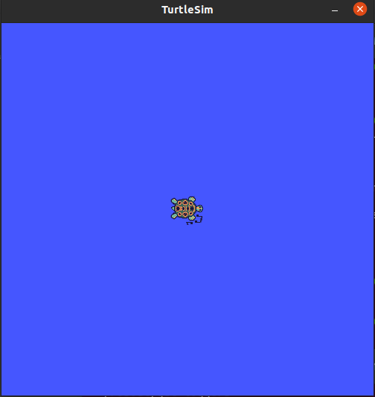

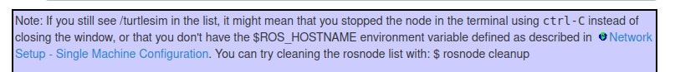

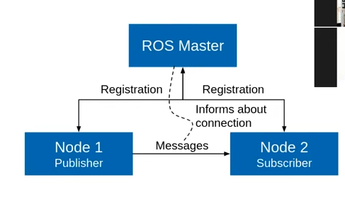
Some more details:

Nodes communicate over topics. Nodes can be a subscriber or publisher. Topic is a name for a stream of messages.

Understanding ROS Topics:
http://wiki.ros.org/ROS/Tutorials/UnderstandingTopics

Run in Separate Terminals:

$ rosrun turtlesim turtlesim_node
$ rosrun turtlesim turtle_teleop_key

These are both different nodes
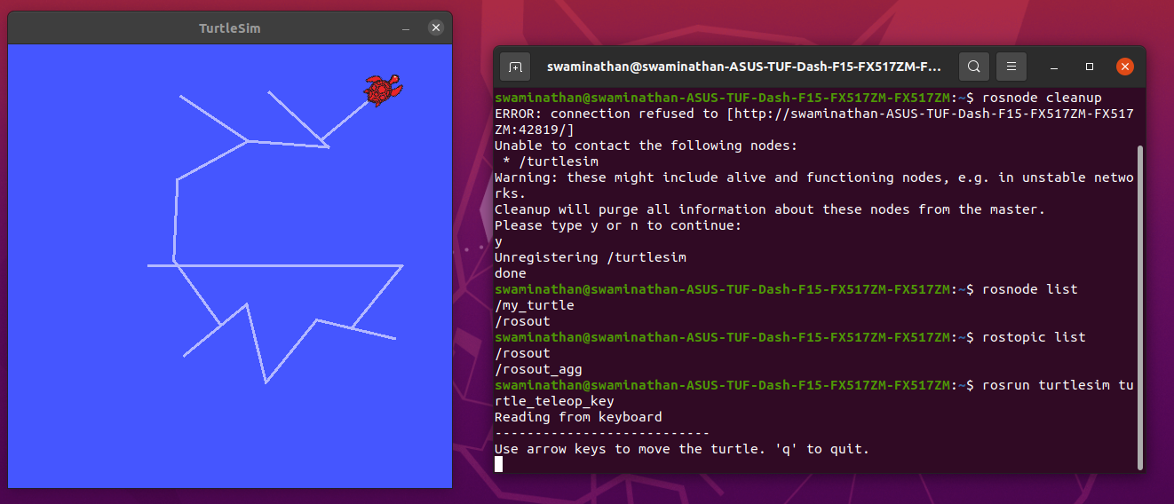
The turtlesim_node and the turtle_teleop_key node are communicating with each other over a ROS Topic. turtle_teleop_key is publishing the key strokes on a topic, while turtlesim subscribes to the same topic to receive the key strokes.

Visualizing using rqt_graph:

$ rosrun rqt_graph rqt_graph
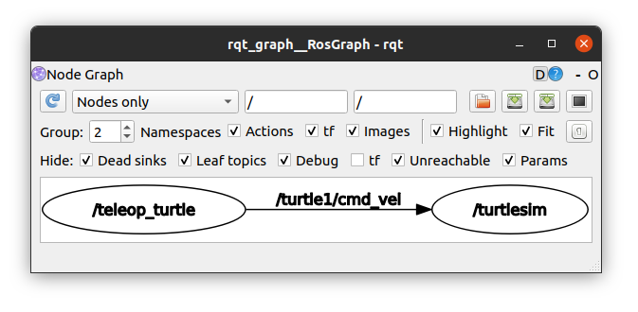
The turtlesim_node and the turtle_teleop_key nodes are communicating on the topic named /turtle1/command_velocity.

rostopic:
The rostopic tool allows you to get information about ROS topics.

rostopic echo shows the data published on a topic.
$ rostopic echo /turtle1/cmd_vel

We wont see anything unless the keys are recorded or any messages are published.

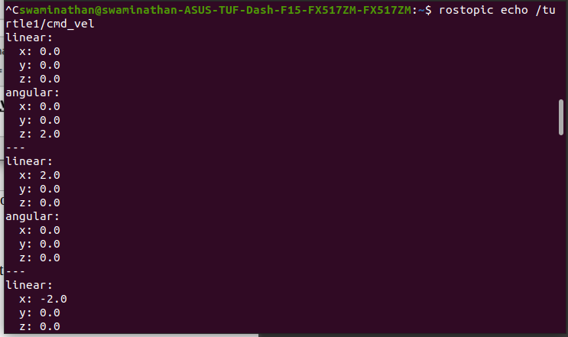
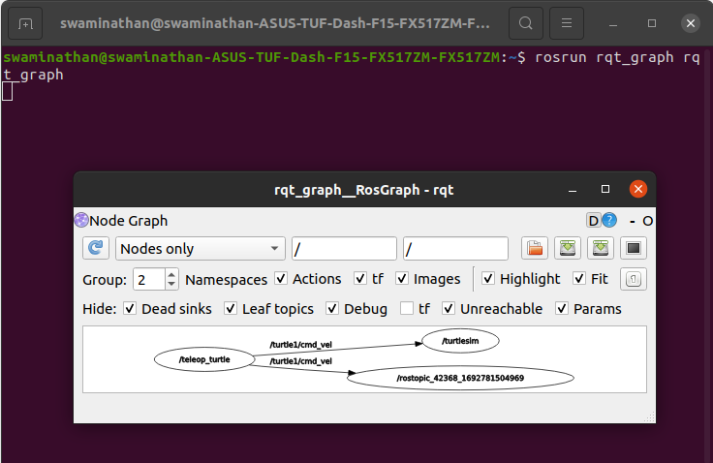
Here the rostopic echo node can also be seen. (Conclusion that rostopic echo also creates a new node).
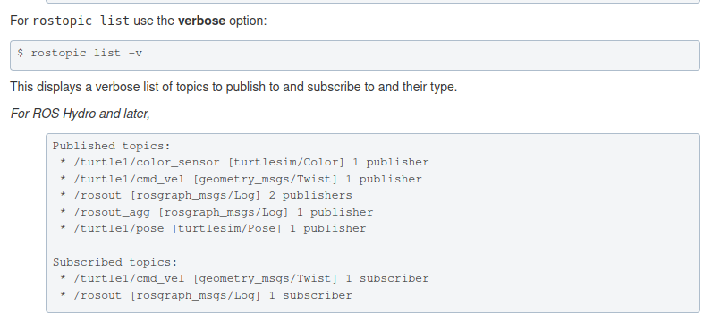
Communication on topics happens by sending ROS messages between nodes. For the publisher (turtle_teleop_key) and subscriber (turtlesim_node) to communicate, the publisher and subscriber must send and receive the same type of message. This means that a topic type is defined by the message type published on it. The type of the message sent on a topic can be determined using rostopic type.
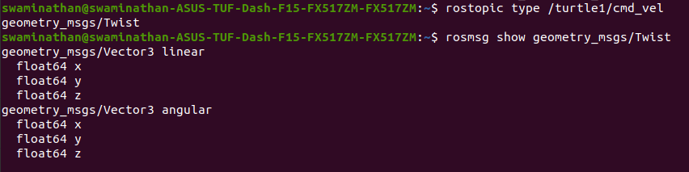
Publishing to a Topic
rostopic pub publishes data on to a topic currently advertised.
$ rostopic pub [topic] [msg_type] [args]

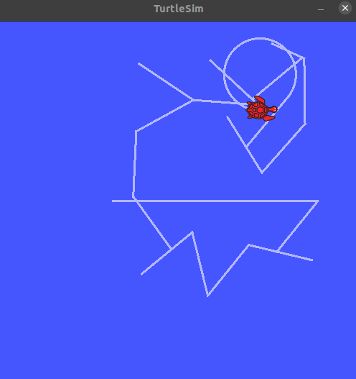

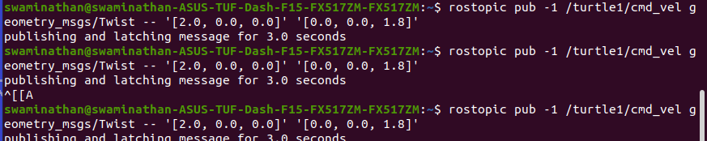
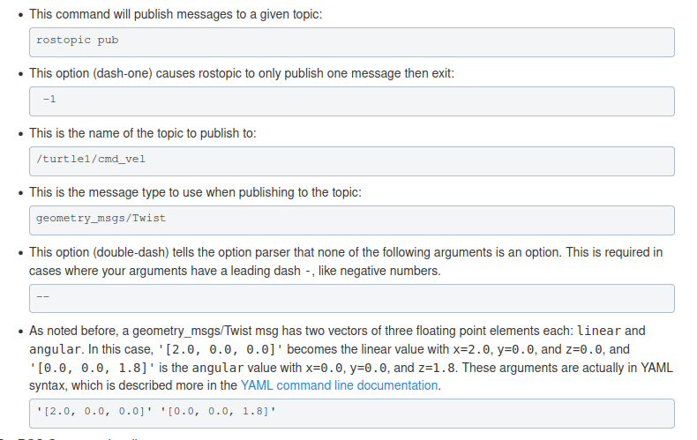
You may have noticed that the turtle has stopped moving; this is because the turtle requires a steady stream of commands at 1 Hz to keep moving. We can publish a steady stream of commands using rostopic pub -r command:

$ rostopic pub /turtle1/cmd_vel geometry_msgs/Twist -r 1 -- '[2.0, 0.0, 0.0]' '[0.0, 0.0, -1.8]'

Understanding ROS services and parameters:
http://wiki.ros.org/ROS/Tutorials/UnderstandingServicesParams

Services are another way that nodes can communicate with each other. Services allow nodes to send a request and receive a response.

rosservice list print information about active services
rosservice call call the service with the provided args
rosservice type print service type
rosservice find find services by service type
rosservice uri print service ROSRPC uri
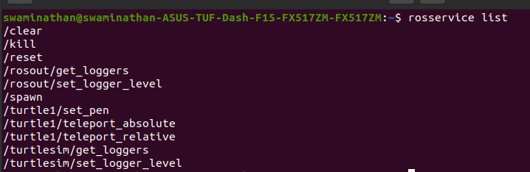
rosservice call [service] [args]
Using rosparam:
rosparam allows you to store and manipulate data on the ROS Parameter Server. The Parameter Server can store integers, floats, boolean, dictionaries, and lists. rosparam uses the YAML markup language for syntax. In simple cases, YAML looks very natural: 1 is an integer, 1.0 is a float, one is a string, true is a boolean, [1, 2, 3] is a list of integers, and {a: b, c: d} is a dictionary.

rosparam set set parameter
rosparam get get parameter
rosparam load load parameters from file
rosparam dump dump parameters to file
rosparam delete delete parameter
rosparam list list parameter names
We can use rosparam get / to show the contents of all the params. We can also store it in a file. By using, rosparam dump [file_name] [namespace].

ROS Workspace Environment
Defines the context we are working on or with. Such as which packages should be used. (For example, when we have different versions of packages installed).

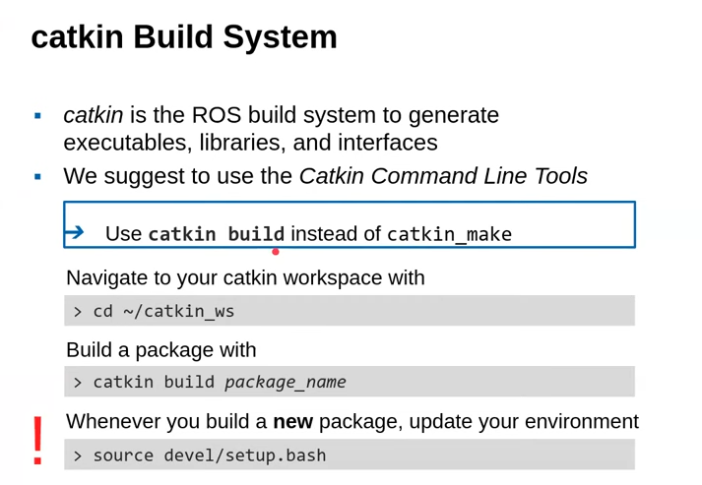
We work with the src directory under catkin workspace. The rest are recommended to not be tinkered with. If necessary, clean the build and devel space with
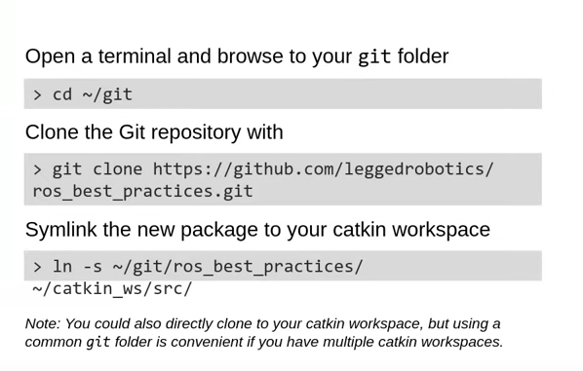
$ catkin clean

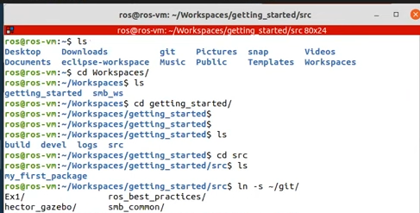

ROS Launch:
Tool for launching multiple nodes as well as setting parameters. Are written in XML as *.launch files. Launch automatically starts a roscore.
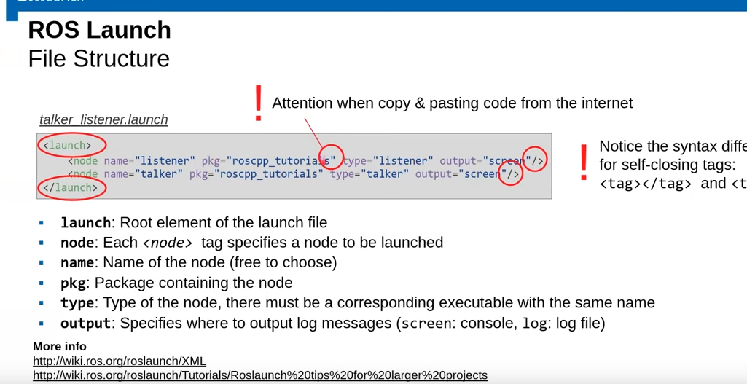
Create reusable launch files with <arg> tag, which works like a parameter.
Use arguments in launch file with $(arg arg_name). Assign arg values in the terminal with roslaunch launch_file.launch arg_name:=value.

Gazebo Simulator:
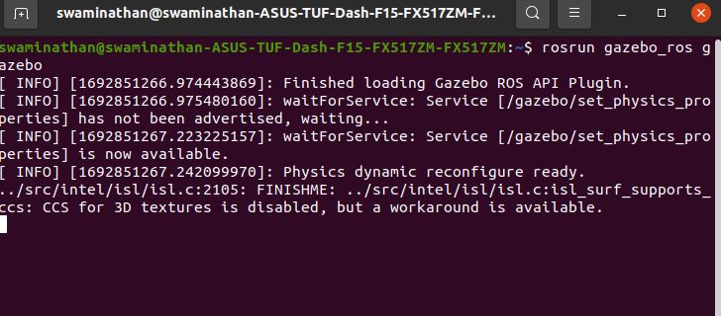
Tool to simulate 3-d rigid body dynamics

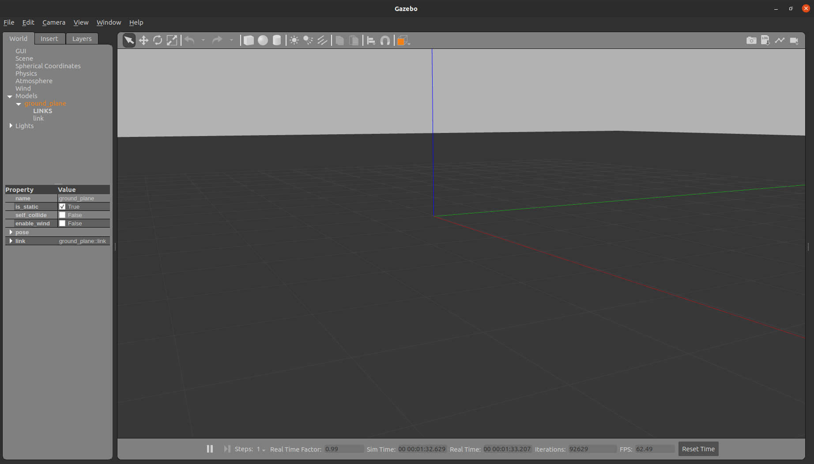
RQT and TF – Lecture 3
Source: https://www.youtube.com/watch?v=WcArOQuJRDI
TF Transformation system:
- Tool for keeping track of coordinate frames over time.
- Maintains relationship between coordinate frames in a tree structure buffered in time.
- Lets the user transform points, vectors, etc., between coordinate frames at desired time.
- Implemented as publisher/subscriber model on the topics /tf and /tf_static.
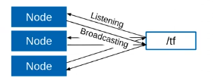
Multiple nodes publishing on the same topic. It doesnt have to be time-synced. for example, 1 node might publish for 10 Hz, another might publish for 30 Hz. TF is not good for long-time tracking, as tree structure might get enormous.

tf messages -> tf2_msgs/TFMessage.msg

Command line
rosrun tf tf_monitor # info about the current transform tree
rosrun tf tf_echo source_frame target_frame # info about the transform between two frames.

RViz -> 3D visualization of the transforms.
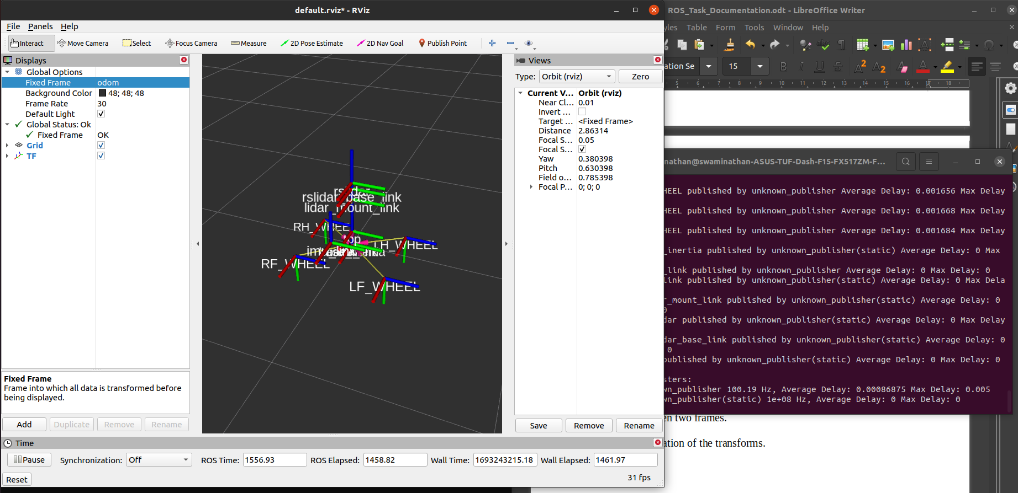
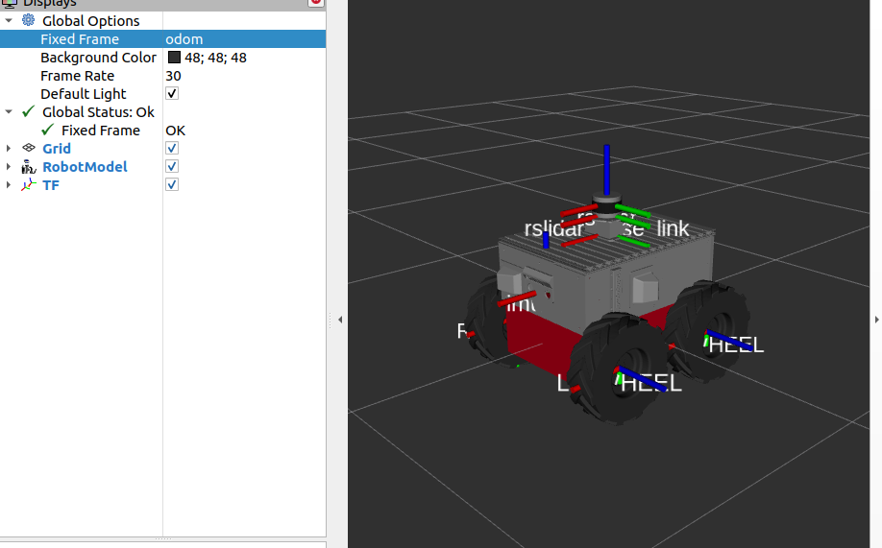
fixed frame should be odom, Add RobotModel and TF.
rqt User Interface:
User interface based on Qt.
Custom interfaces can be setup, lots of plugins exist. Simple to write own plugins.

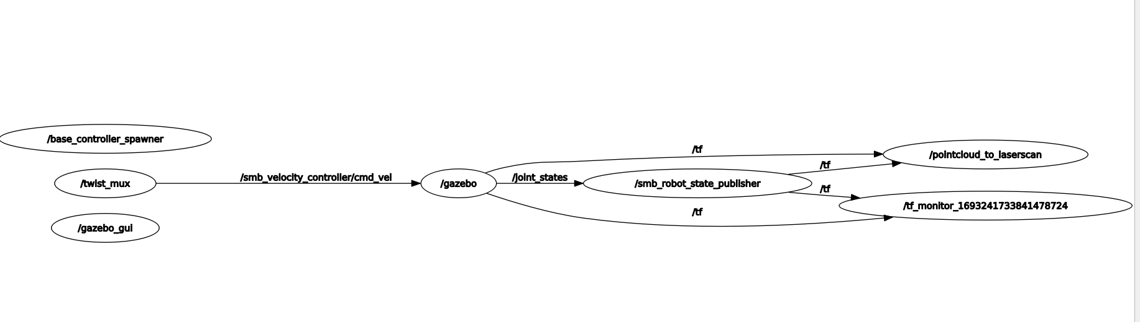
> rosrun rqt_graph rqt_graph

ROS Time, Bag, Debugging strategies:
Normally ROS uses the PC’s system clock. For simulations or playback of logged data, it is convenient to work with a simulated time (pause, slow down, etc.,)

TO work with a simulated clock:
- rosparam set use_sim_time true
- publish the time on the topic /clock from gazebo (default) or ROS bad (use option –clock)

ROS Time API:

ros::Time
ros::Time begin = ros::Time::now();
double secs = begin.toSec();

ros::Duration
ros::Duration duration(0.5); // 0.5 s
ros::Duration passed = ros::Time()::now() - begin;

ros::Rate
ros::Rate rate(10); // 10 Hz

ROS Bag:

A bag is a format for storing message data. binary format with file extension *.bag
Suited for logging and recording datasets for later visualization and analysis.
Record all topics in a bag
> rosbag record -all
> rosbag record topic_1 topic_2 topic_3

Debugging Strategies:
- Use analysis toold to check data flow (rosnode info, rostopic echo, roswtf, rqt_graph, etc.,)
- Vizualize and plot data (Rviz, RQT Multiplot, etc.,)
- Divide program intro smaller steps and check intermediate results (ROS_info, ROS_DEBUG, etc.,)
- Clean workspace if things dont make sense. catkin clean --all.
Build in debug mode and use GDB or Valgrind

catkin config --cmake-args -DCMAKE_BUILD_TYPE=Debug

