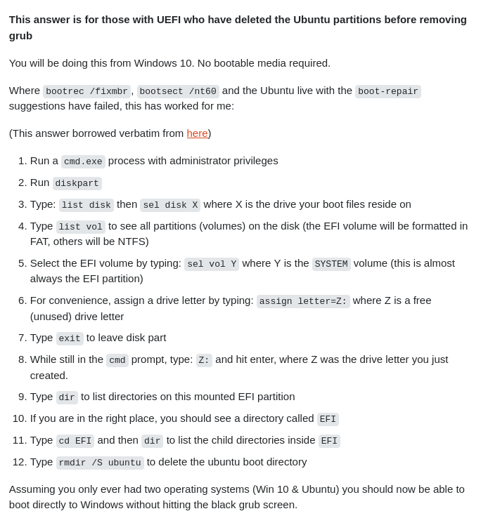
Ubuntu 20.04 Dual Boot

Initial Hiccup:

The ubuntu version that was already installed with dual boot was 22.04 LTS. This was done during the selection task round. Hence, in order to accomodate ROS software which is suitable only for 20.04, the ubuntu version 22.04 was uninstalled with backup on a 16 GB drive.

Fix and Installation:

The backed up folders were shifted to Windows, and the 16 GB drive was wiped. For the installation of ubuntu 20.04, the partitioned disk was kept unallocated and once again, Rufus was used to install the .iso file into the 16 GB drive.

One issue that was faced was the reinstallation of ubuntu. This was possibly because the grub installer was still left uninstalled. Since, after forcefully removing it, the ubuntu installation was successful.

Resources referred to while installing ubuntu for dual boot:
https://www.xda-developers.com/dual-boot-windows-11-linux/
https://www.youtube.com/watch?v=mXyN1aJYefchttps://itsfoss.com/uninstall-ubuntu-linux-windows-dual-boot/
https://askubuntu.com/questions/429610/uninstall-grub-and-use-windows-bootloader

Some Ubuntu Shortcuts:
- In LibreText: ( Shift + F12 ) to bullet point a statement.
- (Ctrl + Shift + PrtSc) to copy screenshot to clipboard.
- (Shift + PrtSc) to save screenshot as picture.

