ROS Task Documentation – Exercises
- Swaminathan S K (AGV Software Team)

Exercise 1:
1.)
- Created ~/git and ~/Workspaces directories.
- Under ~/Workspaces directory, created a directory called smb_ws -> src.
- Extracted the zip folder into ~/git directory.
- Created a symlink (ln -s ........) under the ~/Workspaces/smb_ws/src directory.

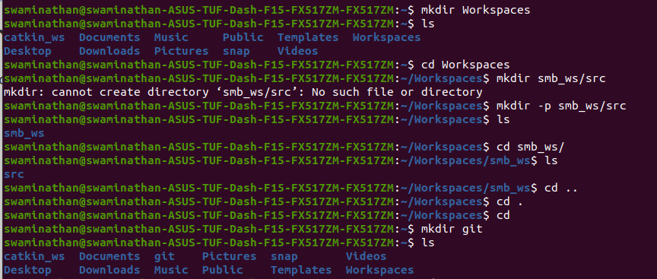
Errors and Fixes:
Resources searched through:
https://stackoverflow.com/questions/41234957/catkin-command-not-found
https://github.com/NelsenEW/eth-zurich-solution
(For the latter link, I did not go through the rest of the solution. The link was strictly used for finding out the dependencies)

- catkin command was not recognized.
Fix: sudo apt-get install python3-catkin-tools
- hector_gazebo_plugins Cmake error.
Fix: Had to install a few dependencies -
sudo apt install -y ros-<distro>-hector-gazebo-plugins \
ros-<distro>-velodyne \
ros-<distro>-velodyne-description \
ros-<distro>-velodyne-gazebo-plugins \
ros-<distro>-pointcloud-to-laserscan \
ros-<distro>-twist-mux
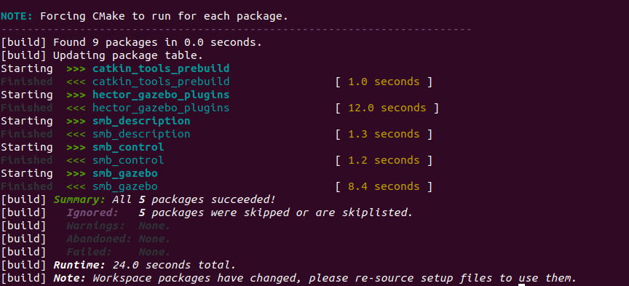
- Sourced the setup file.
- cd to the smb_commons directory through src/
- roslaunch smb_gazebo smb_gazebo.launch
2.)
rosnode

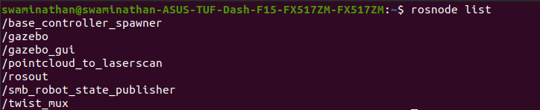
rostopic

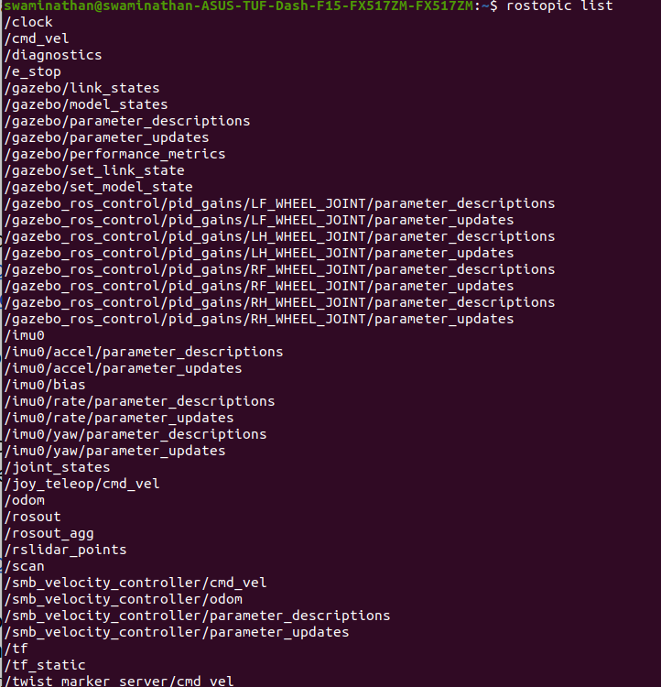
rostopic echo clock
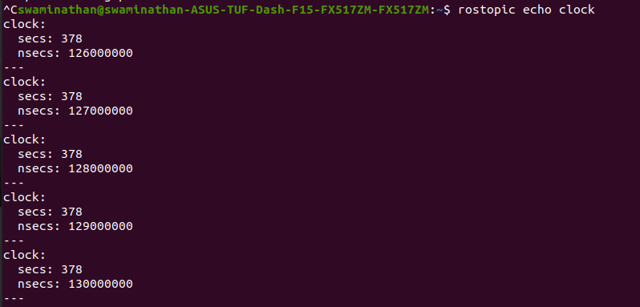
rqt_graph
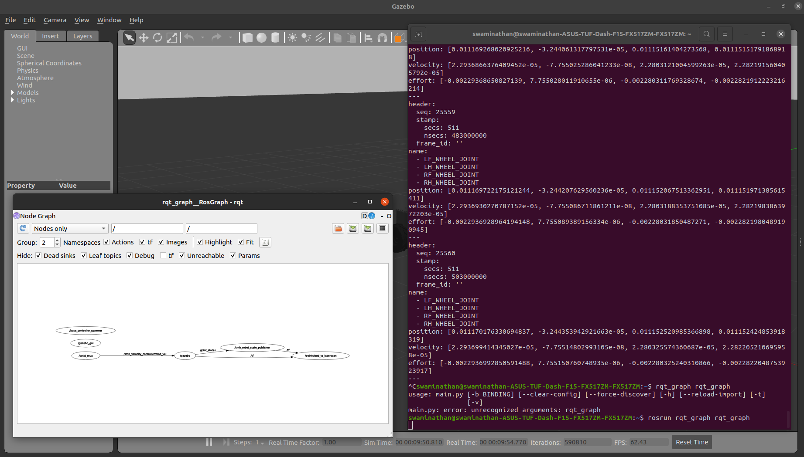
rqt_graph enlarged
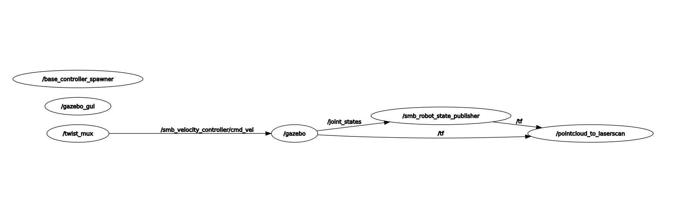
3.) Command a desired velocity:
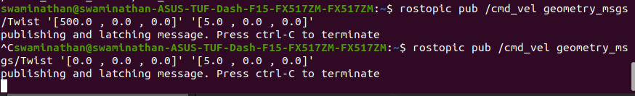
Errors faced:
Looking at the rqt_graph, I had tried to publish to smv_velocity_controller/cmd_vel. However, apparently, publishing to cmd_vel does the job.
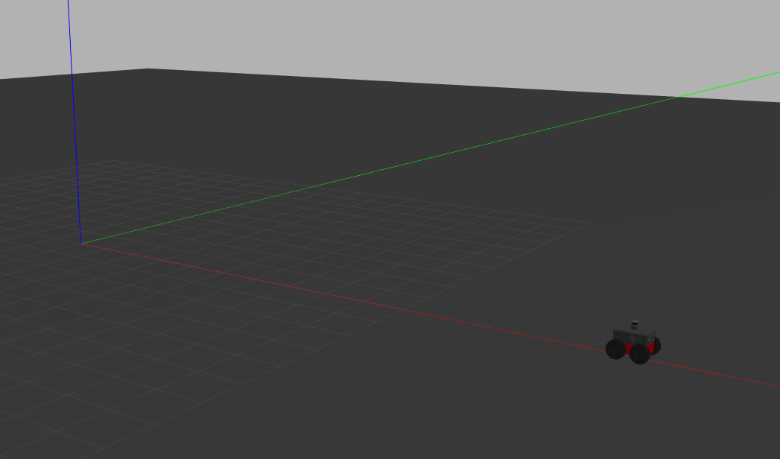
4.)
Resource: https://github.com/ros-teleop/teleop_twist_keyboard
- teleop_twist_keyboard was cloned
- it was compiled through catkin build in the workspace
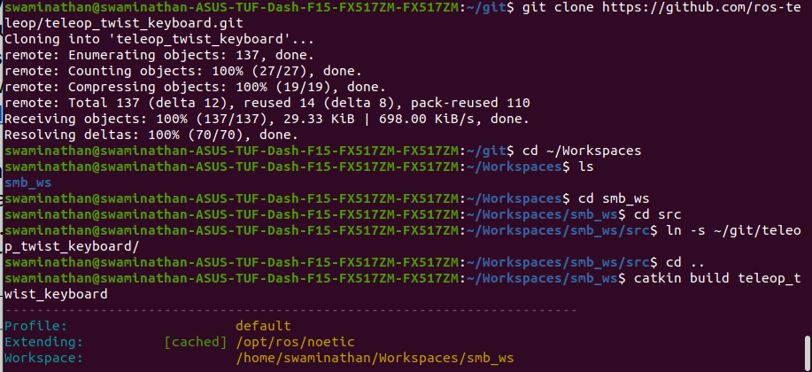
Errors and Fixes:
teleop_twist_keyboard was not recognized as a package. This is because while opening a new terminal, the setup.bash is not sourced. So we have to source it each time.
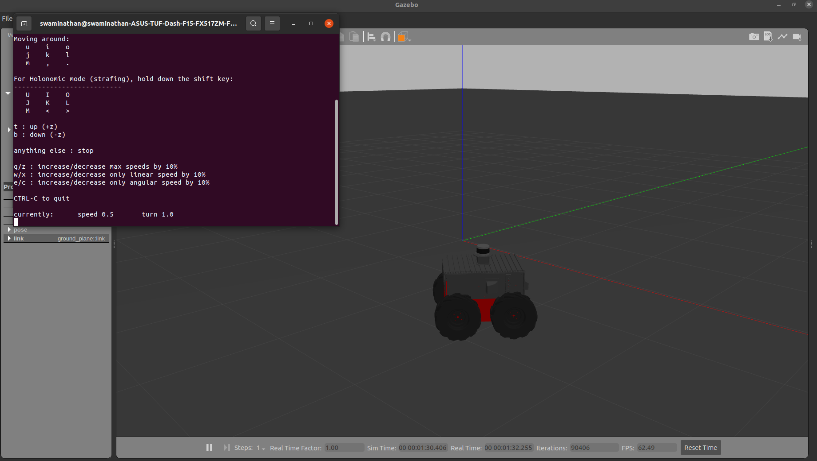
5.)
- Created a new .launch file in src
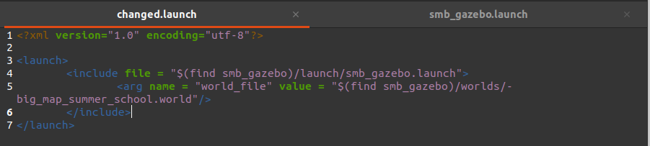
Errors and Fixes:
- The gazebo simulator for some reason (*) does not display world files that are out of the directory of src. (Even after providing the absolute path). So I have used the world file inside the worlds folder present in the src/smb_gazebo directory. World files can also be pasted here from other folders and run similarly.
